Agentic Onboarding - Consolidated Architecture and Purpose Brief

- System Purpose and Strategic Intent

The VERINITE AI CUSTOMER ONBOARD APP is designed as an end-to-end, AI-powered onboarding ecosystem that reduces manual processing, improves compliance execution (KYC/AML), and accelerates risk-aware customer decisioning.
Agentic Onboarding is an event-native underwriting intelligence platform that orchestrates specialized decision agents under a unified governance envelope.
Its architecture is intentionally composable: each slot can evolve independently while the control plane preserves determinism, and operational safety.
The architecture follows a micro services and event-driven pattern, centered around a powerful Orchestration Layer that manages the customer's journey through multiple specialized, decoupled agents.

● Frontend Interaction: The process begins at the VERINITE AI CUSTOMER ONBOARD APP (Frontend), which collects user data via a multi-step form and a real-time chat interface.
● Orchestration: All frontend requests are routed to the Agentic Onboarding Orchestrated (Orchestrator) service. The Orchestrator generates a unique traceId for every application, tracks the state using a state machine, and communicates with specialist services via an internal Event Bus (Pub/Sub pattern) and direct HTTP calls.
● Agent Execution: The Orchestrator manages the sequential or parallel invocation of specialist agents (Address, KYC, AML, Credit).
● Final Decision: The results from all agents are synthesized by the Risk Agent and then evaluated by the Decision Gateway, which enforces conservative policy rules to yield a final APPROVE, DENY, or ESCALATE decision.
● Audit Trail: Every stage, event, and decision is logged in a comprehensive Audit & Tracking System, providing a complete audit trail linked by the traceId.

2) Consolidated Architecture View
The combined architecture follows a microservices-plus-event-driven model: frontend requests are routed to the orchestrator, processed through slotized specialist agents, and finalized by a policy-governed Decision Gateway with traceable audit telemetry.
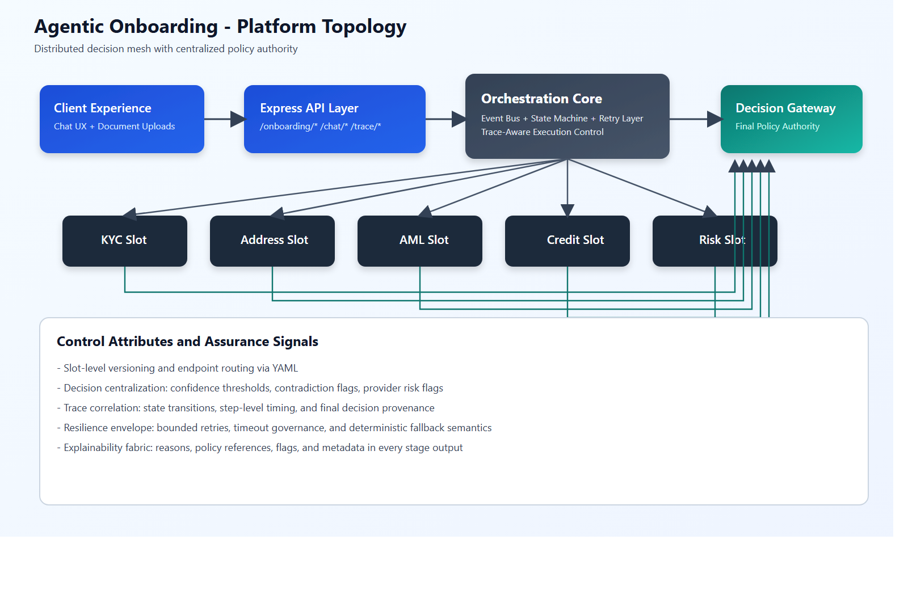
Figure A - Platform Topology
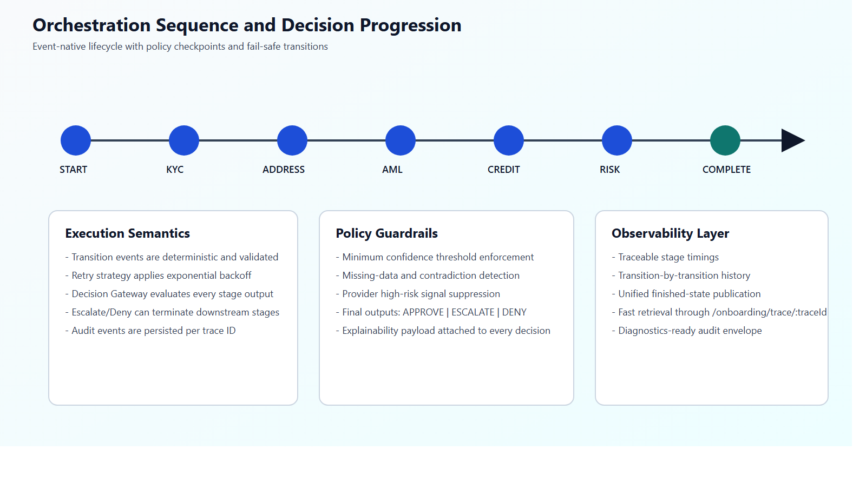
Figure B - Orchestration Sequence
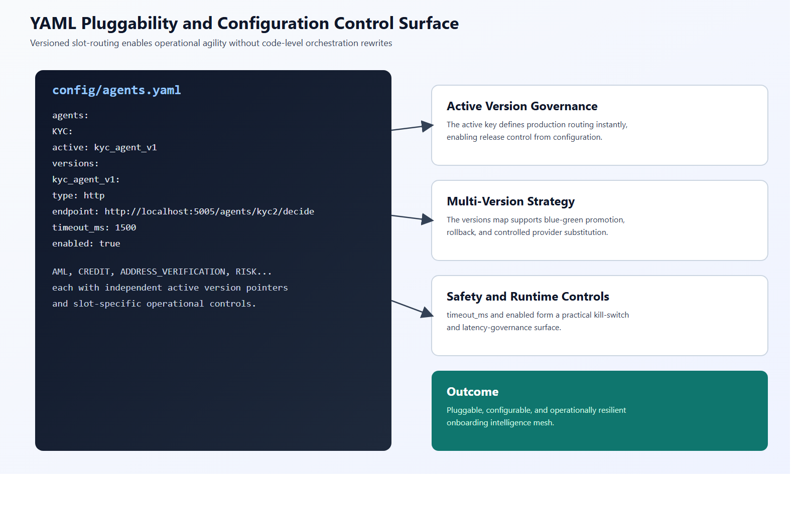
Figure C - YAML Pluggability Control Surface

3) Component Stack and Service Endpoints
The following table contains the service responsibilities with the current orchestration artifacts.
Component | Primary Purpose | Endpoint / Port
Frontend (Next.js + React + TypeScript) | Customer-facing onboarding UI, uploads, and guided chat. | 3000
Orchestrator (Node.js + Express + TypeScript) | Central workflow orchestration, state machine, event bus, audit trail. | 4000
Address Verification Agent | Address validation, normalization, confidence scoring. | 5000
KYC Agent | Identity and document verification workflow. | 5005
AML Agent | Sanctions/PEP/watchlist screening and risk flagging. | 5006
Credit Agent | Credit profile evaluation and eligibility signals. | 5007
Risk + Decision Gateway | Final policy-governed adjudication (APPROVE / DENY / ESCALATE). | Local + orchestrator

4) Workflow State Machine and Decision Logic
The onboarding workflow transitions through deterministic stages (initialized -> KYC -> address -> AML -> credit -> risk -> completion), with retry envelopes and state history tracked per traceId.
- Escalate when confidence is below threshold, data is missing, or signals are contradictory.
- Deny when policy conflict or high-risk conditions are detected.
- Approve only when all critical controls and confidence conditions are satisfied.

The State Machine dictates the logical flow of the application, ensuring that checks are performed in a predefined sequence and providing necessary retry logic and history tracking.
State Transition Event(s) Description INITIALIZED START event Application submission rcvd.
KYC_STARTED KYC\_APPROVED / Know Your Customer KYC\_DENIED verification process begins.
AML_STARTED AML\_APPROVED / Anti-Money Laundering AML\_DENIED checks begin.

CREDIT_STARTED CREDIT\_APPROVED / Credit and financial CREDIT\_DENIED assessment begins.
RISK_ASSESSMENT RISK\_APPROVED / Final composite risk score RISK\_ESCALATE and decision synthesis.
FINAL_APPROVED Application successfully approved.
FINAL_REJECTED Application rejected due to policy or agent denial.
ESCALATION_QUEUE Application requires manual review due to low confidence or missing data.

The Decision Gateway acts as the final authority, enforcing conservative policy rules before an application is approved.

● ESCALE if:
○ Any agent returns a confidence score < 0.8.
○ The system detects a missing_data flag. ○
Contradictory signals are received from multiple agents.
● DENY if:
○ Any agent explicitly returns a deny proposal with high confidence.
○ The system detects a policy_conflict or high_risk flag.
● APPROVE if:
○ All agents return an approve proposal.
○ Overall confidence is >= 0.8.
5) YAML Pluggability and Configuration Model
The platform is operationally pluggable through slot-based YAML configuration, supporting active version pointers, multi-version catalogs, transport-type abstraction (HTTP/local), and runtime safety controls.
- Slot abstraction separates business capability from provider implementation, enabling clear domain boundaries.
- Active-version routing enables release governance by configuration, not by code redeployment.
- Version catalogs support migration, rollback, and blue-green deployment patterns without orchestration redesign.
- The type dimension enables seamless HTTP and local execution modes under one contract-first runtime.
- timeout_ms and enabled fields form an operational resilience layer for latency and incident control.
6) Feature Highlights
- Feature: Event-Native Orchestration | Value: Modular extensibility with clear stage contracts.
- Feature: Deterministic State Machine | Value: High-assurance lifecycle governance and audit precision.
- Feature: Central Decision Gateway | Value: Unified risk posture and policy-consistent final outcomes.
- Feature: Hybrid AI + Rules Intelligence | Value: Better automation while maintaining explainability and control.
- Feature: Trace-Centric Observability | Value: Fast diagnostics, governance transparency, and regulator-ready evidence.
7) Implementation Anchors
- Entry and API control surface: src/index.ts
- Workflow orchestration: src/orchestrator/orchestrator.ts
- State lifecycle model: src/orchestrator/stateMachine.ts
- Decision governance: src/decisionGateway/decisionGateway.ts
- Config registry and YAML loading: src/registry/agentRegistry.ts + config/agents.yaml
- Conversational document onboarding: src/chatbot/onboardingChatbot.ts

