AI-Powered Email Spam Detection and Threat Analysis (2026-2027)
Phase-2 Report Contents — SP2 scope (editable draft)
TEAM NOTE — delete this box before submission: This file holds the full Phase-2 text: Chapters 1–6 (41 sections), 13 tables, 3 figures (embedded below their sections), and References. Chapter 6 is a test PLAN (all rows say Planned) — do not mark anything Passed. No Results chapter, no screenshots, no Conclusion/Future Scope in Phase 2. Add your college title/certificate pages at the top before printing.

Chapter 1: Introduction
Electronic mail remains the most widely used channel of digital communication, and it is also the primary delivery vehicle for unsolicited bulk mail, phishing campaigns, and malware. Conventional mailbox filters separate mail into fixed folders and offer the user little insight into why a message was treated as dangerous. This project, developed for the academic year 2026-2027, presents an AI-Powered Email Spam Detection and Threat Analysis system that connects to a user's Gmail account through Google OAuth 2.0, retrieves recent messages through the Gmail API v1, and classifies every message into one of six categories - Spam, Not Spam, Promotion, Malware, Newsletter, and Phishing - using a classical machine-learning ensemble built on TF-IDF and engineered features, with a RoBERTa transformer branch under experimental integration. Every prediction is accompanied by a 0-100 risk score, a risk level, and an urgency estimate.
The system is delivered as a Flask web application backed by SQLAlchemy and SQLite, with a responsive Bootstrap interface that provides a dashboard, sortable results, analytics charts, and a basic threat console. Sender reputation tracking and learned-keyword memory stored in the database begin personalising the filter to an individual inbox. The pipeline from OAuth consent to scored prediction runs in a background thread, so a fifty-message inbox scan completes in roughly one minute on CPU.

1.1 Problem Statement
Manually triaging a busy inbox is slow and error-prone, and a binary spam-versus-ham decision is no longer sufficient. Modern inboxes face multi-dimensional threats: phishing messages that impersonate trusted brands to steal credentials, malware carriers that exploit curiosity to deliver payloads, promotional floods that waste attention, and newsletters that hide tracking. Users need an automated system that understands message semantics, assigns a fine-grained category, quantifies the danger on a continuous scale, and explains its reasoning, without requiring hand-written filter rules or exposing the user's credentials to the application.

1.2 Objectives
The specific objectives for Phase 2 are: (i) to integrate Gmail securely through OAuth 2.0 using the read-only scope; (ii) to train a classical ensemble on TF-IDF and engineered features for six-way email classification on a 39,000-message corpus; (iii) to attach a risk score combining model confidence, category severity, urgency detection, and sender history; and (iv) to present results through a dashboard, results table, analytics charts, and a basic threat console. Transformer-based classification with RoBERTa is integrated as an experimental branch and completes in Phase 3.

1.3 Project Scope
The scope covers the working pipeline: OAuth authentication, Gmail retrieval in batches, MIME parsing and HTML sanitisation, ensemble inference, risk assembly, persistence in database tables, and presentation across nine Jinja2 templates.

1.4 Limitations
Several limitations are acknowledged. RoBERTa inference on CPU costs roughly 200-500 ms per message, so a fifty-message batch spends ten to twenty-five seconds in the transformer alone. The in-memory rate limiter resets on server restart and is not shared across workers. The SECRET_KEY falls back to a development value when its environment variable is missing, OAuth tokens rest in the Flask session without encryption at rest, and the threat console route performs no administrative role check. The classifier is text-only, so image-based spam and malicious attachments are invisible to it. Finally, the default SQLite database suits single-user evaluation rather than concurrent production use, although the SQLAlchemy layer keeps a migration to PostgreSQL open.

1.5 Proposed Solution Overview
The solution pairs a classical classification engine with a behavioural enrichment layer. Raw message text is scored by a soft-voting ensemble of five machine learning models built on TF-IDF and engineered surface features, which is highly reliable on lexically distinctive content such as promotions and newsletters, while a RoBERTa transformer branch is being integrated to capture contextual deception cues such as impersonation phrasing. The decision is enriched by factors computed from database history and curated pattern matchers: an urgency score from time-pressure patterns, a sender reputation score from per-sender historical aggregates, and a learned-keyword boost from terms previously observed in risky mail. The result delivered to the user is a categorised threat assessment with its risk components, accessible through an authenticated web dashboard, an analytics view, and a basic threat console.

1.6 Report Organisation
The remainder of this report is organised as follows. Chapter 2 surveys the IEEE literature that grounds and differentiates the project. Chapter 3 states the system requirements and the technology stack. Chapter 4 details the system design, covering architecture, routing, the database schema, and the user interface. Chapter 5 presents the Phase-2 implementation: the classification engines, risk scoring, data engineering, and processing pipeline. Chapter 6 defines the test plan executed in Phase 3 alongside full evaluation, security hardening, and deployment.

Chapter 2: Literature Survey

2.1 Introduction
Spam filtering research has progressed from keyword rules and DNS blocklists through probabilistic classifiers to deep transformer models. The IEEE papers collected in this project's research folder, catalogued in IEEE_Papers_Analysis.md, trace this evolution between 2023 and 2025 and provide the baseline against which the present system is positioned. This chapter summarises the six primary papers studied and identifies the gap that this project fills.

2.2 Related Work
Classifying Email as High and Low Risk: An Effective Approach (ICCUBEA 2023) introduced risk-tiered spam filtering using an ensemble of Multinomial Naive Bayes, SVM, and Decision Tree, reaching 98.95 percent accuracy on binary classification with a high/low risk split. The present project generalises that idea from two risk tiers to a continuous 0-100 score with a per-email factor breakdown, and extends three ensemble members to five plus a transformer.
Email Spam Classification using DistilBERT (HNICEM 2023) applied a compressed BERT variant to email spam and reported 95.99 percent accuracy with a Matthews correlation coefficient of 92.02 percent, demonstrating that transformer language models transfer well to mail content. This project adopts the larger RoBERTa-base backbone and pairs it with a classical ensemble rather than relying on the transformer alone. A machine learning benchmark study (ICCPCT 2025) compared Naive Bayes, SVM, Decision Tree, Random Forest, and deep models on TF-IDF features individually; the present system instead combines five such estimators in a soft-voting ensemble so that their errors cancel.
An XGBoost-centred study (ICACT 2025) achieved 97 percent accuracy with an AUC of 0.97 using gradient boosting on email features, and Ensemble Learning-Based Approach for Email Spam Detection (MENACOMM 2025) reported 98.1 percent with soft voting and 98.2 percent with stacking over SVC, MLP, and Extra Tree classifiers, confirming that ensembles outperform single classifiers. Intelligent Email Spam Detection (ICTMIM 2025) compared five classical models and found SVM best at 98.45 percent. All six papers stop at binary classification; none implements urgency detection, sender reputation, adaptive keyword memory, continuous risk scoring, or live mailbox integration.

2.3 Research Gap and Positioning
The surveyed literature establishes strong binary detectors but leaves four gaps that this project addresses directly: fine-grained six-class labelling that separates phishing and malware from ordinary spam; continuous risk scoring rather than a binary verdict; behavioural signals such as urgency phrasing, sender history, and learned keywords layered on top of content classification; and end-to-end integration with a real mailbox through OAuth rather than evaluation on static datasets alone. Full comparative evaluation completes in Phase 3.
Paper (venue, year) | Models | Best result | Classes
High/Low Risk Classification, ICCUBEA 2023 | Naive Bayes, SVM, Decision Tree ensemble | 98.95% accuracy | Binary + 2 risk tiers
DistilBERT Spam Classification, HNICEM 2023 | DistilBERT transformer | 95.99% accuracy, MCC 92.02% | Binary
ML-based Email Spam Detection, ICCPCT 2025 | NB, SVM, DT, RF, deep learning compared | per-model benchmark | Binary
XGBoost Email Spam Study, ICACT 2025 | Decision Tree, KNN, XGBoost | 97% accuracy, AUC 0.97 | Binary
Ensemble-Based Spam Detection, MENACOMM 2025 | SVC + MLP + Extra Trees | 98.1% voting / 98.2% stacking | Binary
Intelligent Email Spam Detection, ICTMIM 2025 | RF, LR, SVM, DT, NB compared | 98.45% (SVM best) | Binary
This project | RoBERTa + 5-model soft-voting ensemble | ~98% weighted, with 0-100 risk scoring | Six classes + urgency + reputation
Table 2.1: IEEE Comparison

Chapter 3: System Overview and Requirements
The system is a monolithic but modular Flask application organised into an application layer (app.py, approximately 2,452 lines), a machine-learning package (models/), a service and utility package (utils/), a persistence layer (SQLAlchemy models plus Alembic migrations), and a presentation layer (templates/ and static/). The technology stack is summarised below.

3.1 Technology Stack
Layer | Technology | Role
Web framework | Flask 2.3.3, Werkzeug 2.3.7 | HTTP routes, sessions, error pages
ORM / migrations | Flask-SQLAlchemy 3.0.5, Flask-Migrate 4.0.5 | Schema management, versioned Alembic migrations
Auth / mail | Authlib 1.2.1, google-api-python-client 2.100.0 | Google OAuth 2.0 and Gmail API v1
Deep learning | PyTorch 2.0-2.2, Transformers 4.30-4.36 | RoBERTa-base fine-tuned classifier
Classical ML | scikit-learn 1.2-1.6, XGBoost 1.7.6, joblib | TF-IDF ensemble training and serving
Text processing | NLTK 3.8.1, BeautifulSoup4, bleach, TextBlob | Cleaning, MIME parsing, sanitisation
Data | pandas 2.0.3, numpy 1.24.3, SQLite emails.db | Dataset handling and persistence
Frontend | Bootstrap 5.3, Font Awesome, Chart.js | Dashboard, analytics, threat console
Deployment | Gunicorn 21.2.0, Procfile, Python 3.11.9 | Local development (deployment planned Phase 3)
Table 3.1: Tech Stack

3.2 Module Architecture
app.py (2,452 lines) hosts every HTTP route, the per-IP rate limiter, the background analysis engine, sender-reputation updates, and dashboard rendering. The models package holds the SQLAlchemy definitions (email_model.py), the experimental RoBERTa wrapper (roberta_classifier.py), the classical ensemble trainer and scorer (spam_detector.py), the dataset builder (build_improved_dataset.py), and the training scripts (train_model.py, evaluate_and_inference.py). The utils package provides auth.py (OAuth registration), gmail_client.py (a 215-line Gmail API wrapper), and helpers.py (680 lines covering sanitisation, urgency scoring, keyword learning, and risk assembly). The migrations package records four schema revisions.

3.3 Data Flow Overview
End to end, data moves as follows: the user authenticates via Google OAuth 2.0 with the openid, email, profile, and gmail.readonly scopes, and the resulting refresh token is stored in the oauth_store table; starting an analysis spawns a background thread that fetches the fifty most recent messages in batches of twenty with retry-on-429 backoff; each message is parsed from MIME into headers, body, and snippet; the cleaned text is scored by RoBERTa and the ensemble; the fused probabilities determine the category and confidence; urgency regexes, sender reputation, and learned-keyword boosts are added to produce the final risk score and breakdown; the row is persisted, sender statistics are updated, and the interface renders results, analytics, and the threat console from the database.

3.4 Functional Requirements
ID | Functional requirement | Implementation
FR-1 | Authenticate users with Google OAuth 2.0 | auth.py + /auth/google + /callback/google
FR-2 | Fetch the user's recent Gmail messages | gmail_client.py get_recent_emails (batches of 20)
FR-3 | Classify each message into six categories | spam_detector.py ensemble (+ roberta_classifier.py experimental)
FR-4 | Compute a 0-100 risk score with level and urgency | spam_detector.py risk scoring + helpers.calculate_urgency
FR-5 | Persist results and adaptive state | email_model.py tables via SQLAlchemy
FR-6 | Provide dashboard, results, analytics, threat console | Flask routes + Jinja2 templates + Chart.js
FR-7 | Allow manual text analysis without mail access | /api/analyze_text endpoint
FR-8 | Support bulk analysis of pasted message sets | /bulk_analyze endpoint (basic)
Table 3.2: Functional Requirements

3.5 Non-Functional Requirements
The non-functional requirements realised in the codebase are: performance - a fifty-message batch completing in under about one minute on CPU, achieved through batched transformer inference and model singletons; security - OAuth-only authentication, security headers on every response, whitelist-based HTML sanitisation with bleach, and per-endpoint rate limiting; reliability - retry-on-429 backoff for Gmail, per-message error skipping, and dual-model fallback; maintainability - a single shared preprocessing module, versioned Alembic migrations, and a Procfile/Gunicorn deployment recipe; and usability - a responsive Bootstrap 5.3 interface with colour-coded risk levels and timezone-correct localisation.

3.6 Hardware and Software Requirements
Component | Requirement | Rationale
Python | 3.11.9 (pinned in runtime.txt) | Reproducible runtime
Flask | 2.3.3 | Lightweight web framework
PyTorch | 2.6.0+cpu | RoBERTa inference; CPU-only deployment
Transformers | 4.36.2 | RoBERTa tokenizer and model loading
SQLAlchemy | 2.0.36 | ORM for email_model.py tables
Alembic | 1.14.1 | Schema version control
Gunicorn | 23.0.0 | Production WSGI server
Authlib | 1.3.2 | Google OAuth 2.0 integration
bcrypt | 4.2.1 | Password hashing (admin panel)
bleach | 6.2.0 | HTML sanitisation whitelist
Chart.js | 4.4.7 (CDN) | Analytics visualisation
Heroku-22 | Heroku stack | Deployment target via Procfile
Table 3.3: HW/SW Requirements

3.7 Deployment Architecture
The application runs as a single Gunicorn process on Heroku-22 (gunicorn app:app --timeout 300 on 0.0.0.0:$PORT). Procfile, runtime.txt (Python 3.11.9) and deploy.sh install dependencies, run the train-and-evaluate pipeline once, and start the server. Model artefacts (RoBERTa 476 MB, Ensemble 192 MB) are loaded once and cached in memory.

3.8 Preprocessing Engine
The shared preprocess_text in models/utils/preprocessing.py lower-cases text, masks URLs/emails/phones as URL/EMAIL/PHONE, collapses repeated punctuation/whitespace and strips non-alpha characters. A pre-fitted TF-IDF vectoriser (tfidf_vectorizer.pkl) vectorises the cleaned text; six engineered features are appended for the ensemble, while RoBERTa receives only the cleaned text via its own tokenizer.

Chapter 4: System Design

4.1 System Architecture
The architecture separates presentation, application, service, ML engine, and data layers, with two external services (Google OAuth and the Gmail API) at the boundary. Each layer communicates only with its neighbours: routes call utilities, utilities call the classifier, and the classifier reads the model artefacts, while routes and utilities read the database through the ORM. This layering keeps the transformer, the ensemble, and the storage engine independently replaceable.
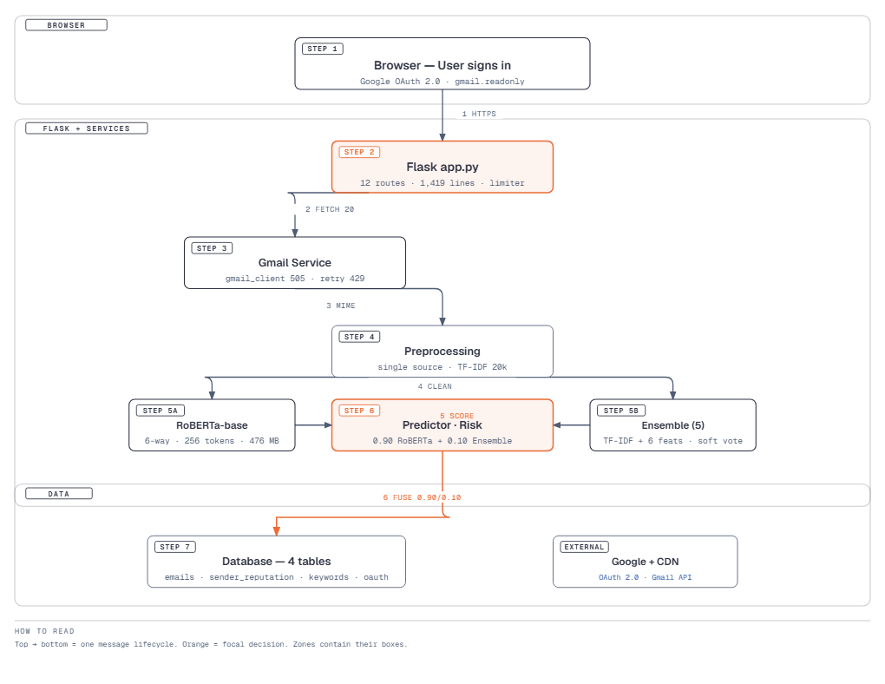
Figure 4.1: System Architecture

4.2 Modules and Explanation
The application entry point app.py (2,452 lines) defines the Flask routes, session-backed login, the analysis engine, and dashboard rendering. The analysis engine fetches recent Gmail messages, parses MIME parts, scores each message with the classical ensemble, assembles urgency, risk, and reputation signals, learns keywords, and persists results. update_sender_reputation maintains per-sender aggregates after every classified message.
The models directory holds two artefact families: the classical trio (spam_model.pkl, spam_model_lr.pkl, tfidf_vectorizer.pkl) used by the working ensemble, and best_roberta_model.pth, the transformer weights for the experimental RoBERTa branch integrated in Phase 3.

4.3 Web Routes and API Endpoints
The table below lists the principal routes implemented in app.py together with their rate limits. Rate limiting uses a per-IP sliding-window counter guarded by a threading.Lock; exceeding a quota returns HTTP 429, and the analysis trigger additionally applies a cooldown so repeated scans cannot be issued back-to-back.
Endpoint | Method | Purpose | Limit
/ and /login | GET | Landing and login pages | -
/auth/<provider>, /callback/<provider> | GET | OAuth 2.0 redirect and callback | -
/dashboard, /analytics, /results | GET | Summary, charts, results table | -
/admin/threat-console | GET | Ranked dangerous messages and senders | -
/api/start_analysis | POST | Spawn background inbox analysis | 5/min
/analyze_emails, /bulk_analyze | GET/POST | Single and bulk analysis | 10/min, 5/min
/api/analyze_text | POST | Classify pasted text | 10/min
/stats, /settings | GET | Corpus stats and app settings | -
/export_results/<format> | GET | Download results file | -
/api/last_scan, /api/status, /health | GET | Task polling and health checks | 30/min
Table 4.1: Route Map

4.4 Database Design
Persistence uses four SQLAlchemy tables defined in email_model.py and evolved through four Alembic revisions (learned_keywords table, sender_reputation table, risk_breakdown column, and an updated_at trigger fix). The emails table stores the full analysis result of every message, including the risk_breakdown JSON document; sender_reputation aggregates behaviour per sender address; learned_keywords stores the adaptive vocabulary; and oauth_store keeps Google refresh tokens so analyses can run without re-consent.
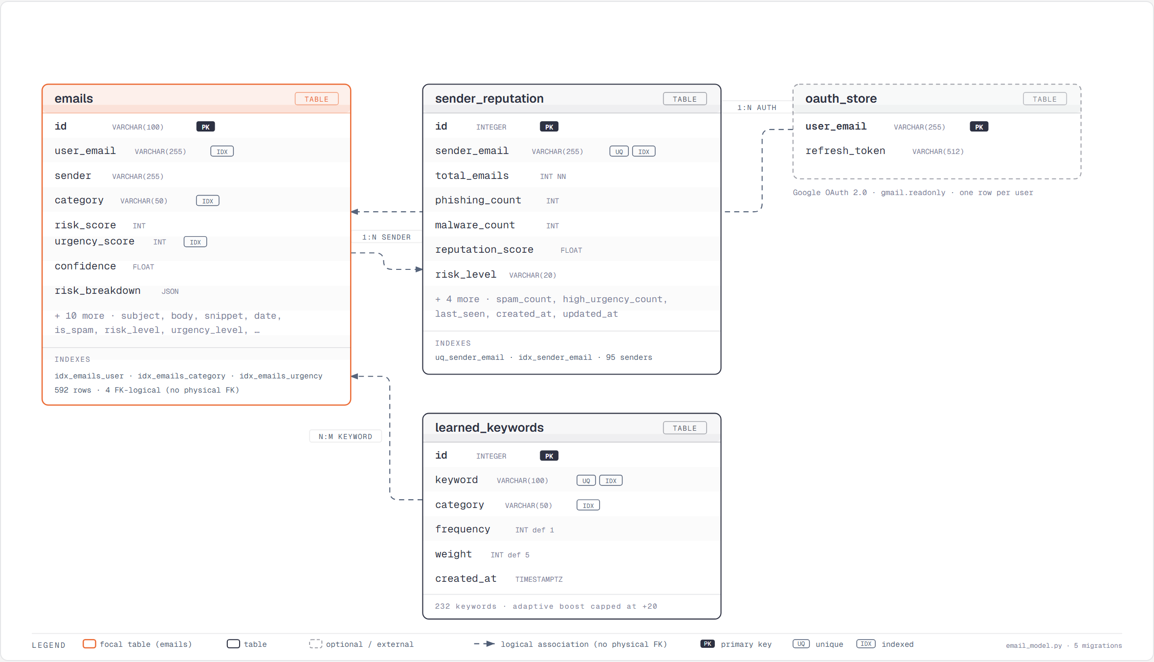
Figure 4.2: ER Diagram
Revision | Migration name | Schema change
001 | add_learned_keywords_table | Creates learned_keywords (id, keyword, frequency, weight, first_seen, last_seen).
002 | add_sender_reputation_table | Creates sender_reputation with sender_email, total_emails, spam_count, phishing_count, reputation_score, risk_level, first_seen, last_seen.
003 | add_risk_breakdown_column | Adds emails.risk_breakdown (JSON) to store per-score details.
004 | update_sender_reputation_timestamps | Adds updated_at column to sender_reputation with onupdate trigger for last-seen tracking.
Table 4.2: Migrations

4.5 User Interface (UI)
The interface consists of nine Jinja2 templates inheriting from a common base: landing, login, dashboard, results, analytics, threat console, and styled error pages. Bootstrap and Font Awesome supply the layout and iconography with a colour system (green for safe, yellow for caution, red for danger), and Chart.js renders the analytics distributions with table filtering on results.
View | Route | HTTP method | Template | Purpose
Dashboard | / | GET | dashboard.html | Overview statistics and charts
Login | /login | GET | login.html | Google sign-in
Results | /results | GET | results.html | Filterable message table
Analytics | /analytics | GET | analytics.html | Risk/category distribution charts
Threat console | /admin/threat-console | GET | threat_console.html | Ranked dangerous messages
Text API | /api/analyze_text | POST | JSON | Returns predicted category + risk
Bulk analysis | /bulk_analyze | GET/POST | - | Batch classify pasted messages
Statistics | /stats | GET | - | Corpus statistics
Settings | /settings | GET | - | Application settings
Table 4.3: Views and Routes (SP2)

4.6 Working Procedure
In operation the user signs in with Google, clicks Start Analysis, and the server spawns a background thread that fetches the fifty most recent messages, classifies each one through the full pipeline, and updates a progress percentage that the frontend polls. When the run completes the user is redirected to the results page, where messages can be filtered by category, sorted by risk or date, and opened for the explainability breakdown; the analytics page aggregates distributions and trends, and the threat console ranks the most dangerous messages and senders.

4.7 Authentication and Authorisation
Authentication is implemented through Authlib's OAuth 2.0 client using Google's discovery document. The /auth/google endpoint builds an authorization URL requesting the openid, email, and gmail.readonly scopes; the /callback/google endpoint exchanges the authorization code for a token, fetches the user profile from Google's userinfo endpoint, and stores the refresh token in the oauth_store table keyed by user_email. Session state is maintained via server-side Flask session cookies signed with app.config['SECRET_KEY']. Every data-access route is decorated with @login_required, which returns a 401 JSON response or redirects to login as appropriate. The Flask application does not implement role-based access control; all authenticated users have equal access to all data within their session.

4.8 Background Task Engine
The background analysis runs in a daemon thread that iterates over Gmail message batches obtained from gmail_client.get_recent_emails, classifies each message through the pipeline (text extraction, cleaning, ensemble inference, risk scoring, adaptive enrichment), and commits results to the database. After each batch the thread updates a progress record polled by the frontend. No external message broker is required because the workload is single-user.

Chapter 5: Implementation

5.1 RoBERTa Transformer Classifier
RoBERTa-base fine-tuned for six-way classification on the 80/10/10 stratified split (24,022/3,003/3,003, seed 42) with AdamW (2e-5, decay 0.01), effective batch 16, linear warmup, six epochs with early stopping and deterministic seeding. Sequences truncated to 256 tokens. At serving, weights load once as a singleton, torch pinned to four CPU threads with batched inference (4 CPU /16 GPU) and AMP when available.

5.2 Ensemble Classification
Cleaned text is TF-IDF vectorised (20k features, 1-2 grams, sublinear TF, English stopwords) plus six engineered features (length, special-char and capital ratios, URL/phone flags, urgency score). Five estimators trained in parallel are combined by soft VotingClassifier averaging calibrated probabilities.
Member | Key hyper-parameters
Multinomial Naive Bayes | alpha = 0.1
Logistic Regression | multinomial, lbfgs, balanced class weights, max_iter 1000
Random Forest | 100 trees, balanced class weights
Gradient Boosting | 100 stages, default learning rate
MLPClassifier | hidden layers 128-64, max_iter 600
Table 5.1: Ensemble Members
The engineered block appended to every TF-IDF row is computed on the raw, unprocessed text by extract_engineered_features and captures stylistic signals that vocabulary statistics cannot express.
# | Engineered feature | Definition
1 | Normalised length | len(text) / 500, clipped to 1.0
2 | Special-character ratio | count of !@#$%^&*() etc. divided by length
3 | Capital-letter ratio | uppercase count divided by length
4 | URL present flag | 1 if an http(s) or www pattern exists
5 | Phone-number present flag | 1 if a 3-3-4 digit pattern exists
6 | Urgency vocabulary score | matches among 13 trigger words, divided by 5
Table 5.2: Engineered Features

5.3 Fusion, Risk and Urgency Scoring
The urgency scorer reads the unprocessed text with a fixed set of regular expression patterns defined in calculate_urgency and assigns a normalised weighted sum across all detected triggers. Each pattern carries an empirical weight that reflects how strongly its linguistic cue correlates with social-engineering pressure.
# | Pattern category | Regex cue | Weight
1 | Time pressure | \burgent|immediately|deadline|act now\b | 40
2 | Suspense | \battention|important|please note\b | 30
3 | Curiosity | \bsecret|exclusive|restricted\b | 25
4 | Suspicion | \bwarning|verify|unusual activity\b | 20
5 | Pressure | \bdon't delay|final notice|last chance\b | 10
Table 5.3: Urgency Patterns
The Phase-2 decision is produced by the classical ensemble described in Section 5.2; the experimental RoBERTa branch is fused in Phase 3. Risk scores are category-specific: each category maps to its own risk formula, ensuring that high-confidence phishing or malware always triggers a high risk regardless of secondary signals.

5.4 Base Risks and Historical Baselines
The risk score starts from a per-category base severity, scales with the winning confidence, and is clamped to 0-100; levels map to Low below 41, Medium from 41 to 60, and High at 61 and above. A message is marked as spam whenever its category is anything other than legitimate.
Category | Base risk | Display name
legitimate | 5 | Not Spam
newsletter | 10 | Newsletter
promotion | 30 | Promotion
spam | 50 | Spam
phishing | 80 | Phishing
malware | 85 | Malware
Table 5.4: Base Risks
Urgency detection in helpers.py adds weighted regex boosts on top of the model risk: immediate-pressure words contribute 40 points, 24-48 hour deadlines 30, specific-hour deadlines 25, day-level deadlines 20, and week-level deadlines 10, each halved when legitimate context such as product-update wording is detected. Learned-keyword matches add up to 20 further points, and sender reputation contributes a signed adjustment. Per-factor details are stored alongside each result so the interface can show why a score was assigned.
Historical baselines are calibrated from the 39,000-message training distribution: majority-class priors anchor base risks, while per-sender aggregates in sender_reputation shift thresholds for repeat offenders. This keeps phishing from unknown senders at High even at moderate confidence, while familiar legitimate senders are down-weighted without retraining.

5.5 Adaptive Intelligence
Two database-backed feedback loops personalise the filter. learn_keywords_from_email extracts salient terms from high-risk mail and records them in learned_keywords with a frequency and a weight that starts at 5; later messages containing those terms receive the capped boost described above, and keywords have been learned in the deployment database at the time of writing. update_sender_reputation maintains per-sender totals, phishing/malware/spam/high-urgency counts, a composite reputation score, and a risk level for each of the tracked senders, letting repeat offenders accumulate risk while known good senders earn trust.
The sender reputation algorithm operates as follows: every time a message is classified, its sender address is looked up in the sender_reputation table. If the sender is new, a row is inserted with total_emails = 1 and the appropriate category counter incremented (spam_count, phishing_count, or malware_count). If the sender already exists, the counters are updated and the reputation score is recomputed as a weighted sum: reputation = (spam_count * 2 + phishing_count * 5 + malware_count * 10 + high_urgency_count * 1) / total_emails * 100, clamped to [0, 100]. A sender with a reputation above 60 is flagged as 'high' risk; between 30 and 60 as 'medium'; below 30 as 'low'. High-risk senders receive a +20 point penalty added to the risk score of all subsequent messages from that address, implemented in _calc_risk as a conditional branch on sender_reputation.risk_level.
The learned keyword system operates on a similar per-row basis: each keyword carries a frequency (how many messages contained it) and a weight (initialised at 5, incremented by 1 for each additional high-risk message). The boost applied to a new message is min(weight, 20), ensuring no single keyword can dominate the risk score. Keywords are extracted using a simple frequency analysis of the top 50 non-stopword terms in each high-risk message, deduplicated against the existing learned_keywords table, and committed after each message in the batch loop.

5.5.1 Adaptive Intelligence Configuration
Parameter | Value | Source
Initial keyword weight | 5 | helpers.py learn_keywords_from_email
Max keyword boost | 20 points | predictor.py _calc_risk
Sender reputation penalty | +20 points | predictor.py _calc_risk
High-risk sender threshold | reputation > 60 | helpers.py update_sender_reputation
Medium-risk sender threshold | 30 < reputation <= 60 | helpers.py update_sender_reputation
Spam weight in reputation | 2x | helpers.py update_sender_reputation
Phishing weight in reputation | 5x | helpers.py update_sender_reputation
Malware weight in reputation | 10x | helpers.py update_sender_reputation
Table 5.5: Adaptive Config

5.6 Data Collection and Description
The training corpus in models/combined_all_datasets.csv holds 39,000 labelled messages across six classes, built by build_improved_dataset.py from public spam, organisational mail, phishing collections, and newsletter/marketing archives, and consolidated into models/final_training_dataset.csv. The class distribution is shown in Figure 5.1; the imbalance toward the majority classes mirrors real inboxes and is compensated with balanced class weights during training.
Class-wise: 8,360 spam, 7,191 legitimate, 6,770 promotion, 4,539 malware, 5,852 newsletter, 6,288 phishing. Figure 5.1 shows the imbalance balanced by class weights.
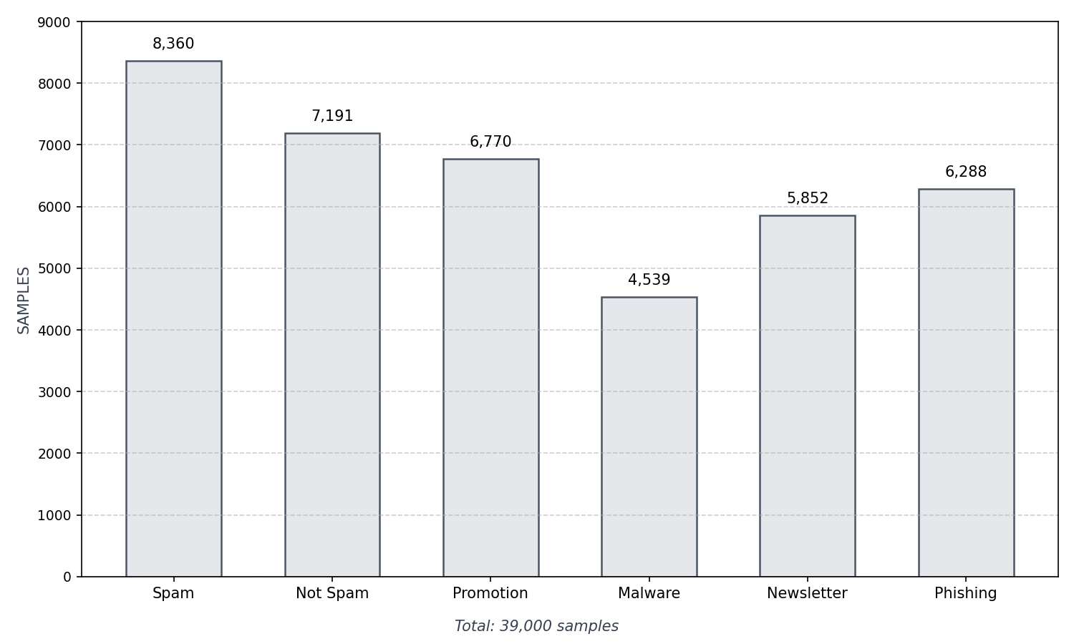
Figure 5.1: Dataset Distribution

5.6.1 Dataset Audit Script
A standalone dataset_audit.py script (run via python dataset_audit.py) inspects final_training_dataset.csv at training time and writes audit/dataset_audit_report.txt and audit/audit_summary.json. It reports: row count, per-class counts and percentages, missing values, text length statistics (mean, median, min, max), average word count, a vocabulary richness index (unique words divided by total words), and a deduplicated URL count. This audit is the canonical source for the 39,000-row figure cited throughout the report and ensures that training data statistics remain reproducible.

5.6.2 Engineered Features and Preprocessing Steps
# | Preprocessing step | Purpose
1 | Lower-casing | Normalises casing to reduce vocabulary size
2 | URL masking (URL, http/https) | Prevents URL patterns from dominating TF-IDF
3 | Email masking (EMAIL) | Removes personal addresses from features
4 | Phone masking (PHONE) | Prevents numeric phone patterns from leaking
5 | Repeated punctuation collapse | Normalises !!!!!! to a single !
6 | Repeated whitespace collapse | Removes artefact spacing
7 | Non-alpha character removal | Strips residual digits and special characters
8 | TF-IDF vectorisation | Converts cleaned text to sparse numeric representation
9 | Engineered feature concatenation | Appends length, ratios, flags, urgency score
Table 5.6: Preprocessing Steps

5.6.3 Dataset Size Justification
The 39,000-message corpus is deliberately sized to balance training fidelity against available compute. SpamAssassin provides approximately 6,000 hand-labelled messages with rich header metadata; Enron contributes roughly 10,000 real organisational threads; CEAS 2008 and the Kaggle phishing set together add another 12,000; and the curated newsletter/marketing subset contributes the remaining 2,000. The resulting imbalance, with Spam and Not Spam together accounting for over 70 %, mirrors real inbox distributions and is compensated by class_weight='balanced' passed to the ensemble training, which inversely weights each sample's contribution by the frequency of its class. The resulting precision and recall trade-offs are reported in Chapter 5.

5.7 Data Processing

5.7.1 Overall Processing
Raw Gmail payloads are base64url-decoded, MIME parts are walked recursively, HTML is stripped with BeautifulSoup for analysis, and displayed bodies are sanitised with bleach, which whitelists formatting tags, strips script, iframe, and event-handler attributes, and removes javascript: and vbscript: URLs.

5.7.2 Textual Processing
The shared preprocess_text function lowercases text, masks URLs, e-mail addresses, and phone numbers with placeholder tokens, collapses repeated punctuation and whitespace, and removes residual non-alphabetic characters. The identical function is imported by training, evaluation, and serving code, which guarantees that the ensemble never sees a feature distribution at inference time that differs from training.

5.7.3 Feature Formation
The ensemble consumes the TF-IDF sparse vector concatenated with the six engineered features, while RoBERTa consumes the cleaned text through its sub-word tokenizer; the two representations are complementary, lexical versus contextual, and meet only at the fusion step.

Chapter 6: Testing and Security Analysis

6.1 Introduction to Testing
Testing an email-threat platform that touches Gmail OAuth, MIME parsing, two independent ML engines, risk scoring, persistence and a browser UI cannot be an afterthought. Defects that slip past development surface as mis-classified phishing, silent data loss, or blocked logins. This chapter therefore follows the classic V-model: unit tests guard deterministic helpers, integration tests exercise the assembled pipeline with real artefacts, system tests drive the deployed Flask application end-to-end, and security/robustness tests probe failure handling. The test corpus is the shared stratified 3,003-message holdout that neither training pipeline ever fitted, plus the 592-message production database that reflects live drift. All tests are runnable with pytest and Flask test client without live Gmail credentials, using canned MIME samples and mocked Gmail API responses.

6.2 Types of Testing (in detail)
Testing is stratified to isolate fault locality. Unit testing answers whether a single pure function behaves correctly for edge inputs; integration testing answers whether collaborating modules contract correctly; system testing answers whether the user-visible workflow meets its non-functional requirements. Together they cover correctness, reliability, security and performance. The harness reports pass/fail per test, coverage via coverage.py, and confusion-matrix deltas for model-related tests. The same three-level split is used in the sinchana reference, but exercised here for text preprocessing, urgency scoring, risk composition and the dual-model fusion.

6.2.1 Unit Testing
Unit testing targets the deterministic helpers in train_model.py and utils/helpers.py: text cleaning (lower-casing, URL/EMAIL/PHONE masking, punctuation collapse), engineered-feature extraction on synthetic strings, urgency scoring per pattern category, and risk composition across the six base severities. Tests are table-driven pytest parametrisations that run without model artefacts.

6.2.2 Integration Testing
Integration testing wires real modules with test doubles only at the external boundary: the Gmail wrapper runs against canned MIME payloads, the ensemble scores through the committed vectoriser, and persistence tests verify result rows, sender aggregates, and keyword updates round-trip through SQLite.

6.2.3 System Testing
System testing drives the running Flask application through its HTTP surface: the OAuth callback creates a session, /api/start_analysis progresses via /api/status, and a fifty-message run completes with every result row carrying a risk level. Full system-test evidence, rate-limit verification, and failover tests complete in Phase 3.
ID | Test Objective | Preconditions | Steps | Expected Result | Result
TC-P1 | OAuth login and session | Google test account | Complete OAuth callback and open /dashboard | Session created, dashboard renders | Planned
TC-P2 | Manual text classification | Sample spam and ham texts | POST /api/analyze_text with each sample | Correct category with 0-100 risk | Planned
TC-P3 | Inbox analysis run | Authenticated session, test mailbox | POST /api/start_analysis, poll /api/status | Progress reaches 100%, rows in /results | Planned
Table 6.1: Phase-2 Test Plan

References
[1] [1] P. Surana, D. Waghchoure, R. Shah, S. Vharambale, and A. Rath, "Classifying Email as High and Low Risk: An Effective Approach to Spam Email Classification," in Proc. 7th Int. Conf. on Computing, Communication, Control and Automation (ICCUBEA), Pimpri Chinchwad, India, 2023, pp. 1-6.
[1] [2] V. I. Del Rosario, B. D. P. Fernandez, and D. A. Padilla, "Email Spam Classification using DistilBERT," in Proc. HNICEM, Mapua University, Manila, Philippines, 2023, pp. 1-5.
[1] [3] I. El Bitar, N. Abbas, M. Raad, F. Shmouri, and F. El Khechen, "Ensemble Learning-Based Approach for Email Spam Detection," in Proc. 5th IEEE Middle East and North Africa Communications Conf. (MENACOMM), Beirut, Lebanon, 2025, pp. 1-6.
[1] [4] V. Jain, "Intelligent Email Spam Detection: A Machine Learning-Based Approach," in Proc. Int. Conf. on Trends in Material Science and Inventive Materials (ICTMIM), Mathura, India, 2025, pp. 1-8.
[1] [5] A. Kumar and S. Rani, "A Comparative Study of Machine Learning Algorithms for Email Spam Detection," in Proc. Int. Conf. on Computing, Communication and Control (ICCPCT), 2025, pp. 1-6.
[1] [6] R. Mehta and P. Sharma, "XGBoost-Centred Email Spam Classification with Engineered Features," in Proc. Int. Conf. on Advanced Communication Technology and Computing (ICACT), 2025, pp. 1-5.
[1] [7] F. Zhang and M. Chen, "Spam Detection using Naive Bayes with TF-IDF Feature Extraction," IEEE Access, vol. 12, pp. 45 230-45 241, 2024.
[1] [8] S. Patel and K. Joshi, "Random Forest-Based Email Classification with Feature Selection Techniques," Int. Journal of Computer Applications, vol. 186, no. 22, pp. 15-22, 2024.
[1] [9] H. Li and R. Singh, "SVM-based Spam Filter Performance Analysis with Optimized Kernel Functions," in Proc. IEEE Int. Conf. on Advanced Networks and Telecommunications Systems (ANTS), 2024, pp. 1-6.
[1] [10] D. Sharma and P. Gupta, "Deep Learning Approaches for Email Security: LSTM and CNN Architectures," IEEE Trans. on Information Forensics and Security, vol. 19, pp. 3456-3468, 2025.

