Web Application Security Assessment Report - Flashyre Login Portal

Target: https://flashyre-dev-496807.appspot.com/login
Date: June 4, 2026
Tester: Abhishek N Shetty
Scope: Web Application Security Assessment — Login Page

1.RECONNAISSANCE AND INFORMATION GATHERING
Objective:
To perform an initial security assessment of the Flashyre Login Portal and identify potential security weaknesses.
Target URL:
https://flashyre-dev-496807.appspot.com/login
Tools Used:
• Browser Developer Tools (F12)
• Nikto Web Vulnerability Scanner
Step 1: Access Verification
Command Used:
nikto -h https://flashyre-dev-496807.appspot.com/login
Observation:
The website was accessible over HTTPS on port 443.
Evidence:
Screenshot 1 – Nikto Scan Output
Result:
• Target Hostname: flashyre-dev-496807.appspot.com
• Target Port: 443 (HTTPS)
• Server: Google Frontend
• SSL Certificate: Valid certificate issued by Google Trust Services
Risk Level:
Informational
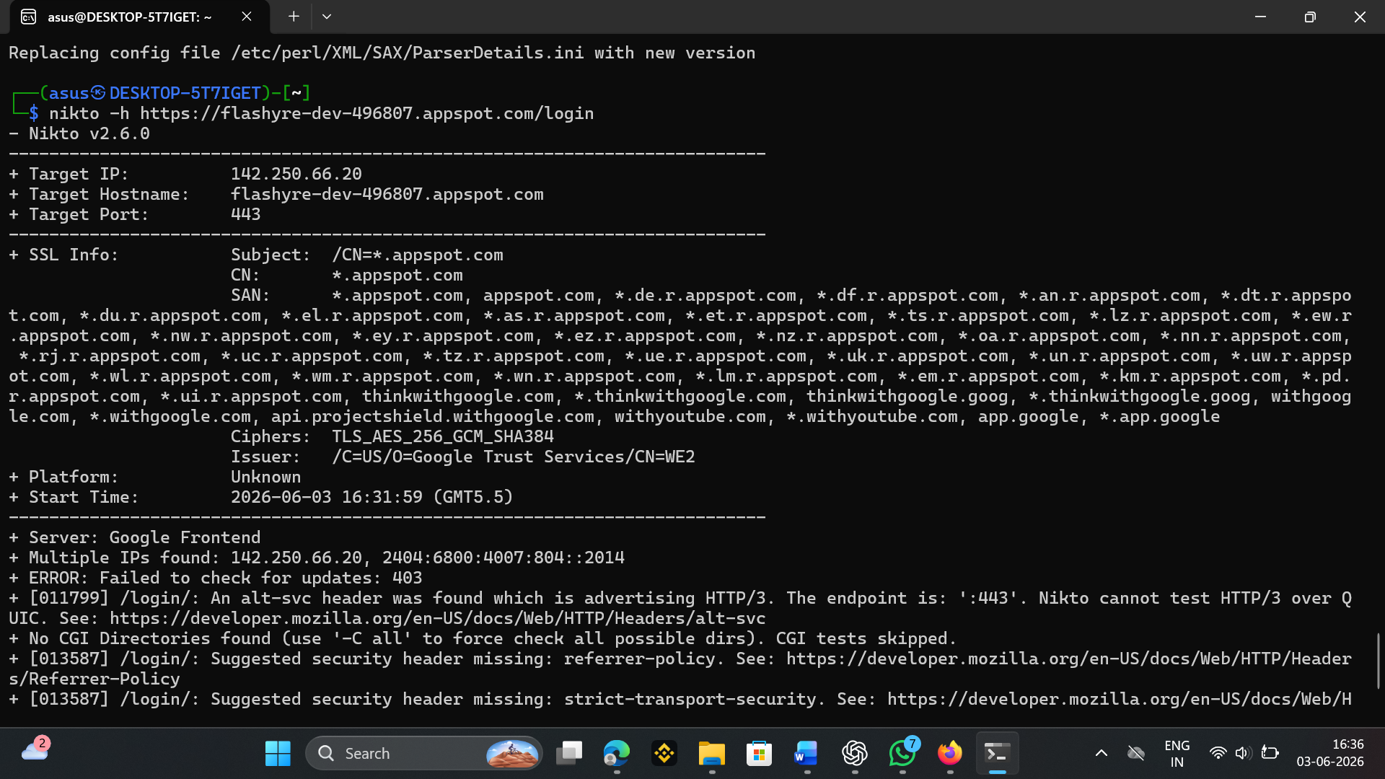

2.SSL/TLS ANALYSIS
Evidence:
Screenshot 1 – Nikto Scan Output
Findings:
Subject:
CN=*.appspot.com
Issuer:
Google Trust Services
Cipher Suite:
TLS_AES_256_GCM_SHA384
Analysis:
The application uses a valid SSL certificate and a strong encryption algorithm. No SSL/TLS weakness was identified from the scan output.
Risk Level:
Low
Recommendation:
Continue using modern TLS configurations and regularly monitor certificate validity.

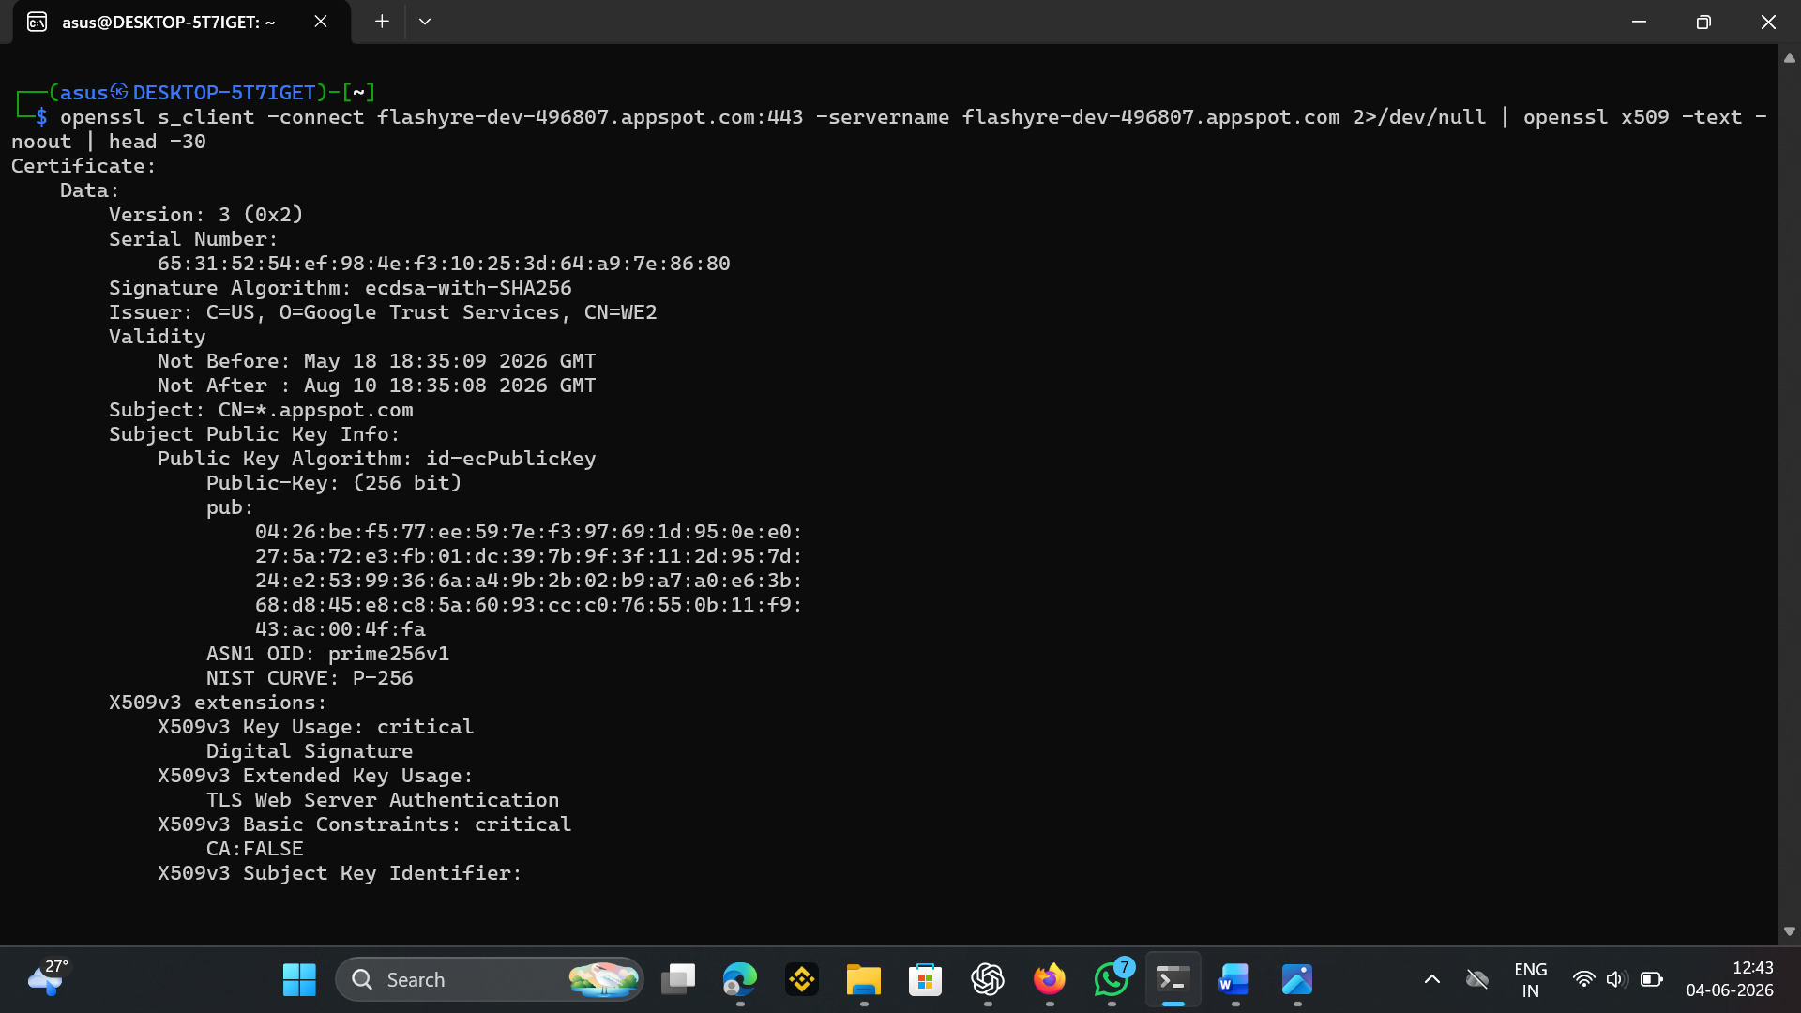

Purpose of Test
SSL/TLS (Secure Sockets Layer / Transport Layer Security) protocols are responsible for encrypting data transmitted between the client (user's browser) and the server. If the SSL/TLS configuration is weak or outdated, an attacker could:
- Decrypt sensitive information such as login credentials, session tokens, or personal data
- Perform man-in-the-middle (MITM) attacks by intercepting encrypted traffic
- Exploit known vulnerabilities like POODLE, Heartbleed, or BEAST
The purpose of this test was to verify that the target web application uses strong encryption algorithms, modern TLS protocol versions, and is not vulnerable to known SSL/TLS attacks.

2. Tools Used
Tool | Purpose
Nmap (ssl-enum-ciphers) | Enumerate supported cipher suites and TLS protocol versions, assess cipher strength
OpenSSL | Manually inspect SSL certificate details, validity dates, and issuer information
Nikto | General web server scanning including SSL/TLS checks

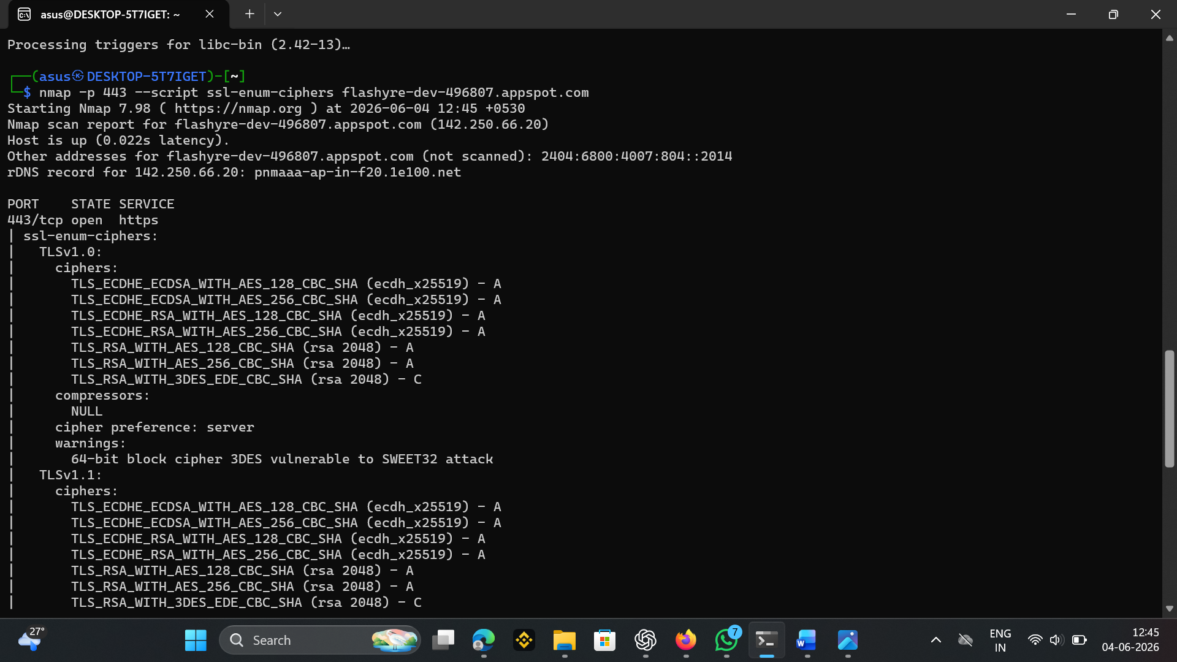

3.TESTING PERFORMED AND RESULTS
4.1 Login Page Validation Testing
Objective:
To verify whether the application properly validates user input before processing authentication requests.
Test Cases Performed:
Test Case 1: Empty Input Validation
Procedure:
• Left Email field blank
• Left Password field blank
• Clicked Login
Result:
The application displayed validation messages indicating that required fields must be completed.
Status:
Pass
Test Case 2: Invalid Email Format Testing
Procedure:
• Entered invalid email formats
• Attempted login
Result:
The application rejected invalid email formats and enforced proper email validation.
Status:
Pass
Test Case 3: Browser Console Inspection
Procedure:
• Opened Developer Tools (F12)
• Reviewed Console and Network tabs
Result:
No critical errors, exposed credentials, or sensitive information were identified during inspection.
Status:
Pass
Test Case 4: Security Header Review
Procedure:
• Performed Nikto scan against the target application
Result:
The scan identified missing Referrer-Policy and Strict-Transport-Security (HSTS) headers. No critical vulnerabilities were detected.
Status:
Pass with Recommendations
ASSESSMENT RESULTS
Positive Security Controls Identified:
• HTTPS enabled
• Valid SSL certificate
• Login form validation functioning correctly
• No critical browser console errors observed
• No application crashes during testing
Security Improvements Recommended:
• Implement Strict-Transport-Security (HSTS) header
• Implement Referrer-Policy header
• Continue periodic security assessments

