Level 1
Get http://localhost:3000/articles -> view all the articles [works without authentication]
Post http://localhost:3000/search -> give search_term like the ss below [for searching]
Sort by comments
Get http://localhost:3000/sort/comments -> returns array of posts sorted by comments count

Sort by likes
Get http://localhost:3000/sort/likes
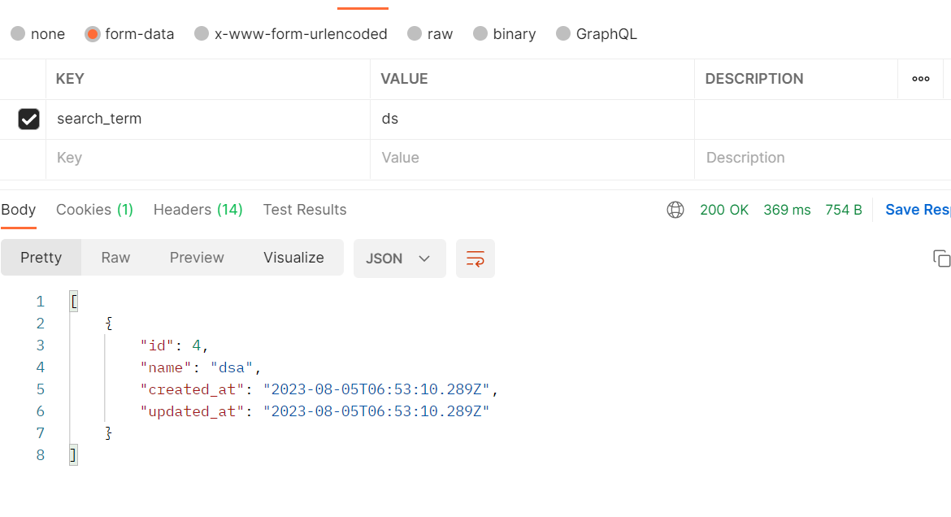

Post http://localhost:3000/add/article ->creating a new article
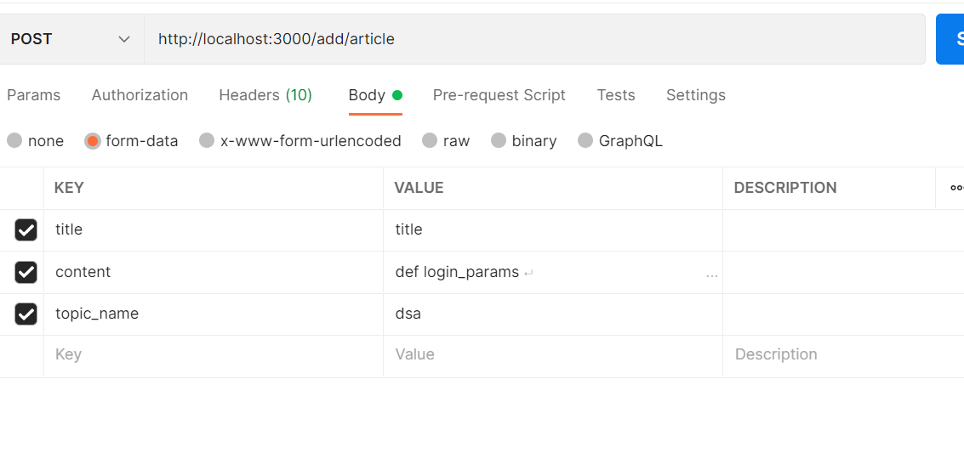\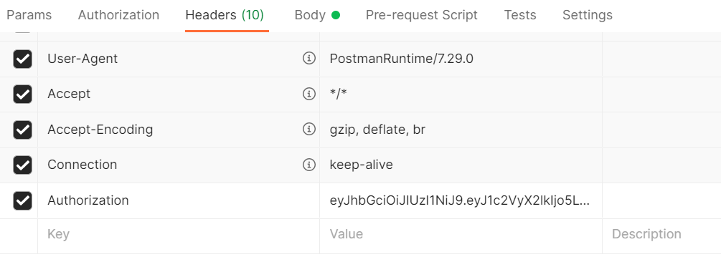
In the header, token will be send, against authorization field

Filter

Get http://localhost:3000/filter/author/:user_id -> filter articles by author, return the array of articles
Get http://localhost:3000/filter/date/:start_date/:end_date [http://localhost:3000/filter/date/2023-08-3/2023-08-5] ->filter by date , returns articles array or error message

Post http://localhost:3000/edit/article/:aritcle_id -> creating post [requires title in the body]
Delete http://localhost:3000/delete/article/:article_id-> deleting article

Get http://localhost:3000/article/like/:article_id -> liking an article

Post http://localhost:3000/article/comment/16 -> commenting on an article

Level 2
Post http://localhost:3000/users -> registering user , I might change change it later, accepts below fields
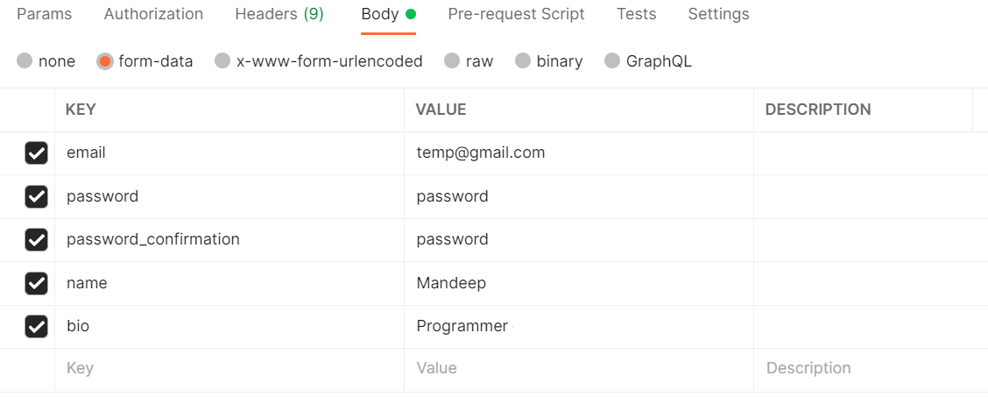

Post http://localhost:3000/auth/login -> for login, will give token for later authentications
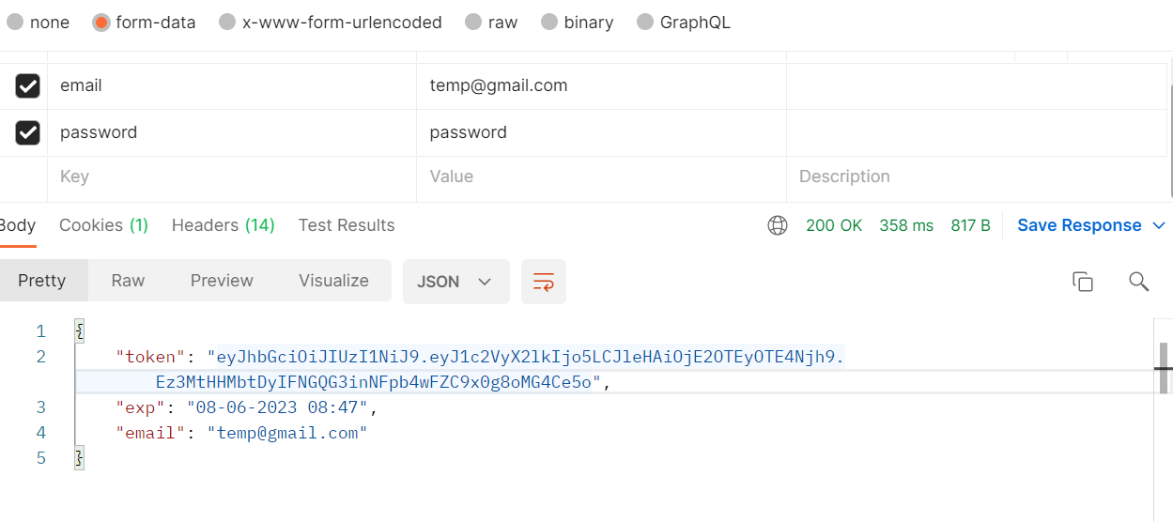

This token will be sent with every request to authorize the user

Get http://localhost:3000/myposts -> get my posts
Get http://localhost:3000/myprofile -> my profile
Get http://localhost:3000/follow/9 -> follow another user
Get http://localhost:3000/view/user/9 -> view another user

Level 3

View all topics
Get http://localhost:3000/topics/view -> view all topics

Level 5
Post http://localhost:3000/create/list -> creating a list, provide name in the body
Get http://localhost:3000/list/add/16/2 -> add to a list /article_id/list_id
Get http://localhost:3000/list/view/ -> lists all the user owned lists
Get http://localhost:3000/list/view/2 -> view articles in the list

Save for later
Get http://localhost:3000/saveforlater/16 -> mark save or unsave for later
Get http://localhost:3000/saveforlater/ -> view all save for later articles

List
Get http://localhost:3000/list/add/16/2 -> adding article of id 16 to a list of id 2 owned by user loggedin
Post http://localhost:3000/create/list -> creating a new list for the user, takes name of list in request body
Get http://localhost:3000/list/view/ -> list of all user made lists
Get http://localhost:3000/list/view/2 -> list of articles in a list , takes list_id in the url

Save for later
Get http://localhost:3000/saveforlater/16 -> mark an article for later
Get http://localhost:3000/saveforlater/ -> view all the articles saved for later

