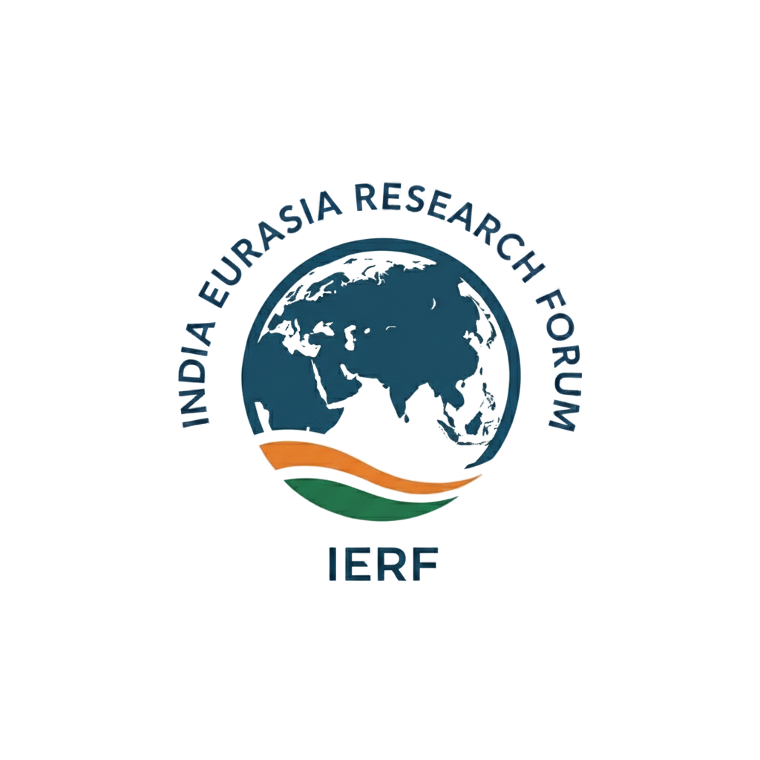
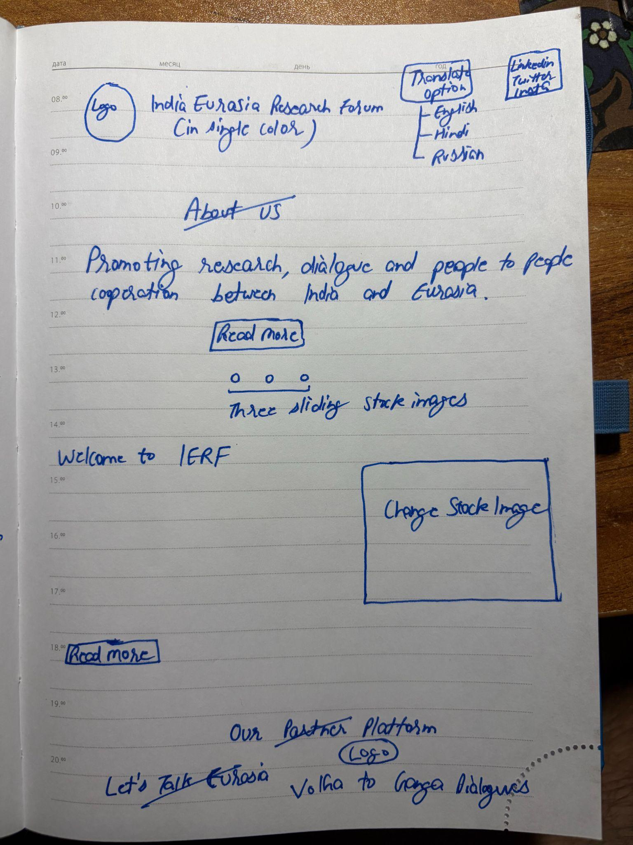
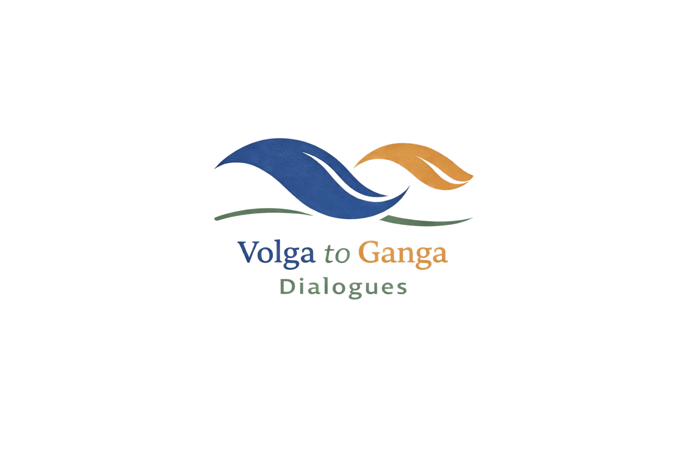
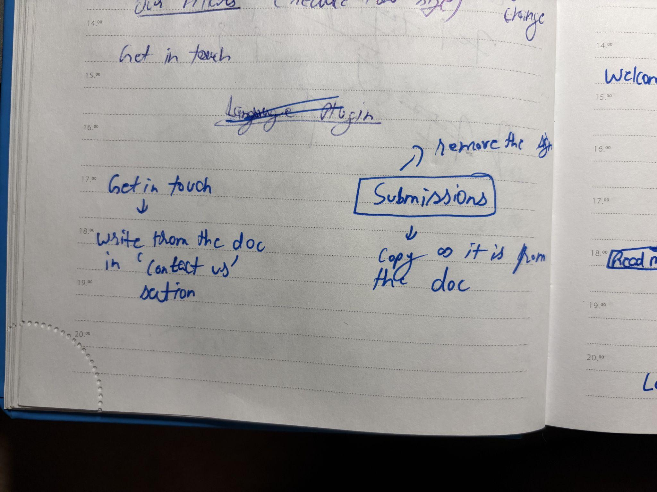
Try writing India Eurasia Research Forum and INDIA EURASIA RESEARCH FORUM after the logo and see which(capitalised or normal) one looks better.

About us (to be put on the homepage, with an image in the background)

Promoting research, dialogue and cooperation between India and Eurasia (with 2-3 moving images in the background).

Welcome to IERF (shows on the home page, just below the text “Promoting research, dialogue and cooperation between India and Eurasia”)

India Eurasia Research Forum (IERF) is an independent research and public diplomacy initiative dedicated to strengthening dialogue and deepening cooperation between India and Eurasia. It endeavours to bridge the intellectual and strategic gap between India and Eurasia, a vast region comprising Russia, Central Asia and the Caucasus. At IERF, we operate at the intersection of scholarly rigour and diplomatic engagement through cutting-edge research and public diplomacy initiatives.

Come join us today! Together, we are building India’s first research network dedicated to a comprehensive study of the Eurasian region by bringing together scholars, policy experts, and emerging voices to explore the political, economic, strategic, and cultural dimensions shaping India’s engagement with Eurasia.

Read More (below “Welcome to IERF” and opens the same page)

Focus Areas:

India’s multidimensional engagement with Eurasian countries
Political, economic and socio-cultural developments in Eurasia
Regional cooperation and integration frameworks across Eurasia
Resource geopolitics and geoeconomic developments
Regional Security in the Eurasian context
BRICS and SCO as Eurasian regional organisations
Eurasian civilisations and cultural hybridity in the twenty-first century

Who we are

The India Eurasia Research Forum (IERF) is India’s first research network dedicated to a comprehensive study of the Eurasian region. Our team comprises early career researchers, journalists, policymakers and emerging voices from India’s leading public universities, including the Jawaharlal Nehru University and the University of Delhi. Together, we endeavour to bridge the intellectual and strategic gap between India and Eurasia, a region comprising Russia, Greater Central Asia and the Caucasus. To bridge this gap, IERF operates at the intersection of scholarly rigour and diplomatic engagement. The forum will serve as a platform for advancing cooperation and trust across Eurasia while supporting India’s evolving global engagement by fostering cross-border cultural exchanges through an interdisciplinary approach.

What we do (copy as it is for the website, with only minor modifications for SEO optimisation)

IERF aims to foster informed dialogue and multidimensional engagement between India and Eurasia. Currently, as part of our foundational mission, IERF’s work is based on four pillars:

Research
Conduct in-depth research on Eurasian geopolitics, economics, and culture to build research pathways between India and Eurasia. Promote and build a comprehensive repository of Indian perspectives on Eurasia.
Dialogue
Facilitate informed dialogue through publications, seminars, and conferences. Foster greater cultural understanding and civilisational dialogue between India and the Eurasian countries through its flagship Volga to Ganga Dialogue series.
Engagement
Promote multidimensional engagement across India and Eurasia through academic collaboration and public diplomacy initiatives. To promote Track 2 dialogues between India and the Eurasian countries in the future.
Policy Impact
Provide up-to-date & policy-relevant insights to decision-makers and industry leaders. To shape the policy landscape of foreign policy-making in the region on Eurasian affairs, particularly in regional cooperation, resource geopolitics, economic developments, and civilisational discourse.

Volga to Ganga Dialogues (put this in the drop-down option in the events section) - In the events section, after clicking on Volga to Ganga, even though it will show coming soon, please copy the description of the platform along with the logo. Below that, we can show the ‘coming soon’ message.



The Volga to Ganga Dialogues is India Eurasia Research Forum’s flagship platform dedicated to exploring the civilisational, cultural and intellectual linkages between India and the wider Eurasian region. Drawing inspiration from the deep historical linkages and intellectual traditions that have connected societies across the Eurasian landmass, the dialogue series brings together scholars, diplomats, artists and practitioners to engage in reflective conversations that transcend geopolitics. The dialogue series seeks to foster mutual understanding, people-to-people connections, and a shared appreciation of the enduring ties between the regions falling between the Volga and the Ganga river basins.

Our Vision (copy as it is for the website)

At the India Eurasia Research Forum (IERF), we believe that informed research and open dialogue are essential to building resilient partnerships and sustained engagement. The forum provides a platform for researchers, policymakers, and practitioners from India and Eurasia to explore the deep historical, cultural, and strategic ties that connect these dynamic regions, ensuring that academic enquiry and research effectively inform public discourse and shape the policy landscape.

As part of IERF’s vision, we promote a homegrown Indian perspective on Eurasian affairs. At IERF, our long-term vision is to become a leading India-origin academic platform that promotes research and publications on all aspects of Eurasian political, economic, and socio-cultural developments, particularly those that can have implications for India. This is because we acknowledge Eurasia’s importance to India’s External Neighbourhood and the need to develop a comprehensive outlook towards this critical region.

IERF’s vision also extends to bringing India and Eurasia closer together - not just through analysis, publications and talks, but through shared stories and ideas that bridge gaps. There is a pressing need to create a welcoming space where scholars, students, and thinkers can look beyond mere geopolitics and the calculations of great power politics to build lasting relationships and find common ground for our future. We believe Eurasian studies need to be reimagined in Indian academic and policy-making circles, and IERF intends to fill this space.

Why India Eurasia Research Forum (IERF) (copy as it is for the website)

India’s role on the global stage is expanding rapidly, with a growing think-tank culture, particularly those dedicated to studying the various dimensions of India’s global engagements. While India’s global footprint grows, dedicated research on the vast Eurasian landmass - a region closely intertwined with India’s history and vital to its future - has often been overlooked. At IERF, we recognise the need to overcome this inertia by building an effective research ecosystem that provides up-to-date analysis of the latest developments, policy-relevant insights and fosters cross-border knowledge exchanges between India and Eurasia. IERF remains open to engaging with people from walks of life interested in exploring the new frontiers of Eurasian studies. We follow an inclusive working style and adhere to the highest standards of academic enquiry.

Special Research Note by IERF’s Research Advisor, Dr Pravesh Kumar Gupta, Associate Fellow, Vivekanand International Foundation (this is only a sample, which can be edited later)

1000-word write-up by Dr Pravesh Kumar Gupta

Contact us (Get in touch)
If you have any queries, want to know more about our work, or want to work with us, write to us at connect@indiaeurasia.org

(Make a message box) Send us a message:
Your name, your email
Subject
Your message

Write for us (copy as it is)

India Eurasia Research Forum (IERF) is always on the lookout for well-informed write-ups. We invite early-career academics, independent researchers, journalists, and informed observers from India and Eurasia to contribute original writings that deepen understanding of the political, economic, social and cultural linkages between India and the Eurasian region.

IERF currently seeks submissions under three categories:

Perspectives (up to 1500 words):

This section features original and analytically grounded articles on broad themes related to Eurasia. Contributors may explore geopolitics, geoeconomics, regional connectivity, security, energy, culture and history of Eurasian countries, or emerging trends in India-Eurasia relations. Submissions should be thematic, well-argued and accessible to a wider policy and academic audience.

Commentary (up to 1200 words)

This section features brief commentaries on contemporary developments and unfolding regional and international dynamics in Eurasia, including the latest shifts in India’s engagement with the region. This section offers informed, timely analysis of regional developments rather than merely descriptive analysis.

Stories from Eurasia (up to 1000 words)

This section features travel accounts and cultural portraits of Indian and Eurasian cities. Submissions may highlight everyday encounters, cultural experiences, people-to-people connections, and lesser-explored aspects of Indian and Eurasian societies. We encourage travellers across India and Eurasia to share their first-hand accounts of each other’s cities and help promote long-term goodwill.

Submission guidelines:

Articles should be well-written, structured and factually correct. IERF reserves the right to edit submissions for clarity and style.

IERF does not use in-text citations or endnotes. All references must be hyperlinked.

We accept unsolicited submissions across all sections, but pitching first for the perspectives section is always welcome.

All submissions must clearly state that they have not been published anywhere.

Please send your submission along with a brief author bio (50 words) and a profile picture to submissions@indiaeurasia.org

People at IERF

(Profile Photo > 50-100 word Bio > Linkedin profile link)

Rahul Gupta

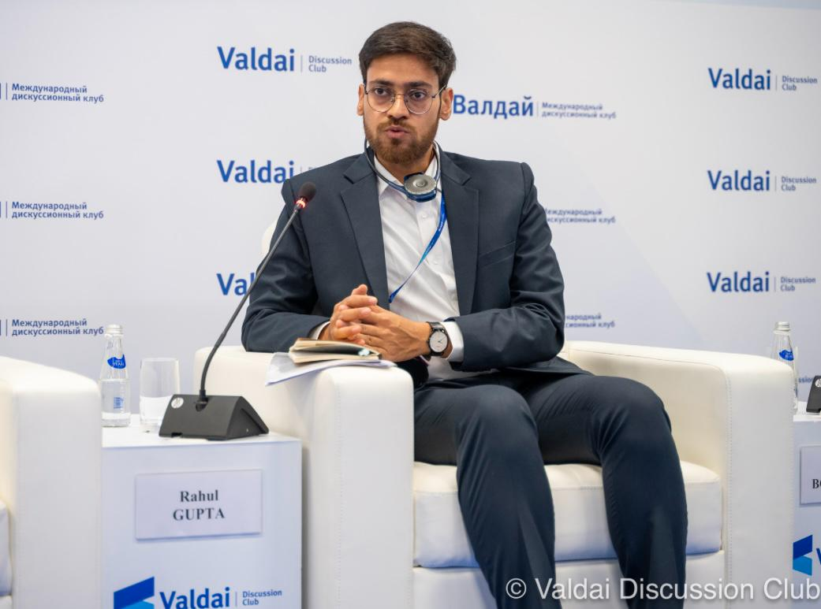

Rahul Gupta is a Senior Research Fellow with the Centre for Russian and Central Asian Studies at the School of International Studies, Jawaharlal Nehru University, New Delhi, India. He is currently pursuing a PhD at the same institution. His research interests include Eurasian geopolitics, regional connectivity between South and Central Asia, and international organisations in the Global South, with a focus on BRICS and SCO. An early career researcher specialising in post-Soviet studies, he has published extensively, including with SAGE, Routledge and the London School of Economics and Political Science Review of Books.

LinkedIn: https://www.linkedin.com/in/rahul-gupta-a8907110a/

Sujal Yadav
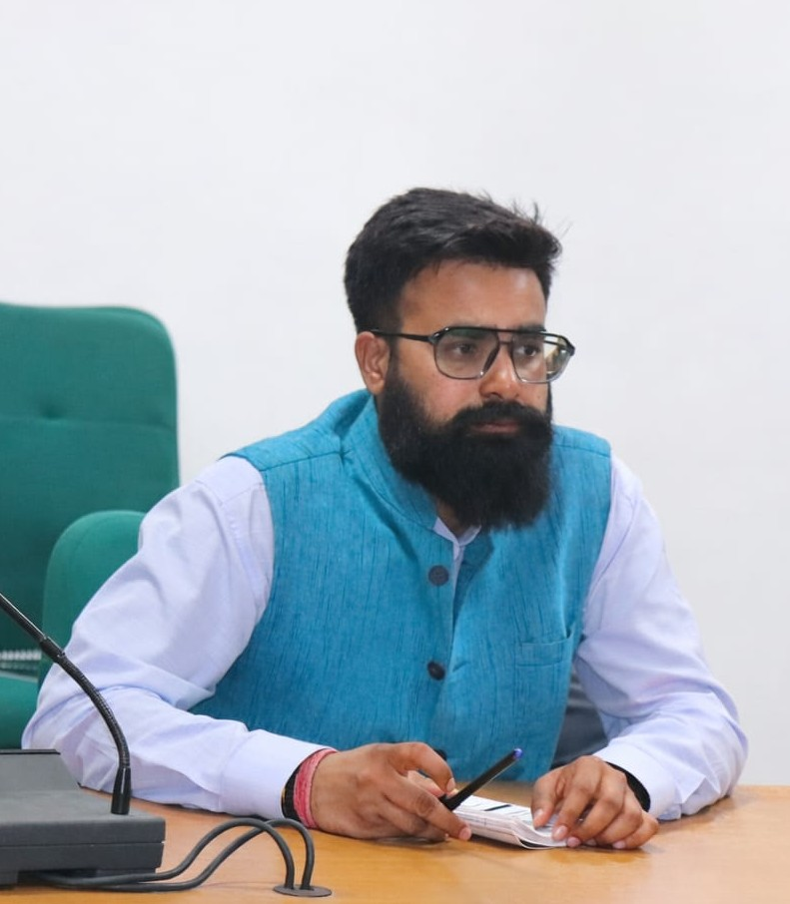

Sujal Yadav is a Senior Research Fellow with the Centre for Russian and Central Asian Studies at the School of International Studies, Jawaharlal Nehru University, New Delhi, India. He is currently pursuing a PhD at the same institution. His research interests include Russian foreign policy, cultural diplomacy, Russian literature, and cultural studies. An early career researcher specialising in contemporary Russian studies, he has published in reputed academic outlets, including the Gorchakov Public Diplomacy Fund Journal, and other national and international publications. He has also worked as an official interpreter at major international events, including the SCO-RATS Forum (2022), the SCO Film Festival (2023), and the India-Russia Business Forum (2025).

LinkedIn: https://www.linkedin.com/in/sujal-yadav-235025208/

Research Advisor

Pravesh Kumar Gupta
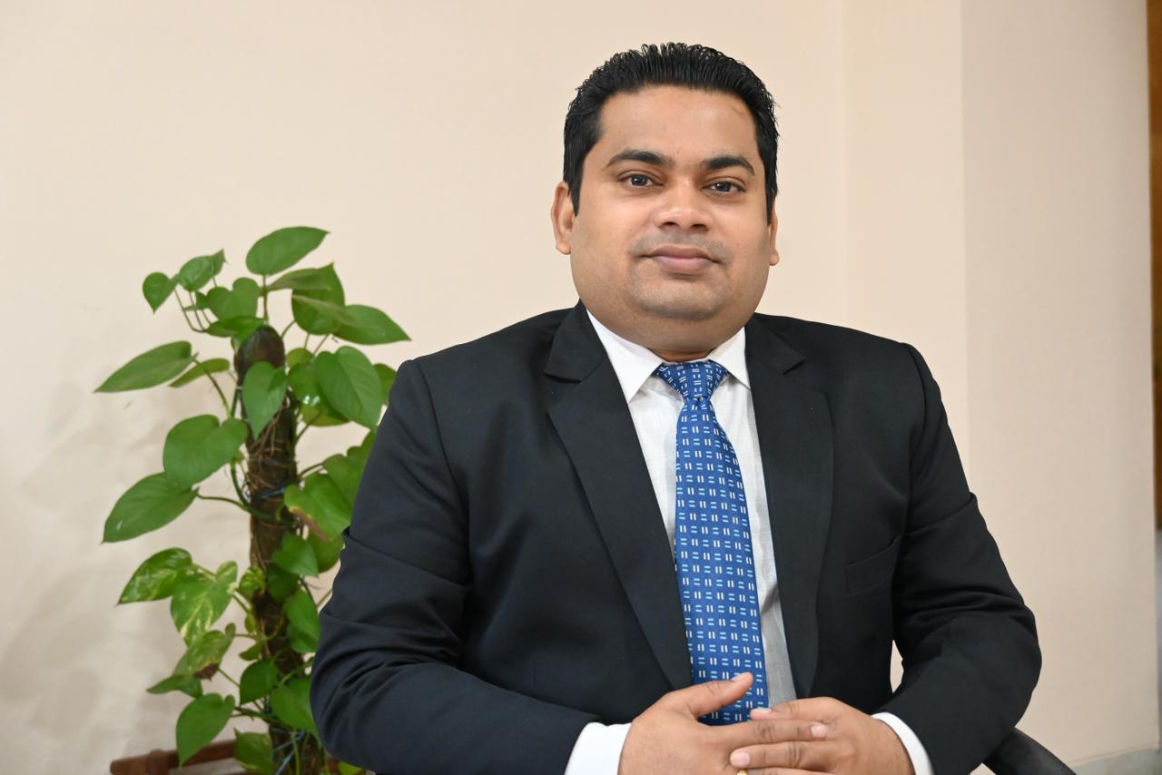
Dr Pravesh Kumar Gupta is an Associate Fellow at the Vivekananda International Foundation (VIF) and an expert on Eurasian geopolitics. He holds a PhD in Central Asian Studies from the School of International Studies, Jawaharlal Nehru University (JNU), New Delhi. His research focuses on the society and politics of the Central Asian Republics, the geopolitics of Central and South Asia, energy security, and trans-regional connectivity and energy linkages between Central and South Asia.

Dr Gupta’s views are regularly published in leading platforms, such as The Hindustan Times, The Financial Express, Dunyo Information Agency (Information Agency of the Ministry of Foreign Affairs of the Republic of Uzbekistan), and the Valdai Discussion Club. He has authored a book and contributed chapters to several edited volumes in his areas of specialisation. He has also served as an International Election Observer during the Presidential Elections in Uzbekistan in 2021 and the constitutional referendum in 2023.

LinkedIn: https://www.linkedin.com/in/dr-pravesh-kumar-gupta-57a607187/

Team

Kishan Srinivas
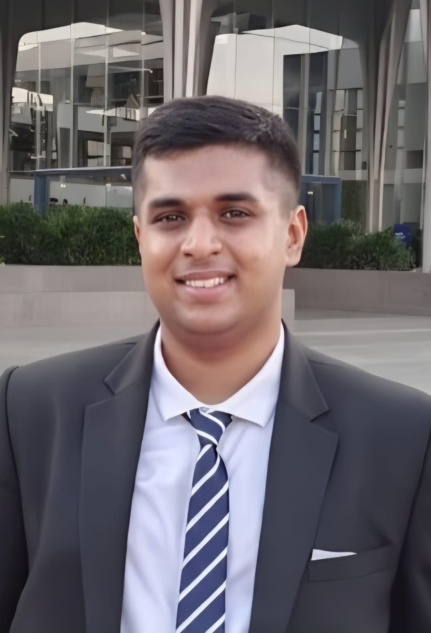

Kishan Srinivas is a Master’s student of Political Science at the Department of Political Science, University of Delhi, India. He holds a B.Tech in Electronics and Communication Engineering from Presidency University, Bangalore, India. With an interdisciplinary academic background, Kishan’s areas of research interest include the intersection of Science and Technology with Political Science and International Relations. His research also includes studying the role of technology in Diplomacy and International Relations. He has previously worked as an AI and Geopolitical Risk intern at Hozint.

LinkedIn: https://www.linkedin.com/in/kishansrinivas070520

Arkadyute Nath

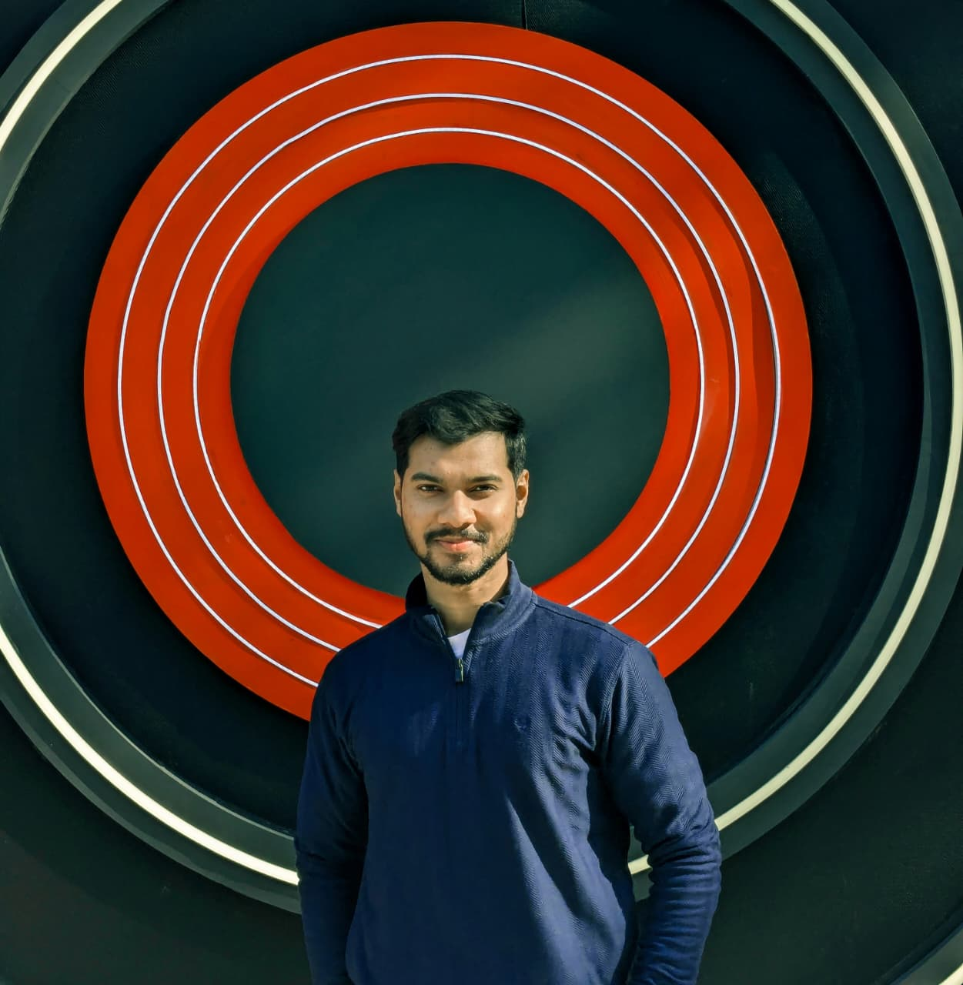

Arkadyute has completed his undergraduate studies in English literature from Hansraj College, University of Delhi. He is currently working as a Program Assistant and Social Media Manager at TGMC, under ArtSpeaks India.

LinkedIn: https://www.linkedin.com/in/arkadyute-nath-503008379/

Saumya Tomar
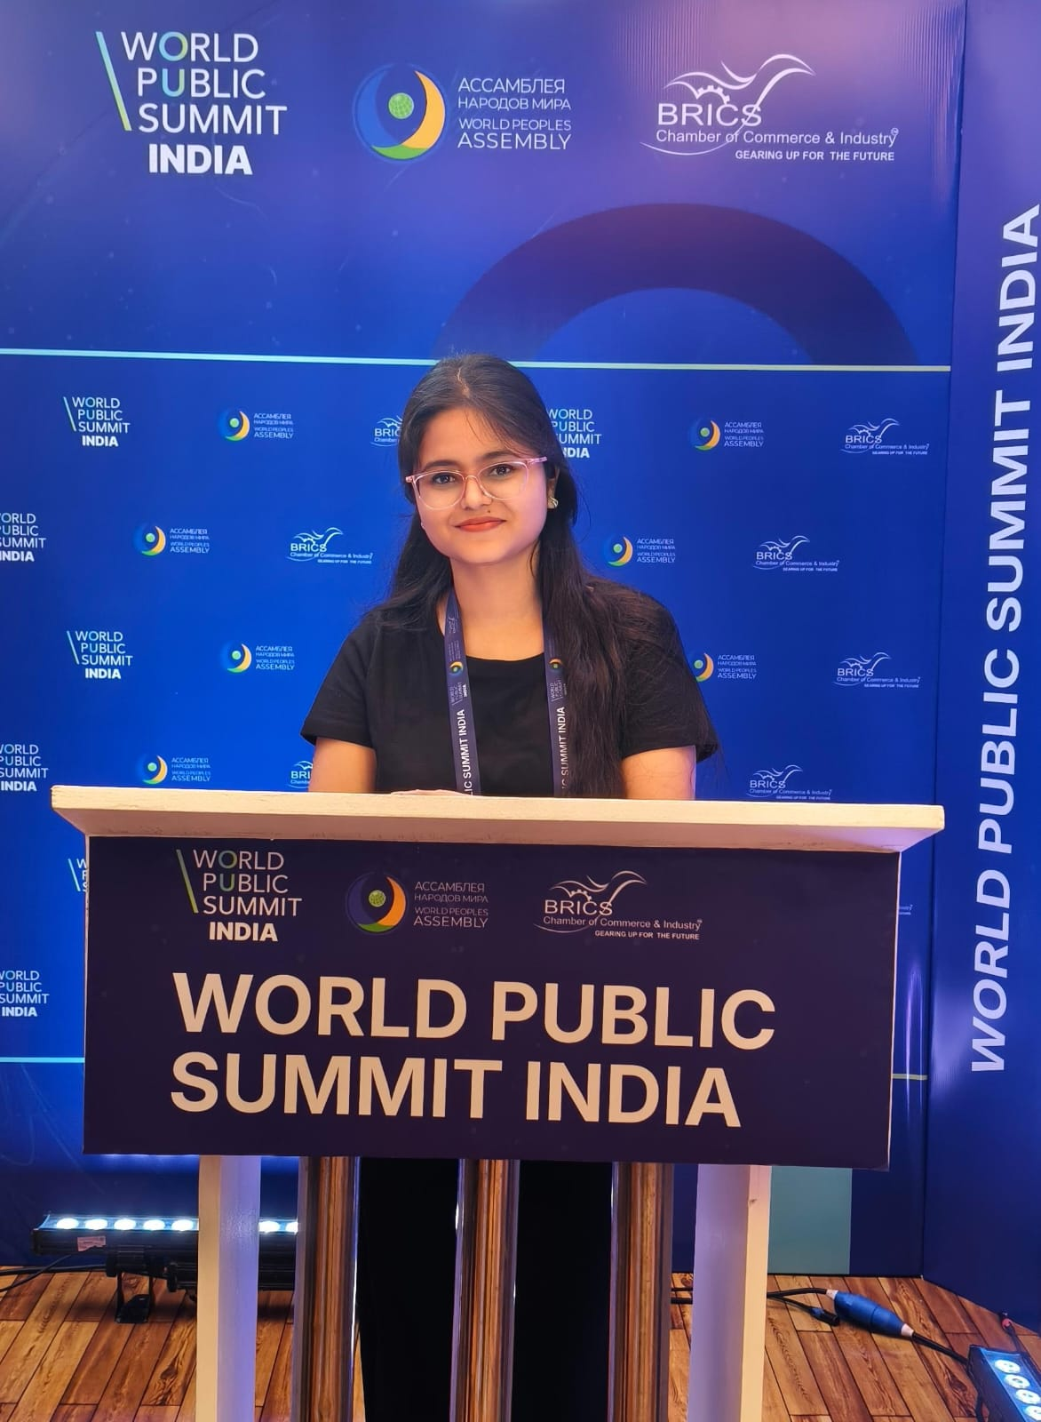

Saumya Tomar is a Junior Research Fellow at the Centre for Russian and Central Asian Studies, School of International Studies, Jawaharlal Nehru University, New Delhi. She is a PhD candidate at the same institution. Her research interests include climate change, environmental security and environmental governance in Eurasia, with a special focus on the Arctic and Baltic Region. Her work examines how environmental transformation influences governance structures, disrupts economic activity, and shapes geopolitical dynamics in the Post-Soviet space.

Linkedin: https://www.linkedin.com/in/saumya-tomar-6b2a76345/

Ravi Raj
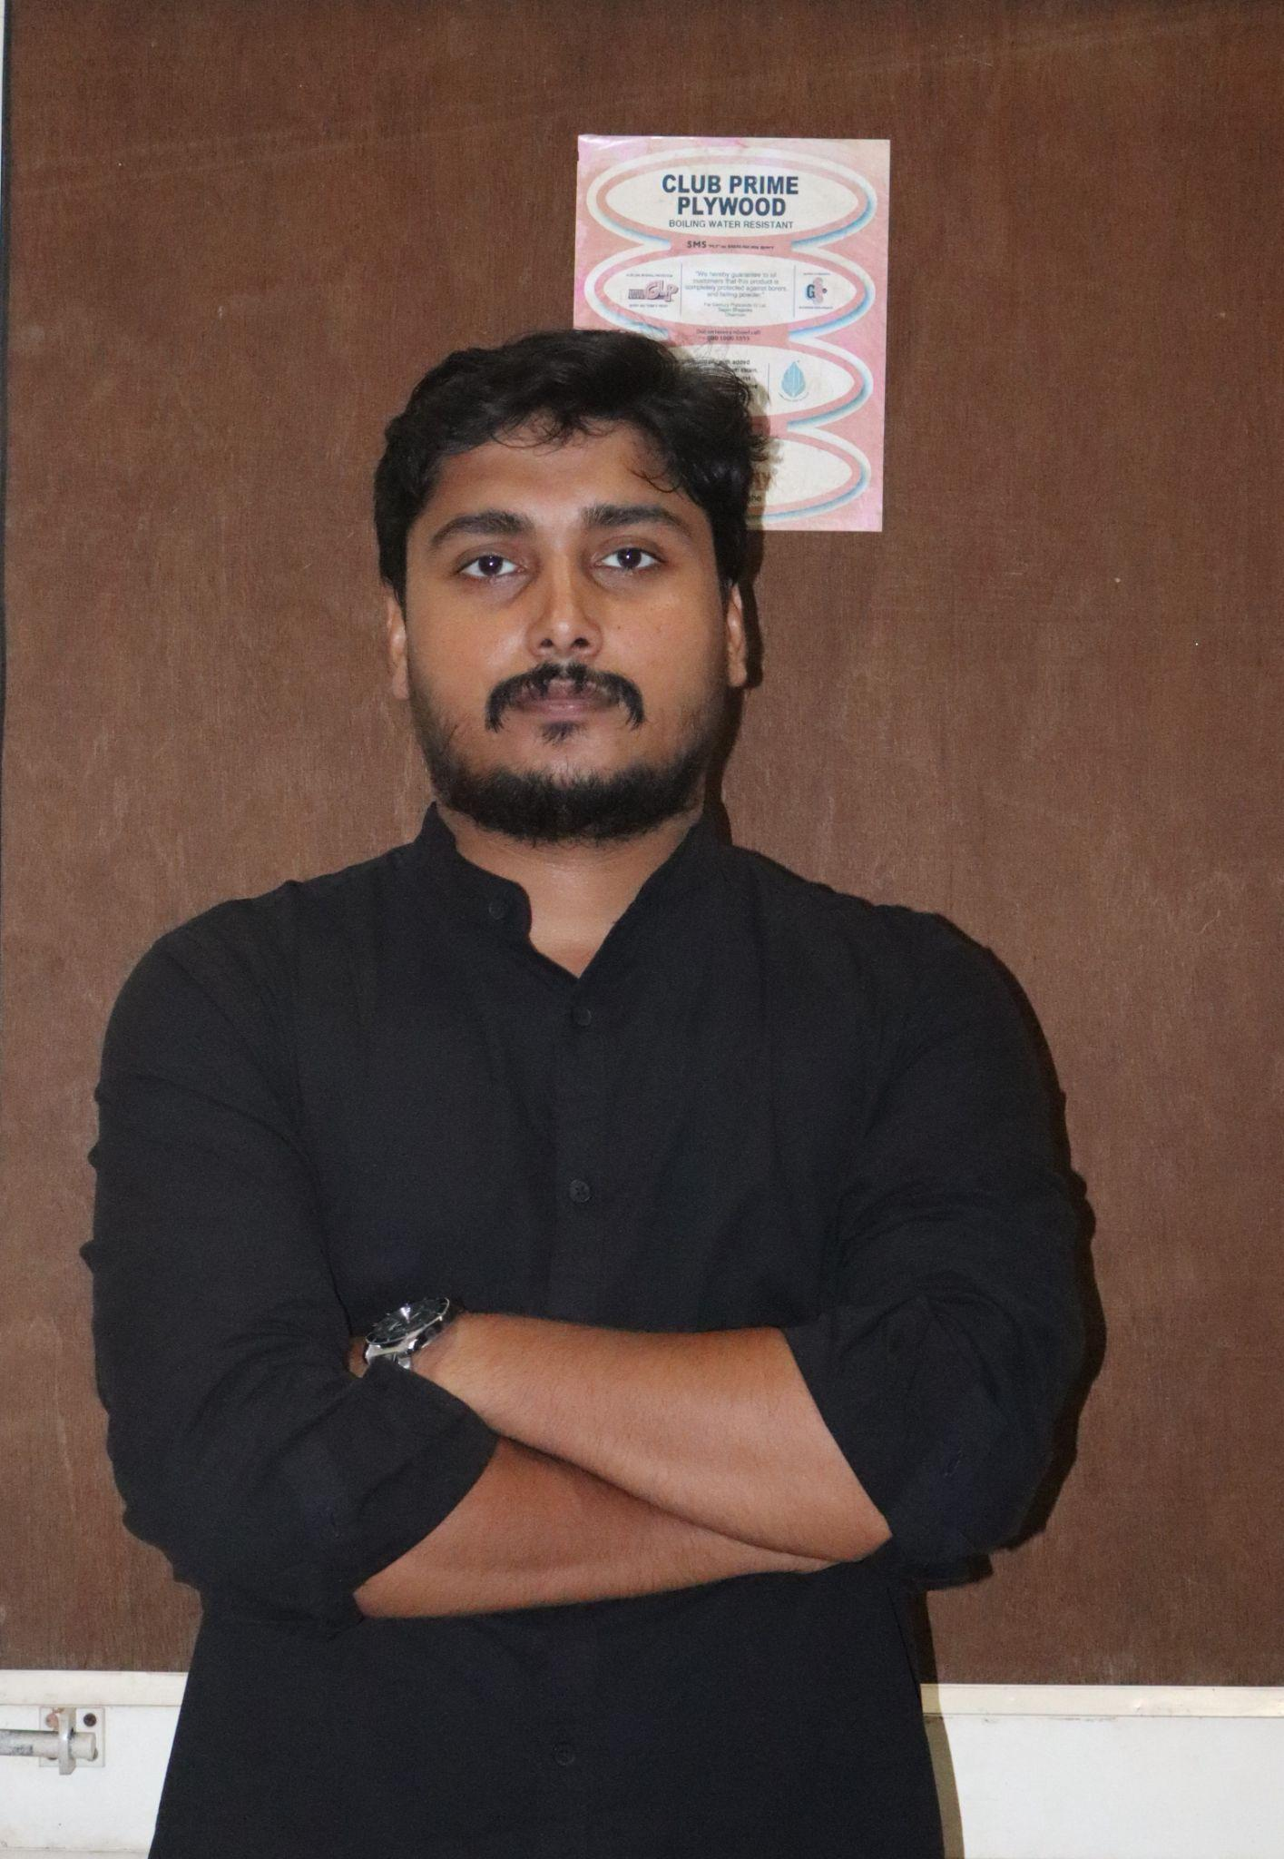

Ravi Raj is a research scholar at the Centre for Russian and Central Asian Studies, School of International Studies, Jawaharlal Nehru University (JNU), New Delhi. His research focuses on nuclear nonproliferation, peacebuilding and conflict resolution in Eurasia, energy geopolitics, and India–Russia relations. He has participated in several international academic and policy forums, including the Nasser Fellowship in Egypt. He regularly contributes analytical pieces on global and regional security affairs.

LinkedIn: https://www.linkedin.com/in/ravi-raj-165145278/

Vaibhavi Gupta

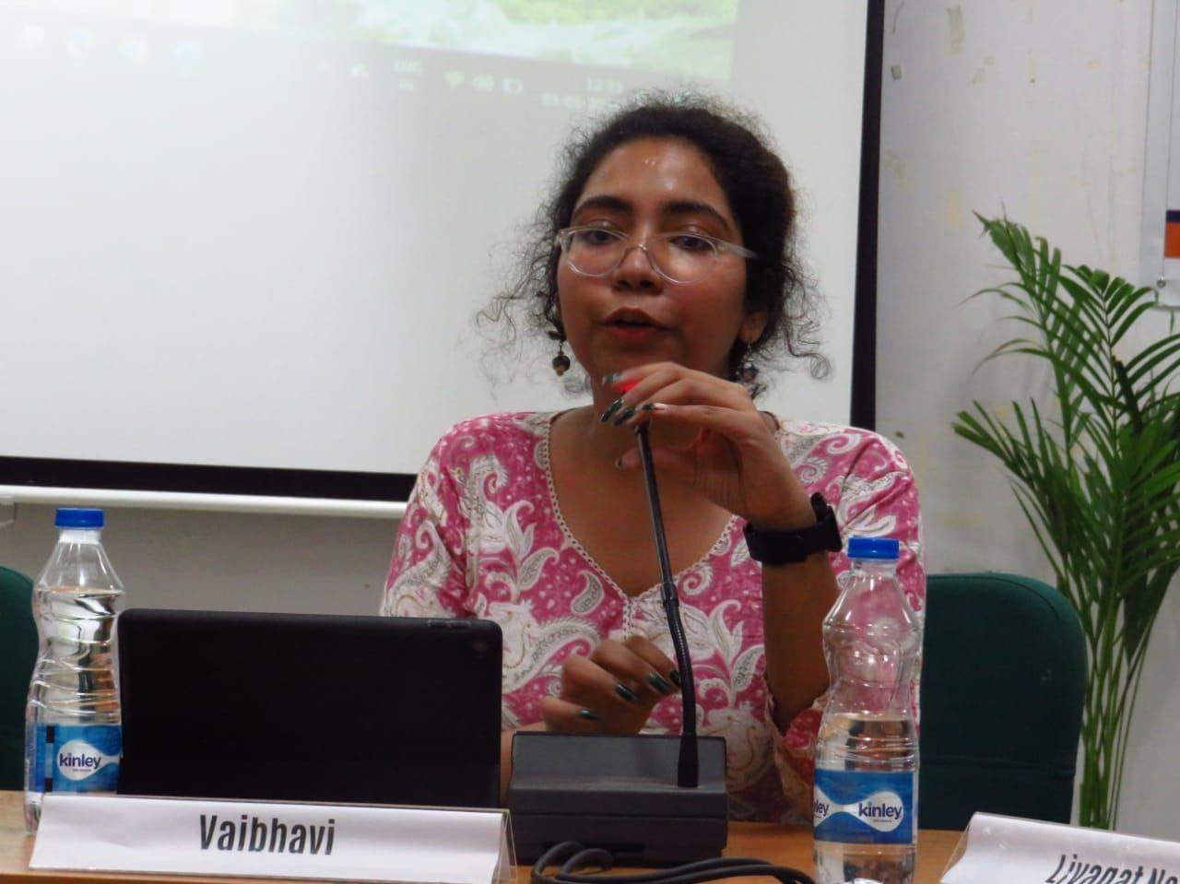

Vaibhavi Gupta is a Junior Research Fellow with the Centre for Russian and Central Asian Studies, School of International Studies, Jawaharlal Nehru University, New Delhi, India. She is currently pursuing a PhD at the same institution. PhD. Her research interests include post-colonial and critical theories of IR, Russian literature and philosophy. As an early career researcher specialising in post-Soviet and contemporary Russian studies, her primary focus is on how non-traditional actors/institutions interact with traditional actors to shape global affairs.

LinkedIn: https://www.linkedin.com/in/vaibhavi-g-67363b226/

Aditya Harsh

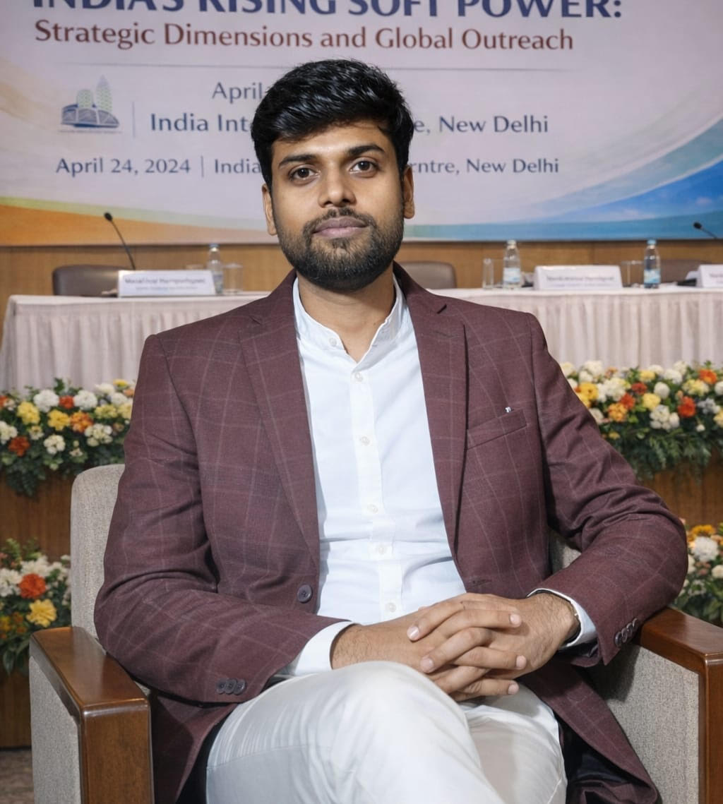

Aditya is a PhD candidate at the Centre for Russian and Central Asian Studies (CRCAS), School of International Studies, Jawaharlal Nehru University (JNU). His research engages with foreign policy analysis, especially Russia’s foreign policy behaviour and India’s strategic positioning within Russian policy frameworks. He has written on issues such as soft power, shifting geopolitical alignments, and the evolving dynamics of regional and global politics.
His research aims to provide policy-relevant insights into contemporary geopolitical trends and their implications for India’s foreign policy and regional security.

LinkedIn: https://www.linkedin.com/in/aditya-harsh-474050250/

Avik Sarkar
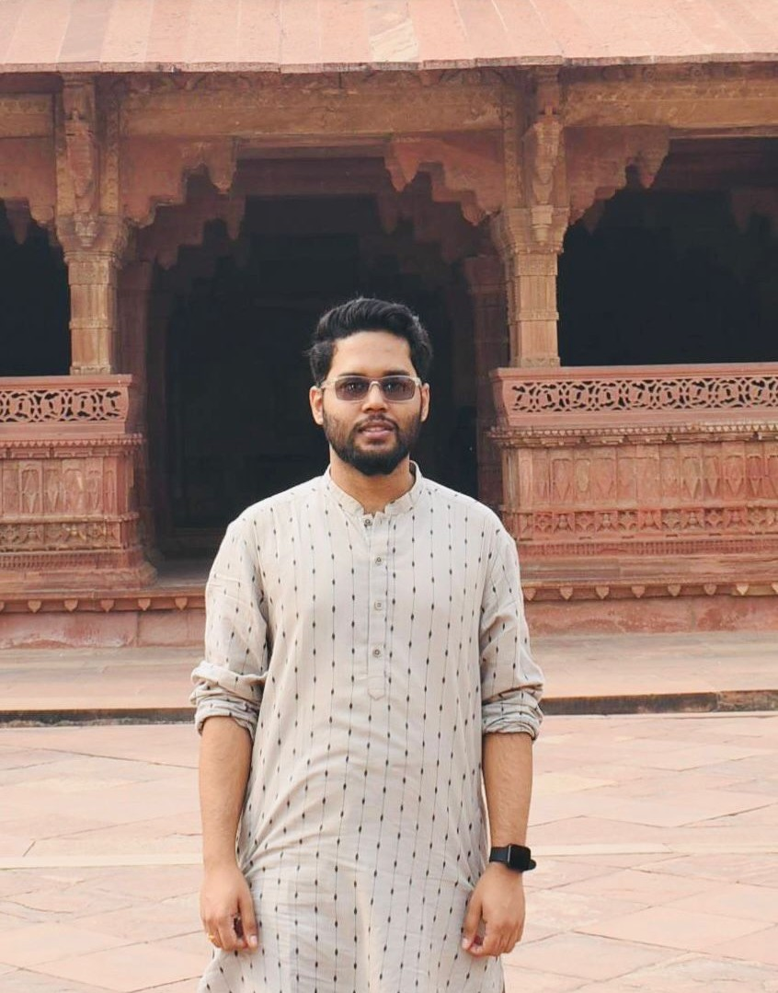

Avik Sarkar is a Senior Research Fellow with the Centre for Political Studies, Jawaharlal Nehru University, New Delhi. He works at the intersection of agrarian political economy and Subaltern Studies in India. His PhD thesis interrogates the fall of the world’s longest-serving democratically elected Communist government in the Indian state of West Bengal by addressing the structural dichotomy between the party’s claim to moral leadership and subterranean aspirations of a highly differentiated rural peasantry. He is also interested in colonial-era Indian engagements with Germany and Russia. With deep interest in political philosophy, he advocates the need to blend Indian and non-Eurocentric conceptual universes.

LinkedIn: Not available

Harshal Raj Patel

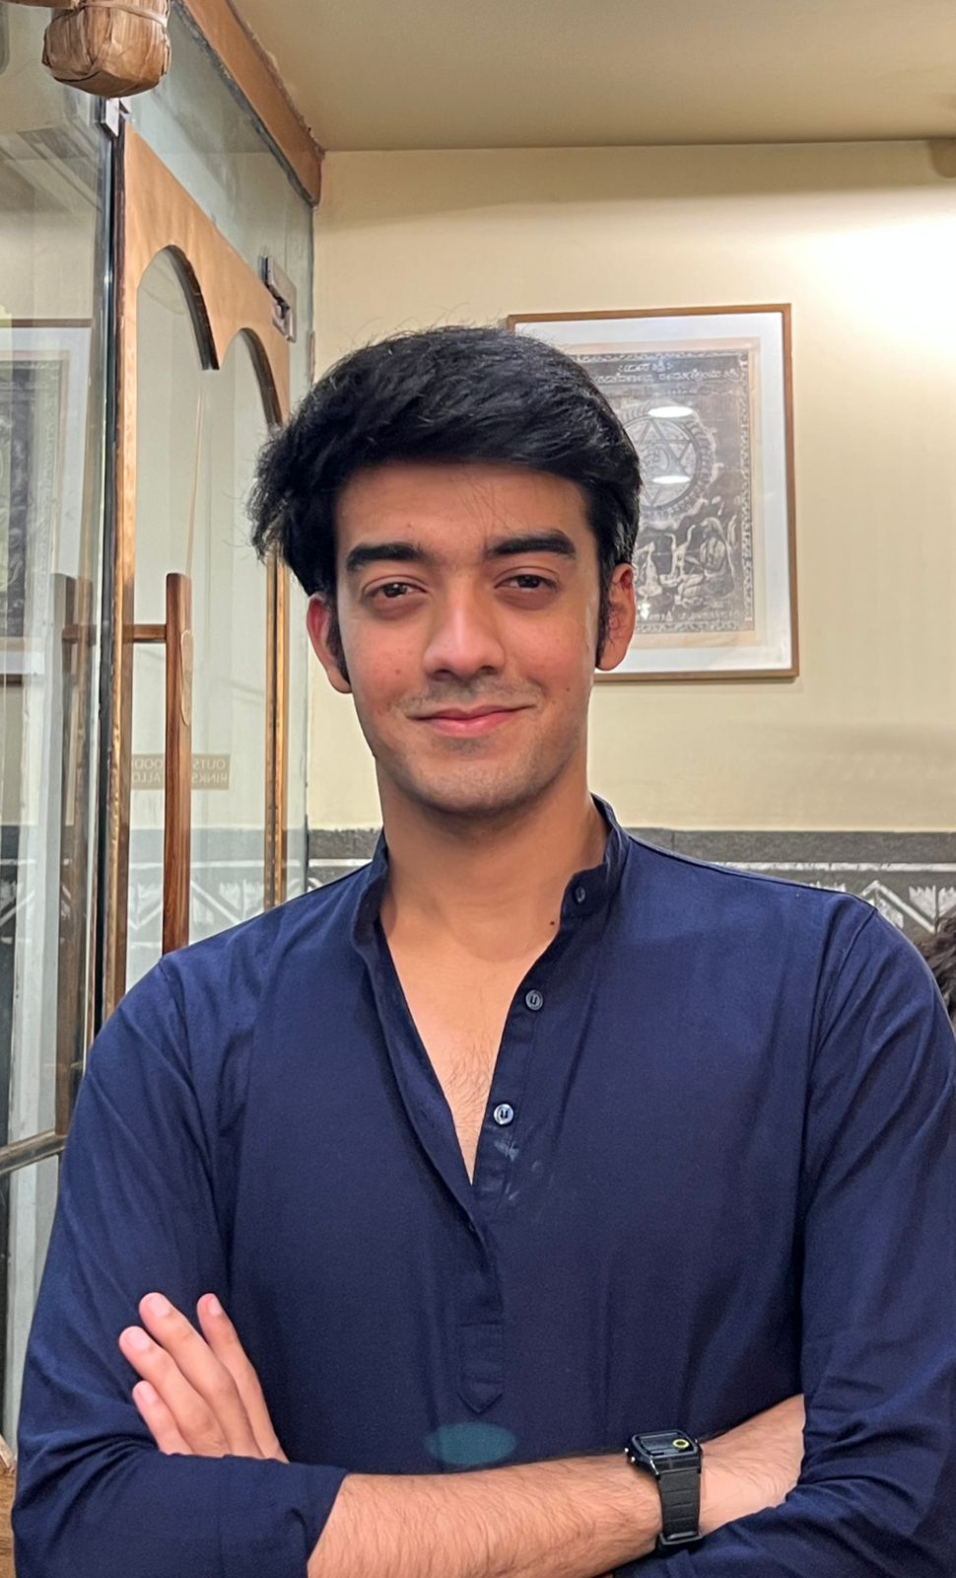

Harshal Raj Patel completed his undergraduate studies in Philosophy at Hansraj College, University of Delhi. His final-year dissertation examined meritocracy and the concept of justice. His research interests include society, diplomatic history, and South Asian affairs. Alongside his academic pursuits, he has worked as a consultant at a New Delhi-based political consultancy. He is also a freelance columnist and contributes regularly to The Tribune, covering nationalism, geopolitics, and diplomatic history.

LinkedIn: https://www.linkedin.com/in/harshal-raj-patel-b81682259/

Abhishek Singh

*Not to be put on the website now/withheld for later addition

DigiEurasia is a curated space for photographs that reflect the physical and human geography of India and Eurasia. A community gallery to capture the common horizons, DigiEurasia seeks to build a people’s repository of Indo-Eurasian landscapes. This is because, at IERF, we believe that true diplomacy begins with the eyes of the people. We invite scholars and general audiences interested in exploring history, architectural marvels, and serene natural landscapes to contribute to our digital gallery. Together, your lens helps us document the living fabric of our diverse civilisations.

*For submissions to DigiEuraisa gallery, attach your photos (up to 3) in PNG/JPG format and write a one-line caption for each photo. Please confirm that you clicked the photo and that it was not taken from any other platform.
Send it to submssions@indiaeurasia.org

Social Media Content

