Lab Sheet–00
Topic: Installation and Setup of Anaconda and Jupyter Notebook

1. Objective

- To install the Anaconda distribution successfully.
- To understand the Anaconda Navigator environment.
- To learn how to launch Jupyter Notebook.
- To create and execute the first Python program.
- To become familiar with the Jupyter Notebook interface and basic operations.

2. Requirements

- Computer/Laptop with Windows/Linux operating system.
- Internet connection.
- Anaconda Distribution.
- Web browser.
- Python 3.x environment.

3. Procedure

Step 1: Download Anaconda

1. Open a web browser.
2. Visit the official Anaconda website.
3. Download the latest version of Anaconda for your operating system.
4. Select the Python 3 version.

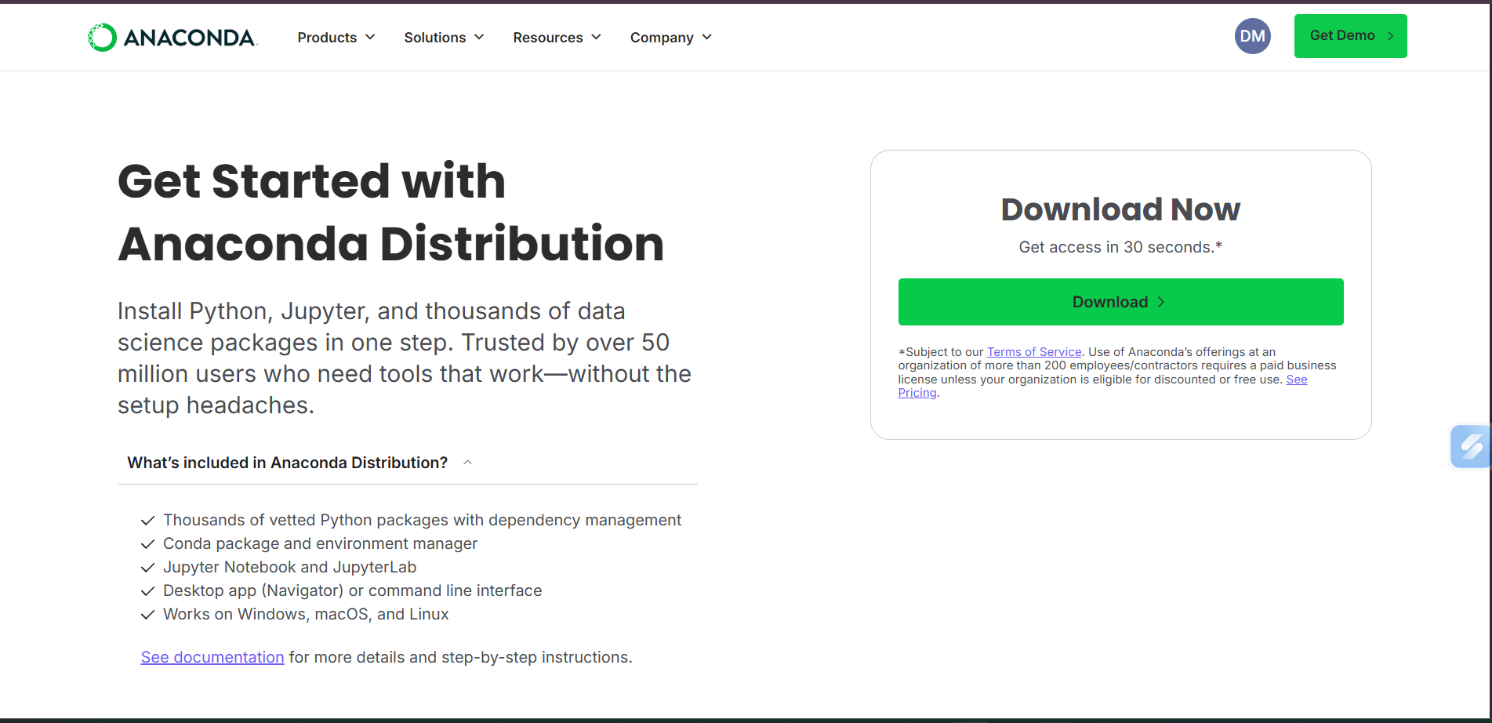
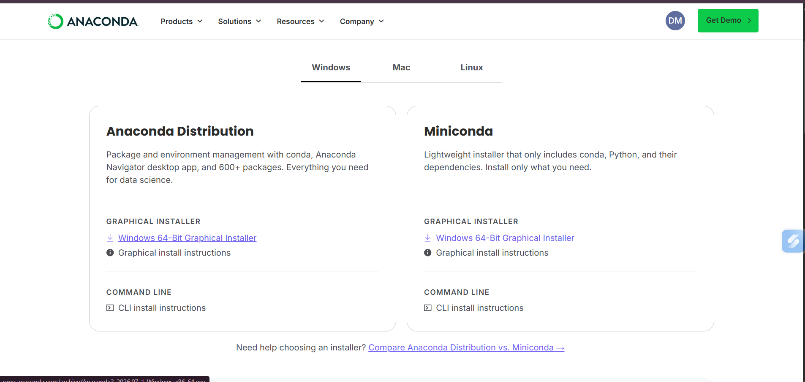

Step 2: Install Anaconda

1. Run the downloaded Anaconda installer.
2. Click Next to continue.
3. Accept the license agreement.
4. Select Just Me installation.
5. Choose the installation directory.
6. Click Install and wait for the installation to complete.
7. Click Finish after successful installation.

Step 3: Launch Anaconda Navigator

1. Open the Start Menu.
2. Search for Anaconda Navigator.
3. Launch the application.
4. Observe the available tools and environments.

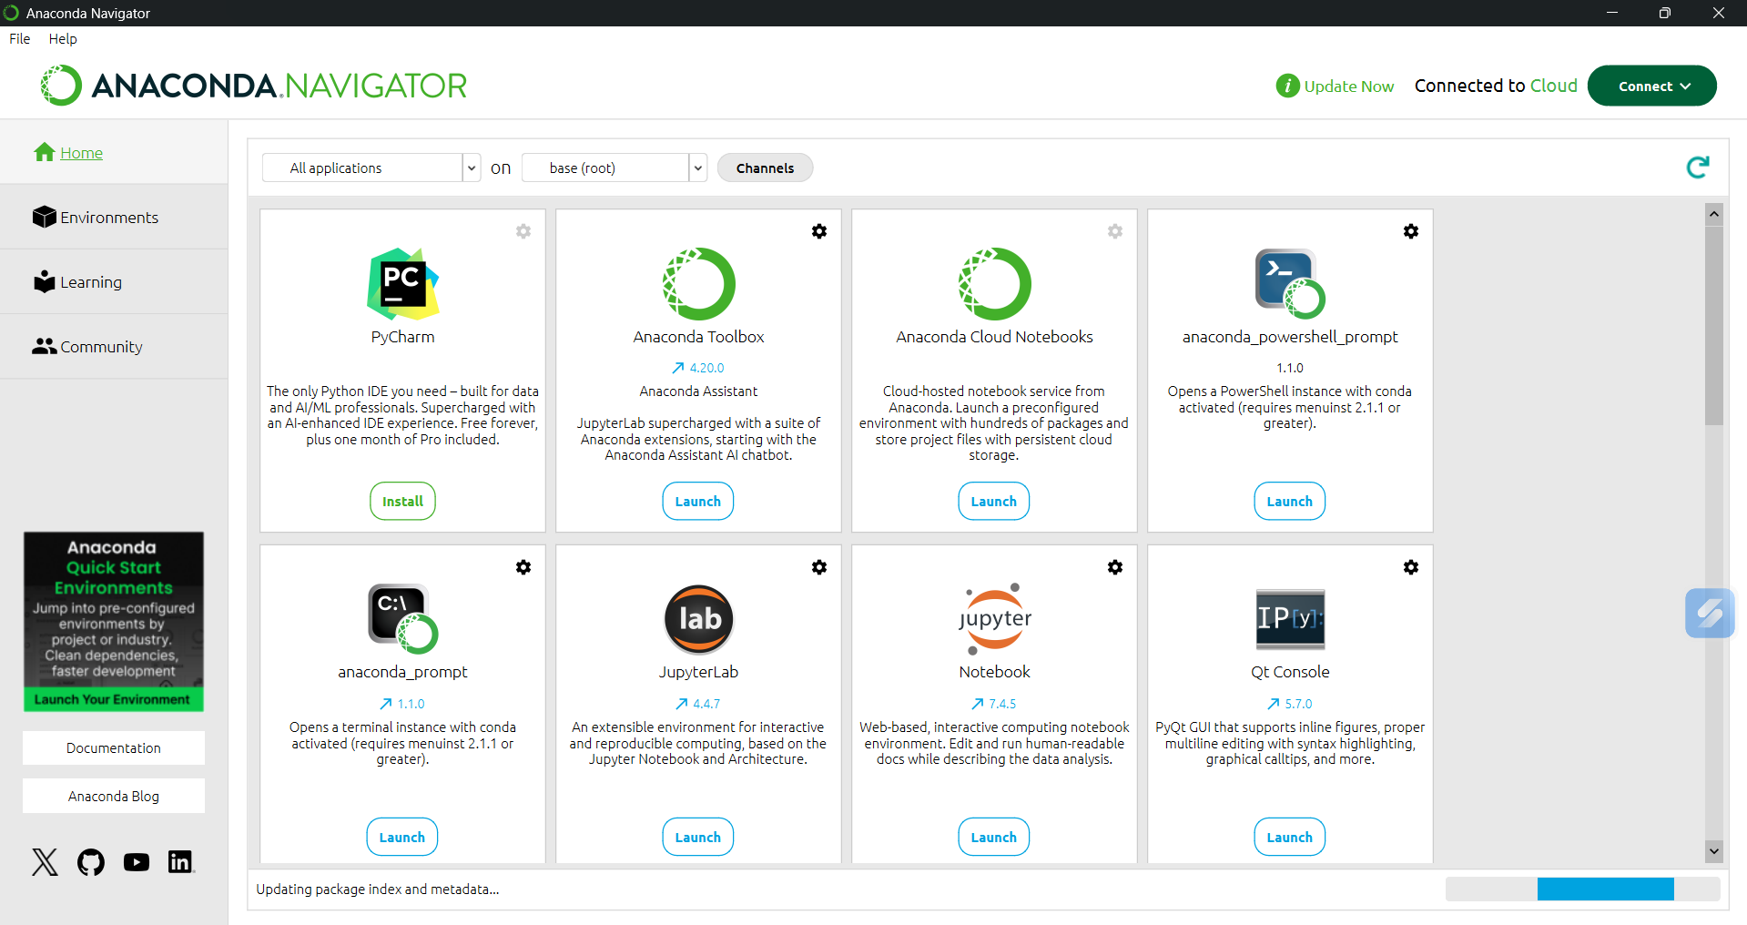
Step 4: Open Jupyter Notebook

1. Open Anaconda Navigator.
2. Find Jupyter Notebook.
3. Click the Launch button.
4. The Jupyter Notebook dashboard will open in the default web browser.

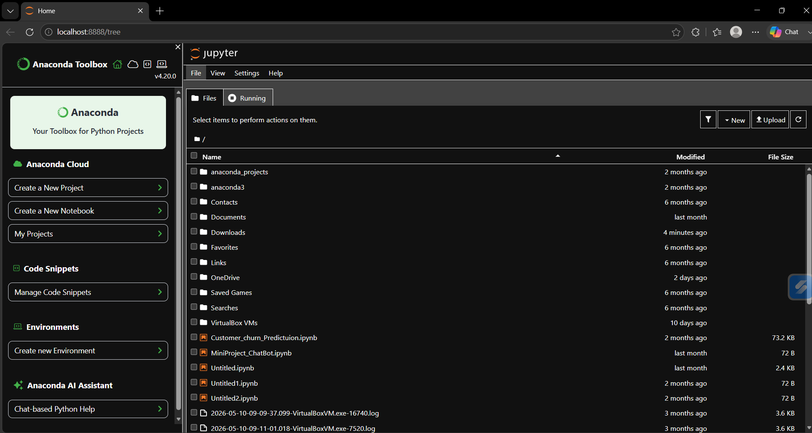
Step 5: Create a New Notebook

1. Click on the New button.
2. Select Python 3 (ipykernel).
3. A new notebook will be created.

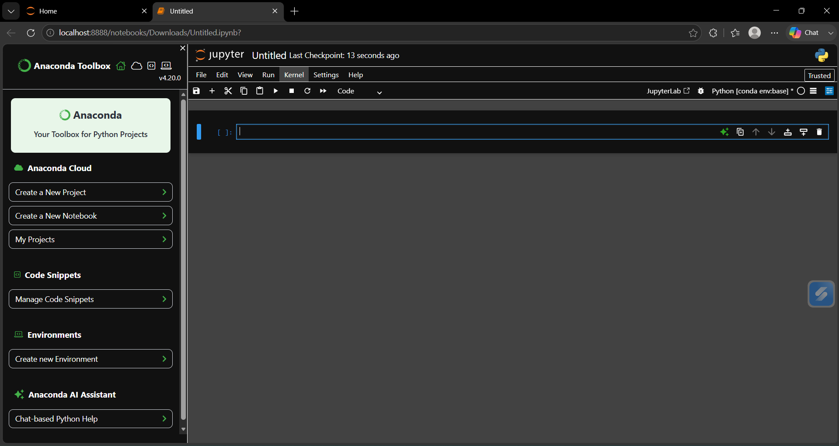

Step 6: Rename the Notebook

1. Click on Untitled at the top.
2. Rename the notebook as FirstProgram.ipynb.

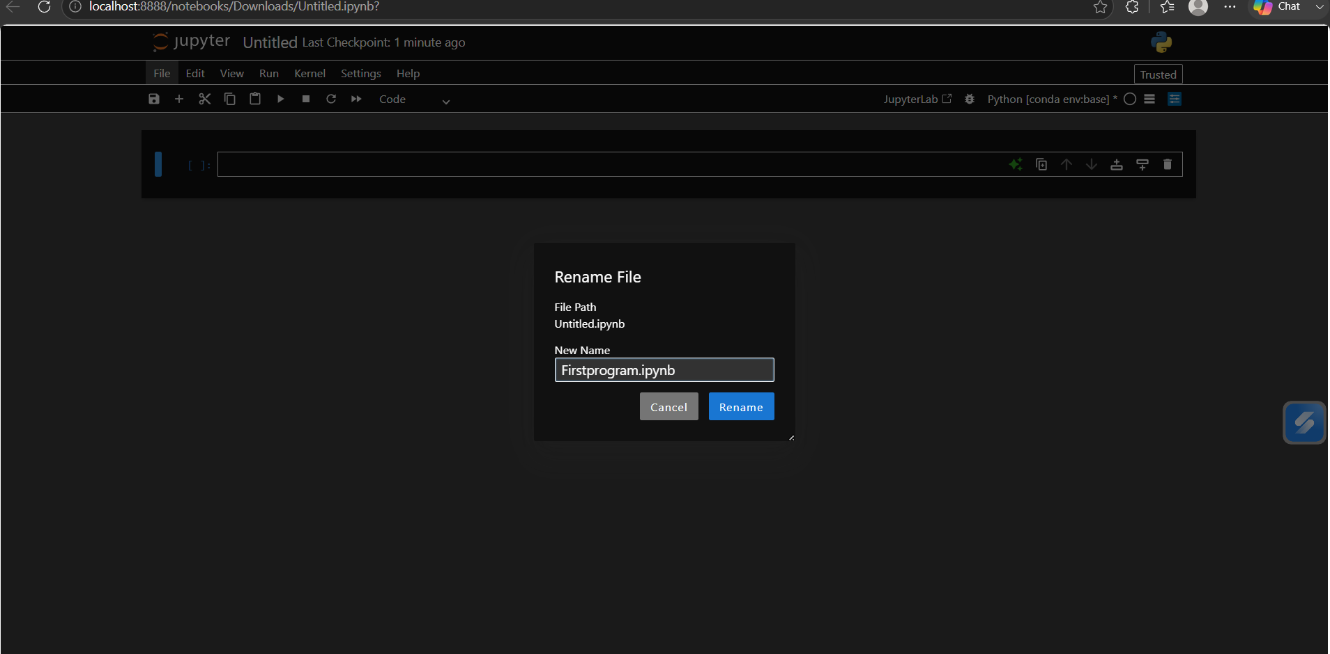
Step 7: Write the First Python Program

Write the following code in the Jupyter Notebook:

print("Hello World")
print("Welcome to Machine Learning Lab")

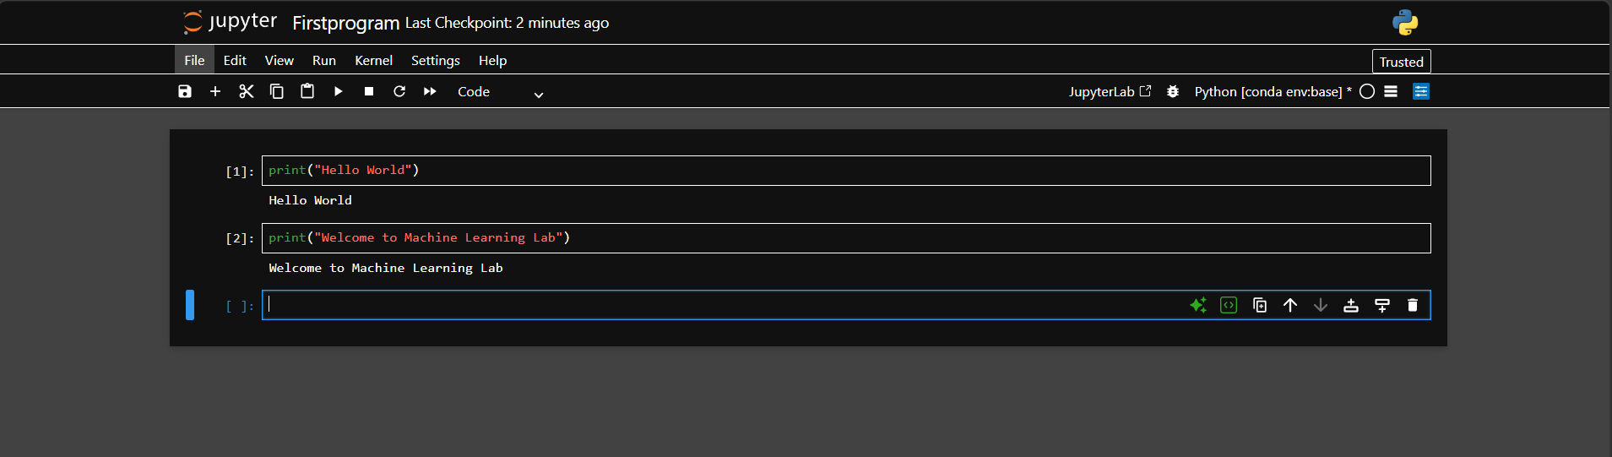

Step 8: Execute the Program

1. Select the code cell.
2. Press Shift + Enter.
3. Observe the output displayed below the cell.

The expected output is:

Hello World
Welcome to Machine Learning Lab
Step 9: Insert Additional Cells

1. Add new code cells.
2. Add Markdown cells for documentation.
3. Practice cell execution and editing.

Step 10: Save the Notebook

1. Click the Save icon.
2. Verify that the notebook file has been saved successfully.
3. Make sure the file is saved with the name FirstProgram.ipynb.

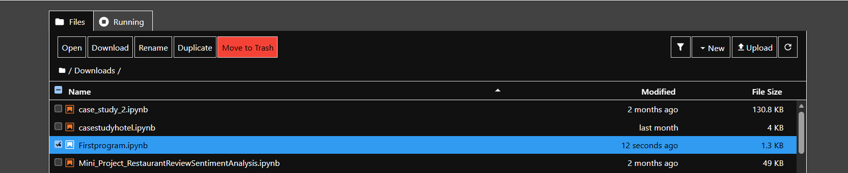

http://localhost:8888/lab/tree/Downloads/Firstprogram.ipynb

4. Conclusion

Thus, Anaconda and Jupyter Notebook were successfully installed and configured. I learned how to launch Anaconda Navigator, create and rename a Jupyter Notebook, write and execute a Python program, use different cells, and save the notebook successfully.

