Internal parameters in Buckets

Internal 2x1 parameters: Histogram
1. Number of parameters in buckets of offset = 0.1

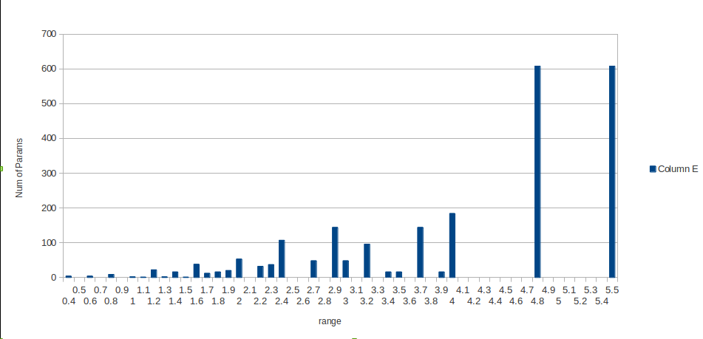
2. Number of parameters in buckets of offset = 0.2 (x-axis are buckets, y-axis is the #params)

Internal 2x2 Parameters: Histograms
1. Buckets of offset = 0.1 (x-axis are buckets, y-axis is the #params)

2. Offset = 0.2 (x-axis are buckets, y-axis is the #params)

3. Offset = 0.5 (x-axis are buckets, y-axis is the #params)

Terminal hairpin parameters in Buckets (tstackh)

a.) Offset = 0.1 (160 params are inf)

Terminal Internal Parameters in Buckets

a.) Offset = 0.1 (160 params are infinite)

Stack Parameters in Buckets (220 params are inf)

a.) Offset = 0.1

