**ECE 457a – Assignment 1**

**Group 1**

1. See Matlab code.

Depth-First Search

a. G2 is reached first.

b. Elements that are popped in order are S,A,D,H,J,G2

Breadth-First Search

a. G1 is reached first.

b. Elements that are popped in order are S,A,B,C,D,H,G1

Greedy – Dijkstra’s Shortest Path

a. Both G1 and G2 has the same shortest path, namely 12

b. Elements that are popped in order are S,A,C,D,E,B,H,F,G1/G2

A* Algorithm

a. G1 is reached first

b. Elements that are popped in order are S,A,C,D,E,H,B,G1

1. *Note: X represents a queen in the following boards

Start: 6 conflicts

|  |  |  |  |
| --- | --- | --- | --- |
| X |  | X |  |
|  | X |  | X |
|  |  |  |  |
|  |  |  |  |

Step 1: 3 conflicts

|  |  |  |  |
| --- | --- | --- | --- |
| X |  | X |  |
|  | X |  |  |
|  |  |  | X |
|  |  |  |  |

Step 2: 2 conflicts

|  |  |  |  |
| --- | --- | --- | --- |
| X |  | X |  |
|  |  |  |  |
|  |  |  | X |
|  | X |  |  |

Step 3: 0 conflicts

|  |  |  |  |
| --- | --- | --- | --- |
|  |  | X |  |
| X |  |  |  |
|  |  |  | X |
|  | X |  |  |

1. 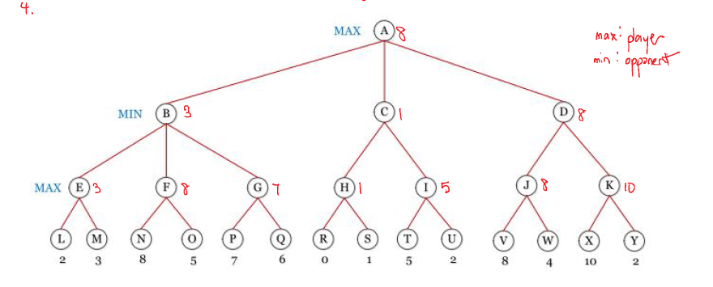
2. The mini-max value at the root node is 8.
3. The max value’s first step should be D. If min then decides to choose J, max should choose V. Else if min decides to choose K, then max should choose X. (Note it would be in min’s best decision to choose J).

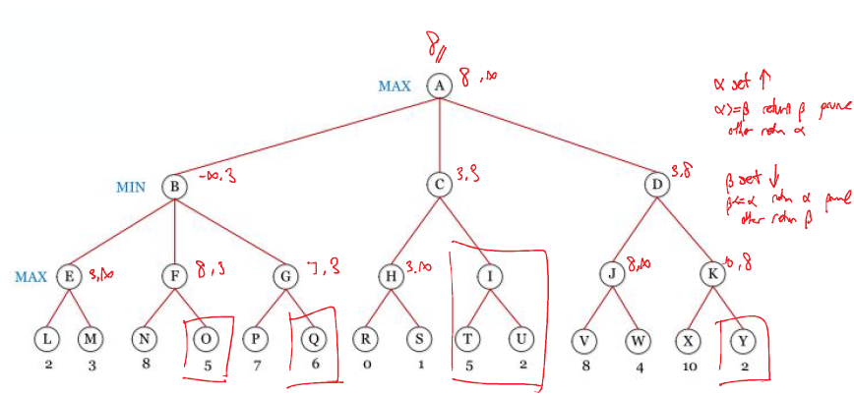

The boxed nodes above are not visited during alpha-beta pruning. These nodes are O, Q, I, T, U, Y.

1. Had node D and node B been swapped (and their following sub-tress), more pruning would of occurred.

