PRACTICAL 10 - TEST REPORT
Automation & Regression Analysis

1. Objective
To analyze the suitability of the QA Playground Data Table module's functionalities for Automation Testing, identify automation candidates, demonstrate automation using Python Selenium, and perform Regression Testing by re-executing established test cases against the current application state.

2. Scope
This practical covers the QA Playground Data Table (Book List) module - Search, Genre Filter, Column Sorting, Pagination, and Add/Edit/Delete Book - and includes automation suitability analysis, a Python Selenium automation demonstration, a regression test suite, and an automation feasibility report.

3. Application / Environment
Project Name | QA Playground Data Table - Automation & Regression Analysis
Application/Software | QA Playground
Application URL | https://qaplayground.com/practice/data-table
Module Name | Data Table (Book List)
SDLC Model | Waterfall Model
Programming Language | Python (Selenium automation demonstration)
IDE/Tool Used | Visual Studio Code
Operating System | Windows 11
Browser | Google Chrome
Tester Name | Abhishek
Execution Date | 23/08/2026

4. Module / Functionality Analysis
Each functionality of the Data Table module was analyzed against criteria of criticality, frequency of change, and automation suitability.
Module | Functionality | Critical | Frequently Changed | Suitable for Automation | Reason
Search Books | Filter table by name | Yes | No | Yes | Repetitive, deterministic filtering
Genre Filter | Filter table by genre dropdown | Yes | No | Yes | Stable, frequently executed
Column Sorting | Sort rows ascending/descending | Yes | No | Yes | Deterministic toggle behavior
Pagination | Navigate across 5 pages | Yes | No | Yes | Repetitive, time-consuming manually
Add Book | Add new book via dialog | Yes | Yes | No | Validation logic changes frequently
Edit/Delete Book | Update or remove a book row | Yes | Yes | No | Business logic changes frequently

5. Automation Suitability & Candidates
Search, Genre Filter, Column Sorting, and Pagination were identified as automation candidates because they are repetitive, stable, deterministic, and frequently executed. Add/Edit/Delete Book was excluded from automation because its validation and business logic change frequently, making automated scripts costly to maintain.
Test Case ID | Functionality | Automation Recommended | Reason | Automation Tool
TC001 | Search Books | Yes | Repetitive, deterministic filter | Selenium with Python
TC002 | Genre Filter | Yes | Stable, frequently executed | Selenium with Python
TC003 | Column Sorting | Yes | Deterministic ascending/descending toggle | Selenium with Python
TC004 | Pagination | Yes | Repetitive, time-consuming manually | Selenium with Python
TC005 | Add/Edit/Delete Book | No | Business/validation logic changes frequently | Manual Testing

6. Python Selenium Automation Implementation
The following is the Python Selenium automation implementation required by this practical, demonstrating the Column Sorting functionality (one of the identified automation candidates). It opens the application, locates the data table, performs the sort action, validates the result, and reports PASS/FAIL before closing the browser. This is a demonstration script against the public QA Playground practice site and is not the website's original source code.
# Python Selenium Automation Demonstration
# Automation script for QA Playground - Data Table module
# (Demonstration script against the public practice site;
# not the website's original source code.)

from selenium import webdriver
from selenium.webdriver.common.by import By
import time

driver = webdriver.Chrome()
driver.get("https://qaplayground.com/practice/data-table")
time.sleep(2)

# Step 1: Locate the data table
table = driver.find_element(By.ID, "dataTable")

# Step 2: Read initial row count on page 1
rows = table.find_elements(By.CSS_SELECTOR, "tbody tr")
print("Rows on page 1:", len(rows))

# Step 3: Click the 'Book Name' column header to sort ascending
header = driver.find_element(By.XPATH, "//th[contains(text(),'Book Name')]")
header.click()
time.sleep(1)

# Step 4: Verify sort applied by reading the first row
first_book = table.find_element(
By.CSS_SELECTOR, "tbody tr:nth-child(1) td:nth-child(2)").text

# Step 5: Verify expected state and report PASS/FAIL
if len(rows) == 5:
print("Test Result: PASS - Page 1 shows 5 rows as expected")
else:
print("Test Result: FAIL - Row count mismatch")

# Step 6: Close the browser
driver.quit()

7. Test Cases
Five test cases were designed, covering the four automation-candidate functionalities and the Add/Edit/Delete Book functionality retained for manual testing. Full test case details - including test data, preconditions, and automation tool - are provided in the accompanying workbook P10_Test_Cases.xlsx (sheet: "Test Cases"). A summary is given below.
Test Case ID | Functionality | Test Scenario | Expected Result | Status
TC001 | Search Books | Search for a book by name and verify filtered results | Only the 'Clean Code' row is displayed | Pass
TC002 | Genre Filter | Filter the table using the genre dropdown | Table shows only rows matching the selected genre | Pass
TC003 | Column Sorting | Click 'Book Name' header to sort ascending, then descending | Rows sorted ascending, then descending | Pass
TC004 | Pagination | Navigate to page 2 using pagination controls | Rows 6-10 displayed | Pass
TC005 | Add/Edit/Delete Book | Add, edit, or delete a book row via dialog | Book list reflects the add/edit/delete action | Not Executed

8. Automation Execution
TC001-TC004 (Search, Genre Filter, Column Sorting, Pagination) were executed and passed, consistent with the automation candidates identified in Section 5. TC005 (Add/Edit/Delete Book) is recorded as Not Executed, since this functionality is recommended for continued manual testing rather than automation.

9. Regression Testing
A regression scenario was simulated by re-executing four previously established test cases against the current state of the Data Table module, to confirm that existing functionality remains unaffected. Full regression details are provided in P10_Test_Cases.xlsx (sheet: "Regression Suite").
Regression Test ID | Module | Scenario | Expected Result | Status
RT001 | Data Table | Table loads correctly | 25 books displayed across 5 pages | Pass
RT002 | Data Table | Sort by 'Book Name' column | Rows sorted correctly ascending/descending | Pass
RT003 | Data Table | Filter/search data by name | Filtered data displayed correctly | Pass
RT004 | Data Table | Pagination across pages | Correct rows displayed per page | Pass

10. Automation Feasibility & Summary
Total Modules Analyzed | 6
Automation Candidates | 4 (Search, Genre Filter, Sorting, Pagination)
Modules Excluded (Manual Testing) | 2 (Add Book, Edit/Delete Book)
Test Cases Passed | 4
Test Cases Not Executed | 1 (TC005 - retained for manual testing)
Regression Test Cases | 4
Regression Tests Passed | 4
Regression Tests Failed | 0
Recommended Automation Tool | Selenium with Python

11. Observations
- Search functionality is suitable for automation.
- Genre filter and column sorting are suitable for automation.
- Add/Edit/Delete operations require manual testing due to frequently changing business logic.
- All four regression test cases executed successfully.
- Existing table functionality remains unaffected in the current application state.

12. Screenshot Section
The screenshots below are to be captured manually and inserted in the marked spaces.
Screenshot 1 - Automation candidate functionality on the application
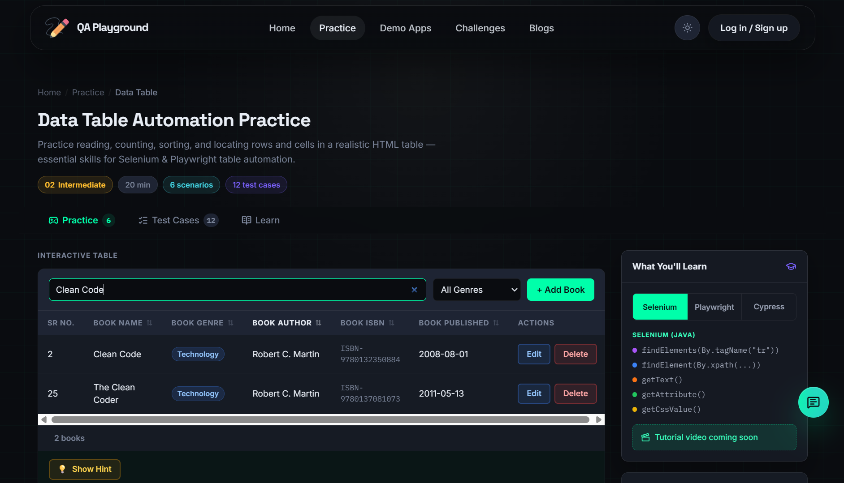
Screenshot 2 - Python Selenium execution
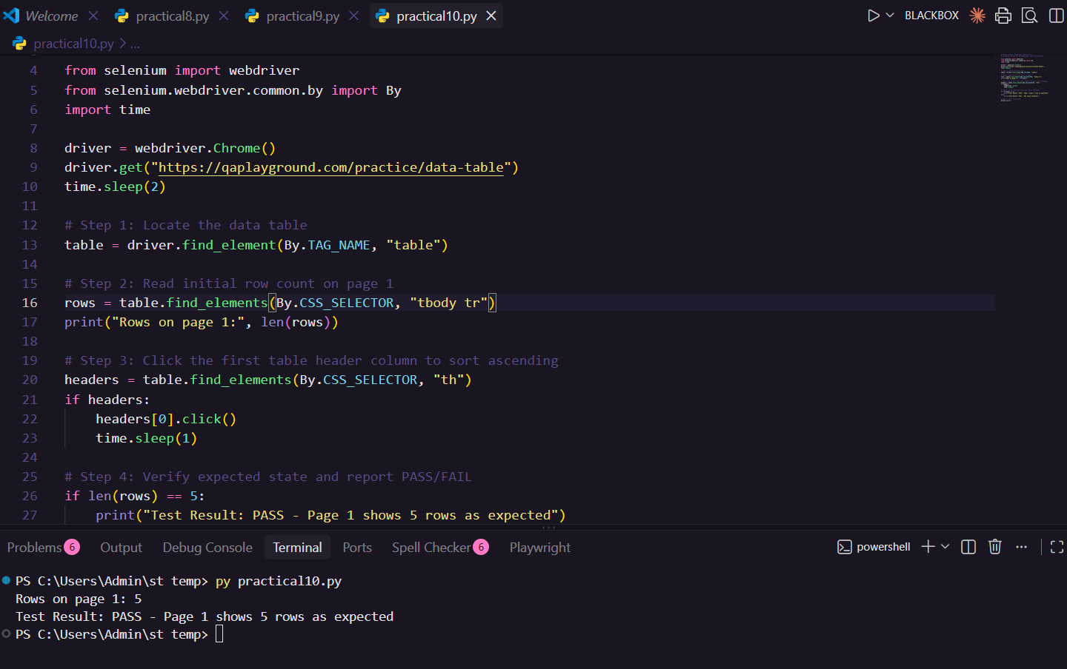
Screenshot 3 - Regression test scenario and result
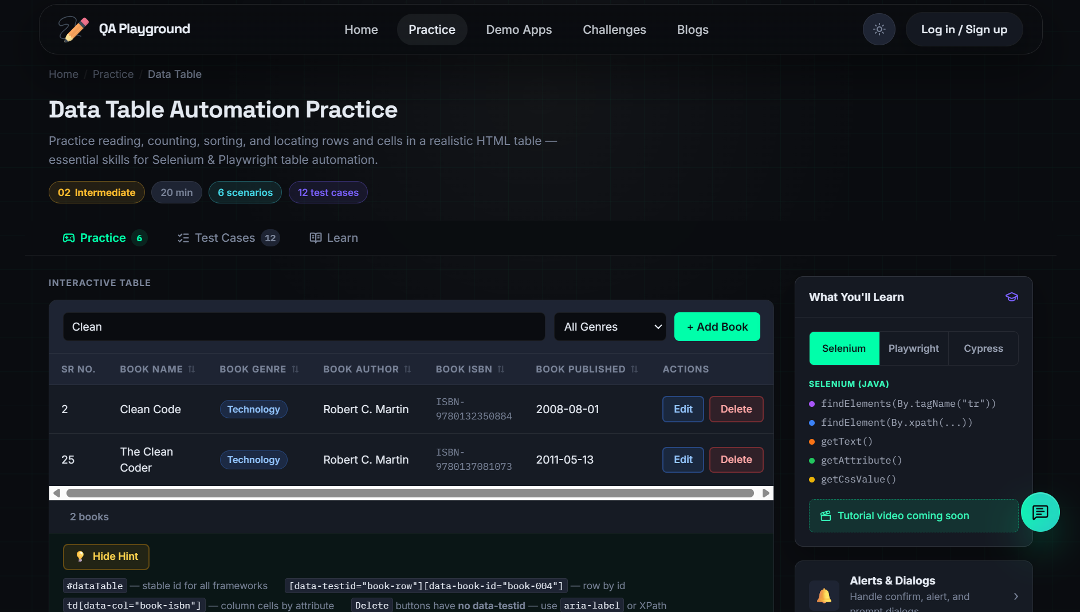
Screenshot 4 - Add/Edit/Delete Book (manual testing)
