PRACTICAL 7 - TEST REPORT
Boundary Value Analysis (BVA) & Equivalence Partitioning (EP)

1. Objective
To apply Equivalence Partitioning (EP) and Boundary Value Analysis (BVA) techniques for validation testing of the Date of Joining field on the Web Form Registration module of the QA Practice website, execute the resulting test cases on the live application, and record any defects observed.

2. Scope
This practical is limited to the Date of Joining field of the QA Practice Web Form Registration module. Testing is restricted to the day component of the date (valid calendar range 1 to 31) and the required dd/mm/yyyy date format. No other fields or modules of the application are covered.

3. Application / Environment
Project Name | QA Practice - Web Form Automation Practice
Application/Module | Web Form Registration Module (Date of Joining field)
Application URL | https://www.qapractice.com/practice-forms
Testing Technique | Equivalence Partitioning (EP) and Boundary Value Analysis (BVA)
Programming Language (Support Code) | Python
IDE/Tool Used | Visual Studio Code
Operating System | Windows 11
Browser | Google Chrome
Tester Name | Abhishek
Test Date | 23/08/2026

4. Testing Methodology
Equivalence Partitioning (EP):
The Date of Joining day input was divided into three equivalence classes - an invalid class for values less than 1, a valid class for values from 1 to 31, and an invalid class for values greater than 31. One representative value was selected from each class. The same approach was applied to the date format field, treating dd/mm/yyyy as the valid partition and any other format (e.g. yyyy-mm-dd) as the invalid partition.
Boundary Value Analysis (BVA):
Since defects most commonly occur at the edges of an input range, boundary values around the valid day range (1-31) were tested: the minimum (1), just above the minimum (2), the maximum (31), just below the maximum (30), and the values immediately outside the range on either side (0 and 32). Together, EP and BVA reduced the overall number of test cases needed while keeping meaningful coverage of the field's behaviour.

5. Source Code (Python)
The following Python script models the Date of Joining validation logic (format check and day-range check) and drives the EP/BVA test data defined for this practical. It is a concise, supporting implementation used to reason about expected behaviour before execution on the live application - it does not replace manual execution on the QA Practice site.
import re

def validate_date_format(date_str):
"""Equivalence Partitioning: confirm the date matches dd/mm/yyyy."""
pattern = r'^\d{2}/\d{2}/\d{4}$'
if not re.match(pattern, date_str):
return "Invalid Format"
day = int(date_str.split('/')[0])
return validate_day(day)

def validate_day(day):
"""Boundary Value Analysis: valid day range is 1 to 31."""
if 1 <= day <= 31:
return "Valid Day"
return "Invalid Day"

def run_ep_bva_suite():
"""Drives the EP and BVA test data defined for the Date of Joining field
and prints a pass/fail style summary for each case."""
boundary_days = [
(0, "Invalid Day"), # Minimum - 1
(1, "Valid Day"), # Minimum
(2, "Valid Day"), # Minimum + 1
(15, "Valid Day"), # Nominal / EP mid-range value
(30, "Valid Day"), # Maximum - 1
(31, "Valid Day"), # Maximum
(32, "Invalid Day"), # Maximum + 1
]
for day, expected in boundary_days:
actual = validate_day(day)
result = "PASS" if actual == expected else "FAIL"
print(f"Day={day:>3} -> {actual:<12} (expected {expected:<12}) [{result}]")

format_cases = [
("01/06/2021", "Valid Day"),
("2021-06-01", "Invalid Format"),
]
for date_str, expected in format_cases:
actual = validate_date_format(date_str)
result = "PASS" if actual == expected else "FAIL"
print(f"{date_str:>12} -> {actual:<15} (expected {expected:<15}) [{result}]")

if __name__ == "__main__":
run_ep_bva_suite()

6. Test Cases
Nine test cases were designed for the Date of Joining field, covering the EP classes and BVA boundary points described above. Full test case details - including test steps, prerequisites, and remarks - are provided in the accompanying workbook P7_Test_Cases.xlsx (sheet: "Test Cases"). A summary of the test cases is given below.
Test Case ID | Technique | Test Input | Expected Result | Status
P7_TC_01 | BVA | Day = 00 (00/06/2021) | Invalid Day - rejected | Not Executed
P7_TC_02 | BVA | Day = 01 (01/06/2021) | Valid Day - accepted | Not Executed
P7_TC_03 | BVA | Day = 02 (02/06/2021) | Valid Day - accepted | Not Executed
P7_TC_04 | EP | Day = 15 (15/06/2021) | Valid Day - accepted | Not Executed
P7_TC_05 | BVA | Day = 30 (30/06/2021) | Valid Day - accepted | Not Executed
P7_TC_06 | BVA | Day = 31 (31/06/2021) | Valid Day - accepted | Not Executed
P7_TC_07 | BVA | Day = 32 (32/06/2021) | Invalid Day - rejected | Not Executed
P7_TC_08 | EP | Format 01/06/2021 | Accepted - valid format | Not Executed
P7_TC_09 | EP | Format 2021-06-01 | Rejected - invalid format message | Not Executed

7. Test Execution & Results
Live execution on https://www.qapractice.com/practice-forms had not been completed at the time this report was prepared. All nine test cases are therefore recorded as "Not Executed" in both this report and in P7_Test_Cases.xlsx. Expected results below are derived directly from the EP/BVA design in the Practical 7 manual; Actual Result and Status must be updated by the tester once each test case is run on the live application.
Expected behaviour: Day = 00 and Day = 32 -> rejected as Invalid Day; Day = 01, 02, 15, 30, 31 -> accepted as Valid Day; date format yyyy-mm-dd -> rejected with the message "Date of Joining format should be dd/mm/yyyy".

8. Summary / Statistics
Total Test Cases | 9
Passed | 0
Failed | 0
Not Executed / Pending | 9
Pass % | 0.0% (pending execution)
Note: These figures will be updated once the test cases in P7_Test_Cases.xlsx are executed on the live application.

9. Observations
- Day values 00 and 32 fall outside the valid calendar range (1-31) and are expected to be rejected.
- Day values 01 and 31 lie exactly on the valid boundary and are expected to be accepted.
- The dd/mm/yyyy format requirement was verified against the yyyy-mm-dd format through Equivalence Partitioning.
- EP and BVA together reduced the number of test cases needed for the Date of Joining field from a much larger exhaustive set down to nine representative cases.
- Live execution on qapractice.com is pending; results above will be finalised after manual testing.

10. Defect / Bug Report Template
No defects have been raised at the design stage. This template will be completed only if the live application accepts an invalid day (00 or 32) or rejects a valid day (01, 02, 15, 30, or 31) during execution.
Bug ID | N/A - Pending Execution
Bug Summary | To be completed only if a genuine deviation is observed during live execution
Module Name | Web Form Registration Module
Feature Affected | Date of Joining Validation
Severity | To be determined
Priority | To be determined
Steps to Reproduce | Enter an invalid Day value (00 or 32) in the Date of Joining field and click Submit
Expected Result | Invalid day should be rejected with an appropriate error message
Actual Result | To be recorded during execution
Status | Not Executed

11. Screenshot Section
The screenshots below are to be captured manually during live execution and inserted in the marked spaces.
Screenshot 1 - Invalid Day rejected (Day = 00)
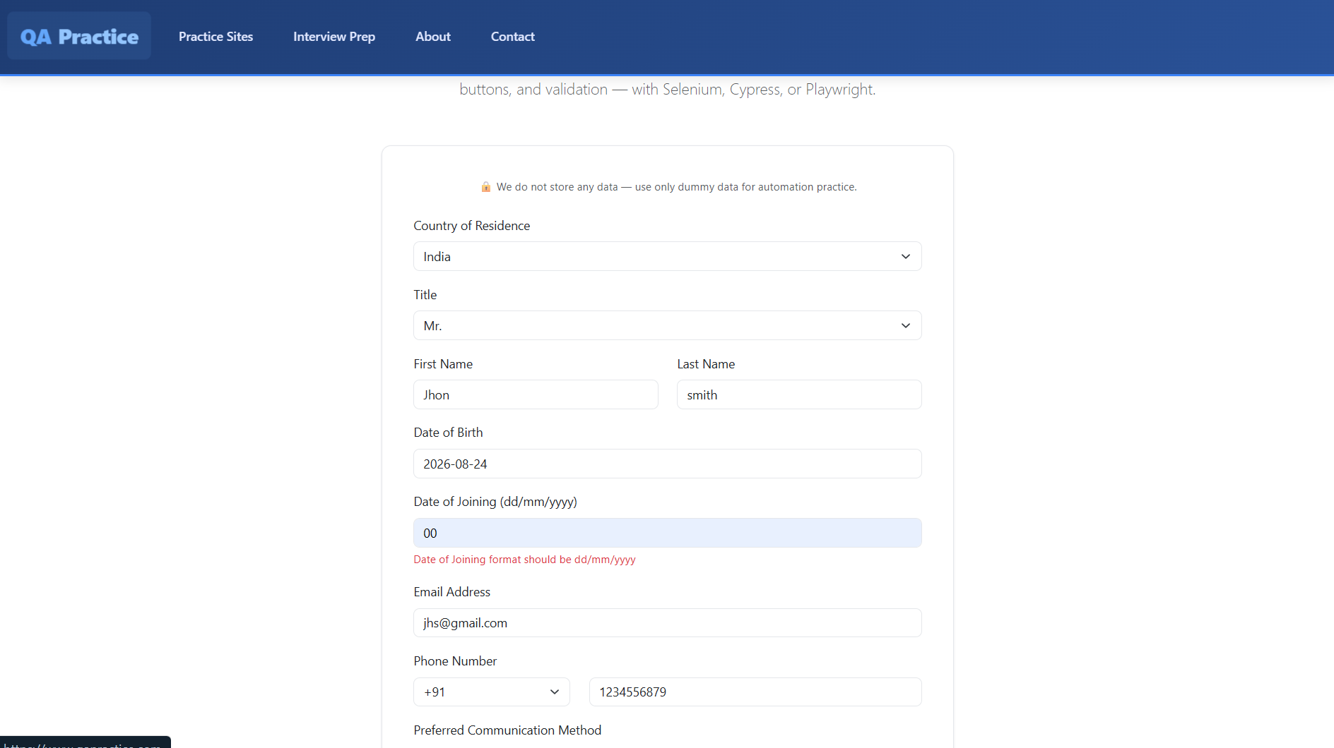
Screenshot 2 - Invalid Day rejected (Day = 32)
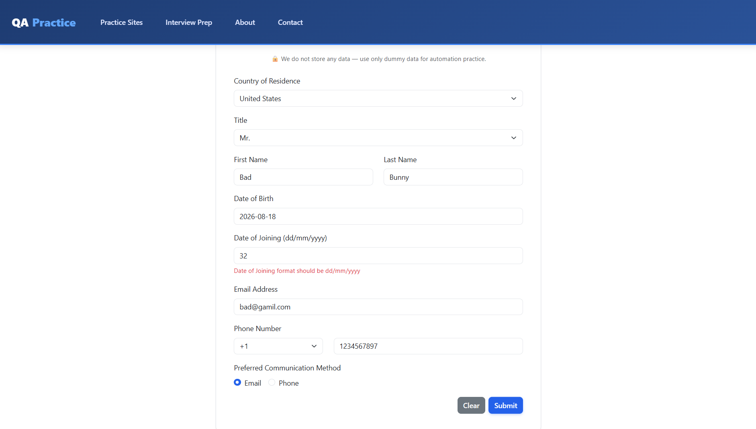
Screenshot 3 - Valid boundary days accepted (Day = 01 and Day = 31)
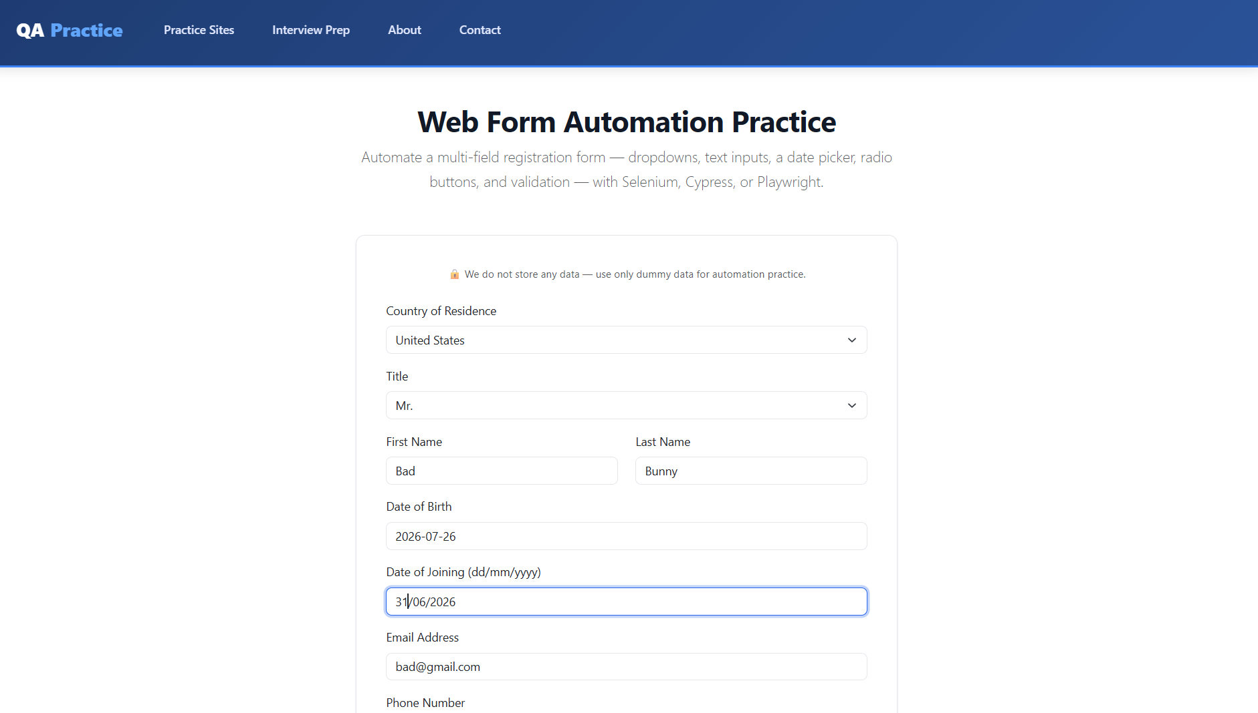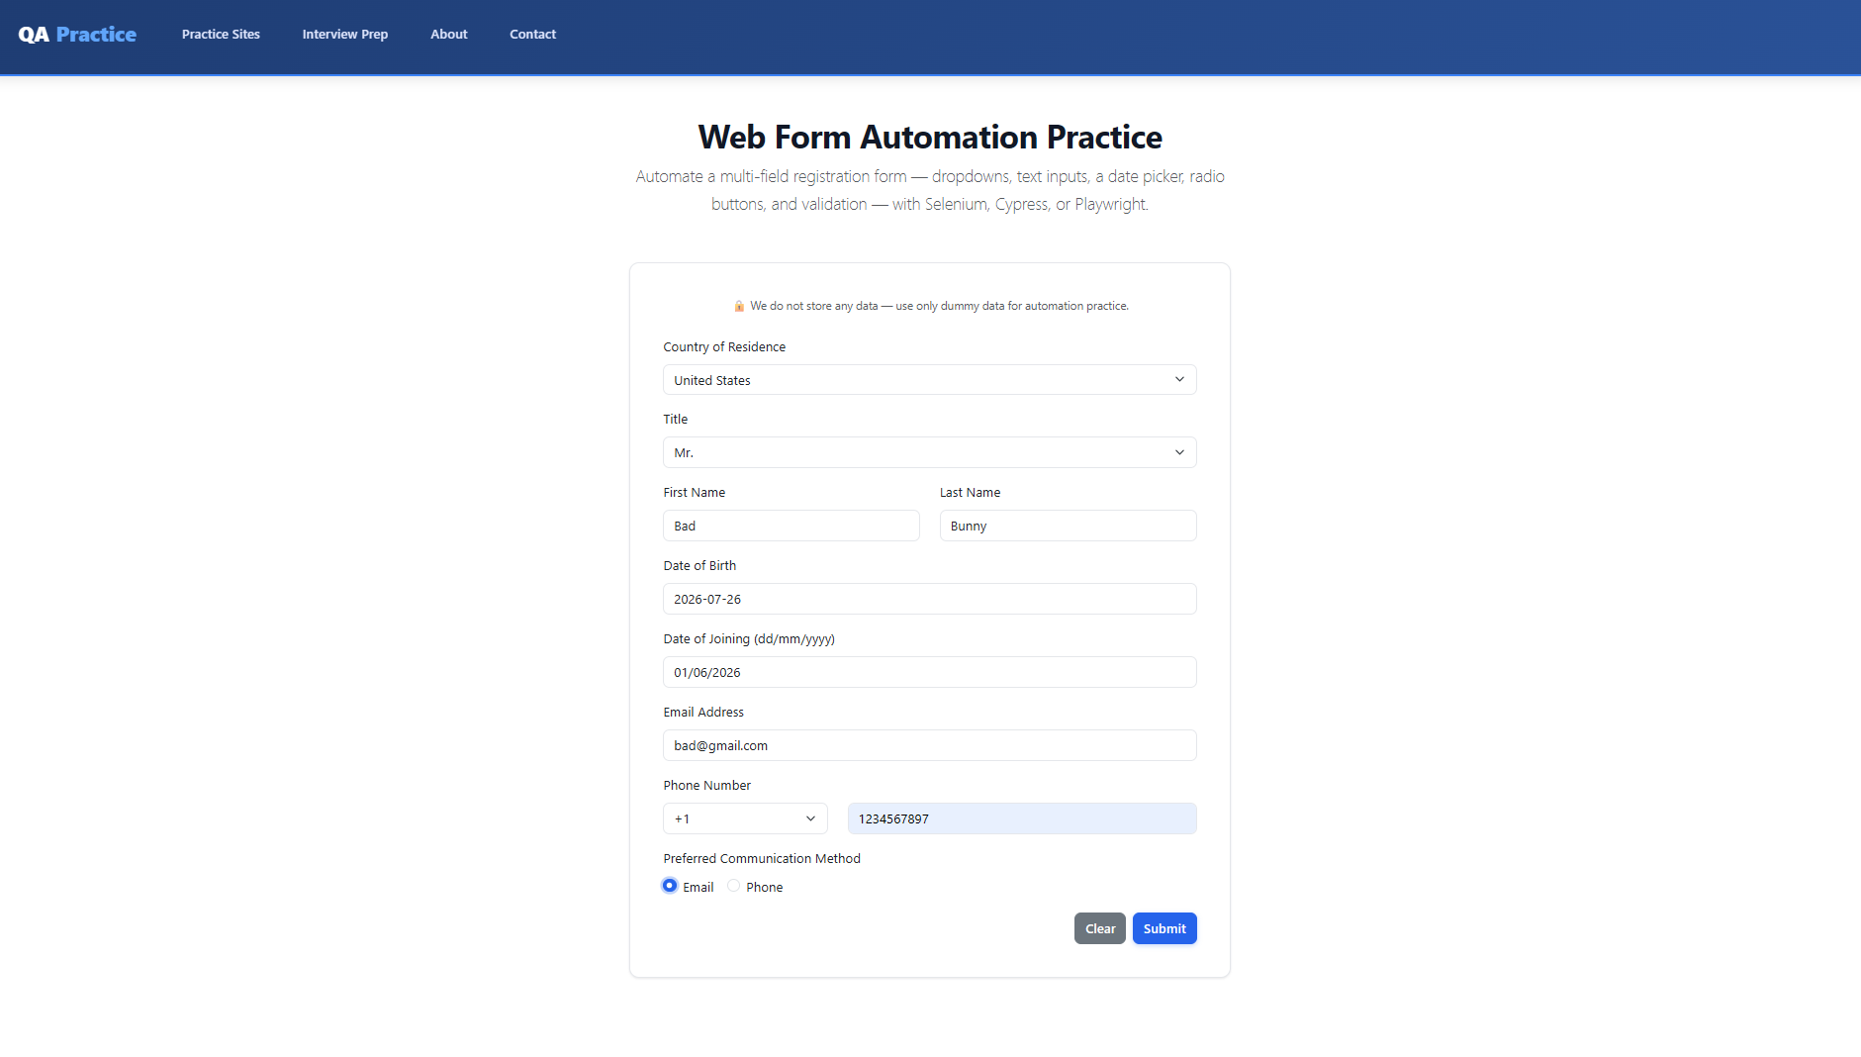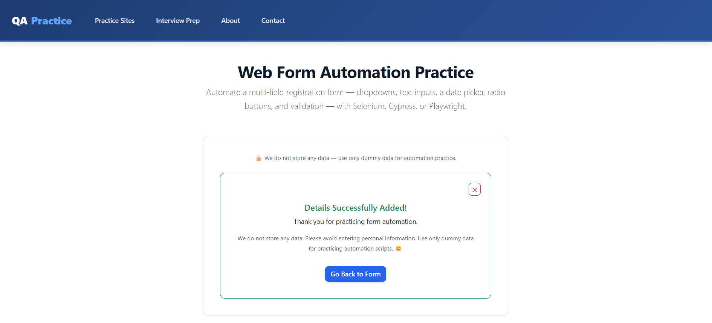
Screenshot 4 - Invalid date format rejected
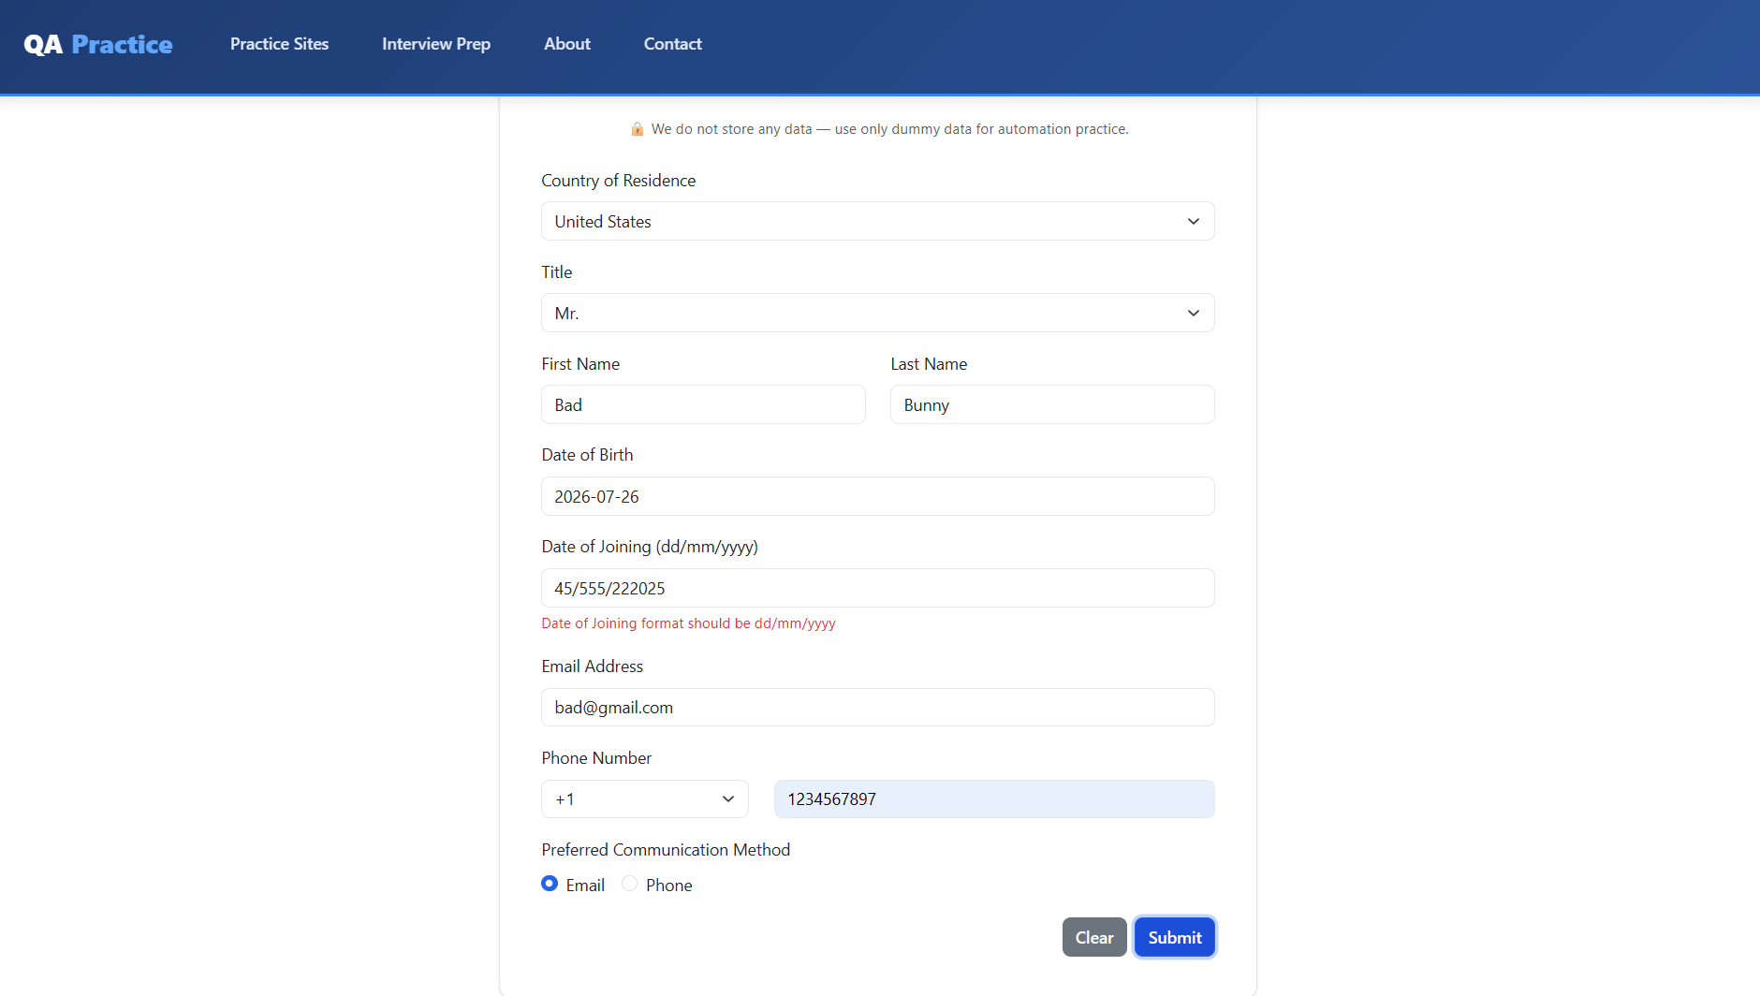

Screenshot 5 - Python source code execution output
