PRACTICAL 8 - TEST REPORT
Test Case Management (TestLink) & Defect Tracking (Bugzilla)

1. Objective
To design and manage test cases for the Registration Module of the QA Brains Practice Site using TestLink's project/plan/suite/test-case structure, execute the test cases on the live registration form, and report any observed defect using a simulated Bugzilla workflow.

2. Scope
This practical covers the Registration form (Name, Country, Account Type, Email, Password, Confirm Password) of the QA Brains Practice Site. It includes test case creation and organisation in TestLink, live execution of the designed test cases, generation of a Test Execution Report and Test Summary Report, and defect logging in Bugzilla. TestLink and Bugzilla are used as an academic simulation - no live TestLink/Bugzilla server was used.

3. Application / Environment
Project Name | QA Brains Practice Site
Application/Module | QA Brains - Registration Module
Module Under Test | User Authentication - Registration
Application URL | https://practice.qabrains.com/registration
SDLC Model | Waterfall Model
Test Management Tool | TestLink (workflow simulation)
Defect Tracking Tool | Bugzilla (workflow simulation)
Programming Language (Support Code) | Python
IDE/Tool Used | Visual Studio Code
Operating System | Windows 11
Browser | Google Chrome
Tester Name | Abhishek
Execution Date | 23/08/2026

4. TestLink Activity
A test project, test plan, and test suite were created in TestLink (simulated) to organise the Registration Module test cases. Four test cases (TC001-TC004) covering valid registration, mandatory-field validation, email-format validation, and password-confirmation matching were added to the suite and executed against the live application.
Test Project Created | QA Brains Practice Site
Test Plan Created | Registration Module Testing
Test Suite | Registration - Functional Validation
Test Cases Added to TestLink | TC001, TC002, TC003, TC004
Test Cases Executed | 2 of 4 (TC001, TC002)
Execution Result Summary | Passed: 2 | Failed: 0 | Not Executed: 2

5. Source Code (Python)
The following Python script models the Registration form's validation logic (required-field check, email-format check, and password-confirmation check) and drives the same input data used for TC001-TC004. It supports reasoning about expected behaviour and does not replace manual execution on the live application.
import re

def register(name, country, account_type, email, password, confirm_password):
"""Registration validation logic for the QA Brains Registration form."""

# Equivalence Partitioning: required-field check (covers TC002)
if not name or not country or not account_type or not email \
or not password or not confirm_password:
return "Error: All fields are required"

# Email format validation (covers TC003)
pattern = r'^[^@\s]+@[^@\s]+\.[a-zA-Z]{2,}$'
if not re.match(pattern, email):
return "Error: Invalid Email Address"

# Confirm-password matching (covers TC004)
if password != confirm_password:
return "Error: Passwords do not match"

return "Registration Successful"

def run_test_suite():
"""Drives TC001-TC004 against the registration logic and prints
a PASS/FAIL style result for each, mirroring the TestLink cases."""
cases = [
("TC001", ("Jhon Doe", "India", "Standard", "jhon.doe@example.com",
"Test@1234", "Test@1234"), "Registration Successful"),
("TC002", ("", "India", "Standard", "jhon.doe@example.com",
"Test@1234", "Test@1234"), "Error: All fields are required"),
("TC003", ("Jhon Doe", "India", "Standard", "notanemail",
"Test@1234", "Test@1234"), "Error: Invalid Email Address"),
("TC004", ("Jhon Doe", "India", "Standard", "jhon.doe@example.com",
"Test@1234", "Test@1235"), "Error: Passwords do not match"),
]
for tc_id, args, expected in cases:
actual = register(*args)
result = "PASS" if actual == expected else "FAIL"
print(f"{tc_id}: {actual} [{result}]")

if __name__ == "__main__":
run_test_suite()

6. Test Cases
Four test cases were designed for the Registration form, covering the positive flow, mandatory-field validation, email-format validation, and password-confirmation matching. Full test case details - including requirement IDs, priority, severity, and remarks - are provided in the accompanying workbook P8_Test_Cases.xlsx (sheet: "Test Cases"). A summary is given below.
Test Case ID | Test Scenario | Expected Result | Actual Result | Status
TC001 | Valid registration - all fields filled correctly | "Registration Successful" message displayed | "You have successfully logged in" message displayed (wording defect - BUG-001) | Pass
TC002 | Submit form with mandatory fields left empty | Validation error shown for each mandatory field | Validation errors shown for all empty fields | Pass
TC003 | Invalid email format entered (e.g. "notanemail") | "Invalid Email Address" error shown | To be recorded during execution | Not Executed
TC004 | Password and Confirm Password do not match | "Passwords do not match" error shown | To be recorded during execution | Not Executed

7. Test Execution & Results
TC001 and TC002 were executed live on https://practice.qabrains.com/registration and passed. TC003 and TC004 had not been executed at the time this report was prepared and are recorded as "Not Executed" in both this report and in P8_Test_Cases.xlsx (sheet: "Test Execution"). Actual Result and Status for TC003 and TC004 must be updated by the tester once each is run on the live application.

8. Bugzilla - Defect Report
While executing TC001, the registration confirmation message was found to read "You have successfully logged in" instead of confirming registration. This is a minor wording defect and has been logged in Bugzilla (simulated) as BUG-001.
Bug ID | BUG-001
Summary | Registration success message incorrectly states "You have successfully logged in" instead of confirming registration
Related Test Case | TC001
Module Name | Registration Module
Steps to Reproduce | Enter valid Name, Country, Account Type, Email, Password and Confirm Password on the registration page and click SIGNUP
Expected Result | "Registration Successful" confirmation is displayed
Actual Result | "You have successfully logged in" message is displayed
Severity | Low (Cosmetic)
Priority | Low
Status (Defect Lifecycle) | New
Reported By | Abhishek

9. Summary / Statistics
Total Test Cases Designed | 4
Total Test Cases Executed | 2
Total Passed | 2
Total Failed | 0
Total Blocked | 0
Total Not Executed | 2
Pass % (of executed cases) | 100%
Fail % (of executed cases) | 0%
Overall Test Status | Partial - 2 Executed / 2 Pending
Defects Logged (Bugzilla) | 1 (BUG-001)
Note: These figures will be updated once TC003 and TC004 in P8_Test_Cases.xlsx are executed on the live application.

10. Observations
- Registration succeeded with valid Name, Country, Account Type, Email, Password and Confirm Password (TC001).
- Submitting the form with empty mandatory fields correctly triggered validation errors for each field (TC002).
- The success message reads "You have successfully logged in" instead of confirming registration - logged as BUG-001.
- Invalid-email and password-mismatch scenarios (TC003, TC004) are yet to be executed.
- TestLink and Bugzilla workflows are demonstrated as an academic simulation; no live TestLink/Bugzilla server was used.

11. Screenshot Section
The screenshots below are to be captured manually and inserted in the marked spaces.
Screenshot 1 - TestLink test case list
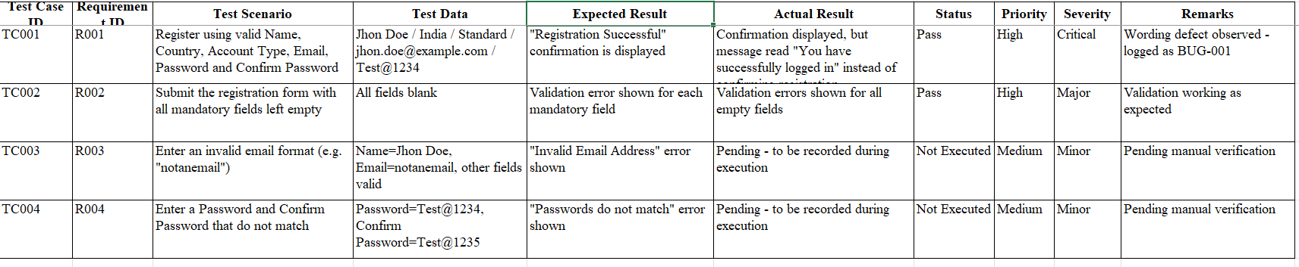
Screenshot 2 - TC001 executed on the live application
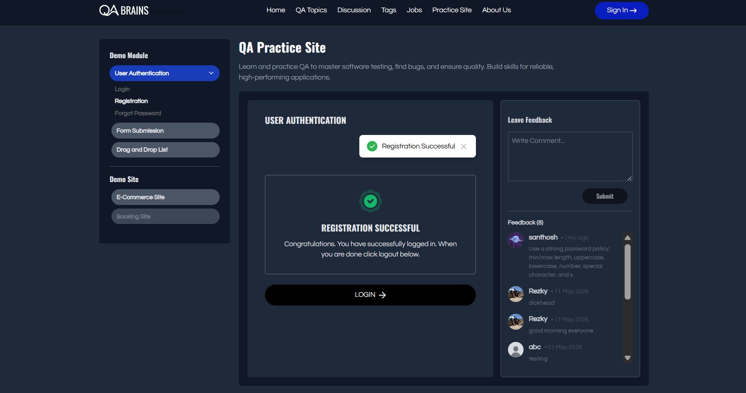
Screenshot 3 - TC002 executed on the live application
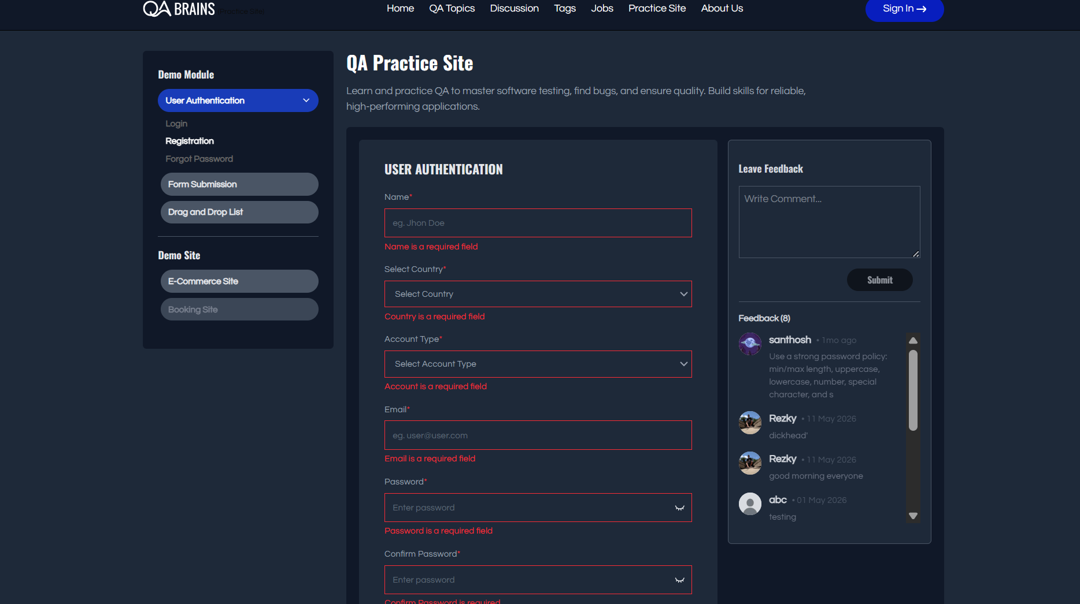
Screenshot 4 - BUG-001 logged in Bugzilla
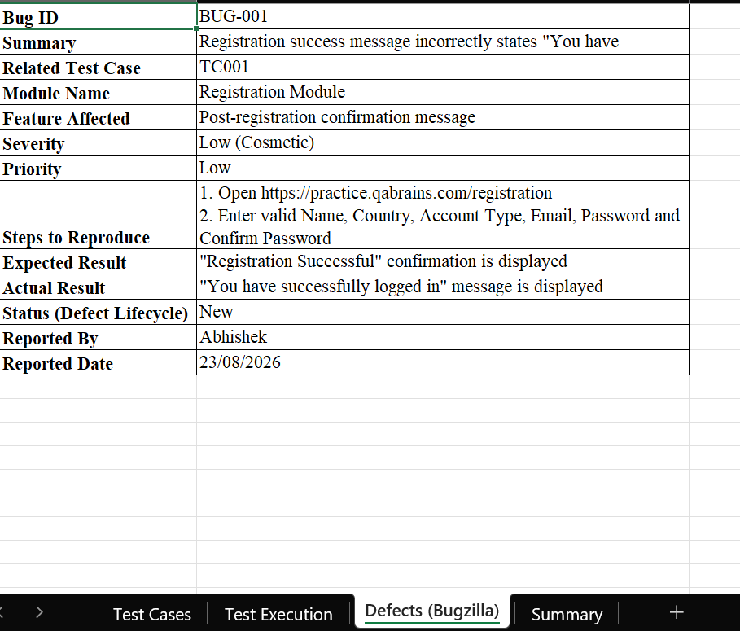
Screenshot 5 - Python source code execution output
