PRACTICAL 9 - TEST REPORT
Black-Box, White-Box, Integration & System Testing

1. Objective
To analyze and apply Black-Box Testing, White-Box Testing, Integration Testing, and System Testing on the QA Playground Bank Demo App, and to document the testing process, execution, and results.

2. Scope
This practical covers the observable Login, Dashboard, Accounts, and Transaction modules of the QA Playground Bank Demo App. Black-Box Testing is performed directly on the live application; White-Box Testing is demonstrated through a small original Python implementation that models the same login-validation logic conceptually, since the application's internal source code is not externally accessible; Integration Testing verifies communication between the Login and Dashboard modules; and System Testing validates the complete end-to-end workflow.

3. Application / Environment
Project Name | QA Playground Bank Demo - Testing
Application/Software | QA Playground Bank Demo App
Application URL | https://qaplayground.com/demo
Modules Covered | Login, Dashboard, Accounts, Transactions
SDLC Model | Waterfall Model
Programming Language (White-Box support code) | Python
IDE/Tool Used | Visual Studio Code / Web Browser
Operating System | Windows 11
Browser | Google Chrome
Tester Name | Abhishek
Execution Date | 23/08/2026

4. Testing Approach / Methodology
Black-Box Testing:
The Login module was tested from an external, user-facing perspective without reference to internal code - verifying that valid credentials open the Dashboard and invalid credentials produce an error message (TC001, TC002).
White-Box Testing:
Since the Bank Demo App's internal source is not accessible, White-Box Testing is demonstrated using an original Python supporting implementation that models the login -> dashboard -> accounts -> transaction flow. Both the valid-credentials branch and the invalid-credentials branch were executed and verified (TC003, TC004).
Integration Testing:
The handoff between the Login module and the Dashboard module was verified to confirm that a successful login correctly triggers the Dashboard to load, demonstrating correct communication between the two real, observable modules (TC005).
System Testing:
The complete end-to-end workflow - Login, Dashboard, Accounts, Transaction, and Logout - was executed as a single continuous flow to validate the application's behaviour as a whole, from a user's perspective (TC006).

5. Source Code (Python) - White-Box Support Implementation
The following Python script is an original, academic-purpose implementation used only to demonstrate branch and statement execution logic for the login-validation flow. It is not a representation of the QA Playground Bank Demo App's actual source code, which is not accessible externally.
# Python Supporting Implementation for White-Box Testing
# (Conceptual model of Bank Demo login -> dashboard -> transaction flow)
# Original academic-purpose code - not the Bank Demo site's actual source.

def login(username, password):
if username == "testuser" and password == "Test@123":
print("Login Successful")
return dashboard()
else:
print("Invalid Username or Password")
return None

def dashboard():
print("Dashboard Loaded")
return accounts()

def accounts():
print("Accounts Module Loaded")
balance = 5000
return transaction(balance)

def transaction(balance):
amount = 500
if amount <= balance:
balance -= amount
print(f"Transaction Successful. New Balance: {balance}")
else:
print("Transaction Failed: Insufficient Balance")
return balance

# Driver Code - Branch 1: valid credentials (success path, covers TC003)
login("testuser", "Test@123")

# Branch 2: invalid credentials (failure path, covers TC004)
login("wronguser", "wrongpass")

Branch 1 (valid credentials): Login Successful -> Dashboard -> Accounts -> Transaction (success path). Branch 2 (invalid credentials): error message printed and the flow terminates (failure path). Both branches were executed and verified against the driver code above.

6. Test Cases
Six test cases were designed, two for each of Black-Box and White-Box Testing and one each for Integration and System Testing. Full test case details - including requirement IDs, preconditions, test data, and priority - are provided in the accompanying workbook P9_Test_Cases.xlsx (sheet: "Test Cases"). A summary is given below.
Test Case ID | Testing Type | Test Scenario | Expected Result | Status
TC001 | Black-Box | Login with valid username and password | Login Successful and Dashboard Opens | Pass
TC002 | Black-Box | Login with invalid username and/or password | Error Message Displayed | Pass
TC003 | White-Box | Verify valid-credentials branch (success path) | Branch Executed | Pass
TC004 | White-Box | Verify invalid-credentials branch (failure path) | Branch Executed | Pass
TC005 | Integration | Login module hands off correctly to Dashboard module | Dashboard Opens | Pass
TC006 | System | End-to-end: Login -> Dashboard -> Accounts -> Transaction -> Logout | All Modules Work Correctly | Pass

7. Test Execution & Results
All six test cases were executed - TC001 and TC002 on the live Bank Demo App, TC003 and TC004 via the Python supporting implementation, and TC005 and TC006 on the live application end-to-end. All six test cases passed, with expected results matching actual results in every case. Step-by-step execution detail for the System Testing flow (TC006) is provided in P9_Test_Cases.xlsx (sheet: "Test Execution").

8. Summary / Statistics
Total Test Cases | 6
Black-Box Test Cases | 2
White-Box Test Cases | 2
Integration Test Cases | 1
System Test Cases | 1
Total Passed | 6
Total Failed | 0
Pass % | 100%
Overall Test Status | Testing Completed Successfully

9. Observations
- Black-Box Testing completed successfully on the Login, Dashboard, Accounts, and Transaction modules.
- The Python supporting implementation's branch execution (valid and invalid credential paths) was verified successfully.
- The Login module communicates correctly with the Dashboard module, confirming Integration Testing passed.
- The complete Bank Demo workflow was tested successfully end-to-end (System Testing).
- No defects were observed during execution.

10. Screenshot Section
The screenshots below are to be captured manually and inserted in the marked spaces.
Screenshot 1 - Black-Box: valid login

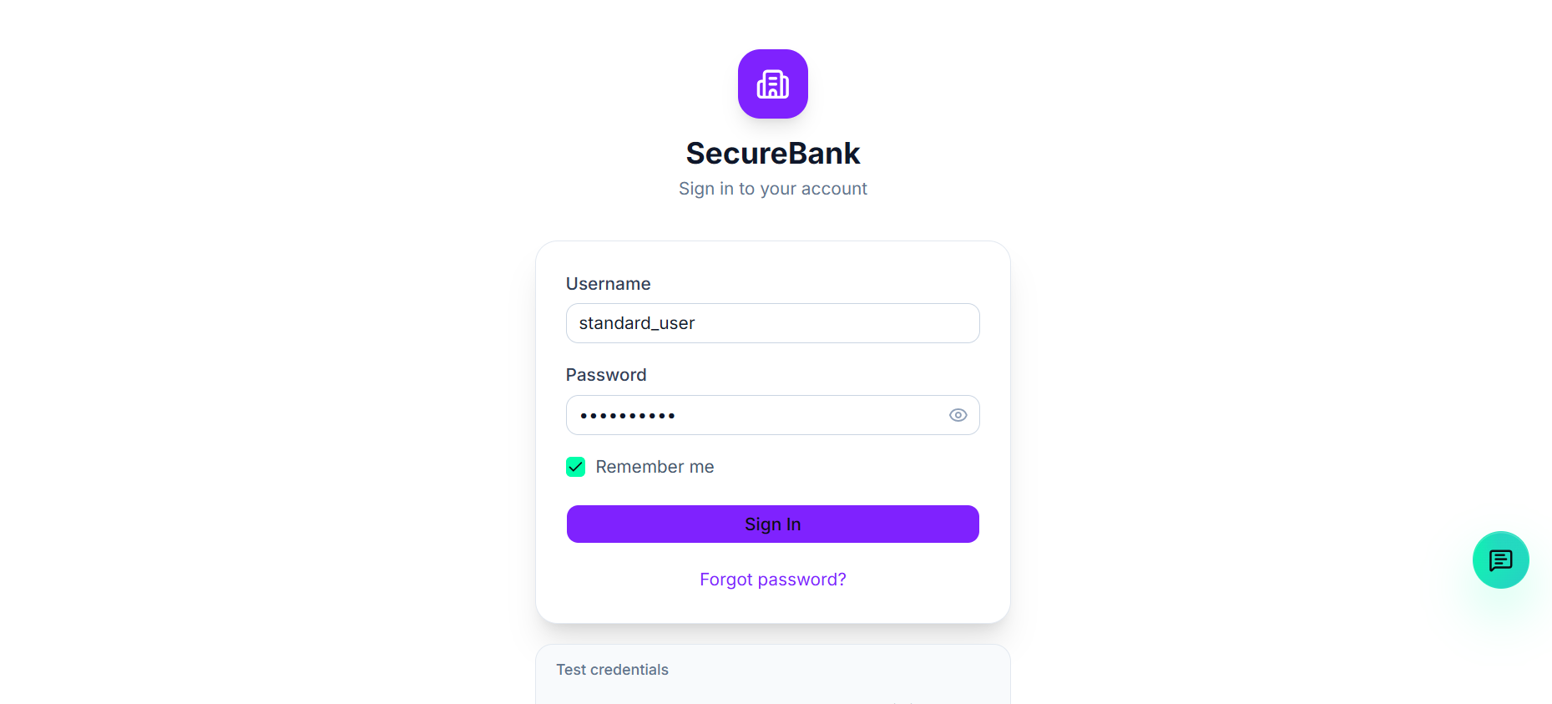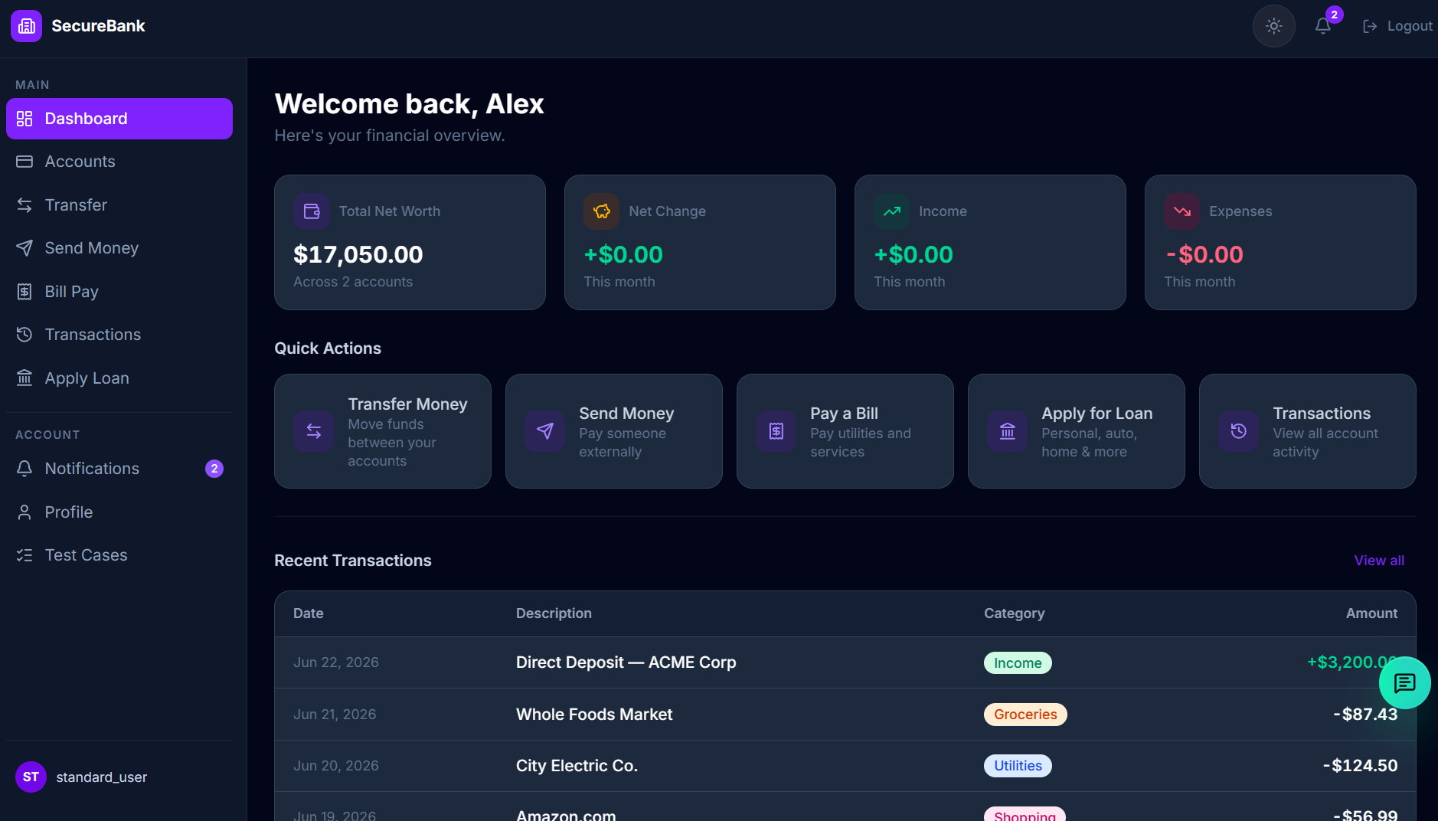
Screenshot 2 - Black-Box: invalid login
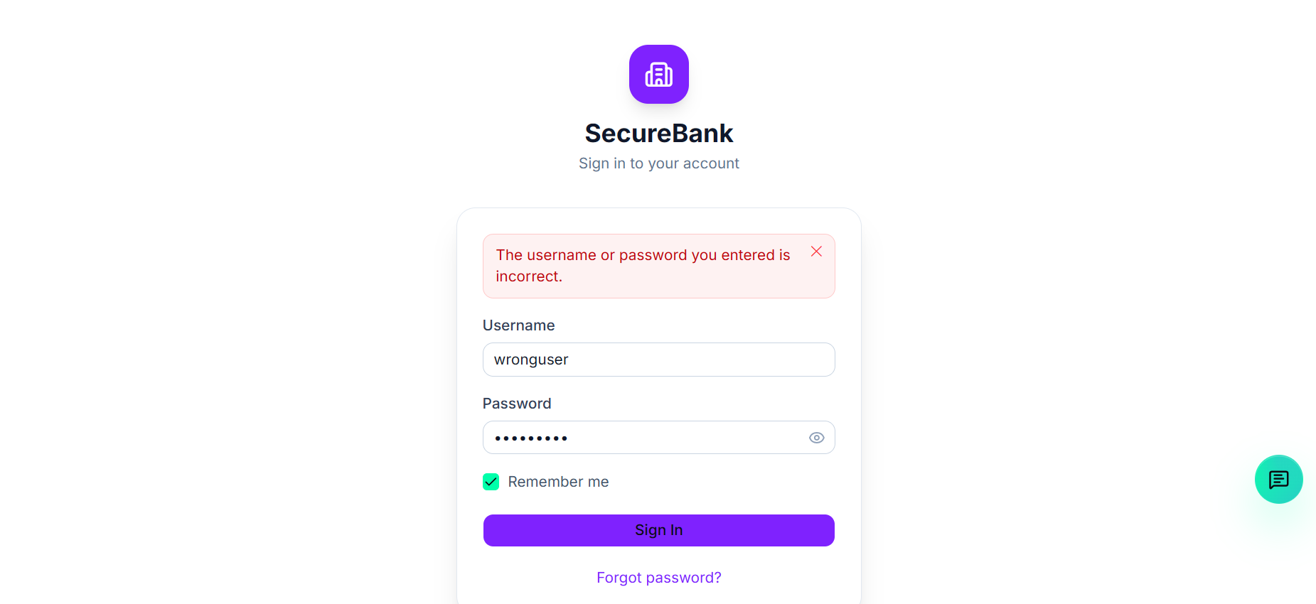
Screenshot 3 - White-Box: branch execution
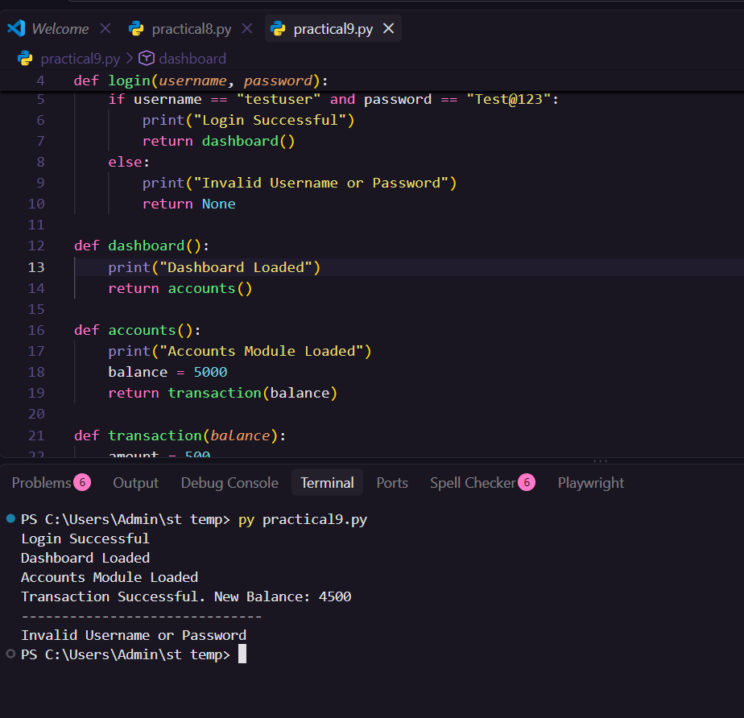
Screenshot 4 - Integration: Login to Dashboard handoff
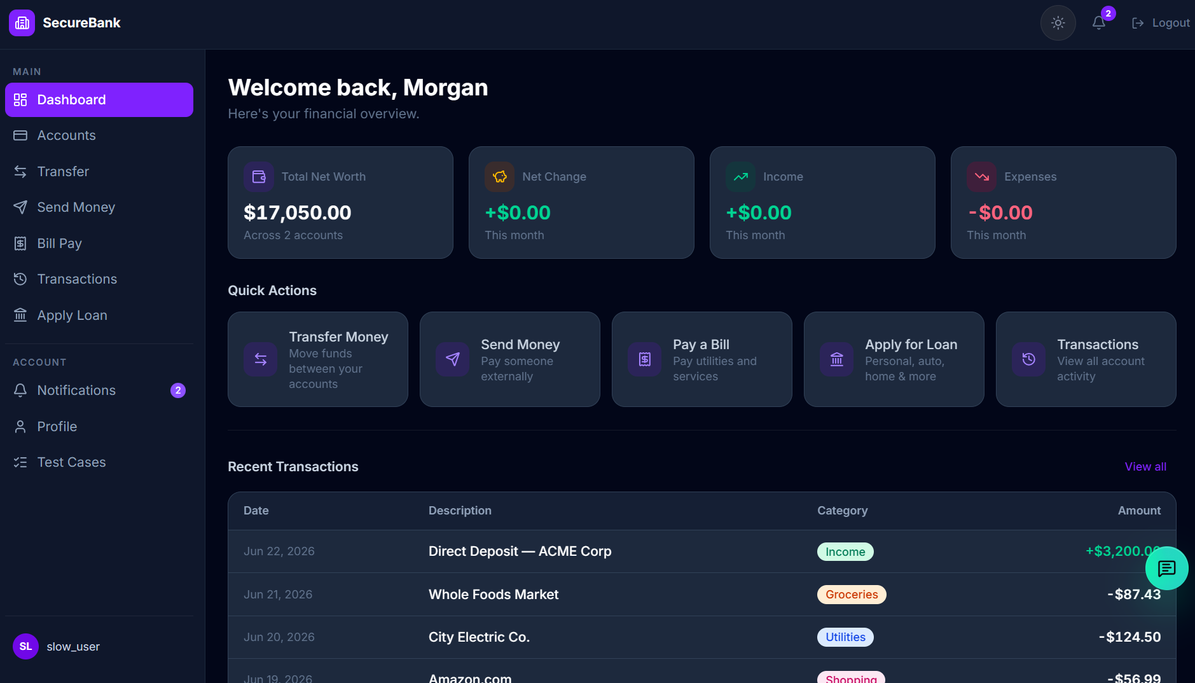
Capture from: Application screen (https://qaplayground.com/demo). Screenshot to insert: Take a screenshot showing the moment of transition from the Login module to the Dashboard module - e.g. the Dashboard page immediately after a successful login - demonstrating the interaction between the two modules (TC005).
Screenshot 5 - System: end-to-end flow
