SOFTWARE TESTING LABORATORY
PRACTICAL 1
SOFTWARE TEST REPORT
Functional, UI, Negative and Non-Functional Testing of a Live Corporate Website
Application Under Test: https://jeksonvision.com
Prepared By: Abhishek
Date: 28 July 2026

Table of Contents
Table of Contents 2
1. Objective 3
2. Scope 3
3. Application Details 3
4. Testing Environment 3
5. Browser Details 4
6. OS Details 4
7. Testing Methodology 4
8. Test Execution Summary 5
9. Module-wise Execution 5
10. Pass/Fail Summary 6
11. Bug Summary 6
12. Defect Details 6
Defect 1 — BUG-BRK-01: 'Download Brochure' Buttons Non-Functional Sitewide 7
Defect 2 — BUG-BRK-02: Logo and Hero Banner Images Fail With HTTP 429 7
Defect 3 — BUG-PERF-01: Uncaught JavaScript Errors on Page Load 8
Defect 4 — BUG-NAV-01: Inconsistent 'Industries' Menu Across Pages 8
Defect 5 — BUG-FTR-01: Conflicting WhatsApp Contact Numbers 9
13. Recommendations 9
14. Conclusion 10
15. Screenshot Section 10
Figure 1 — Homepage 10
Figure 2 — Navigation 11
Figure 3 — About Page 11
Figure 4 — Solutions 11
Figure 5 — Contact Page 11
Figure 6 — Contact Form 11
Figure 7 — Validation Message 11
Figure 8 — Footer 12

1. Objective
The objective of this practical is to plan, design and execute a structured, black-box test cycle against the live Jekson Vision corporate website (https://jeksonvision.com), and to formally document the process, results and defects following industry-standard QA reporting practice.
This exercise is intended to demonstrate the complete manual/automation-assisted testing workflow — from test case design through execution, defect logging and results reporting — on a real-world, production website rather than a simulated or academic sandbox application.

2. Scope
The scope of this test cycle covers the public-facing marketing website of Jekson Vision and includes the following areas:
- Homepage — hero banner, Our Solutions section, statistics, Knowledge Base preview, footer
- Primary navigation — Company, Products & Solutions, Industries and Knowledge Base mega-menus
- About Us page — company profile, vision/mission, statistics
- Products & Solutions pages — Track & Trace, Vision Inspection and related solution landing pages
- Contact Us page and lead-generation enquiry form, including client-side field validation
- Global footer — useful links, social channels, WhatsApp/contact widgets
- Cross-cutting concerns — responsive design, cross-browser rendering, basic accessibility checks and client-side performance/console-error observations
Out of scope: authenticated/back-office CMS testing, server infrastructure and load/stress testing, and full WCAG 2.1 conformance audit (only representative accessibility spot-checks are covered).

3. Application Details
Application Name | Jekson Vision — Corporate Website
URL | https://jeksonvision.com
Application Type | Public marketing website (WordPress CMS)
Industry Domain | Vision Inspection & Track-and-Trace solutions for Pharma, Agrochemical, Food & Beverage and allied industries
Primary Business Function | Lead generation — brochure downloads, solution enquiries, contact form submissions
Technology Stack (observed) | WordPress CMS, HTML5, CSS3, JavaScript, jQuery (with jQuery Migrate), PHP

4. Testing Environment
Environment Type | Production (live, publicly accessible website)
Test Execution Window | 28 July 2026
Network | Standard broadband connection
Automation Tooling | Playwright (functional/UI/regression cases); Chrome DevTools (console/network diagnostics)
Test Data Policy | Read-only exploration and client-side validation only; final submission of the live lead-generation form was withheld to avoid creating false enquiries in the production CRM (see Section 9 and TC_VAL_01)

5. Browser Details
Browser | Version Tested | Role in This Cycle
Google Chrome | Latest stable (Desktop) | Primary execution browser for all functional, UI and console/network diagnostics
Mozilla Firefox | Latest stable (Desktop) | Cross-browser rendering comparison
Microsoft Edge | Latest stable (Desktop, Chromium) | Cross-browser rendering comparison
Safari | macOS (latest) | Planned — not executed this cycle due to environment unavailability (TC_CBT_02)

6. OS Details
Operating System | Purpose
Windows 11 (Desktop) | Primary execution environment for Chrome, Firefox and Edge test passes
Android (Mobile Emulation via DevTools) | Responsive design verification at mobile viewport widths
macOS | Reserved for Safari cross-browser pass (not available this cycle)

7. Testing Methodology
Testing followed a black-box, requirement-driven approach appropriate to a website with no available source repository. Test cases were derived directly from the observed behaviour and structure of the live site, using the following design techniques:
- Equivalence Partitioning — grouping valid/invalid input classes for form fields (e.g. email, mobile)
- Boundary Value Analysis — minimum-length/format edge cases for mobile number and email fields
- Error Guessing — informed by tester experience of common WordPress/marketing-site defect patterns
- Exploratory Testing — freeform navigation to surface cross-page content and menu inconsistencies
- Console/Network Diagnostic Testing — Chrome DevTools inspection to correlate silent functional failures with their underlying JavaScript root cause
Execution combined manual verification (visual/UX judgement, responsive and cross-browser comparison) with Playwright-automatable checks (navigation routing, link resolution, field-level validation, console error capture) flagged per test case in the 'Automation Status' column of Practical1_TestCases.xlsx.
Test data creation was deliberately constrained on the Contact Us form: field-level validation (blank-field, malformed-email, invalid-mobile checks) was executed and observed directly in the browser without a final submission, since the form is wired to Jekson Vision's live production marketing pipeline. Full end-to-end submission (TC_VAL_01) and injection testing (TC_NEG_01) were logged as Blocked, with a recommendation to re-run them on a staging environment.

8. Test Execution Summary
A total of 40 test cases were designed across 14 functional and non-functional modules, covering the Homepage, Navigation, About Page, Products & Solutions, Contact Page, Contact Form Validation, Footer Links, Responsive Design, Cross-browser Testing, UI Testing, Negative Testing, Broken Links, Accessibility Checks and Performance Observations. Full details are recorded in the accompanying Practical1_TestCases.xlsx workbook.
Of the 40 test cases: 27 passed, 10 failed, and 3 were marked Blocked/Not Executed — the latter withheld deliberately to protect the live production system (final form submission, an XSS injection probe, and one browser pass pending environment availability), not due to any test-design gap.

9. Module-wise Execution
Module | Total | Pass | Fail | Blocked
Homepage | 5 | 3 | 2 | 0
Navigation | 4 | 3 | 1 | 0
About Page | 3 | 3 | 0 | 0
Products/Solutions | 4 | 4 | 0 | 0
Contact Page | 4 | 3 | 1 | 0
Contact Form Validation | 5 | 4 | 0 | 1
Footer Links | 3 | 2 | 1 | 0
Responsive Design | 3 | 3 | 0 | 0
Cross-browser Testing | 2 | 1 | 0 | 1
UI Testing | 2 | 1 | 1 | 0
Negative Testing | 1 | 0 | 0 | 1
Broken Links | 2 | 0 | 2 | 0
Accessibility Checks | 1 | 0 | 1 | 0
Performance Observations | 1 | 0 | 1 | 0
TOTAL | 40 | 27 | 10 | 3

Broken Links (Track & Trace brochure buttons) and Performance Observations (console error load) produced the highest concentration of failures relative to test volume, both tracing back to the same root cause — a missing client-side script — confirming that a single fix would resolve the majority of the High-severity findings in this cycle.

10. Pass/Fail Summary
Status | Count | % of Total (40) | % of Executed (37)
Pass | 27 | 67.5% | 73.0%
Fail | 10 | 25.0% | 27.0%
Blocked / Not Executed | 3 | 7.5% | —

Excluding the 3 cases withheld for production-safety reasons, the effective pass rate across the 37 executed test cases is 73.0%. This falls below a typical 90%+ release-readiness threshold and reflects primarily the confirmed brochure-download defect and its cascading console errors, alongside several lower-severity content and consistency issues.

11. Bug Summary
A total of 10 defects were logged during this test cycle: 3 High severity, 4 Medium severity and 3 Low severity. Every Fail-status test case in Practical1_TestCases.xlsx maps to exactly one bug record below.
Bug ID | Description | Module | Linked TC | Severity
BUG-HP-01 | Product Digitization CTA links to REESMART page, not a dedicated page | Homepage | TC_HP_03 | Medium
BUG-HP-02 | Company statistics inconsistent between Homepage and About Us (650 vs 600 clients; 5 vs 7 offices) | Homepage / About | TC_HP_05 | Low
BUG-NAV-01 | 'Industries' dropdown lists 7 items on Homepage but only 6 on About Us / Contact Us | Navigation | TC_NAV_03 | Medium
BUG-CNT-01 | Several tel: links contain an invalid embedded space (e.g. 'tel: +91...') | Contact Page | TC_CNT_03 | Medium
BUG-FTR-01 | Floating WhatsApp icon and footer '24x7 Service Support' WhatsApp contact show two different numbers | Footer | TC_FTR_03 | Medium
BUG-UI-01 | White CTA text has reduced contrast on the Product Digitization hero banner | Homepage / UI | TC_UI_02 | Low
BUG-BRK-01 | 'Download Brochure' buttons are non-functional sitewide (Uncaught ReferenceError: downloadBrochureLinks is not defined) | Track & Trace / Global | TC_BRK_01 | High
BUG-BRK-02 | Logo and hero banner images intermittently fail to load with HTTP 429 (Too Many Requests) | Homepage | TC_BRK_02 | High
BUG-ACC-01 | Footer WhatsApp icon reuses alt text 'Phone Icon', reducing screen-reader clarity | Footer / Accessibility | TC_ACC_01 | Low
BUG-PERF-01 | Browser console reports uncaught JS errors, HTTP 429 failures and 100+ warnings on homepage load | Global / Performance | TC_PERF_01 | High

12. Defect Details
The five most significant defects are documented in full below, following a standard bug-report format. The remaining five (BUG-HP-01, BUG-HP-02, BUG-UI-01, BUG-ACC-01) are Low/Medium severity content or presentation issues; their full steps-to-reproduce and expected/actual results are recorded against the corresponding test case in Practical1_TestCases.xlsx.

Defect 1 — BUG-BRK-01: 'Download Brochure' Buttons Non-Functional Sitewide
Bug ID | BUG-BRK-01
Title | Download Brochure buttons do not respond to clicks
Module | Track & Trace product listing / Global site scripts
Linked Test Case | TC_BRK_01
Severity | High
Priority | P1 — Immediate
Steps to Reproduce | 1. Open homepage or Track & Trace listing 2. Click any 'Download Brochure' button 3. Observe no request/download/form is triggered 4. Open DevTools Console and reload
Expected Result | Brochure request form opens and, on submission, the PDF is delivered or emailed to the requester
Actual Result | Button click produces no visible action (href="javascript:void(0);"). Console logs 'Uncaught ReferenceError: downloadBrochureLinks is not defined', confirming the click handler's dependency function is missing from the page
Root Cause | The script file expected to define downloadBrochureLinks() is missing, misnamed, or fails to load before the inline call executes on page load
Business Impact | Directly blocks the site's primary lead-generation pathway for brochure requests
Recommendation | Locate and correctly enqueue the missing script; verify the function is defined before the inline handler call runs

Defect 2 — BUG-BRK-02: Logo and Hero Banner Images Fail With HTTP 429
Bug ID | BUG-BRK-02
Title | Above-the-fold images intermittently return HTTP 429 (Too Many Requests)
Module | Homepage — global assets
Linked Test Case | TC_BRK_02
Severity | High
Priority | P1 — Immediate
Steps to Reproduce | 1. Open homepage with DevTools Network tab active 2. Refresh the page 3. Inspect status codes for Jekson-Vision-Logo.png and the hero banner image
Expected Result | Logo and hero banner images return HTTP 200 and render correctly on first load
Actual Result | Both requests intermittently return HTTP 429, producing broken or missing branding imagery for affected visitors
Root Cause | Server-side rate limiting or a WAF/security layer rejecting image requests above a request-volume threshold
Business Impact | Broken above-the-fold branding imagery undermines first impression and brand trust
Recommendation | Review hosting/CDN and security-plugin rate-limit thresholds for static asset requests

Defect 3 — BUG-PERF-01: Uncaught JavaScript Errors on Page Load
Bug ID | BUG-PERF-01
Title | Browser console reports multiple uncaught errors and a high warning count on homepage load
Module | Global site scripts
Linked Test Case | TC_PERF_01
Severity | High
Priority | P2 — High
Steps to Reproduce | 1. Open DevTools Console tab 2. Load/refresh the homepage 3. Record all logged errors, warnings and informational messages
Expected Result | Console remains free of uncaught errors, with a reasonable warning volume for a production site
Actual Result | 1 uncaught ReferenceError, 2 HTTP 429 failures, additional uncaught TypeErrors from null DOM references, plus 100+ warnings/informational messages in the Issues panel
Root Cause | Cascading failure from the missing downloadBrochureLinks function, combined with unrelated null-reference errors in DOM lookup/pre-fill scripts and general front-end code-health debt
Business Impact | Indicates the site's JavaScript is not executing cleanly, which risks further feature breakage as the page structure evolves
Recommendation | Fix BUG-BRK-01 first (root cause); add defensive null checks around DOM lookups and .value assignments; triage remaining warnings as a separate code-quality task

Defect 4 — BUG-NAV-01: Inconsistent 'Industries' Menu Across Pages
Bug ID | BUG-NAV-01
Title | 'Industries' navigation dropdown omits an item on inner pages
Module | Navigation
Linked Test Case | TC_NAV_03
Severity | Medium
Priority | P3 — Medium
Steps to Reproduce | 1. Open homepage, expand 'Industries' menu, record items 2. Open /about-us/ and /contact-us/, expand 'Industries' menu on each 3. Compare the two item lists
Expected Result | The 'Industries' dropdown lists the same set of industries on every page
Actual Result | Homepage lists 7 industries including 'Bottle & Container Inspection'; About Us and Contact Us list only 6, omitting that item
Root Cause | Menu content likely differs per page template or is cached inconsistently across the site
Business Impact | Reduces discoverability of the Bottle & Container Inspection solution for visitors landing on inner pages
Recommendation | Standardize the Industries menu to a single managed navigation source across all templates

Defect 5 — BUG-FTR-01: Conflicting WhatsApp Contact Numbers
Bug ID | BUG-FTR-01
Title | Floating WhatsApp widget and footer '24x7 Service Support' entry show different numbers
Module | Footer
Linked Test Case | TC_FTR_03
Severity | Medium
Priority | P3 — Medium
Steps to Reproduce | 1. Note the number under footer '24x7 Service Support' 2. Click the floating WhatsApp icon 3. Compare the number the chat opens against the footer-listed number
Expected Result | Both the floating icon and the footer entry present the same WhatsApp support number
Actual Result | Floating icon opens a chat to +91 63525 29570; footer '24x7 Service Support' displays +91 93741 68622
Root Cause | Two different phone numbers hard-coded in separate theme widgets without a shared configuration source
Business Impact | Customer confusion over the correct support channel; potential missed enquiries
Recommendation | Consolidate WhatsApp contact numbers to a single value referenced by both widgets

13. Recommendations
- Restore or correctly enqueue the script defining downloadBrochureLinks as the top priority — this single fix resolves the site's highest-impact defect (BUG-BRK-01) and removes the largest contributor to console error volume (BUG-PERF-01).
- Investigate the intermittent HTTP 429 responses on logo/hero-banner image requests with the hosting or CDN provider (BUG-BRK-02).
- Add defensive null checks around DOM element lookups and .value assignments in main.js to prevent a single early error from cascading into unrelated script failures.
- Consolidate the 'Industries' navigation menu and company statistics (team/client/office counts) into a single managed source so that every template renders identical figures (BUG-NAV-01, BUG-HP-02).
- Normalize all tel: and WhatsApp contact links sitewide — remove embedded whitespace from tel: hrefs and reconcile the two differing WhatsApp numbers into one authoritative support channel (BUG-CNT-01, BUG-FTR-01).
- Introduce automated console-error monitoring (e.g. Sentry or an equivalent JS error tracker) in production, and add a pre-deployment checklist step requiring a clean DevTools console before publishing template or script changes.
- Re-run TC_VAL_01 (full form submission) and TC_NEG_01 (injection test) against a staging/UAT environment, and complete the Safari cross-browser pass (TC_CBT_02) once a macOS environment is available, to close out the three Blocked test cases from this cycle.

14. Conclusion
This test cycle exercised 40 test cases across 14 modules of the Jekson Vision corporate website, achieving a 73.0% pass rate on the 37 cases executed. The website's core informational and navigational functionality — homepage, About Us, product pages, and the majority of the Contact Us experience — performed reliably. However, this cycle confirmed a High-severity, sitewide functional defect in the brochure-download flow, traced to a missing JavaScript function, along with related console errors, intermittent image-loading failures, and several Medium/Low-severity content-consistency and contact-information discrepancies.
Given the confirmed impact on a primary lead-generation pathway, this report's overall QA verdict for the current production build is CONDITIONAL PASS — the site is functionally usable for the majority of visitor journeys, but BUG-BRK-01 and BUG-BRK-02 should be treated as release blockers for the affected flows and remediated before the next content or feature deployment. A focused retest of the Broken Links, Performance Observations and Contact Form Validation modules is recommended once fixes are deployed.

15. Screenshot Section
The figures below correspond one-to-one with the primary test case for each module, as required for this practical. Live screenshots have not been embedded in this document; each figure is represented by a placeholder and is intended to be captured via an automated Playwright script during the next execution pass, ensuring screenshots stay in sync with actual, timestamped test runs rather than manually captured images.

Figure 1 — Homepage
Corresponding Test Case: TC_HP_01 — Full homepage load with header, hero banner, Our Solutions and footer sections visible
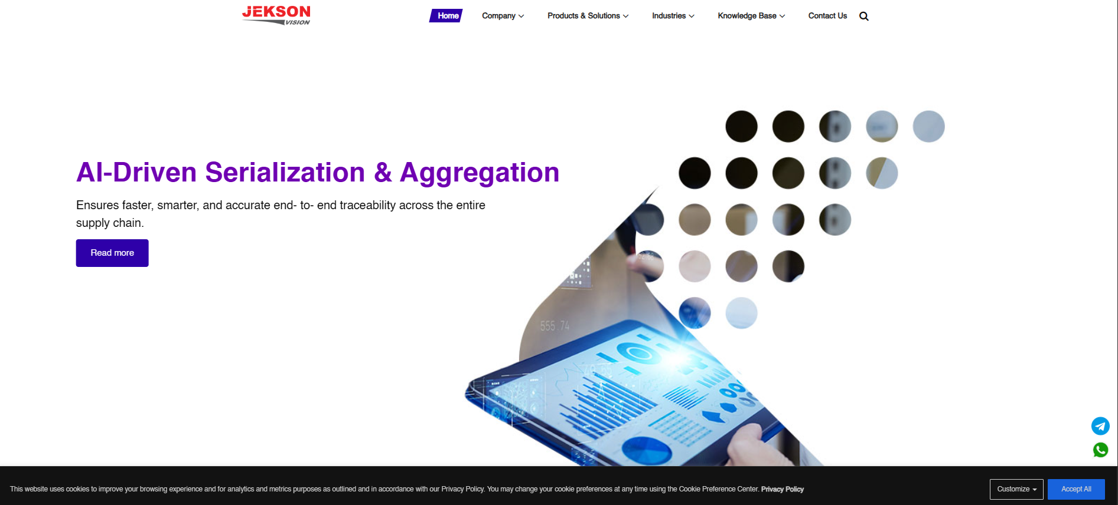

Figure 2 — Navigation
Corresponding Test Case: TC_NAV_01 / TC_NAV_02 — 'Company' and 'Products & Solutions' mega-menus expanded
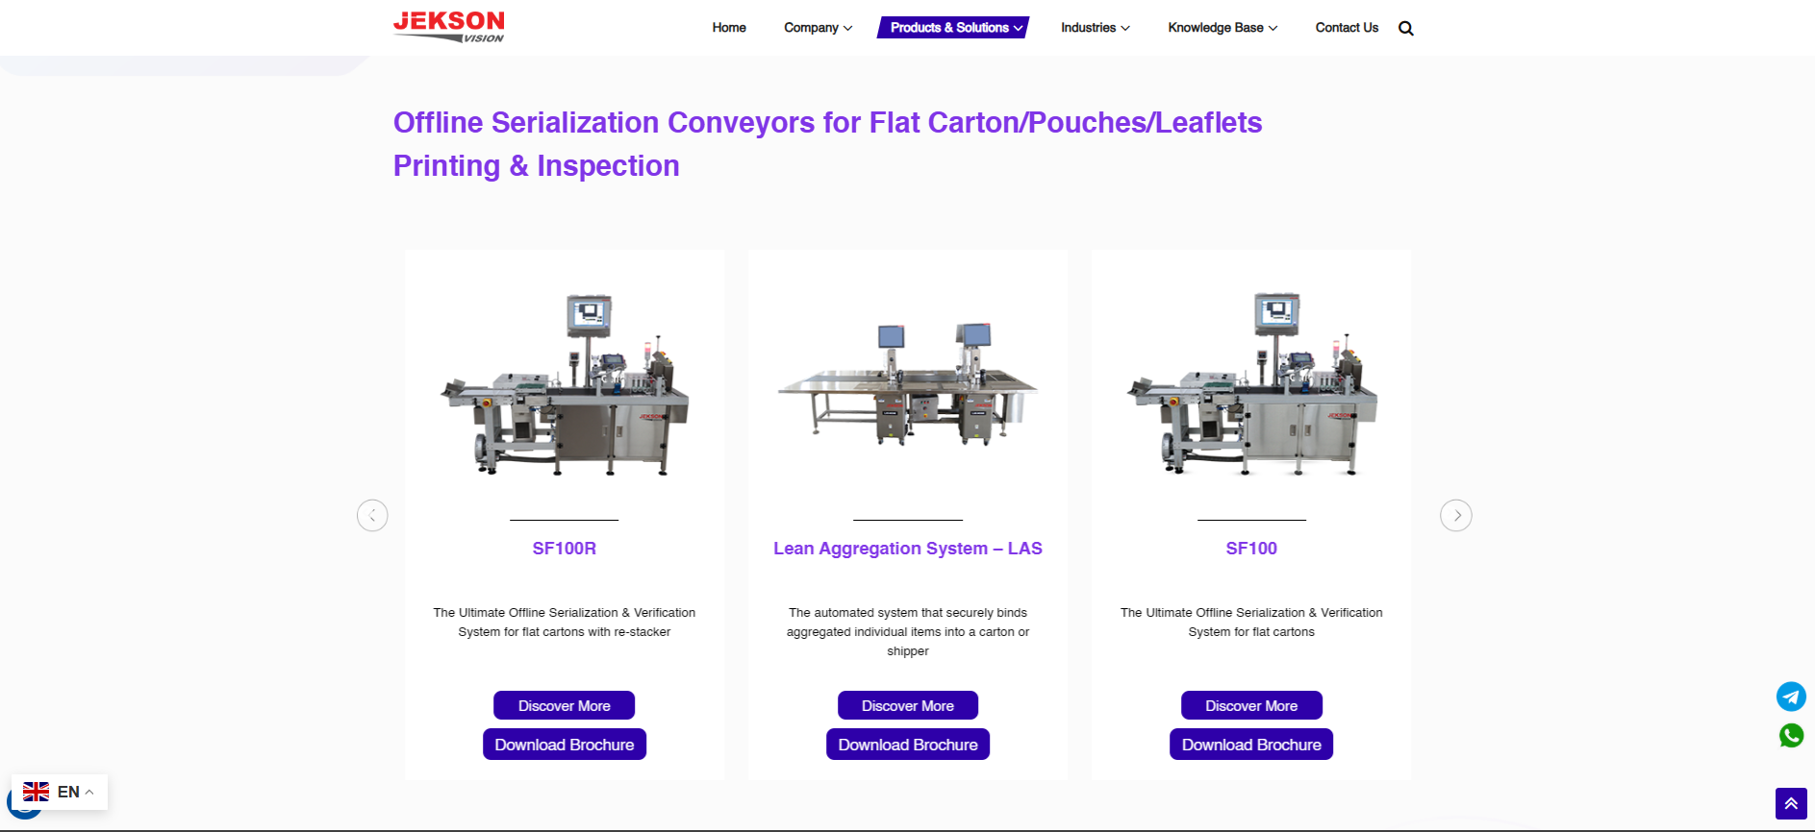

Figure 3 — About Page
Corresponding Test Case: TC_ABT_01 — About Us page showing Vision, Mission and statistics sections
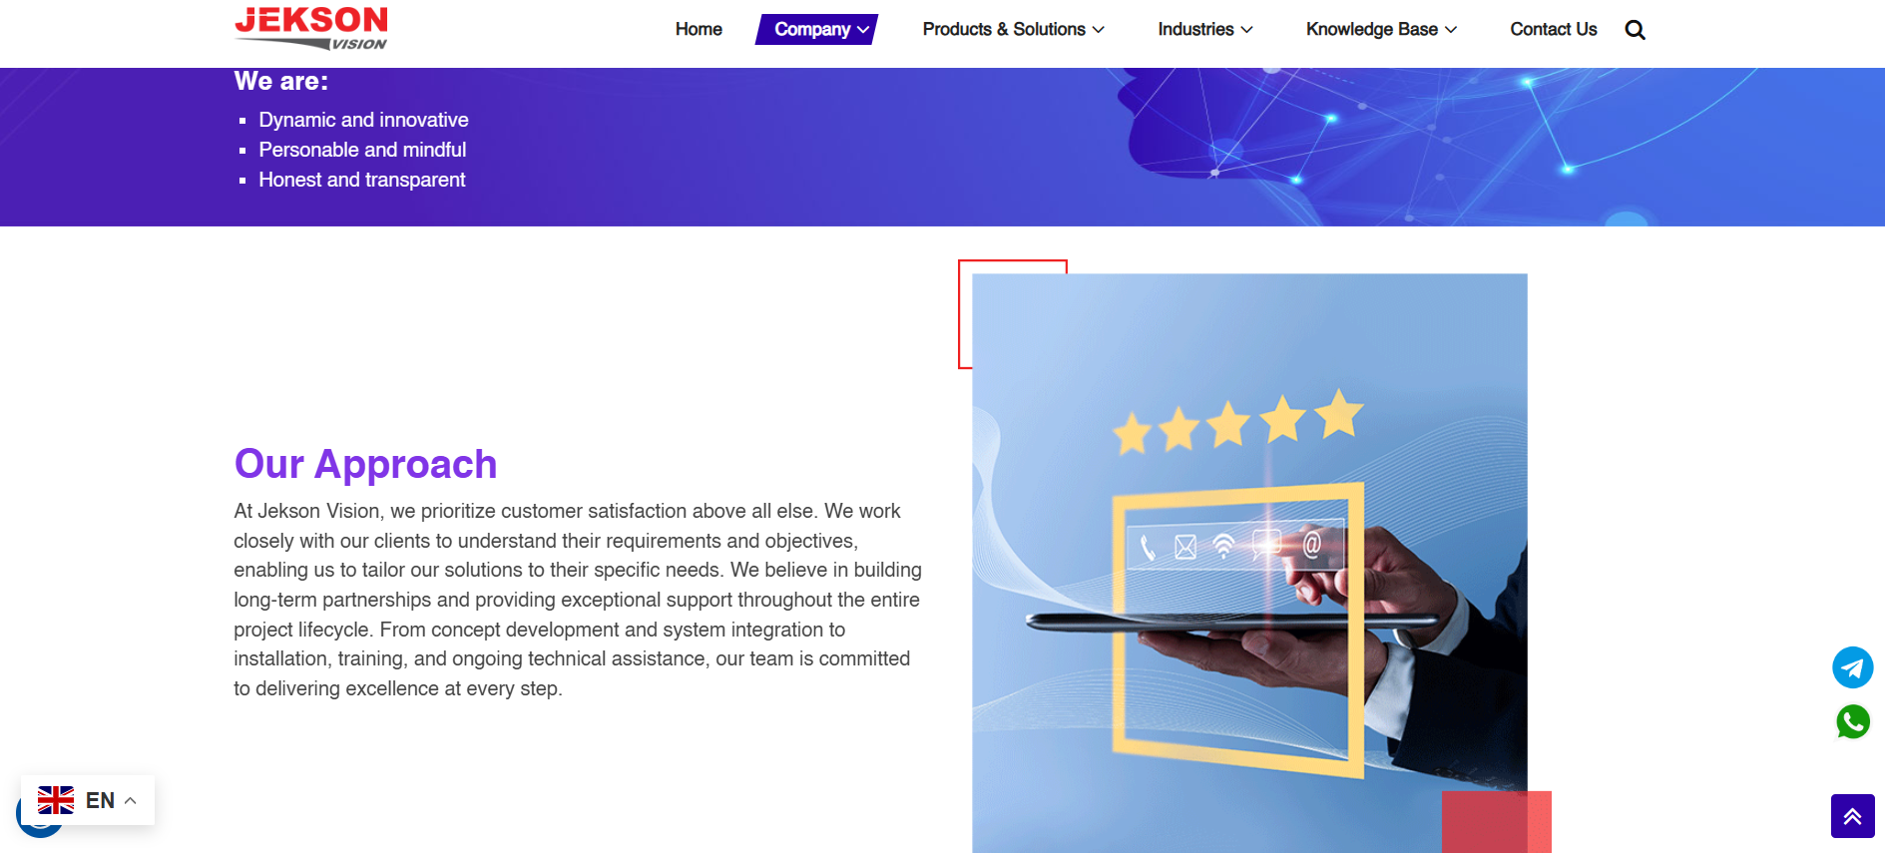

Figure 4 — Solutions
Corresponding Test Case: TC_PRD_01 — Track & Trace product page with heading and description
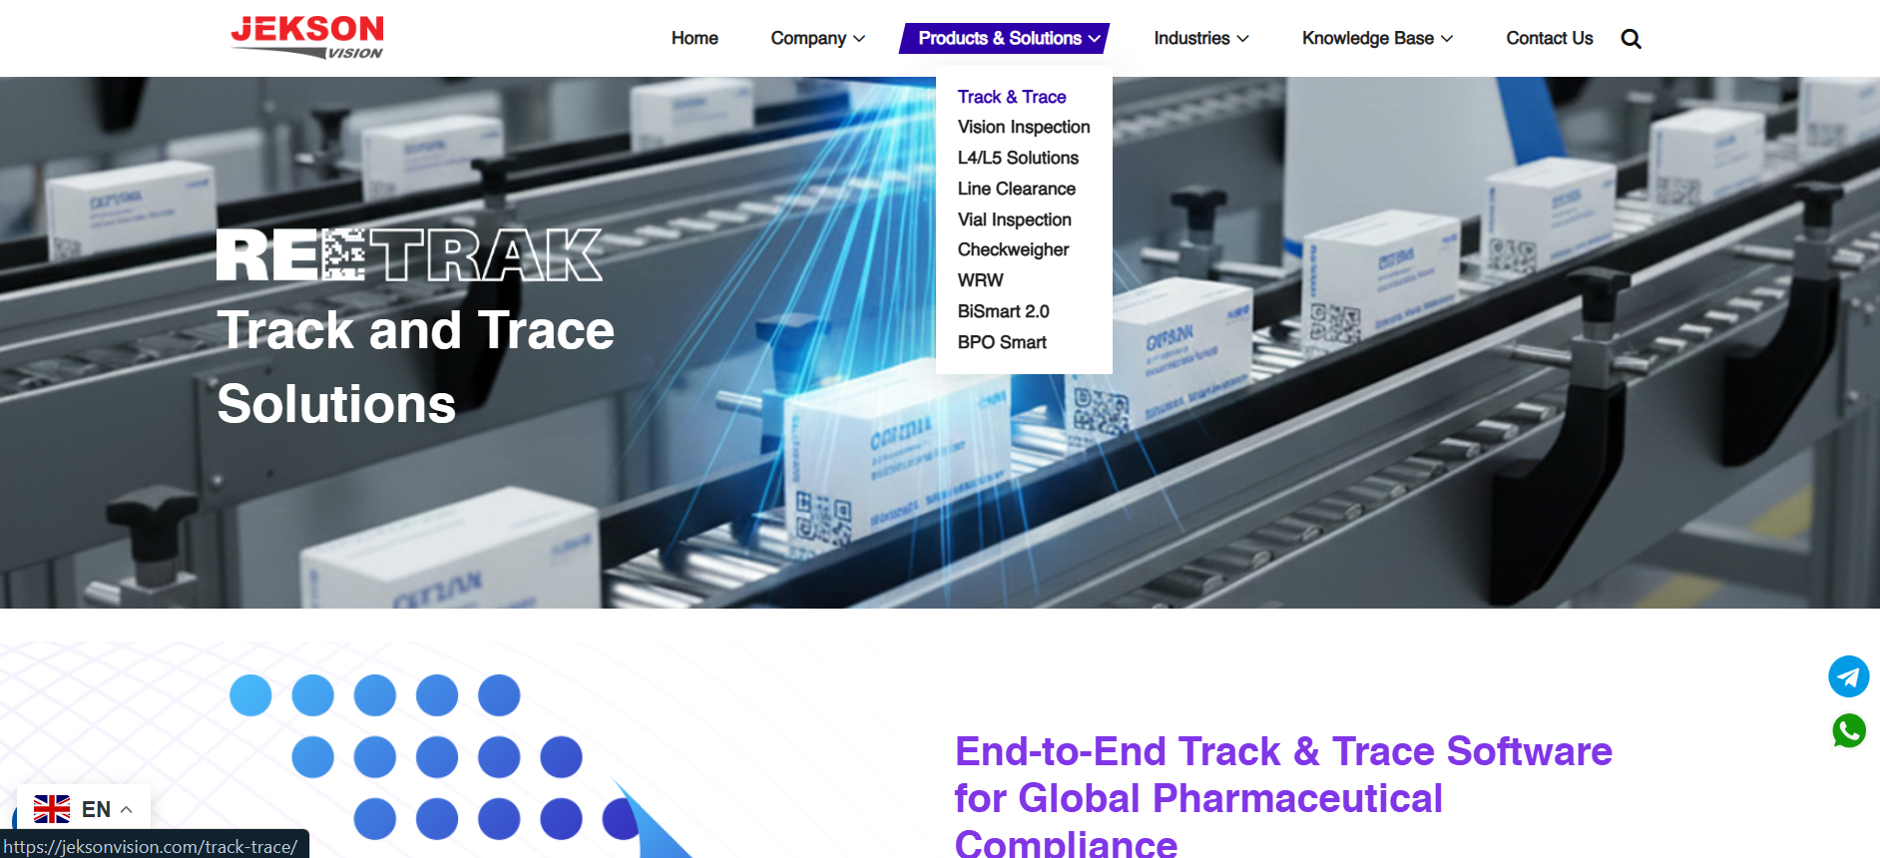

Figure 5 — Contact Page
Corresponding Test Case: TC_CNT_01 — Contact Us page with enquiry form and Global Offices listing
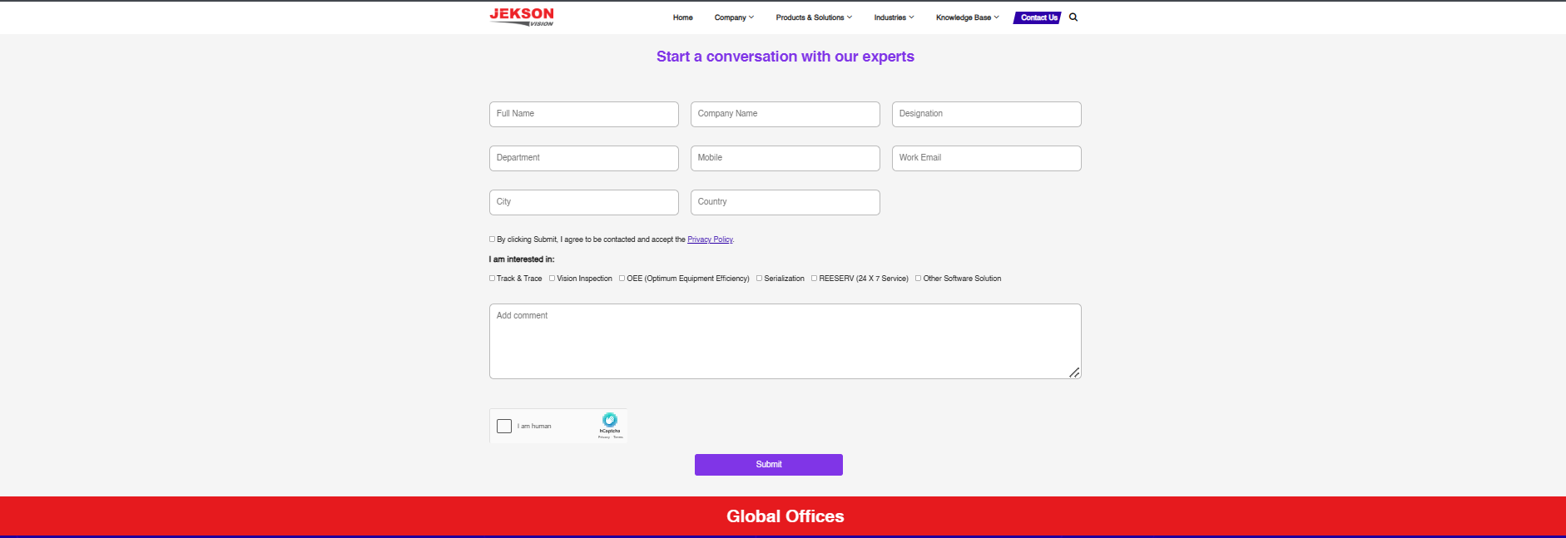

Figure 6 — Contact Form
Corresponding Test Case: TC_VAL_02 — Enquiry form with mandatory fields and consent checkbox

Figure 7 — Validation Message
Corresponding Test Case: TC_VAL_03 — Inline validation message shown for a malformed Work Email entry
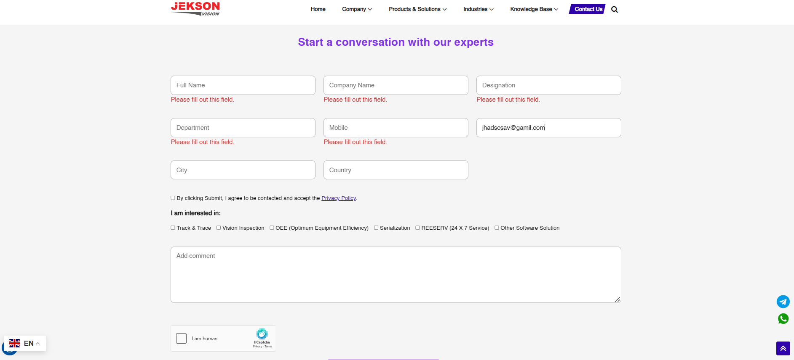
Corresponding Test Case: TC_FTR_01 / TC_FTR_03 — Footer showing Useful Links, social icons and WhatsApp/contact widgets
