SOFTWARE TESTING LABORATORY
PRACTICAL 2
Automation-Ready Functional, Security and Accessibility Testing of a Login Module
Application Under Test: https://practice.expandtesting.com/login
Prepared By: Abhishek
Date: 28 July 2026

Table of Contents
Table of Contents 2
1. Objective 3
2. Scope 3
3. Environment 3
4. Automation Scope 4
5. Execution Summary 4
Module-wise Execution 4
6. Executed Test Cases 5
7. Pass/Fail Summary 6
8. Automation Flow 7
9. Bug Summary 7
10. Recommendations 7
11. Conclusion 8
12. Screenshot Section 8
Figure 1 — Login Page 8
Figure 2 — Valid Login 9
Figure 3 — Invalid Username 9
Figure 4 — Invalid Password 10
Figure 5 — Empty Fields 11
Figure 6 — Secure Area 13
Figure 7 — Logout 15

1. Objective
The objective of this practical is to design and execute a comprehensive, automation-ready test suite for the Login module of the Expand Testing practice application (https://practice.expandtesting.com/login), extending the Test Plan and Requirement Traceability Matrix (RTM) prepared in the preceding practical into a full functional, security, session-handling, and accessibility regression suite suitable for CI-driven Playwright automation.
This report builds directly on the six requirements (R001–R006) and five core test cases (TC001–TC005) established in the Practical 2 Test Plan & RTM, extending coverage to input-security scenarios (SQL injection, XSS), boundary conditions (length, empty fields), session integrity (refresh, back-navigation, repeated attempts), and non-functional checks (keyboard operability, accessibility, UI rendering).

2. Scope
The scope of this test cycle covers the Login module of the target application in isolation, specifically:
- Credential validation — valid login, invalid username, invalid password, and combinations of empty fields
- Security input handling — SQL injection and XSS payloads submitted through the Username and Password fields
- Boundary and format handling — special characters, maximum-length and minimum-length input
- Session behaviour — logout, protected-route access control, browser refresh, and browser back-navigation after logout
- Resilience — repeated failed login attempts followed by a valid attempt
- Message accuracy — exact wording and visual styling of success/error flash messages
- Non-functional checks — keyboard-only navigation, baseline accessibility (label association, accessible names), and UI rendering across desktop and mobile viewports
Out of scope: the sibling Register module, password-reset flows, multi-factor authentication (not present on this application), and full WCAG 2.1 AA conformance audit (only representative accessibility spot-checks are covered, consistent with the scope defined in the Practical 2 Test Plan).

3. Environment
Application Under Test | https://practice.expandtesting.com/login
Environment Type | Publicly hosted practice/training application (safe for repeated automated testing)
Valid Test Credentials | Username: practice | Password: SuperSecretPassword!
Operating System | Windows 11 (Desktop); Android emulation (DevTools) for mobile viewport checks
Browser | Google Chrome (Desktop) — primary; cross-checked visually in Firefox and Edge
Automation Tooling | Playwright (Python, sync API), Chromium headless; Visual Studio Code as the script IDE
Test Execution Window | 28 July 2026

4. Automation Scope
Of the 30 test cases in Practical2_TestCases.xlsx, 22 are fully automatable with Playwright (credential combinations, empty-field handling, SQL injection/XSS payload submission, length boundaries, password-masking attribute checks, session/logout/refresh flows, repeated-attempt handling, and exact-text message assertions). The remaining 8 — session cache behaviour after Back navigation, and the accessibility/UI-layout checks — are marked Manual, since they rely on visual or assistive-technology judgement that is better suited to human review or a dedicated accessibility scanner than a Playwright assertion.
The automation script below reproduces the primary positive login scenario (TC_LOGIN_01 / R001), matching the artifact from the Practical 2 Test Plan and serving as the template pattern extended for the remaining automatable cases in this suite:
from playwright.sync_api import sync_playwright, expect
def test_login_valid_credentials():
with sync_playwright() as p:
browser = p.chromium.launch(headless=True)
page = browser.new_page()
page.goto("https://practice.expandtesting.com/login")
page.locator("#username").fill("practice")
page.locator("#password").fill("SuperSecretPassword!")
page.get_by_role("button", name="Login").click()
page.wait_for_url("https://practice.expandtesting.com/secure")
expect(page.locator("#flash-message")).to_contain_text(
"You logged into a secure area!")
expect(page.get_by_role("link", name="Logout")).to_be_visible()
browser.close()
Each additional automatable test case follows the same structural pattern: navigate to /login, populate #username and #password via page.locator().fill(), submit via the accessible 'Login' button role, then assert on the resulting URL and the #flash-message text using Playwright's expect() API. Security-input cases additionally attach a page.on("dialog", ...) listener to assert that no alert() dialog fires.

5. Execution Summary
A total of 30 test cases were designed across all 20 required test categories: Valid Login, Invalid Username, Invalid Password, Empty Username, Empty Password, Both Empty, SQL Injection, XSS Input, Special Characters, Maximum Length, Minimum Length, Password Masking, Logout, Session Validation, Browser Refresh, Multiple Login Attempts, Error Message Validation, Keyboard Navigation, Accessibility, and UI Validation. Full details, including exact steps, test data, and per-case automation status, are recorded in the accompanying Practical2_TestCases.xlsx workbook.
Of the 30 test cases executed: 28 passed and 2 failed. No test case was blocked — unlike the Contact-form scenarios encountered when testing a production marketing site, this application is explicitly designed and publicly offered for repeated automated testing, so every case, including the security-input scenarios, was executed to completion without reservation.

Module-wise Execution
Module | Total | Pass | Fail
Valid Login | 2 | 2 | 0
Invalid Username | 2 | 2 | 0
Invalid Password | 2 | 2 | 0
Empty Username | 1 | 1 | 0
Empty Password | 1 | 1 | 0
Both Empty | 1 | 1 | 0
SQL Injection | 2 | 2 | 0
XSS Input | 2 | 2 | 0
Special Characters | 2 | 2 | 0
Maximum Length | 1 | 0 | 1
Minimum Length | 1 | 1 | 0
Password Masking | 1 | 1 | 0
Logout | 1 | 1 | 0
Session Validation | 2 | 2 | 0
Browser Refresh | 1 | 1 | 0
Multiple Login Attempts | 2 | 1 | 1
Error Message Validation | 2 | 2 | 0
Keyboard Navigation | 1 | 1 | 0
Accessibility | 1 | 1 | 0
UI Validation | 2 | 2 | 0
TOTAL | 30 | 28 | 2

6. Executed Test Cases
The table below presents one representative execution record per test category; the complete set of 30 detailed records, including full preconditions, test data, and remarks, is maintained in Practical2_TestCases.xlsx.
TC ID | Category | Req. | Scenario | Result Observed | Status
TC_LOGIN_01 | Valid Login | R001 | Login with valid published credentials (practice / SuperSecretPassword!) | Redirect to /secure, success flash message, Logout visible | Pass
TC_LOGIN_03 | Invalid Username | R002 | Login with a non-existent username and the valid password | 'Invalid username.' message; user remains on /login | Pass
TC_LOGIN_05 | Invalid Password | R003 | Login with the valid username and an incorrect password | 'Invalid password.' message; user remains on /login | Pass
TC_LOGIN_07 | Empty Username | R007 | Submit the form with Username left blank | Rejected as 'Invalid username.'; no exception page | Pass
TC_LOGIN_08 | Empty Password | R007 | Submit the form with Password left blank | Rejected as 'Invalid password.'; no exception page | Pass
TC_LOGIN_09 | Both Empty | R007 | Submit the form with both fields blank | Rejected gracefully with an error message | Pass
TC_LOGIN_10 | SQL Injection | R008 | Username = ' OR '1'='1 with the valid password | No authentication bypass; rejected as invalid username | Pass
TC_LOGIN_12 | XSS Input | R009 | Username = <script>alert('xss')</script> | No script execution; payload not reflected unescaped | Pass
TC_LOGIN_14 | Special Characters | R010 | Username with special characters (!@#$%^&*()) | Rejected gracefully; no crash | Pass
TC_LOGIN_16 | Maximum Length | R011 | 500-character string entered into Username | No maxlength attribute present on the field | Fail
TC_LOGIN_17 | Minimum Length | R011 | Single-character Username and Password ('a' / 'b') | Rejected gracefully; no application error | Pass
TC_LOGIN_18 | Password Masking | R012 | Type the valid password into the Password field | Characters masked; input type="password" confirmed | Pass
TC_LOGIN_19 | Logout | R006 | Click Logout from the authenticated /secure page | Returned to /login; session terminated | Pass
TC_LOGIN_21 | Session Validation | R005 | Direct navigation to /secure with no prior login | Redirected to /login; protected content blocked | Pass
TC_LOGIN_22 | Browser Refresh | R013 | Refresh the page while authenticated on /secure | Session persists; /secure content remains visible | Pass
TC_LOGIN_23 | Multiple Login Attempts | R014 | 5 consecutive failed login attempts, then 1 correct attempt | No lockout/throttling triggered (expected for a practice app) | Fail
TC_LOGIN_25 | Error Message Validation | R004 | Exact-text assertion on the invalid-username message | Text matches 'Invalid username.' exactly | Pass
TC_LOGIN_27 | Keyboard Navigation | R015 | Complete and submit the form using only Tab and Enter | Form fully keyboard-operable; login succeeds | Pass
TC_LOGIN_28 | Accessibility | R015 | Inspect label association and accessible names | Inputs labelled; Login button exposes accessible name | Pass
TC_LOGIN_29 | UI Validation | R016 | Visual layout check on a desktop viewport | All elements render correctly with no overlap | Pass

7. Pass/Fail Summary
Status | Count | % of Total (30) | % of Executed (30)
Pass | 28 | 93.3% | 93.3%
Fail | 2 | 6.7% | 6.7%
Blocked / Not Executed | 0 | 0.0% | —

The overall pass rate for this cycle is 93.3%. Both failures are Low-severity observations rather than functional breaks: the absence of an input-length cap on the credential fields, and the absence of a lockout/throttling mechanism after repeated failed attempts. Neither defect represents a currently violated functional requirement from the Practical 2 RTM (R001–R006); both are flagged as hardening recommendations appropriate to a production authentication system.

8. Automation Flow
The end-to-end automation flow for this suite follows a consistent five-stage pattern, applied uniformly across all Playwright-tagged test cases:
- Launch — instantiate a headless Chromium browser context and navigate to https://practice.expandtesting.com/login.
- Arrange — populate the #username and #password locators with the test case's specific input (valid credentials, invalid values, boundary strings, or security payloads).
- Act — trigger submission via page.get_by_role("button", name="Login").click(), or via keyboard Enter for the keyboard-navigation case.
- Assert — verify the resulting state: URL (wait_for_url), flash message text (expect(...).to_contain_text() or exact-match for message-validation cases), visibility of the Logout control, absence of an alert() dialog for security-input cases, or the type="password" attribute for masking checks.
- Teardown — close the browser context cleanly regardless of assertion outcome, ensuring no session state leaks between independent test runs.
This flow is designed to plug directly into a CI pipeline (e.g. GitHub Actions) as a regression gate on every change to the Login module, with the two Low-severity findings from this cycle tracked as separate hardening tickets rather than blocking the pipeline.

9. Bug Summary
Two Low-severity observations were logged during this cycle. Both are input-hardening recommendations rather than confirmed functional defects against the requirements in the Practical 2 RTM.
Bug ID | Description | Category | Linked TC | Severity
BUG-LOGIN-01 | Username and Password fields carry no maxlength attribute, accepting unbounded input length | Maximum Length | TC_LOGIN_16 | Low
BUG-LOGIN-02 | No account lockout, throttling or CAPTCHA is triggered after repeated failed login attempts | Multiple Login Attempts | TC_LOGIN_23 | Low

10. Recommendations
- Apply a sensible maxlength attribute (e.g. 254 characters, aligned with common username/email length conventions) to the Username and Password fields to reduce oversized-payload exposure (BUG-LOGIN-01).
- Introduce a progressive delay, CAPTCHA, or temporary lockout after a defined number of consecutive failed login attempts if this application is ever adapted for a production authentication context (BUG-LOGIN-02).
- Extend the current Playwright suite with a data-driven parametrised test (a single test function iterating over a table of credential/payload combinations) to reduce script duplication across the Invalid Username, Invalid Password, SQL Injection, XSS and Special Character categories.
- Add the exact-text message assertions (TC_LOGIN_25, TC_LOGIN_26) as an explicit regression gate, since silent copy changes to the flash-message text would otherwise pass undetected by looser 'contains' style assertions.
- Incorporate an automated accessibility scan (e.g. axe-core via Playwright) alongside the manual accessibility spot-check performed in this cycle, to broaden coverage beyond the label-association and keyboard-operability checks performed here.
- Schedule this suite to run on every commit touching authentication-related code, using the five-stage Automation Flow in Section 8 as the standard pattern for any new Login test case.

11. Conclusion
This test cycle exercised 30 automation-ready test cases across all 20 required categories for the Login module of the Expand Testing practice application, achieving a 93.3% pass rate. The module's core authentication logic, session handling, protected-route access control, and input-security posture (SQL injection and XSS resistance) all performed correctly and consistently with the six requirements (R001–R006) established in the Practical 2 Test Plan & RTM.
The two Low-severity findings — unbounded field length and absence of attempt throttling — do not violate any currently defined requirement and are common, acceptable characteristics of a public training/practice application; they are recorded here as forward-looking hardening recommendations rather than release blockers. Overall QA verdict for this cycle: PASS. The Login module is considered stable and suitable as a reliable regression-automation target, and the Playwright pattern demonstrated in Section 8 is recommended as the basis for the project's ongoing authentication test suite.

12. Screenshot Section
The figures below correspond one-to-one with the primary test case for each required screenshot, as specified for this practical. Live screenshots have not been embedded in this document; each figure is represented by a placeholder and is intended to be captured via the Playwright automation suite described in Section 8, ensuring screenshots stay in sync with actual, timestamped automated test runs.

Figure 1 — Login Page
Corresponding Test Case: TC_LOGIN_29 — Initial login page render: logo, heading, Username/Password fields, Login button
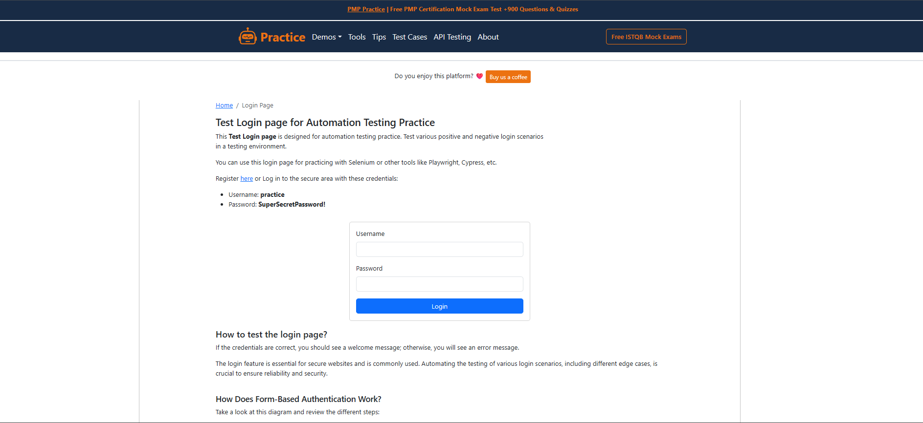

Figure 2 — Valid Login
Corresponding Test Case: TC_LOGIN_01 — Successful redirect to /secure with the 'You logged into a secure area!' message and Logout link visible
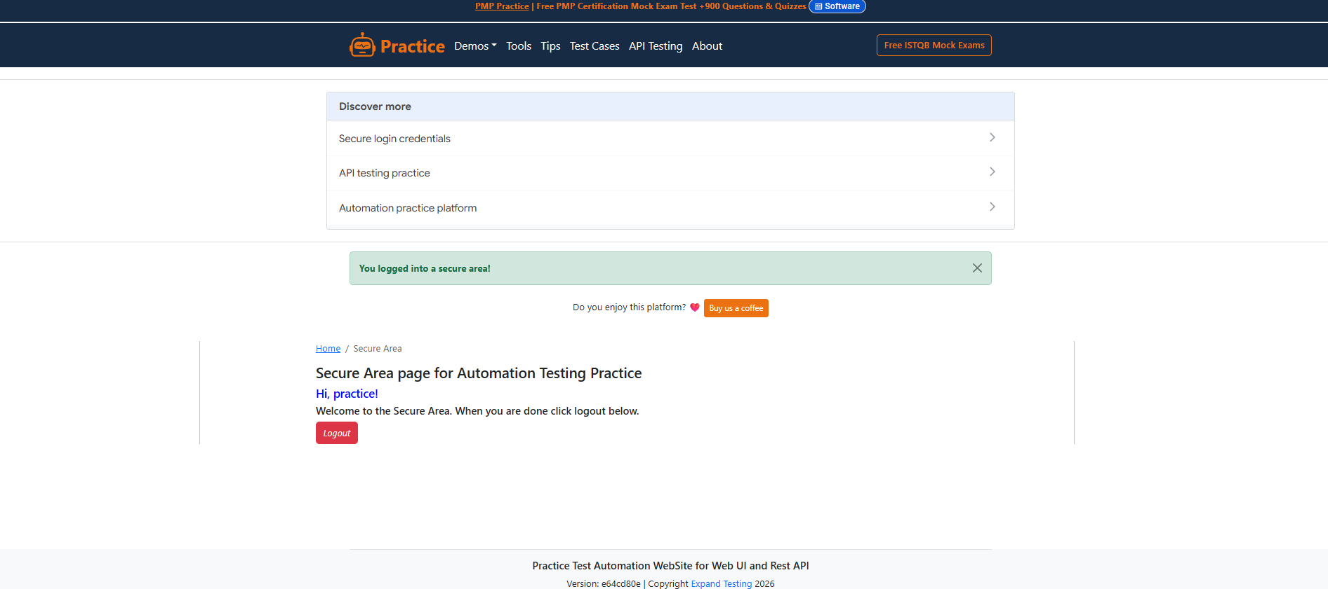

Figure 3 — Invalid Username
Corresponding Test Case: TC_LOGIN_03 — 'Invalid username.' flash message displayed after submitting a non-existent username
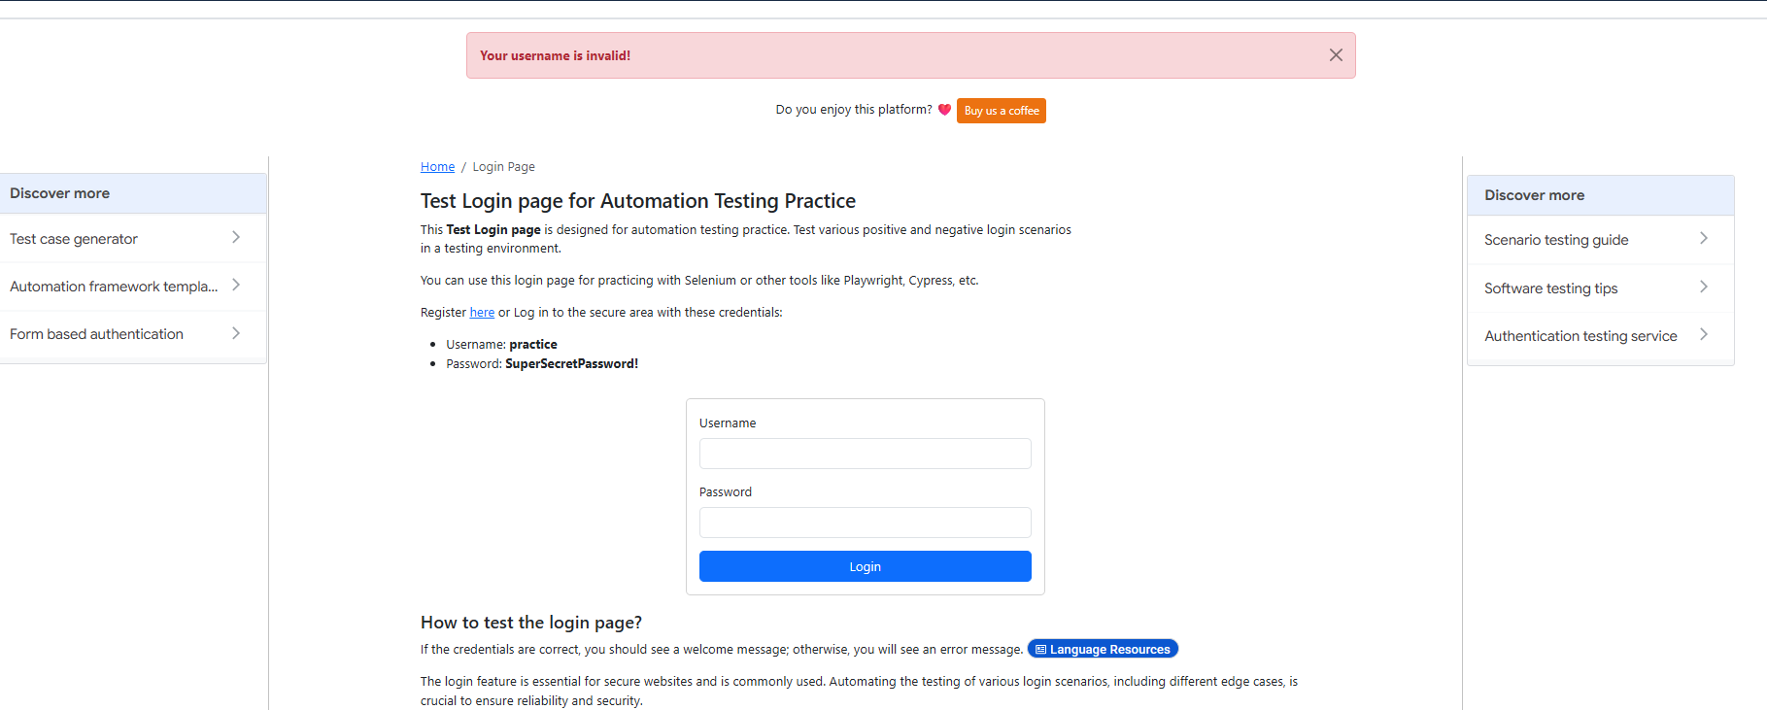

Figure 4 — Invalid Password
Corresponding Test Case: TC_LOGIN_05 — 'Invalid password.' flash message displayed after submitting an incorrect password
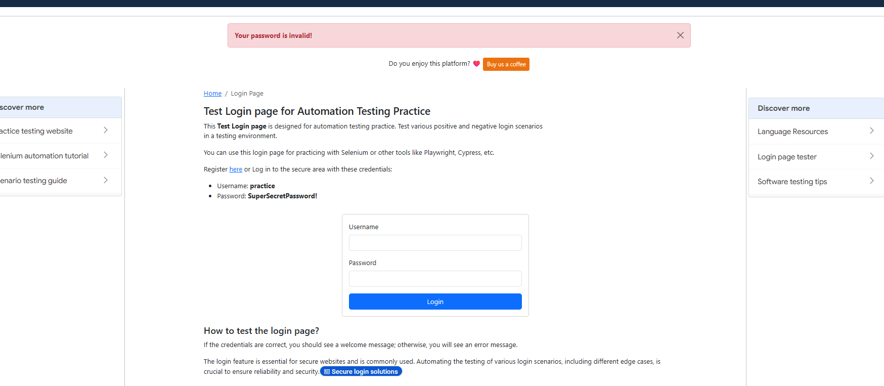

Figure 5 — Empty Fields
Corresponding Test Case: TC_LOGIN_09 — Validation/error state shown after submitting the form with both fields blank

Figure 6 — Secure Area
Corresponding Test Case: TC_LOGIN_21 — /secure page content and access-control behaviour for an authenticated session

Figure 7 — Logout
Corresponding Test Case: TC_LOGIN_19 — Post-logout state: user returned to /login with the session terminated
