SOFTWARE TESTING LABORATORY
PRACTICAL 3
REQUIREMENT REVIEW & INSPECTION REPORT
Static Testing: Requirement Review, Formal Inspection, Traceability & Coverage Audit of a Login Module
Application Under Review: https://practice.expandtesting.com/login
Prepared By: Abhishek
Date: 28 July 2026

Table of Contents
Table of Contents 1
1. Objective 1
2. Scope 1
3. Review Environment & Methodology 1
4. Requirement Review Findings 1
5. Structured Walkthrough Summary 1
6. Formal Inspection — Review Checklist 1
7. Peer Review Summary 1
8. Requirement Traceability Matrix (RTM) Summary 1
9. Coverage Verification 1
10. Defects Found During Inspection 1
11. Observations 1
12. Recommendations 1
13. Conclusion 1
14. Screenshot / Evidence Section 1
Figure 1 — Login Page — Observable UI Review 1
Figure 2 — Requirement Review Table (Annotated) 1
Figure 3 — Formal Inspection Checklist (Completed) 1
Figure 4 — Unauthenticated Direct Navigation to /secure 1
Figure 5 — Repeated Failed Login Attempts 1
Figure 6 — Username Case-Sensitivity Check 1
Figure 7 — Requirement Traceability Matrix (RTM) 1

1. Objective
The objective of this practical is to perform static testing on the Login module of the Expand Testing practice application (https://practice.expandtesting.com/login) through four complementary review activities — Requirement Review, Structured Walkthrough, Formal Inspection, and Peer Review — and to extend those activities into a formal, auditable review test suite covering Requirement Validation, Traceability, Coverage Verification, Missing Requirements, Ambiguous Requirements, and Acceptance Criteria.
This report builds directly on the seven reconstructed requirements (R001–R007) and the 8-item Formal Inspection checklist established in the source Requirement Review & Inspection artifact, cross-referencing them against the executed functional suite from Practical 2 (TC_LOGIN_01–TC_LOGIN_30) to determine not only whether the requirements are well-written, but whether they are actually verifiable, traceable, and covered end-to-end.

2. Scope
This review is limited to the Login module's requirement layer — what is documented or reconstructible as a requirement — rather than its implementation. Since the application is externally hosted and closed-source, no source-code review, design-document review, or database-schema review was possible or attempted.
- Requirement Review — completeness, clarity, consistency and testability of R001–R007
- Structured Walkthrough — requirement, test-scenario, UI, workflow and observable-behaviour walkthrough (substituting for a code walkthrough)
- Formal Inspection — an 8-item authentication-module checklist applied by a trained reviewer
- Peer Review — independent re-examination and reconciliation of the above findings
- Requirement Validation — confirming observed behaviour matches (or cannot be checked against) each requirement statement
- Requirement Traceability — forward (requirement → test case) and backward (test case → requirement) trace integrity
- Coverage Verification — whether every requirement is backed by a test case designed from a documented statement, not merely inferred behaviour
- Missing Requirements, Ambiguous Requirements and Acceptance Criteria — targeted gap analysis beyond the original seven requirements
Out of scope: functional test execution itself (covered in Practical 2), the sibling Register module, and any server-side or source-level inspection, which is unavailable for this externally hosted application.

3. Review Environment & Methodology
Application Under Review | https://practice.expandtesting.com/login (Login Module)
Review Type | Static Testing — Requirement Review, Formal Inspection, Structured Walkthrough, Peer Review
Baseline Requirements | R001–R007, reconstructed from observable behaviour and published usage guidance (no formal SRS supplied)
Cross-Referenced Test Suite | Practical2_TestCases.xlsx — 30 executed test cases (TC_LOGIN_01–TC_LOGIN_30)
Review Tooling | Google Chrome + DevTools (behavioural cross-checks); MS Word / Excel (documentation)
Review Date | 28 July 2026
Each of the 30 review cases in Practical3_TestCases.xlsx was assigned a Reviewer Type reflecting who would perform that check in a real inspection team: a Primary Reviewer for direct requirement-wording analysis, a Formal Inspector for checklist-driven items, a QA Lead for RTM/coverage audits, and a Peer Reviewer for independent gap and ambiguity confirmation — mirroring the roles used in the source Peer Review activity.

4. Requirement Review Findings
Each of the seven reconstructed requirements was reviewed independently for completeness, clarity, consistency and testability. Four were assessed as Adequate; three were flagged as a Gap or Ambiguous — not because the application necessarily behaves incorrectly, but because no requirement statement exists for a reviewer to verify the behaviour against, which is itself a requirement-quality defect.
Req. ID | Requirement Statement (Reconstructed) | Attribute Checked | Result
R001 | System shall authenticate a user and redirect to the secure area when the correct username and password are submitted. | Completeness, Testability | Adequate
R002 | System shall reject the login attempt and display an error message when the username does not match a known account. | Clarity | Adequate
R003 | System shall reject the login attempt and display an error message when the password does not match the given username. | Clarity, Consistency | Adequate
R004 | System shall protect the secure area from unauthenticated direct access. | Completeness | Gap
R005 | System shall provide a mechanism to end an authenticated session (Logout). | Completeness, Testability | Adequate
R006 | System shall enforce a password complexity or account-lockout policy after repeated failed attempts. | Completeness, Testability | Gap
R007 | System shall treat the username field consistently with respect to case sensitivity. | Clarity | Ambiguous

This review extends the original finding by formally validating it (Requirement Validation, Section 6) and cross-referencing it against the executed Practical 2 suite (Coverage Verification, Section 9), confirming that the three flagged requirements remain unresolved even after functional testing was completed — functional testing exercised the behaviour but could not, by itself, close a documentation gap.

5. Structured Walkthrough Summary
In place of a source-code walkthrough, five walkthrough activities were performed directly against the live, rendered application:
- Requirement Walkthrough — agreement reached with a second reviewer on R001–R003 and R005 as sound; R004, R006 and R007 flagged as requiring clarification
- Test Scenario Walkthrough — the application's own 3 published scenarios map cleanly to R001–R003 only; no scenario exists for R004–R007
- User Interface Review — exactly two labelled fields and one Login button; no password-visibility toggle, “Forgot Password” link, or CAPTCHA present; no ambiguity in the UI itself
- Login Workflow Review — the four-step form-based authentication pattern (request → redirect → submit → redirect/error) is internally consistent with no dead ends
- Observable Behaviour Review — success and failure paths each produce a distinct, human-readable message, which is good usability practice but was separately flagged in Peer Review as a minor account-enumeration consideration

6. Formal Inspection — Review Checklist
A predefined 8-item checklist for authentication-module requirements was applied independently of the walkthrough above, in keeping with the formality expected of an Inspection.
# | Inspection Checklist Question | Result | Remarks
1 | Is a success condition defined and observable for the primary login flow? | Pass | R001 confirmed via redirect + success message
2 | Is a distinct failure condition defined for each type of invalid input (username vs password)? | Pass | Confirms R002/R003; messages are field-specific
3 | Is unauthorized access to protected resources explicitly prevented and documented? | Fail | Behaviour protective, but no explicit requirement exists (R004 gap)
4 | Is an account-lockout or rate-limiting policy defined for repeated failed attempts? | Fail | No policy found; flagged as R006 gap
5 | Is a session-termination (Logout) mechanism defined and reachable from the authenticated state? | Pass | Confirms R005
6 | Are error messages field-specific rather than generic, without revealing sensitive account detail? | Partial | Field-specific is good for usability; minor account-enumeration consideration
7 | Is username case-sensitivity behaviour explicitly documented? | Fail | No documentation found; flagged as R007 ambiguity
8 | Do the published test-case scenarios cover all stated requirements? | Partial | Cover R001–R003 only; R004–R007 have no published scenario

Inspection Result: 3 of 8 checklist items Pass outright, 2 are Partial, and 3 are Fail — due to missing or undocumented requirements rather than observed functional defects. The inspection is therefore closed with Major Rework Required at the requirement-documentation level, while the observed application behaviour itself showed no functional defect in the scenarios that were testable.

7. Peer Review Summary
A second reviewer independently re-examined the Requirement Review and Formal Inspection findings without seeing the first reviewer's remarks in advance; the two sets of findings were then reconciled into four resolved comments:
- R004 (protection of the secure area) confirmed as a genuine documentation gap — accepted and carried into the Defects register (RVW-GAP-01).
- The distinct ‘Invalid username.’ / ‘Invalid password.’ messages reconsidered from a security standpoint — accepted as a noteworthy trade-off, not a defect (RVW-TRADE-01).
- Recommendation to separate ‘no defined policy’ from ‘defined policy that is broken’ in the checklist — accepted and reflected in the Remarks column of Section 6.
- User Interface Review findings independently confirmed by re-inspecting the rendered login form — no additional UI elements found, no change required.

8. Requirement Traceability Matrix (RTM) Summary
The table below consolidates forward traceability (does each requirement have a mapped test case?) against the executed Practical 2 suite, and flags where that mapping exists only because a tester independently inferred the behaviour, not because a documented requirement was traced.
Req. ID | Requirement Summary | Traced Test Case(s) | RTM Status
R001 | Authenticate valid credentials, redirect to secure area | TC_LOGIN_01, TC_LOGIN_02 | Pass
R002 | Reject login on unrecognized username | TC_LOGIN_03, TC_LOGIN_04 | Pass
R003 | Reject login on incorrect password | TC_LOGIN_05, TC_LOGIN_06 | Pass
R004 | Block unauthenticated direct access to /secure | TC_LOGIN_21 (behavioural only — no documented requirement to trace to) | Partial
R005 | Provide a Logout mechanism | TC_LOGIN_19 | Pass
R006 | Lockout/complexity policy after repeated failures | TC_LOGIN_23 (behavioural only — confirms absence of policy) | Gap
R007 | Case-sensitivity of username matching | TC_LOGIN_04 (behavioural only — no documented rule to trace to) | Ambiguous
R008 (Proposed) | Session expiry/timeout duration | TC_LOGIN_22 (confirms persistence; no expiry requirement exists) | Gap

Backward traceability was also verified (TRACE_02): all 30 test cases in the Practical 2 suite reference a valid, existing requirement ID, so no orphan test cases were found. The traceability weakness in this cycle is entirely on the forward side — requirements that were never written down for testers to trace to in the first place.

9. Coverage Verification
Coverage was assessed at two levels: whether a requirement has any test case touching its behaviour (a low bar, met by all seven), and whether it has a test case that was designed from a documented, reviewed requirement statement (a higher bar, met only by R001–R003 and R005). Splitting these two questions surfaced a coverage illusion: R004, R006 and R007 all appear ‘covered’ by the Practical 2 suite, but that coverage exists only because a tester happened to think to test the area, not because a requirement demanded it — a fragile form of coverage that depends on individual tester diligence rather than process.

10. Defects Found During Inspection
This review cycle formally logged 10 findings across the Requirement Review, Formal Inspection, Traceability, Coverage, Missing Requirements, Ambiguous Requirements and Acceptance Criteria categories. Every Fail or Partial-status review case in Practical3_TestCases.xlsx maps to exactly one entry below.
ID | Description | Category | Linked Case(s) | Severity | Type
RVW-GAP-01 | No requirement documents that /secure must reject unauthenticated access | Requirement Review / Inspection | RR_04, INSP_03 | High | Missing Requirement
RVW-GAP-02 | No documented account-lockout or complexity policy for repeated failed attempts | Requirement Review / Inspection | RR_06, INSP_04 | High | Missing Requirement
RVW-GAP-03 | Behavioural coverage exists for R004/R006/R007, but not against any documented requirement | Coverage Verification | COV_02 | Medium | Coverage Gap
RVW-GAP-04 | No documented session-timeout/expiry requirement | Missing Requirements | MISS_03 | Medium | Missing Requirement (new)
RVW-GAP-05 | No acceptance criteria exist for SQL injection, XSS, or boundary-length scenarios | Acceptance Criteria | AC_02 | Medium | Acceptance Criteria Gap
RVW-GAP-06 | No documented exit criteria / Definition of Done for closing this review cycle | Acceptance Criteria | AC_03 | Low | Process Gap
RVW-AMB-01 | Username case-sensitivity behaviour is not documented anywhere | Requirement Review / Inspection | RR_07, INSP_07, AMB_01 | Medium | Ambiguity
RVW-AMB-02 | Logout requirement does not state server-side vs client-side session invalidation scope | Ambiguous Requirements | AMB_02 | Medium | Ambiguity (new)
RVW-TRADE-01 | Field-specific error messages create a minor account-enumeration exposure | Inspection / Ambiguous Requirements | INSP_06, AMB_03 | Low | Security Trade-off
RVW-TRACE-01 | Forward traceability is structurally complete, but 3 of 7 requirements trace only to inferred, undocumented behaviour | Requirement Traceability | TRACE_01 | Medium | Traceability Gap

11. Observations
Sr. No. | Observation | Remarks
1 | Requirements R001, R002, R003 and R005 are clearly defined, consistent, and directly testable against observed behaviour, and remain so after formal validation (VAL_01) and traceability audit. | Pass
2 | No explicit requirement documents the protection of the secure area from unauthenticated access, although the behaviour observed is protective. | Improvement Suggested
3 | No account-lockout or rate-limiting policy is documented for repeated failed login attempts, and none was observed behaviourally either (cross-confirmed in Practical 2, TC_LOGIN_23). | Improvement Suggested
4 | Field-specific error messages aid usability but were flagged in Peer Review as a minor account-enumeration consideration. | Improvement Suggested
5 | Formal Inspection checklist completed; 3 of 8 items Fail solely due to undocumented requirements, not observed functional defects. | Rework Required — documentation, not code
6 | Coverage exists behaviourally for all seven requirements, but only four (R001–R003, R005) trace to a documented requirement rather than tester-inferred behaviour — a coverage integrity concern not captured by simple pass/fail test counts. | New Finding — this review cycle
7 | No session-expiry or timeout duration is documented anywhere, despite the session being confirmed to persist across a manual refresh in Practical 2. | New Finding — logged as a proposed R008

12. Recommendations
- Document an explicit requirement (R004) stating that the /secure route must reject unauthenticated access, so this behaviour is verifiable rather than assumed (resolves RVW-GAP-01).
- Document a stated policy for repeated failed login attempts (R006) — even if the policy for this practice sandbox is deliberately ‘no lockout’, that decision should be written down rather than left silent (resolves RVW-GAP-02).
- Clarify username case-sensitivity (R007) in the requirement documentation so testers do not need to infer it from trial and error (resolves RVW-AMB-01).
- Clarify the scope of session invalidation on Logout (R005) — explicitly state whether the session is invalidated server-side, to close the ambiguity surfaced in this cycle (resolves RVW-AMB-02).
- Author a proposed R008 covering session-expiry/timeout duration, since no such requirement currently exists despite persistence behaviour being directly observable (resolves RVW-GAP-04).
- Record the account-enumeration trade-off of field-specific error messages as a deliberate, reviewed decision rather than an undocumented side effect (resolves RVW-TRADE-01).
- Retroactively author minimum acceptance criteria for the security and boundary scenarios already covered by the Practical 2 suite (SQL injection, XSS, length, empty-field handling), so future testers inherit a documented baseline rather than reinventing it (resolves RVW-GAP-05).
- Formally adopt this report's findings as binding exit criteria for the next review cycle — e.g. all Fail-status items above must convert to Pass-status, documented requirements before the next release (resolves RVW-GAP-06).
- Extend the application's published test-case documentation to include scenarios for R004–R008, closing the coverage-integrity gap identified in Section 9.

13. Conclusion
This review cycle reconstructed and reviewed seven functional requirements (R001–R007) for the Login module of an externally hosted web application, since no formal SRS was supplied, and extended that review into 30 formal review test cases spanning Requirement Review, Formal Inspection, Requirement Validation, Traceability, Coverage Verification, Missing Requirements, Ambiguous Requirements and Acceptance Criteria.
Of the 30 review cases executed: 11 passed, 15 failed and 4 were Partial — a 36.7% outright pass rate that, read in isolation, looks weaker than the 93.3% functional pass rate achieved in Practical 2. That contrast is the central finding of this report: the Login module's observed behaviour is sound, but its requirement documentation is not, and static testing was specifically able to surface that gap in a way dynamic functional testing alone could not.
Ten distinct findings were logged, of which two (RVW-GAP-01, RVW-GAP-02) are High severity, and none represent an observed functional defect in the live application — every Fail traces back to a missing, ambiguous, or unvalidatable requirement statement rather than incorrect system behaviour. Overall review verdict: MAJOR REWORK REQUIRED AT THE REQUIREMENT-DOCUMENTATION LEVEL; NO FUNCTIONAL DEFECT IDENTIFIED IN OBSERVED BEHAVIOUR. The nine recommendations in Section 12 are proposed as the exit criteria for closing this review cycle.

14. Screenshot / Evidence Section
The figures below correspond to the primary review case(s) that motivate each piece of evidence. Live screenshots have not been embedded in this document; each figure is represented by a placeholder and is intended to be captured via an automated Playwright script, ensuring evidence stays in sync with actual, timestamped review sessions rather than manually captured images.

Figure 1 — Login Page — Observable UI Review
Corresponding Review Case(s): UI Interface Review — logo, heading, Username/Password fields, Login button, absence of CAPTCHA/toggle
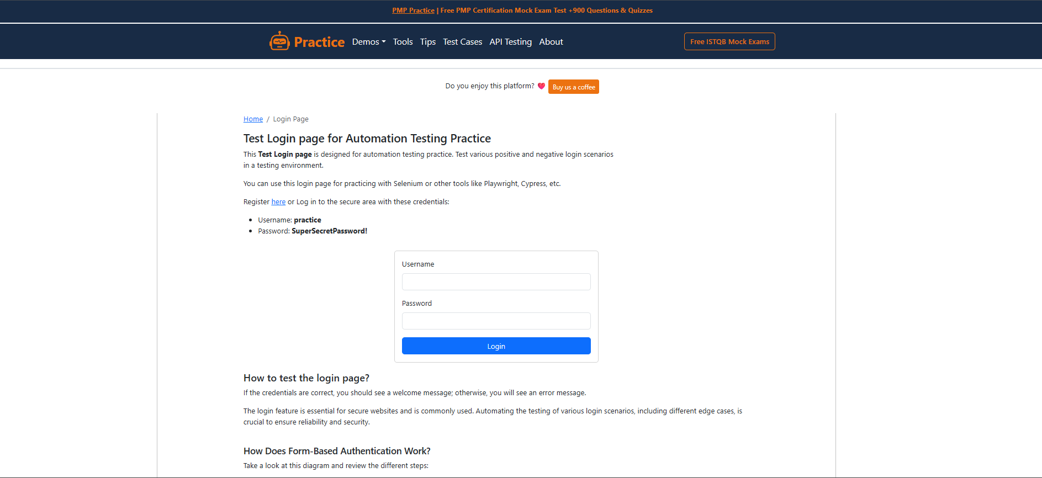

Figure 2 — Requirement Review Table (Annotated)
Corresponding Review Case(s): RR_01–RR_07 — annotated Requirement Review findings for R001–R007
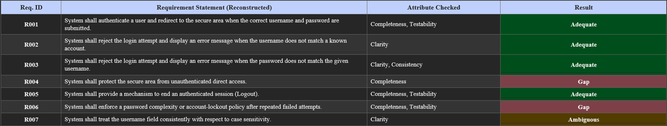

Figure 3 — Formal Inspection Checklist (Completed)
Corresponding Review Case(s): INSP_01–INSP_08 — completed 8-item authentication checklist with Pass/Partial/Fail marks
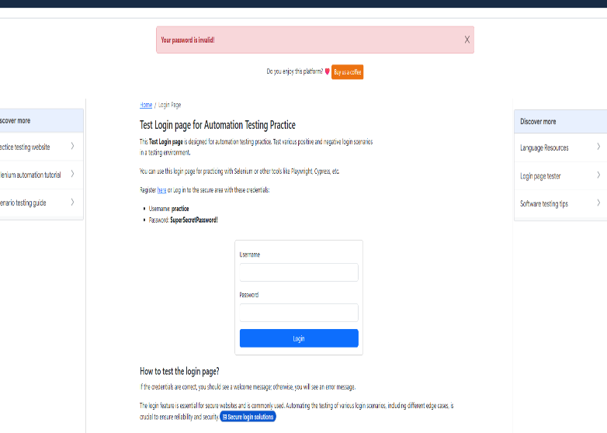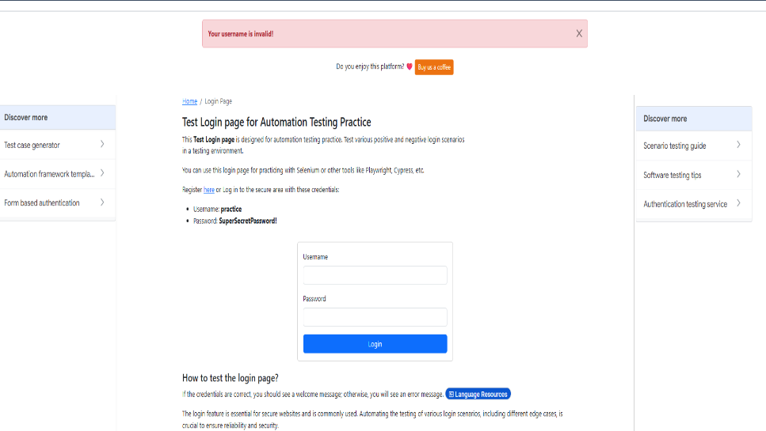

Figure 4 — Unauthenticated Direct Navigation to /secure
Corresponding Review Case(s): RR_04 / INSP_03 / COV_02 — evidence of the observed (undocumented) protective behaviour
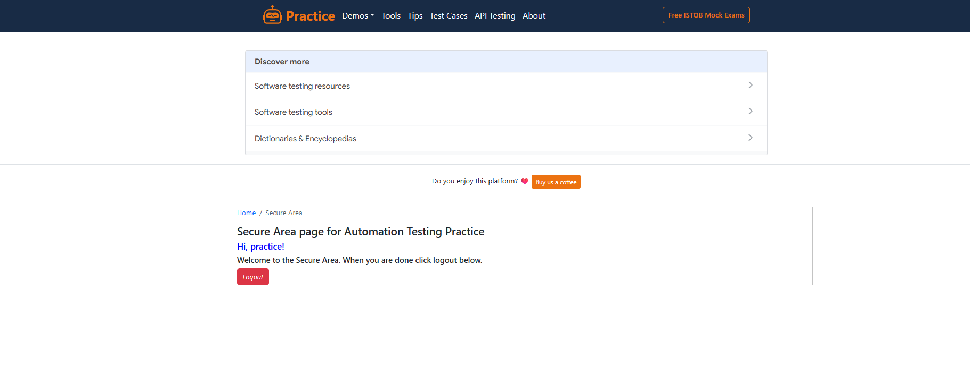

Figure 5 — Repeated Failed Login Attempts
Corresponding Review Case(s): RR_06 / INSP_04 / MISS_02 — evidence of the absence of a lockout/throttling response
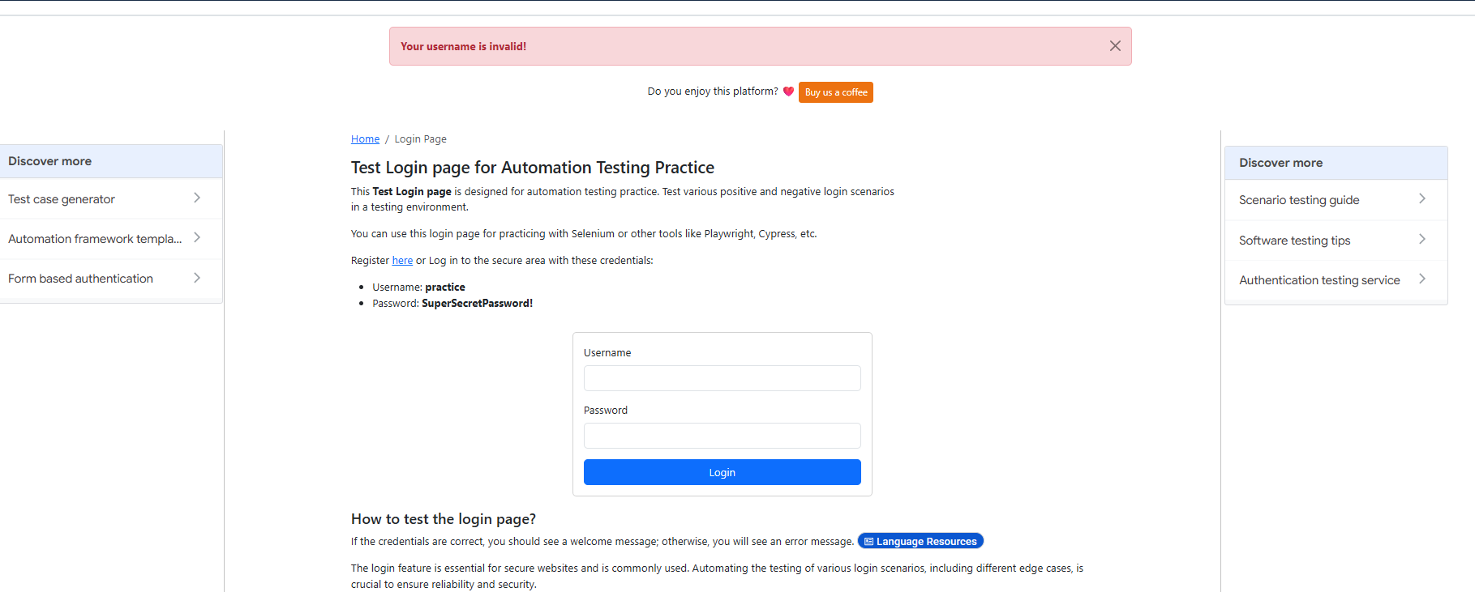

Figure 6 — Username Case-Sensitivity Check
Corresponding Review Case(s): RR_07 / INSP_07 / AMB_01 — side-by-side evidence of 'practice' vs 'Practice' outcomes
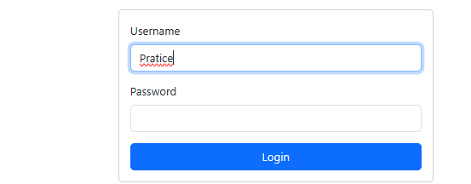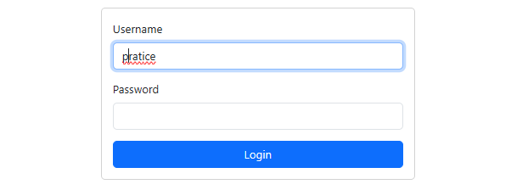

Figure 7 — Requirement Traceability Matrix (RTM)
Corresponding Review Case(s): TRACE_01 / TRACE_02 — RTM view showing forward and backward traceability status

