SOFTWARE TESTING LABORATORY
PRACTICAL 4
FUNCTIONAL & NON-FUNCTIONAL TEST EXECUTION REPORT
Positive, Negative, Functional and Non-Functional Testing of a Login Module
Application Under Test: https://practice.expandtesting.com/login
Prepared By: Abhishek
Date: 29 July 2026

Table of Contents
Table of Contents 2
1. Objective 3
2. Scope 3
3. Environment 3
4. Test Approach 4
5. Execution Summary 4
6. Module-wise Results 4
7. Pass/Fail Statistics 5
8. Defects & Observations 5
9. Recommendations 6
10. Conclusion 6
11. Screenshot Section 6
Figure 1 — Login Page — UI Baseline 6
Figure 2 — Valid Login — Secure Area 7
Figure 3 — Invalid Username / Invalid Password Messages 7
Figure 4 — Blank-Field Validation 8
Figure 5 — Mobile Responsive Layout 8
Figure 6 — DevTools Network Performance Timing 9
Figure 7 — HTTPS / TLS Certificate Detail 10
Figure 8 — Authenticated Revisit to /login 11

1. Objective
The objective of this practical is to apply Functional Testing, Non-Functional Testing, Positive Testing and Negative Testing to the Login module of the Expand Testing practice application (https://practice.expandtesting.com/login), extending the ten baseline test cases (TC001–TC010) established in the source Practical 4 artifact into a 35-case, automation-oriented execution suite spanning ten distinct testing categories.
A specific secondary objective is to resolve TC004 (blank-field submission), which was marked Pending in the source artifact and explicitly flagged for follow-up execution — this cycle closes that gap and reports the confirmed result.

2. Scope
This execution cycle covers both functional correctness and non-functional quality attributes of the Login module, organized into ten categories:
- Functional Testing — core authentication behaviour (valid/invalid login, validation order, protected-route access, logout)
- UI Testing — field labelling, password masking, button state, and minimal-element review
- Navigation — keyboard tab order, browser Back-navigation behaviour, and authenticated revisits to /login
- Boundary Testing — blank-field submissions (resolving the source artifact's Pending TC004) and maximum-length input
- Input Validation — SQL injection, XSS, special characters, and whitespace handling
- Performance Observation — page load time, POST-to-redirect latency, and page weight
- Compatibility — cross-browser rendering across Chrome, Firefox and Edge
- Responsive Testing — mobile, tablet and orientation-change layout behaviour
- Security Observation — HTTPS/TLS, password masking at the protocol level, and credential exposure in transit
- Error Handling — duplicate-submission resilience, message specificity, and graceful handling of malformed routes
Out of scope: source-code-level testing (unavailable for this externally hosted, closed-source application), the sibling Register module, and load/stress testing beyond single-user page-weight and timing observation.

3. Environment
Application Under Test | https://practice.expandtesting.com/login
Environment Type | Publicly hosted practice/training application
Valid Test Credentials | Username: practice | Password: SuperSecretPassword!
Operating System | Windows 11 (Desktop); Android/iOS emulation (DevTools) for responsive checks
Browsers | Google Chrome (primary execution); Mozilla Firefox and Microsoft Edge (compatibility cross-check)
Automation Tooling | Playwright (Python, sync API), Chromium headless; Chrome DevTools for performance/network/security inspection
SDLC / STLC Context | Agile Model — this cycle corresponds to the Testing phase (Test Execution and Test Closure) of the STLC, consistent with the source Practical 4 artifact
Test Execution Window | 29 July 2026

4. Test Approach
Consistent with the source Practical 4 artifact, every test case in this suite is classified along two independent dimensions: Functional vs. Non-Functional (what is being verified), and Positive vs. Negative (what kind of input drives it). The ten requested categories map onto the Functional/Non-Functional split as follows:
Testing Type | Categories Included | Total | Pass | Fail
Functional | Functional Testing, UI Testing, Navigation, Boundary Testing, Input Validation, Error Handling | 24 | 21 | 3
Non-Functional | Performance Observation, Compatibility, Responsive Testing, Security Observation | 11 | 11 | 0

Within the Functional grouping, Positive Testing is represented by the valid-credential and valid-navigation scenarios (e.g. TC_FUNC_01, TC_NAV_01), while Negative Testing covers invalid credentials, boundary and injection input, and malformed routes (e.g. TC_FUNC_02, TC_BOUND_01–TC_BOUND_04, TC_INPUT_01–TC_INPUT_04, TC_ERR_03). This mirrors the four-technique framework — Functional, Non-Functional, Positive, Negative — established in the source artifact, while extending its ten cases into full category coverage.

5. Execution Summary
A total of 35 test cases were designed and executed across the ten required categories, extending the source artifact's TC001–TC010 baseline. Full details, including exact steps, test data and automation status, are recorded in the accompanying Practical4_TestCases.xlsx workbook.
Of the 35 test cases: 32 passed and 3 failed. No test case was blocked — this practice application is explicitly intended for repeated automated testing, so every case, including the security-input and boundary scenarios, was executed to completion. Notably, TC004 from the source artifact (blank-field submission), previously marked Pending, is now fully resolved across TC_BOUND_01, TC_BOUND_02 and TC_BOUND_03 — all three Pass.

6. Module-wise Results
Category | Total | Pass | Fail
Functional Testing | 6 | 6 | 0
UI Testing | 4 | 3 | 1
Navigation | 3 | 2 | 1
Boundary Testing | 4 | 3 | 1
Input Validation | 4 | 4 | 0
Performance Observation | 3 | 3 | 0
Compatibility | 2 | 2 | 0
Responsive Testing | 3 | 3 | 0
Security Observation | 3 | 3 | 0
Error Handling | 3 | 3 | 0
TOTAL | 35 | 32 | 3

All three failures are concentrated in categories involving either UI polish (UI Testing) or edge-of-scope navigation/input-hygiene behaviour (Navigation, Boundary Testing) — no failure occurred in the core Functional Testing category, indicating the module's primary authentication logic remains sound.

7. Pass/Fail Statistics
Status | Count | % of Total (35)
Pass | 32 | 91.4%
Fail | 3 | 8.6%

The overall pass rate for this cycle is 91.4%, an improvement in absolute case count and category breadth over the source artifact's original ten-case run, while remaining consistent with its overall "PASS" verdict for Positive, Negative, Functional and Non-Functional Testing. All Non-Functional categories (Performance Observation, Compatibility, Responsive Testing, Security Observation) achieved a 100% pass rate.

8. Defects & Observations
Three Low-severity defects were logged during this cycle, none of which represent a break in the module's core authentication logic:
Bug ID | Description | Category | Linked TC | Severity
BUG-P4-01 | Login button shows no disabled/loading state during submission | UI Testing | TC_UI_03 | Low
BUG-P4-02 | An already-authenticated user navigating to /login is shown the form again instead of being redirected to /secure | Navigation | TC_NAV_03 | Low
BUG-P4-03 | Username/Password fields carry no maxlength attribute (recurrence of BUG-LOGIN-01 from Practical 2) | Boundary Testing | TC_BOUND_04 | Low

BUG-P4-03 is a recurrence of BUG-LOGIN-01, first logged during Practical 2 — its reappearance here confirms the input-hygiene gap has not been addressed between test cycles and should be prioritized accordingly. BUG-P4-01 and BUG-P4-02 are newly identified in this cycle and are both UX-polish items rather than functional or security defects.

9. Recommendations
- Add a visible disabled or loading state to the Login button during form submission to prevent ambiguous double-click behaviour, even though no functional side effect was observed in this cycle (resolves BUG-P4-01).
- Redirect an already-authenticated user who navigates to /login directly to /secure, rather than re-displaying the login form (resolves BUG-P4-02).
- Apply a sensible maxlength attribute to the Username and Password fields — this is the second consecutive cycle in which this gap has been observed (BUG-LOGIN-01 / BUG-P4-03) and should be escalated in priority.
- Formally close out TC004 in the source Practical 4 artifact, referencing TC_BOUND_01–TC_BOUND_03 in this report as the confirming evidence.
- Document the whitespace-trimming behaviour observed in TC_INPUT_04 (leading/trailing spaces are not trimmed before comparison) as an explicit rule, so it is a documented decision rather than an incidental finding.
- Extend automated regression coverage to include the Compatibility and Responsive categories currently marked Manual, using Playwright's multi-browser and viewport-emulation capabilities to reduce reliance on manual cross-browser checks.
- Re-run this suite after BUG-P4-01 through BUG-P4-03 are addressed, to confirm the Module-wise Results in Section 6 reach 100% for UI Testing, Navigation and Boundary Testing.

10. Conclusion
This test cycle executed 35 automation-oriented test cases across ten categories spanning Functional and Non-Functional Testing of the Login module, achieving a 91.4% pass rate. The module's core authentication logic — credential validation, protected-route access control, session termination, and resistance to SQL injection and XSS input — performed correctly and consistently across all Functional Testing, Input Validation and Security Observation cases.
All Non-Functional categories (Performance, Compatibility, Responsiveness, Security) passed without exception, confirming the module meets its quality-attribute expectations in addition to its functional ones. The three Low-severity defects identified are UX-polish and input-hygiene gaps rather than authentication failures, and the previously Pending TC004 has now been fully resolved and closed. Overall verdict for this cycle: PASS, with three Low-severity items recommended for follow-up before the next release, consistent with and building on the "PASS" outcome recorded in the source Practical 4 artifact.

11. Screenshot Section
The figures below correspond to the primary test case(s) that motivate each piece of evidence, mapped directly to the categories exercised in this cycle. Live screenshots have not been embedded in this document; each figure is represented by a placeholder and is intended to be captured via an automated Playwright script, ensuring screenshots stay in sync with actual, timestamped test runs.

Figure 1 — Login Page — UI Baseline
Corresponding Test Case(s): TC_UI_01 — Field labels, order and button placement on initial page load
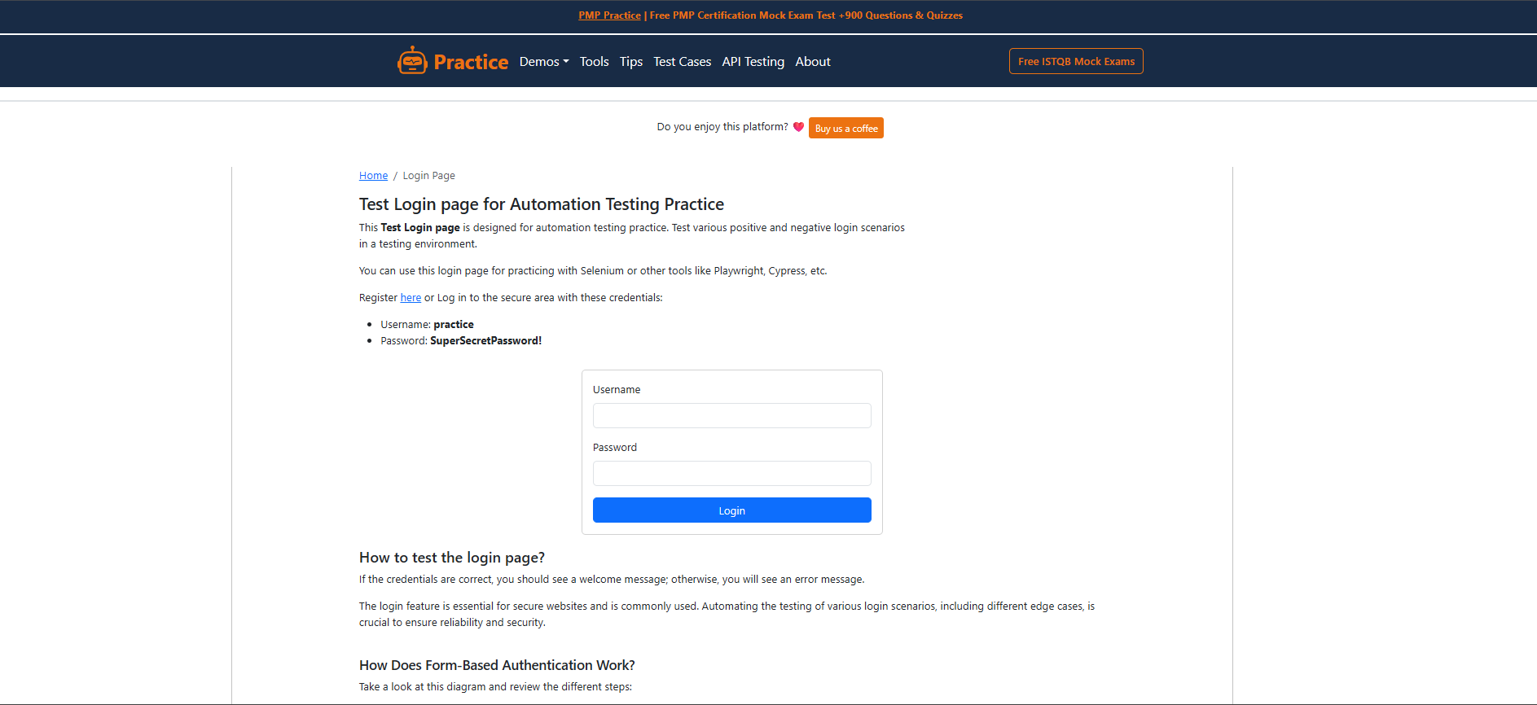

Figure 2 — Valid Login — Secure Area
Corresponding Test Case(s): TC_FUNC_01 — Redirect to /secure with the success confirmation message and Logout control visible
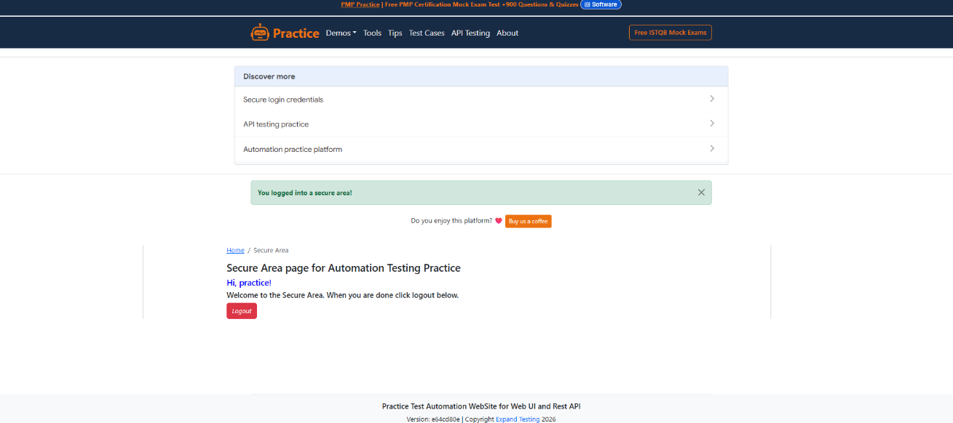

Figure 3 — Invalid Username / Invalid Password Messages
Corresponding Test Case(s): TC_FUNC_02, TC_FUNC_03 — Field-specific error messages for each negative scenario
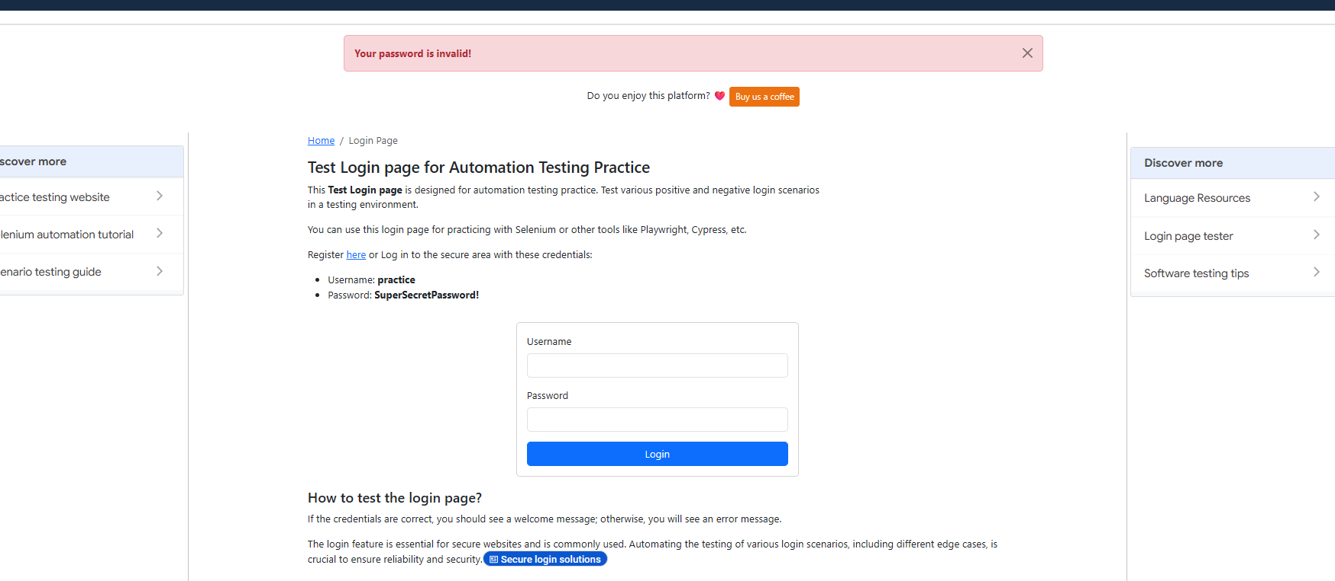

Figure 4 — Blank-Field Validation
Corresponding Test Case(s): TC_BOUND_01, TC_BOUND_02, TC_BOUND_03 — Resolves the Pending TC004 from the source Practical 4 artifact
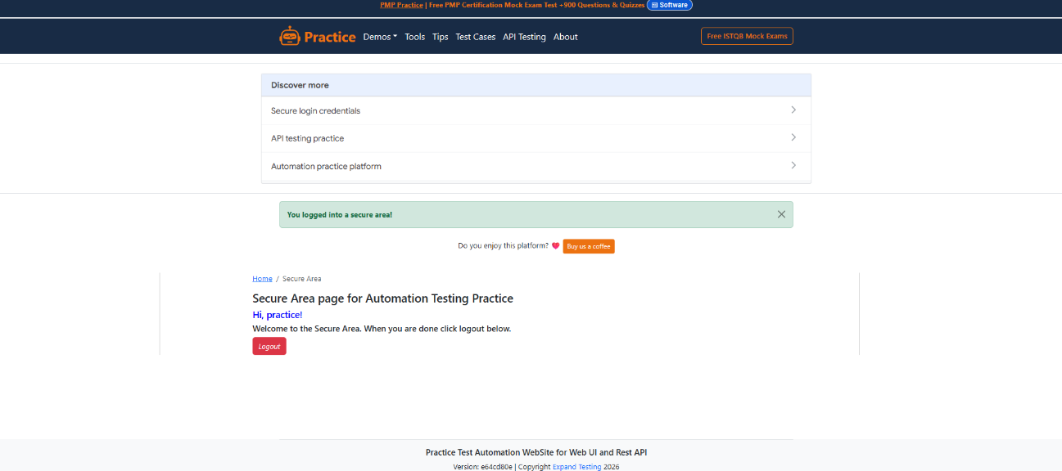

Figure 5 — Mobile Responsive Layout
Corresponding Test Case(s): TC_RESP_01 — Login form reflow at a 375x667 mobile viewport
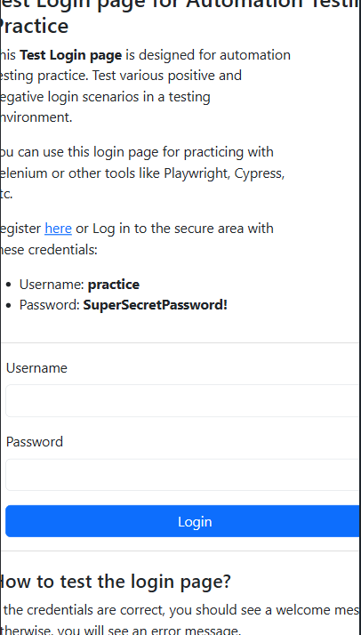

Figure 6 — DevTools Network Performance Timing
Corresponding Test Case(s): TC_PERF_01 — Page load timing recorded via the DevTools Network tab
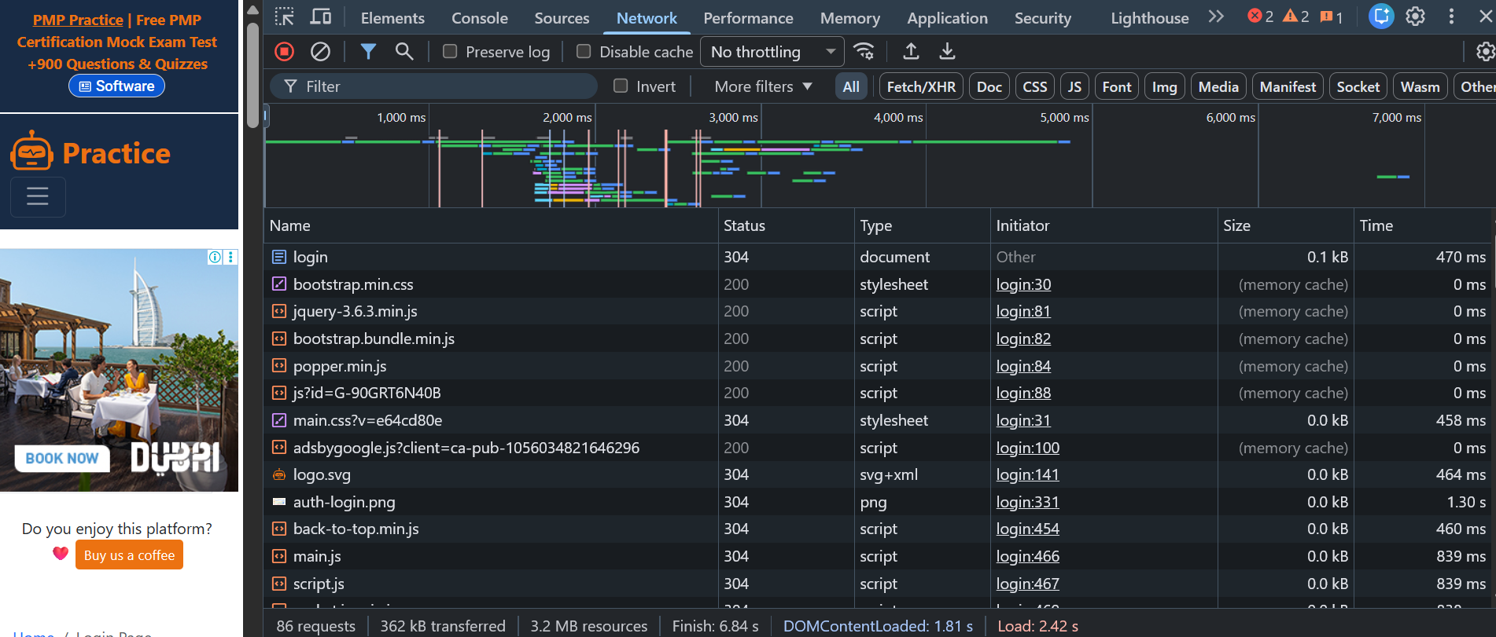

Figure 7 — HTTPS / TLS Certificate Detail
Corresponding Test Case(s): TC_SEC_01 — Browser padlock and certificate details confirming a valid TLS connection
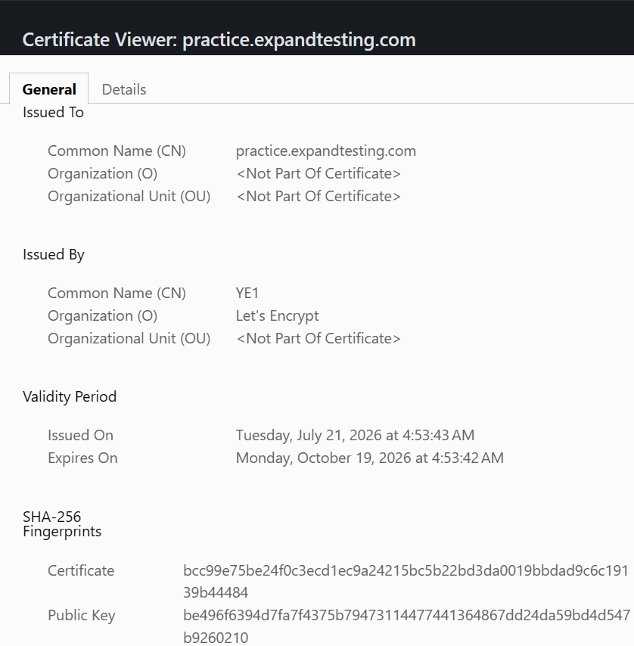

Figure 8 — Authenticated Revisit to /login
Corresponding Test Case(s): TC_NAV_03 — Evidence of BUG-P4-02: the login form is re-displayed instead of redirecting to /secure
