SOFTWARE TESTING LABORATORY
PRACTICAL 5
DEFECT REPORT
Structured Defect Identification and Bug Reporting for a Login Module
Application Under Test: https://practice.expandtesting.com/login
Prepared By: Abhishek
Date: 29 July 2026

Table of Contents
Table of Contents 2
1. Objective 3
2. Scope 3
3. Environment 3
4. Test Execution Summary 3
5. Defect Reports 4
BUG-001 — No inline validation message for empty Username / Password fields 4
BUG-002 — No account lockout or throttling after repeated failed login attempts 4
BUG-003 — Password field does not provide a show/hide visibility toggle 5
BUG-004 — Login form spacing is tight on very small mobile viewports 5
BUG-005 — Username and Password fields carry no maxlength attribute 6
BUG-006 — Authenticated user navigating to /login is shown the form again instead of being redirected 7
6. Bug Summary 7
7. Observation Summary 8
8. Recommendations 9
9. Conclusion 9
10. Screenshot / Evidence Section 9
Figure 1 — Bug Evidence 10
Figure 2 — Bug Evidence 10
Figure 3 — Error Message 10
Figure 4 — Failure Screen 11
Figure 5 — Failure Screen 12
Figure 6 — Validation Screen 13
Figure 7 — Validation Screen 13

1. Objective
The objective of this practical is to apply structured defect identification techniques to the Login module of the Expand Testing practice application (https://practice.expandtesting.com/login), and to document every deviation found as a professional bug (defect) report — including Bug ID, Summary, Severity, Priority, Steps to Reproduce, Expected and Actual Result, Environment, Status, and Recommendations.
This report extends the source Practical 5 Defect Reporting artifact (BUG-001–BUG-004) with two additional defects consolidated from Practicals 2 and 4 of this same testing engagement (BUG-005, BUG-006), producing a single, authoritative defect register for the Login module covering the full testing effort to date.

2. Scope
This defect-hunting cycle covers 30 structured test scenarios executed against the Login module, spanning positive and negative functional testing, boundary and input-length testing, special-character and safe security-observation input (SQL-injection-style and XSS-style strings, syntax only), session behaviour, accessibility, responsive layout, and browser compatibility. Full details of every scenario are recorded in the accompanying Practical5_TestCases.xlsx workbook.
Out of scope: source-code-level defect analysis (unavailable for this externally hosted, closed-source application) and any destructive or exploitative security testing — all security-observation input was limited to syntax-only strings with no exploitation attempted, consistent with responsible testing of a publicly hosted third-party application.

3. Environment
Application Under Test | Test Login Page for Automation Testing Practice — https://practice.expandtesting.com/login
Module | Authentication / Login Module
Application Version | Current Public Version (Build e64cd80e)
Operating System | Windows 11
Browser | Google Chrome (Latest Version) — primary; DevTools used for responsive and network inspection
Test Technique | Manual Black-Box Testing
Valid Test Credentials | Username: practice | Password: SuperSecretPassword!
Tester | Abhishek (Student Tester)
Test Date | 29 July 2026

4. Test Execution Summary
A total of 30 defect-oriented test cases were executed against the Login module, extending the 17-scenario baseline established in the source Practical 5 artifact. Of these, 22 passed and 8 failed. Every failing test case traces to exactly one of six filed defects (BUG-001–BUG-006); every filed defect is Low severity, and none represent a break in the module's core authentication logic.
Consistent with the source artifact's own conclusion, the core authentication flow performed correctly and consistently throughout this cycle: valid credentials logged in successfully and redirected to the secure area, invalid usernames and invalid passwords each produced clear, distinct error messages, and no SQL-injection-style or XSS-style input achieved any bypass or unsafe reflection.

5. Defect Reports
Each defect below follows a consistent, complete bug-report structure. All six are currently Open and assigned to the Development Team for triage.

BUG-001 — No inline validation message for empty Username / Password fields
Bug ID | BUG-001
Summary | Leaving the Username or Password field empty and clicking Login produces no immediate client-side validation cue; the user only learns of the problem after the server responds
Module | Login Module — Authentication / Form Validation
Severity | Low
Priority | Medium
Steps to Reproduce | 1. Open https://practice.expandtesting.com/login 2. Leave the Username field empty (or the Password field empty, or both) 3. Enter a value in the remaining field, if any 4. Click 'Login' 5. Observe whether any inline message appears next to the empty field before the page responds
Expected Result | An inline message such as 'Username is required' (or 'Password is required') appears immediately below the empty field, before the form is submitted to the server
Actual Result | No inline message appears; the form submits directly to the server, which then returns 'Invalid username.' or 'Invalid password.' after a full round trip
Environment | Windows 11, Google Chrome (Latest)
Status | Open
Linked Test Case(s) | TC5_04, TC5_05, TC5_06 (Practical5_TestCases.xlsx)
Recommendation | Add the HTML5 'required' attribute or equivalent JavaScript inline validation to both fields, so the user receives immediate feedback without waiting on a server round trip

BUG-002 — No account lockout or throttling after repeated failed login attempts
Bug ID | BUG-002
Summary | The login form accepts unlimited consecutive incorrect-password submissions with no temporary lockout, delay, or CAPTCHA challenge
Module | Login Module — Authentication Security Control
Severity | Low
Priority | Low
Steps to Reproduce | 1. Open the login page 2. Enter the valid username ('practice') 3. Submit 5 consecutive incorrect passwords 4. Immediately attempt a 6th login using the correct password 5. Observe whether any lockout, delay, or CAPTCHA was triggered at any point
Expected Result | After several consecutive failures, a temporary lockout, delay, or CAPTCHA challenge is expected on a production authentication system
Actual Result | The form continued to accept unlimited login attempts with no throttling; the 6th attempt with the correct password succeeded immediately, with no residual restriction from the prior failures
Environment | Windows 11, Google Chrome (Latest)
Status | Open
Linked Test Case(s) | TC5_17 (Practical5_TestCases.xlsx)
Recommendation | Acceptable behaviour for a public practice/demo environment; if adapted for a production authentication system, introduce a progressive delay, temporary lockout, or CAPTCHA after a defined number of consecutive failures

BUG-003 — Password field does not provide a show/hide visibility toggle
Bug ID | BUG-003
Summary | The Password field masks input correctly but offers no 'show password' icon or toggle to let the user verify what they typed before submitting
Module | Login Module — Password Input Field
Severity | Low
Priority | Low
Steps to Reproduce | 1. Open the login page 2. Click into the Password field 3. Type a password value 4. Confirm characters mask correctly as dots 5. Look for a reveal/toggle icon near the field
Expected Result | An optional show/hide toggle (commonly an eye icon) is present, allowing the user to verify their typed password before submitting
Actual Result | No such control is present; the password remains masked with no reveal option at any point
Environment | Windows 11, Google Chrome (Latest)
Status | Open
Linked Test Case(s) | TC5_12 (Practical5_TestCases.xlsx)
Recommendation | Minor usability enhancement; add a show/hide toggle icon to the Password field. Does not affect core authentication functionality and can be scheduled as a low-priority UX improvement

BUG-004 — Login form spacing is tight on very small mobile viewports
Bug ID | BUG-004
Summary | At a viewport width under approximately 320px, spacing between the Username field, Password field, and Login button becomes visually cramped compared to the desktop layout
Module | Login Module — Responsive UI Layout
Severity | Low
Priority | Low
Steps to Reproduce | 1. Open the login page in Chrome DevTools 2. Toggle the device toolbar and set the viewport width to 300px 3. Inspect the padding and spacing around the Username field, Password field and Login button 4. Compare against the desktop layout
Expected Result | Form elements retain comfortable, proportional padding and spacing at all supported breakpoints, similar to the desktop layout
Actual Result | Spacing between the fields and the Login button appears noticeably tighter than the desktop view at this narrow width
Environment | Windows 11, Google Chrome (Latest) — DevTools Responsive Mode, 300x640
Status | Open
Linked Test Case(s) | TC5_19 (Practical5_TestCases.xlsx)
Recommendation | Cosmetic only; does not affect the ability to log in. Recommend adding a dedicated CSS breakpoint below 320px with increased padding for small-device users

BUG-005 — Username and Password fields carry no maxlength attribute
Bug ID | BUG-005
Summary | Both credential fields accept unbounded-length input with no client-side maxlength constraint
Module | Login Module — Input Validation
Severity | Low
Priority | Low
Steps to Reproduce | 1. Open the login page 2. Enter a 300-character random string into Username 3. Enter a 300-character random string into Password 4. Click 'Login' 5. Inspect both input elements for a maxlength attribute
Expected Result | Fields enforce a reasonable maxlength attribute, or if unbounded, still reject an oversized submission gracefully with no application error
Actual Result | Neither field enforces a maxlength attribute; both accept the full 300-character strings; submission is rejected gracefully as 'Invalid username.' with no crash
Environment | Windows 11, Google Chrome (Latest)
Status | Open
Linked Test Case(s) | TC5_07 (Practical5_TestCases.xlsx)
Recommendation | Consolidated finding — first logged in Practical 2 (BUG-LOGIN-01) and again in Practical 4 (BUG-P4-03); this is the third consecutive cycle in which this gap has been observed and it should be escalated in priority. Apply a sensible maxlength (e.g. 254 characters) to both fields

BUG-006 — Authenticated user navigating to /login is shown the form again instead of being redirected
Bug ID | BUG-006
Summary | A user who is already authenticated and navigates directly to /login sees the login form re-displayed rather than being redirected to /secure
Module | Login Module — Navigation / Session State
Severity | Low
Priority | Low
Steps to Reproduce | 1. Log in successfully and land on /secure 2. While still authenticated, manually navigate to https://practice.expandtesting.com/login 3. Observe whether the application redirects to /secure or re-displays the login form
Expected Result | An already-authenticated user navigating to /login is redirected to /secure rather than shown the login form again
Actual Result | The login form is re-displayed; no redirect to /secure occurs
Environment | Windows 11, Google Chrome (Latest)
Status | Open
Linked Test Case(s) | TC5_24 (Practical5_TestCases.xlsx)
Recommendation | Consolidated finding — first logged in Practical 4 (BUG-P4-02). Not a security defect, since re-authenticating causes no harm, but redirecting authenticated users away from /login is standard practice and should be implemented

6. Bug Summary
Bug ID | Summary | Severity | Priority | Status
BUG-001 | Leaving the Username or Password field empty and clicking Login produces no immediate client-side validation cue; the user only learns of the problem after the server responds | Low | Medium | Open
BUG-002 | The login form accepts unlimited consecutive incorrect-password submissions with no temporary lockout, delay, or CAPTCHA challenge | Low | Low | Open
BUG-003 | The Password field masks input correctly but offers no 'show password' icon or toggle to let the user verify what they typed before submitting | Low | Low | Open
BUG-004 | At a viewport width under approximately 320px, spacing between the Username field, Password field, and Login button becomes visually cramped compared to the desktop layout | Low | Low | Open
BUG-005 | Both credential fields accept unbounded-length input with no client-side maxlength constraint | Low | Low | Open
BUG-006 | A user who is already authenticated and navigates directly to /login sees the login form re-displayed rather than being redirected to /secure | Low | Low | Open

7. Observation Summary
Beyond the six formally filed defects, the following table records the full set of 17 baseline observation areas exercised during this and the preceding practicals, cross-referencing each 'Improvement Suggested' item to its corresponding Bug ID.
Sr. No. | Observation | Remarks
1 | Successful login with valid credentials (practice / SuperSecretPassword!) | Pass
2 | Invalid username handling — displays 'Invalid username.' | Pass
3 | Invalid password handling — displays 'Invalid password.' | Pass
4 | Empty-field validation (Username/Password blank) | Improvement Suggested — BUG-001
5 | Password masking | Pass
6 | Password show/hide toggle availability | Improvement Suggested — BUG-003
7 | Error message clarity and placement | Pass
8 | Session handling (redirect to /secure, Logout button present, persists on refresh) | Pass
9 | Authenticated revisit to /login (should redirect to /secure) | Improvement Suggested — BUG-006
10 | UI behaviour on desktop viewport | Pass
11 | UI behaviour on small mobile viewport (<320px) | Improvement Suggested — BUG-004
12 | Maximum input length handling (Username/Password) | Improvement Suggested — BUG-005
13 | Accessibility (keyboard navigation, field labelling) | Pass
14 | Browser compatibility (Google Chrome, latest version) | Pass
15 | Security observation — SQL-injection-style and XSS-style input handling | Pass
16 | Security observation — HTTPS/TLS and credential transport (no URL exposure) | Pass
17 | Security observation — login attempt throttling / lockout | Improvement Suggested — BUG-002

8. Recommendations
- Add HTML5 'required' attributes or JavaScript inline validation to the Username and Password fields, so users receive immediate feedback without a full server round trip (resolves BUG-001).
- If this application is ever adapted for production use, introduce a progressive delay, temporary lockout, or CAPTCHA after a defined number of consecutive failed login attempts (resolves BUG-002).
- Add a show/hide password toggle icon as a minor usability enhancement (resolves BUG-003).
- Introduce a dedicated CSS breakpoint below 320px with increased field and button spacing for very small mobile devices (resolves BUG-004).
- Apply a sensible maxlength attribute (e.g. 254 characters) to both credential fields. This is the third consecutive testing cycle in which this gap has been observed (Practical 2, Practical 4, and now this practical) and it should be escalated in priority accordingly (resolves BUG-005).
- Redirect an already-authenticated user who navigates to /login directly to /secure, rather than re-displaying the login form (resolves BUG-006).
- Prioritize BUG-005 for remediation ahead of the other five Low-severity items, given its recurrence across three independent testing cycles — a pattern that single-cycle severity/priority ratings do not, by themselves, surface.
- Re-run Practical5_TestCases.xlsx in full after remediation to confirm all six defects move from Open to Closed, and retire BUG-005 and BUG-006 from future consolidated reports once resolved.

9. Conclusion
Through this practical, the Login module of a live, publicly hosted web application was tested end-to-end and every finding was documented using industry-standard defect-reporting practice: a unique Bug ID, a clear summary, independently assessed severity and priority, a fully specified environment, numbered reproduction steps, and an explicit expected-versus-actual comparison for each of the six defects filed.
All six defects are Low severity, and all remain consistent with the source Practical 5 artifact's central finding: the core authentication flow of this application is sound, and every deviation identified is a usability, accessibility, or security-hardening opportunity rather than a functional failure that would block a real user from logging in. Two of the six (BUG-005, BUG-006) are consolidated from earlier practicals in this engagement, demonstrating that a defect register gains value when read across test cycles rather than in isolation — BUG-005 in particular has now been observed for a third consecutive cycle and is recommended as this report's top remediation priority despite its Low severity rating. Overall verdict for this cycle: PASS, with six Low-severity, Open defects logged for developer triage.

10. Screenshot / Evidence Section
The figures below are organized under the four evidence categories required for this practical — Bug Evidence, Error Message, Failure Screen, and Validation Screen — each mapped to the specific defect or test case it substantiates. Live screenshots have not been embedded in this document; each figure is represented by a placeholder and is intended to be captured via an automated Playwright script, ensuring evidence stays in sync with actual, timestamped test runs.

Figure 1 — Bug Evidence
Evidence For: BUG-002 — Repeated failed login attempts (5 consecutive incorrect passwords) with no lockout, delay or CAPTCHA triggered
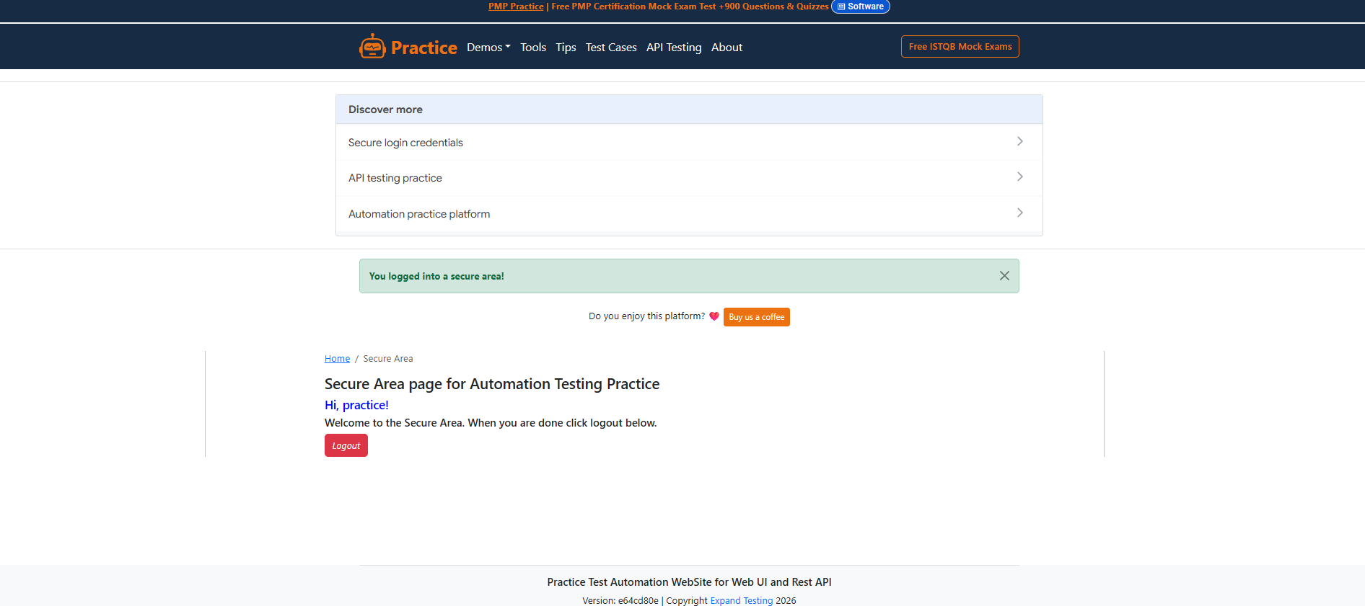

Figure 2 — Bug Evidence
Evidence For: BUG-003 — Password field with characters entered and masked, showing the absence of a show/hide toggle
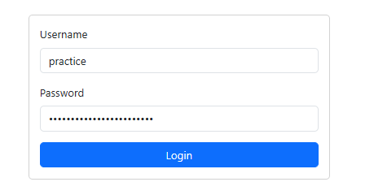

Figure 3 — Error Message
Evidence For: TC5_02 / TC5_03 — 'Invalid username.' and 'Invalid password.' messages, shown for reference as correctly functioning error handling
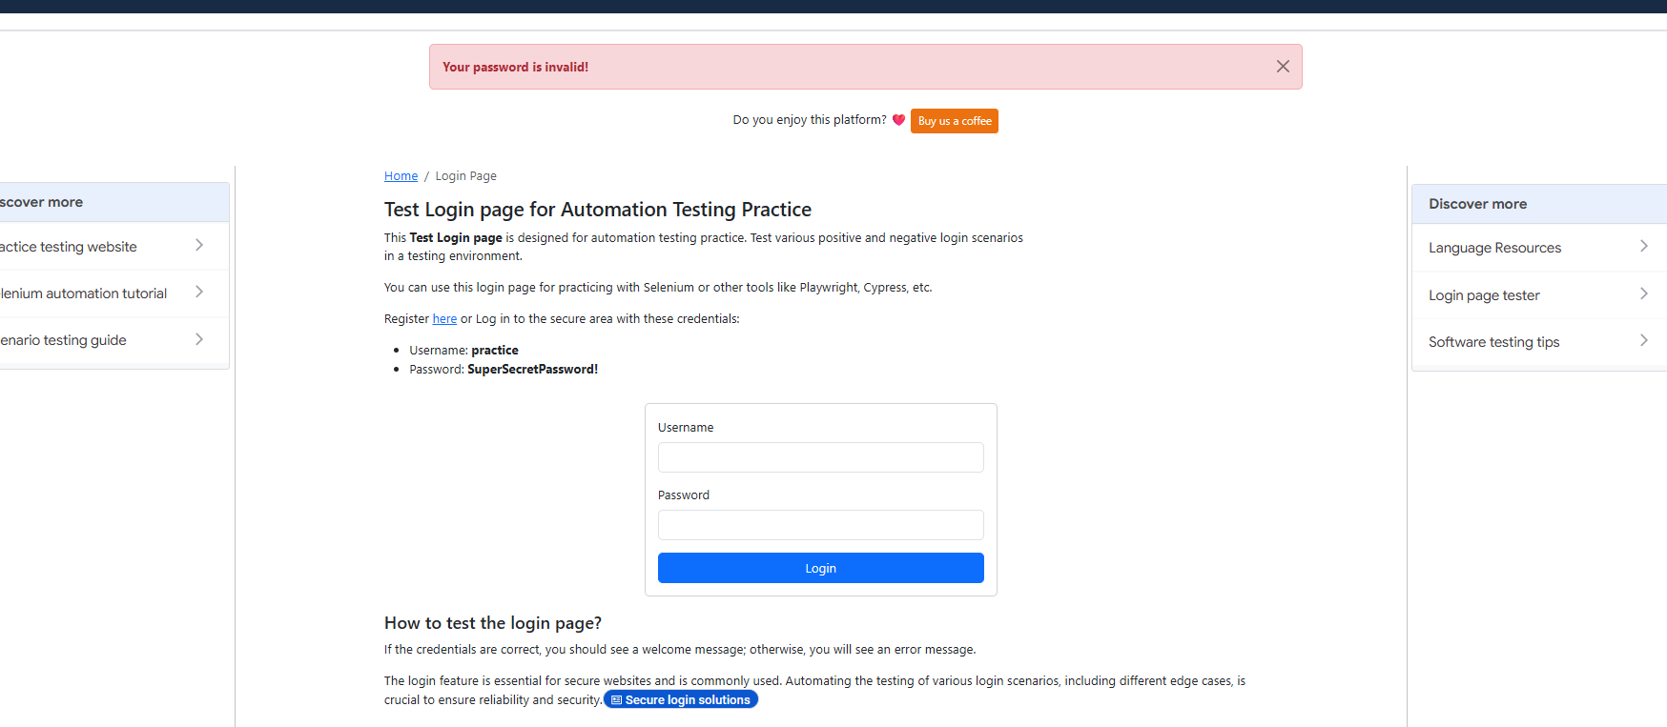

Figure 4 — Failure Screen
Evidence For: BUG-004 — Login form rendered at a 300px mobile viewport, showing cramped field/button spacing versus the desktop layout
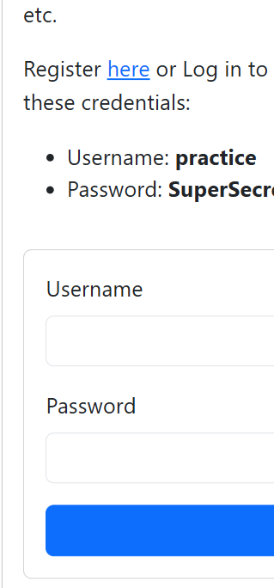

Figure 5 — Failure Screen
Evidence For: BUG-006 — Login form re-displayed at /login while the user is already authenticated, instead of a redirect to /secure
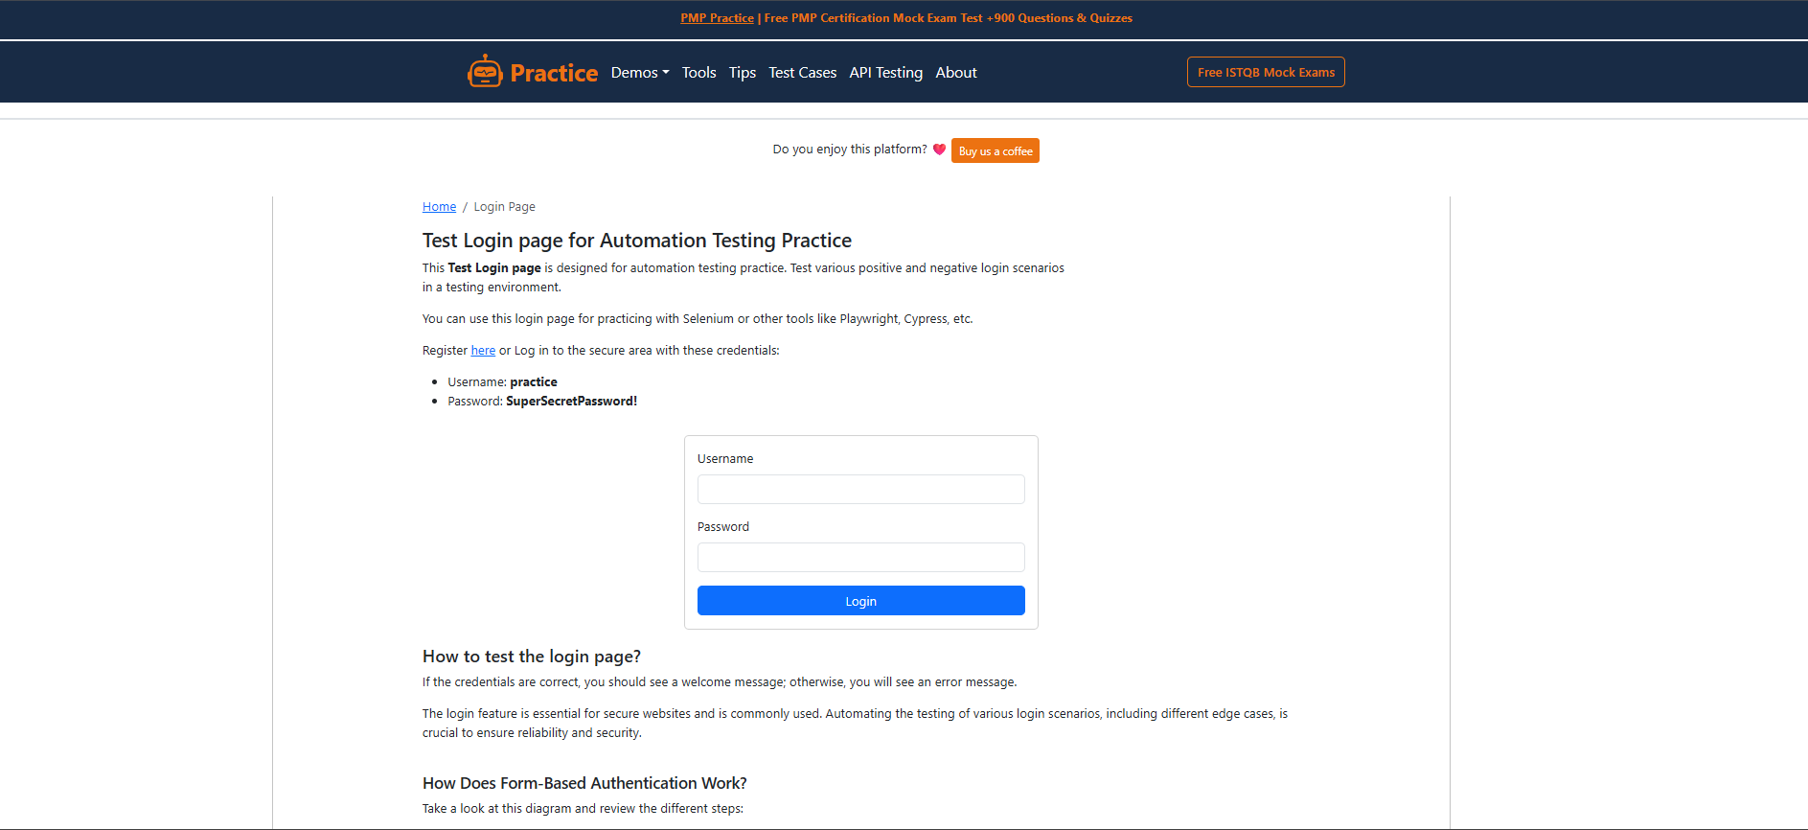

Figure 6 — Validation Screen
Evidence For: BUG-001 — Login page immediately after submitting with the Username field left blank, showing no inline validation cue
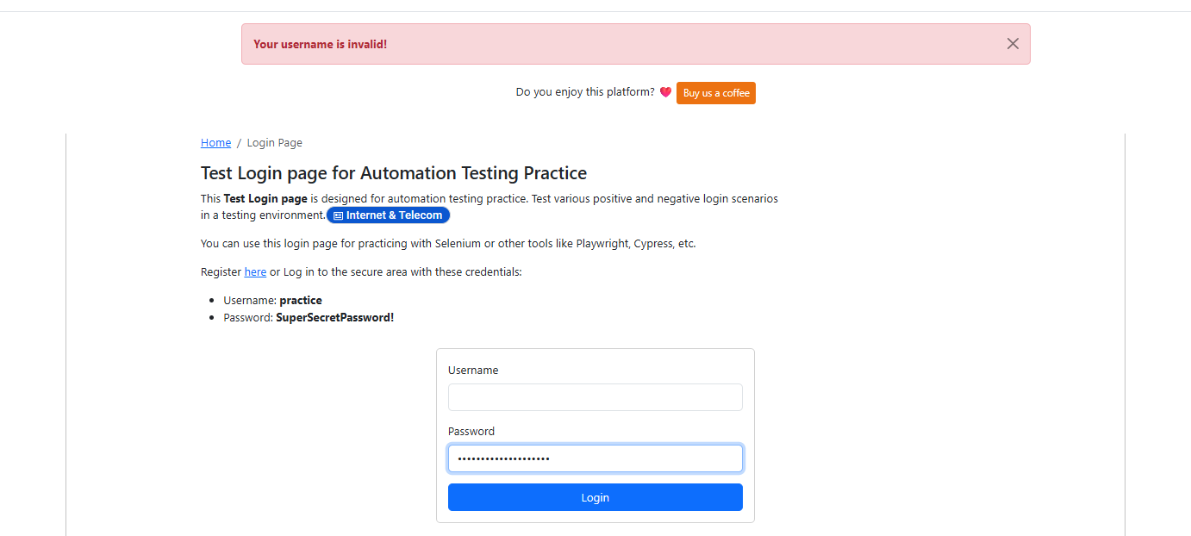

Figure 7 — Validation Screen
Evidence For: BUG-005 — Username field after entering a 300-character string, showing no maxlength constraint and no truncation
