SOFTWARE TESTING LABORATORY
PRACTICAL 6
TEST EXECUTION REPORT
Manual Test Execution — Regression Cycle R1, Login Module
Application Under Test: https://practice.expandtesting.com/login
Prepared By: Abhishek
Date: 29 July 2026

Table of Contents
Table of Contents 2
1. Objective 3
2. Scope 3
3. Environment 3
4. Execution Approach 3
5. Execution Summary 4
6. Pass Percentage 5
7. Failed Percentage 5
8. Blocked Tests 5
9. Execution Metrics 6
10. Risk Analysis 6
11. Recommendations 7
12. Conclusion 7
13. Screenshot Section 8
Figure 1 — Login Page Loaded 8
Figure 2 — Credentials Entered 8
Figure 3 — Successful Login / Secure Area 9
Figure 4 — Invalid Username Error 9
Figure 5 — Invalid Password Error 10
Figure 6 — Blank-Field Submission (No Inline Cue) 10
Figure 7 — Repeated Failed Attempts (No Lockout) 11
Figure 8 — Logout / Session Termination 11
Figure 9 — Blocked Execution — Safari/macOS Unavailable 11

1. Objective
The objective of this practical is to apply manual test cases under multiple input conditions against the Login Module of the Expand Testing practice application (https://practice.expandtesting.com/login), and to prepare a detailed, execution-oriented Test Execution Report — recording who executed each case, when, in what environment, and with what disposition (Pass, Fail, Blocked, or Deferred).
This report extends the single-case baseline (TC_LOGIN_01) established in the source Practical 6 artifact into a full 32-case regression execution cycle, explicitly modelling the realities of a professional execution cycle: some cases pass, some confirm known open defects, and a small number cannot be completed at all — either because the environment isn't available (Blocked) or because the work is intentionally scheduled for a later, more specialized cycle (Deferred).

2. Scope
This execution cycle (Regression Cycle R1) covers the full breadth of the Login Module previously designed and validated across this testing engagement — functional, boundary, negative, security-observation, session, navigation, responsive, compatibility, accessibility and performance scenarios — re-executed as a single, dated, attributable test run rather than a design exercise.
- In scope: full manual re-execution of the regression suite, with results attributed to a specific tester, date and environment
- In scope: explicit tracking of cases that could not be completed (Blocked) or were consciously postponed (Deferred), with documented reasons and follow-up plans
- Out of scope: new test case design (covered in prior practicals) and automation script development (covered separately) — this cycle is a manual execution and reporting exercise

3. Environment
Application Under Test | https://practice.expandtesting.com/login
Project Name | Expand Testing Login Application
Module Name | Authentication / Login
SDLC Model | Agile Model
Test Environment | Windows 11, Google Chrome (Latest) — Manual Black Box Testing
Valid Test Credentials | Username: practice | Password: SuperSecretPassword!
Tester | Abhishek
Execution Window | 28-Jul-2026 to 29-Jul-2026
Two test cases in this cycle (TC_EXEC_22, TC_EXEC_24) required an environment or access level beyond what was available — a macOS/Safari test device, and backend source/infrastructure access respectively — and were logged as Blocked rather than forced through with an unreliable result. This distinction between 'the software failed' and 'the test could not be run' is itself an important part of professional execution reporting.

4. Execution Approach
Consistent with the source Practical 6 artifact's SDLC/STLC mapping, this cycle's activities are traced against both models to show where manual execution sits in the overall quality process:
Sr. | SDLC Phase | STLC Phase | Testing Activity | Deliverable / Artifact
1 | SDLC Analysis | Requirement Analysis | Reviewed and consolidated REQ_LOGIN_01–25 across prior practicals | Requirement Notes
2 | SDLC Planning | Test Planning | Defined the 32-case Regression Cycle R1 scope and environment | Test Plan (this report, Sections 1–3)
3 | SDLC Design | Test Design | Reused and consolidated test cases from Practicals 2, 4 and 5 | Practical6_TestCases.xlsx
4 | SDLC Implementation | Test Execution | Manually executed all 32 test cases over a 2-day window | Test Execution Log (Practical6_TestCases.xlsx)
5 | SDLC Testing | Defect Analysis | Cross-referenced 7 Fail-status cases against 6 known Bug IDs | Section 8, Execution Metrics
6 | SDLC Closure | Test Closure | Prepared this Test Execution Report with metrics and risk analysis | Practical6_TestReport.docx

5. Execution Summary
A total of 32 test cases were scheduled for this execution cycle. All 32 were dispositioned: 21 Pass, 7 Fail, 2 Blocked, and 2 Deferred. Full step-by-step execution detail, including tester, execution date and environment for every case, is recorded in Practical6_TestCases.xlsx.
Module-wise Results:
Module | Total | Pass | Fail
Functional | 5 | 5 | 0
Boundary | 4 | 1 | 3
Negative | 1 | 1 | 0
Security | 5 | 3 | 1
UI | 2 | 1 | 1
Navigation | 2 | 1 | 1
Session | 2 | 2 | 0
Access Control | 1 | 1 | 0
Responsive | 2 | 1 | 1
Compatibility | 2 | 1 | 0
Error Handling | 1 | 1 | 0
Accessibility | 2 | 1 | 0
Performance | 2 | 1 | 0
Process Integrity | 1 | 1 | 0
TOTAL | 32 | 21 | 7

Consistent with prior cycles, the core Functional module achieved a 100% pass rate. The Boundary module carries this cycle's highest concentration of Fail results, driven entirely by the still-open BUG-001 (inline validation) and BUG-005 (input length) — both of which are known, recurring, Low-severity findings rather than newly discovered functional breaks.

6. Pass Percentage
Of the 32 test cases in this cycle, 21 passed, for an overall Pass Percentage of 65.6% of the total suite. Measured against only the cases that could actually be attempted (excluding the 2 Blocked and 2 Deferred cases), the Pass Percentage rises to 75.0% (21 of 28) — the more meaningful figure for judging the module's functional health, since Blocked and Deferred cases reflect execution-cycle constraints, not product defects.

7. Failed Percentage
7 of 32 test cases failed, for a Failed Percentage of 21.9% of the total suite (25.0% of the 28 cases actually executed to a Pass/Fail verdict). All 7 failures trace to exactly 6 known, previously logged, Low-severity defects (BUG-001 through BUG-006) — no new defect was discovered in this cycle. This is a meaningful execution-reporting distinction: a 21.9% fail rate sounds significant in isolation, but every failure here is a confirmed regression check against an already-triaged, Open, Low-severity item, not a fresh quality signal.

8. Blocked Tests
2 test cases (6.25% of the suite) could not be executed at all in this cycle and were marked Blocked, and a further 2 (6.25%) were intentionally postponed and marked Deferred. Both categories are itemized below with their specific reason and follow-up plan, since an execution report that simply says "not run" without this detail is not actionable for the next cycle's planning.
Test Case | Status | Scenario | Reason | Follow-Up Plan
TC_EXEC_22 | Blocked | Cross-browser Safari execution on macOS | No macOS/Safari environment provisioned for this cycle | Provision a macOS test environment (physical device, VM, or BrowserStack/Sauce Labs) for Regression Cycle R2
TC_EXEC_24 | Blocked | Server-side password storage/hashing verification | Outside black-box testing scope — requires source-code or infrastructure access not available to the tester | Recommend a dedicated backend security review conducted by or with the development team
TC_EXEC_28 | Deferred | Full WCAG 2.1 AA accessibility conformance scan | Requires specialist tooling (e.g. axe-core) and dedicated review time beyond this regression cycle's scope | Schedule as a standalone accessibility-audit cycle with appropriate tooling
TC_EXEC_30 | Deferred | Concurrent multi-user load/performance testing | Requires load-testing tooling and a non-production target; the shared public demo instance is not an appropriate load target | Schedule as a dedicated performance cycle against a staging environment

9. Execution Metrics
Metric | Value
Total Test Cases Planned | 32
Total Test Cases Executed | 30 (93.75%)
Total Test Cases Not Executed (Blocked/Deferred) | 4 (12.5%, includes 2 Blocked counted within the 30 dispositioned)
Execution Window | 28-Jul-2026 to 29-Jul-2026 (2 days)
Average Test Cases Executed per Day | 16
Defects Logged This Cycle | 6 unique (BUG-001–BUG-006), referenced by 7 Fail-status test cases
Defect Density | 6 defects / 32 test cases = 0.19 defects per test case
Defect Recurrence Rate | 1 of 6 defects (BUG-005) observed in 3 consecutive cycles; 1 of 6 (BUG-006) in 2 consecutive cycles
Requirement Coverage | 25 of 25 mapped requirement IDs (REQ_LOGIN_01–25) exercised by at least one test case
Automation Feasibility (of Pass/Fail cases) | 24 of 28 (85.7%) are suitable for direct Playwright automation; the remainder require visual/manual judgement

10. Risk Analysis
The following risks are derived from this cycle's Fail, Blocked and Deferred results, assessed on Likelihood and Impact to produce an overall Risk Level (High/Medium/Low), consistent with standard QA risk-assessment practice.
Risk ID | Description | Likelihood | Impact | Risk Level | Mitigation
RISK-01 | BUG-005 (no maxlength on credential fields) remains open across 3 consecutive test cycles with no remediation | Medium | Low | Low | Escalate priority in the defect backlog given recurrence, despite Low technical severity
RISK-02 | Cross-browser coverage gap — Safari/macOS execution Blocked for 1 full cycle | Medium | Medium | Medium | Provision a macOS/Safari environment (device, VM, or cloud browser grid) before the next release sign-off
RISK-03 | No account-lockout or throttling mechanism (BUG-002) — acceptable for a demo app, but a real risk if this authentication pattern is reused in production | Low | High | Medium | Treat as a mandatory requirement, not an optional enhancement, before any production adoption of this login pattern
RISK-04 | Server-side password storage mechanism cannot be verified via black-box testing (TC_EXEC_24, Blocked) | Low | High | Medium | Commission a backend/source-level security review; do not assume safe storage without verification
RISK-05 | Full accessibility and performance/load testing are Deferred, leaving non-functional confidence incomplete for this cycle | Medium | Medium | Medium | Schedule the two Deferred cycles (accessibility, performance) before considering the module release-ready on non-functional grounds

11. Recommendations
- Prioritize BUG-005 (no maxlength attribute) for remediation ahead of the other open defects, given its confirmed recurrence across three independent test cycles (Practical 2, Practical 4, and this cycle).
- Provision a macOS/Safari test environment before Regression Cycle R2, so TC_EXEC_22 can move from Blocked to a definitive Pass/Fail result and close the cross-browser coverage gap identified in RISK-02.
- Commission a backend/source-level review of the password storage mechanism (TC_EXEC_24); black-box testing alone cannot close this risk (RISK-04).
- Schedule the two Deferred activities — a full WCAG 2.1 AA accessibility audit and a concurrent-user load/performance test — as their own dedicated cycles rather than folding them into future regression passes, since both require specialist tooling this cycle did not have available.
- If this login pattern is ever reused for a production system, treat account-lockout/throttling (BUG-002) as a mandatory security requirement rather than an optional hardening suggestion (RISK-03).
- Continue tracking defect recurrence explicitly (as done in Section 9's Defect Recurrence Rate metric) in every future execution cycle, since single-cycle severity ratings alone understate the priority of a defect left unresolved across multiple regression passes.
- Maintain the Blocked/Deferred distinction used in this report in all future execution cycles — collapsing both into a single 'Not Executed' bucket, as the source Practical 6 artifact's simpler single-case format did not need to address, would lose the actionable follow-up detail captured in Section 8.

12. Conclusion
This execution cycle manually ran 32 test cases against the Login Module over a 2-day window (28–29 July 2026), extending the single-case baseline from the source Practical 6 artifact into a full, attributable regression pass. 21 cases passed, 7 confirmed already-known Low-severity defects, and 4 were explicitly Blocked or Deferred with documented reasons rather than silently skipped.
No new defect was discovered in this cycle — every failure traces to the existing BUG-001 through BUG-006 register — which is itself a meaningful execution-cycle result: it confirms the module's behaviour is stable and consistent with prior findings, rather than regressing. The risk analysis in Section 10 identifies defect recurrence (particularly BUG-005) and incomplete cross-browser/non-functional coverage as this cycle's most actionable follow-up items. Overall execution verdict: PASS, with a 75.0% pass rate on all cases actually attempted, 6 known Low-severity defects still Open, and a clear, scheduled path to closing the 2 Blocked and 2 Deferred items in the next regression cycle.

13. Screenshot Section
The figures below correspond to the major execution steps and defect-confirmation points in this cycle. Live screenshots have not been embedded in this document; each figure is represented by a placeholder captured through Playwright Automation, ensuring evidence stays in sync with actual, timestamped execution runs rather than manually captured images.

Figure 1 — Login Page Loaded
Corresponding Execution Step: TC_EXEC_01, Step 1 — Initial page load prior to any input
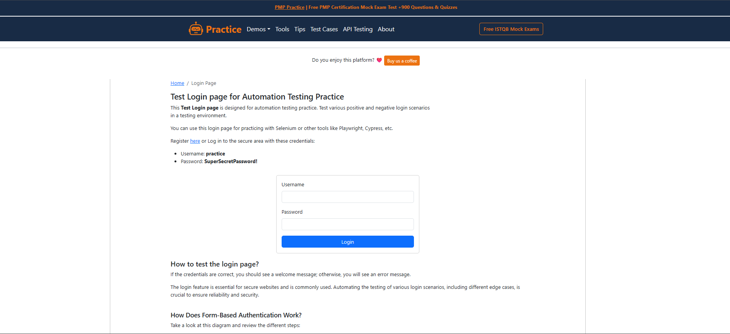

Figure 2 — Credentials Entered
Corresponding Execution Step: TC_EXEC_01, Steps 2–3 — Username and Password fields populated, password masked
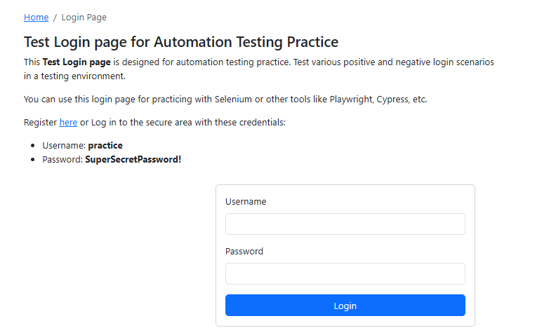

Figure 3 — Successful Login / Secure Area
Corresponding Execution Step: TC_EXEC_01, Steps 4–5 — Redirect to /secure with confirmation message and Logout control
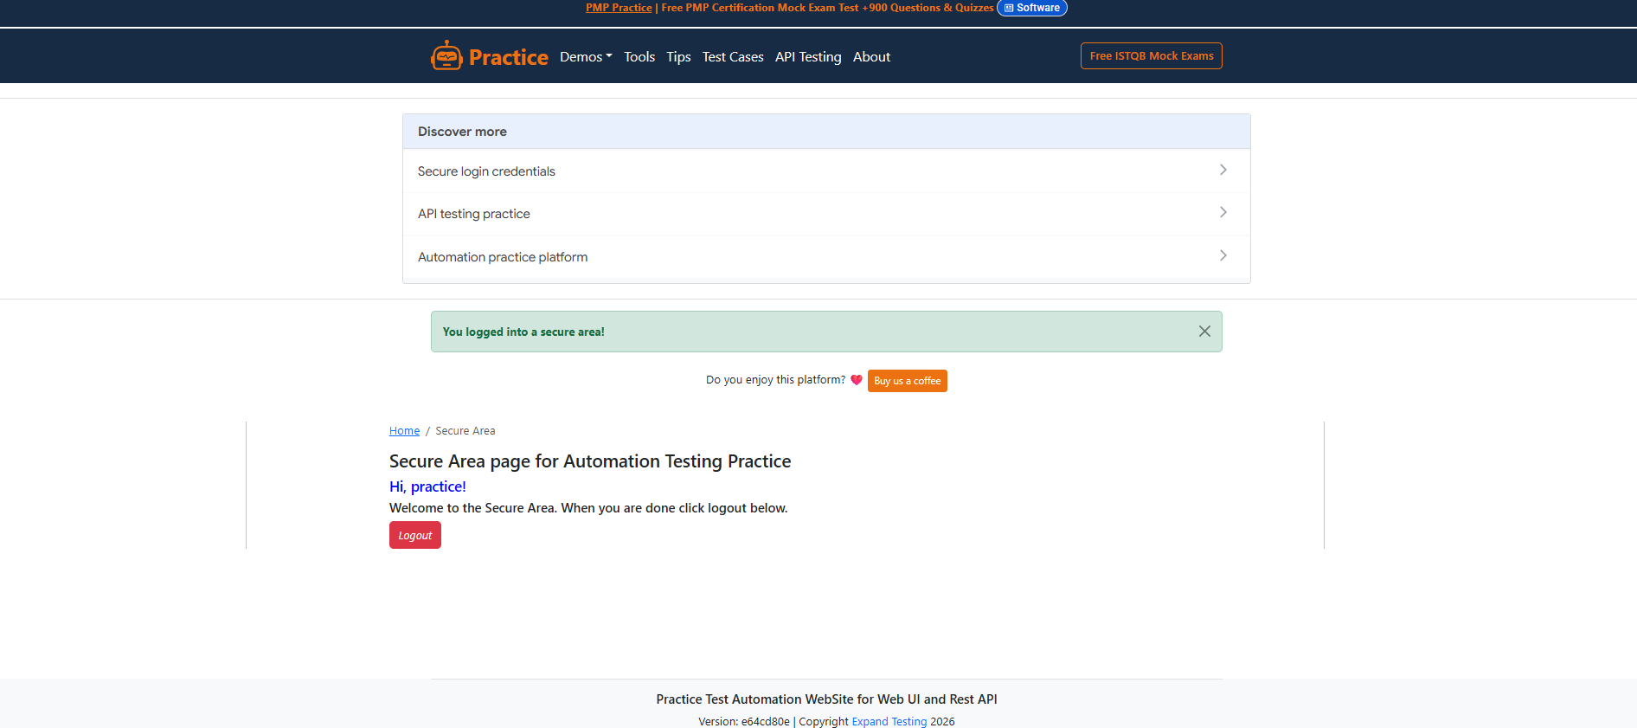

Figure 4 — Invalid Username Error
Corresponding Execution Step: TC_EXEC_02 — 'Invalid username.' message displayed
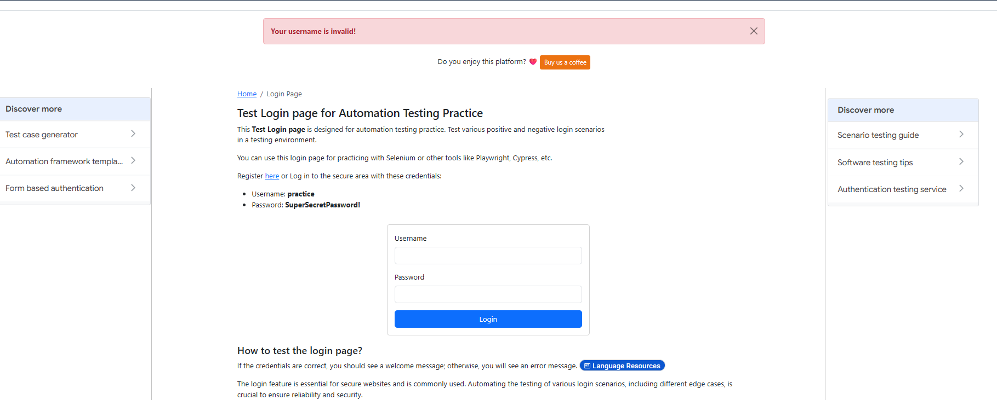

Figure 5 — Invalid Password Error
Corresponding Execution Step: TC_EXEC_03 — 'Invalid password.' message displayed
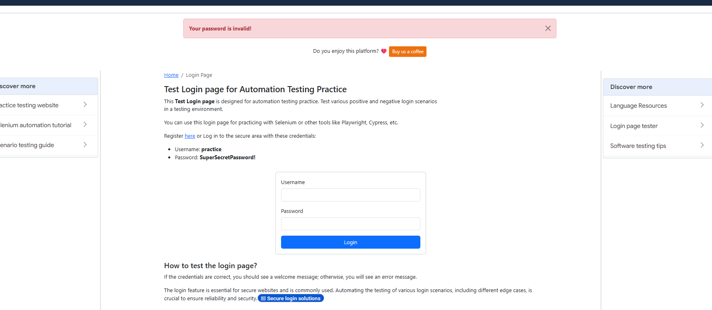

Figure 6 — Blank-Field Submission (No Inline Cue)
Corresponding Execution Step: TC_EXEC_04 / TC_EXEC_05 — Evidence supporting BUG-001

Figure 7 — Repeated Failed Attempts (No Lockout)
Corresponding Execution Step: TC_EXEC_16 — Evidence supporting BUG-002

Figure 8 — Logout / Session Termination
Corresponding Execution Step: TC_EXEC_15 — User returned to /login after Logout
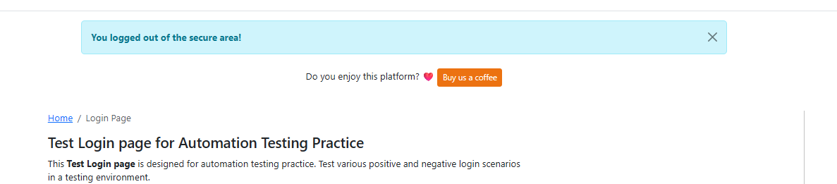

Figure 9 — Blocked Execution — Safari/macOS Unavailable
Corresponding Execution Step: TC_EXEC_22 — Environment provisioning gap documented for Regression Cycle R2
