SOFTWARE TESTING – TEST REPORT
Practical 11: Python Automation Testing of SauceDemo
1. Test Report Information
Project Name | Python Automation Testing
Practical | Practical 11 – Tutorial 11
Application Under Test | SauceDemo (https://www.saucedemo.com/)
Module Tested | Navigation, Forms, Links and Multi-Page Workflow
Test Type | Automated functional, validation and regression testing (black box)
Automation Script | P11.py
Executed By | Abhishek
Execution Date | 01-10-2026 (started 13:25:20)
Overall Result | PASS (17 of 17 test steps passed)
2. Aim
To analyze automation testing in Python for website navigation, forms, multi-page workflows, links and regression testing scenarios, by automating the SauceDemo shopping workflow with Selenium WebDriver.
3. Application Under Test
SauceDemo is a publicly available demo e-commerce web application. It provides a login page, a product listing page, a shopping cart, a three-page checkout (information, overview, confirmation) and a menu with logout and links. The tested user journey was login, product selection, cart, checkout and logout.
4. Test Environment
Parameter | Details
Programming Language | Python 3.14.3
Automation Tool | Selenium WebDriver 4.49.0
Browser | Google Chrome 154.0.8037.58
IDE | PyCharm
Target URL | https://www.saucedemo.com/
Test Data | Valid: standard_user / secret_sauce  Invalid password: wrong_password  Product: Sauce Labs Backpack  Checkout: Student, Testing, 380001
5. Testing Scope
The following areas were covered by the automation script. Areas not listed (for example other user accounts, product sorting, other browsers and performance) were outside the scope of this practical.
Area | Scenarios | Test IDs
Website navigation | Open site, page title and URL, back/forward navigation | TC-11-01, TC-11-11
Login form handling | Wrong password, empty credentials, valid login | TC-11-02, 03, 04
Web link interaction | Menu About link, Continue Shopping link | TC-11-06, TC-11-09
Product and cart | Product listing, add to cart, cart verification | TC-11-05, 07, 08
Checkout / multi-page workflow | Checkout form, order overview, order completion | TC-11-10, 12, 13
Validation testing | Empty checkout form error | TC-11-17
Logout and regression | Logout, re-login, cart reset after order | TC-11-14, 15, 16
6. Test Case Execution
Results below are taken from the actual console output of P11.py.
Test ID | Scenario | Test Data | Expected Result | Actual Result | Status
TC-11-01 | Open website / page title | URL: https://www.saucedemo.com/ | Login page opens with title "Swag Labs" | Title = 'Swag Labs', URL = https://www.saucedemo.com/ | PASS
TC-11-02 | Invalid login (wrong password) | standard_user / wrong_password | Error "Username and password do not match" shown; user stays on login page | Epic sadface: Username and password do not match any user in this service | PASS
TC-11-03 | Invalid login (empty credentials) | No username, no password | Error "Username is required" shown | Epic sadface: Username is required | PASS
TC-11-04 | Valid login | standard_user / secret_sauce | Products page (inventory.html) opens | URL = https://www.saucedemo.com/inventory.html, heading = 'Products' | PASS
TC-11-05 | Verify product listing | – | 6 products displayed | 6 products displayed | PASS
TC-11-06 | Web link interaction (menu About link) | Menu → About | About link points to saucelabs.com | 'About' link points to https://saucelabs.com/ | PASS
TC-11-07 | Product selection (add to cart) | Sauce Labs Backpack | Product added; cart badge shows 1 | 'Sauce Labs Backpack' added, cart badge = 1 | PASS
TC-11-08 | Open cart and verify item | Cart icon | Cart page opens with the selected product | URL = https://www.saucedemo.com/cart.html, item in cart = 'Sauce Labs Backpack' | PASS
TC-11-09 | Continue Shopping link | Continue Shopping | Products page opens | 'Continue Shopping' returned to Products page; cart re-opened | PASS
TC-11-10 | Checkout form handling | Student / Testing / 380001 | Form data accepted; checkout-step-two opens | Form accepted, URL = https://www.saucedemo.com/checkout-step-two.html | PASS
TC-11-11 | Back / forward navigation | Browser back, forward | back() opens step one; forward() opens step two | back() -> checkout-step-one, forward() -> checkout-step-two | PASS
TC-11-12 | Verify order overview | – | Selected product listed in overview | Order overview lists 'Sauce Labs Backpack' | PASS
TC-11-13 | Finish order (multi-page workflow) | Finish | checkout-complete page with confirmation message | URL = https://www.saucedemo.com/checkout-complete.html, message = 'Thank you for your order!' | PASS
TC-11-14 | Logout | Menu → Logout | User returns to login page | Returned to login page | PASS
TC-11-15 | Regression: re-login after logout | standard_user / secret_sauce | Login works again; 6 products shown | Login works again after logout; 6 products displayed | PASS
TC-11-16 | Regression: cart reset after order | – | Cart empty; product can be added again | Cart is empty and product can be added again | PASS
TC-11-17 | Validation: empty checkout form | All fields empty | Error "First Name is required" shown | Error: First Name is required | PASS
7. Execution Summary
Metric | Value
Total Test Steps | 17
Executed | 17
Passed | 17
Failed | 0
Pass Percentage | 100%
Execution Time | 13.38 seconds
Overall Status | PASS
8. Observations
Sr. No. | Observation
1 | All 17 test steps passed and no defects were found in the tested scenarios.
2 | Invalid login attempts were rejected with clear error messages, and the user was not taken to the Products page.
3 | The complete purchase workflow (login, add to cart, cart, checkout, overview, order confirmation) worked end to end.
4 | Browser back/forward navigation on the checkout pages moved between step one and step two correctly.
5 | After logout and re-login, the Products page loaded with 6 products and the cart was empty, so the earlier functionality was unaffected.
6 | Error message wording differs between pages: login errors start with "Epic sadface:" while the checkout error starts with "Error:". This is a cosmetic difference, not a failure.
7 | Testing used one user account, one product and one browser, so results apply to those conditions only.
9. Evidence
Insert the screenshots below before submission.
Figure 1: Login page
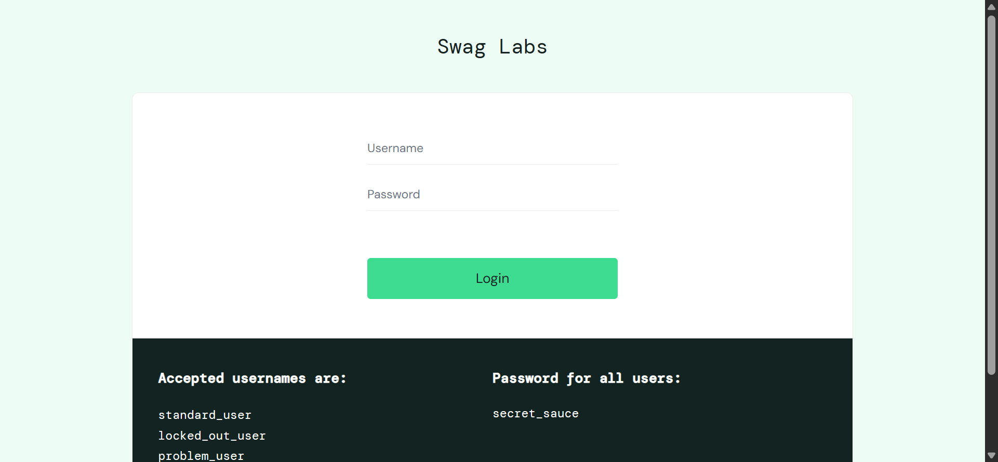
Figure 2: Products page
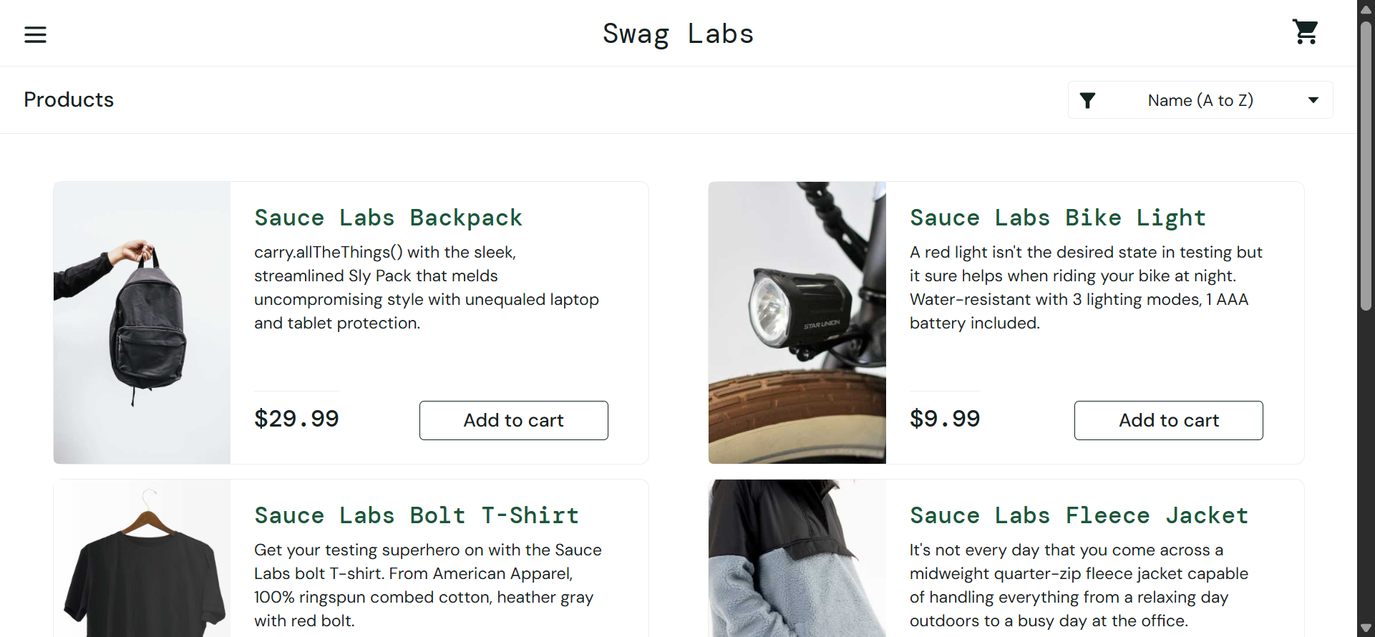
Figure 3: Cart page
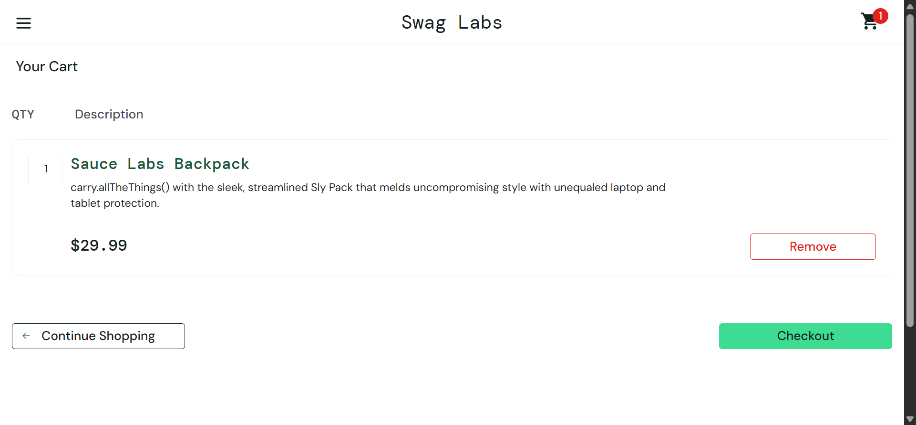
Figure 4: Checkout page
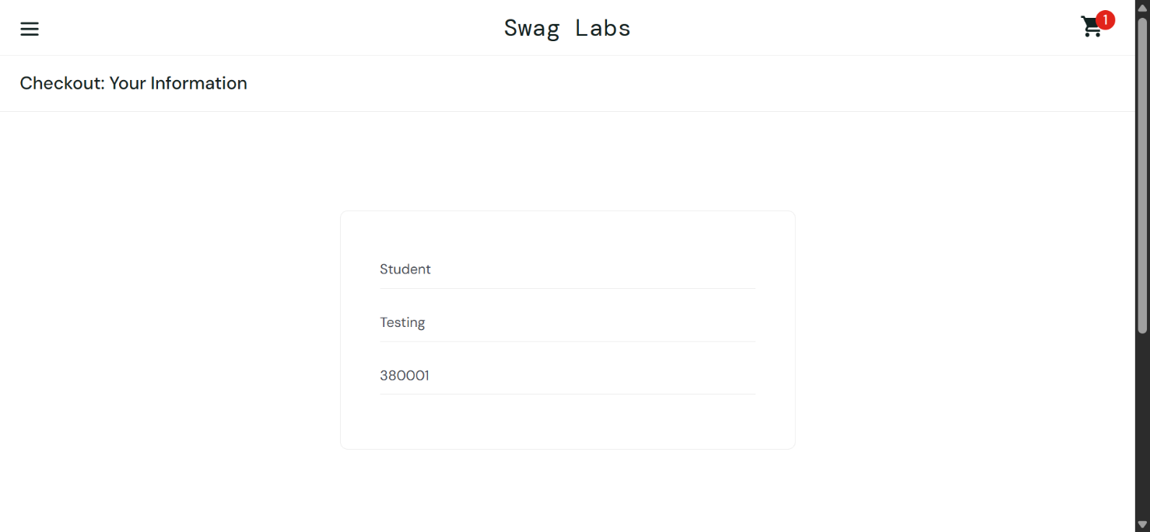
Figure 5: Order confirmation page
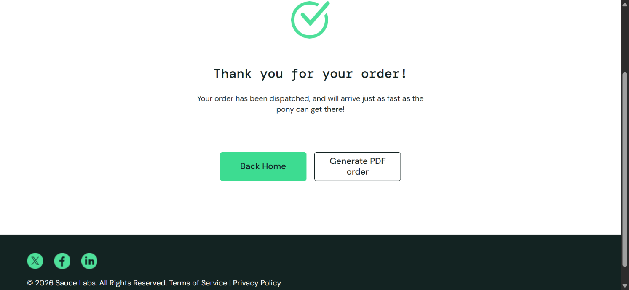
Appendix A: Console Output
======================================================================
Practical 11 - Python Automation Testing (SauceDemo)
Execution started: 01-10-2026 13:25:20
======================================================================
Browser : chrome 154.0.8037.58
Selenium: 4.49.0
Python : 3.14.3

[TC-11-01] Open website / page title: PASS
-> Title = 'Swag Labs', URL = https://www.saucedemo.com/
[TC-11-02] Invalid login (wrong password): PASS
-> Error shown: Epic sadface: Username and password do not match any user in this service
[TC-11-03] Invalid login (empty credentials): PASS
-> Error shown: Epic sadface: Username is required
[TC-11-04] Valid login: PASS
-> URL = https://www.saucedemo.com/inventory.html, heading = 'Products'
[TC-11-05] Verify product listing: PASS
-> 6 products displayed
[TC-11-06] Web link interaction (menu About link): PASS
-> 'About' link points to https://saucelabs.com/
[TC-11-07] Product selection (add to cart): PASS
-> 'Sauce Labs Backpack' added, cart badge = 1
[TC-11-08] Open cart and verify item: PASS
-> URL = https://www.saucedemo.com/cart.html, item in cart = 'Sauce Labs Backpack'
[TC-11-09] Continue Shopping link: PASS
-> 'Continue Shopping' returned to Products page; cart re-opened
[TC-11-10] Checkout form handling: PASS
-> Form accepted, URL = https://www.saucedemo.com/checkout-step-two.html
[TC-11-11] Back / forward navigation: PASS
-> back() -> checkout-step-one, forward() -> checkout-step-two
[TC-11-12] Verify order overview: PASS
-> Order overview lists 'Sauce Labs Backpack'
[TC-11-13] Finish order (multi-page workflow): PASS
-> URL = https://www.saucedemo.com/checkout-complete.html, message = 'Thank you for your order!'
[TC-11-14] Logout: PASS
-> Returned to login page
[TC-11-15] Regression: re-login after logout: PASS
-> Login works again after logout; 6 products displayed
[TC-11-16] Regression: cart reset after order: PASS
-> Cart is empty and product can be added again
[TC-11-17] Validation: empty checkout form: PASS
-> Error shown: Error: First Name is required

======================================================================
EXECUTION SUMMARY
======================================================================
TC-11-01 Open website / page title PASS
TC-11-02 Invalid login (wrong password) PASS
TC-11-03 Invalid login (empty credentials) PASS
TC-11-04 Valid login PASS
TC-11-05 Verify product listing PASS
TC-11-06 Web link interaction (menu About link) PASS
TC-11-07 Product selection (add to cart) PASS
TC-11-08 Open cart and verify item PASS
TC-11-09 Continue Shopping link PASS
TC-11-10 Checkout form handling PASS
TC-11-11 Back / forward navigation PASS
TC-11-12 Verify order overview PASS
TC-11-13 Finish order (multi-page workflow) PASS
TC-11-14 Logout PASS
TC-11-15 Regression: re-login after logout PASS
TC-11-16 Regression: cart reset after order PASS
TC-11-17 Validation: empty checkout form PASS
----------------------------------------------------------------------
Total test steps : 17
Passed : 17
Failed : 0
Execution time : 13.38 seconds
Overall status : PASS
======================================================================
Appendix B: Source Code (P11.py)
"""
Practical 11 - Python Automation Testing (Software Testing)
Application Under Test : SauceDemo (https://www.saucedemo.com/)
Tool / Language : Selenium WebDriver + Python (Google Chrome, PyCharm)

Covers: website navigation, login form handling (invalid + valid), web link
interaction, product selection, multi-page workflow (inventory -> cart ->
checkout -> overview -> complete), back/forward navigation, logout and a
small regression check (re-login after logout).

Install : pip install selenium
Run : python PR11.py
"""

import sys
import time
from datetime import datetime

from selenium import webdriver
from selenium.common.exceptions import (
NoSuchElementException,
TimeoutException,
WebDriverException,
)
from selenium.webdriver.common.by import By
from selenium.webdriver.support import expected_conditions as EC
from selenium.webdriver.support.ui import WebDriverWait

# --------------------------------------------------------------------------
# Test data
# --------------------------------------------------------------------------
BASE_URL = "https://www.saucedemo.com/"
VALID_USER = "standard_user"
VALID_PASS = "secret_sauce"
INVALID_PASS = "wrong_password"
PRODUCT_NAME = "Sauce Labs Backpack"
FIRST_NAME = "Student"
LAST_NAME = "Testing"
POSTAL_CODE = "380001"

# --------------------------------------------------------------------------
# Locators
# --------------------------------------------------------------------------
USERNAME = (By.ID, "user-name")
PASSWORD = (By.ID, "password")
LOGIN_BTN = (By.ID, "login-button")
ERROR_MSG = (By.CSS_SELECTOR, "[data-test='error']")
PAGE_TITLE = (By.CLASS_NAME, "title")
INVENTORY_ITEMS = (By.CLASS_NAME, "inventory_item")
ADD_BACKPACK = (By.ID, "add-to-cart-sauce-labs-backpack")
REMOVE_BACKPACK = (By.ID, "remove-sauce-labs-backpack")
CART_LINK = (By.CLASS_NAME, "shopping_cart_link")
CART_BADGE = (By.CLASS_NAME, "shopping_cart_badge")
CART_ITEM_NAME = (By.CLASS_NAME, "inventory_item_name")
CONTINUE_SHOPPING = (By.ID, "continue-shopping")
CHECKOUT_BTN = (By.ID, "checkout")
FIRST_NAME_FIELD = (By.ID, "first-name")
LAST_NAME_FIELD = (By.ID, "last-name")
POSTAL_FIELD = (By.ID, "postal-code")
CONTINUE_BTN = (By.ID, "continue")
FINISH_BTN = (By.ID, "finish")
COMPLETE_HEADER = (By.CLASS_NAME, "complete-header")
MENU_BTN = (By.ID, "react-burger-menu-btn")
ABOUT_LINK = (By.ID, "about_sidebar_link")
LOGOUT_LINK = (By.ID, "logout_sidebar_link")

# --------------------------------------------------------------------------
# Result tracking
# --------------------------------------------------------------------------
results = [] # list of (test_id, description, status, detail)

def run_step(test_id, description, func):
"""Run one test step, catch failures, print and record the result."""
try:
detail = func()
status = "PASS"
except AssertionError as err:
status, detail = "FAIL", f"Assertion failed: {err}"
except TimeoutException:
status, detail = "FAIL", "TimeoutException: expected element/condition not found in time"
except NoSuchElementException as err:
status, detail = "FAIL", f"NoSuchElementException: {err.msg}"
except WebDriverException as err:
status, detail = "FAIL", f"WebDriverException: {str(err).splitlines()[0]}"

results.append((test_id, description, status, detail))
print(f"[{test_id}] {description}: {status}")
if detail:
print(f" -> {detail}")
return status == "PASS"

# --------------------------------------------------------------------------
# Test steps
# --------------------------------------------------------------------------
def open_website(driver, wait):
driver.get(BASE_URL)
wait.until(EC.visibility_of_element_located(LOGIN_BTN))
assert "Swag Labs" in driver.title, f"Unexpected title: {driver.title}"
assert driver.current_url == BASE_URL, f"Unexpected URL: {driver.current_url}"
return f"Title = '{driver.title}', URL = {driver.current_url}"

def login(driver, wait, username, password):
wait.until(EC.visibility_of_element_located(USERNAME)).clear()
driver.find_element(*USERNAME).send_keys(username)
driver.find_element(*PASSWORD).clear()
driver.find_element(*PASSWORD).send_keys(password)
driver.find_element(*LOGIN_BTN).click()

def invalid_password_login(driver, wait):
driver.get(BASE_URL)
login(driver, wait, VALID_USER, INVALID_PASS)
error = wait.until(EC.visibility_of_element_located(ERROR_MSG)).text
assert "Username and password do not match" in error, f"Unexpected error: {error}"
assert "inventory" not in driver.current_url, "User should not reach the inventory page"
return f"Error shown: {error}"

def empty_credentials_login(driver, wait):
driver.get(BASE_URL)
wait.until(EC.element_to_be_clickable(LOGIN_BTN)).click()
error = wait.until(EC.visibility_of_element_located(ERROR_MSG)).text
assert "Username is required" in error, f"Unexpected error: {error}"
return f"Error shown: {error}"

def valid_login(driver, wait):
driver.get(BASE_URL)
login(driver, wait, VALID_USER, VALID_PASS)
wait.until(EC.url_contains("inventory"))
assert "inventory.html" in driver.current_url, f"Unexpected URL: {driver.current_url}"
title = wait.until(EC.visibility_of_element_located(PAGE_TITLE)).text
assert title == "Products", f"Unexpected page heading: {title}"
return f"URL = {driver.current_url}, heading = '{title}'"

def verify_product_listing(driver, wait):
items = wait.until(EC.presence_of_all_elements_located(INVENTORY_ITEMS))
assert len(items) == 6, f"Expected 6 products, found {len(items)}"
return f"{len(items)} products displayed"

def web_link_interaction(driver, wait):
wait.until(EC.element_to_be_clickable(MENU_BTN)).click()
about = wait.until(EC.visibility_of_element_located(ABOUT_LINK))
href = about.get_attribute("href")
assert "saucelabs.com" in href, f"Unexpected About link: {href}"
# Close the menu again so later steps are not affected
driver.find_element(By.ID, "react-burger-cross-btn").click()
wait.until(EC.invisibility_of_element_located(ABOUT_LINK))
return f"'About' link points to {href}"

def add_product(driver, wait):
wait.until(EC.element_to_be_clickable(ADD_BACKPACK)).click()
badge = wait.until(EC.visibility_of_element_located(CART_BADGE)).text
assert badge == "1", f"Cart badge expected 1, found {badge}"
remove_text = driver.find_element(*REMOVE_BACKPACK).text
assert remove_text == "Remove", f"Button text expected 'Remove', found '{remove_text}'"
return f"'{PRODUCT_NAME}' added, cart badge = {badge}"

def open_cart(driver, wait):
driver.find_element(*CART_LINK).click()
wait.until(EC.url_contains("cart.html"))
name = wait.until(EC.visibility_of_element_located(CART_ITEM_NAME)).text
assert name == PRODUCT_NAME, f"Cart item expected '{PRODUCT_NAME}', found '{name}'"
return f"URL = {driver.current_url}, item in cart = '{name}'"

def continue_shopping_link(driver, wait):
wait.until(EC.element_to_be_clickable(CONTINUE_SHOPPING)).click()
wait.until(EC.url_contains("inventory"))
assert "inventory.html" in driver.current_url
# Return to the cart for the checkout steps
driver.find_element(*CART_LINK).click()
wait.until(EC.url_contains("cart.html"))
return "'Continue Shopping' returned to Products page; cart re-opened"

def checkout_form(driver, wait):
wait.until(EC.element_to_be_clickable(CHECKOUT_BTN)).click()
wait.until(EC.url_contains("checkout-step-one"))
wait.until(EC.visibility_of_element_located(FIRST_NAME_FIELD)).send_keys(FIRST_NAME)
driver.find_element(*LAST_NAME_FIELD).send_keys(LAST_NAME)
driver.find_element(*POSTAL_FIELD).send_keys(POSTAL_CODE)
driver.find_element(*CONTINUE_BTN).click()
wait.until(EC.url_contains("checkout-step-two"))
assert "checkout-step-two" in driver.current_url, f"Unexpected URL: {driver.current_url}"
return f"Form accepted, URL = {driver.current_url}"

def checkout_validation_error(driver, wait):
"""Leave the checkout form empty on a fresh visit to step one and click Continue."""
driver.get("https://www.saucedemo.com/checkout-step-one.html")
wait.until(EC.element_to_be_clickable(CONTINUE_BTN)).click()
error = wait.until(EC.visibility_of_element_located(ERROR_MSG)).text
assert "First Name is required" in error, f"Unexpected error: {error}"
return f"Error shown: {error}"

def back_forward_navigation(driver, wait):
wait.until(EC.url_contains("checkout-step-two"))
driver.back()
wait.until(EC.url_contains("checkout-step-one"))
assert "checkout-step-one" in driver.current_url, "back() did not reach step one"
driver.forward()
wait.until(EC.url_contains("checkout-step-two"))
assert "checkout-step-two" in driver.current_url, "forward() did not reach step two"
return "back() -> checkout-step-one, forward() -> checkout-step-two"

def verify_order_overview(driver, wait):
name = wait.until(EC.visibility_of_element_located(CART_ITEM_NAME)).text
assert name == PRODUCT_NAME, f"Overview item expected '{PRODUCT_NAME}', found '{name}'"
return f"Order overview lists '{name}'"

def finish_order(driver, wait):
wait.until(EC.element_to_be_clickable(FINISH_BTN)).click()
wait.until(EC.url_contains("checkout-complete"))
header = wait.until(EC.visibility_of_element_located(COMPLETE_HEADER)).text
assert "Thank you for your order" in header, f"Unexpected message: {header}"
return f"URL = {driver.current_url}, message = '{header}'"

def logout(driver, wait):
wait.until(EC.element_to_be_clickable(MENU_BTN)).click()
wait.until(EC.element_to_be_clickable(LOGOUT_LINK)).click()
wait.until(EC.visibility_of_element_located(LOGIN_BTN))
assert driver.current_url == BASE_URL, f"Unexpected URL after logout: {driver.current_url}"
return "Returned to login page"

def regression_relogin(driver, wait):
login(driver, wait, VALID_USER, VALID_PASS)
wait.until(EC.url_contains("inventory"))
items = wait.until(EC.presence_of_all_elements_located(INVENTORY_ITEMS))
assert len(items) == 6, f"Expected 6 products, found {len(items)}"
return f"Login works again after logout; {len(items)} products displayed"

def regression_cart_reset(driver, wait):
button = wait.until(EC.visibility_of_element_located(ADD_BACKPACK))
assert button.text == "Add to cart", f"Unexpected button text: {button.text}"
assert not driver.find_elements(*CART_BADGE), "Cart badge should be empty after completed order"
return "Cart is empty and product can be added again"

# --------------------------------------------------------------------------
# Main
# --------------------------------------------------------------------------
def build_driver():
options = webdriver.ChromeOptions()
# Stops Chrome's password-manager / breach pop-ups from blocking clicks
options.add_experimental_option("prefs", {
"credentials_enable_service": False,
"profile.password_manager_enabled": False,
"profile.password_manager_leak_detection": False,
})
options.add_experimental_option("excludeSwitches", ["enable-automation"])
driver = webdriver.Chrome(options=options)
driver.maximize_window()
return driver

def print_summary(elapsed):
total = len(results)
passed = sum(1 for r in results if r[2] == "PASS")
failed = total - passed
print("\n" + "=" * 70)
print("EXECUTION SUMMARY")
print("=" * 70)
for test_id, description, status, _ in results:
print(f"{test_id:<10} {description:<45} {status}")
print("-" * 70)
print(f"Total test steps : {total}")
print(f"Passed : {passed}")
print(f"Failed : {failed}")
print(f"Execution time : {elapsed:.2f} seconds")
print(f"Overall status : {'PASS' if failed == 0 else 'FAIL'}")
print("=" * 70)

def main():
print("=" * 70)
print("Practical 11 - Python Automation Testing (SauceDemo)")
print(f"Execution started: {datetime.now():%d-%m-%Y %H:%M:%S}")
print("=" * 70)

start = time.time()
driver = None
try:
driver = build_driver()
wait = WebDriverWait(driver, 10)
print(f"Browser : {driver.capabilities.get('browserName')} "
f"{driver.capabilities.get('browserVersion')}")
print(f"Selenium: {webdriver.__version__ if hasattr(webdriver, '__version__') else 'n/a'}")
print(f"Python : {sys.version.split()[0]}\n")

run_step("TC-11-01", "Open website / page title", lambda: open_website(driver, wait))
run_step("TC-11-02", "Invalid login (wrong password)", lambda: invalid_password_login(driver, wait))
run_step("TC-11-03", "Invalid login (empty credentials)", lambda: empty_credentials_login(driver, wait))
run_step("TC-11-04", "Valid login", lambda: valid_login(driver, wait))
run_step("TC-11-05", "Verify product listing", lambda: verify_product_listing(driver, wait))
run_step("TC-11-06", "Web link interaction (menu About link)", lambda: web_link_interaction(driver, wait))
run_step("TC-11-07", "Product selection (add to cart)", lambda: add_product(driver, wait))
run_step("TC-11-08", "Open cart and verify item", lambda: open_cart(driver, wait))
run_step("TC-11-09", "Continue Shopping link", lambda: continue_shopping_link(driver, wait))
run_step("TC-11-10", "Checkout form handling", lambda: checkout_form(driver, wait))
run_step("TC-11-11", "Back / forward navigation", lambda: back_forward_navigation(driver, wait))
run_step("TC-11-12", "Verify order overview", lambda: verify_order_overview(driver, wait))
run_step("TC-11-13", "Finish order (multi-page workflow)", lambda: finish_order(driver, wait))
run_step("TC-11-14", "Logout", lambda: logout(driver, wait))
run_step("TC-11-15", "Regression: re-login after logout", lambda: regression_relogin(driver, wait))
run_step("TC-11-16", "Regression: cart reset after order", lambda: regression_cart_reset(driver, wait))
run_step("TC-11-17", "Validation: empty checkout form", lambda: checkout_validation_error(driver, wait))

except WebDriverException as err:
print(f"\nCRITICAL ERROR: could not start or continue the browser session.\n{err}")
finally:
if driver is not None:
driver.quit()
print_summary(time.time() - start)

if __name__ == "__main__":
main()

