E-Commerce Sales Analytics and Product Recommendation using Hadoop, Hive and Spark
BCSE402L – Big Data Analytics (TH) | DA-1: Topic Selection & Planning
Team Members: [K PRADEEP KUMAR – 23BLC1240], [VAHRAN P – 23BLC1221], [ASHVATH KUMAR – 23BLC1269], [K.P ABHISHEK – 23BLC1292]
1. Problem Statement
Domain: E-Commerce Analytics (Brazilian marketplace transaction data – Olist).
Problem (one line): To build a batch Big Data analytics pipeline over multi-CSV e-commerce transaction data that uncovers sales trends and customer behaviour and generates personalised product recommendations at a scale where single-machine tools fail.
Why this problem is meaningful:
- Recommendations drive a large share of e-commerce revenue (industry estimates go up to 35%); small marketplaces lack affordable analytics stacks.
- Transaction data arrives as multiple large relational CSVs (orders, items, payments, reviews) whose joins and aggregations outgrow in-memory tools as volume grows.
- Insights such as top categories, delivery delays, payment preferences and demand seasonality directly support inventory and marketing decisions.
- It is a classic volume + variety Big Data problem, ideal for the Hadoop ecosystem tools.

2. Course Relevance
The project maps directly onto four modules of the course syllabus:
Course Module | Concept | Use in Project
Module 2 – Hadoop, HDFS, Hive, Pig | HDFS storage, HQL, partitioning, Pig Latin | HDFS data lake for all CSVs; Hive external tables partitioned by purchase month; Pig scripts for cleaning.
Module 3 – MapReduce | Map/Reduce, key-value pairs, combiners, partitioners | Custom MR jobs: revenue per product category, orders per state, payment-type distribution (combiners for local aggregation).
Module 4 – NoSQL (MongoDB) | Document store | Serving layer storing per-user recommendation lists for fast lookup.
Module 5 – Spark | DataFrames, Spark SQL, MLlib, ETL | Multi-table joins and feature preparation; ALS collaborative-filtering recommender; reporting DataFrames.

3. Basic Concepts
3.1 Tools
- HDFS: splits files into 128 MB replicated blocks; gives horizontal scalability and fault tolerance.
- MapReduce: mappers emit (key, value) pairs, e.g. (category, revenue); shuffle groups by key; reducers aggregate; combiners cut network traffic.
- Apache Hive: SQL-like warehouse layer (HQL) over HDFS with metastore, partitioning and bucketing.
- Apache Spark + MLlib: in-memory DataFrames for joins/ETL; ALS matrix factorisation for recommendations.
- MongoDB: stores final recommendation documents of the form {user_id, [product_ids]}.
3.2 Algorithm – ALS Collaborative Filtering
- A ratings matrix is built from purchase counts and review scores (users × products).
- ALS alternates between fixing user and item factor matrices to minimise regularised least-squares error — naturally parallel and supported by Spark MLlib.
- Evaluation: RMSE on held-out ratings and top-N hit-rate; popularity-based fallback for cold-start users.
3.3 Workflow Diagram
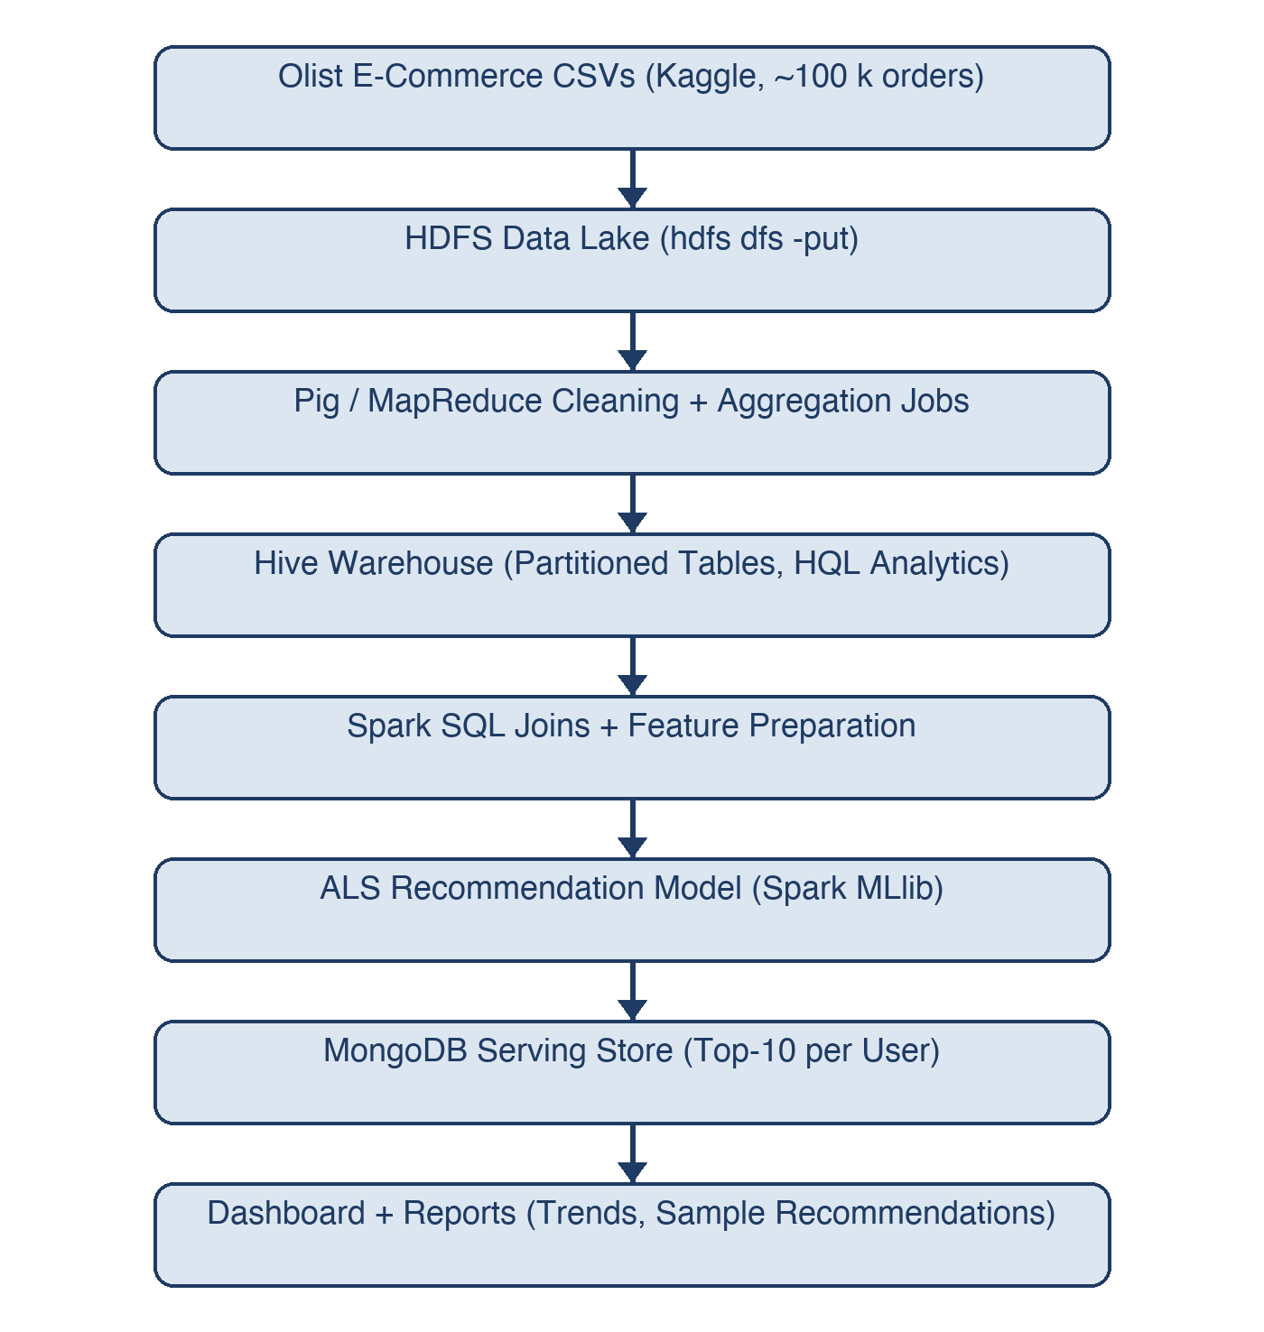
Fig. 1: End-to-end batch analytics and recommendation workflow.
4. Approach & Roles
4.1 Methodology
- Data collection – Brazilian E-Commerce Public Dataset (Olist, Kaggle): 9 CSVs, ~100 k orders (2016–2018), ≈ 120 MB; optional synthetic scale-up to the GB range.
- Environment setup – Hadoop pseudo-distributed (HDFS + YARN), Hive, Spark, MongoDB.
- Ingestion & cleaning – hdfs dfs -put; Pig/MR cleaning: null handling, type casting, de-duplication, timestamp parsing.
- MapReduce analytics – revenue by category, orders by state, payment distribution, monthly order counts.
- Hive warehouse – external/partitioned tables; HQL queries for monthly GMV trend, top categories, delivery-delay analysis, repeat-customer rate.
- Spark ETL + recommendation – join orders/items/payments/reviews; build ratings; train ALS; generate top-10 recommendations per user.
- Serving & visualisation – recommendations written to MongoDB; Matplotlib/Streamlit dashboard for trends and sample recommendations.
- Evaluation & documentation – RMSE/hit-rate; DA-2 and DA-3 deliverables.
4.2 Tentative Timeline
Phase | Work | Duration
Phase 1 | Setup (Hadoop/Hive/Spark/MongoDB), dataset download | 4 – 10 Aug
Phase 2 | HDFS ingestion + Pig/MR cleaning | 11 – 24 Aug
Phase 3 | MapReduce analytics jobs + Hive warehouse | 25 Aug – 7 Sep
Phase 4 | Spark ETL + ALS recommender (DA-2: 19 Sep) | 8 – 19 Sep
Phase 5 | MongoDB serving + dashboard + tuning | 20 Sep – 12 Oct
Phase 6 | Final report + presentation (DA-3: 20 Oct) | 13 – 20 Oct

4.3 Team Roles
Member | Responsibility
Member 1 – K PRADEEP KUMAR | Hadoop/Hive cluster setup, overall architecture, integration
Member 2 – VAHRAN P | Data ingestion and cleaning (Pig / MapReduce)
Member 3 – ASHVATH KUMAR | MapReduce + HQL analytics, results documentation
Member 4 – K.P ABHISHEK | Spark ALS recommender, MongoDB serving layer, dashboard

5. Feasibility
5.1 Dataset Sources
- Brazilian E-Commerce Public Dataset by Olist (Kaggle, public licence): 9 relational CSVs, ~100 k orders, ≈ 120 MB – identified and downloaded.
- Growth path if more volume is needed: synthetic order generator or a larger public clickstream dataset (e.g. REES46).
5.2 Evidence of Setup (Initial Progress)
- Hadoop single-node (pseudo-distributed) cluster running; hdfs dfs -ls verified.
- Hive metastore initialised; sample HQL queries executed on the dataset.
- Spark + PySpark verified; MongoDB Community Server running.
- Dataset CSVs inspected (schemas, row counts); Git repository initialised.
5.3 Expected Challenges & Mitigation
Challenge | Mitigation
Single-node hardware limits | Pseudo-distributed config; develop on samples, full run for final results
Skewed keys (a few big categories) | Combiners and a custom partitioner
Complex joins in raw MapReduce | Do joins in Hive/Spark; keep MR for aggregations only
Cold-start users in ALS | Popularity-based fallback recommendations
Hadoop/Hive/Spark version compatibility | Pin compatible versions; document the setup steps

The dataset is public, the full stack is open-source, and the cluster is already running on a single machine — the project is feasible within the semester timeline.

