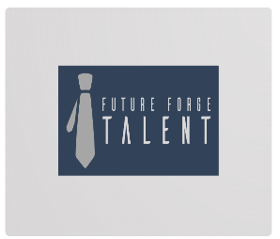 Home About us services Career

CONTACT US

YOUR FUTURE, OUR MISSION- This is the tag line
Future Forge Talent connects top talent with leading companies through expert executive search and career advisory services. We help job seekers advance their careers and organizations find the best-fit professionals for business growth and success. – This is the sub text

Get in touch or or Join now (Should redirect the page to get the seeker details like mobile number name, email ID OR optional option to submit their resume but all mobile number, name and email ID should be mandatory one) Job search – Please suggest should we add Job search here where seekers will be redirected to the jpb section in our previous website.

We can add the icon of whatsaap, insta, linked, facebook – You can allocate the place as per suggestion.
But at the bottm let’s add another contact us section a shown in the picture or since we’re a start up we do not have testimonals or registered company names to be mentioed then below sub text we can add a contact section for JOB SEEKERS AND EMPLOYER, something which I have attached as a screenshot below, you can work and bring in more unique ideas.

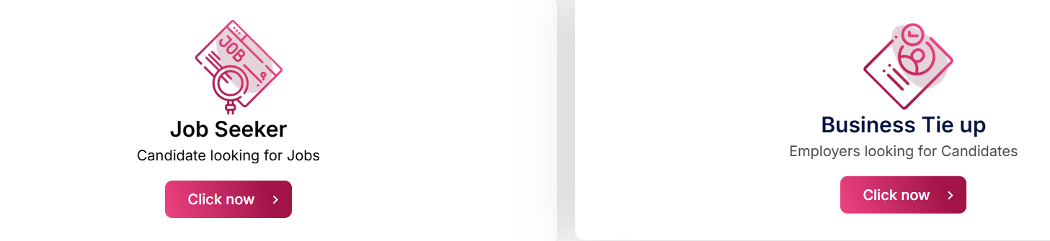

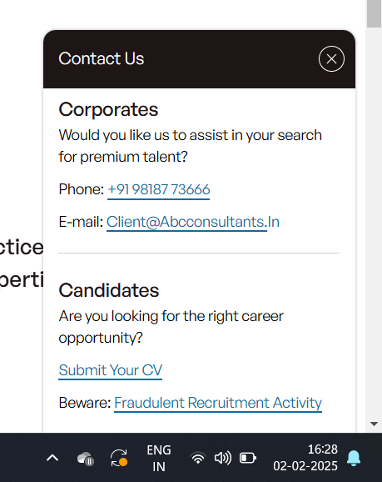

Right after that this we can add services we offer or industries however we since we’re a start up company we would be focussing on all the industries so in my opinion I would suggest to list down the services part rather than industries now .
For all the services we can list few lines and add a button to learn more or know more For an instance Talent Acquisition & Recruitment Services - Quickly find and hire the best talent with our talent acquisition and recruitment services, tailored to meet your business needs. [Know More] with few more detailed explanation after clicking know more it should redirect to the SERVICE page where audience can read more about it. And there should be an button on each page as contact us or connect with us
where user will have an option to provide their basic details for us to get in touch
Here I’m listing down the services and one liner and description as well for the option called know more
- Talent Acquisition & Recruitment Services
Quickly find and hire the best talent with our talent acquisition and recruitment services, tailored to meet your business needs.
Know more details - - O

ur Talent Acquisition & Recruitment Services are designed to help businesses find the right talent quickly and efficiently. Whether you're hiring entry-level professionals or experienced executives, we use a data-driven approach to recruit candidates who align with your company culture. Our recruitment team sources top talent through market research, job boards, and networks, ensuring you get the right fit for your organization’s needs. We ensure a smooth, efficient process, reducing hiring time and costs.
Key Benefits:
- Custom recruitment strategies tailored to your hiring needs
- Access to a wide network of qualified candidates
- Efficient, cost-effective hiring process
- In-depth candidate screening and vetting to ensure the best fit

- Executive Search & Leadership Hiring
Hire top-level executives with executive search services, ensuring the perfect leadership fit for your business growth.
Know more details - Our Executive Search & Leadership Hiring services specialize in finding top-tier executives to lead your company. We understand the importance of finding leaders who not only have the necessary skills but also fit your organizational culture and business strategy. Our search process involves deep industry research, candidate screening, and personalized interviews, ensuring your organization gets the leadership it needs to drive growth and innovation.
Key Benefits:
- Targeted search for C-suite and executive-level roles
- Access to a high-caliber talent pool with industry expertise
- Confidential and strategic search process
- Tailored leadership solutions aligned with company goals

3.Employee Training & Development
Enhance your team’s skills and drive performance with our customized employee training and development programs.
Know More: Our Employee Training & Development programs are designed to enhance the skills of your workforce and build a culture of continuous learning. We offer bespoke training solutions across various industries, including leadership development, technical training, soft skills enhancement, and more. With our training, your employees will stay ahead of industry trends, perform better, and be more productive, leading to overall business growth.
Key Benefits:
- Customized training programs that align with your organizational goals
- Scalable solutions for teams of all sizes
- Increased employee engagement and productivity
- Focus on both hard skills and soft skills development

4.HR Outsourcing & Compliance
Simplify HR functions and ensure compliance with our HR outsourcing and compliance solutions for a smooth operation.
Know More: Our HR Outsourcing & Compliance services allow you to outsource your HR functions to experts while ensuring your business stays compliant with local, state, and national regulations. From payroll management to employee benefits and legal compliance, we manage it all. We ensure your business meets all labor laws and regulatory requirements, reducing risk and allowing you to focus on growing your business.
Key Benefits:
- Cost-effective HR management solutions
- End-to-end HR services including payroll, benefits, and compliance
- Regulatory compliance to avoid legal risks
- Scalable solutions that grow with your business

5.Employee Engagement & Retention
Boost employee satisfaction and retention with our effective employee engagement and retention strategies.
Know More: Employee retention is a key driver of success for any business. Our Employee Engagement & Retention services are aimed at creating a positive and productive work environment that encourages employees to stay long-term. We help you implement engagement strategies, improve workplace culture, and build a strong employee value proposition (EVP) that resonates with your staff.
Key Benefits:
- Employee satisfaction surveys to assess and improve morale
- Custom retention strategies tailored to your business
- Focus on building a positive workplace culture
- Employee development programs to improve loyalty and performance

6.Recruitment Process Outsourcing (RPO)
Streamline your hiring process with our RPO services, providing end-to-end recruitment outsourcing solutions.
Know More: Our Recruitment Process Outsourcing (RPO) services provide businesses with an effective, scalable way to manage their recruitment needs. From the initial candidate search to the final placement, we manage the entire recruitment cycle. We provide end-to-end solutions, ensuring you find the best talent while saving time and resources.
Key Benefits:
- Scalable solutions that grow with your business
- Access to advanced recruitment technology
- Expert recruiters managing the hiring process from start to finish
- Cost-effective and efficient recruitment solutions

7.Job Market & Salary Benchmarking
Stay competitive with salary benchmarking and job market analysis to attract top talent with the right compensation.
[Know More]
Know More: Stay competitive and make informed hiring decisions with our Job Market & Salary Benchmarking services. We provide data-driven insights into current salary trends, industry benchmarks, and market conditions. By using this valuable data, you can offer competitive salaries, improve your recruitment strategies, and attract top-tier talent.
Key Benefits:
- Comprehensive salary data for industry-specific roles
- Market trends analysis to understand hiring patterns
- Competitive pay insights to attract and retain top talent
- Cost-efficient solutions to optimize compensation packages

For Job seekers
1.Career Counseling & Coaching
Navigate your career path with career counseling and expert coaching services, tailored to your professional goals.
Know More: Our Career Counseling & Coaching services are designed to help you navigate your career path with confidence. Whether you’re looking to transition to a new role, advance in your current job, or change industries, our expert coaches provide personalized advice and guidance. We help you build a roadmap to success, offering strategic insights and actionable advice to maximize your career potential.
Key Benefits:
- Personalized coaching to align career goals with opportunities
- Strategic advice for job transitions, growth, and advancement
- In-depth industry insights and networking support
- Goal-setting and actionable plans to enhance career development

2.Resume Writing & LinkedIn Profile Optimization
Stand out to employers with professional resume writing and LinkedIn optimization that highlight your strengths.
Know More: Stand out in the competitive job market with our Resume Writing & LinkedIn Profile Optimization services. We create custom resumes and optimize LinkedIn profiles to showcase your strengths, experience, and skills effectively. By integrating SEO-friendly keywords and industry-relevant terms, we ensure that your resume and profile attract the right attention from recruiters and employers.
Key Benefits:
- Professional resumes tailored to your industry
- Optimized LinkedIn profiles for better visibility
- Keyword-rich content to attract employers
- Customized formatting that highlights your achievements

3.Job Matching & Placement Services
Find the perfect job with our job matching and placement services, connecting your skills to top employers.
[Know More]
Know More: Our Job Matching & Placement services are designed to match you with the right job opportunities based on your skills, experience, and career aspirations. We work with top employers across multiple industries to place you in roles where you can thrive. Our personalized approach ensures that every job match aligns with your professional goals and growth potential.
Key Benefits:
- Customized job matching based on your skills and aspirations
- Access to exclusive job opportunities with top employers
- Expert placement services that align with your career goals
- Ongoing support throughout the hiring process

4.Interview Preparation & Mock Interviews
Prepare for success with interview coaching and mock interviews, ensuring you’re ready to impress potential employers.
[Know More]
Know More: Ace your interviews with our Interview Preparation & Mock Interviews services. We provide in-depth coaching to help you refine your interview skills, including how to respond to common questions, handle difficult scenarios, and present yourself effectively. Our mock interviews simulate real-life interview experiences to help you build confidence and enhance your chances of success.
Key Benefits:
- Personalized interview coaching for various industries
- Mock interview sessions to practice real-life scenarios
- Tips on body language, communication, and interview etiquette
- Feedback and improvements to refine your approach

5.Job Search Strategy & Networking
Elevate your job search with proven strategies and networking tips, making connections that open doors to new opportunities.
[Know More]
6.Freelancing & Remote Work Opportunities
Explore freelancing jobs and remote work opportunities that offer flexibility and growth in various industries.
[Know More]
Know More: Explore Freelancing & Remote Work Opportunities with Future Forge Talent. We connect you to flexible, high-quality freelance and remote roles across multiple industries, allowing you to work from anywhere. Whether you're looking for part-time gigs or full-time remote work, we provide the resources and support to help you succeed in the growing remote job market.
Key Benefits:
- Access to flexible freelancing opportunities
- Remote job listings from top companies globally
- Guidance on building a successful freelance career
- Work-life balance with flexible schedules

After this if required we can add some blogs
ABOUT US PAGE
About Us | Future Forge Talent
Company Introduction:
At Future Forge Talent, we are dedicated to shaping the future of talent by connecting exceptional individuals with organizations that are driven by innovation. As a forward-thinking recruitment and talent solutions firm, we focus on bridging the gap between employers and job seekers by offering customized hiring solutions, career coaching, and cutting-edge recruitment strategies.
Founded by a team of passionate professionals, Future Forge Talent is built on the belief that the right talent is the foundation for any successful organization. We aim to empower businesses to grow and flourish while helping individuals achieve their career goals and realize their full potential.
Whether you're a company looking to hire top talent or a job seeker searching for your next opportunity, Future Forge Talent is here to make that connection seamless, efficient, and impactful.

Mission Statement:
Our mission is simple: "Your Future, Our Mission." We are committed to shaping the careers of tomorrow by delivering high-quality talent solutions that enable businesses to succeed and individuals to achieve their professional aspirations. Through innovative strategies, personalized services, and an unwavering commitment to excellence, we aim to create lasting impacts on both employers and job seekers.

Vision Statement:
To become the leading global talent solutions provider, empowering organizations with the right people while fostering a culture of career growth and success. We envision a future where businesses thrive because they have the right talent, and individuals flourish because they are in the right careers.
Why Choose Future Forge Talent?
- Tailored Solutions: Whether you're an employer or a job seeker, we offer personalized services that meet your unique needs.
- End-to-End Services: From recruitment to career coaching, we offer comprehensive services to help you succeed in the talent marketplace.
- Industry Expertise: Our team brings deep industry knowledge to ensure you get the best guidance and opportunities.
- Focus on Growth: At Future Forge Talent, we are passionate about helping businesses grow and individuals excel in their careers.

