NETWORK FILE SYSTEM
Student id: 24017071 | Cybersecurity ,Sault college
Capstone project
Abhishek Vallittayil
2025

Contents
INTRODUCTION 2
Architecture of NFS 2
KEY USES 2
COMMANDS 2
INSTALLING AND CONFIGURING NFS IN WINDOWS SERVER AND WINDOWS 10 3
Security measures implemented 9
1.Use of VPN encryption for secure NFS communication. 10
2.Implementation of event logging for monitoring access 19
3.IP-based permission to restrict unauthorized clients 24
CONCLUSION 27
References 28

INTRODUCTION
NFS is a networking protocol for file sharing which means NFS lets windows server or linux computer share files with other windows or linux/unix systems.
NFS in windows server includes server for NFS and client for NFS.A computer running windows can use server for NFS to act as a NFS file server for other windows or non-windows operating systems and for other client users can use Client for NFS inorder to access it.
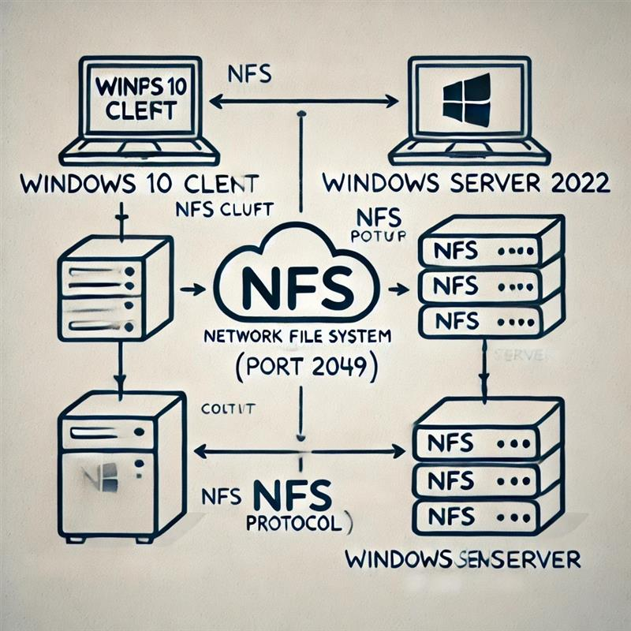

Architecture of NFS
In 1984, Sun Microsystems created the Network File System (NFS), a distributed file system protocol. Through a network, users can access files just like they would on their local computers. The foundation of NFS is a client-server design, in which clients ask to access data that is stored on the server.

KEY USES
- Share files between windows and linux using same folder.
- Migrate data between operating system easily.

COMMANDS
- Mount: it use to connect to client windows using cmd
- showmount :use to show share folder in client computer.
- Umount: use to unmount share folder in client os.

INSTALLING AND CONFIGURING NFS IN WINDOWS SERVER AND WINDOWS 10
For installing NFS share in windows server:
Open server manager > Add Roles and Features > go to server roles > check File and Storage > File and iscsi Services > select server for NFS
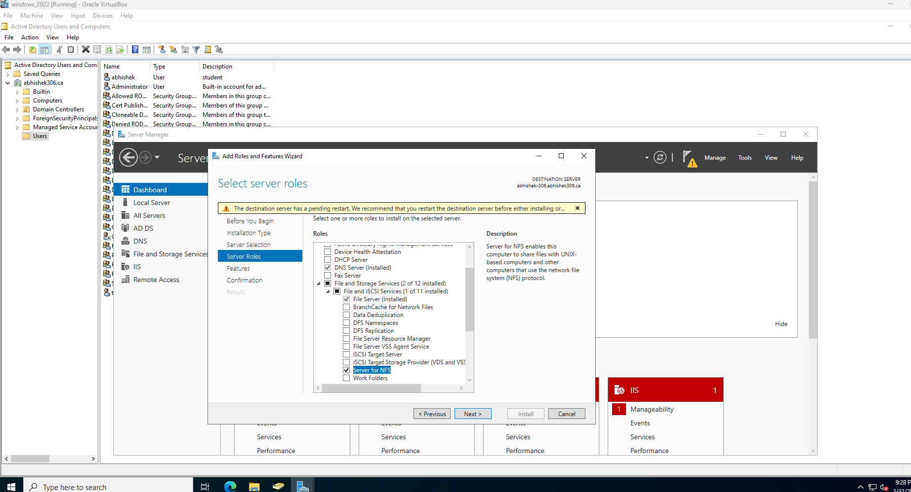
Complete the installation.
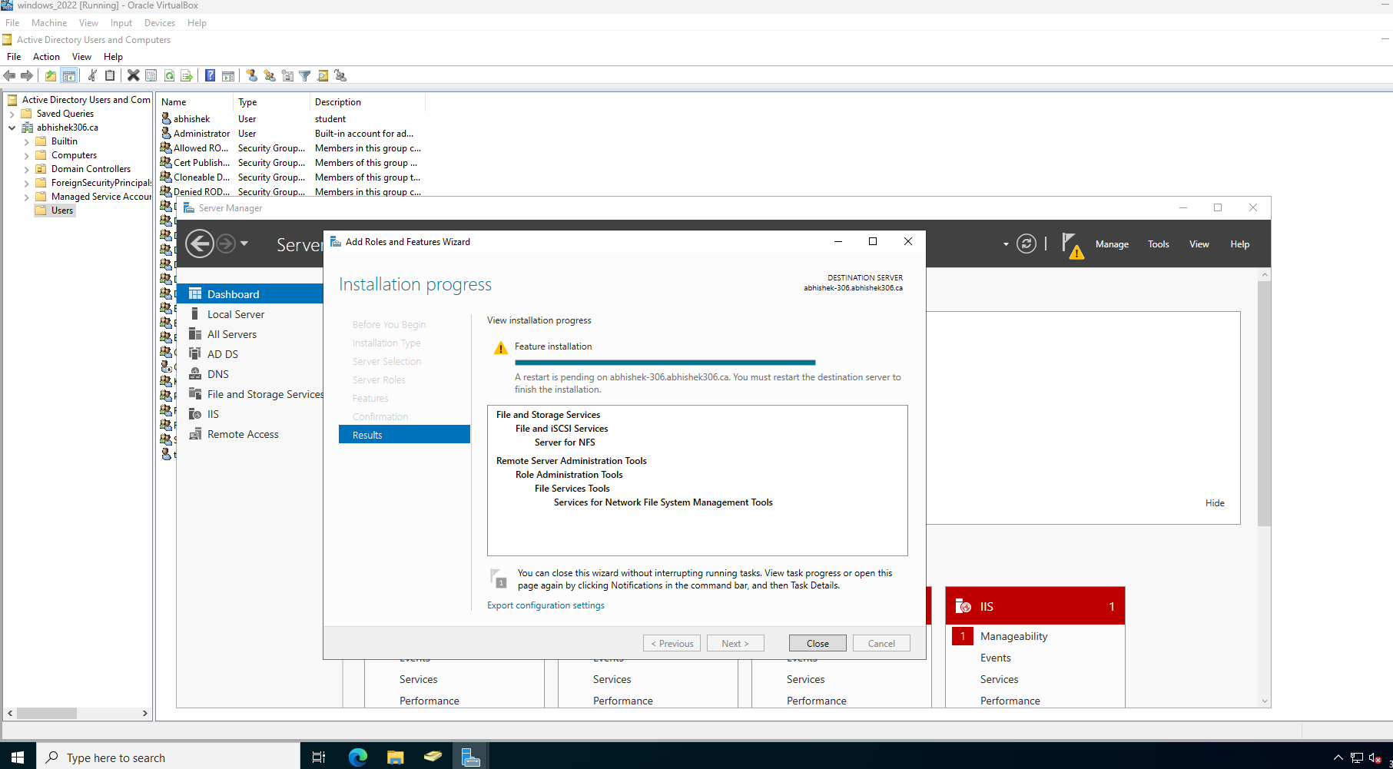

In server manager navigate to file and storage services > shares.In here right click in empty area select new share
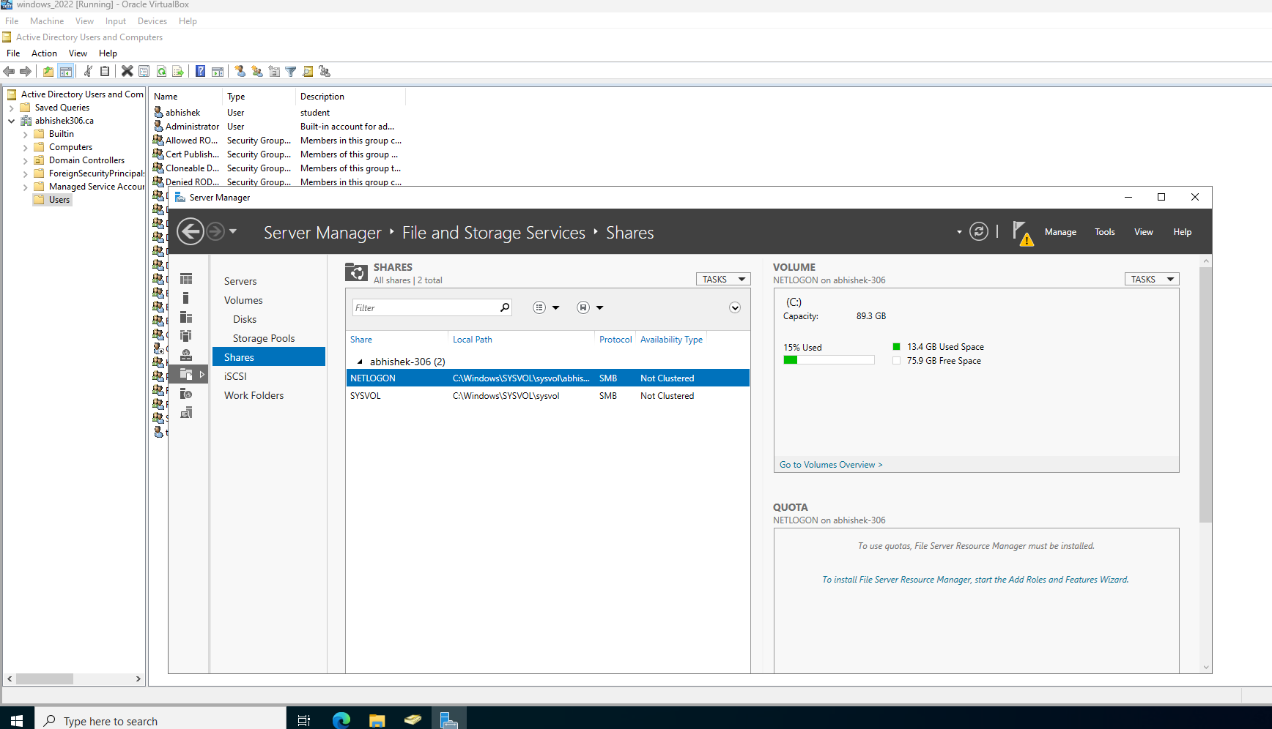
Select NFS share -quick or advance > click next
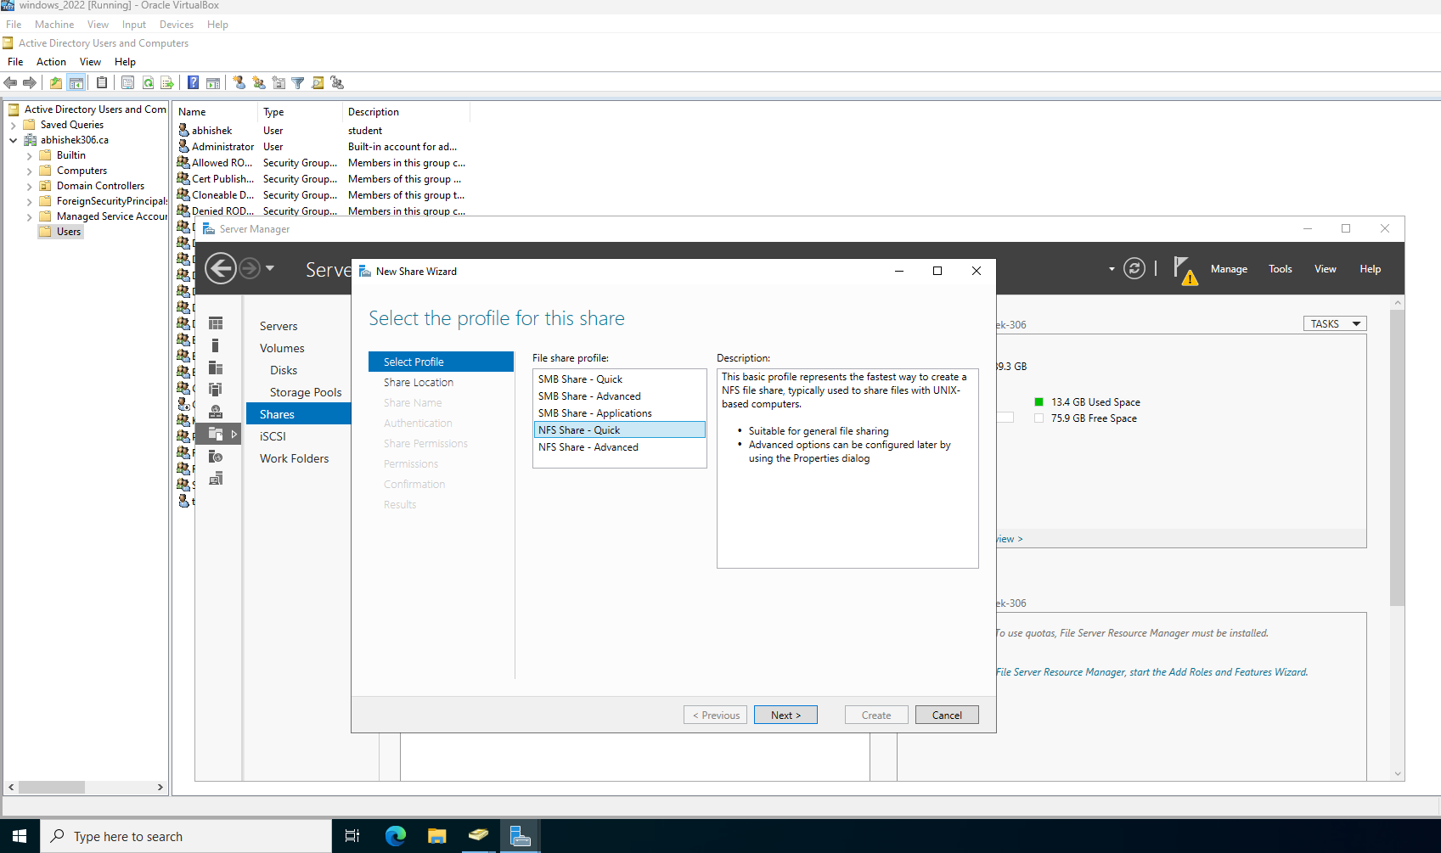

Select the location in my case I choose my custom path that is C:\nfs_share
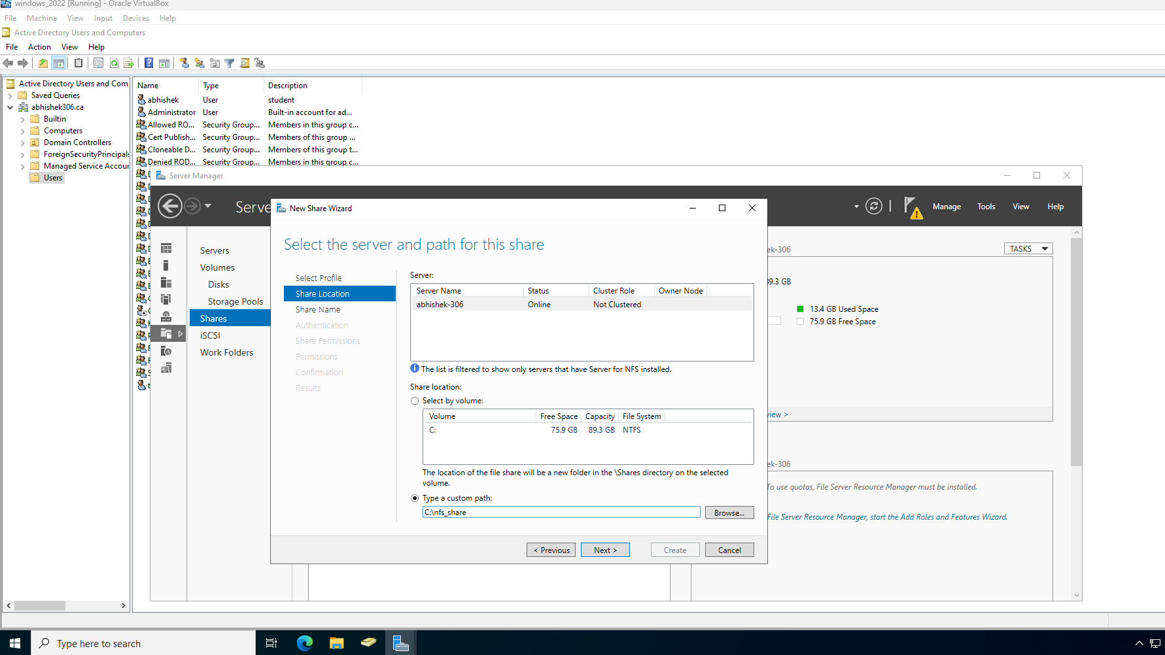
Move to authentication section ,select :
- Kerberos v5 authentication(krb5)
- Kerberos v5 authentication and integrity(krb5i)
- Kerberos v5 authentication and privacy(krb5p)
- No server authentication
- Enable unmapped user access
- Allow unmapped user access by UID/GID
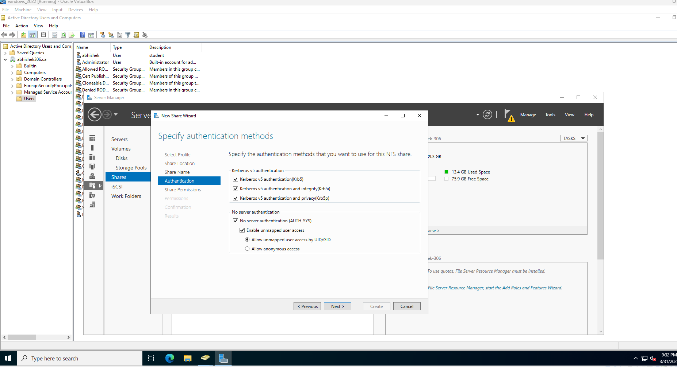

In share permissions add All machines with Read/Write access.
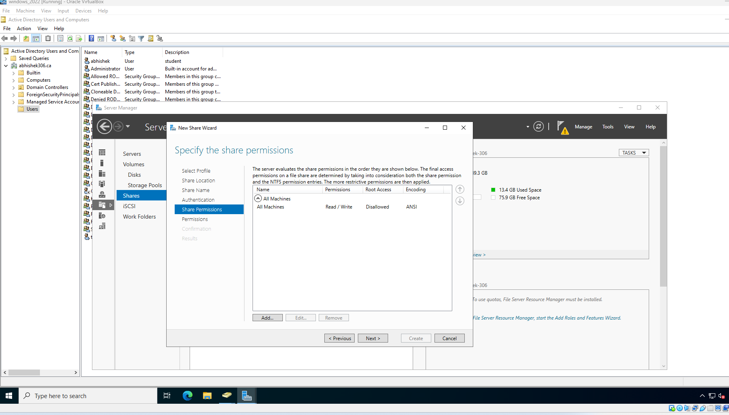

Lastly click create. Make sure the installation is complete.
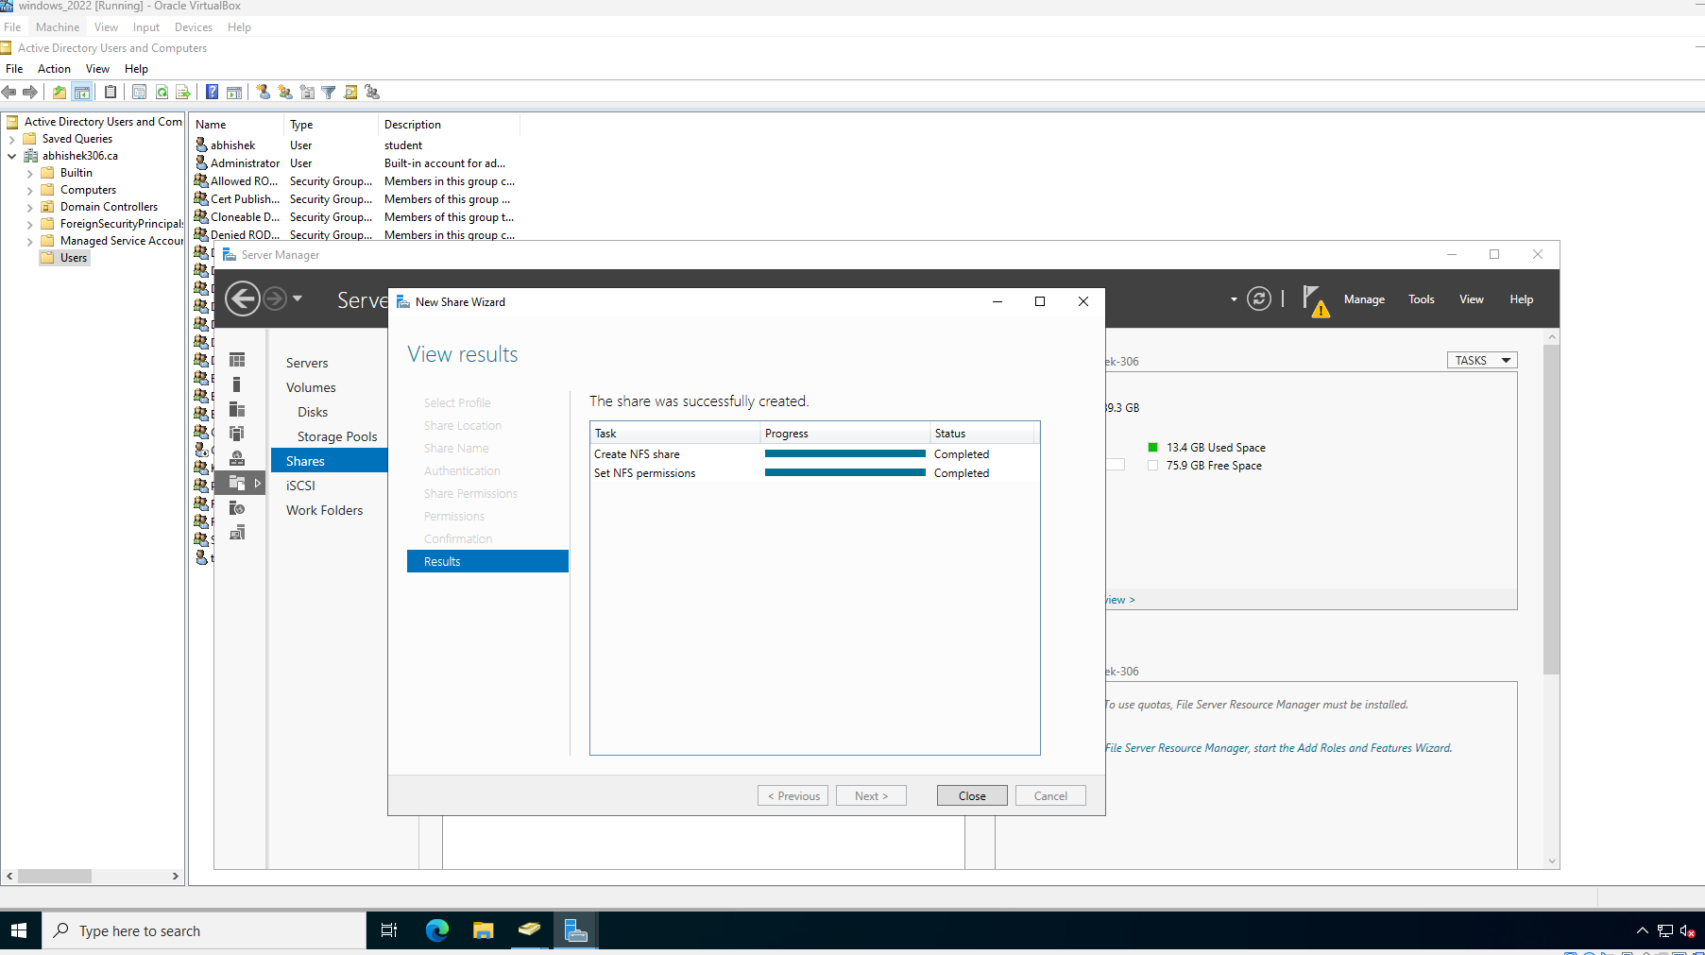

In the location of nfs sharing directory, check if the sharing folder has green arrow icon or not
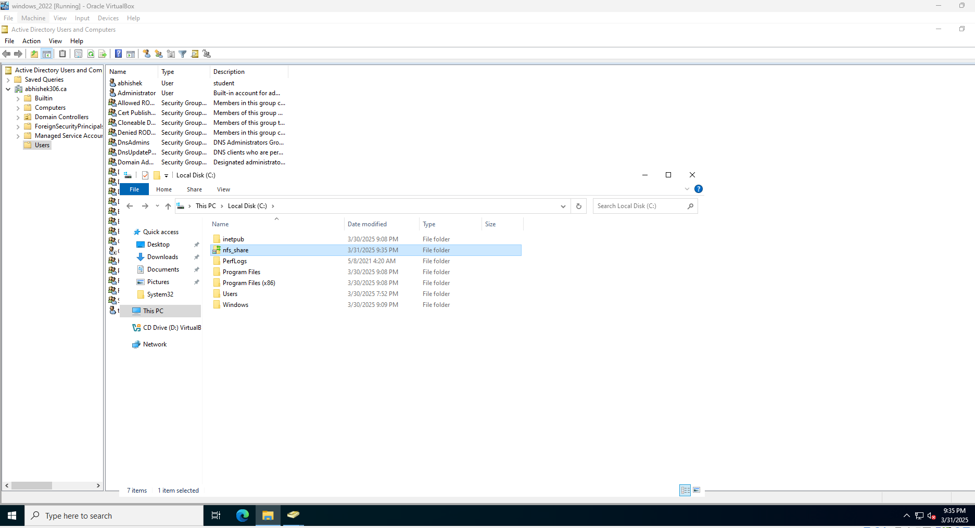

Create a file inside nfs share folder.
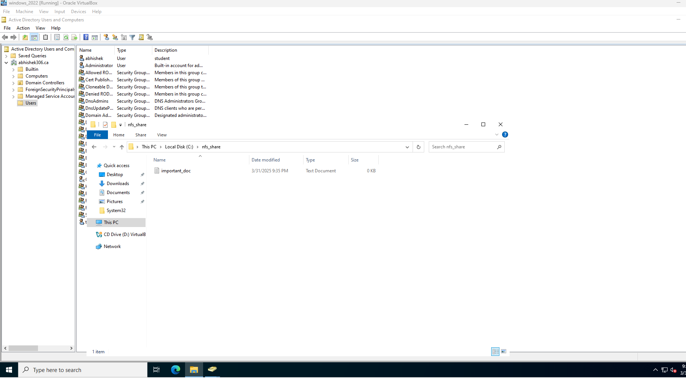

Now from windows 10 try to connect to windows server if every thing set properly the mount will succeed
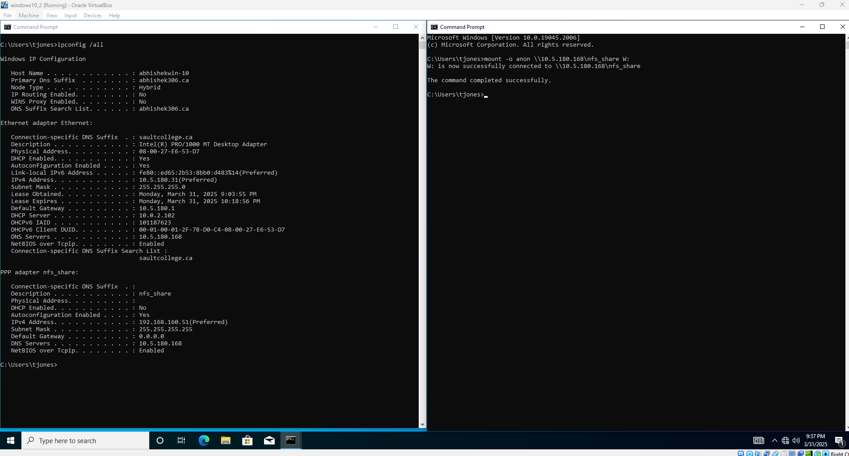

Now open the mounted directory and check if the file is in there or not.
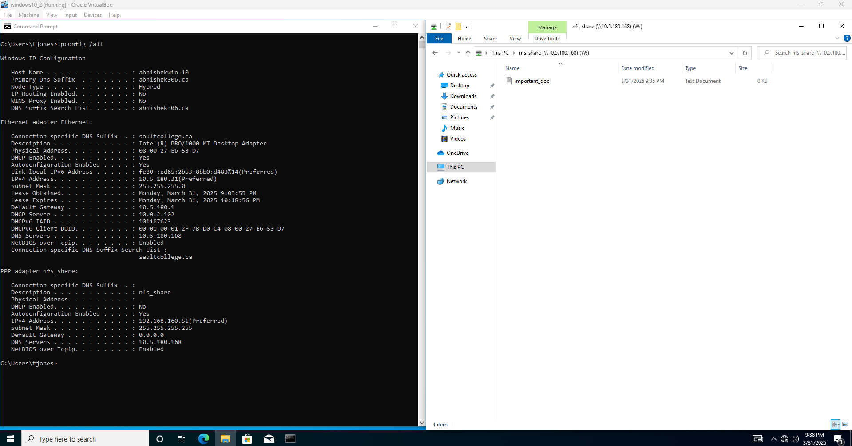

Security measures implemented

In order to secure NFS protocol there are several methods, so in here I described 3 security practices to ensure data confidentiality, integrity and better access control.

- Use of VPN encryption for secure NFS communication.
- Implementation of event logging for monitoring the access.
- IP-based permissions to restrict unauthorized clients .

1.Use of VPN encryption for secure NFS communication.
In windows server 2022 ,Open server manager > add role and features > select Role-based installation > click next > check remote access > click next .
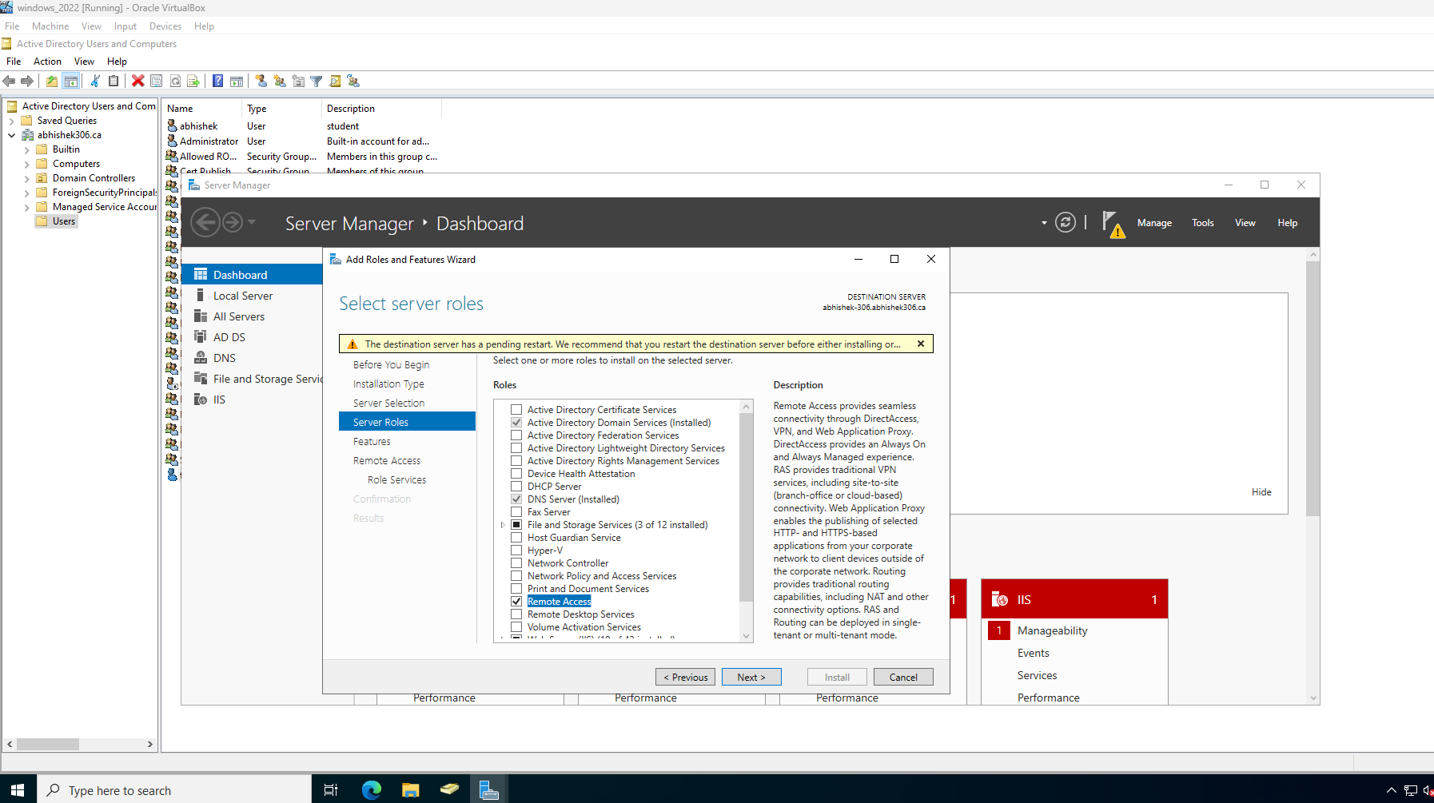

Under role services select Direct Access and VPN(RAS) and Routing > click next .
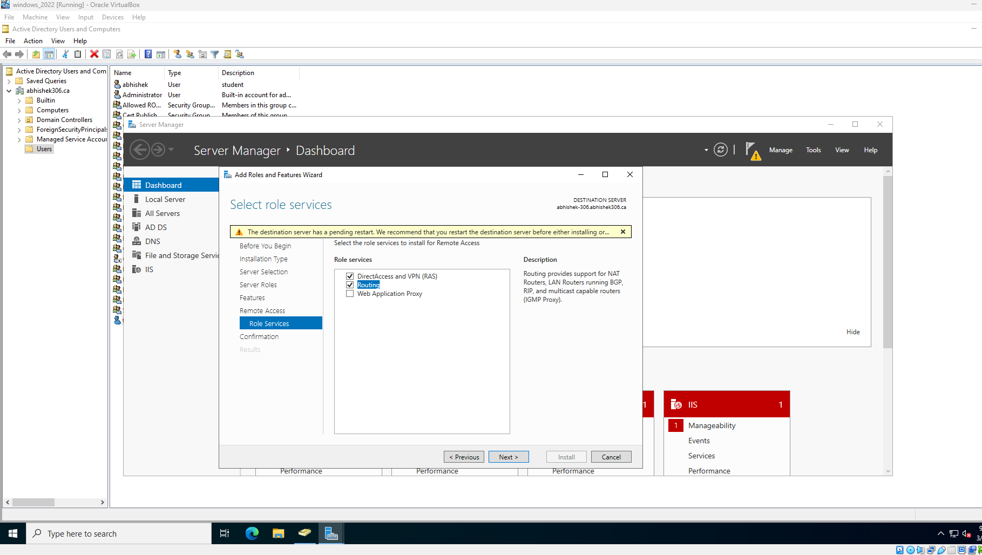

On the next screen select Install. Make sure installation is completed.
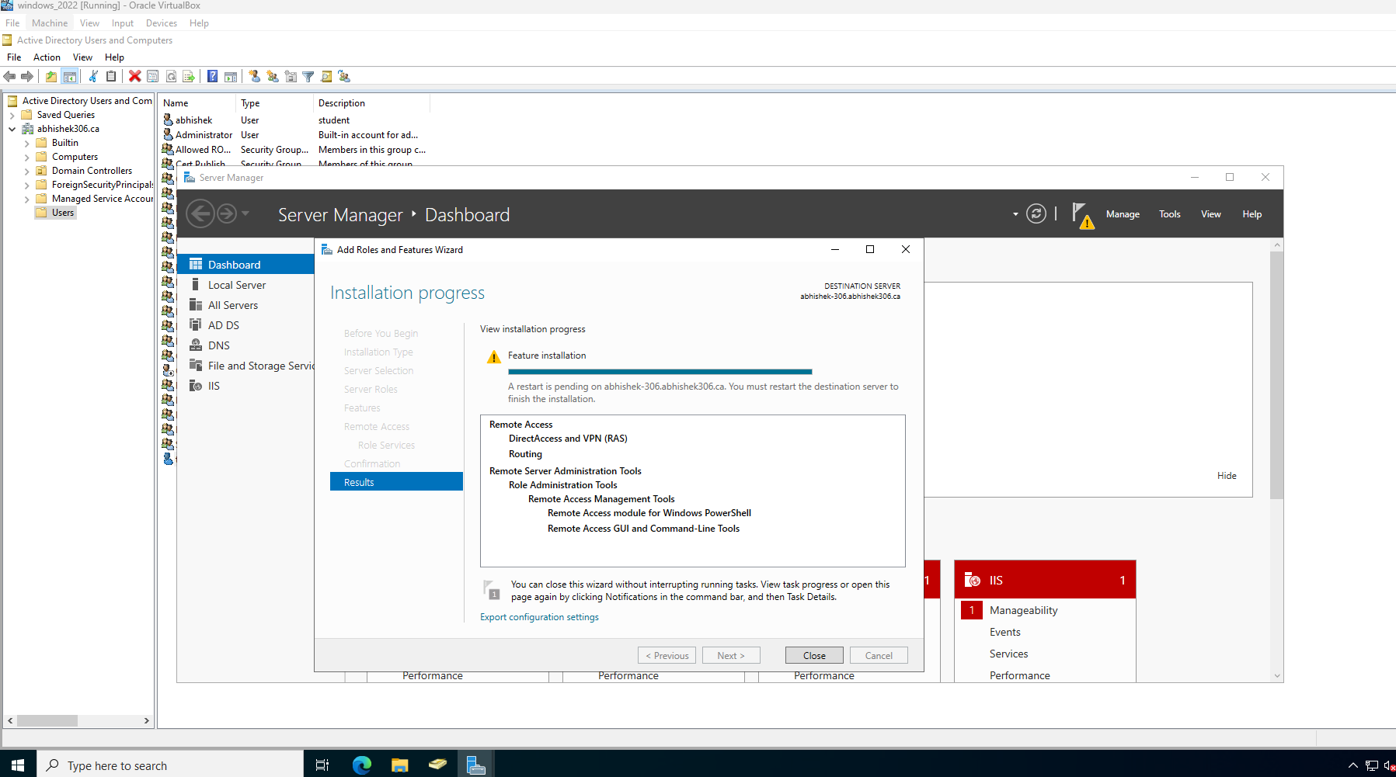
Then open Routing and Remote Access and right click the domain name and select the option “Configuration and Enable Routing and remote Access”.
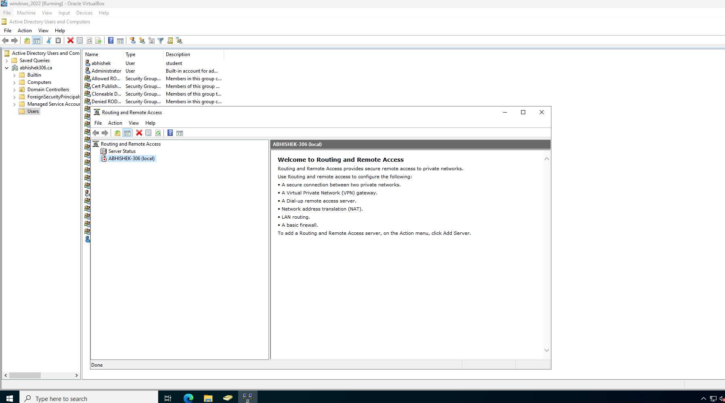

This prompt an installation wizard > click next .
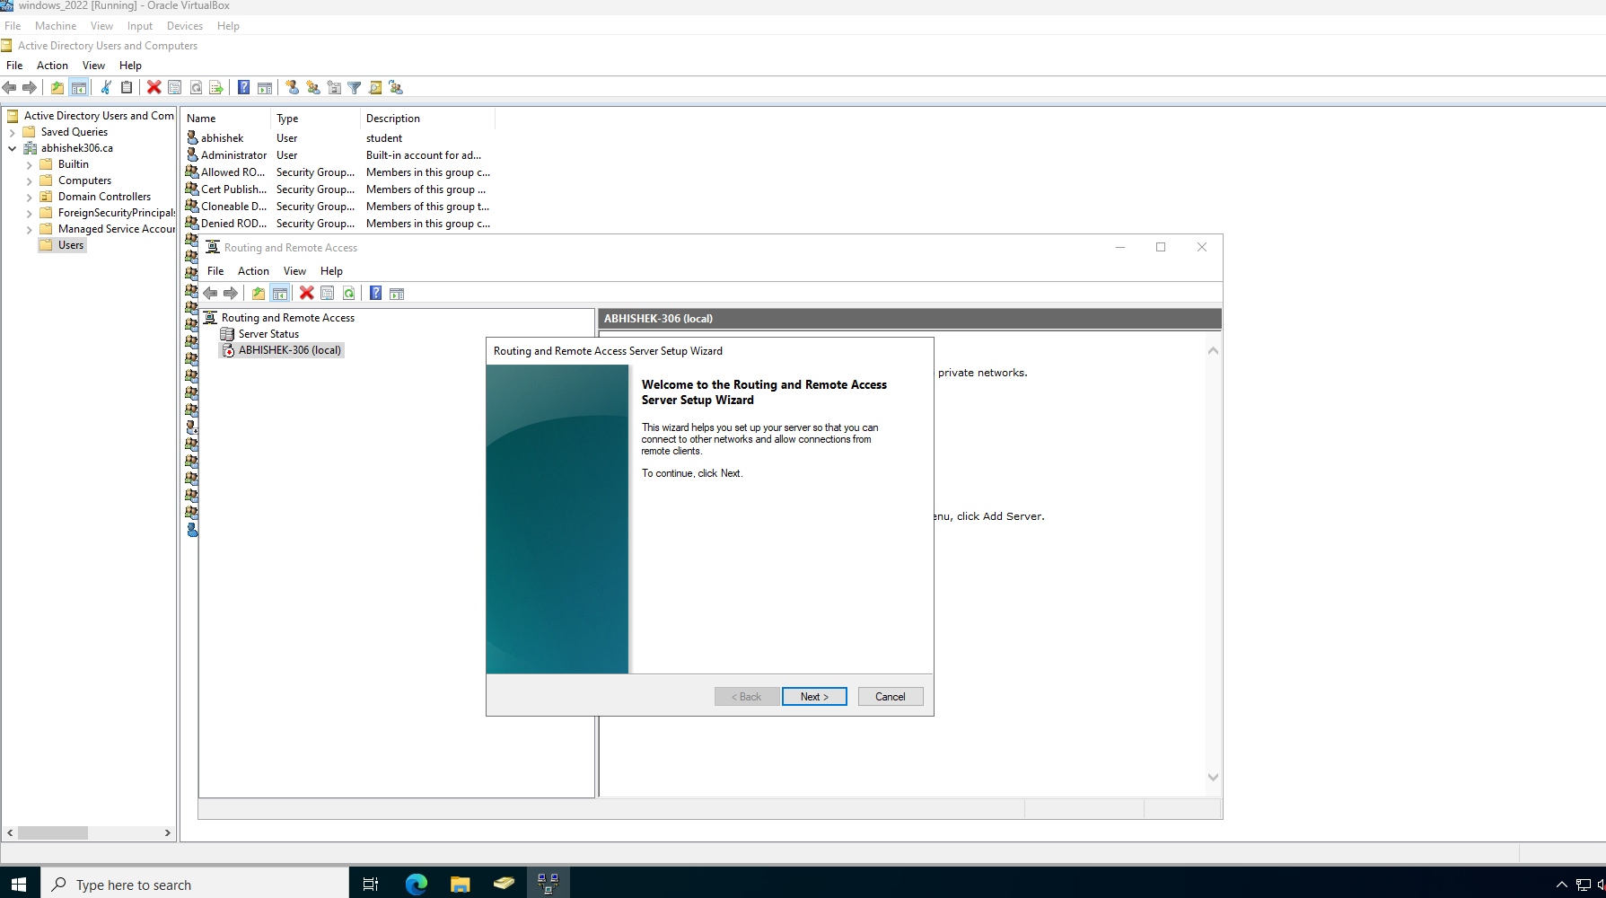

select custom configuration on next screen
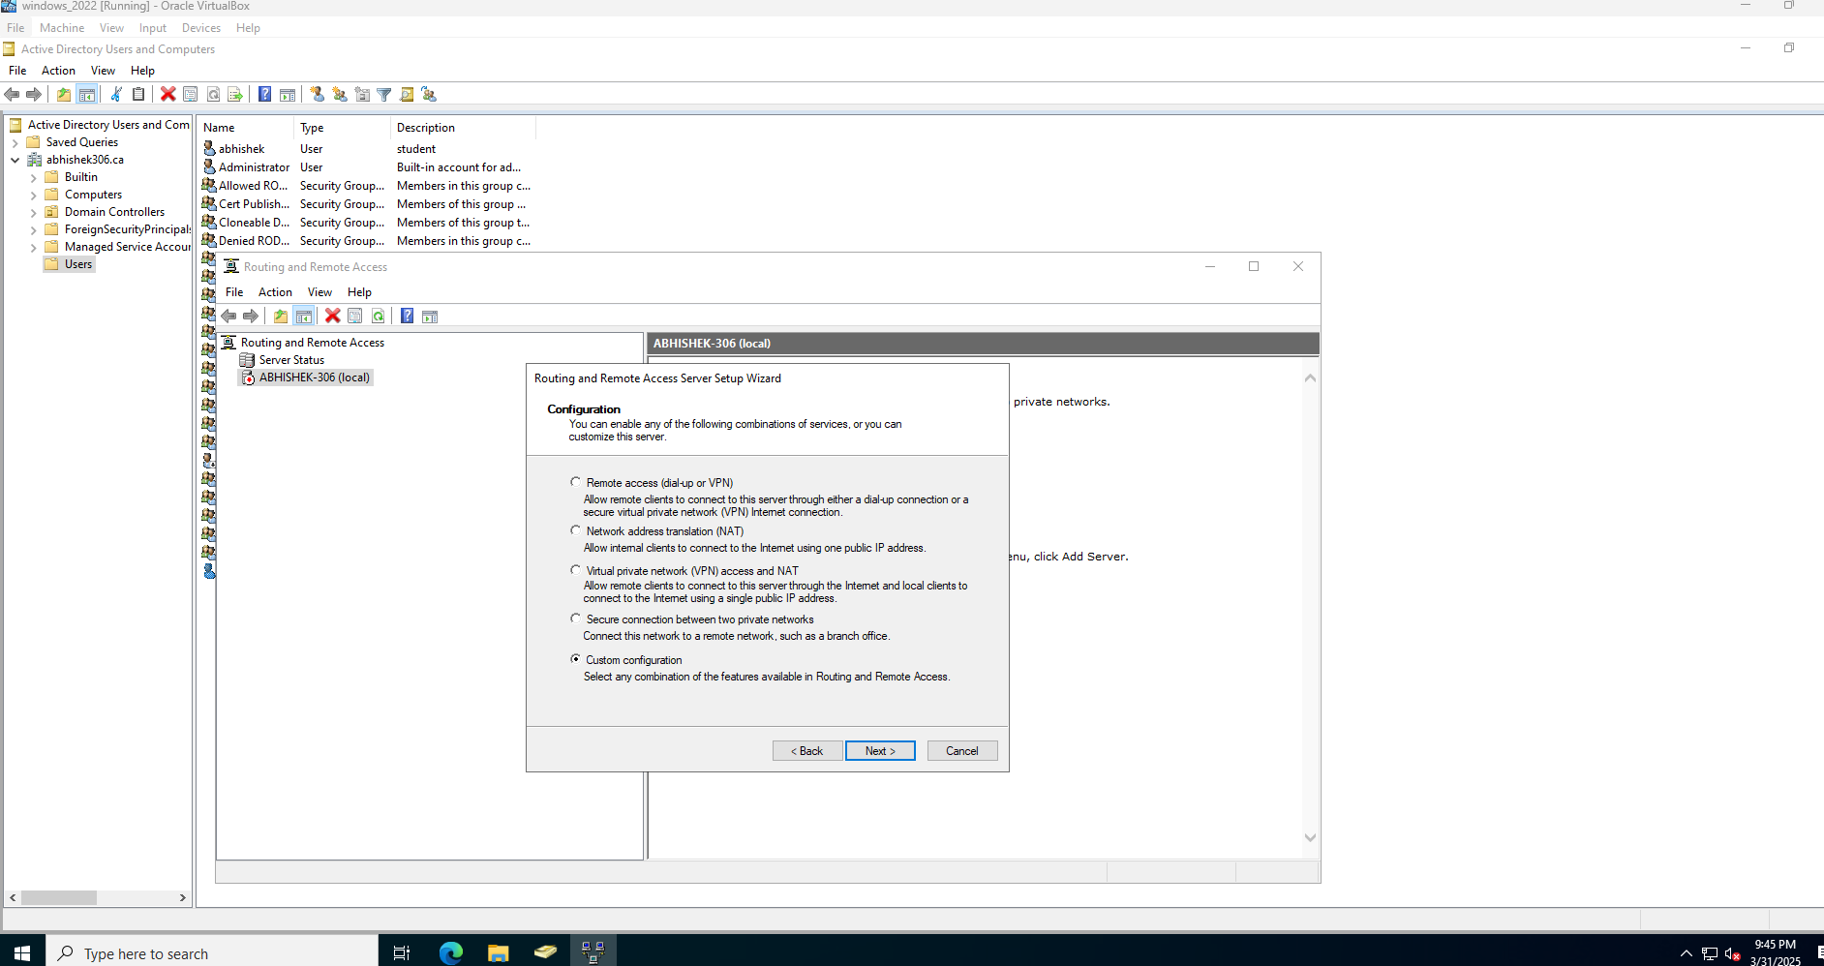

In next screen check vpn access
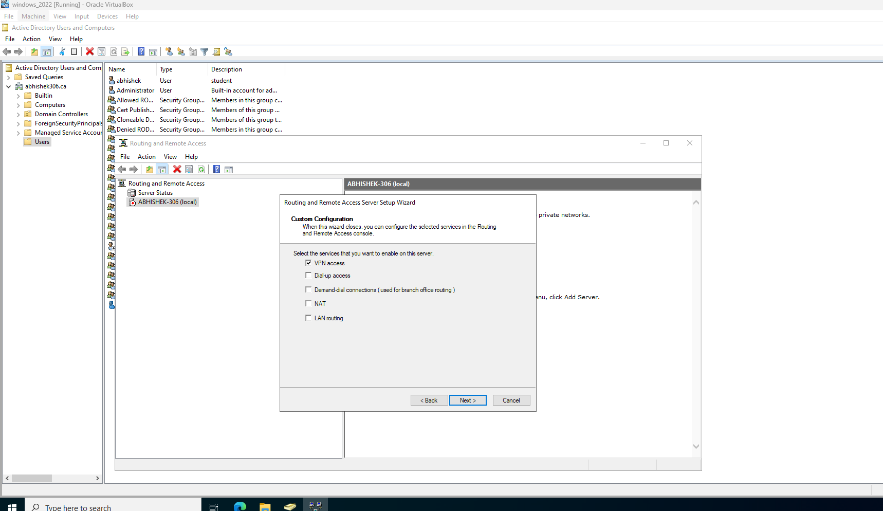

Lastly click finish to exit the wizard.
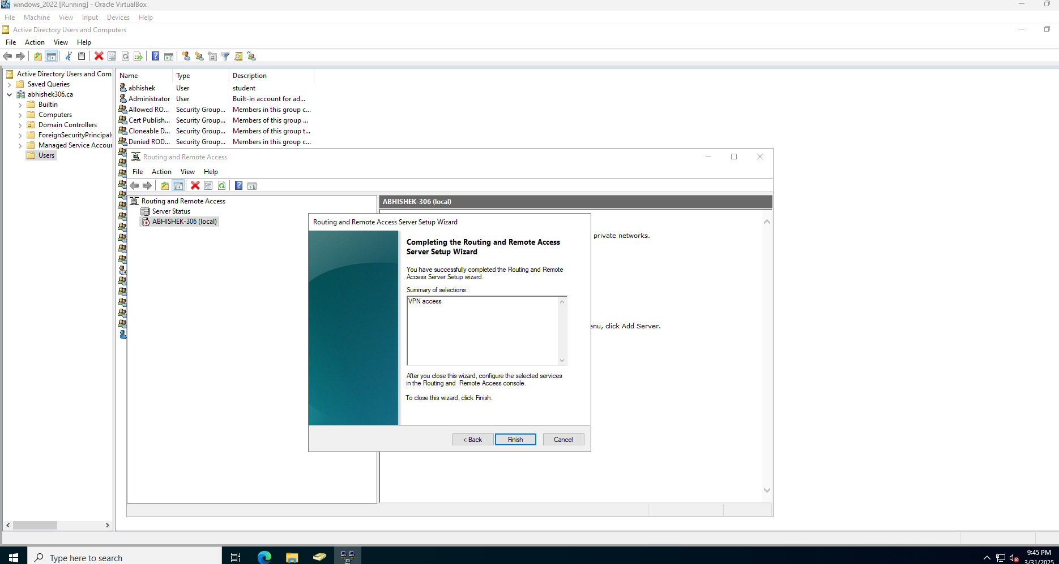

Then a popup to start service will come > click start.
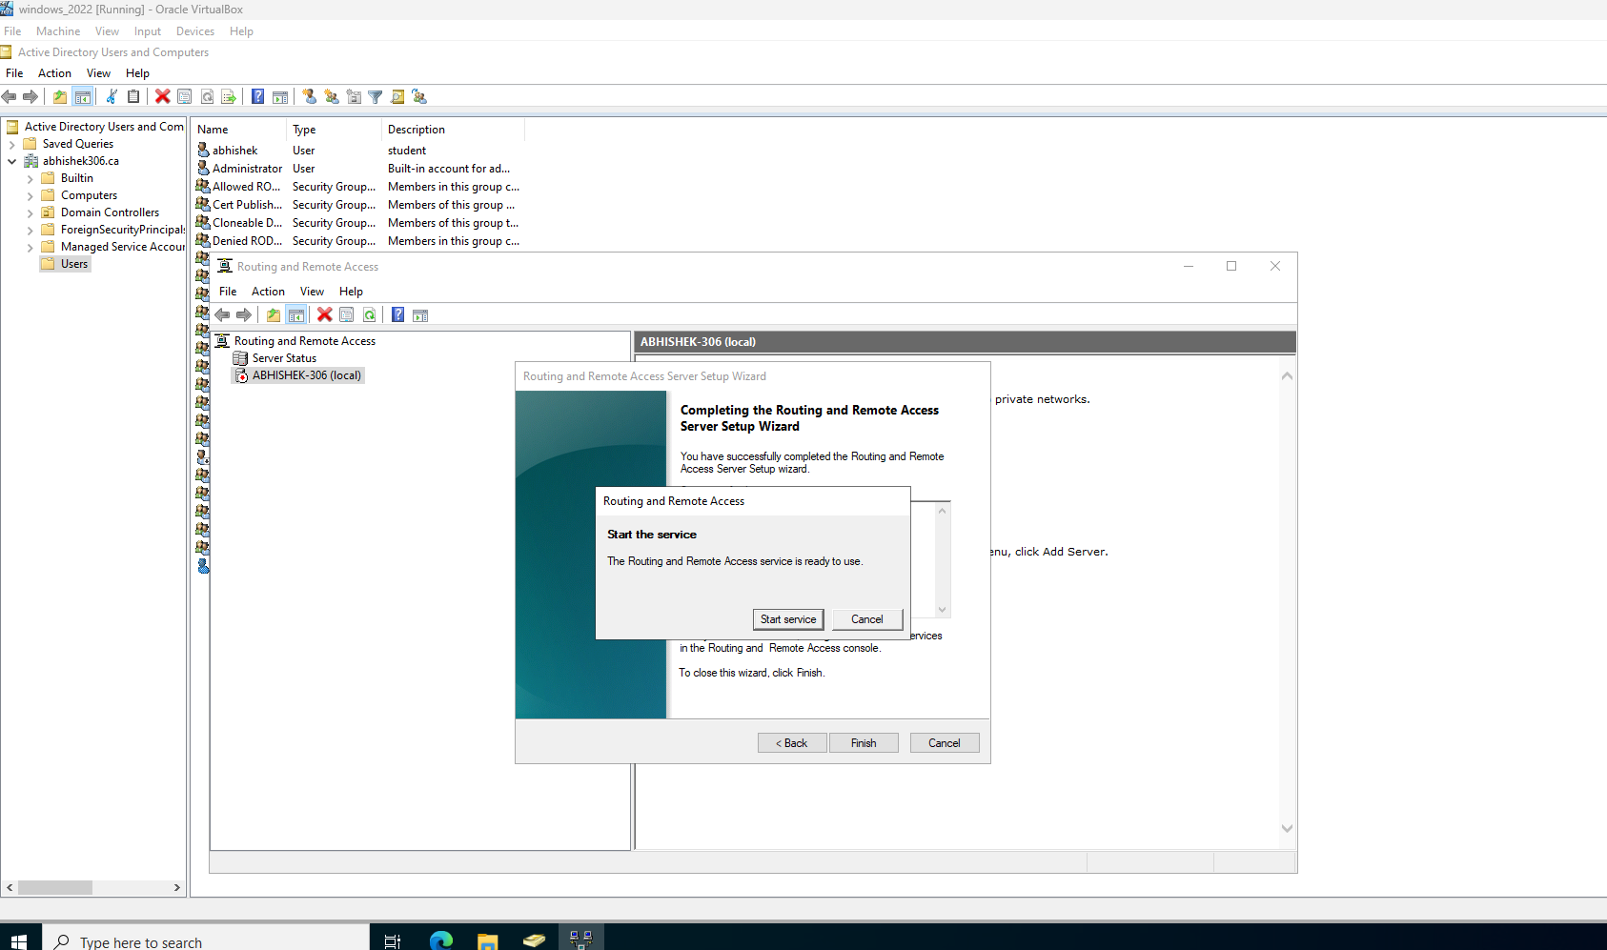
Next open active directory users and computers > right click the user that want vpn connection > select Dial-in tab and check allow access for network access permission.
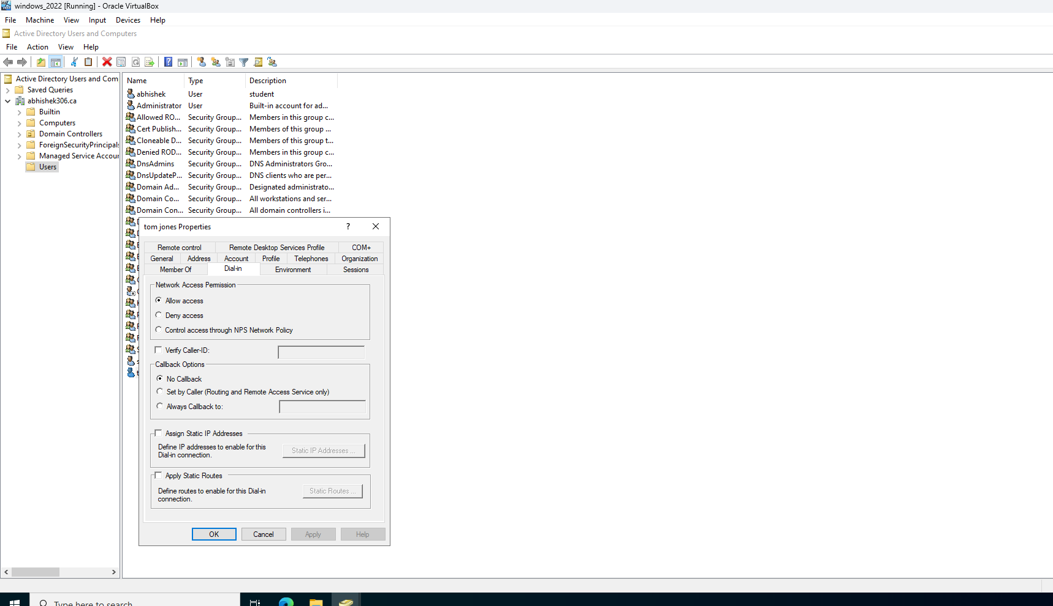
Afterward in windows 10 we need to create a vpn connection, for that open setting > select network & internet > add a vpn connection
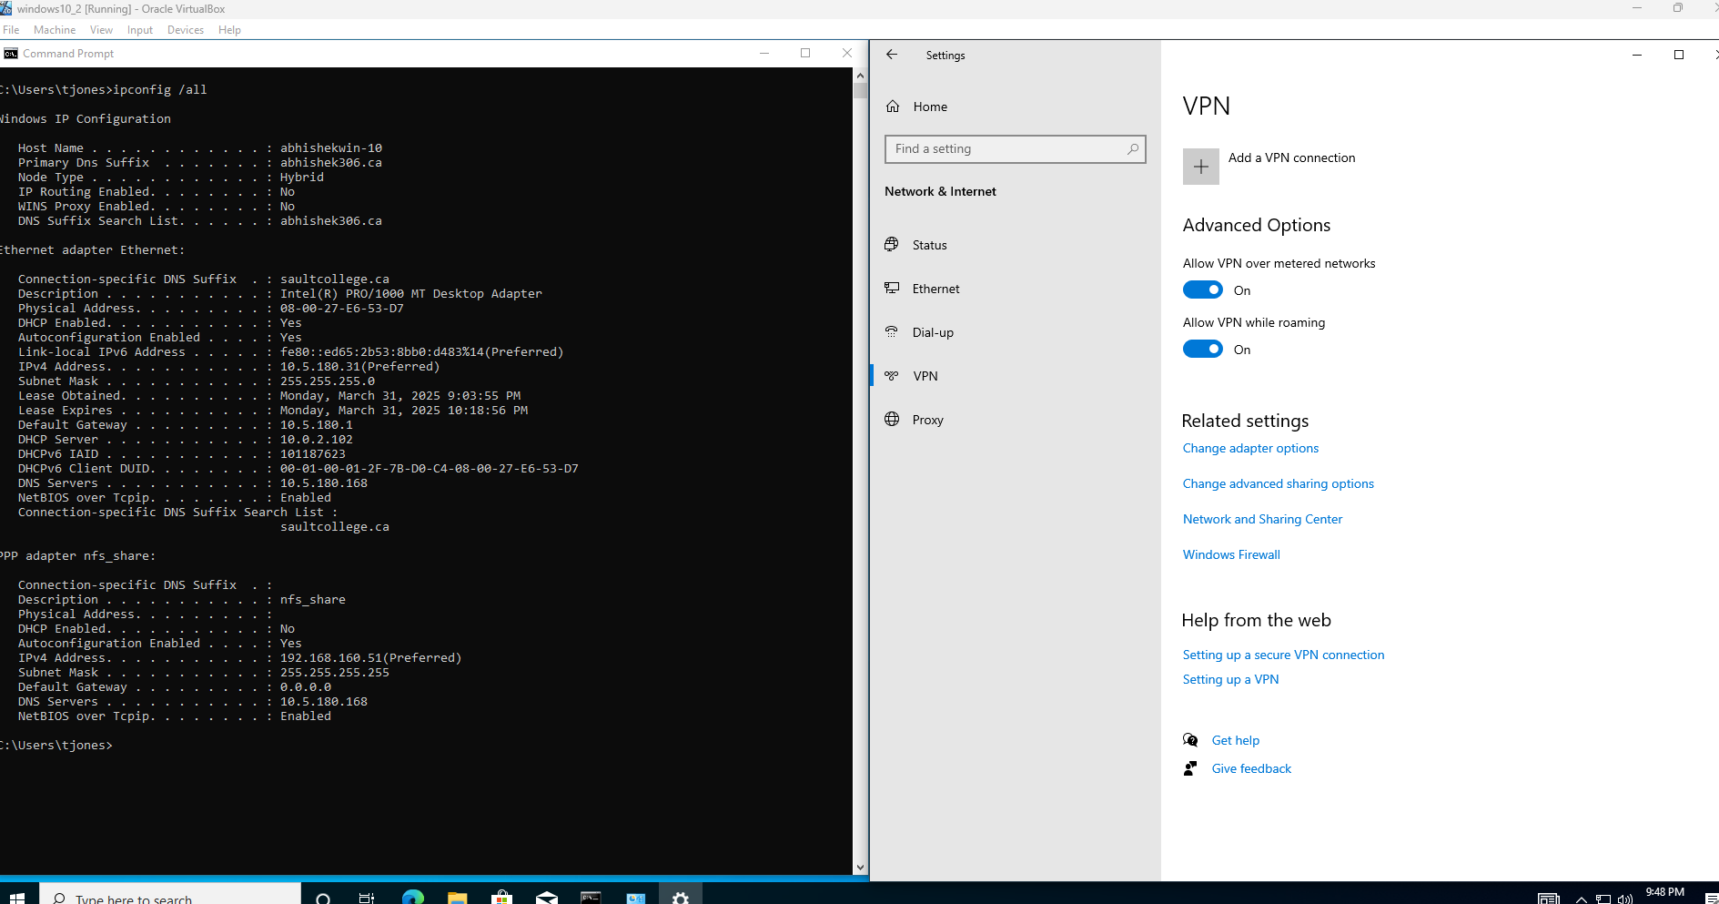
Then some input field will come .
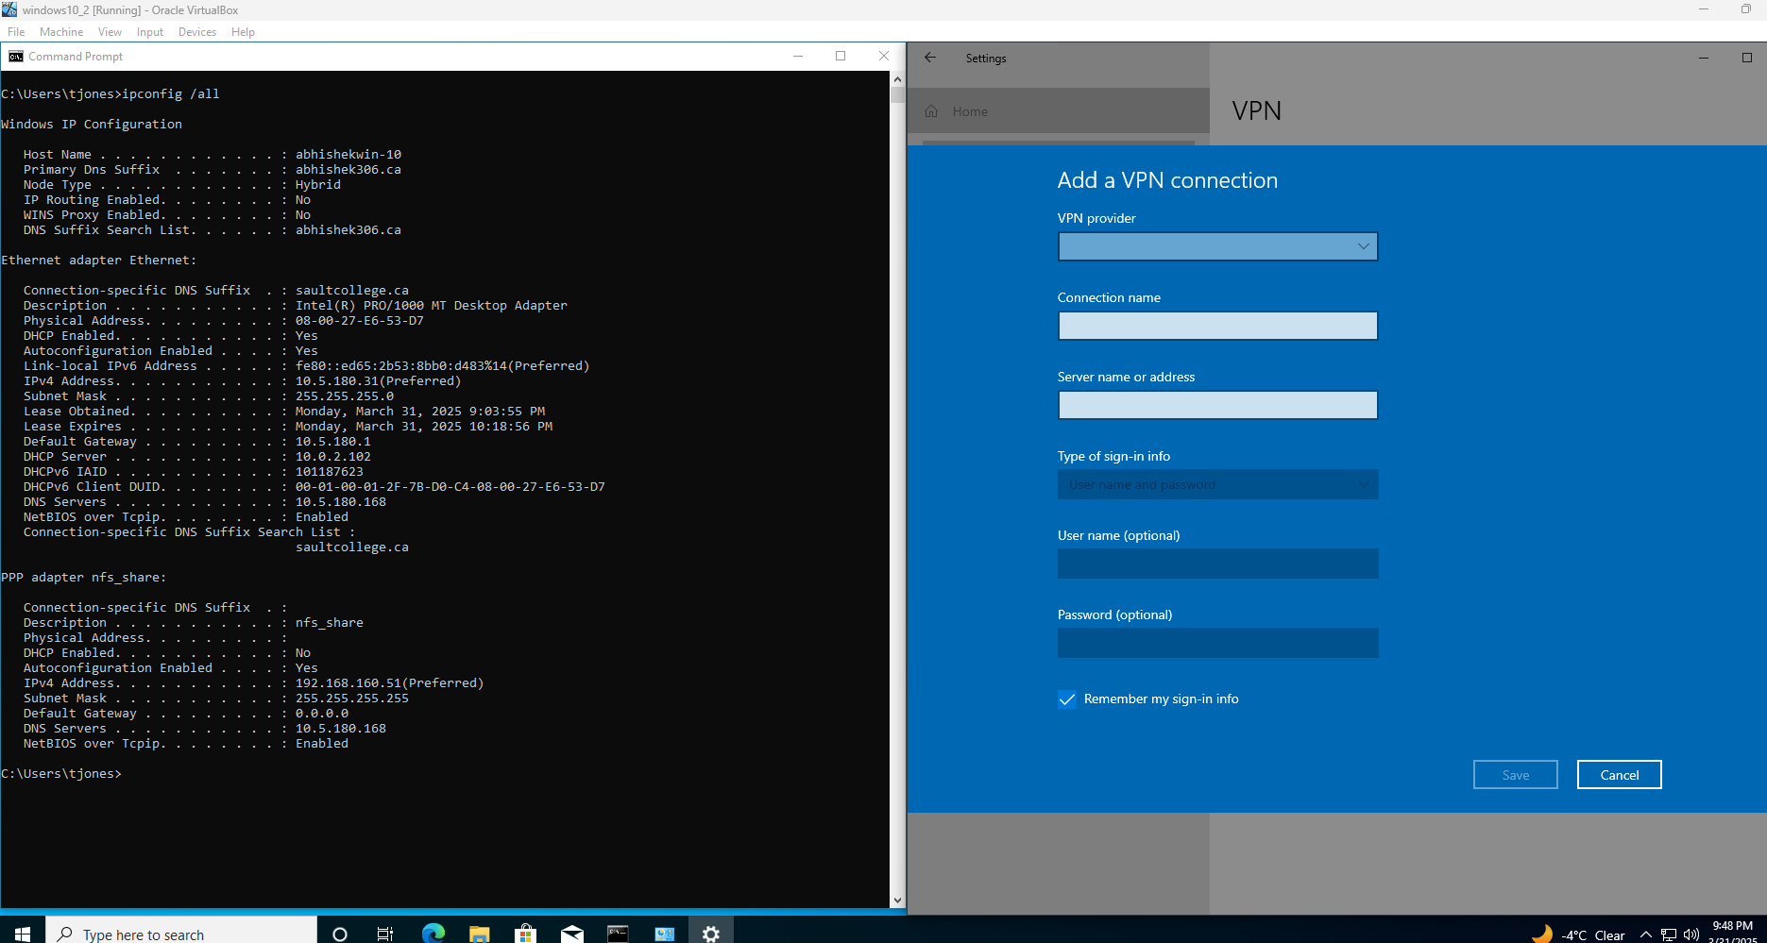

Fill in:
vpn provider - windows (built-in)
In connection name - type vpn name
In server name or address – type the windows server ip address 10.5.180.168
VPN type – point to point tunneling protocol(PPTP)
Type of sign-in info – Username and Password
Username – windows 10 username
Password – windows 10 password
Afterward save it
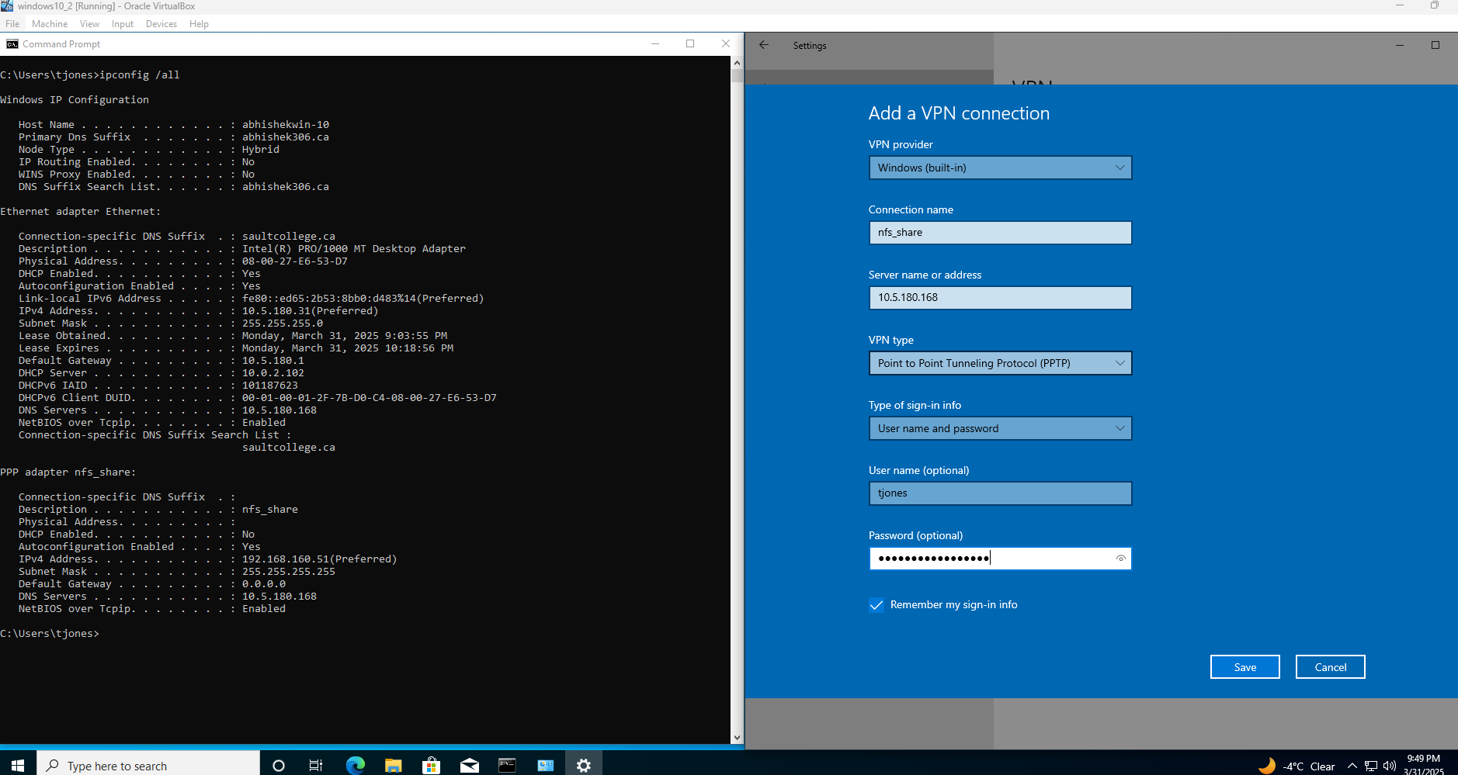

Then click connect > now if every thing given correctly the vpn will connect to windows server.
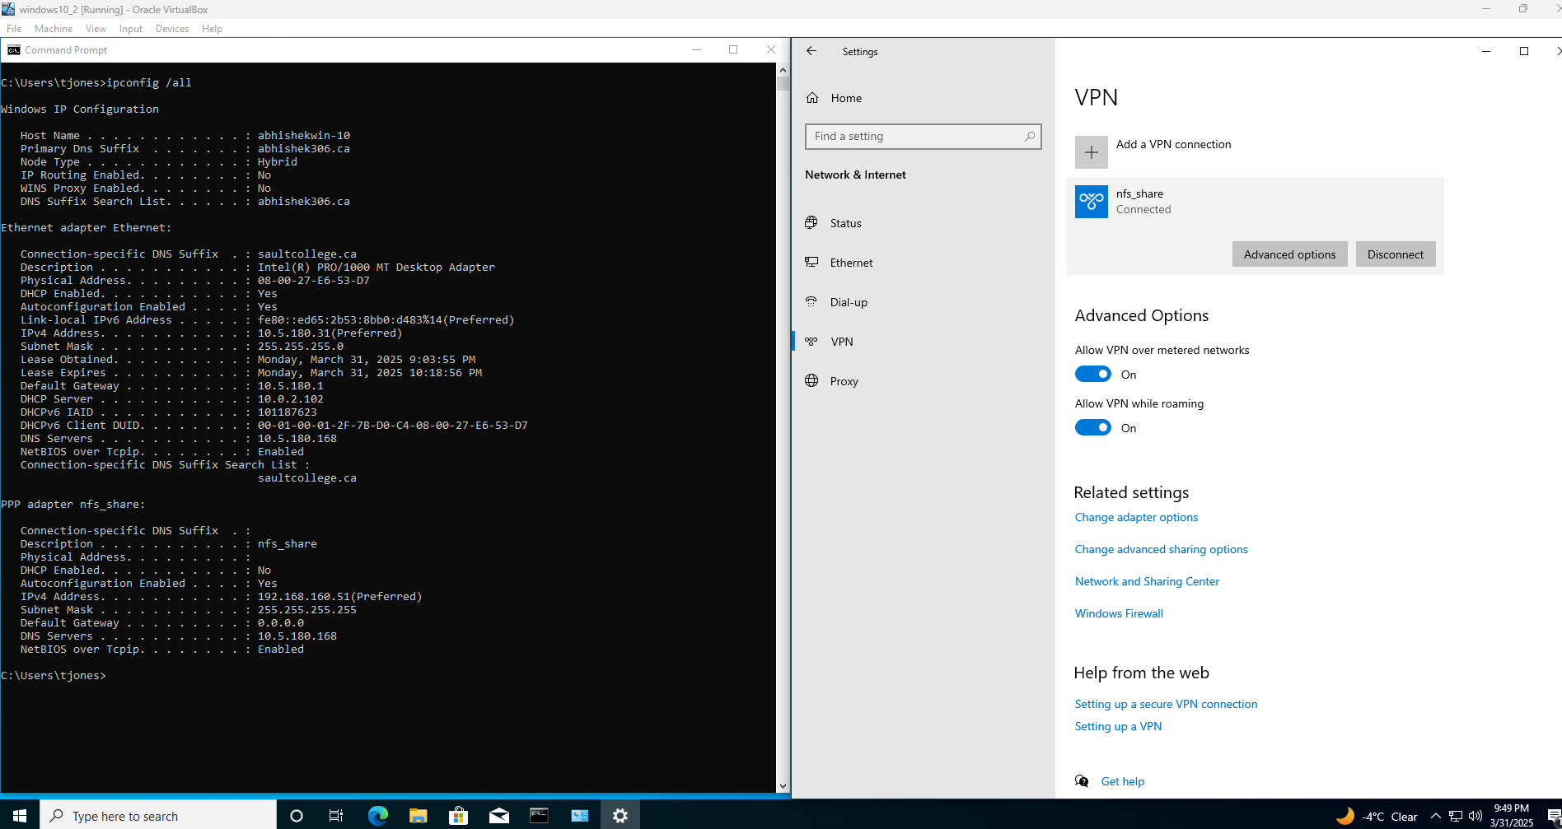
Now open and look in windows server routing and remote access .click ports there will be one active connection.
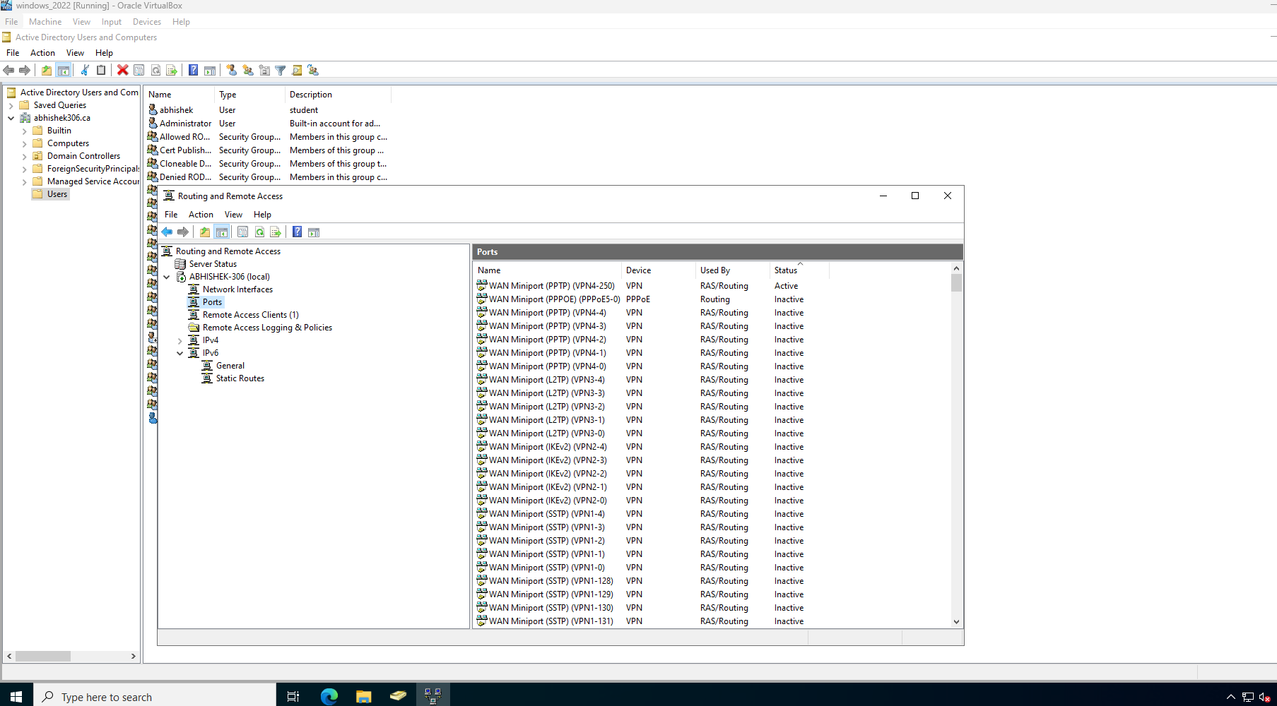

Then check the Remote access clients there will be one user connected.By doing this the configuration of VPN is done and this will create a secure connection to windows server.
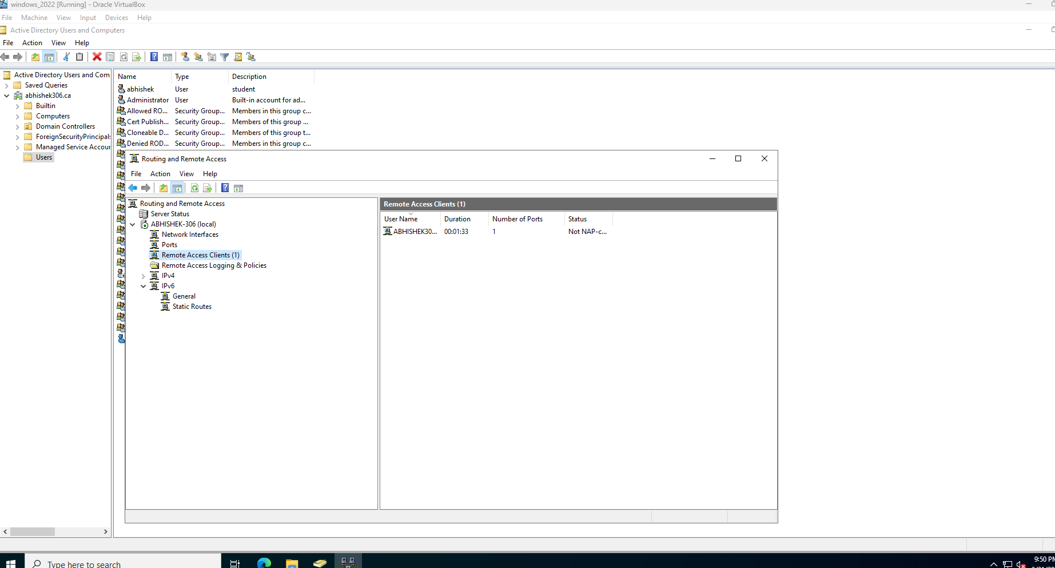

2.Implementation of event logging for monitoring access
For implementing second security feature I use security logging in event viewer.
For doing this ,in windows server ,open server manager > select tools > navigate to services for network file system(NFS)
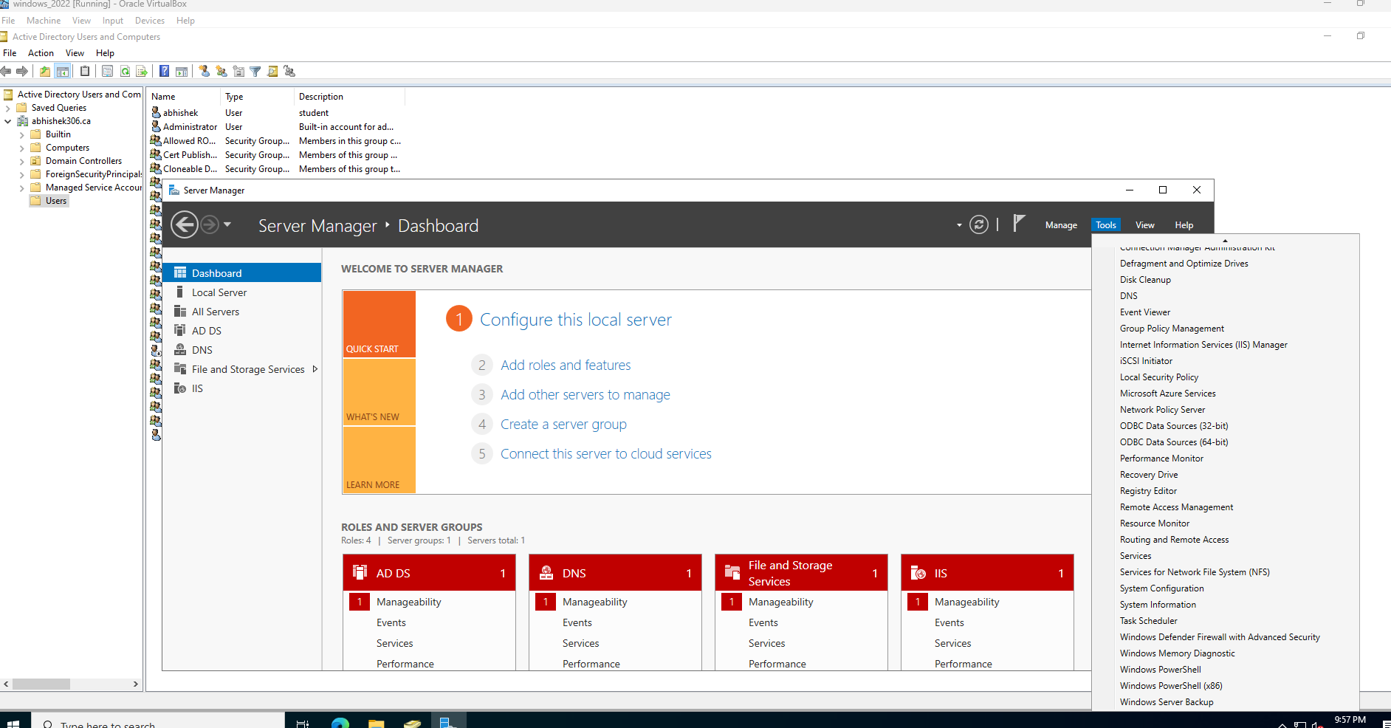

In that right click server for NFS
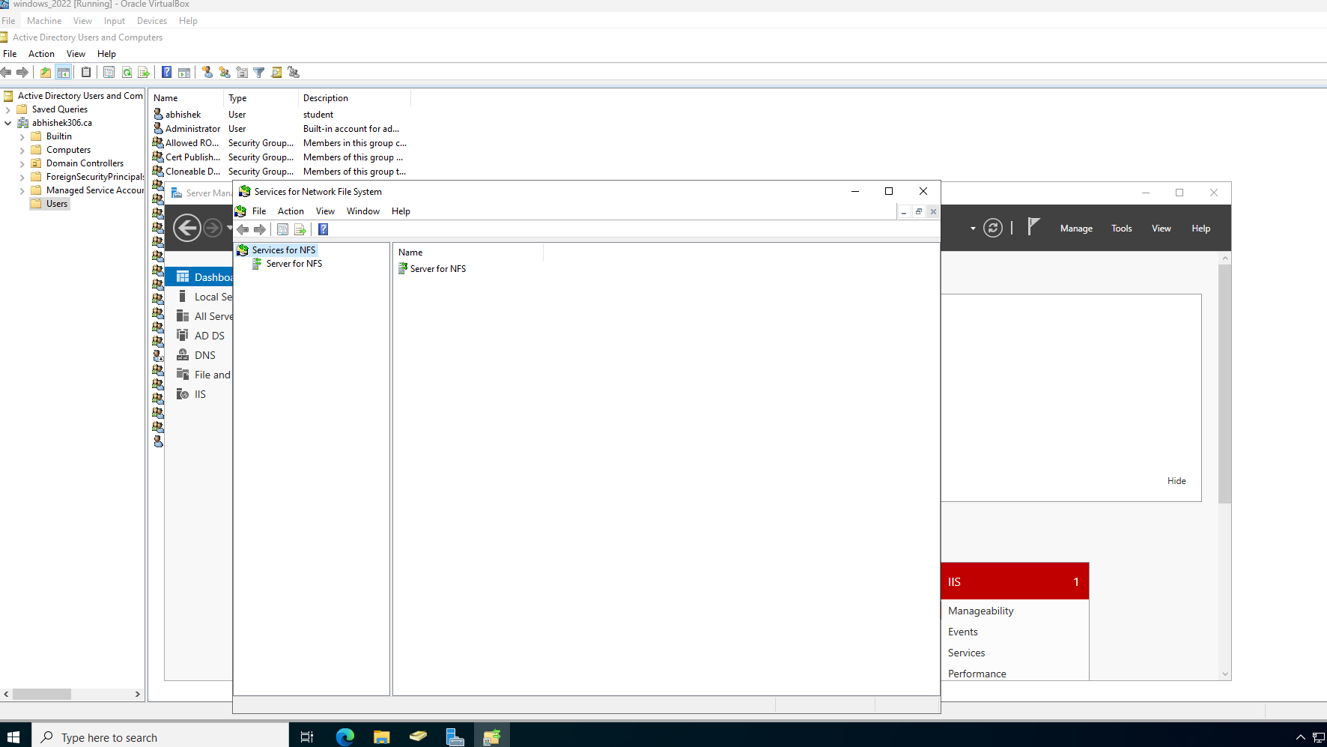

Move to activity logging tab check 4 loggings(mount and unmount requests, lock and unlock requests, read and write requests ,create and delete requests)
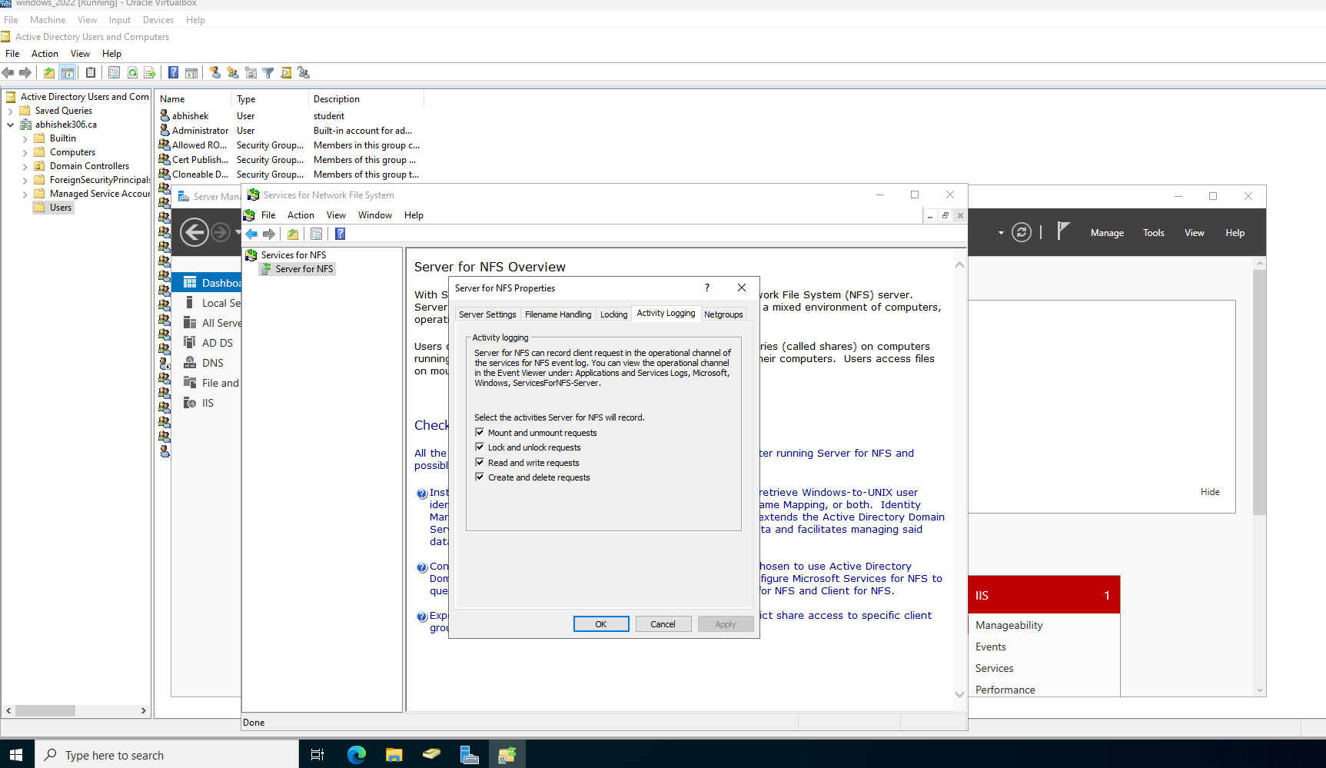

Now mount the nfs share
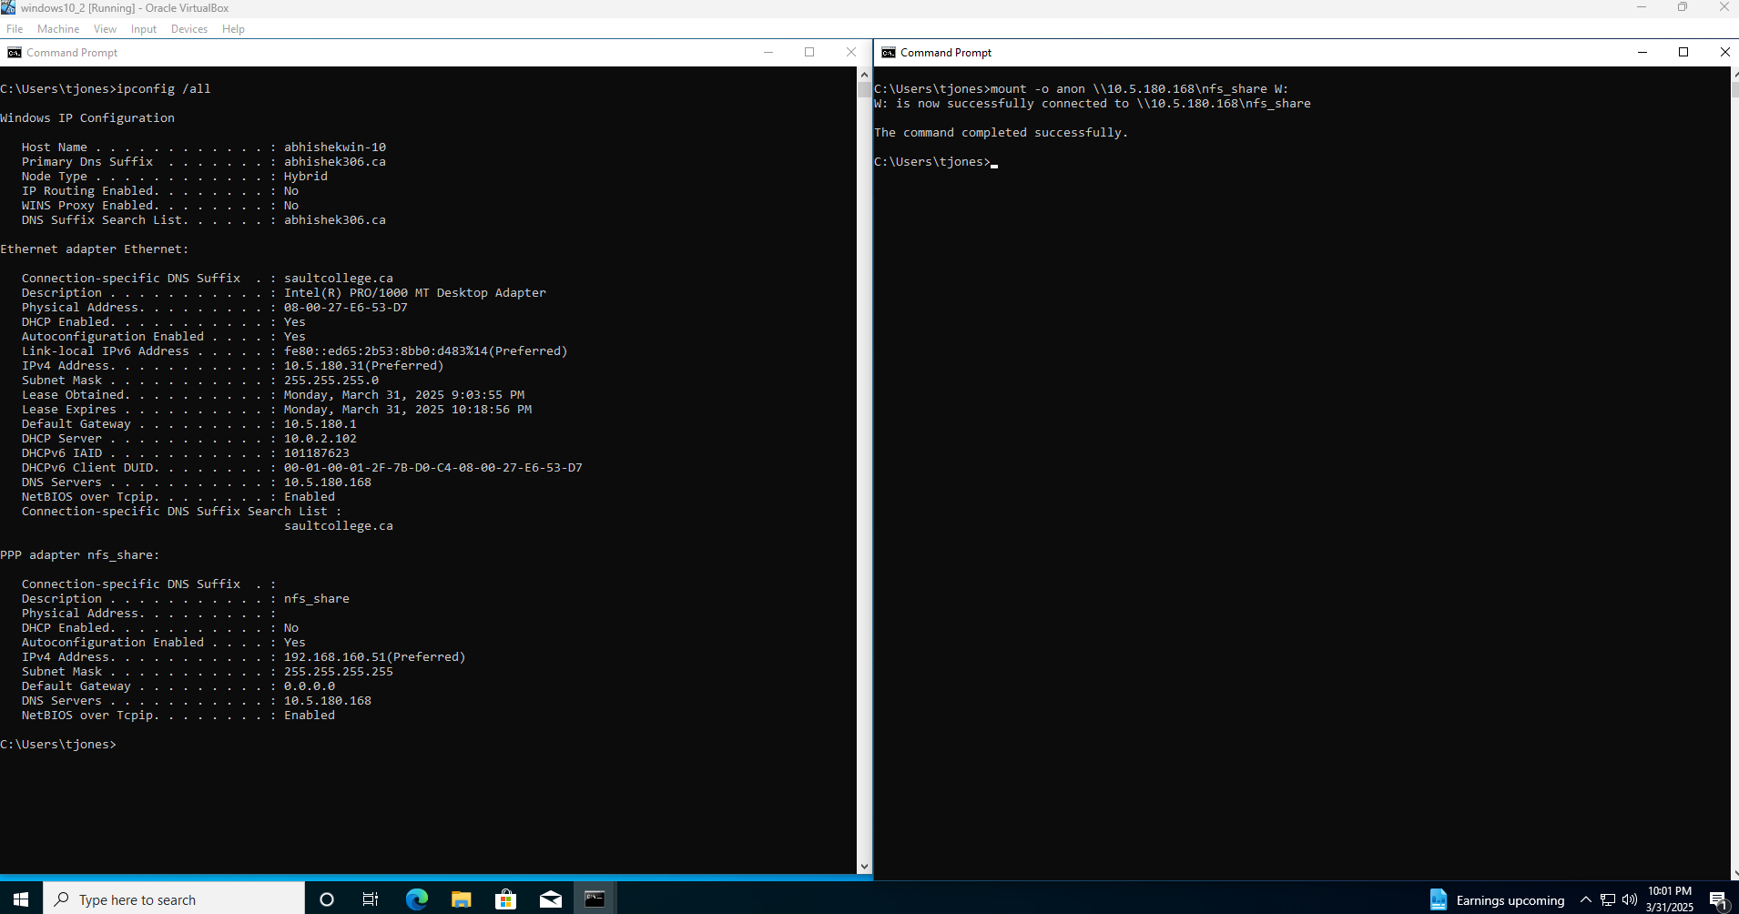

In event viewer navigate to Application and services logs > Microsoft > windows > ServicesForNFS-Server > operational ,in here we can see that mounted operation succeeded.
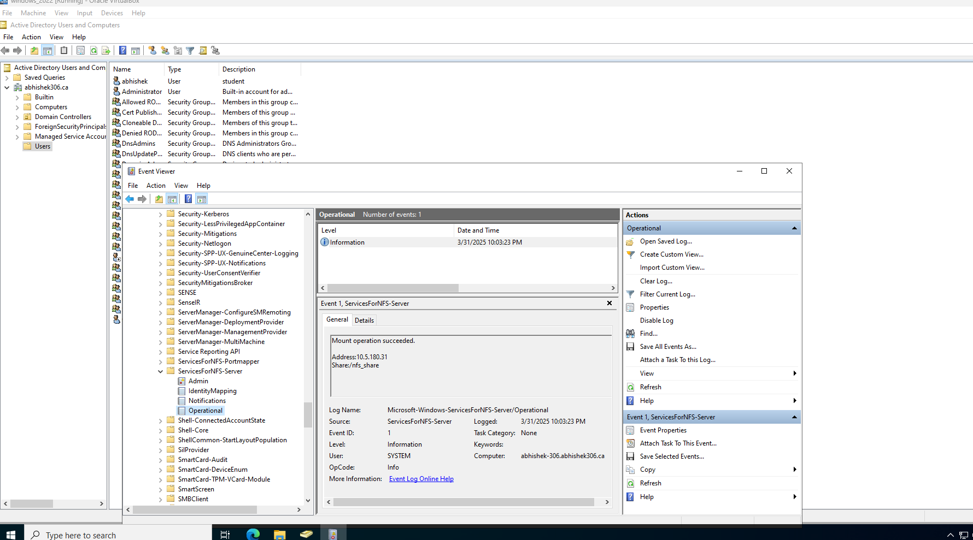
From windows 10 open the shared directory
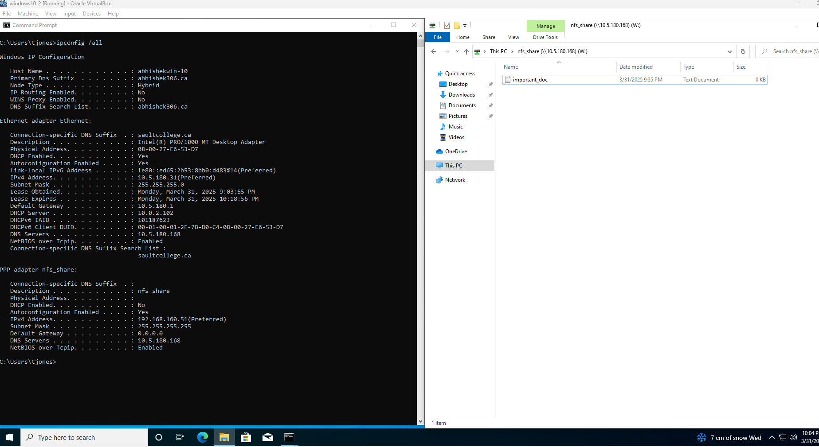

Create a folder
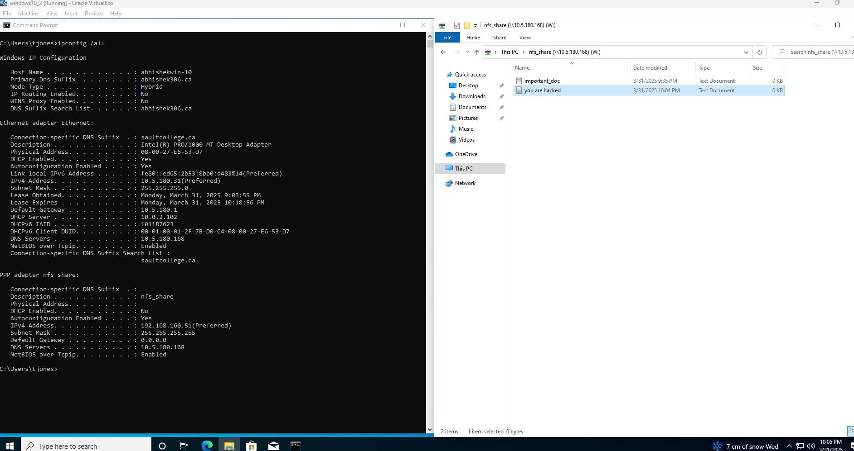
In event viewer we can see document created succeeded.
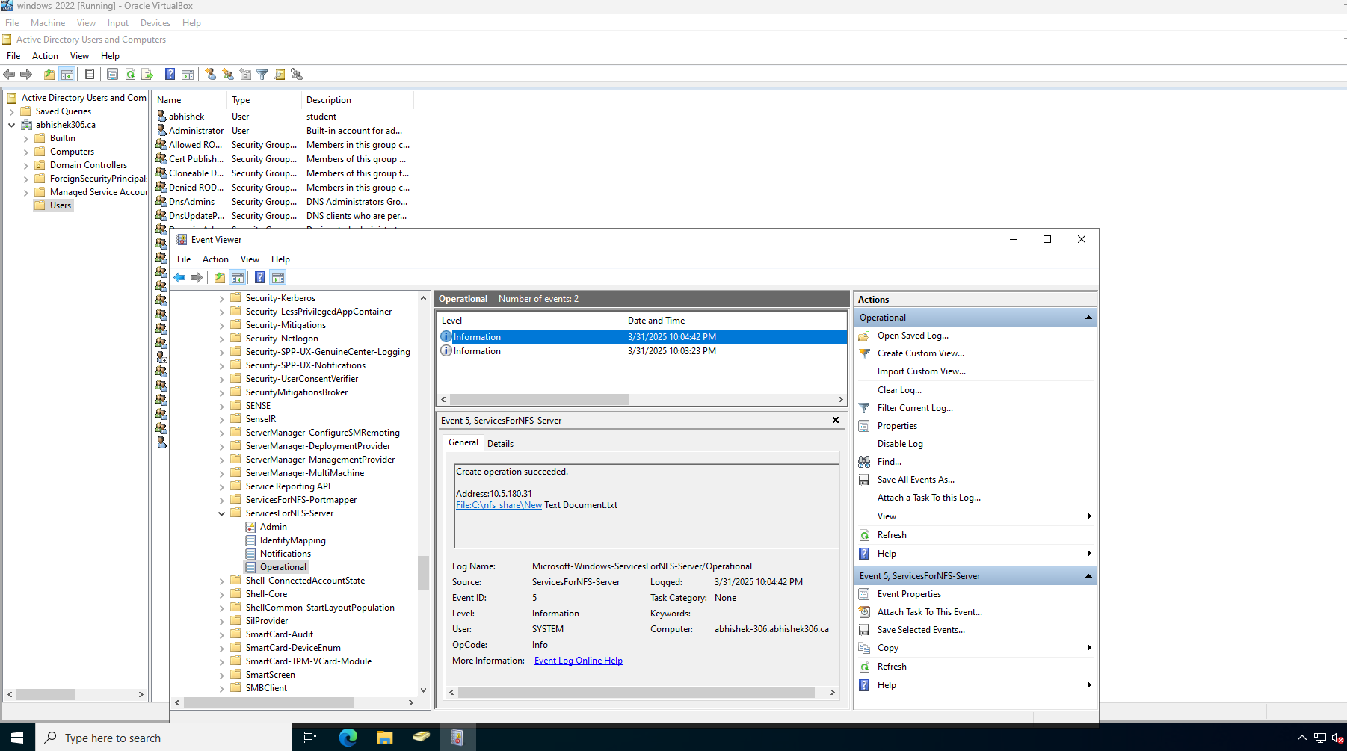

If we edit the document and save it.
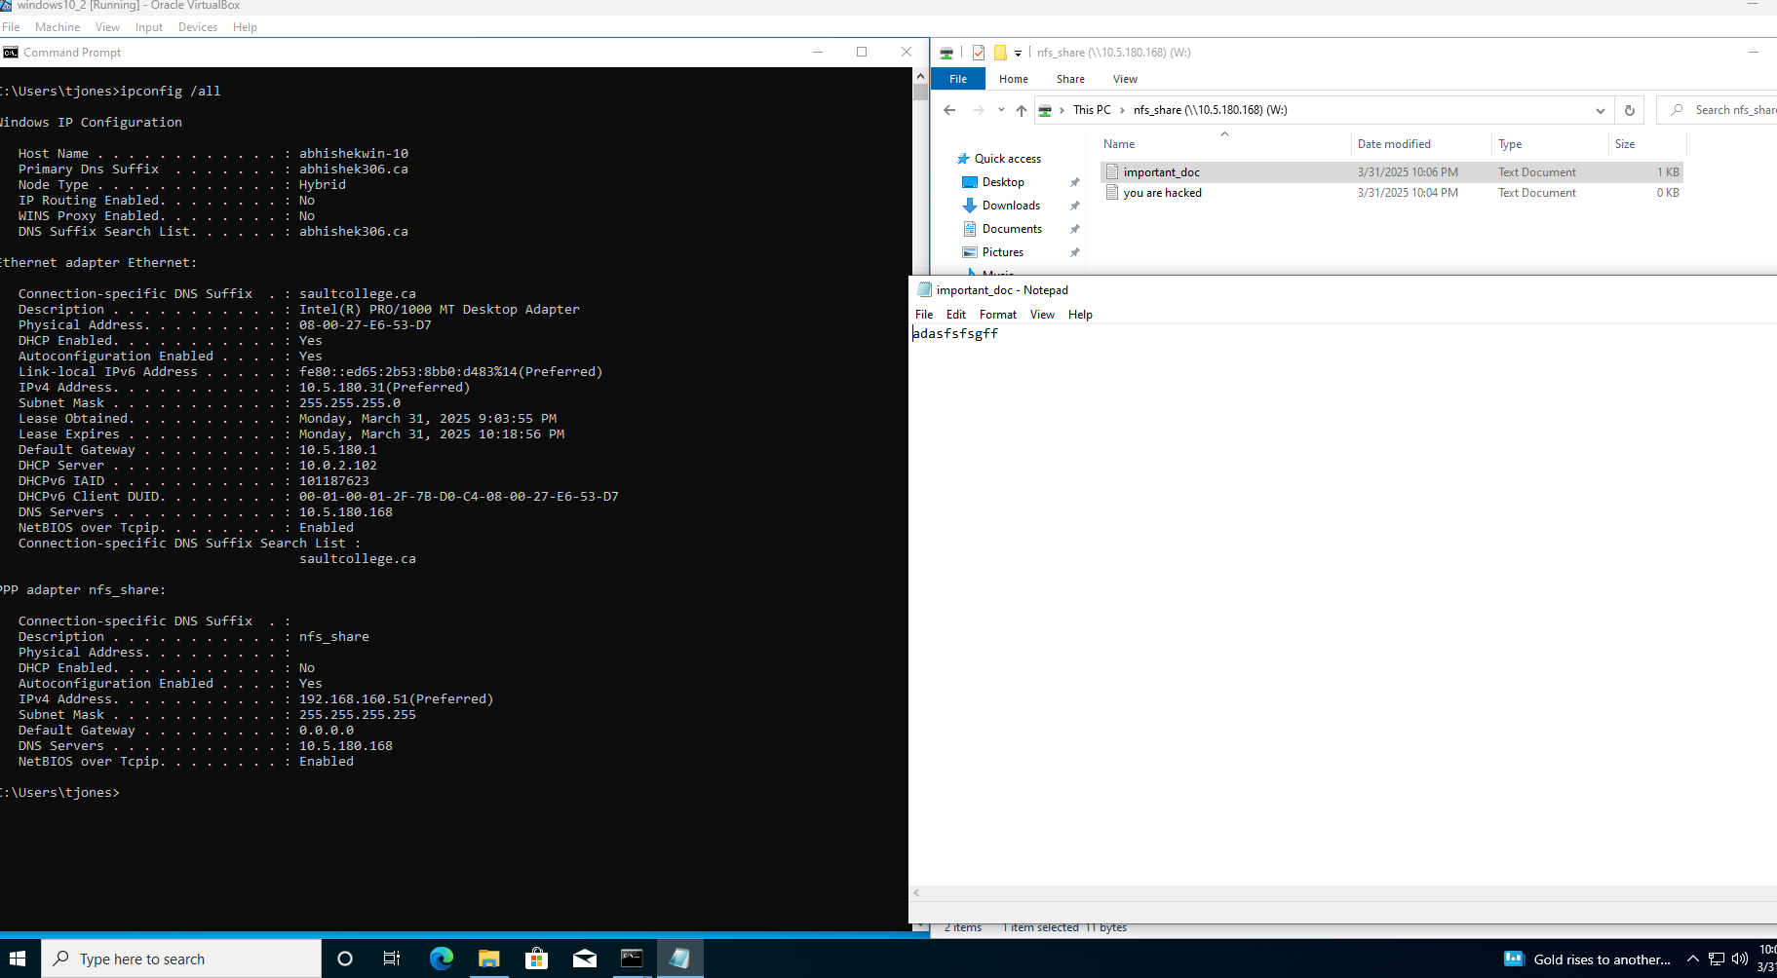
We can see in event viewer “written operation succeded”.
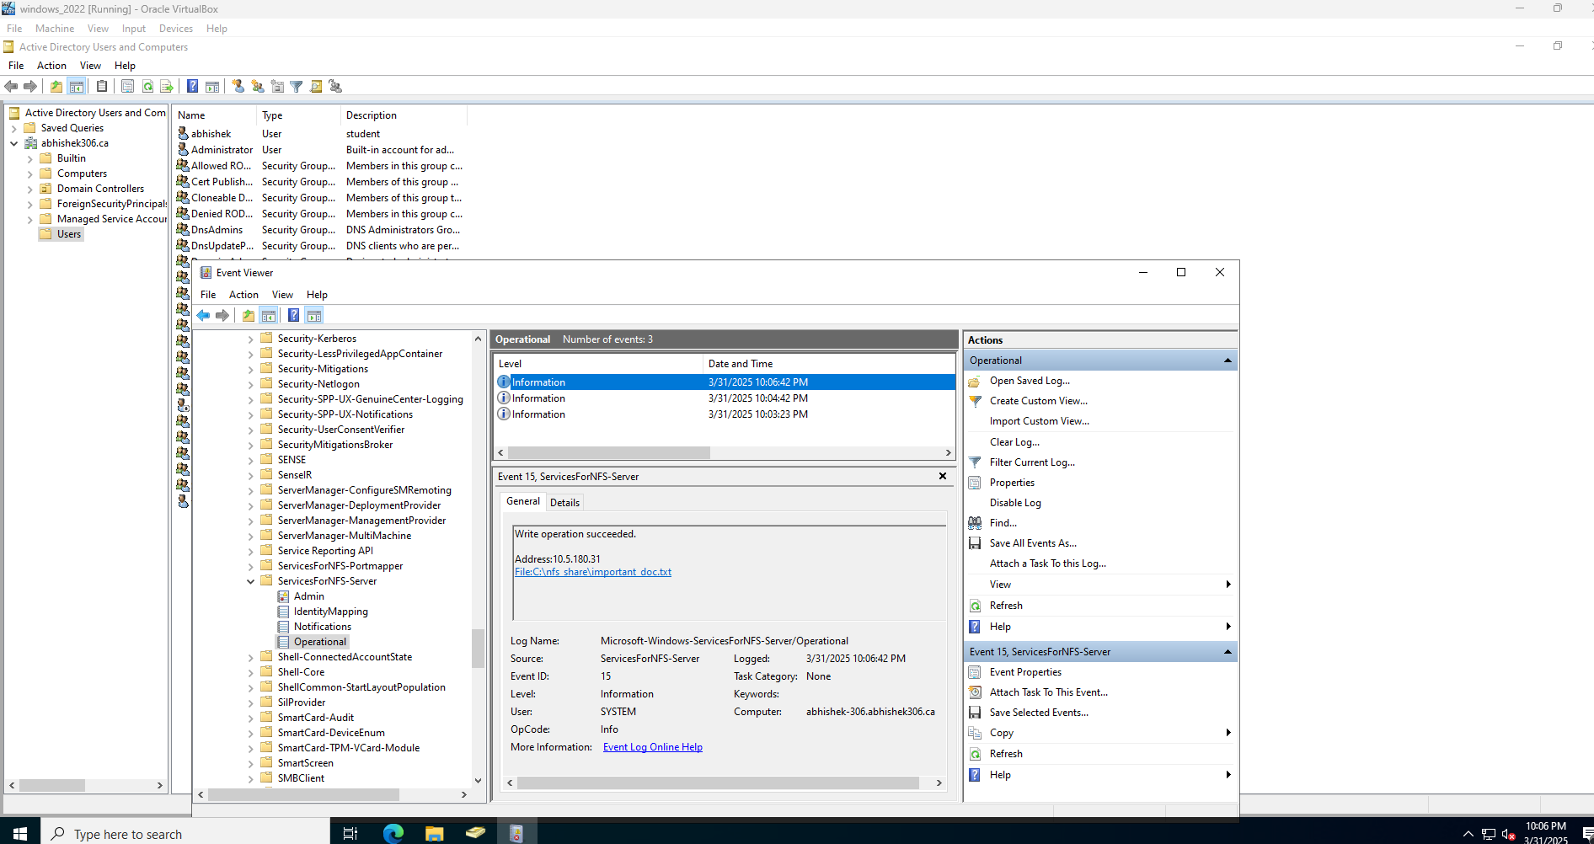

3.IP-based permission to restrict unauthorized clients
On my third security implementation I use inbuild share permissions.
For configuring this:
Firstly in windows server ,open server manager navigate to file and storage services > shares
On share we can see all shares .
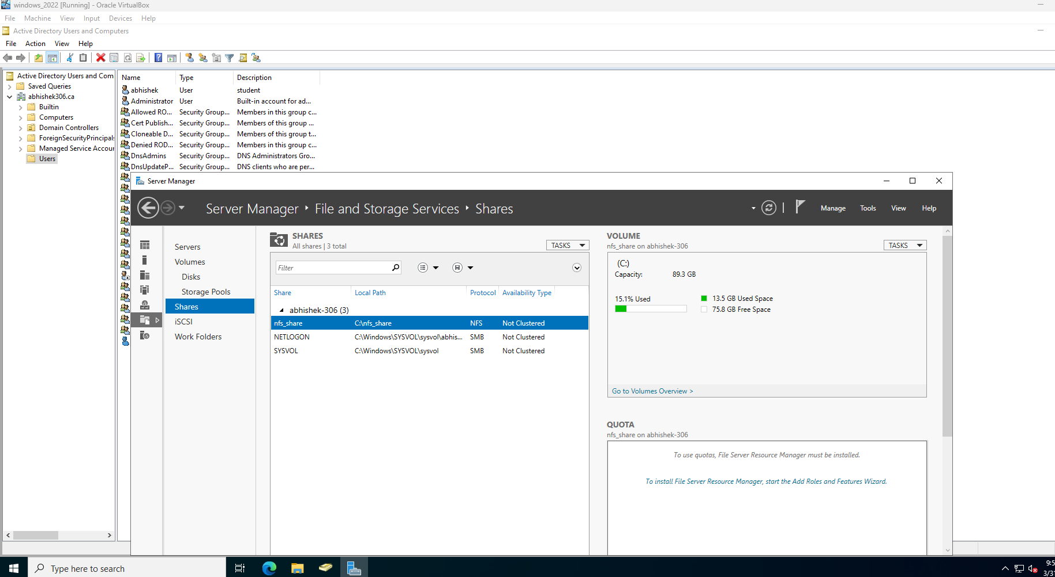
so for setting allocated ip’s only .Right click the share that we want to implement security ,move to share permission section .

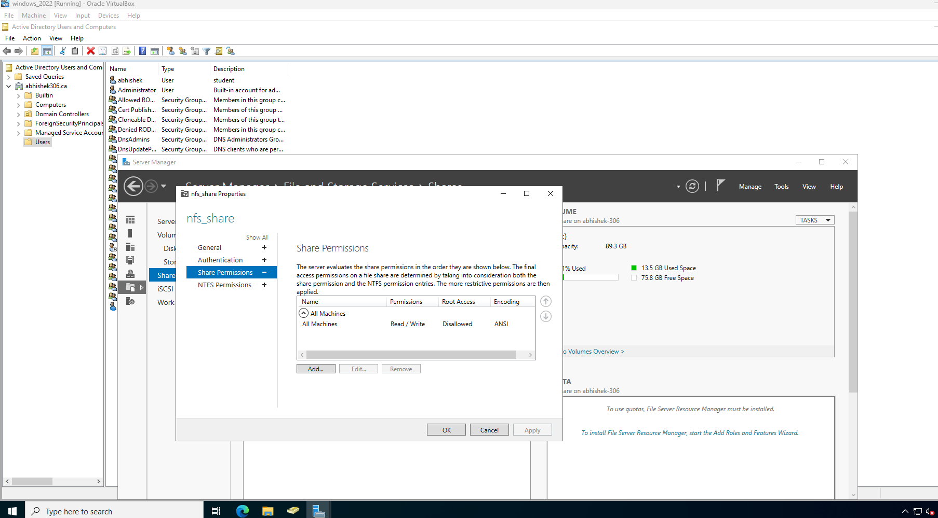
In there edit the All machines and remove read/write and select No access
Subsequently select add and type the ip that want to give permission to share .Then select read/write permission and click add.
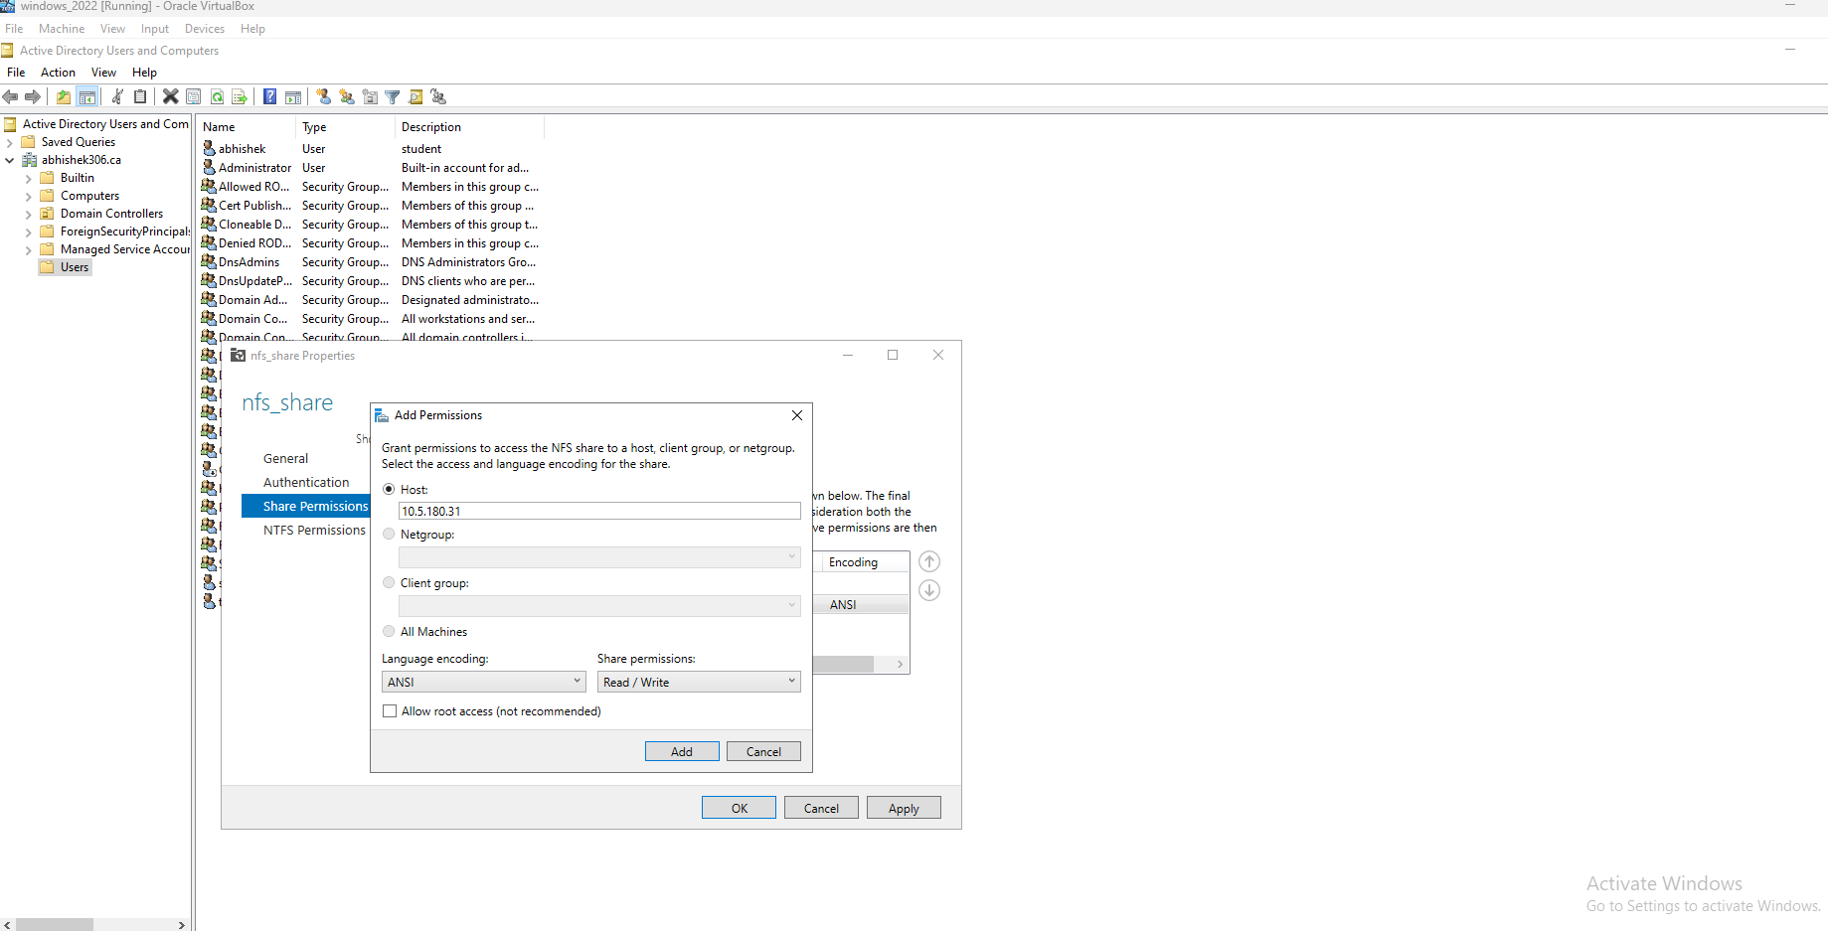

Now we can see in share permission that ,we given read/write to selected ip and no read or write access to all machines.
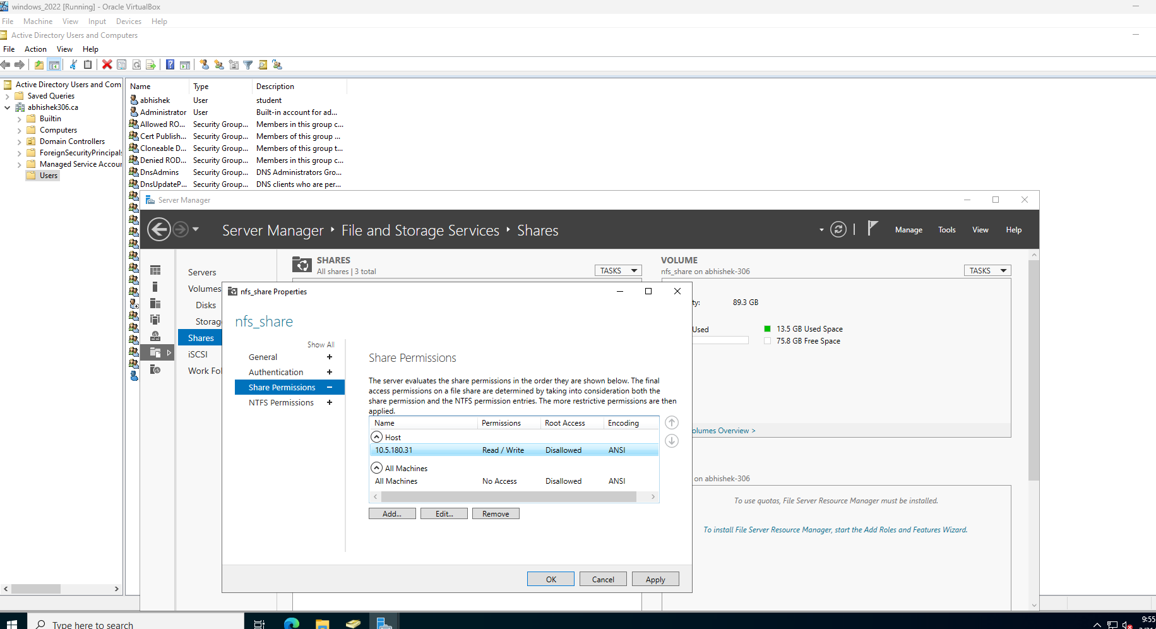

Now if we mount from other device we can’t get the shares. But we can get access for our selected ip.

In event log we can see mounted operation is succeded from given ip.

CONCLUSION
In conclusion, this project shows the practical usage of the Network File System (NFS) in a real-world Windows setup, highlighting its functionality and security aspects. With the installation of NFS on Windows Server and seamless integration with Windows 10, we made sharing files between systems simple—users could access remote files as if they were stored locally. This makes it much easier to work together, manage files, and connect systems in a network.Other than initial configuration, the project focused on implementing three critical security features to enhance the security of the NFS deployment:
- VPN Encryption was configured to enable secure data transmission across the network, safeguarding against hacker other malicious software's.
- Event Logging was enabled to monitor file system activity in real time. This provide useful information on mount, read/write, and delete operations.
- IP-Based Permissions were given to restrict access to authorized devices, minimizing the chance of unauthorized clients accessing the shared information in the network of company.
Such security measures prove how NFS can be integrated into a secure and manageable file-sharing environment in multi-user or enterprise environments. Proper configuration and constant monitoring, and NFS is an efficient tool for scalable, efficient, and secure file sharing.To enhance the configuration further, future updates can include automated backup integration, user-based permission models, and advanced authentication techniques like Kerberos with Active Directory for added security.In summary, this project illustrates NFS as an essential solution to modern network-based file sharing.

2025

References
Introduction to NFS and its architecture.
Network File System (NFS) | GeeksforGeeks
For understanding the concept to install NFS Server and its configuration.
39. Installing and Configuring NFS Server role in Windows Server 2019 - YouTube

TO IMPLEMENT THREE SECURITY MEASURES: -
For security 1: -Use of VPN encryption for secure NFS communication.
How to install and configure Remote Access (RAS) as a VPN server | Microsoft Learn
For security2: - Implementation of event logging for monitoring the access.
Server for NFS Diagnostics | Microsoft Community Hub
For security 3: - Ip – based permissions to restrict unauthorized clients.
Deploy Network File System | Microsoft Learn

************************ THANKYOU *****************************

