

  - Used Car Price Estimation
with Neural Networks

PROJECT REPORT
A study of car price prediction using linear regression, Keras and a neural network built with NumPy.

Course | MSc Data Science
Subject | NNDL
Trimester | 4

SUBMITTED BY
Ghinaiya Axit Rasikbhai [ 25122008 ]
Abhishek Vanahalli [ 25122026 ]

Submitted To
Yogesh Sir

Abstract
AutoValue is a web application that estimates a used car’s selling price from its details. It uses information such as the car’s age, brand, kilometres driven, engine size, fuel and ownership. This report explains how the data was prepared, how the models were trained, how their results were compared, and how the application returns an estimate.
The project used the CarDekho dataset file Car details v3.csv. After removing 1,202 duplicate rows, 6,926 records remained. These records were split into training, validation and test sets. The training set was used to learn model parameters and data transformations. The validation set was used to choose settings. The test set was kept for the final comparison.
Three models were evaluated: linear regression, a Keras artificial neural network, and a neural network written with NumPy. The selected Keras model used a learned brand embedding, two hidden layers, dropout and RMSprop. It learned standardized natural-log prices and converted its outputs back to rupees.
On 1,039 test cars, the Keras model had a mean absolute error of INR 77,564.60. This was 44.37% lower than the linear regression error. Its log-price R² was 0.9085, above the project target of 0.85. The NumPy model gave similar results and showed how the main training calculations can be implemented directly.

Application and main limitation
FastAPI serves the trained model, and Streamlit provides the user interface. The app includes a price estimate, an uncertainty range, what-if comparisons and a feature-importance chart.
The uncertainty range covered only 49.66% of validation prices. It must therefore be described as uncalibrated. The model also uses historical data and does not provide a verified current-market valuation.

Keywords
Used car price estimation; artificial neural network; brand embedding; NumPy; RMSprop; MC dropout; FastAPI; Streamlit.

Index
Use this index to find each part of the report. Chapter titles are clickable in the Word document.
Chapter | Topic | Page
01 | Project purpose and dataset | 4
02 | Data preparation | 5
03 | Models used in the project | 6
04 | Neural network architecture | 7
05 | Training formulas | 8
06 | Evaluation formulas | 9
07 | Experiments and model selection | 10
08 | Training behaviour | 11
09 | Final test results | 12
10 | Prediction checks | 13
11 | Errors by vehicle group | 14
12 | Understanding uncertainty | 15
13 | Feature importance | 16
14 | Web application | 17
15 | Prediction workflow | 18
16 | Verification and project files | 19
17 | Limitations and conclusion | 20
18 | References and glossary | 21

How to read the numbers
INR means Indian rupees. One lakh equals INR 100,000. Tables marked INR 000 show thousands of rupees. Lower MAE and RMSE are better. R² is a comparison with a mean-value prediction; it is not the percentage of cars predicted correctly.
DATA AND STUDY DESIGN

01 Project purpose and dataset

The problem
Buyers and sellers need a reasonable starting point when discussing a used car’s price. Cars with different ages, usage and specifications can have very different values. AutoValue learns patterns in recorded selling prices and uses those patterns to estimate the price of another car.
The assigned project requires a linear baseline, a neural network with a brand embedding, a model built from scratch, experiment comparisons and a working application [1]. The two numerical targets are lower test MAE than linear regression and log-price R² of at least 0.85.
TABLE 01 Dataset summary
Item | Value
Source file | Car details v3.csv
Original records | 8,128
Original columns | 13
Duplicate rows removed | 1,202
Records used | 6,926
Manufacturing years | 1983 to 2020
Recorded price range | INR 29,999 to INR 10,000,000

What the model predicts
The target is selling_price in rupees. The source is the CarDekho Vehicle Dataset on Kaggle [2]. The records contain listed selling prices; they are not verified completed transactions.
The original columns are name, year, selling_price, km_driven, fuel, seller_type, transmission, owner, mileage, engine, max_power, torque and seats. Brand is extracted from name. The final model does not use the full model name, variant or torque. This limits the details it can distinguish.
DATA AND STUDY DESIGN

02 Data preparation
Data preparation converts the original car details into consistent inputs. Exact duplicate rows were removed before the split. Engine and power units were removed from text values. Mileage was separated into its numeric value and its unit, because kilometres per litre and kilometres per kilogram describe different quantities.
Fifteen zero or negative mileage values and three zero or negative power values were treated as missing. There were no zero or negative target prices. Very large positive values were retained, so possible extreme-data errors remain a limitation.
TABLE 02 Data split
Set | Cars | Purpose
Training | 4,848 | Learn transformations and model weights
Validation | 1,039 | Choose settings and stopping point
Test | 1,039 | Final model comparison

Missing values and scaling
Missing numeric values were filled using training-set summaries. Seats used the training mode of five. Mileage used the training median within its unit: 19.40 kmpl or 21.94 km/kg. Numeric inputs were then standardized. Category encoders and the brand dictionary were also fitted on training data only.
TABLE 03 Final input groups
Type | Inputs
Numeric | Car age, kilometres, mileage value, engine, maximum power, seats
Categorical | Brand, fuel, seller type, transmission, owner, mileage unit

The fixed age reference
$$Car age = 2020 - Manufacturing year$$
For example, a car made in 2014 has a model input age of 6. The year 2020 comes from the training data. It is part of the saved model definition and must also be used by the app. This is not the car’s current calendar age. Both split operations used random seed 42.
MODEL DEVELOPMENT

03 Models used in the project

Linear regression
Linear regression is the baseline. It learns a weighted sum of the input values and predicts the price directly in rupees. It uses six numeric features and 39 encoded category columns, giving 45 inputs.
This model provides a simple comparison. However, its output has no positive-price restriction. It can therefore produce zero or negative values, which do not represent usable selling prices.

The Keras neural network
An artificial neural network, or ANN, passes inputs through layers of learned weights. ReLU allows the network to learn relationships that are more complex than a straight line. For example, the effect associated with engine power can differ across brands and ages.
Brand uses a learned embedding: each brand ID selects eight values from a table. These values are updated during training. Other categories use one-hot encoding, which creates columns indicating category membership. The selected model predicts a standardized log price.

The NumPy neural network
The scratch implementation uses NumPy matrix operations for the forward pass, error calculation, backpropagation and weight updates. It includes the same layer sizes, brand embedding and dropout rates as the Keras network.
Repeated brand IDs can appear in a batch. Their gradients are added to the same embedding row using np.add.at. RMSprop updates the weights. The scratch model uses different initialization and numeric precision from Keras, so identical outputs are not expected.
TABLE 04 Comparison of the three models
Model | Output learned | Main role
Linear regression | Raw rupee price | Simple baseline
Keras ANN | Standardized log price | Selected application model
NumPy ANN | Standardized log price | Demonstrate training from scratch

MODEL DEVELOPMENT

04 Neural network architecture
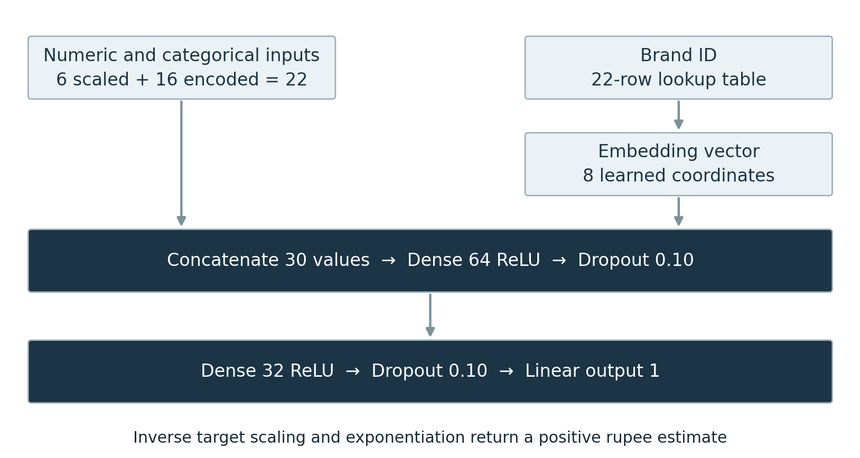
FIGURE 01 How the two input branches join
TABLE 05 Layers and trainable parameters
Component | Size | Parameters
Brand embedding | 22 IDs × 8 values | 176
Combined input | 22 other values + 8 embedding values | 0
First hidden layer | 64 ReLU units | 1,984
First dropout | 10% dropout | 0
Second hidden layer | 32 ReLU units | 2,080
Second dropout | 10% dropout | 0
Output layer | 1 linear unit | 33
Total | Trainable parameters | 4,273

Brands with at least five training records received their own ID. Rare and unseen brands share ID 0. Sixteen training cars used this shared ID. The model can process an unseen brand, but this does not prove that its estimate will be reliable.
During normal prediction, dropout is off. For uncertainty sampling, dropout is turned on to generate different outputs [5]. The network has no batch-normalization layer.
MODEL DEVELOPMENT

05 Training formulas

Converting price to the training target
Let y be a positive price in rupees. We take its natural logarithm and then standardize it using the training mean μ and training standard deviation σ. The model learns the transformed value z. A hat over a symbol means a prediction.
$$z_{i} = \frac{ln y_{i} - μ_{ln y}}{σ_{ln y}} , \hat{y_{i}} = exp(μ_{ln y} + σ_{ln y}\hat{z_{i}})$$
The formula on the right converts a predicted z back into rupees. Exponentiation makes the output positive. It does not automatically remove bias when converting log predictions back to raw prices; no bias correction was applied here.

Learning from the error
The selected model minimizes mean squared error, or MSE, on the transformed targets. B is the number of examples in a batch. The derivative shows how each predicted value contributes to the update.
$$L = \frac{1}{B}\sum_{i = 1}^{B}{{(\hat{z_{i}} - z_{i})}^{2}} , \frac{∂L}{∂\hat{z_{i}}} = \frac{2}{B}(\hat{z_{i}} - z_{i})$$
Backpropagation carries this error through the output layer, hidden layers and embedding. ReLU keeps positive values and replaces negative values with zero. Its gradient is applied only where the saved activation was positive.

Updating weights with RMSprop
Here g is the gradient, v is a running average of squared gradients, and θ is a model parameter. The formula below matches the NumPy implementation, including the small value inside the square root.
$$v_{t} = 0.9v_{t-1} + 0.1{g_{t}}^{2} , θ_{t+1} = θ_{t} - \frac{0.001g_{t}}{\sqrt{v_{t} + {10}^{-7}}}$$
The learning rate is 0.001. The running average uses decay 0.9. During training, dropout keeps each hidden activation with probability 0.9 and divides retained values by 0.9. Early stopping restores the weights that gave the lowest validation loss.
MODEL DEVELOPMENT

06 Evaluation formulas
These measures compare actual prices y with predicted prices ŷ across n cars. The mean actual price is written as ȳ. Raw-price measures use rupees. Each measure answers a different question, so they are reported together.

Mean absolute error
$$MAE = \frac{1}{n}\sum_{i = 1}^{n}{|y_{i} - \hat{y_{i}}|}$$
MAE gives the average size of the error without its sign. If a car’s actual price is INR 5 lakh and its estimate is INR 4.5 lakh, the absolute error is INR 50,000. This is an illustration, not a saved project prediction.

Root mean squared error
$$RMSE = \sqrt{\frac{1}{n}\sum_{i = 1}^{n}{{(y_{i} - \hat{y_{i}})}^{2}}}$$
RMSE squares errors before averaging them. Large mistakes therefore have more influence. RMSE being much higher than MAE suggests that some cars have much larger errors.

Coefficient of determination
$$R^{2} = 1 - \frac{\sum_{i = 1}^{n}{{(y_{i} - \hat{y_{i}})}^{2}}}{\sum_{i = 1}^{n}{{(y_{i} - ȳ)}^{2}}}$$
R² compares the squared errors with predicting the mean actual price. One means perfect predictions; zero matches that reference; negative values are worse. For log-price R², apply the same formula to natural-log actual and predicted prices.

Mean absolute percentage error
$$MAPE = \frac{100}{n}\sum_{i = 1}^{n}{|\frac{y_{i} - \hat{y_{i}}}{y_{i}}|} \%$$
MAPE reports average error relative to the actual price. The same rupee error becomes a larger percentage for a cheaper car. Actual prices must be non-zero; all retained target prices in this project are positive.
MODEL DEVELOPMENT

07 Experiments and model selection
The plan contained 36 possible combinations. Seven unique configurations were completed in stages. The study compared Adam, RMSprop and SGD; learning rates 0.0001, 0.001 and 0.01; MSE and Huber losses; and raw and log-price targets. It was not a full 36-run grid search.
TABLE 06 Validation results for completed experiments
ID | Optimizer | Rate | Loss | Target | MAE  INR 000 | Log R²
001 | Adam | 0.001 | MSE | Log | 78.86 | 0.9102
013 | RMSprop | 0.001 | MSE | Log | 76.24 | 0.9094
014 | RMSprop | 0.001 | MSE | Raw | 80.68 | Undefined
015 | RMSprop | 0.001 | Huber | Log | 77.20 | 0.9085
017 | RMSprop | 0.0001 | MSE | Log | 79.85 | 0.9055
021 | RMSprop | 0.01 | MSE | Log | 81.82 | 0.8990
025 | SGD | 0.001 | MSE | Log | 85.09 | 0.8838

Why ANN 013 was selected
ANN_013 had the lowest validation MAE among the completed configurations meeting log-price R² ≥ 0.85. Its validation MAE was INR 76,239.44 and log-price R² was 0.9094. It used RMSprop, learning rate 0.001, MSE and a standardized log-price target.
RMSprop gave lower MAE than Adam and SGD at the common settings. Its learning rate of 0.001 also gave lower MAE than 0.0001 and 0.01. Huber had slightly lower RMSE, but MSE had lower MAE, which was the selection measure.
The raw-price ANN produced six zero or negative validation estimates, making its log-price R² undefined. The log-price model avoided this issue. These comparisons support the selected configuration within the tested settings; they do not prove it is the best possible configuration.
MODEL DEVELOPMENT

08 Training behaviour
Training loss measures how well a model fits the training examples. Validation loss checks its behaviour on separate examples. Early stopping prevents training from continuing indefinitely after validation performance stops improving.
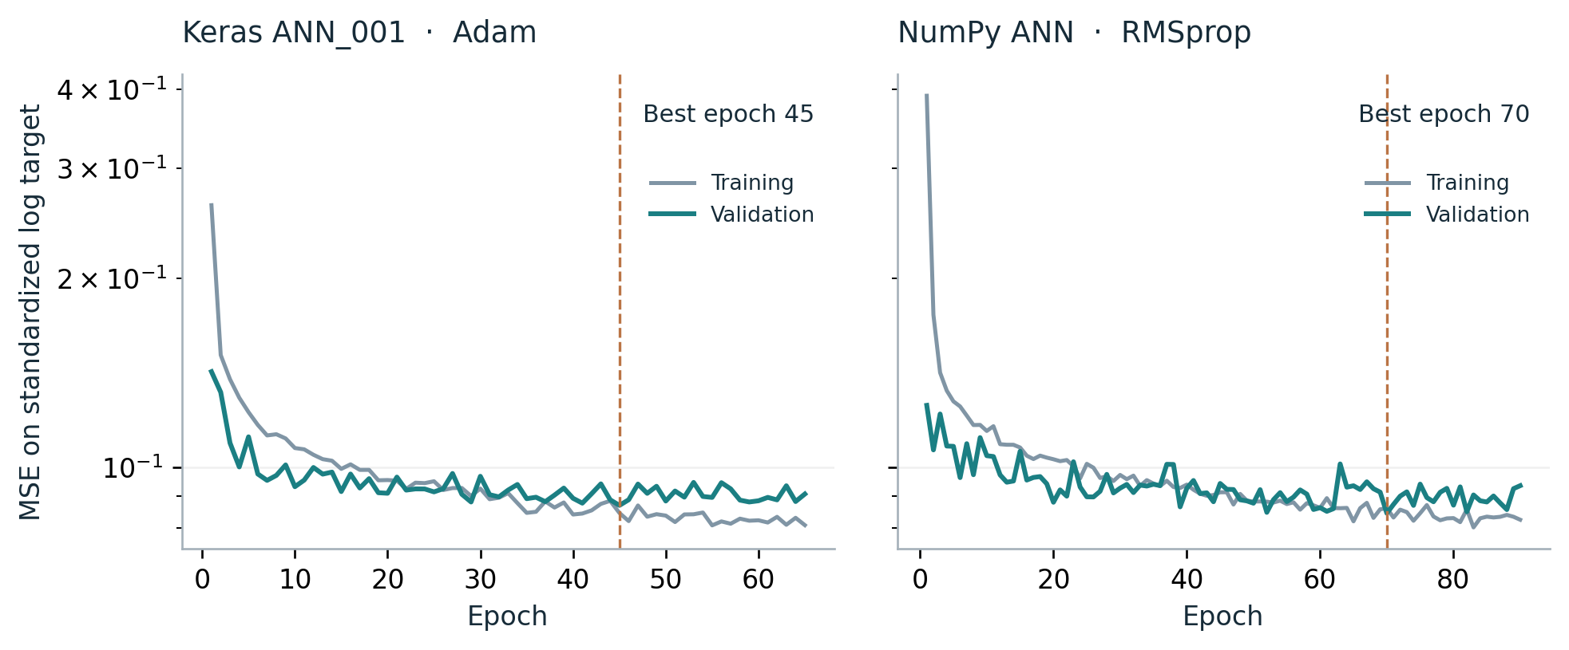
FIGURE 02 Saved learning curves for ANN 001 and the NumPy model
TABLE 07 Stopping and restored checkpoints
Model | Stopped epoch | Restored epoch
Keras ANN_001 | 65 | 45
Keras ANN_013 | 60 | 40
NumPy ANN | 90 | 70

What the curves show
The NumPy loss falls quickly at first and then improves more slowly. Its best saved validation loss is at epoch 70. Training continues for 20 more epochs before those best weights are restored. Each batch contains 32 examples, with a maximum of 200 epochs.
The package contains full learning histories for ANN_001 and the NumPy model. It does not contain the full history of selected ANN_013. The chart therefore labels ANN_001 clearly and does not present it as the selected model.
Dropout is active when training loss is calculated and inactive during validation. Training loss can therefore be higher than validation loss. The chart uses standardized log-target MSE, so the values are not rupee errors.
RESULTS AND INTERPRETATION

09 Final test results
All models were compared on the same 1,039 test cars after model selection. The following values come from the saved final test results. No new training or model selection was done when preparing this report [3].
TABLE 08 Final performance on the test set
Model | MAE  INR 000 | RMSE  INR 000 | Raw R² | MAPE % | Log R²
Linear regression | 139.44 | 269.48 | 0.7256 | 46.34 | Undefined
Keras ANN | 77.56 | 150.23 | 0.9147 | 16.93 | 0.9085
NumPy ANN | 78.49 | 160.59 | 0.9026 | 17.26 | 0.9074

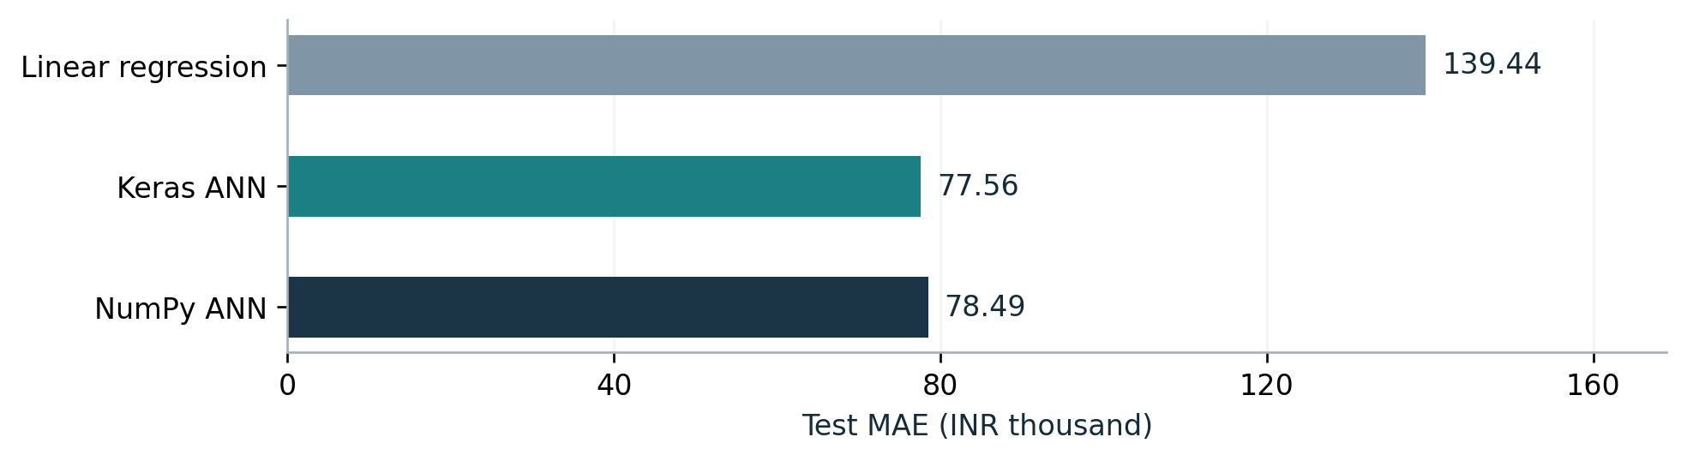
FIGURE 03 Average rupee error across the three models

Main finding
Keras achieved MAE INR 77,564.60, compared with INR 139,438.18 for linear regression. The reduction was 44.37%. Keras also achieved log-price R² of 0.9085. Both numerical project targets were met. The NumPy model’s MAE was only INR 924.25 higher, although one split is not enough to show whether that difference is statistically meaningful.

Why linear regression shows undefined log R²
Linear regression produced 63 zero or negative test estimates. Their logarithms are not finite real numbers, so full-test log-price R² cannot be calculated. This is an honest result, not a report error. These estimates remain included in raw-price MAE, RMSE, R² and MAPE. They were not clipped or removed to improve the score.
RESULTS AND INTERPRETATION

10 Prediction checks
These plots compare actual and predicted prices for the two neural networks. A point on the dashed line is an exact prediction. A point below the line is an underestimate; a point above it is an overestimate. Both axes use a log scale so low and high prices remain visible.
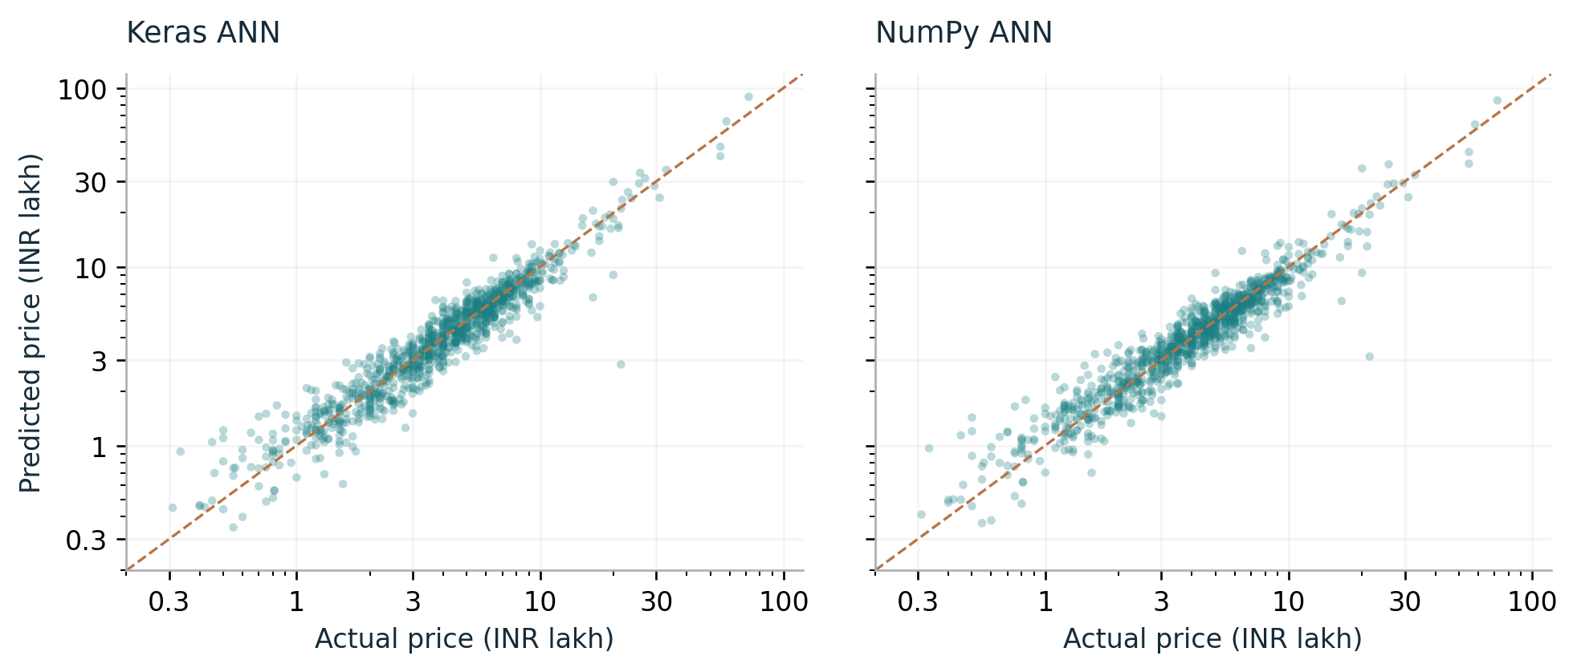
FIGURE 04 Actual and predicted prices in INR lakh
TABLE 09 Distribution of test errors
Model | Median error  INR 000 | 90th percentile  INR 000 | Within 1 lakh  % of cars
Linear regression | 91.52 | 262.88 | 53.80
Keras ANN | 48.23 | 150.97 | 78.63
NumPy ANN | 45.78 | 150.50 | 79.21

Why these checks matter
The median is the middle absolute error. The 90th percentile is a level below which roughly nine out of ten observed absolute errors fall. The final column shows how often the error was at most INR 1 lakh.
These values describe this test set. They do not guarantee an error limit for a new car. Keras RMSE is about 1.94 times its MAE, showing that some large mistakes remain despite the strong overall R².
RESULTS AND INTERPRETATION

11 Errors by vehicle group
A residual is actual price minus predicted price. A positive average residual means the model underestimated that group on average. A negative average means it overestimated. These tables use the selected Keras model.
TABLE 10 Errors by actual price band
Price band | Cars | MAE  INR 000 | Mean residual  INR 000 | MAPE %
Up to 3 lakh | 358 | 35.88 | -4.09 | 22.03
>3 to 6 lakh | 409 | 65.82 | 0.35 | 14.76
>6 to 10 lakh | 212 | 99.10 | 34.66 | 12.79
>10 lakh | 60 | 330.27 | 90.03 | 15.86

The 60 cars above INR 10 lakh had the highest absolute MAE, INR 330,266.52. Their average residual was positive, showing average underestimation. Low-price cars had smaller rupee errors but larger percentage errors.
TABLE 11 Errors by fuel type
Fuel | Cars | MAE  INR 000 | Mean residual  INR 000 | MAPE %
CNG | 13 | 34.31 | 11.49 | 12.83
Diesel | 557 | 97.78 | 15.38 | 16.89
LPG | 4 | 49.20 | 42.70 | 22.18
Petrol | 465 | 54.80 | 5.47 | 17.04

Diesel cars had higher MAE than petrol cars, but fuel alone cannot explain the difference. Their prices and other specifications can also differ. CNG and LPG groups contain only 13 and four cars. Their results should not be treated as strong evidence of performance for all CNG or LPG vehicles.
RESULTS AND INTERPRETATION

12 Understanding uncertainty
Monte Carlo dropout uses repeated predictions with dropout switched on to explore variation in the fitted model [4, 5]. AutoValue first calculates its normal point estimate with dropout off. It then performs 50 stochastic passes and converts each output back to rupees.
The low and high values are the 5th and 95th percentiles of these 50 outputs. They describe variation across sampled predictions. They are not automatically a reliable interval for the actual selling price.
TABLE 12 Uncertainty results on validation data
Measure | Value
Draws per car | 50
Validation cars | 1,039
Actual prices inside the range | 49.66%
Average range width | INR 149,671.56
Calibration status | Uncalibrated

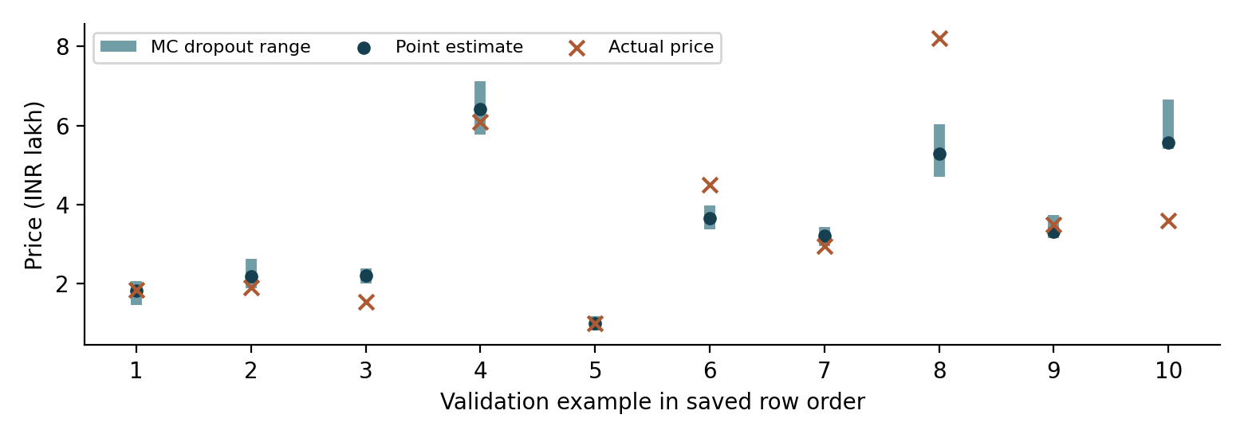
FIGURE 05 First ten validation examples in saved order

How to explain the range
Only about half of the actual validation prices were inside their ranges. The range must not be described as a guaranteed 90% prediction interval. A narrow range can still accompany a poor estimate.
The interface therefore labels it as an estimated model-uncertainty range. A future version should calibrate intervals on separate data and evaluate their coverage on a new untouched set. The current test set should not be reused to choose interval widths.
RESULTS AND INTERPRETATION

13 Feature importance
Permutation importance checks how much the model depends on a feature. We shuffle that feature across validation cars and measure how much MAE rises. A larger rise means the model relied more on that input for these data [6].
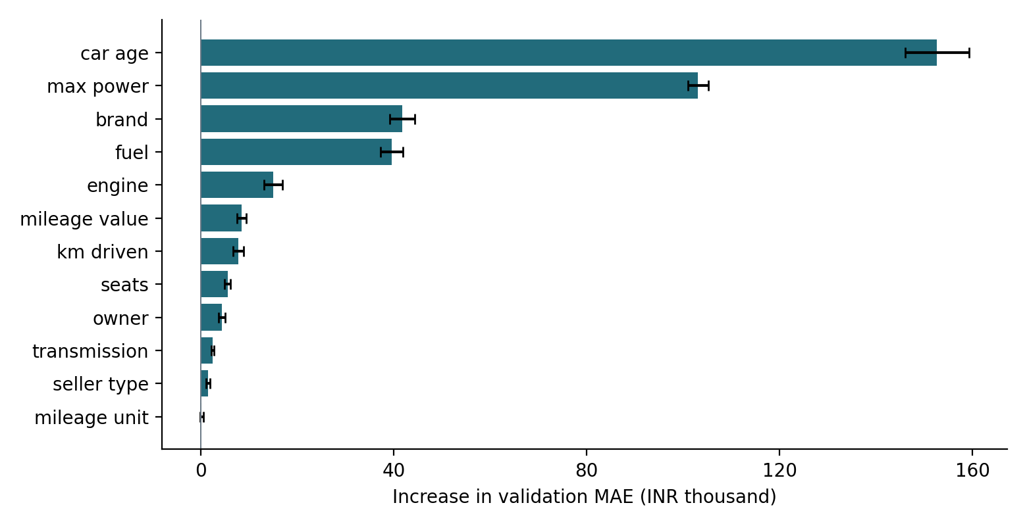
FIGURE 06 Increase in validation MAE after shuffling each feature
Each feature was shuffled ten times. The bars show the average increase in MAE, and the small error bars show the standard deviation across repeats. Encoded columns from one category were shuffled together. Brand IDs were treated as one separate feature.
Car age had the largest average increase, INR 152,591.75. Maximum power followed at INR 103,104.69. Brand and fuel followed at INR 41,777.63 and INR 39,633.46. These values show which inputs this model used most strongly.

Limits of this explanation
Importance describes the fitted model as a whole. It does not explain the exact price contribution for one car, prove cause and effect, or show that a low-ranked feature is useless. Related inputs can share information, and shuffling can create unrealistic combinations. Correct units remain necessary even when mileage unit has low measured importance.
APPLICATION AND REPRODUCIBILITY

14 Web application
The application has two parts. Streamlit collects the user’s car details and displays the result. FastAPI receives those details, checks them, applies saved preprocessing and calls the trained Keras model. The prediction comes from the project’s own model.
The interface includes three tabs. Price Estimate shows the price in rupees and lakh, the uncertainty range and a JSON download. What-if Studio changes age or kilometres while other inputs stay fixed. Model Insights displays permutation importance and allows a CSV download.
TABLE 13 API endpoints
Method | Endpoint | Purpose
GET | /health | Check that the service is running
GET | /metadata | Load input options and summaries
GET | /feature-importance | Read saved feature importance
POST | /predict | Return the price and uncertainty range

Input checks and logging
The API requires all 12 inputs. It rejects missing or extra fields, non-finite numbers and invalid scalar ranges, including negative kilometres. Category labels are normalized and checked. Unknown brands use the shared embedding ID, with a note. Values outside training ranges also produce notes.
Successful predictions are written to a JSON Lines log with a timestamp, normalized inputs and results. A process lock keeps model calls and log writes from overlapping. The recorded launch command uses one API worker.

Using the app correctly
The prefilled numeric values are training summaries, not verified specifications for the selected brand. Users should enter details for one real vehicle and use matching fuel and mileage units. The existing API does not check every relationship between fields.
APPLICATION AND REPRODUCIBILITY

15 Prediction workflow
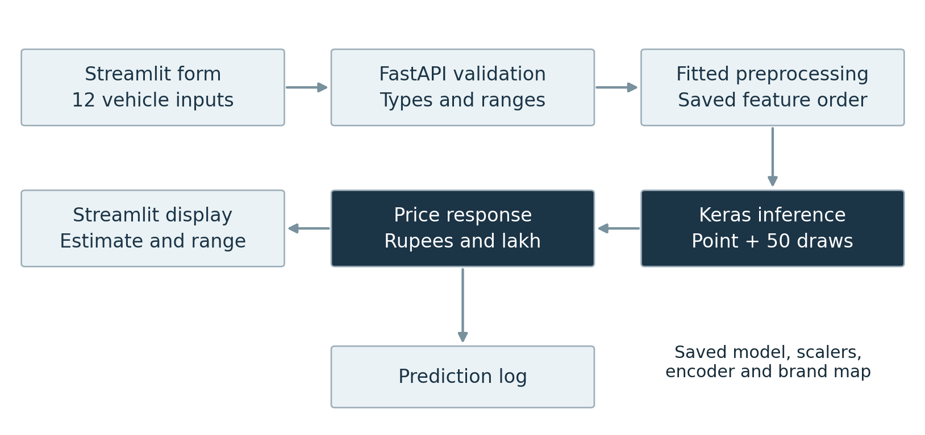
FIGURE 07 From vehicle details to the displayed estimate

How a request moves through the system
The user enters the car details in Streamlit. The app converts manufacturing year into model age using the fixed reference year 2020. FastAPI checks the request and arranges the fields in the same order used during training.
Saved scalers, category encoders and the brand mapping transform the inputs. The model produces a standardized log-price prediction. The saved target scaler reverses standardization, and exponentiation converts the result into a positive rupee value.
Fifty extra passes produce the uncertainty range. The API returns the point estimate, range and notes. Streamlit formats them for the user, and the API records the successful request.

What the what-if comparison means
Changing kilometres or model age gives another model estimate while the other details stay fixed. The difference helps explore the fitted relationship. It is not a guaranteed future resale value or a measured causal effect of driving another kilometre.

Keeping prediction consistent
The app reuses saved preprocessing objects and does not fit new ones during prediction. Changing feature order, encoding or the age reference without retraining would change the meaning of the model inputs.
APPLICATION AND REPRODUCIBILITY

16 Verification and project files
TABLE 14 Checks supported by the saved notebook
Check | Recorded result
Exported preprocessing | Matched five validation examples
Reloaded model | Matched notebook point predictions
Valid API request | HTTP 200 with a prediction
Invalid negative kilometres | HTTP 422
First validation API estimate | About INR 1.821 lakh
Colab service startup | API and Streamlit started

These checks were recorded in the submitted notebook. They were not repeated as a fresh deployment during report preparation. The saved prediction files were used to check the reported metrics.

Files needed to run the application
The package includes api.py, streamlit_app.py, requirements.txt, README.md and the artifacts and results folders. The model file is car_price_model.keras. Preprocessing is saved in preprocessing.joblib. The results folder stores experiment comparisons, test predictions, residual summaries, uncertainty outputs and scratch-model weights.
python -m pip install -r requirements.txt
python -m uvicorn api:app --host 127.0.0.1 --port 8000 --workers 1
python -m streamlit run streamlit_app.py
Run the API and Streamlit commands in separate terminals from the extracted application folder. In Colab, Cell 60 starts the services and provides the interface link. The link depends on the runtime remaining active.

Submission items that still need confirmation
The supplied files do not verify a Git repository with commit history from both members, a recorded demonstration, or installation in a fresh environment. These are final checks against the assignment. Additional experiment histories should also be added when available; the ZIP contains only ANN_001 and NumPy learning histories.
APPLICATION AND REPRODUCIBILITY

17 Limitations and conclusion

Limitations
Historical data. Manufacturing years end in 2020 and model age uses that reference year. Market changes, inflation and newer vehicles are not explicitly modelled. The output should not be presented as a verified live-market price.
Missing vehicle details. The model does not use exact model or variant, condition, accident history, service history or location. Cars that share the retained inputs receive the same point estimate even when these omitted details differ.
Limited evaluation. Results come from one random split and one seed. Duplicate removal does not prove that all records represent independent vehicles. A random split also does not show how well the model works on future-market data.
Uneven coverage. Rare brands share an embedding row. Some fuel groups have few test examples. Expensive cars have much larger rupee errors. Form validation does not ensure that every combination describes a real vehicle.
Uncertainty. The current range is uncalibrated and covers only 49.66% of validation prices. It requires further work before it can support a reliable coverage claim.

Conclusion
AutoValue met the two numerical targets in the supplied assignment. The selected Keras ANN reduced test MAE by 44.37% compared with linear regression and achieved log-price R² of 0.9085. The NumPy model achieved similar performance and demonstrated the training calculations. FastAPI and Streamlit made the trained model available through an interactive form.

Future improvements
The next improvements are to collect newer and more detailed vehicle data, validate relationships between input fields, calibrate uncertainty on separate data, and evaluate repeated seeds or time-based splits. Completing a clean installation test and the submission evidence will also make the project easier to review and reproduce.
APPLICATION AND REPRODUCIBILITY

18 References and glossary
[1] Course project instructions. Axit and Abhishek.docx. Project P2, Used-car price estimator for the Indian market. Supplied assignment document.
[2] Nehal Birla. Vehicle dataset from CarDekho. Kaggle. Source file used: Car details v3.csv. https://www.kaggle.com/datasets/nehalbirla/vehicle-dataset-from-cardekho
[3] Project evidence. NNDL_Car_Price_Project (1).ipynb and AutoValue_Project_Package (1)(1).zip. Submitted notebook, code, saved model and result files, September 2026.
[4] Gal, Y., and Ghahramani, Z. (2016). Dropout as a Bayesian Approximation: Representing Model Uncertainty in Deep Learning. PMLR 48, 1050–1059. https://proceedings.mlr.press/v48/gal16.html
[5] Keras. Dropout layer documentation. https://keras.io/api/layers/regularization_layers/dropout/ Accessed 2 October 2026.
[6] scikit-learn. Permutation feature importance. User Guide. https://scikit-learn.org/stable/modules/permutation_importance.html Accessed 2 October 2026.

Glossary
Term | Simple meaning
ANN | Artificial neural network
Embedding | A small set of learned numbers for a category
Epoch | One pass through the training data
Backpropagation | Calculate how weights contribute to the error
Dropout | Randomly turn off some activations during training
Residual | Actual price minus predicted price
API | The service through which the app requests a prediction
Calibration | Check and adjust whether intervals achieve useful coverage

All project-specific counts and results in this report come from the supplied evidence. Charts are redrawn from saved outputs. No new model training was performed for this report.

