**INDEX**

|  |  |  |
| --- | --- | --- |
| **Sr.no** | **Contents** | **Page.no** |
| **1** | **INTRODUCTION** | **2** |
|  | Existing voting system without website | **2** |
|  | Proposed system | **2** |
| **2** | **SYSTEM DESIGN** | **3** |
|  | System Design | **3** |
|  | ER Diagram | **6** |
|  | Flow Chart | **7** |
|  | Database design | **8** |
|  | Database structure | **9** |
| **3** | **APPLICATIONS** | **11** |
| **4** | **FUTURE ENHACEMENTS** | **12** |
| **5** | **TECHNOLOGY DETAILS** | **13** |
|  | HTML | **13** |
|  | CSS | **14** |
|  | JavaScript | **15** |
|  | PHP | **16** |
|  | MySQL | **21** |
|  | XAMPP | **22** |
| **6** | **HARDWARE & SOFTWARE SPECIFICATIONS** | **25** |
|  | Software requirements | **25** |
|  | Hardware requirements | **25** |
| **7** | **PROJECT SNAP SHOTS** | **26** |
|  | Project snap shots | **26** |
| **8** | **SOURCE-CODE** | **29** |
|  | Project source code | **29** |

**INTRODUCTION**

**Existing Voting System:**

* Large space and manpower is required to setup voting booths in multiple areas around city or village.
* High security has to be maintained on the date of election.
* Voter must visit the place where voting booth is arranged.
* Sometimes, voter needs to stand in a queue for a long time.
* Again, manpower is required for volunteering and assistant of voters at the place of voting.
* Voting process is done manually on voting machine.
* Vote counting is done with the manual process.
* Then there is a gap of few days for results to be displayed.
* So if we see, here in traditional voting system, we need lot of manpower, energy, and time to conduct this process.

**Proposed System**

* Now as we all know, almost everything can be done online.
* Like Money transfer, Shopping, Booking, Teaching, Data sharing, Admissions, Job search, etc. And so many other activities are done with the help of internet.
* So with the easy access and use of internet, we are going to take this existing voting system on advance level.
* We are going to develop an online platform with high security so that the same process could be done easily without the waste of time, afford, and energy.
* So firstly, voters and groups/candidates are required to register on online voting system.
* Once registration is done, voter can easily vote to their respected candidate or group by just signing in with the comfort of his/her home.
* And similarly, groups/candidates can do the same as well as also monitor their status with the comfort of home.
* So this system will save a lot of time, energy, and afford for both voters and groups.

**SYSTEM DESIGN**

Groups

System

Voters

**1. Voters**

Voters are the people who will first sign up on online voting panel. And then at the time of voting, they will login and do vote to their respective group or candidate via system.

Following data from voter side will be provided to the system at the time of registration:

* Name
* Mobile
* Address
* Status
* Votes
* Role (voter/group)
* Photo
* Password

**Voter responsibilities:**

* Registration on system
* Login to system
* Voting for the candidate

**2. System**

System is an online platform where election process is held. So the voters and groups are registered here. And with the help of system, voters can do voting and groups can monitor their status.

**System responsibilities:**

* Registration of both voter and candidate
* Display of registered candidates with respective votes on homepage
* Display of registered candidates on voter dashboard if any
* Display of profile info and voting status on voter dashboard
* Display of profile info, voting status, and votes on candidate dashboard
* Maintaining record for each candidate and voter without making any duplicate record.

**3. Groups**

Groups/Candidates/Parties are those who will be given votes at the time of voting. And they can monitor their status by just doing login into system.

Following data from group/party side will be provided to the system at the time of registration:

* Name
* Mobile
* Address
* Status
* Votes
* Role (voter/group)
* Photo
* Password

**ER Diagram**

User

**Flow Chart**

**Group - Sign up**

**Voter - Sign up**

**Voting P**

**Voter Login**

**Online Voting System**

**Group - Login**

**Results**

**Database design**

* MySQL is a technology which is used to maintain overall data of voters and candidates in this system.
* We created a database with name *“****online-voting-system”*** in MySQL.
* Then we created a table called ***user*** inside database

Following fields are created in *register* table:

* Name
* Mobile
* Address
* Status
* Votes
* Role (voter/group)
* Photo
* Password

**Database Structure**

**online-voting-system**

**user**

Table name

Database name

**id**

**name**

**mobile**

**password**

**address**

**photo**

**role**

Fields

**votes**

**status**

**How to create database, table, and fields**

* Open XAMPP application.
* Click on ***Start*** button right next to MySQL module.
* Click on ***Admin*** button next to ***Start*** button on MySQL module.
* You’ll see ***phpmyadmin*** panel opened browser. There is a list of default databases on left hand side. So click on ***New***, give the name XYZ, and click on ***Create***.
* New database in created with the name of XYZ. Now inside XYZ database, there is an option ***New*** to create tables.
* Click on ***New*** and you’ll see option to add table name on top and below it the names of fields.
* Now add fields inside table like name, email, mobile, etc.
* Once all this done, you have finished the process of creating database, tables, and fields.

**How to run project**

* Suppose project name is XYZ. So place the XYZ project folder in “*xampp/htdocs/”* location in your respective drive.
* Open XAMPP Control Panel and Start ***Apache*** and ***MySQL.***
* Open browser and type “*localhost/XYZ*”.
* You will see the output in browser.

**APPLICATIONS**

This system is applicable in below fields for election purpose:

* **School**
* **College**
* **Industry**
* **Corporate**
* **Government**
* **Hospital**
* **Food and Restaurant**
* **Tourism**
* **Sports**
* **Entertainment**
* **Production**
* **Investment**
* **News and Media**
* **Technology**

**FUTURE ENHANCEMENTS**

**ADMIN ACCESS**

* Admin functionality would be used to control overall election process. Admin, means election committee or election authority, could maintain overall election process.
* Like voter and candidate verification. Admin would verify and authenticate whether voter or candidate is qualified to take part or not. Admin could also start and stop election process.
* Admin could monitor voting process, like total number of votes given, total number of remaining votes, voting percentage, etc.
* Admin could get results in excel sheet once voting is completed.

**EMAIL VERIFICATION**

* Three times voter would have to go through email verification process.
* First, at the time of registration. Second, at the time of voting and third when someone has forgotten his or her password.
* Once verification is completed, he or she would be qualified for voter position.

**TECHNOLOGY DETAILS**

**HTML**

* **HTML** (HyperText Markup Language) is the most basic building block of the Web. It defines the meaning and structure of web content. Other technologies besides HTML are generally used to describe a web page's appearance/presentation ([CSS](https://developer.mozilla.org/en-US/docs/Web/CSS)) or functionality/behavior ([JavaScript](https://developer.mozilla.org/en-US/docs/Web/JavaScript)).
* "Hypertext" refers to links that connect web pages to one another, either within a single website or between websites. Links are a fundamental aspect of the Web. By uploading content to the Internet and linking it to pages created by other people, you become an active participant in the World Wide Web.
* HTML uses "markup" to annotate text, images, and other content for display in a Web browser. HTML markup includes special "elements" such as [<head>](https://developer.mozilla.org/en-US/docs/Web/HTML/Element/head), [<title>](https://developer.mozilla.org/en-US/docs/Web/HTML/Element/title), [<body>](https://developer.mozilla.org/en-US/docs/Web/HTML/Element/body), [<header>](https://developer.mozilla.org/en-US/docs/Web/HTML/Element/header), [<footer>](https://developer.mozilla.org/en-US/docs/Web/HTML/Element/footer), [<article>](https://developer.mozilla.org/en-US/docs/Web/HTML/Element/article), [<section>](https://developer.mozilla.org/en-US/docs/Web/HTML/Element/section), [<p>](https://developer.mozilla.org/en-US/docs/Web/HTML/Element/p), [<div>](https://developer.mozilla.org/en-US/docs/Web/HTML/Element/div), [<span>](https://developer.mozilla.org/en-US/docs/Web/HTML/Element/span), [<img>](https://developer.mozilla.org/en-US/docs/Web/HTML/Element/img), [<aside>](https://developer.mozilla.org/en-US/docs/Web/HTML/Element/aside), [<audio>](https://developer.mozilla.org/en-US/docs/Web/HTML/Element/audio), [<canvas>](https://developer.mozilla.org/en-US/docs/Web/HTML/Element/canvas), [<datalist>](https://developer.mozilla.org/en-US/docs/Web/HTML/Element/datalist), [<details>](https://developer.mozilla.org/en-US/docs/Web/HTML/Element/details), [<embed>](https://developer.mozilla.org/en-US/docs/Web/HTML/Element/embed), [<nav>](https://developer.mozilla.org/en-US/docs/Web/HTML/Element/nav), [<output>](https://developer.mozilla.org/en-US/docs/Web/HTML/Element/output), [<progress>](https://developer.mozilla.org/en-US/docs/Web/HTML/Element/progress), [<video>](https://developer.mozilla.org/en-US/docs/Web/HTML/Element/video), [<ul>](https://developer.mozilla.org/en-US/docs/Web/HTML/Element/ul), [<ol>](https://developer.mozilla.org/en-US/docs/Web/HTML/Element/ol), [<li>](https://developer.mozilla.org/en-US/docs/Web/HTML/Element/li) and many others.
* An HTML element is set off from other text in a document by "tags", which consist of the element name surrounded by "<" and ">".  The name of an element inside a tag is case insensitive. That is, it can be written in uppercase, lowercase, or a mixture. For example, the <title> tag can be written as <Title>, <TITLE>, or in any other way.

**CSS**

* Cascading Style Sheets (CSS) is a [style sheet language](https://en.wikipedia.org/wiki/Style_sheet_language) used for describing the [presentation](https://en.wikipedia.org/wiki/Presentation_semantics) of a document written in a [markup language](https://en.wikipedia.org/wiki/Markup_language) such as [HTML](https://en.wikipedia.org/wiki/HTML).[[1]](https://en.wikipedia.org/wiki/CSS#cite_note-1) CSS is a cornerstone technology of the [World Wide Web](https://en.wikipedia.org/wiki/World_Wide_Web), alongside HTML and [JavaScript](https://en.wikipedia.org/wiki/JavaScript).[[2]](https://en.wikipedia.org/wiki/CSS#cite_note-2)
* CSS is designed to enable the separation of presentation and content, including [layout](https://en.wikipedia.org/wiki/Page_layout), [colors](https://en.wikipedia.org/wiki/Color), and [fonts](https://en.wikipedia.org/wiki/Typeface).[[3]](https://en.wikipedia.org/wiki/CSS#cite_note-3) This separation can improve content [accessibility](https://en.wikipedia.org/wiki/Accessibility), provide more flexibility and control in the specification of presentation characteristics, enable multiple [web pages](https://en.wikipedia.org/wiki/Web_page) to share formatting by specifying the relevant CSS in a separate .css file which reduces complexity and repetition in the structural content as well as enabling the .css file to be [cached](https://en.wikipedia.org/wiki/Cache_(computing)) to improve the page load speed between the pages that share the file and its formatting.
* Separation of formatting and content also makes it feasible to present the same markup page in different styles for different rendering methods, such as on-screen, in print, by voice (via speech-based browser or [screen reader](https://en.wikipedia.org/wiki/Screen_reader)), and on [Braille-based](https://en.wikipedia.org/wiki/Braille_display) tactile devices. CSS also has rules for alternate formatting if the content is accessed on a [mobile device](https://en.wikipedia.org/wiki/Mobile_device).[[4]](https://en.wikipedia.org/wiki/CSS#cite_note-4)
* The name cascading comes from the specified priority scheme to determine which style rule applies if more than one rule matches a particular element. This cascading priority scheme is predictable.
* The CSS specifications are maintained by the [World Wide Web Consortium](https://en.wikipedia.org/wiki/World_Wide_Web_Consortium) (W3C). Internet media type ([MIME type](https://en.wikipedia.org/wiki/MIME_media_type)) text/css is registered for use with CSS by [RFC 2318](https://tools.ietf.org/html/rfc2318) (March 1998). The W3C operates a free [CSS validation service](https://en.wikipedia.org/wiki/W3C_Markup_Validation_Service#CSS_validation) for CSS documents.[[5]](https://en.wikipedia.org/wiki/CSS#cite_note-5)
* In addition to HTML, other markup languages support the use of CSS including [XHTML](https://en.wikipedia.org/wiki/XHTML), [plain XML](https://en.wikipedia.org/wiki/Plain_Old_XML), [SVG](https://en.wikipedia.org/wiki/Scalable_Vector_Graphics), and [XUL](https://en.wikipedia.org/wiki/XUL).

**JavaScript**

* JavaScript ([/ˈdʒɑːvəˌskrɪpt/](https://en.wikipedia.org/wiki/Help:IPA/English)),[[6]](https://en.wikipedia.org/wiki/JavaScript#cite_note-6) often abbreviated as JS, is a [programming language](https://en.wikipedia.org/wiki/Programming_language) that conforms to the [ECMAScript](https://en.wikipedia.org/wiki/ECMAScript) specification.[[7]](https://en.wikipedia.org/wiki/JavaScript#cite_note-tc39-7) JavaScript is [high-level](https://en.wikipedia.org/wiki/High-level_programming_language), often [just-in-time compiled](https://en.wikipedia.org/wiki/Just-in-time_compilation), and [multi-paradigm](https://en.wikipedia.org/wiki/Programming_paradigm). It has [curly-bracket syntax](https://en.wikipedia.org/wiki/List_of_programming_languages_by_type#Curly-bracket_languages), [dynamic typing](https://en.wikipedia.org/wiki/Dynamic_typing), [prototype-based](https://en.wikipedia.org/wiki/Prototype-based_programming) [object-orientation](https://en.wikipedia.org/wiki/Object-oriented_programming), and [first-class functions](https://en.wikipedia.org/wiki/First-class_function).
* Alongside [HTML](https://en.wikipedia.org/wiki/HTML) and [CSS](https://en.wikipedia.org/wiki/CSS), JavaScript is one of the core technologies of the [World Wide Web](https://en.wikipedia.org/wiki/World_Wide_Web).[[8]](https://en.wikipedia.org/wiki/JavaScript#cite_note-8) JavaScript enables interactive [web pages](https://en.wikipedia.org/wiki/Web_page) and is an essential part of [web applications](https://en.wikipedia.org/wiki/Web_application). The vast majority of [websites](https://en.wikipedia.org/wiki/Website) use it for [client-side](https://en.wikipedia.org/wiki/Client-side) page behavior,[[9]](https://en.wikipedia.org/wiki/JavaScript#cite_note-deployedstats-9) and all major [web browsers](https://en.wikipedia.org/wiki/Web_browser) have a dedicated [JavaScript engine](https://en.wikipedia.org/wiki/JavaScript_engine) to execute it.
* As a multi-paradigm language, JavaScript supports [event-driven](https://en.wikipedia.org/wiki/Event-driven_programming), [functional](https://en.wikipedia.org/wiki/Functional_programming), and [imperative](https://en.wikipedia.org/wiki/Imperative_programming) [programming styles](https://en.wikipedia.org/wiki/Programming_paradigm). It has [application programming interfaces](https://en.wikipedia.org/wiki/Application_programming_interface) (APIs) for working with text, dates, [regular expressions](https://en.wikipedia.org/wiki/Regular_expression), standard [data structures](https://en.wikipedia.org/wiki/Data_structure), and the [Document Object Model](https://en.wikipedia.org/wiki/Document_Object_Model) (DOM). However, the language itself does not include any [input/output](https://en.wikipedia.org/wiki/Input/output) (I/O), such as [networking](https://en.wikipedia.org/wiki/Computer_network), [storage](https://en.wikipedia.org/wiki/Data_storage), or [graphics](https://en.wikipedia.org/wiki/Computer_graphics) facilities, as the host environment (usually a web browser) provides those APIs.
* JavaScript engines were originally used only in web browsers, but they are now embedded in some [servers](https://en.wikipedia.org/wiki/Server_(computing)), usually via [Node.js](https://en.wikipedia.org/wiki/Node.js). They are also embedded in a variety of applications created with [frameworks](https://en.wikipedia.org/wiki/Software_framework) such as [Electron](https://en.wikipedia.org/wiki/Electron_(software_framework)) and [Cordova](https://en.wikipedia.org/wiki/Apache_Cordova).
* Although there are similarities between JavaScript and [Java](https://en.wikipedia.org/wiki/Java_(programming_language)), including language name, [syntax](https://en.wikipedia.org/wiki/Syntax_(programming_languages)), and respective [standard libraries](https://en.wikipedia.org/wiki/Standard_library), the two languages are distinct and differ greatly in design.

**PHP**

* Hypertext Preprocessor is a server side scripting language designed for web development and also used as a general purpose programming language. It was originally created by Rasmus Lerdorf in 1994. The php reference is now produced by the php group. Php originally stood for personal home page. But now it stands for recursive initialism php hypertext preprocessor.
* Php code may be embedded into html code. It can be used in combination with various web template systems, web content management systems, and web frameworks. Php code is usually processed by a php interpreter implemented as a module in the web server or as a common gateway interface executable. The web server combines the results of interpreted and executed php code, which may be any type of data, including images, with the generated web page. Php code may also be executed with a command line interface and can be used to implement standalone graphical applications.
* The standard php interpreter, powered by the Zend engine, is free software released under the php license. Php has been widely ported and can be deployed on most web servers on almost every operating system and platform, free of charge.
* The php language evolved without a written formal specification or standard until 2014, with the original implementation acting as the de facto standard which other implementations aimed to follow. Since 2014 work has gone on to create a formal php specification

## What is a PHP File?

* PHP files can contain text, HTML, CSS, JavaScript, and PHP code
* PHP code are executed on the server, and the result is returned to the browser as plain HTML
* PHP files have extension ".php"

## What Can PHP Do?

* PHP can generate dynamic page content
* PHP can create, open, read, write, delete, and close files on the server
* PHP can collect form data
* PHP can send and receive cookies
* PHP can add, delete, modify data in your database
* PHP can be used to control user-access
* PHP can encrypt data

With PHP you are not limited to output HTML. You can output images, PDF files, and even flash movies. You can also output any text, such as XHTML and XML.

## Why PHP?

* PHP runs on various platforms (Windows, Linux, UNIX, Mac OS X, etc.)
* PHP is compatible with almost all servers used today (Apache, IIS, etc.)
* PHP supports a wide range of databases
* PHP is free. Download it from the official PHP resource: [www.php.net](http://www.php.net/)
* PHP is easy to learn and runs efficiently on the server side

PHP is an amazing and popular language!

It is powerful enough to be at the core of the biggest blogging system on the web (WordPress)!  
It is deep enough to run the largest social network (Facebook)!  
It is also easy enough to be a beginner's first server side language!

**Advantages of PHP:**

The reason behind the popularity of PHP is its several advantages. PHP is most suited for the purpose of web development. The advantages of PHP are discussed briefly below:

1. **Cross Platform.**

* All the PHP based applications can run on various types of platforms. PHP is supported by majority of Operating Systems, some of which includes Solaris, UNIX, Windows and Linux. The mentioned platforms can be used to write codes in PHP and also view web pages or run the PHP based applications.
* PHP easily interfaces with MySQL and Apache both. An effortless integration of PHP can be done with various other technologies like Java and there is no requirement of re-development. Therefore, saving both time and money, giving it an important advantage.

1. **Easy database connection.**

* A programming language like PHP is widely used on the internet and needs to connect to the database very often. Therefore, having a feature that could help PHP to connect to database easily is mandatory. Several websites such as the ecommerce websites require good database management system.
* PHP has a built-in module that helps it in connecting with database easily. Therefore, PHP has a great demand in the field of web development where a data driven website needs to be developed. PHP significantly reduces the time needed in developing the web application that needs an efficient database management system.

1. **Easy to use.**

* PHP is widely used because it is easy to use. In contrast with other programming languages that are complex, PHP is simple, fluent, clean and organized; hence it is a boon for the new users. PHP has a well-organized syntax which is logical at the same time.
* PHP does not require any intensive studying or manual to use it. Command functions of PHP are easily understood as the user can easily figure out from the name of the commands itself what it does. A person who is new to PHP can still code because the syntax is somewhat similar to C.
* A person who is new to PHP can still code because the syntax is somewhat similar to C. Hence, if a person who knows C can easily code in PHP. Hence, it is easier to create and optimize the application using PHP.

1. **Speed**

* Speed is the primary need of web development. There are people who face the challenge of slow internet connection and slow data speed. Furthermore, a fast loading website is always preferred by people across the globe.When compared to other programming languages, PHP is found to be the fastest programming language.
* In normal circumstances, it takes a lot of time to connect to the database, when you attempt to fetch certain data from the database. It takes a lot of time in connecting to the database, then executing the statement and finally getting the data. PHP performs these set of tasks faster than other scripting languages. PHP is faster in both connecting to the database and in using other important applications.
* The high speed of PHP gives it an advantage over other scripting languages and gives it an application in important administrations such as the server administration and mail functionalities.

1. **Open source.**

* One of the important advantages of PHP is that it is Open Source. Therefore, PHP is readily available and is entirely free. In contrast to other scripting languages used for web development which requires the user to pay for the support files, PHP is open to everyone, anytime and anywhere.
* A beginner in PHP need not worry about the support as PHP is maintained and developed by a large group of PHP developers which helps in creating support community of PHP that helps people in PHP implementation and manipulation.

[**MYSQL**](https://www.mysql.com/)

MYSQL is an open source software. It is actually a relational database management system(RDBMS). This SQL stands for Structured Query Language.It is the most popular and best RDBMS used for developing a variety of web-based software applications. With the help of MYSQL, it is possible to organize the information, manage, retrieve and update the data whenever you wish to do. 

**XAMPP**

XAMPP is an open source free software developed by [Apache friends](https://www.apachefriends.org/download.html). XAMPP software package contains Apache distributions for Apache server, MariaDB, PHP, and Perl. And it is basically a local host or a local server. This local server works on your own desktop or laptop computer. You can just install this software on your laptop or desktop and test the clients or your website before uploading it to the remote web server or computer. This XAMPP server software gives you suitable environment for testing MYSQL, PHP, Apache and Perl projects on the local computer.

The full form of XAMPP is X stands for Cross-platform, (A) Apache server, (M) MariaDB, (P) PHP and (P)Perl. The Cross-platform usually means that it can run on any computer with any operating system.

Next MariaDB is the most famous database server and it is developed by MYSQL team. PHP usually provides a space for web development. PHP is a server-side scripting language. And the last Perl is a programming language and is used to develop a web application.

### What are the Main Tools of XAMPP and its definition?

XAMPP contains tools such as Apache, MYSQL, PHP, and Perl. We will see these tools.

[**Apache**](https://httpd.apache.org/)

Apache server is an open source free software which is initially developed by a group of software developers and now it is maintained by Apache software foundation. Apache HTTP is a remote server(computer) if someone request files, images or documents using their browser they will serve those files to clients using HTTP servers. Mainly hosting companies use this application to create a VPS server and shared hosting for their clients.

[**MYSQL**](https://www.mysql.com/)

MYSQL is an open source software. It is actually a relational database management system(RDBMS). This SQL stands for Structured Query Language.It is the most popular and best RDBMS used for developing a variety of web-based software applications. With the help of MYSQL, it is possible to organize the information, manage, retrieve and update the data whenever you wish to do.

**PHP**

The full form of PHP is Hypertext Preprocessor. It is a server-side scripting language that helps you to create dynamic websites. This language is mainly used to build web-based software applications. It is an open source software and works fine with MYSQL. What actually happens is, the PHP code will be executed on the server and at the browser side its HTML code will be displayed.

[**Perl**](https://www.perl.org/)

Perl is usually said to be general purpose programming language. This Perl language is interpreted and highly dynamic. Actually, this language is used for web development, GUI development, system administration etc. Perl is capable of working with HTML, XML and other markup languages.

In the latest version of XAMPP, there are additional tools such as Mail server Mercury, OpenSSL, phpMyAdmin etc. With the above tools, you can create a full-fledged desktop server.

**XAMPP Screen View**

**Control Panel**

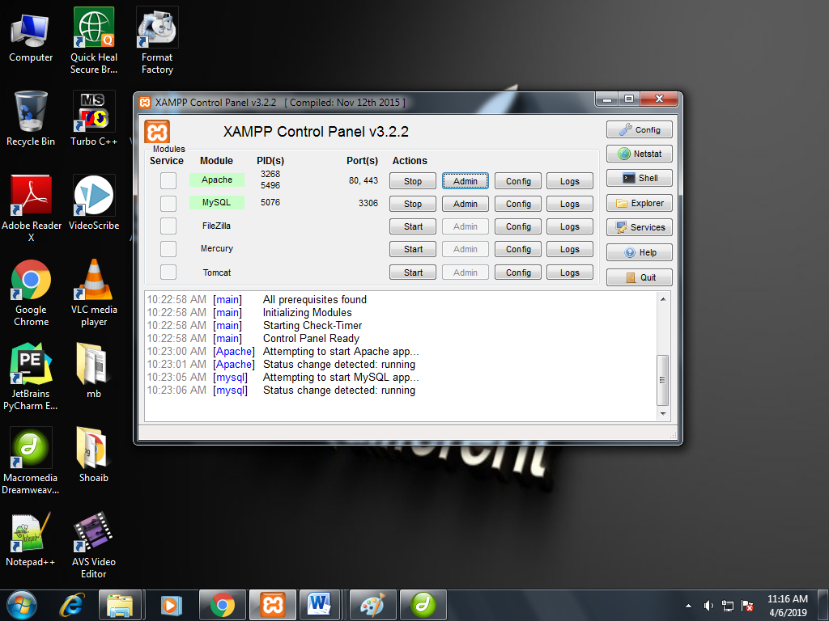

**Apache**

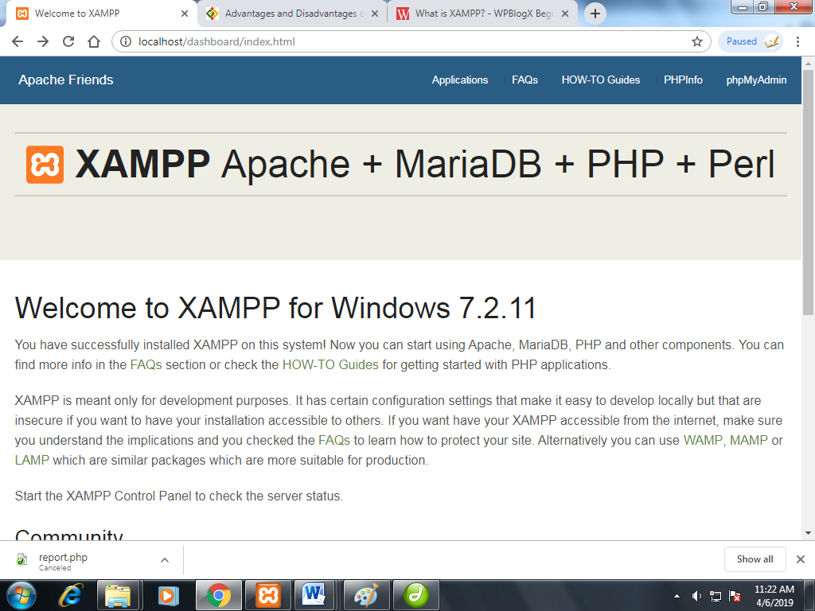

**MySQL**

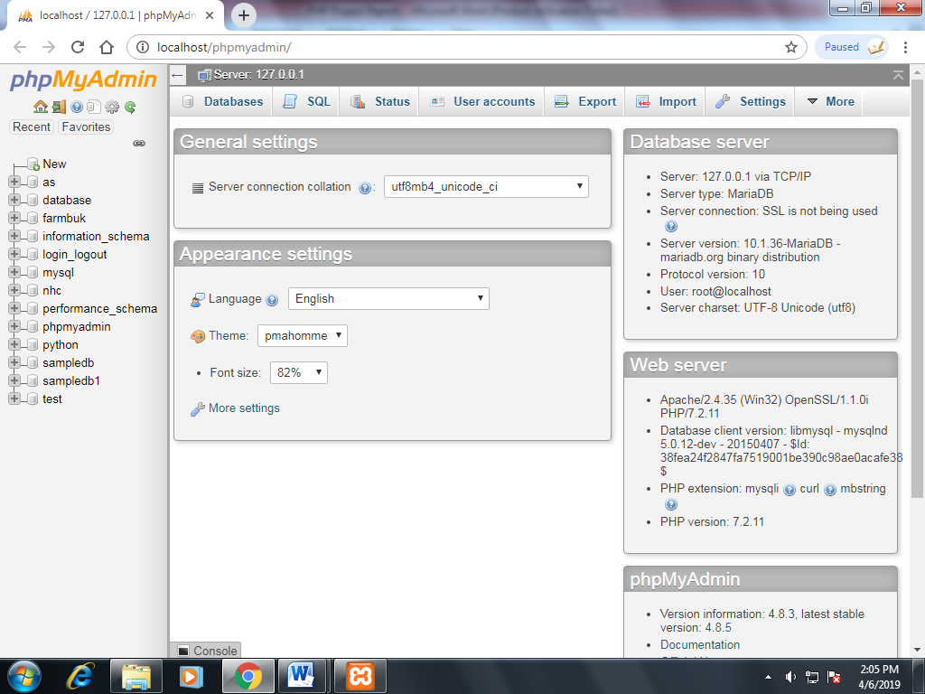

**HARDWARE & SOFTWARE REQUIREMENT SPECIFICATION**

**Hardware specifications**

[**Operating system**](https://en.wikipedia.org/wiki/Operating_system) **:** [Windows Server 2008](https://en.wikipedia.org/wiki/Windows_Server_2008) and later [Windows Vista](https://en.wikipedia.org/wiki/Windows_Vista) and later [Mac OS X 10.6](https://en.wikipedia.org/wiki/Mac_OS_X_10.6) and later

[CentOS](https://en.wikipedia.org/wiki/CentOS), [Ubuntu](https://en.wikipedia.org/wiki/Ubuntu_(operating_system)), [Fedora](https://en.wikipedia.org/wiki/Fedora_(operating_system)), [Gentoo](https://en.wikipedia.org/wiki/Gentoo_Linux),  [Arch](https://en.wikipedia.org/wiki/Arch_Linux), [SUSE](https://en.wikipedia.org/wiki/SUSE)

**Platform** : [IA-32](https://en.wikipedia.org/wiki/IA-32) (Windows package only) and [x64](https://en.wikipedia.org/wiki/X64) (macOS and Linux packages only)

**Size** : Windows: 156 MB Linux: 150 MB

macOS: 161 MB

**Software specifications**

**Database :** MySQL

**Server :** Apache

**PROJECT SNAP SHOTS**

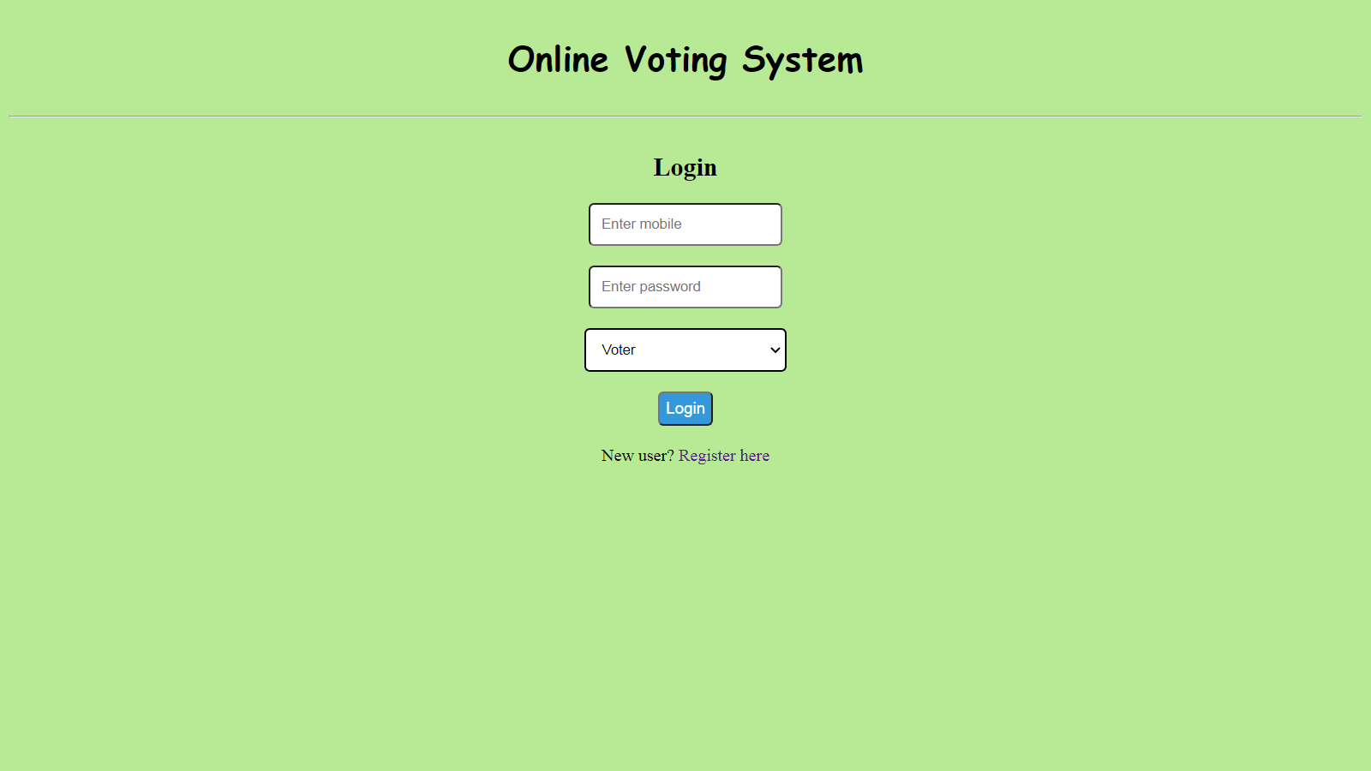**Homepage**

**Registration Page**

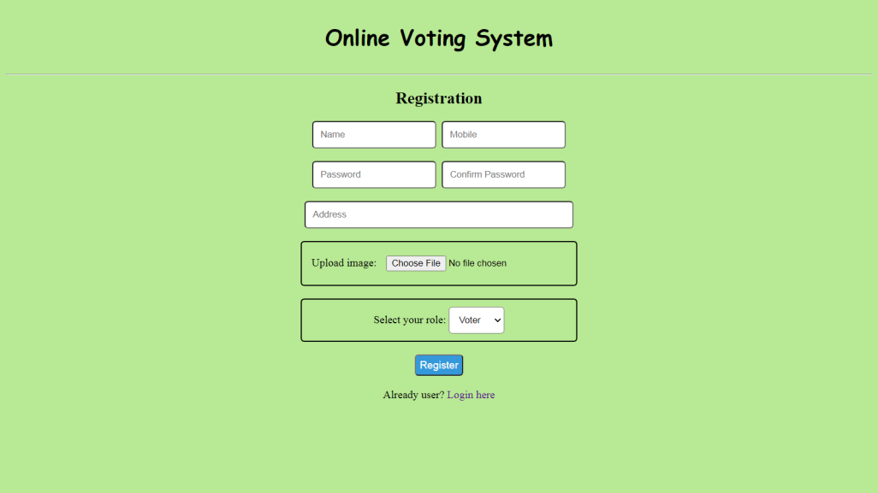

**Voter Dashboard (before voting)**

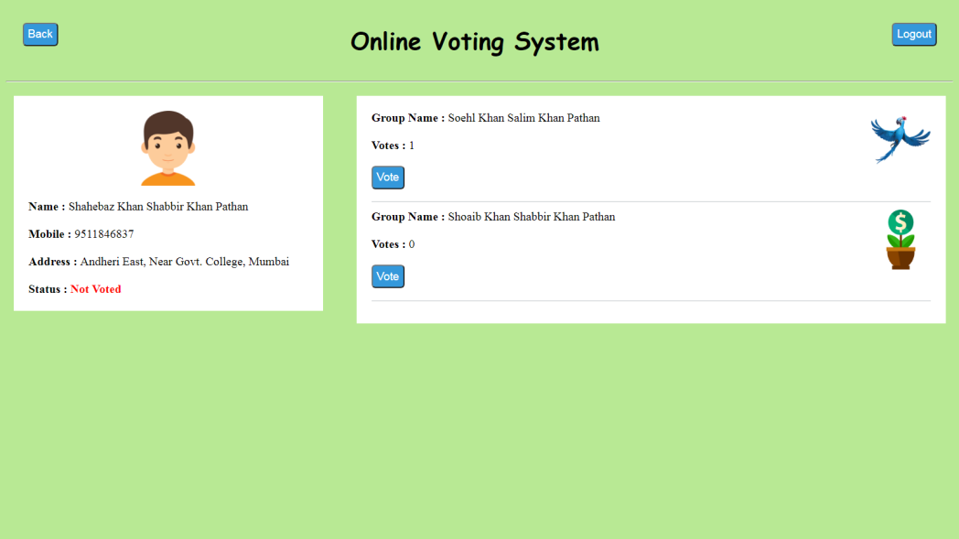

**Voter Dashboard (after voting)**

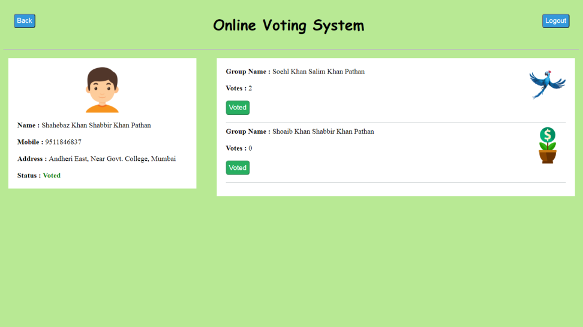

**MySQL Database**

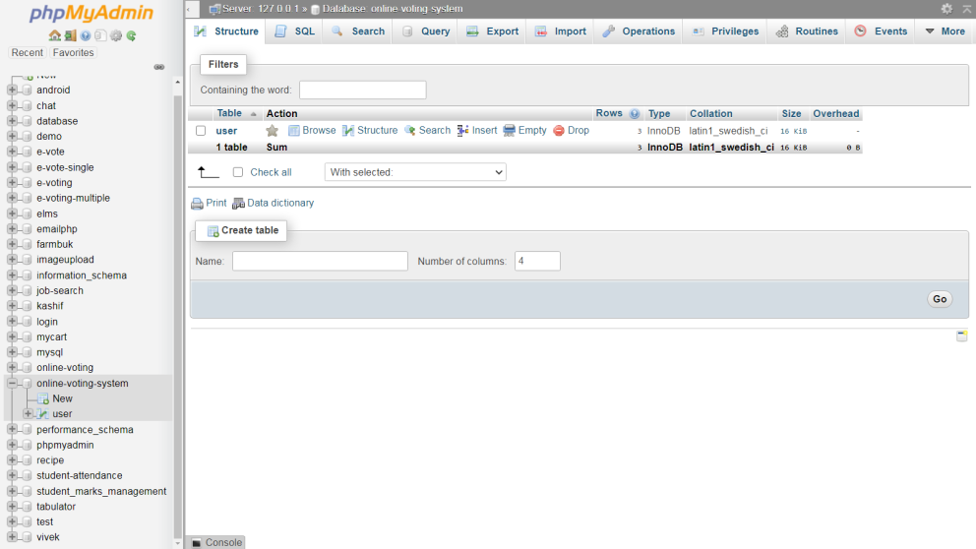

**Database table structure**

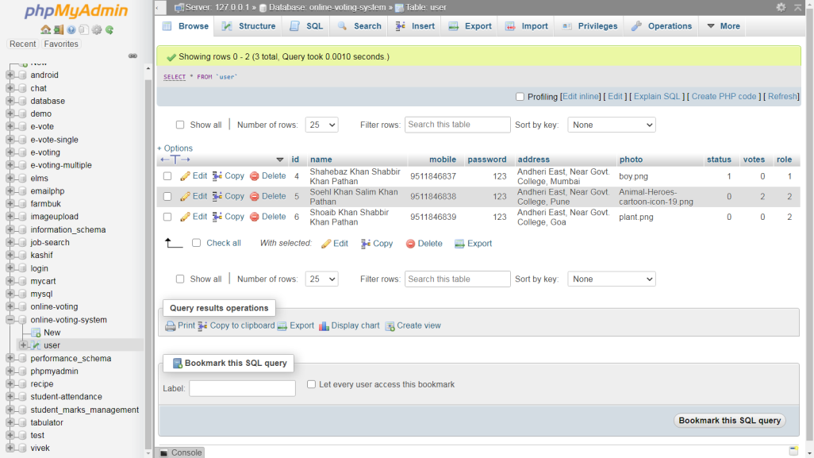

**SOURCE CODE**

**Homepage**

<html>

    <head>

        <title>Online voting system - Home</title>

        <link rel="stylesheet" href="css/stylesheet.css">

    </head>

    <body>

            <center>

            <div id="headerSection">

            <h1>Online Voting System</h1>

            </div>

            <hr>

            <div id="loginSection">

                <h2>Login</h2>

                <form action="api/login.php" method="POST">

                    <input type="number" name="mob" placeholder="Enter mobile" required><br><br>

                    <input type="password" name="pass" placeholder="Enter password" required><br><br>

                    <select name="role" style="width: 15%; border: 2px solid black">

                        <option value="1">Voter</option>

                        <option value="2">Group</option>

                    </select><br><br>

                    <button id="loginbtn" type="submit" name="loginbtn">Login</button><br><br>

                    New user? <a href="routes/register.php">Register here</a>

                </form>

            </div>

            </center>

    </body>

</html>

**Registration**

<html>

    <head>

        <title>Online voting system - Registratrion</title>

        <link rel="stylesheet" href="../css/stylesheet.css">

    </head>

    <body>

        <center>

            <div id="headerSection">

            <h1>Online Voting System</h1>

            </div>

            <hr>

            <h2>Registration</h2>

                <form action="../api/register.php" method="POST" enctype="multipart/form-data">

                    <input type="text" name="name" placeholder="Name" required>&nbsp

                    <input type="number" name="mob" placeholder="Mobile" required><br><br>

                    <input type="password" name="pass" placeholder="Password" required>&nbsp

                    <input type="password" name="cpass" placeholder="Confirm Password" required><br><br>

                    <input style="width: 31%" type="text" name="add" placeholder="Address" required><br><br>

                    <div id="upload" style="width: 30%">

                        Upload image: <input type="file" id="profile" name="image" required>

                    </div><br>

                    <div id="upload" style="width: 30%">

                        Select your role:

                        <select name="role">

                            <option value="1">Voter</option>

                            <option value="2">Group</option>

                        </select><br>

                    </div><br>

                    <button id="loginbtn" type="submit" name="registerbtn">Register</button><br><br>

                    Already user? <a href="../">Login here</a>

                </form>

            </center>

    </body>

</html>

**Main Dashboard**

<?php

    session_start();

    if(!isset($_SESSION['id'])){

        header("location: ../");

    }

    $data = $_SESSION['data'];

    if($_SESSION['status']==1){

        $status = '<b style="color: green">Voted</b>';

    }

    else{

        $status = '<b style="color: red">Not Voted</b>';

    }

?>

<html>

    <head>

        <title>Online voting system - Dashboard</title>

        <link rel="stylesheet" href="../css/stylesheet.css">

    </head>

    <body>

            <center>

            <div id="headerSection">

            <a href="../"><button id="back-button"> Back</button></a>

            <a href="logout.php"><button id="logout-button">Logout</button></a>

            <h1>Online Voting System</h1>

            </div>

            </center>

            <hr>

            <div id="mainSection">

                <div id="profileSection">

                    <center><img src="../uploads/<?php echo $data['photo']?>" height="100" width="100"></center><br>

                    <b>Name : </b><?php echo $data['name'] ?><br><br>

                    <b>Mobile : </b><?php echo $data['mobile'] ?><br><br>

                    <b>Address : </b><?php echo $data['address'] ?><br><br>

                    <b>Status : </b><?php echo $status ?>

                </div>

                <div id="groupSection">

                    <?php

                    if(isset($_SESSION['groups'])){

                        $groups = $_SESSION['groups'];

                        for($i=0; $i<count($groups); $i++){

                            ?>

                                <div style="border-bottom: 1px solid #bdc3c7; margin-bottom: 10px">

                                <img style="float: right" src="../uploads/<?php echo $groups[$i]['photo']?>" height="80" width="80">

                                <b>Group Name : </b><?php echo $groups[$i]['name']?><br><br>

                                <b>Votes :</b> <?php echo $groups[$i]['votes']?><br><br>

                                <form method="POST" action="../api/vote.php">

                                <input type="hidden" name="gvotes" value="<?php echo $groups[$i]['votes'] ?>">

                                <input type="hidden" name = "gid" value="<?php echo $groups[$i]['id'] ?>">

                                <?php

                                if($_SESSION['status']==1){

                                    ?>

                                    <button disabled style="padding: 5px; font-size: 15px; background-color: #27ae60; color: white; border-radius: 5px;" type="button">Voted</button>

                                    <?php

                                }

                                else{

                                    ?>

                                    <button style="padding: 5px; font-size: 15px; background-color: #3498db; color: white; border-radius: 5px;" type="submit">Vote</button>

                                    <?php

                                }

                                ?>

                                </form>

                                </div>

                            <?php

                        }

                    }

                    else{

                        ?>

                            <div style="border-bottom: 1px solid #bdc3c7; margin-bottom: 10px">

                                <b>No groups available right now.</b>

                            </div>

                        <?php

                    }

                    ?>

                </div>

            </div>

    </body>

</html>

**Logout**

<?php

    session_start();

    session_destroy();

    header('location:../index.php');

?>

**CSS**

input {

  padding: 10px;

  border-radius: 5px;

}

select {

  padding: 10px;

  border-radius: 5px;

}

#upload {

  padding: 10px;

  border-radius: 5px;

  border: 2px solid black;

}

#headerSection {

  padding: 2px;

  font-family: Cursive;

}

#loginSection {

  padding: 5px;

}

body {

  background-color: #b8e994;

}

#loginbtn {

  padding: 5px;

  font-size: 15px;

  background-color: #3498db;

  color: white;

  border-radius: 5px;

}

#reglink {

  padding: 5px;

  font-size: 15px;

  background-color: #3498db;

  color: white;

  border-radius: 5px;

  text-decoration: none;

}

a {

  text-decoration: none;

}

#mainSection {

  padding: 10px;

}

#profileSection {

  width: 30%;

  float: left;

  background-color: white;

  padding: 20px;

}

#groupSection {

  width: 60%;

  float: right;

  background-color: white;

  padding: 20px;

}

#back-button {

  float: left;

  margin-left: 20px;

  margin-top: 20px;

  padding: 5px;

  font-size: 15px;

  background-color: #3498db;

  color: white;

  border-radius: 5px;

}

#logout-button {

  float: right;

  margin-right: 20px;

  margin-top: 20px;

  padding: 5px;

  font-size: 15px;

  background-color: #3498db;

  color: white;

  border-radius: 5px;

}

**Login API**

<?php

    session_start();

    include("connection.php");

    $mobile = $_POST['mob'];

    $pass = $_POST['pass'];

    $role = $_POST['role'];

    $check = mysqli_query($connect, "select * from user where mobile='$mobile' and password='$pass' and role='$role' ");

    if(mysqli_num_rows($check)>0){

        $getGroups = mysqli_query($connect, "select name, photo, votes, id from user where role=2 ");

        if(mysqli_num_rows($getGroups)>0){

            $groups = mysqli_fetch_all($getGroups, MYSQLI_ASSOC);

            $_SESSION['groups'] = $groups;

        }

        $data = mysqli_fetch_array($check);

        $_SESSION['id'] = $data['id'];

        $_SESSION['status'] = $data['status'];

        $_SESSION['data'] = $data;

        echo '<script>

                window.location = "../routes/dashboard.php";

            </script>';

    }

    else{

        echo '<script>

                alert("Invalid credentials!");

                window.location = "../";

            </script>';

    }

?>

**Database connectivity**

<?php

$connect = mysqli_connect("localhost", "root", "", "online-voting-system");

?>

**Registration API**

<?php

    include("connection.php");

    $name = $_POST['name'];

    $mobile = $_POST['mob'];

    $pass = $_POST['pass'];

    $cpass = $_POST['cpass'];

    $add = $_POST['add'];

    $image = $_FILES['image']['name'];

    $tmp_name = $_FILES['image']['tmp_name'];

    $role = $_POST['role'];

    if($cpass!=$pass){

        echo '<script>

                alert("Passwords do not match!");

                window.location = "../routes/register.php";

            </script>';

    }

    else{

        move_uploaded_file($tmp_name,"../uploads/$image");

        $insert = mysqli_query($connect, "insert into user (name, mobile, password, address, photo, status, votes, role) values('$name', '$mobile', '$pass', '$add', '$image', 0, 0, '$role') ");

        if($insert){

            echo '<script>

                    alert("Registration successfull!");

                    window.location = "../";

                </script>';

        }

    }

?>

**Voting API**

<?php

    session_start();

    include("connection.php");

    $votes = $_POST['gvotes'];

    $total_votes= $votes+1;

    $gid = $_POST['gid'];

    $uid = $_SESSION['id'];

    $update_votes = mysqli_query($connect, "update user set votes='$total_votes' where id='$gid'");

    $update_status = mysqli_query($connect, "update user set status=1 where id='$uid'");

    if($update_status and $update_votes){

        $getGroups = mysqli_query($connect, "select name, photo, votes, id from user where role=2 ");

        $groups = mysqli_fetch_all($getGroups, MYSQLI_ASSOC);

        $_SESSION['groups'] = $groups;

        $_SESSION['status'] = 1;

        echo '<script>

                    alert("Voting successfull!");

                    window.location = "../routes/dashboard.php";

                </script>';

    }

    else{

        echo '<script>

                    alert("Voting failed!.. Try again.");

                    window.location = "../routes/dashboard.php";

                </script>';

    }

?>