Encrypted and Decentralized Cloud Storage Using Ethereum Blockchain and Keccak-256 Hashing

Rashmi Ashtagi
Department of Computer Engineering
Vishwakarma Institute of Technolgy
Pune, India
rashmi.ashtagi@vit.edu

Abbas Shaikh
Department of Computer Engineering
Vishwakarma Institute of Technolgy
Pune, India
abbas.shaikh23@vit.edu

Abhishek Veer
Department of Computer Engineering
Vishwakarma Institute of Technolgy
Pune, India
abhishek.veer23@vit.edu

Kanchan Swami
Department of Computer Engineering
Vishwakarma Institute of Technolgy
Pune, India
kanchan.swami23@vit.edu
Sai Watile
Department of Computer Engineering
Vishwakarma Institute of Technolgy
Pune, India
sai.watile23@vit.edu

Abstract— Cloud storage is widely used to store a variety of data in large amounts. The cloud storage systems till now mostly rely on large service providers for storage and sharing of data. This centralized system has many drawbacks like high operational cost, data availability, and data vulnerability. The system that we have proposed in the paper, utilizes blockchain technology and IPFS (InterPlanetary File System) to develop a secure Decentralized cloud storage. In this system, firstly, user uploads their data to cloud, then IPFS stores multiple copies of the file across nodes in its network. Then using cryptographic techniques, data serialization and ABI encoding/decoding, the IPFS Hash of file is stored in a Ethereum Blockchain in the form of encrypted byte code which is generated using Keccak-256 Hashing Algorithm.
Keywords— Cloud Storage, Decentralized Storage, Ethereum, Blockchain, IPFS, ABI, Keccak-256.

Introduction
In the current era dominated by cloud computing, traditional centralized storage systems face various challenges related to data privacy, integrity, and control. High-profile data breaches happening now a days highlight the vulnerability of centralized systems to hacking and data leaks. The system empowered by Blockchain and IPFS, with its decentralized architecture, offers a promising alternative to traditional cloud storage by providing a decentralized, transparent, and immutable Cloud storage.
Blockchain is a reliable, tamper-resistant public ledger that records P2P(peer to peer) network transactions. The transactional data between nodes in an ordered chain of blocks connected by storing the hashes and nonces of neighboring blocks is permanently recorded in this ledger.
By using the blockchain technology we can develop a system where all participants can generate a ledger with all transaction data whenever a new transaction takes place. All the users will be able to verify every transaction's authenticity thanks to advancements in Web and cryptographic technologies, and the dependence on a third party service provider has been removed. A solid impermeable database of transactional data is created using this type of distributed ledger.
This paper introduces a decentralized storage system which utilizes Ethereum Blockchain for storage of encrypted byte code, which is generated using Keccak-256 hashing algorithm and Pinata IPFS for decentralized cloud storage of files. The system stores metadata and file hashes on the blockchain, ensuring integrity and transparency, while Pinata IPFS manages the actual file storage, enabling portability and efficiency. The tampering of any file in the IPFS will result in the change of IPFS HASH of that file which is a unique hash generated based on the file's content using SHA-256 and Base58 encoding. The byte code of this changed hash will not match with the byte code of the previous hash and thus, any manipulation of file can be monitored. As a result, the blockchain serves as an immutable public, ledger. By implementing this approach with the traditional cloud storage, the users are empowered with top notch security, data ownership and easy access management.

Problem Formulation
In today’s world, Cloud storage platforms are a base of modern digital infrastructure. But these platforms follow the Centralized approach which fails to provide users with the necessary data privacy and security and has many issues like :
- First, as users are relying on service providers for handling their sensitive data, users' privacy is compromised while the users’ data is in danger of leaking and unauthorized accessing.
- Second, centralized systems face the problem of single points of failure(SPOF), which is part of the system, where disruptions or cyberattacks can lead to data loss or service outage of the entire system.
- Third, the operational cost for the existing Cloud storage systems increases with the increasing storage demands, making such systems economically inefficient for users and service providers.
- Finally, the lack of transparency in the centralized storage systems leaves users with less visibility about how their data is handled.
The project's goal is to create a decentralized cloud storage solution that addresses each of the issues listed above. By using IPFS for distributed file storage, Ethereum Blockchain for access control and metadata management, and Keccak-256 hashing for cryptographic integrity, the resulting system will accomplish data integrity, transparency, and security. Users will be able to fully own and control their data thanks to the decentralization of power and storage.

Literature Review
Hoang Giang Do, Wee Keong Ng [3] show how encryption increases user data security in cloud storage. To retain system performance while offering security and speed, they used the AES encryption technology. Satoshi Nakamoto [4] developed the concept of Bitcoin as a blockchain mechanism for recording transactions. Transaction information are stored in blocks that are serially linked via hashing. To verify the blockchain's legitimacy, each network participant retains a copy. Transactions in the peer-to-peer network, according to Nakamoto, are tamper-proof and secure, with the identities of the parties involved protected. If honest nodes control the great majority of CPU power, the network's public transaction history is maintained through the use of proof-of-work, which makes it computationally hard for an attacker to alter. The challenges of centralized cloud storage are described by Ilya Sukhodolskiy, Sergey Zapechnikov [5], who suggests blockchain as a remedy. \t access (transaction-based access control) and .\t data (transaction-based data storage) are the two transaction types that the proposed system can manage. Data is protected from third parties via a shared encryption key. The architecture, electronic token limitations, and proof-of-work consensus algorithms of the Hyperledger blockchain network are described by Christian Cachin [6]. Only authorized nodes are able to produce new blocks on the permissioned blockchain network known as Hyperledger Fabric. The smart contract architecture and capabilities are described by the paper's author [7]. Ethereum is appropriate for uses like autonomous systems and decentralized file storage, whereas Bitcoin is typically utilized for financial transactions. In order to increase the security and transparency in Medical Applications, Rahmani MKI, Shuaib M, Alam S, Siddiqui ST, Ahmad S, Bhatia S, Mashat A [8] suggest Internet of Medical Things (IoMT), a decentralized architecture that makes use of blockchain technology. The system uses both proof of storage and proof of work to ensure that hosts do not alter patient’s medical data stored on blockchain. Nevertheless, the recommended method compromises privacy and confidentiality by failing to encrypt or encode data prior to uploading it. A new peer-to-peer file transfer system called IPFS (InterPlanetary File System) is introduced by Juan Benet [9]. A content-based addressing system is used by IPFS to deliver a high-throughput content-addressed.
The Solidity language, which is used to create blockchain smart contracts, is described by M. Wohrer and U. Zdun [11] along with its challenges. The following security concerns are addressed by them: Emergency Stop, Speed Bump, Rate Limit, Mutex, Checks-Effects Interaction, and Balance Limit. Both blog posts and gray literature include this information. In An, Min & Fan, Qiyuan & Yu, Hao & An, Bo & Wu, Nannan & Zhao, Haiyang & Wan, Xinhao & Li, Jiaxuan & Wang, Rui & Zhen, Jingyu & Zou, Qinyan & Zhao, Bin [12], blockchain is demonstrated to give scalability, security, and sustainability, hence revolutionizing business processes. The structure and various consensus processes of blockchain technology are thoroughly examined in this article. A timestamp, a hash of the address of the previous block, and data make up the blockchain structure. For every length of input, a hash function produces a distinct fixed-length output, and the timestamp shows when the block was created. To increase security, each block contains the hash value of the one before it. Blockchain uses proof of stake (POS) and proof of work (POW) consensus algorithms (as shown in Fig. 1. ) to counteract Denial of Service attacks. Consequently, blockchain technology's decentralized architecture and peer-to-peer capabilities are gaining more recognition and acceptance.
Nicolas Bordes, Joan Daemen, Daniël Kuijsters, Gilles Van Assche [14] explores alternative design frameworks for block ciphers and cryptographic permutations, challenging the conventional approach given by the Advanced Encryption Standard (AES). The oriented approach facilitates hierarchical structures like super boxes by grouping bits along S-box borders, such as bytes. These structures make it possible to think combinatorially about linear and differential propagation features. This alignment, though, may bring in recurring patterns that enemies could exploit. The results of this study indicate that although the aligned method provides known security proofs and analytical tractability, it may unintentionally add structural weaknesses. By avoiding recurring patterns, the unaligned strategy may be able to lessen these weaknesses, although being more analytically complicated. By stressing the trade-offs between structural alignment and security and arguing for a nuanced assessment of alignment in the construction of future cryptographic primitives, this study adds to the continuing conversation on cryptographic design techniques.
Guido Bertoni, Joan Daemen, Michaël Peeters, Gilles Van Assche: “The Making of KECCAK.” [14] documents the development of Keccak Hashing which was later standardized as SHA-3 by NIST. The authors describe Keccak's development in detail, emphasizing its distinct sponge structure and the design decisions that set it apart from its forerunners, including SHA-1 and the SHA-2 family. They highlight how their past work on the PANAMA hash function and its successor, RadioGatún, inspired the creation of Keccak and trace the origins of Keccak back to these projects. Offering important insights into the iterative process of designing cryptographic algorithms, the paper also explores the difficulties encountered during the NIST hash function competition and the reasoning behind particular design choices.

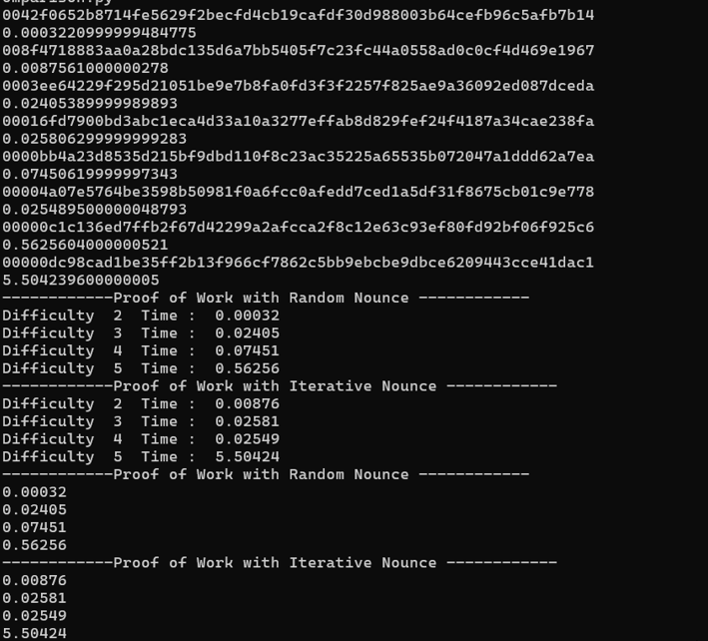

Fig. 1. Proof of Work Comparison
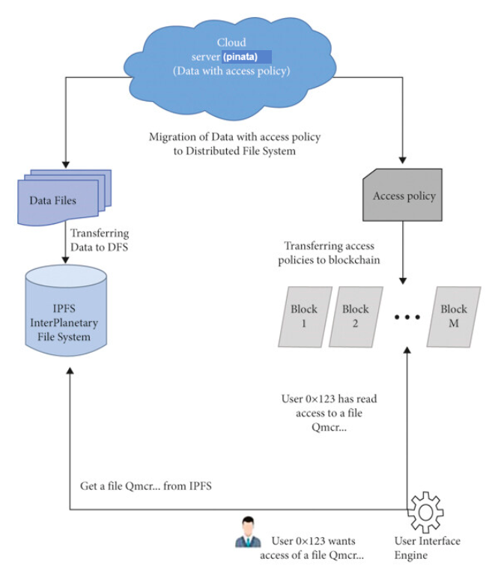

Fig. 2. System Design of the proposed model

Methodology
The proposed model of Decentralized Cloud Storage system makes use of multi-layered architecture with IPFS to tackle with issues like single points of failure, Ethereum Blockchain to maintain an impenetrable distributed ledger, and React for designing the frontend user interface. Firstly user links to any crypto wallet which comes as an extension with browser. The system retrieves all of the user's credentials. The user then uploads a file to the Pinata IPFS cloud, where it is shared across multiple peer-to-peer networks via the IPFS protocol. The IPFS hash of the file is generated using the SHA-256 algorithm and ABI encryption standards, and it is unique for each file; any changes made to the content of the file will alter the IPFS hash. Then, in order to maintain an impenetrable public ledger of every file transaction and manipulation, a unique 256-bit byte code is generated using Keccak-256 hashing algorithm. This algorithm is deployed in blockchain along with the solidity contract. Then this 256-bit unique hash is stored in the newly created Block of the Ethereum Blockchain in Ganache test net in the form of transaction data.

IPFS for Distributed Storage
Files are uploaded to a distributed peer-to-peer network called IPFS, which then gives each file a unique, content-based identifier known as an IPFS hash through a cryptographic hash function. This hash becomes a key for file retrieval and maintains the integrity of the stored content against tampering. To improve deduplication and storage efficiency, IPFS arranges file chunks into a Merkle DAG (Directed Acyclic Graph) structure.
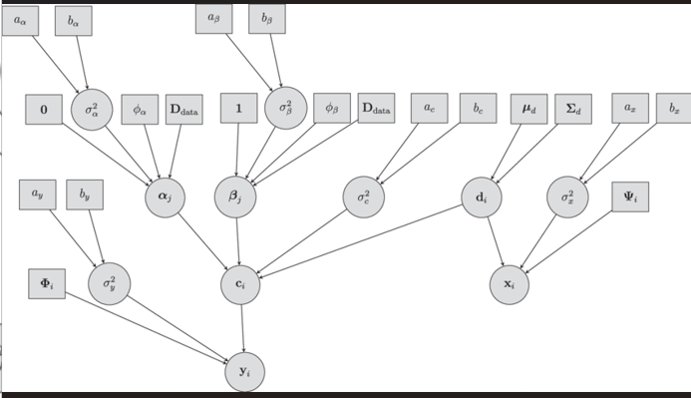

Fig. 3. DAG (Directed Acyclic Graph)

We have used Pinata IPFS storage in our system because it provides free of cost Cloud storage. Any type of file (jpg, text, mp3, mp4) can be uploaded on this cloud storage. Pinata provides secure and efficient private storage for the files on the IPFS network. This means the data is distributed across various nodes, making it buoyant and tamper-proof. Each file uploaded to Pinata gets a unique Content Identifier (CID), ensuring its authenticity and immutability. Pinata provides dedicated gateways for faster content delivery. These gateways ensure the content is always accessible, even if traditional servers go down. Custom domains can be used to showcase your content, giving user full control over how the uploaded files are accessed. Pinata IPFS cloud simplifies the process of uploading and retrieving files, allowing developers to focus on building their applications.
You upload your files to Pinata, which then pins them to the IPFS network. Once pinned, your files are distributed across multiple nodes, ensuring severance and availability. You can retrieve your files using the unique CID or through the dedicated IPFS gateway. Pinata provides tools to manage your files, including analytics and access control.

Ethereum Blockchain for Metadata and Access Control
The Ethereum uses metadata, which includes IPFS hashes, access permissions and user addresses. Smart contracts developed in the Solidity programming language will manage the ownership, sharing, and revocation of files. The smart contract functions include:
- Add: It registers a file's IPFS hash and associates it with the user's Ethereum address.
- Allow: Grants access to a specific user through modifying its access permissions residing in the smart contract.
- Disallow: It revokes access through modification of the corresponding permissions.
- Transaction(\t) display: Verifies user access rights and fetches the file's metadata.
All the above mentioned functions are based on Ethereum's decentralized consensus mechanism to ensure that all operations are immutable and verifiable.
Ethereum serves as the underlying blockchain network (here used Ganache test net instead of Ethereum main net), providing a decentralized platform for executing smart contracts and storing metadata. The terms and conditions of these self-executing smart contracts are encoded directly into the solidity file. Ethereum smart contracts can handle data storage agreements, access control, and other features. Data stored on the blockchain is end to end encrypted to ensure security and privacy of the user. Only the primary user who uploaded the data and the authorized users can decrypt and access the data. Smart contracts in solidity file deployed on Ethereum test net manage the access control, and other rules. For example, the smart contract can specify who has access to certain data and under what conditions. A Solidity contract contains a set of rules written in code that is deployed and runs on the Ethereum blockchain. It can store data and perform actions based on those rules. We write this contract in solidity (.sol) file. We create this contract according to our system requirements and functionalities of our cloud storage.

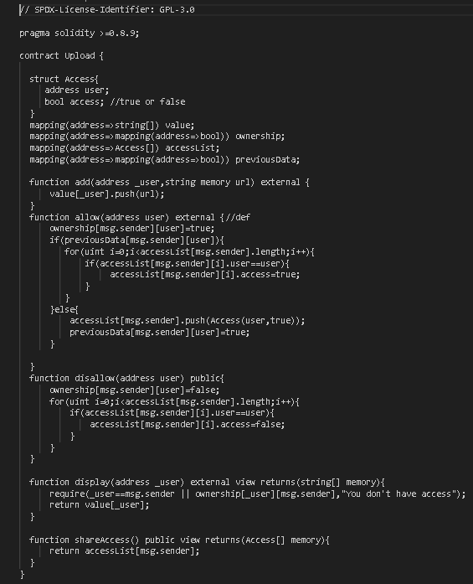

Fig. 4. Solidity Contract

The above-mentioned contract in Fig.4, named Upload, manages file storage and access control on the Ethereum blockchain. It allows users to upload files, grant access to other users, and manage permissions. Users can upload files (represented as URLs) to their account. Users can grant access to their files to other users. This means other users can view the files if they have been given permission. The contract keeps track of who has access to which files. It uses a combination of mappings and structs to manage these permissions. Users can view the list of people who have access to their files. The contract allows users to check if they have access to a specific file.
We have used Ganache test net as personal blockchain for Ethereum development. It allows developers to create and test decentralized applications and smart contracts in a controlled environment. Ganache creates a private blockchain that you can use for development and testing. In Ganache, Blocks are mined instantly, allowing for quick testing and iteration. Ganache provides a predictable and repeatable testing environment. Ganache includes all the popular RPC functions and features, such as events. Ganache includes a block explorer to inspect blocks and transactions.

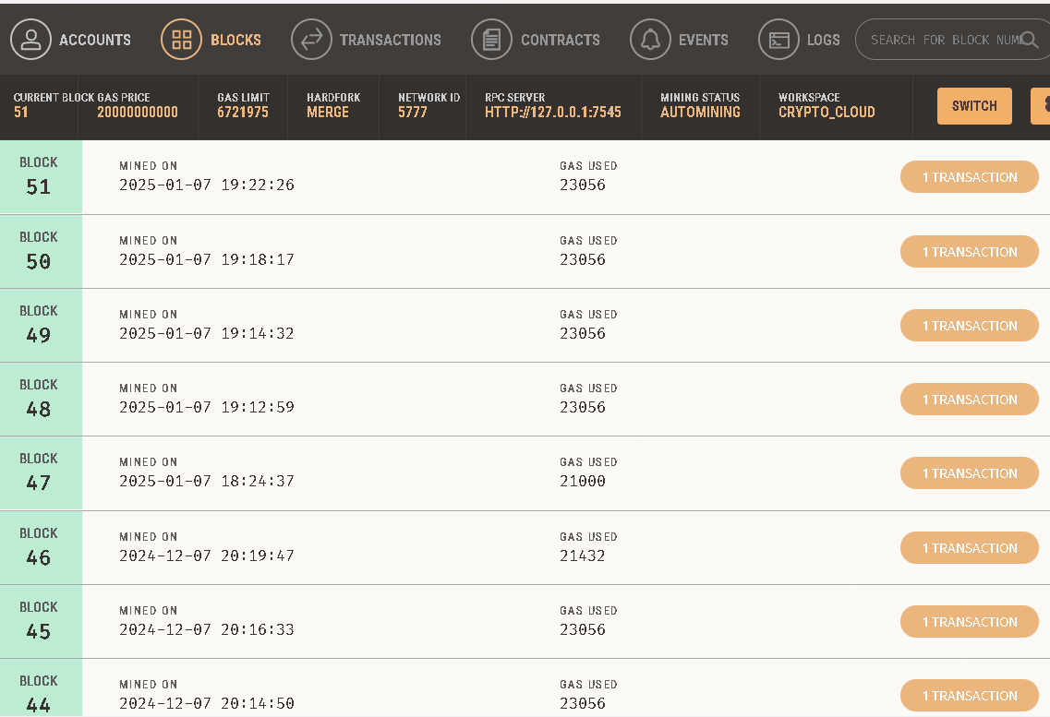

Fig. 5. Ganache UI (Blocks created after every transaction)

Keccak-256 Hashing
Keccak-256, a hashing algorithm deployed with the Solidity smart contract, guarantees the integrity of data in the blockchain. A hash function is a function that maps arbitrary data to a fixed-length output and is computationally infeasible to reverse or tamper with. This property is essential for validating transaction data and access permissions in the proposed system. Mathematically, Keccak-256 is defined as a sponge construction that absorbs input data and produces a 256-bit hash. Keccak-256 is a one way encryption technique. Which means the generated 256-bit code cannot be decoded or cannot be used to retrieve any information from it. Using it ensures the integrity of data stored in the cloud as it acts as a unique key for every transaction and every file stored in Pinata.
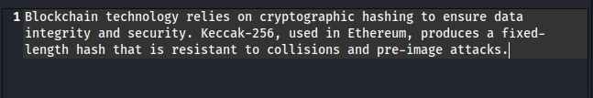

Fig. 6. Keccak-256 Hashing Example

Frontend Interface
Frontend is built using React and integrates directly with MetaMask(or any other crypto wallet), thus allowing for direct interaction with the Ethereum network. Users can upload files to IPFS, smart contracts manage the access permissions, and file metadata is retrieved from the blockchain. It also gives the frontend real-time feedback on the status of a transaction and how it interacts with the network. It has a unique user-friendly design with all the functionalities displayed directly on the screen.
One well-liked tool for communicating with the Ethereum blockchain is MetaMask. It functions as a wallet for Ethereum and other tokens and is accessible as a mobile app and browser extension. MetaMask allows users to store and manage their Ethereum private keys, making it a secure wallet for Ether and other tokens. Users have control over their privacy settings, including options for phishing detection, incoming transactions, and additional token price information. Users can install MetaMask as a browser extension. Users can import a current wallet or create a new one. After that, users can access the free Ethereum blockchain network by connecting to any Ethereum network or the Ganache test network. MetaMask injects a Web3 JavaScript object into web pages, allowing our application to interact with the blockchain.

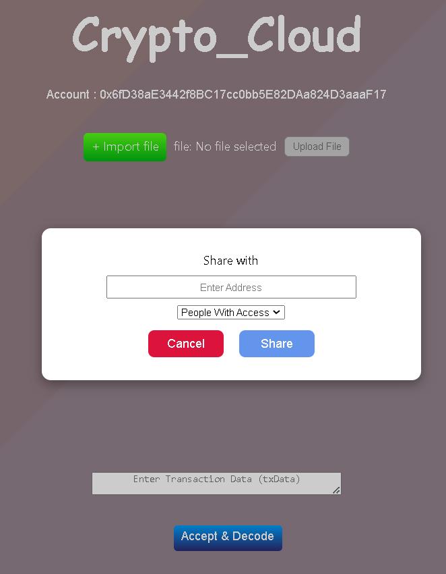

Fig. 7. User Interface of Application

Testing and Deployment
The system has gone through testing on local Ethereum networks (Ganache) in order to confirm functionality and performance. Deployments on Ethereum test net mimicked real-world scenarios, guaranteeing compatibility and robustness.

Math

Keccak-256 Algorithm Hash Calculation Steps:

Step 1: Convert Input to Binary
The input (text, number, file) is first converted into a binary format.

Step 2: Apply Padding
Keccak-256 uses a unique pad10*1 padding method:
- Append a 1 bit.
- Add 0s until the last block is almost full.
- Append another 1 bit to fit the block size.
- For Keccak-256, the block size (rate) is 576 bits.
P=M∣∣1∣∣0k∣∣1 
where:
- M is the original message.
- k is the number of zeros added.
- The final 1 ensures unambiguous padding.

Step 3: Initialize State (5×5×64-bit Matrix)
Keccak’s internal state is a (5×5×64) 1600-bit matrix, structured as:
- A 5×5 grid of 64-bit words, forming a total 1600-bit state.

Step 4: Absorption Phase
- The padded input is split into blocks of 576 bits.
- Each block is XORed with the corresponding section of the state.
- The padded message P is divided into blocks of r = 576 bits.
- Each block is represented as 5×5×64-bit words.
- The initial state matrix formed is:
S[i, j]=0, ∀i, j∈[0,4] 2
- For each input block, the state matrix is updated as:
S[i, j]=S[i, j]⊕P[i, j] 3
where:
- P[i, j]P[i, j]P[i, j] is the block mapped to the state matrix.
- ⊕\ oplus is a bitwise XOR operator.

Step 5: Keccak-f[1600] Permutation
This transformation consists of 24 rounds, applying five operations:

- Theta (Θ): Ensures diffusion by XORing each bit with the parity of its column.
Each column's parity is computed as:
C[x]=S[x,0]⊕S[x,1]⊕S[x,2]⊕S[x,3]⊕S[x,4] 4
Then, a correction is applied using:
D[x]=C[x−1]⊕ROT(C[x+1],1) 5
Finally, the new state is:
S[x, y]=S[x, y]⊕D[x] 6

- Rho (ρ): Rotates bits in each word.
Each state word is rotated by a predefined offset:
S′[x, y]=ROT(S[x, y],r[x, y]) 6
where r[x, y] is a fixed rotation offset per position.

- Pi (π): Rearranges the positions of the bits in the state.
The state is rearranged:
S′′[x, y]=S′[y, (2x+3y)mod5] 7

- Chi (χ): Introduces non-linearity using an XOR and AND operation.
S′′′[x, y]=S′′[x, y]⊕((¬S′′[x+1,y])∧S′′[x+2,y]) 8

- Iota (ι): XORs the state with a round-dependent constant.
S′′′′[0,0]=S′′′[0,0]⊕RC[r] 9
where RC[r] is a round-dependent constant.

Step 6: Squeezing Phase
After absorbing all input blocks, bits are extracted from the state until 256 bits are obtained.

Keccak-256 Comparison

This is detailed comparison of Keccak-256 with other popular hashing algorithms like SHA-256, MD5, and BLAKE2 considering different features and requirements.

Table 1: Algorithmic Differences
Feature | Keccak-256 (SHA-3) | SHA-256 (SHA-2) | BLAKE2 | MD5
Structure | Sponge construction | Merkle–Damgård | HAIFA | Merkle–Damgård
Security | Higher resistance to preimage & collision attacks | Secure but some theoretical attacks exist | Secure | Broken (collision attacks exist)
Efficiency | Efficient in hardware, moderate in software | Optimized for software | Extremely fast | Fast
Parallelization | Less parallelizable | Less parallelizable | Highly parallelizable | Not parallelizable
Speed (CPU) | Moderate | Faster than Keccak | Fastest | Fast

Table 2: Security Comparison
Security Feature | Keccak-256 | SHA-256 | BLAKE2 | MD5
Preimage Resistance | Strong | Strong | Strong | Weak
Collision Resistance | Very Strong | Strong | Strong | Broken
Length Extension Attack | Immune | Vulnerable | Immune | Vulnerable
Cryptanalysis Attacks | No known weaknesses | Some theoretical attacks | No known weaknesses | Fully broken

Table 3: Speed and Performance
Hashing a 1KB of data
Algorithm | Speed (CPU) | Speed (GPU) | Speed (Hardware)
Keccak-256 | Medium | Moderate | Very Fast
SHA-256 | Fast | Fast | Fast
BLAKE2 | Very Fast | Very Fast | Fast
MD5 | Fastest | Fast | Low

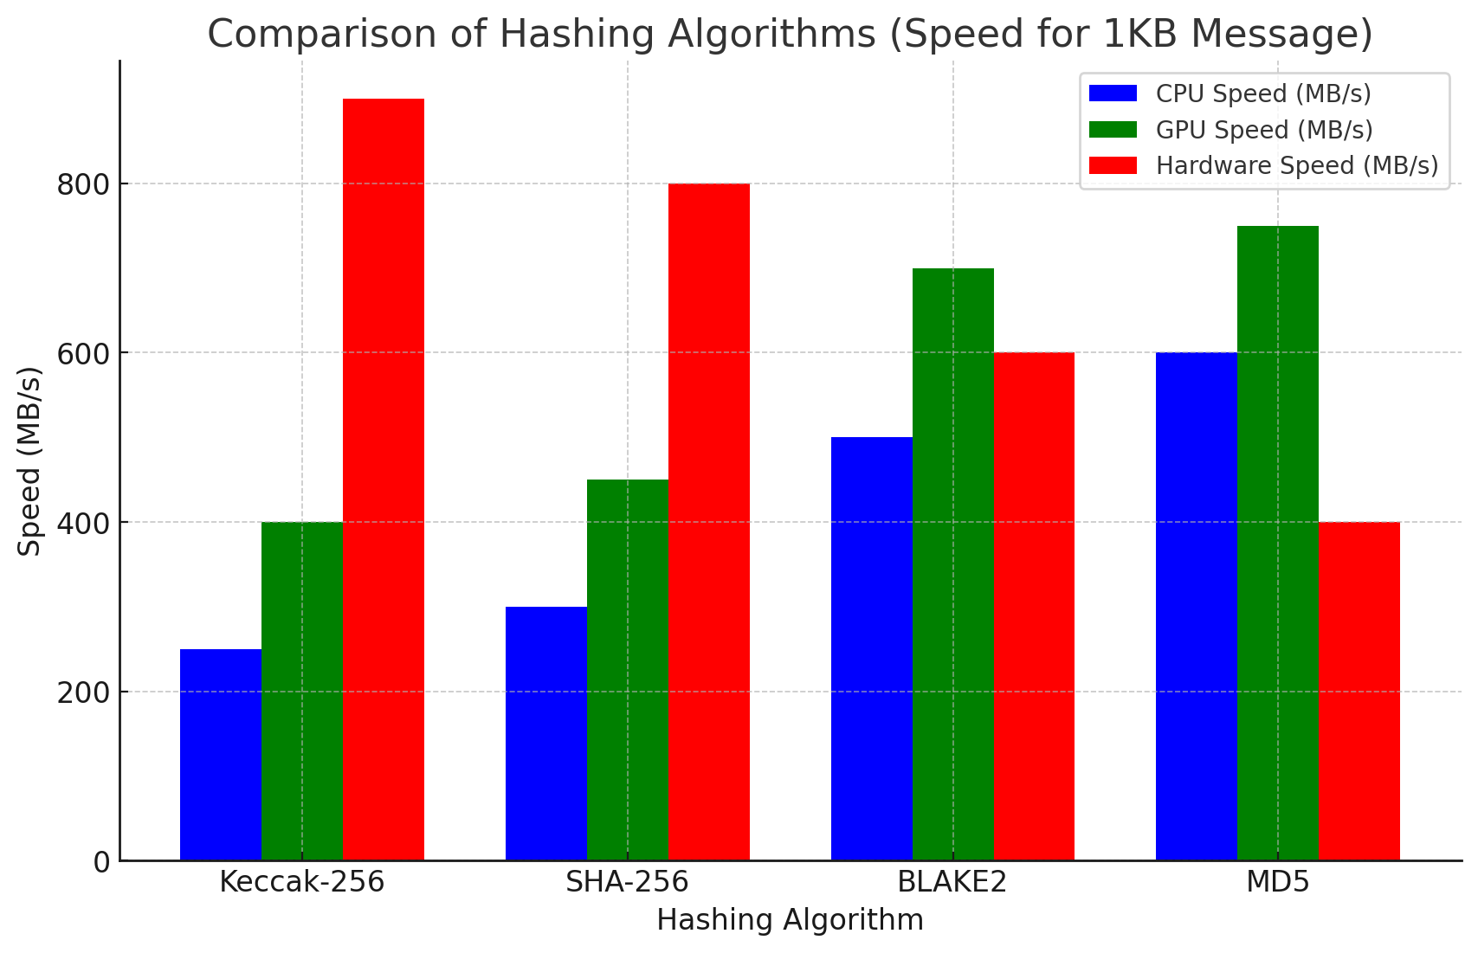

Fig. 8. Comparison of Hashing Algorithms

Results
The decentralized system for cloud storage proved to yield improved data protection, scalability and user control capabilities. Files submitted to IPFS have been stored reliably and retrieved efficiently utilizing content-based addressability. It utilized Ethereum-based smart contracts, where metadata with access permissions guarantee non-tamper able transparency.
Performance Measures
The System gave the following performance measures for uploading different types of files:
• Transaction(\t) File Upload Latency: The average latency required for uploading and retrieving the files via IPFS was 2.6 sec.
• Transactions(.\t) Gas Costs: The average gas cost for smart contract operations, including file registration and access control, was 0.005 ETH.
• Transactions(.\t) Scalability: The system supported concurrent file uploads and access requests without performance degradation.
• Transactions(.\t) Data Integrity: Keccak-256 hashing ensured the cryptographic integrity of stored metadata.
Initial testing under different circumstances showed high satisfaction for the easy usage and transparency of the system, signifying its potential for scaling.

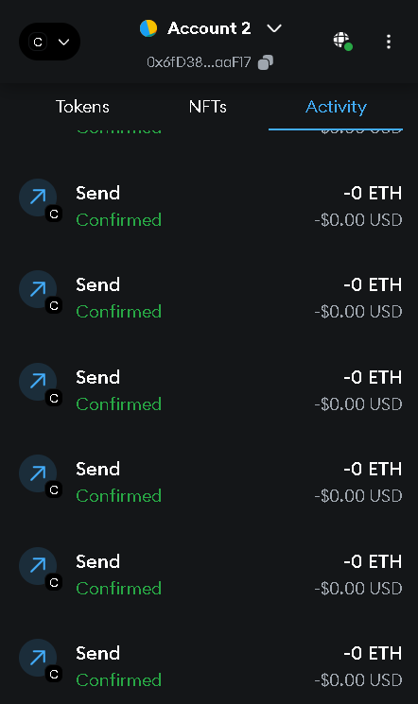

Fig. 9. List of transactions on MetaMask

References

- Ilya Sukhodolskiy, Sergey Zapechnikov, “A Blockchain Based Access Control System for Cloud Storage,” IEEE Conference of Russian Young Researchers in Electrical and Electronic Engineering (ElConRus), 2018.
- Zhe, Diao, ”Study on Data Security Policy Based On Cloud Storage” 2017 ieee 3rd international conference on big data security on cloud (bigdatasecurity), ieee international conference on intelligent data and security (ids) IEEE, 2017.
- Hoang Giang Do, Wee Keong Ng, “Blockchain-based System for Secure Data Storage with Private Keyword Search” 2017 IEEE 13th World Congress on Services.
- Satoshi Nakamoto, “Bitcoin: A Peer-to-Peer Electronic Cash System” www.bitcoin.org.
- Meng, L.; Sun, B. “Research on Decentralized Storage Based on a Blockchain.” Sustainability 2022, 14, 13060.
- Christian Cachin, “Architecture of the Hyperledger Blockchain Fabric” IBMResearch- Zurich CH-8803 R¨ uschlikon, Switzerland July 2016.
- S. Wang, Y. Yuan, X. Wang, J. Li, R. Qin and F. -Y. Wang, "An Overview of Smart Contract: Architecture, Applications, and Future Trends," 2018 IEEE Intelligent Vehicles Symposium (IV), Changshu, China, 2018, pp. 108-113, doi: 10.1109/IVS.2018.8500488.
- Rahmani MKI, Shuaib M, Alam S, Siddiqui ST, Ahmad S, Bhatia S, Mashat A. “Blockchain-Based Trust Management Framework for Cloud Computing-Based Internet of Medical Things (IoMT): A Systematic Review.” Comput Intell Neurosci. 2022 May 19.
- Benet, J. (2014) ”IPFS - Content Addressed, Versioned, P2P File System.” ArXiv. https://arxiv.org/abs/1407.3561
- Macharia, Wahome. (2021). Cryptographic Hash Functions.
- M. Wohrer and U. Zdun, "Smart contracts: security patterns in the ethereum ecosystem and solidity," 2018 International Workshop on Blockchain Oriented Software Engineering (IWBOSE), Campobasso, Italy, 2018, pp. 2-8, doi: 10.1109/IWBOSE.2018.8327565.
- An, Min & Fan, Qiyuan & Yu, Hao & An, Bo & Wu, Nannan & Zhao, Haiyang & Wan, Xinhao & Li, Jiaxuan & Wang, Rui & Zhen, Jingyu & Zou, Qinyan & Zhao, Bin. (2023).”Blockchain Technology Research and Application: A Literature Review and Future Trends.” Journal of Data Science and Intelligent Systems. 10.47852/bonviewJDSIS32021403.
- Dinur, Itai & Dunkelman, Orr & Shamir, Adi. (2011). “New Attacks on Keccak-224 and Keccak-256.” IACR Cryptology ePrint Archive. 2011. 624. 10.1007/978-3-642-34047-5_25.
- Nicolas Bordes, Joan Daemen, Daniël Kuijsters, Gilles Van Assche: ”Thinking Outside the Superbox.” CRYPTO (3) 2021: 337-367
- Joan Daemen, Seth Hoffert, Michaël Peeters, Gilles Van Assche, Ronny Van Keer: Xoodyak,”a lightweight cryptographic scheme.” IACR Trans. Symmetric Cryptol. 2020(S1): 60-87 (2020)
- Guido Bertoni, Joan Daemen, Michaël Peeters, Gilles Van Assche, Ronny Van Keer, Benoît Viguier: “KangarooTwelve: Fast Hashing Based on Keccak-p.” ACNS 2018: 400-418
- Guido Bertoni, Joan Daemen, Michaël Peeters, Gilles Van Assche: “The Making of KECCAK.” Cryptologia 38(1): 26-60 (2014)
- Sideris, A., Sanida, T., Tsiktsiris, D., Dasygenis, M. (2022). Image Hashing Based on SHA-3 Implemented on FPGA. In: Kumar, S., Ramkumar, J., Kyratsis, P. (eds) Recent Advances in Manufacturing Modelling and Optimization. Lecture Notes in Mechanical Engineering. Springer, Singapore. https://doi.org/10.1007/978-981-16-9952-8_44
- S. Kumar, G. Karnani, M. S. Gaur and A. Mishra, "Cloud Security using Hybrid Cryptography Algorithms," 2021 2nd International Conference on Intelligent Engineering and Management (ICIEM), London, United Kingdom, 2021, pp. 599-604, doi: 10.1109/ICIEM51511.2021.9445377.
- J. Anthal, S. Choudhary and R. Shettiyar, "Decentralizing File Sharing: The Potential of Blockchain and IPFS," 2023 International Conference on Advancement in Computation & Computer Technologies (InCACCT), Gharuan, India, 2023, pp. 773-777, doi: 10.1109/InCACCT57535.2023.10141817.
- Q. Zheng, Y. Li, P. Chen and X. Dong, "An Innovative IPFS-Based Storage Model for Blockchain," 2018 IEEE/WIC/ACM International Conference on Web Intelligence (WI), Santiago, Chile, 2018, pp. 704-708, doi: 10.1109/WI.2018.000-8.

