**1. SSH to your AWS Workstation and run the below commands. Replace <your-name> with your name and Replace the <PRIVATE_SUB_X> and <PUBLIC_SUB_X> as given below.**

|  |
| --- |
| $ sudo su  # eksctl create cluster --name=<your-name> --nodes=1 --node-type=t3.small --region=us-east-2 --vpc-private-subnets=<PRIVATE_SUB_1>,<PRIVATE_SUB_2> --vpc-public-subnets=<PUBLIC_SUB_1>,<PUBLIC_SUB_2> |

Replace -

|  |
| --- |
| private subnet - subnet-0e048b90bdc7fc446,subnet-0d996a2fb03decec3  public subnet - subnet-0a67d6c7e33fc1cc4,subnet-09d8cc99bd170ce12 |

**It will take around 10-15 Mins for the Cluster to gets created.**

**2. You can Login to the AWS Portal and goto Cloudformation in us East (Ohio) and check the Stack Event**

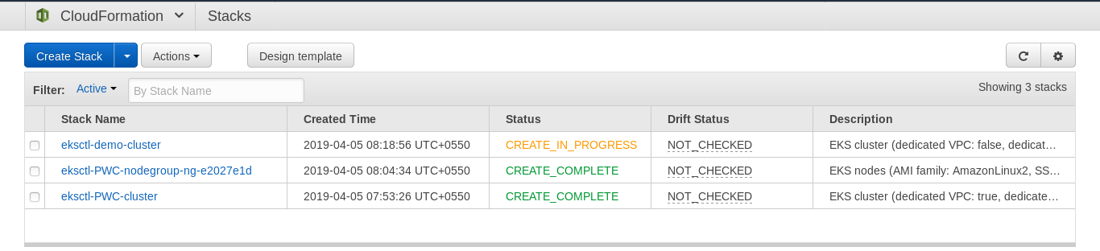

3. Once the Stacks are Created run the below command

|  |
| --- |
| # aws eks list-clusters --region=us-east-2 --output=table |