Define the mood words list (happy, sad, romantic, calm)

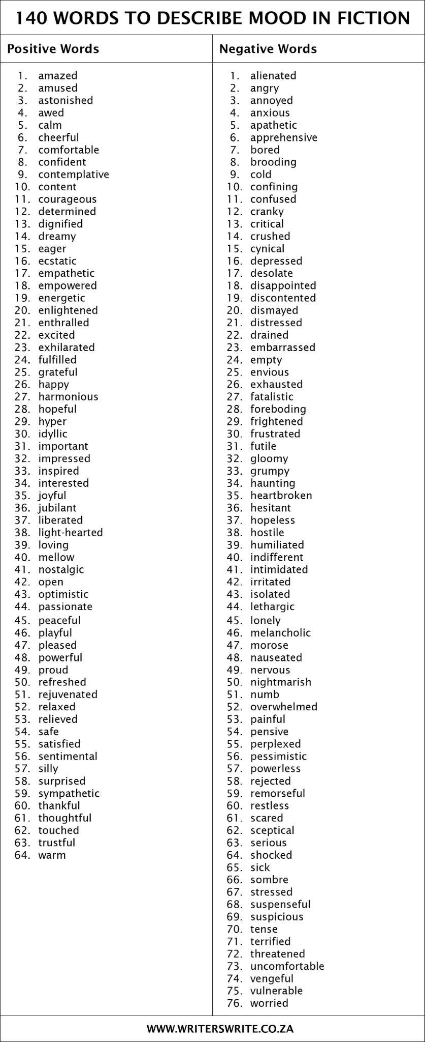

Lyrics stemming and inverted-indexing (we can use the processed lyrics for search)

Query stemming

Return the relevance ranked list upon lyrics(top100?) (from searching end)

Return the mood ranked list (the final results)(present to the user)(target emotional words come more, rank higher?)

Interface design

happy = [ ‘happy’, ‘smiling’, ‘happiness’, ‘laughing’, ]

sad = []

romantic = []

adventures / uplifting = []