ABHISHEK VERMA

PROFESSIONALSUMMARY

TECHNICAL SKILLS

C/C++ | JAVA | OOPS | GIT | SHELL SCRIPTING | C++ STANDARD LIBRARY | IDE | SQL | HTML | CSS

INTERPERSONAL SKILLS

Team

Leadership

|

Critical Thinking

Coordination

|

Logical Reasoning

|

| Problem

Solving

Communication skills

INTERESTS & HOBBIES

Travelling

|

Reading

|

Coding| Cooking

LANGUAGES KNOWN

English

|

Hindi

EDUCATION

TRAINING & PROJECTS

ACADEMIC ACHIEVEMENT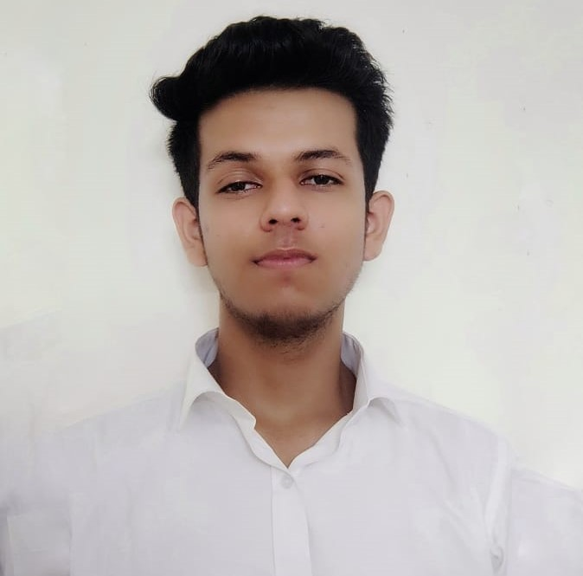DEMICACHIEVEMENTS

CERTIFICATIONS & AWARDS

* Internshala training passed with 100% score.
* Web Development Certification from Coursera.

EXTRA CURRICULAR & CO-CURRICULAR ACHIEVEMENTS

* Participation in Cluster Level Badminton competition

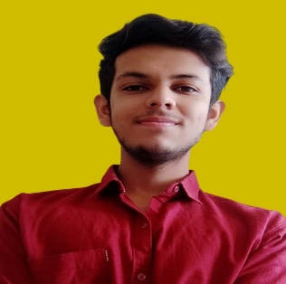

I want to start my career as a C/C++ developer. I gained experience in developing algorithms, data structures and content-oriented projects. Additionally, my skills involve implementing complex programs and debugging code. My ability to quickly learn programming languages ​​and technologies, combined with my passion for work, makes me a strong candidate for entry into the C/C+ level + developer role.

* First position in Inter School Group Dance Competition.

Address : Tehsil Sunni, Shimla (171301)

Email : [abhishekvermacu20@gmail.com](mailto:abhishekvermacu20@gmail.com)

Phone : +91 8580880038

LinkedIn:[www.linkedin.com/in/dataanalyticsabhishek](http://www.linkedin.com/in/dataanalyticsabhishek)

* Bronze Medal in School Level Science Olympiad..
* 4 Start Coder in Hacker Rank

PNEUMONIA DETECTION - April 2023

* Designed a **Website** in which doctors can detect whether a patient has Pneumonia or not using X-ray and past patient dataset
* This software use **HTML**, **CSS, JAVASCRIPT** and **OOPS** concept to create a website.

RIO AI VOICE ASSISTANT - June 2022

* Designed a Virtual Assistant using **classes and libraries.** Its task is to write emails, playing you tube, music, searching information on Wikipedia, playing games, crack jocks and many more.

GOLF STICK WEBSITE - 2021

* Create a blog website which recommends best golf sticks.
* It consists of **Web Development, Hosting, Domain Name.**

BE, Computer Science Engineering, AIML,

Chandigarh University

Session: 2020-2024 | ongoing CGPA: 7.28

Senior Secondary (XII), Science

Aryan Public Senior Secondary School, Sunni (Shimla)

Board-CBSE: 2020 | Percentage: 82%

Matriculation (X)

Aryan Public Senior Secondary School, Sunni (Shimla)

Board-CBSE: 2018 | Percentage: 63.83%