My Portfolio WEBSITE - 2023

* Developed and maintained a professional portfolio website showcasing my skills, projects, and accomplishments
* The website features a modern design, intuitive navigation, and responsive layout, ensuring a seamless user experience across various devices.
* Employed HTML, CSS, and JavaScript to build the website, and git hub for Hosting.

PNEUMONIA DETECTION - 2023

* Designed a System in which doctors can detect whether a patient has Pneumonia or not using X-ray and past patient dataset using Machine Learning.
* This software use HTML, CSS, JAVASCRIPT and Python concept to create a website.

Stock Prediction System – 2022

* Implemented regression models, time series analysis, and neural networks to predict future stock prices through data analysis using machine learning techniques.

ABHISHEK VERMA

PROFESSIONALSUMMARY

TECHNICAL SKILLS

C/C++ | JAVA | Python | GIT | SHELL SCRIPTING | JS | IDE | SQL | HTML | CSS

INTERPERSONAL SKILLS

Self

Motivated

|

Critical Thinking

Analytical Skill

|

Logical Reasoning

|

| Problem

Solving

Communication skills

INTERESTS & HOBBIES

Travelling

|

Reading

|

Coding| Cooking

LANGUAGES KNOWN

English

|

Hindi

EDUCATION

TRAINING & PROJECTS

ACADEMIC ACHIEVEMENT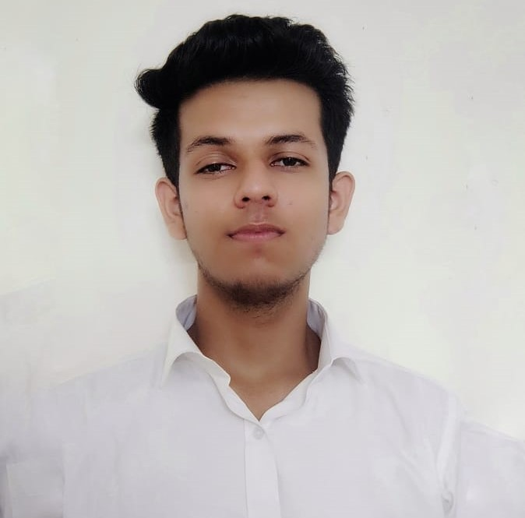DEMICACHIEVEMENTS

CERTIFICATIONS & AWARDS

* Data Science training passed with 100% score. - Internshala
* Web Development Certification from Coursera.
* Data Structure and Algorithms using C++ - Coursera.

EXTRA CURRICULAR & CO-CURRICULAR ACHIEVEMENTS

* Participation in Cluster Level Badminton competition



* Bronze Medal in School Level Science Olympiad.
* 4 Start Coder in Hacker Rank

I want to start my career as a C/C++ developer. I gained experience in developing algorithms, data structures and content-oriented projects. Additionally, my skills involve implementing complex programs and debugging code. My ability to quickly learn programming languages ​​and technologies, combined with my passion for work, makes me a strong candidate for entry into the C/C+ level + developer role.

Portfolio : [abhishekverma.github.io](https://abhishekvermacu20.github.io/abhishekverma.github.io/)

Address : Tehsil Sunni, Shimla (171301)

Email : [abhishekvermacu20@gmail.com](mailto:abhishekvermacu20@gmail.com)

Phone : +91 8580880038

LinkedIn: [abhishek.linkedin.com](https://www.linkedin.com/in/abhishek-verma-91640a1bb/)

BE, Computer Science Engineering, AIML,

Chandigarh University

Session: 2020-2024 | ongoing CGPA: 7.28

Senior Secondary (XII), Science

Aryan Public Senior Secondary School, Sunni (Shimla)

Board-CBSE: 2020 | Percentage: 82%

Matriculation (X)

Aryan Public Senior Secondary School, Sunni (Shimla)

Board-CBSE: 2018 | Percentage: 63.83%