**2.**

**Query**

DECLARE

temp1 NUMBER := &input_a_temp;

new_temp NUMBER;

BEGIN

new_temp := ( ( temp1 - 32 ) * 5 ) / 9;

dbms_output.Put_line ('The new temperature is '

||' is: '

||new_temp);

END;

/

**Output:**

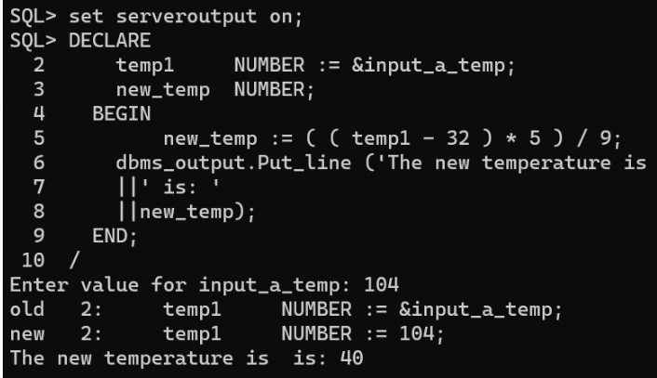

> DECLARE

z_student Student1%ROWTYPE;

num char(1);

phn Student1.Phone%TYPE;

BEGIN

num:='&num';

phn:='&phn';

SELECT * INTO z_student from Student1 WHERE STUDENTID= concat('0010',num);

z_student.phone:=phn;

dbms_output.Put_line('Student Details : Name:' ||z_student.first ||' Phone No: ' ||z_student.phone ||' City: ' ||z_student.city);

END;

/

Output:

Enter value for num: 0

old 6: num:='&num';

new 6: num:='0';

Enter value for phn: 43245632

old 7: phn:='&phn';

new 7: phn:='43245632';

Student Details : Name:Jose Phone No: 43245632 City: Hill