**Software Requirement Specifications (SRS)**

Title of the Project: **‘Find My Lawyer’**

**Purpose:**

The purpose of this SRS document is to provide a detailed description of the "FindMyLawyer" system. It will outline the functional and non-functional requirements, system features, external interface requirements, and constraints to ensure the successful development and implementation of the project.

**Scope:**

"FindMyLawyer" is a web-based platform designed to connect users with lawyers. Users can view lawyer profiles, select a lawyer, chat with the selected lawyer, and schedule appointments. Lawyers can manage their profiles, availability, and appointments. Administrators can manage the overall system, including user and lawyer accounts, and site content.

**Definitions, acronym and abbreviations:**

* **User**: An individual seeking legal advice or services.
* **Lawyer**: A legal professional offering advice or services on the platform.
* **Admin**: An administrator responsible for managing the platform.
* **SRS**: Software Requirements Specification.

**Product Perspective:**

"FindMyLawyer" is a standalone web application designed to streamline the process of finding and consulting with lawyers. It integrates various functionalities including user registration, profile management, appointment scheduling, and real-time chat. The system is intended to provide a seamless experience for both users and lawyers

**Product Functions:**

The main functions of the "FindMyLawyer" system include:

* User and Lawyer registration and login.
* Viewing and managing lawyer profiles.
* Chatting with selected lawyers.
* Scheduling appointments based on lawyer availability.
* Managing user and lawyer profiles.
* Administrative management of users, lawyers, and content.

**User Classes and Characteristics:**

* **Users**: Individuals looking for legal services. They need an intuitive interface to search for lawyers, view profiles, chat, and schedule appointments.
* **Lawyers**: Legal professionals providing services. They need tools to manage their profiles, availability, and appointments.
* **Admins**: System administrators who manage user accounts, lawyer accounts, and platform content.

**Operating Environment:**

The system will operate in a web environment and should be accessible on common web browsers (e.g., Chrome, Firefox, Safari, Edge) across various devices (desktops, tablets)

**Actors:**

1. **User**
2. **Lawyer**

**Use Cases:**

1. **Login/Register**
2. **View Lawyer Profiles**
3. **Select Lawyer**
4. **Chat with Lawyer**
5. **Schedule Appointment**
6. **View Home/About Page**

**Use Case Diagram**

#### 1. Login/Register

**Actors:** User, Lawyer, Admin

* **Preconditions:** The user, lawyer, or admin must have access to the internet and the platform.
* **Postconditions:** The user, lawyer, or admin is authenticated and can access the appropriate parts of the platform.

**Steps:**

1. The actor navigates to the login/register page.
2. The actor enters their credentials or registration details.
3. The system verifies the credentials or saves the registration details.
4. Upon successful verification, the actor is redirected to their respective dashboard (User/Lawyer/Admin).

**Extensions:**

* If the credentials are incorrect, the system displays an error message.
* If the registration details are incomplete, the system prompts for the missing information.

#### 2. View Lawyer Profiles

**Actor:** User

* **Preconditions:** The user must be logged in.
* **Postconditions:** The user views a list of available lawyers.

**Steps:**

1. The user navigates to the lawyer profiles page.
2. The system retrieves and displays a list of available lawyers with basic information (e.g., name, specialization, location, availability).

**Extensions:**

* The user can filter the list by specialization, location, or availability.
* The user can sort the list by rating, experience, or fees.

#### 3. Select Lawyer

**Actor:** User

* **Preconditions:** The user must be logged in and viewing lawyer profiles.
* **Postconditions:** The user selects a lawyer and can initiate contact.

**Steps:**

1. The user clicks on a lawyer's profile.
2. The system displays the detailed profile of the selected lawyer, including contact options.

**Extensions:**

* The user can view reviews and ratings of the lawyer.
* The user can add the lawyer to their favorites.

#### 4. Chat with Lawyer

**Actors:** User, Lawyer

* **Preconditions:** The user must have selected a lawyer.
* **Postconditions:** The user and lawyer can exchange messages.

**Steps:**

1. The user clicks on the chat option in the lawyer's profile.
2. The system opens a chat window.
3. The user and lawyer exchange messages.

**Extensions:**

* The system notifies both parties of new messages.
* The chat history is saved and can be reviewed later.

#### 5. Schedule Appointment

**Actors:** User, Lawyer

* **Preconditions:** The user must be logged in and have selected a lawyer.
* **Postconditions:** An appointment is scheduled and added to both the user’s and the lawyer’s calendars.

**Steps:**

1. The user clicks on the schedule appointment option in the lawyer's profile.
2. The system displays the lawyer's available slots.
3. The user selects a suitable slot and confirms the appointment.
4. The system sends notifications to both the user and the lawyer.

**Extensions:**

* The user can reschedule or cancel the appointment.
* The system sends reminders before the appointment.

#### 6. View Home/About Page

**Actor:** User

* **Preconditions:** None.
* **Postconditions:** The user views information about the platform.

**Steps:**

1. The user navigates to the home or about page.
2. The system displays information about the platform, services offered, and contact details.

#### 7. Manage Profile

**Actors:** User, Lawyer

* **Preconditions:** The actor must be logged in.
* **Postconditions:** The actor's profile is updated.

**Steps:**

1. The actor navigates to the profile management page.
2. The actor updates their personal information and saves the changes.
3. The system validates and updates the profile information.

**Extensions:**

* The system prompts for mandatory fields if they are left blank.
* The actor can upload a profile picture.

#### 8. Manage Appointments

**Actors:** User, Lawyer

* **Preconditions:** The actor must be logged in.
* **Postconditions:** The actor can view, update, or cancel appointments.

**Steps:**

1. The actor navigates to the appointments page.
2. The system displays a list of upcoming and past appointments.
3. The actor can select an appointment to view details, reschedule, or cancel.

**Extensions:**

* The system sends notifications for changes to appointments.
* The user can provide feedback after the appointment.

#### 9. Manage Availability Slots

**Actor:** Lawyer

* **Preconditions:** The lawyer must be logged in.
* **Postconditions:** The lawyer's availability slots are updated.

**Steps:**

1. The lawyer navigates to the availability management page.
2. The lawyer sets or updates their available time slots.
3. The system saves the changes and updates the lawyer’s profile.

**Extensions:**

* The system prevents overlapping slots.
* The lawyer can set recurring availability.

**Diagram:**

This diagram shows the interactions between the **User** and **Lawyer** with various use cases in the system.

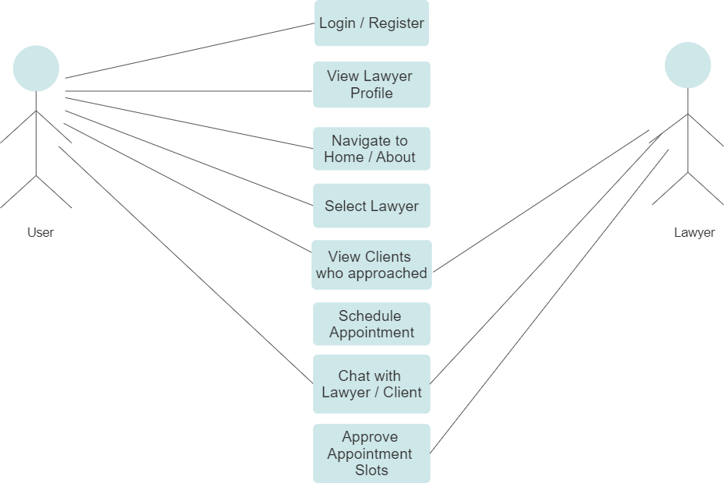

**Explanation:**

1. **Login/Register**:
   * **User** can log in or register on the platform.
2. **View Lawyer Profiles**:
   * Once logged in, **User** can view various lawyer profiles.
3. **Select Lawyer**:
   * **User** can select a lawyer from the displayed profiles.
4. **Chat with Lawyer**:
   * **User** can initiate a chat with the selected lawyer.
   * **Lawyer** can respond to the user.
5. **Schedule Appointment**:
   * **User** can schedule an appointment with the lawyer based on available slots.
   * **Lawyer** manages their availability slots.
6. **View Home/About Page**:
   * **User** can view the home and about pages, which provide general information about the service.

This use case diagram outlines the primary interactions and functionalities of the "FindMyLawyer" system.