**Report on**

**Joy of Programming using Python**

Submitted for Summer Internship Program

**By**

**NAME : ABHISHEK YADAV**

**BRANCH : CS**

**ROLL NO. : 1900270120002**

Under the guidance of

Dr. Pratima Singh

Mr. Binayak Parashar



**AJAY KUMAR GARG ENGINEERING COLLEGE, GHAZIABAD**

**YEAR 2020-21**

**INDEX**

|  |  |
| --- | --- |
| **1.** | **Project -11 (Website Blocking)** |
|  | HOSTFILE |
|  | CODE IN PYTHON |
|  | CHANGE IN HOSTFILE |
|  | TEST CASE IN BROWSER |
| **2.** | **ASSIGMENT** |
|  | ALL (1-24) |

Project-11: Website block

Q1: - “Python Website Blocker” When we surf the internet, many unwanted websites keep showing up. You can build a program that blocks certain websites from opening. This program is beneficial for students who want to study without any social media distractions.

SOLUTION : -

Every system have **host** file whether it is Mac, Windows or Linux.

HOSTFILE IN WINDOWS :

C:\Windows\System32\drivers\etc\hosts

**Working of host file:**Host is an operating system file which maps hostnames to IP addresses. In this program we will be mapping hostnames of websites to our localhost address. Using python file handling manipulation we will write the hostname in hosts.txt and remove the lines after your working hours.

HOSTFILE IN WINDOWS :

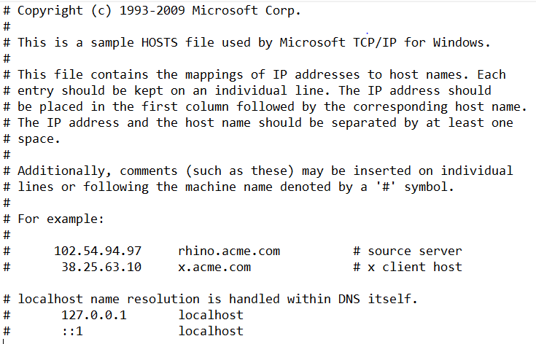

Before running this code website working properly :

.

CODE IN PYTHON :-

INPUT – “website names”

localhost = "127.0.0.1"

host_path = "C:\Windows\System32\drivers\etc\hosts"

website = ["www.facebook.com","www.instagram.com","www.youtube.com"]

with open(host_path,"r+") as f:

    x = f.read()

    for item in website:

        if x.__contains__(item):

            pass

        else:

            f.write("\n"+localhost+" "+item)

print("All done")

AFTER RUNNING THE CODE (OUTPUT):-

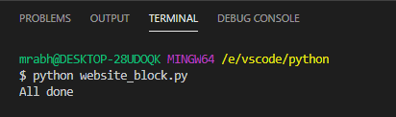

CHANGE IN HOSTFILE (OUTPUT):

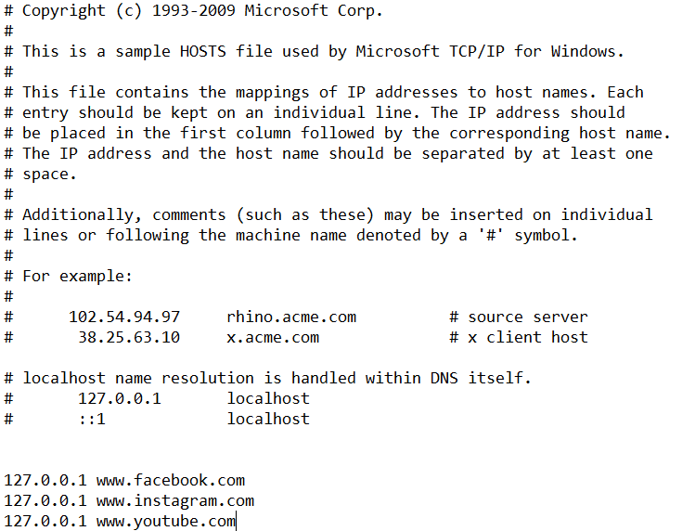

IN BROWSER :

Test case 1 : Facebook is not running.

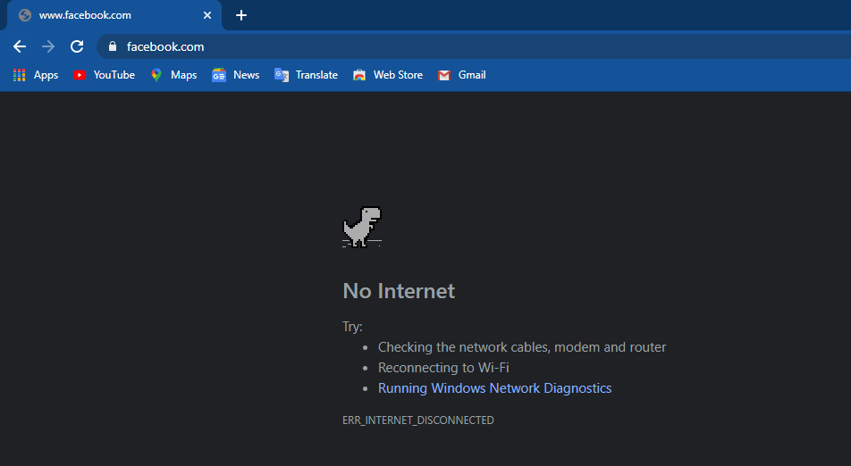

Test case 2 : Instagram is not running.

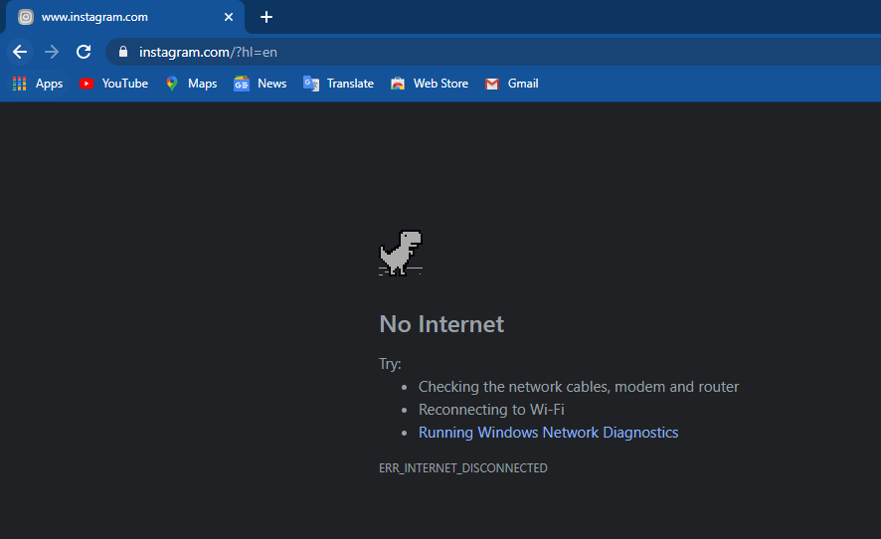

Test case 3 : Youtube is not working.

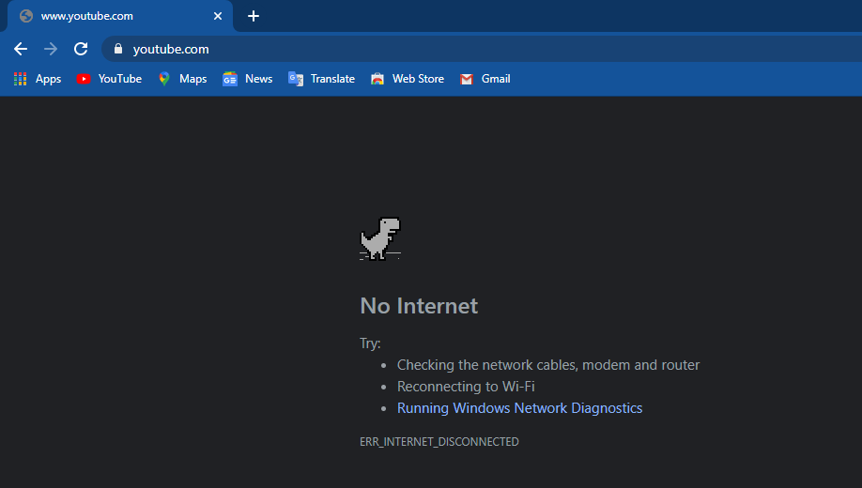

: Assignment :

1. Write a Python program to multiplies all the items in a list.

list1 = [3,5,4,8,2]

mul = 1

for item in list1:

mul *= item

print("multiple of list1 item is : ",mul)

Output :- multiple of list1 item is : 960

2. Write a Python program to check a list is empty or not.

def list_empty(lis):

if len(lis) == 0:

return "list is empty"

else:

return "list is not empty"

print(list_empty([]))

print(list_empty([1,2]))

Output :-

list is empty

list is not empty

3. Write a Python function that takes two lists and returns True if they have at least one common member.

def comman_list(list1,list2):

set1 = set(list1)

set2 = set(list2)

x = set1.intersection(set2)

if len(x)!=0:

print("true")

else:

print("false")

list1 = [1,2,3,4,5]

list2 = [7,6,5,8]

comman_list(list1,list2)

Output :- true

4. Write a Python program to print the numbers of a specified list after removing even numbers from it.

list1 = [1,2,3,4,5,6,7,8,9,10]

for i in list1:

if i%2==0:

list1.remove(i)

print(list1)

Output :- [1, 3, 5, 7, 9]

5.Write a Python program to generate and print a list of first and last 5 elements where the values

# are square of numbers between 1 and 30 (both included).

list1 = []

for i in range(1,31):

list1.append(i*i)

print("first 5 element : ",list1[:5])

print("last 5 element : ",list1[-5:])

Output :-

first 5 element : [1, 4, 9, 16, 25]

last 5 element : [676, 729, 784, 841, 900]

6.Write a Python program to insert an element before each element of a list.

list1 = ["ram","shyam","mohan","geeta"]

j=0

i=0

x = len(list1)

while i<x:

list1.insert(j,"a")

j = j+2

i += 1

print(list1)

Output :- ['a', 'ram', 'a', 'shyam', 'a', 'mohan', 'a', 'geeta']

7.Write a Python program to extend a list without append.

Sample data: [10, 20, 30]

[40, 50, 60]

Expected output : [40, 50, 60, 10, 20, 30]

list1 = [10,20,30]

list2 = [40,50,60]

print(list1+list2)

Output : [10, 20, 30, 40, 50, 60]

8. Write a Python program to sort the elements of list is descending order.

list1 = [5,2,7,2,6,1,5,9]

print(sorted(list1)[::-1])

Output : [9, 7, 6, 5, 5, 2, 2, 1]

9.Given a positive integer number n, you have to write a program that generates a dictionary d which contains (i, i*i*i) such that i is the key and i*i*i is its value, where i is from 1 to n (both included).

dict1 = {}

n=5

for i in range(1,n+1):

dict1.update({i:i*i*i})

print(dict1)

Output : {1: 1, 2: 8, 3: 27, 4: 64, 5: 125}

10. Given an integer number n, define a function named printDict() which can print a dictionary where the keys are numbers between 1 and n (both included) and the values are square of keys.

# The function printDict() doesn't take any argument.

def printDict():

n = int(input("enter no : "))

dict1 = {}

for i in range(1,n+1):

dict1.update({i:i*i*i})

print(dict1)

printDict()

Output : {1: 1, 2: 8, 3: 27, 4: 64, 5: 125, 6: 216, 7: 343}

11.You are provided with a playlist containing N songs, each has a unique positive integer length. Assume you like all the songs from this playlist, but there is a song, which you like more than others.

# It is named "Computing Paradox".

tot_song = 5

song_length_all = [4,7,5,6,17,8]

song_name = "Computing Paradox"

song_lenght = len(song_name)

x = sorted(song_length_all)

print("position of song is : ",x.index(song_lenght)+1)

Output : position of song is : 6

12. Write a Python program to find palindromes in a given list of strings using Lambda.

texts = ["php", "w3r", "Python", "abcd", "Java", "aaa"]

print("Orginal list of strings:")

print(texts)

result = list(filter(lambda x: (x == "".join(reversed(x))), texts))

print("\nList of palindromes:")

print(result)

Output :

Orginal list of strings:

['php', 'w3r', 'Python', 'abcd', 'Java', 'aaa']

List of palindromes:

['php', 'aaa']

13.Write a Python program to create Fibonacci series upto n using Lambda.

from functools import reduce

fib_series = lambda n: reduce(lambda x, _: x+[x[-1]+x[-2]],

range(n-2), [0, 1])

print("Fibonacci series upto 8:")

print(fib_series(8))

Output :- [0, 1, 1, 2, 3, 5, 8, 13]

14. Write a Python program to count the even, odd numbers in a given array of integers using Lambda.

array_nums = [1, 2, 3, 5, 7, 8, 9, 10]

print("Original arrays:")

print(array_nums)

odd_ctr = len(list(filter(lambda x: (x%2 != 0) , array_nums)))

even_ctr = len(list(filter(lambda x: (x%2 == 0) , array_nums)))

print("Number of even numbers in the above array: ", even_ctr)

print("Number of odd numbers in the above array: ", odd_ctr)

Output :

Original arrays:

[1, 2, 3, 5, 7, 8, 9, 10]

Number of even numbers in the above array: 3

Number of odd numbers in the above array: 5

15. Write a Python program to add two given lists using map and lambda.

list1 = [1, 2, 3]

list2 = [4, 5, 6]

result = map(lambda x, y: x + y, list1, list2)

print("after adding two list : ",list(result))

Output : after adding two list : [5, 7, 9]

16.Write a Python program to find numbers divisible by nineteen or thirteen from a list of numbers using Lambda

nums = [19, 65, 57, 39, 152, 639, 121, 44, 90, 190]

print("Orginal list:")

print(nums)

result = list(filter(lambda x: (x % 19 == 0 or x % 13 == 0), nums))

print("Numbers of the above list divisible by nineteen or thirteen:")

print(result)

Output :

Orginal list:

[19, 65, 57, 39, 152, 639, 121, 44, 90, 190]

Numbers of the above list divisible by nineteen or thirteen:

[19, 65, 57, 39, 152, 190]

17. Write a Python program to calculate the length of a string

name = "abhishek yadav"

print("length of string name : ",len(name))

Output : length of string name : 14

18. Write a Python program to count the number of characters (character frequency) in a string.

name = input("enter your name : ")

i=0

l=len(name)

while l>i:

un = name[i]

p=0

insum=0

while l>p:

sn = name[p]

if un==sn:

insum += 1

p+=1

print(f"{un} : {insum}")

i+=1

Output :-

enter your name : abhishek

a : 1

b : 1

h : 2

i : 1

s : 1

h : 2

e : 1

k : 1

19. Write a Python program to get a string made of the first 2 and the last 2 chars from a given a string. If the string length is less than 2, return instead of the empty string.

str1 = "abhsihek"

if len(str1)>2:

print(str1[:2]+str1[-2:])

else:

print(str1)

Output : abek

20. Write a Python program to get a string from a given string where all occurrences of its first char have been changed to '$', except the first char itself

def change_char(str1):

char = str1[0]

str1 = str1.replace(char, '$')

str1 = char + str1[1:]

return str1

print(change_char('restart'))

Output : resta$t

21. Write a Python program to get a single string from two given strings, separated by a space and swap the first two characters of each string

def separate_string(str1,str2):

str3 = str2[:2] + str1[2:]

str4 = str1[:2] + str2[2:]

print(f"{str3} {str4}")

separate_string("abc","xyz")

Output : xyc abz

22. Write a Python program to add 'ing' at the end of a given string (length should be at least 3). If the given string already ends with 'ing' then add 'ly' instead. If the string length of the given string is less than 3, leave it unchanged.

def add_string(str1):

length = len(str1)

if length > 2:

if str1[-3:] == 'ing':

str1 += 'ly'

else:

str1 += 'ing'

return str1

print(add_string('ab'))

print(add_string('abc'))

print(add_string('string'))

Output :

ab

abcing

stringly

23. Write a Python program to find the first appearance of the substring 'not' and 'poor' from a given string, if 'not' follows the 'poor', replace the whole 'not'...'poor' substring with 'good'. Return the resulting string.

def poor(str1):

if str1.__contains__("not" and "poor"):

x = str1.find("not")

y = str1.find("poor")

print(str1[:x]+str1[y:])

elif str1.__contains__("good"):

x = str1.find("good")

str2 = str1.replace(str1[x:x+4],'poor')

print(str2)

poor("this lyrics is not that poor")

poor("the lyrics is good")

Output :

this lyrics is poor

the lyrics is poor

24.Write a Python function that takes a list of words and returns the length of the longest one.

list1 = ["abhishek","ram","rahul","kamlesh"]

list2 = []

for item in list1:

list2.append(len(item))

x = list2.index(max(list2))

print("longest one is : ",list1[x])

Output :-longest one is : abhishek