# Ftp Server Configuration and file transfer

1. Launch Packet Tracer and use desktop icons to create three machines. Give their names as ftpserver, ftp client1, ftp client2. Let the IP address be 192.168.1.100, 192.168.1.2 and 192.168.1.3.

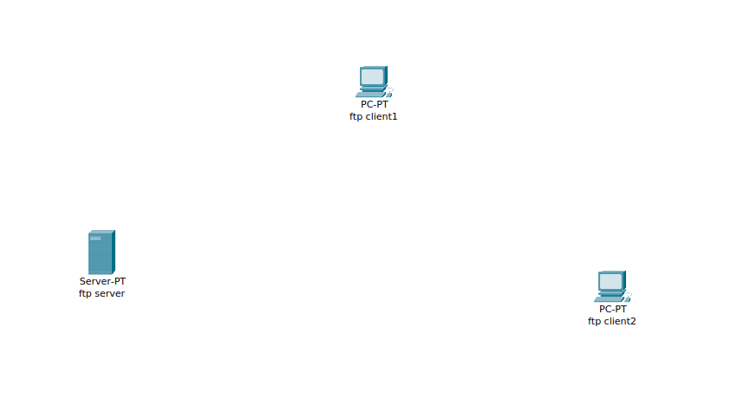

1. Create another desktop with name DNS server and configure the IP to be 192.168.1.1

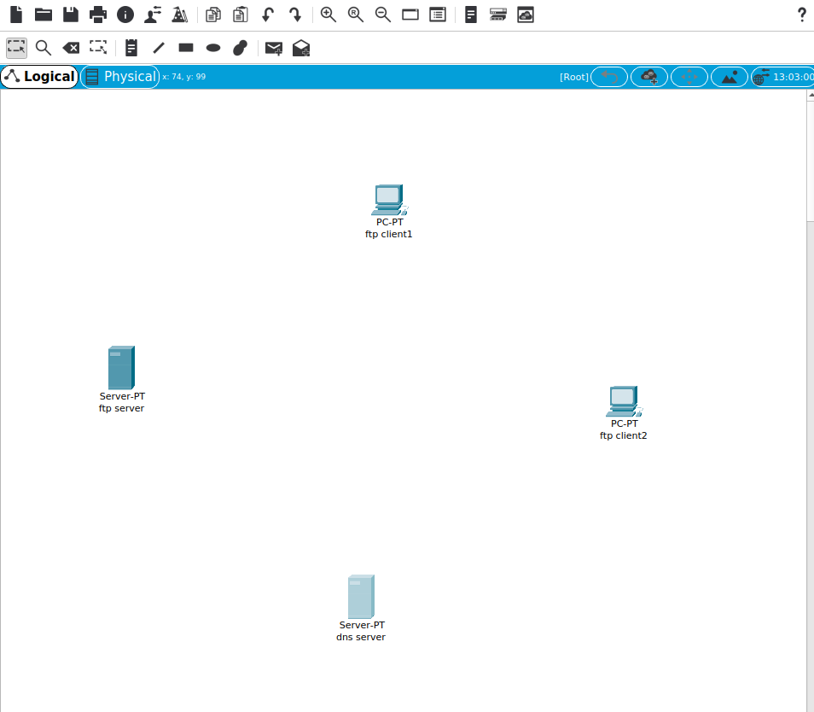

1. Using the Desktop tab, configure the IP address for the server and clients as Static address and make their subnet mask as 255.255.255.0 and DNS server as 192.168.1.100
2. Make a switch connecting these four desktops and enable the links. Your network configuration should look similar to diagram given below.

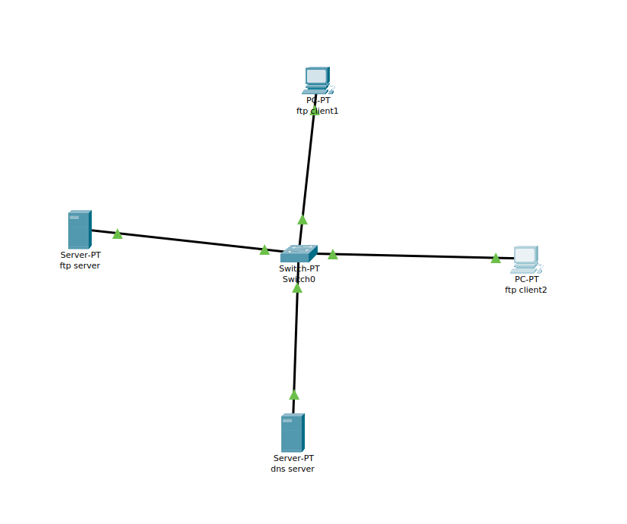

1. Configure ftp server using drop down menu as ftp server and create a user login and password
2. Create a text file in ftp client 1 machine by using a Text Editor.

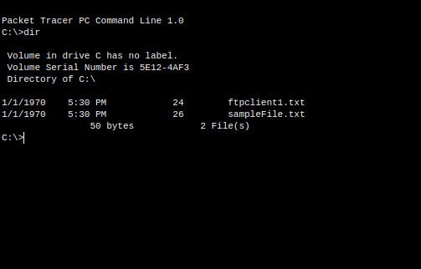

1. Make an entry in the DNS server for the ftp server and give its name and IP address.
2. 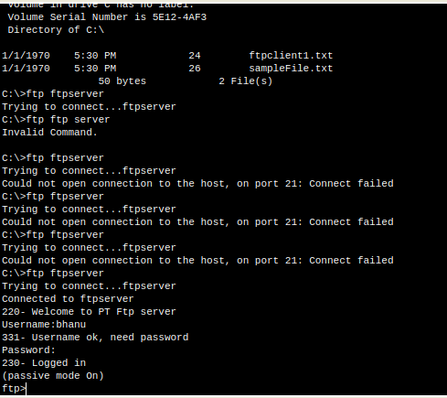Then open a command prompt at ftp client 1 and invoke the command “ftp ftpserver”
3. It’ll ask for login and password, provide the username and password you created on the ftp server.
4. Then type put textfile on the ftp command prompt. It’ll upload the file to the ftpserver. Verify by running dir command that the file is actually uploaded.

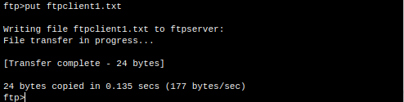

1. 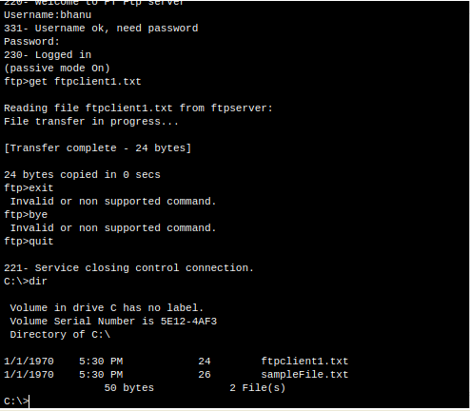Next from the ftp client 2 machine, access the ftp server in the same way and download the file using get textfile. Verify by running dir command that the file is actually downloaded.

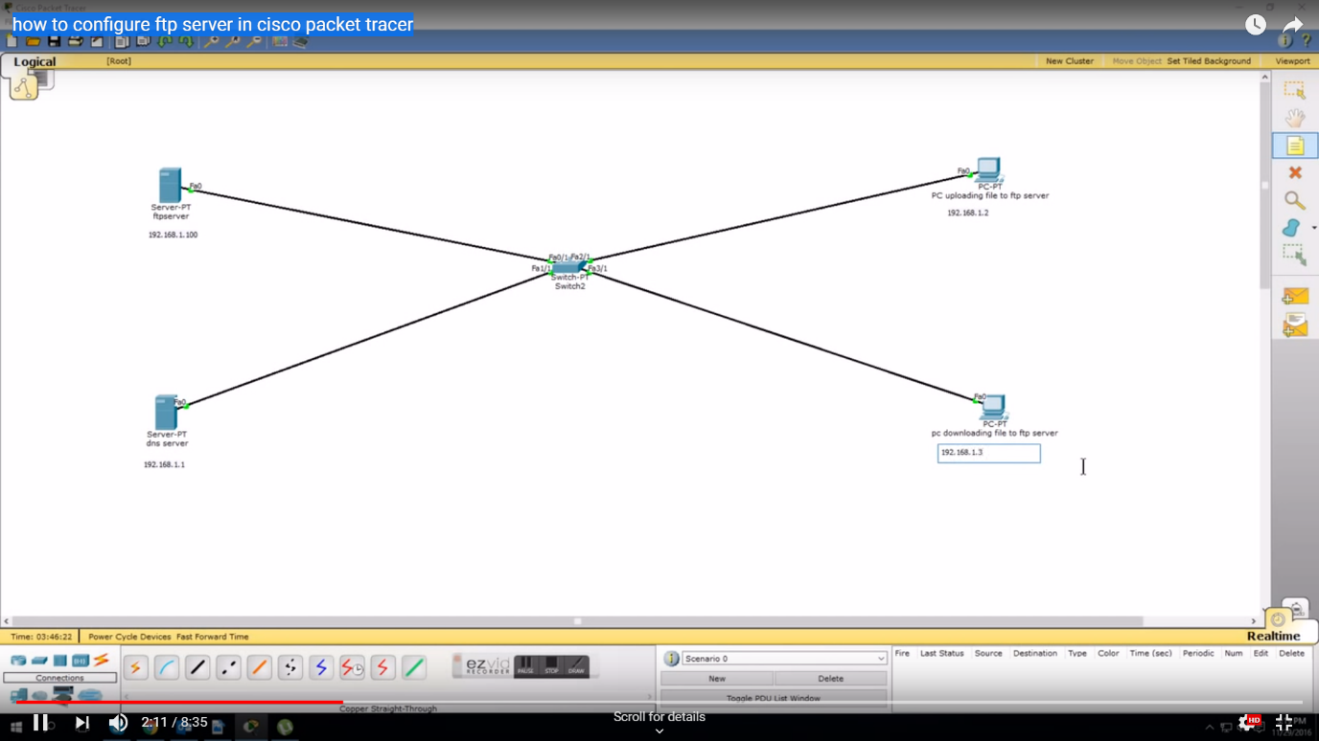

Network 1