Help Document

1. In the beginning we have to create an account which will provide an authentication .
   1. <http://localhost:8080/account>
      1. In the body please provide:
      2. 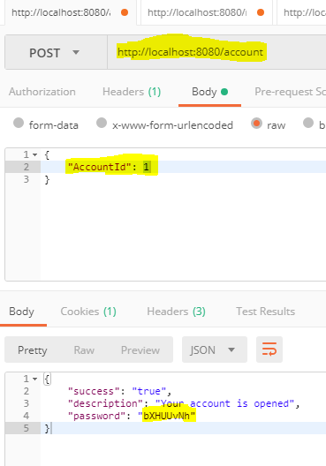
2. Now use the returned password from the first URL to register a URL for shortening .
3. 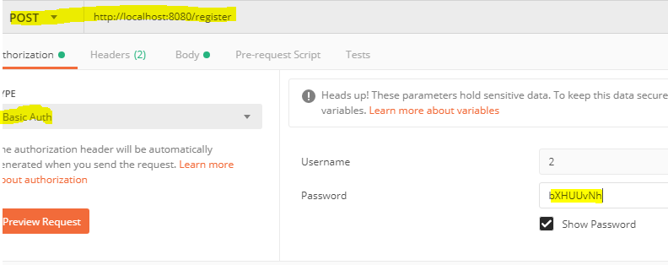

Body of the call .

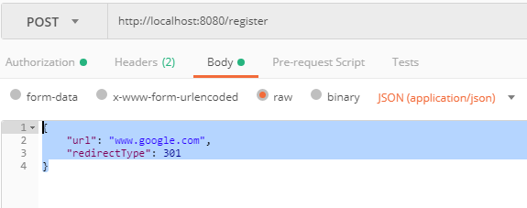

Once done you can type in the browser the returned shortUrl and it will be redirected to the registered URL .

The hitCount is also stored .