**ITMT-594-Project-SahajYog Chicago Organization Website Redesign Project Report till Spring 2024 Semester**

* **By Abhishek Panjwani**

**Requirements of organization:**

1. Mission Statement: Our collective mission is to redesign our website, transforming it into a modern platform that resonates with new seekers in Sahaja yoga, thereby enhancing their journey of self-realization.
2. Goals:
   * Our Primary goal is to inspire new seekers to join the center for a meditation program, eventually join our Sahaja Yoga Community, and spread knowledge of Self-Realization and Sahaja Yoga.
   * To address all the queries and FAQs, make this site more interactive and robust.
   * Create call-to-action items so seekers have a reason to return to the website.
   * Event Calendar for local programs throughout Chicagoland
3. Specifications:

* We will first create a login page for current and new users (they can create or register users or access or write it through their Gmail, Instagram, and Facebook IDs).
* Plus, we will integrate calendars and WhatsApp to announce any event (like Puja or Havan) on the website. We can be spread autonomously on WhatsApp Group, Instagram, FB, and social media platforms. Plus, it creates a calendar event (like 2 hours before, just like a flight event prompts on a mobile device to update and keep the seekers posted) in case they miss any announcements.
* We will create an FAQ page and provide them with a Q&A session daily from 6 to 7 or 7 to 8 pm CST. If they have queries, they will be answered on the live platform, and we will give them an email or blog platform to ask them.
* We will also share Shri Mataji videos, which will be more apparent as a reference.
* We will also create more straightforward content to help people understand the concepts of Self-Realization, Kundalini awakening, etc.
* Have a video of Shri Mataji giving realization on the Homepage.
* Share Her quotes.
* The website should have links to other meditation websites, such as Sahaja Online and We Meditate, so that people can meditate when they visit it.
* Add a blog with relevant articles.
* Add local updates.
* Share US/world news - content related to giving self-realization.
* Website example: <https://sahajayoga.at/>
* Make it attractive for all seekers, young to old.
* Adding Event Calendar.
* Information is that any program changes at the last minute.

**Phase 1:**

* Preparation and Planning (Understand the Vision and Requirements of the Organization, get the source of the current Website, and Configure the FTP Server)
* Development Environment Setup (Creating a Test Site, installing a Local Xampp Server, and Configuring Extensions VS Code).

**Tasks for Phase 1:**  
  
1. Need source code of the current website from the organization.

2. Create an FTP account for the website and access it.

3. Install the Xampp Server and Deploy the Apache server on a local host for login,

4. Install Code Editor such as VS code and Add PHP Extension Pack, MySQL Extension Pack, and Live Share.

5. Configure Virtual Host in Xampp Server.

6. Create a GitHub Repo for this project.

Completed the Following tasks by the end of this Spring 2024 Semester:

1. The Current website Source code is in Siteground.com:

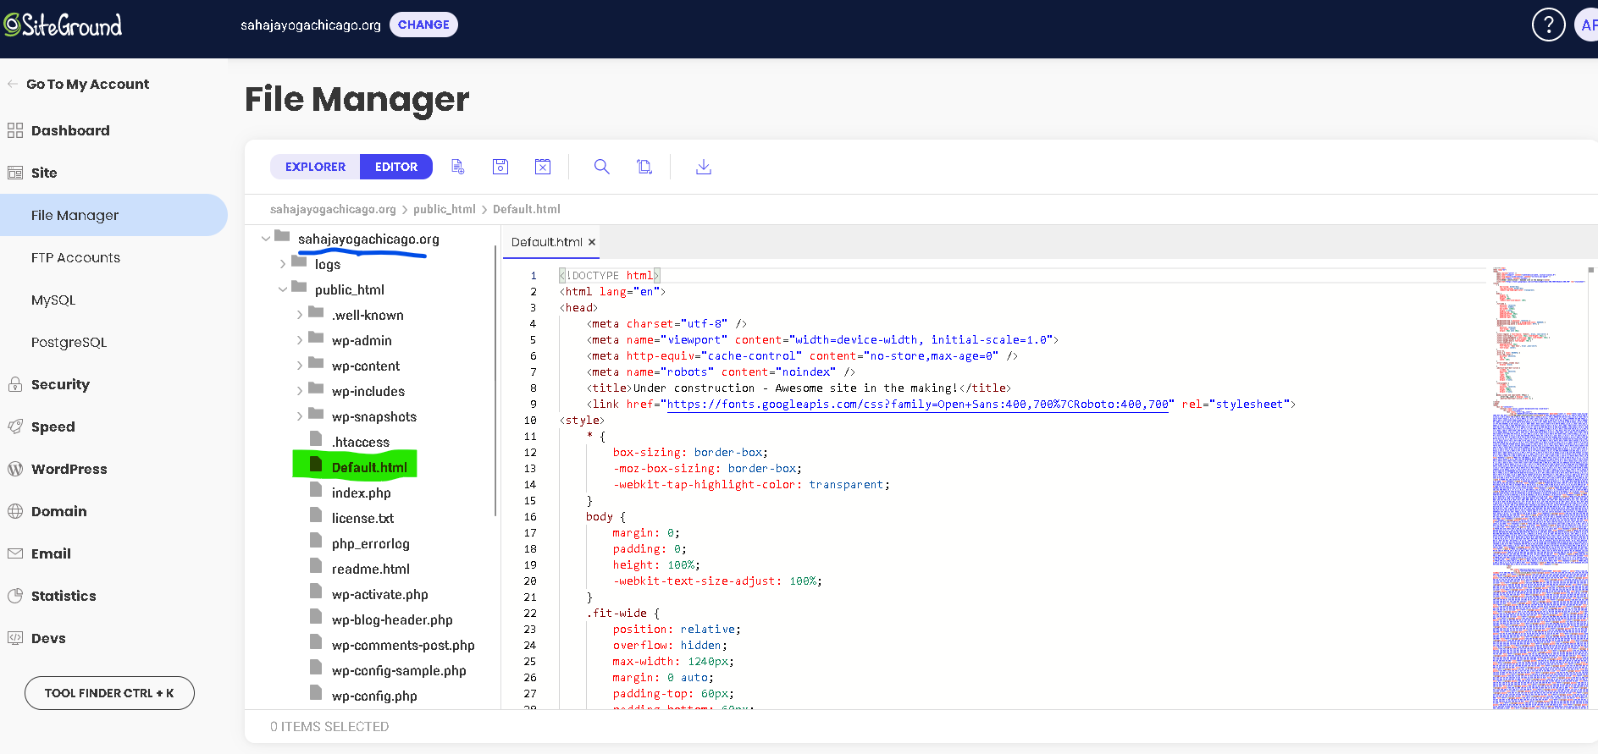

1. Created FTP Account for this website and successfully Accessed it through FileZilla:



* Downloaded the files and source code from FTP.

1. Got Xampp Server installed (started Apache and My SQL Modules Successfully) with VS Code and the following Extensions in VS Code: PHP Extension Pack (including IntelliSense, linting, and debugging), MySQL Extension, and Live Share.

* Transferred all the files and source code downloaded to C:\xampp\htdocs

1. Accessing MySQL via phpMyAdmin

* Imported SQL db “dblneqr0gohgxj” in phpMyAdmin page from Site ground site.

* Created a User Account: uw92ksggalt4u Password: zizlgxlunyaw

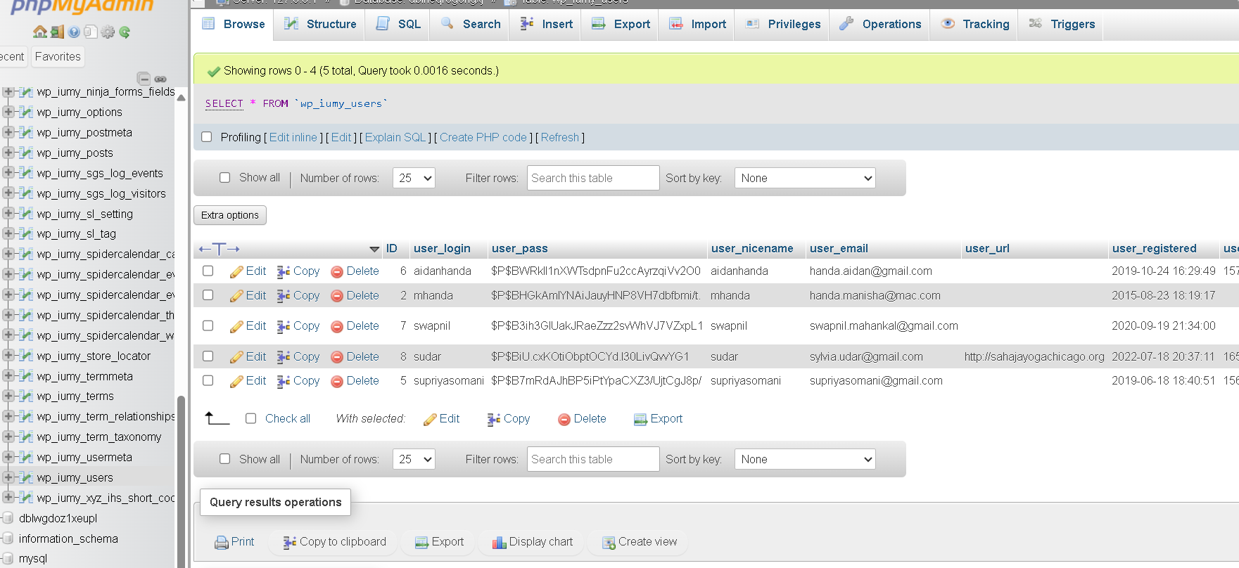

* Connected this DB in VScode successfully:  
  A screenshot of a computer

  Description automatically generated

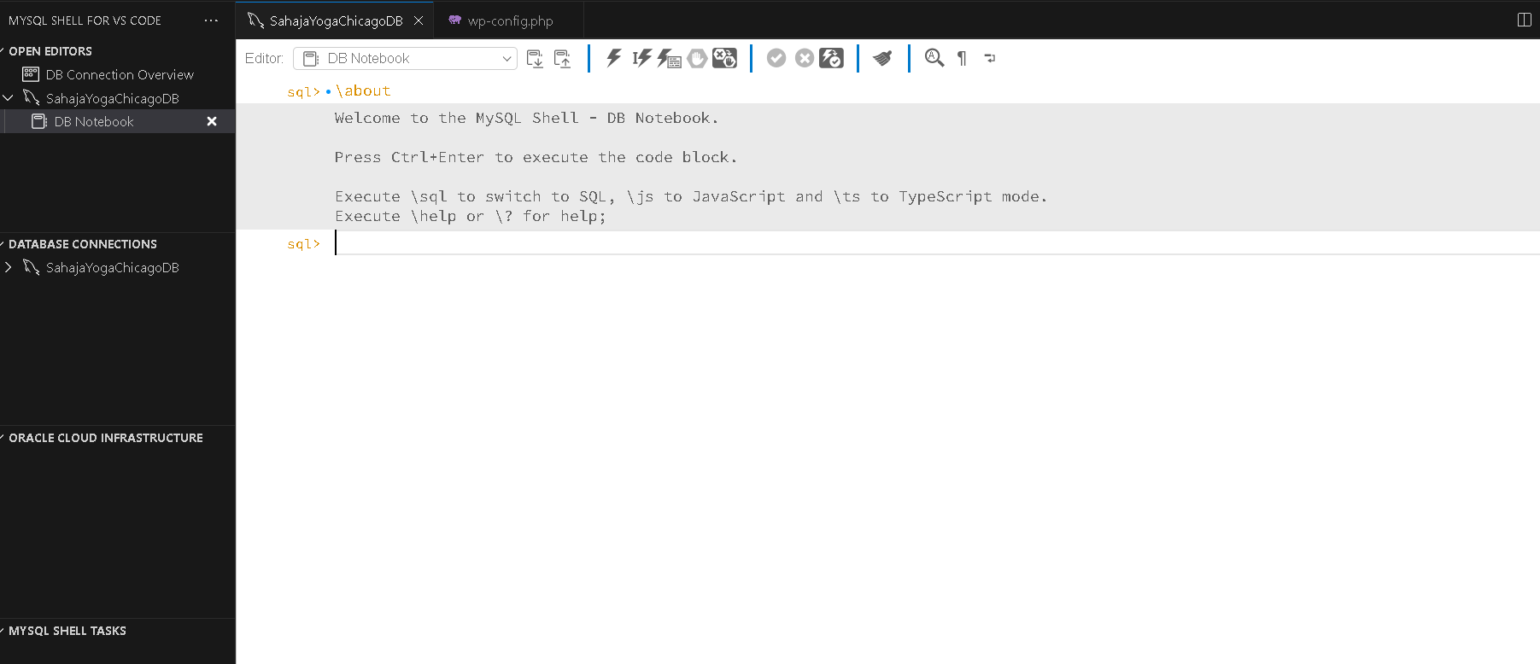

1. Configured httpd.conf and httpd-vhosts.conf files for Virtual host settings in Xampp Server (Apache on localhost) and Networks host file:

* However, earlier we were unable to start Apache Services, as we were providing relative path for this D:\Master's Work\sahajayogachicago.org or D:\Master's Work\ITMT-594-Project-Sahajyog_Chicago_Website\Website Work\sahajayogachicago.org, Due to which we had “Error: Apache shutdown unexpectedly. This may be due to a blocked port, missing dependencies, improper privileges, a crash, or a shutdown by another method. Press the Logs button to view error logs and check the Windows Event Viewer for more clues.”
* I extensively researched this and followed the steps to fix it. I checked the status of ports 80 and 443 through Netstat to see if they are used by any other applications or processes and changed the ports multiple times in httpd.conf and httpd-ssl.conf.
* Changed the relative paths and verified the permissions. Reverting these file changes has resolved this issue only once, but it failed on multiple occasions.
* Then, I copied the parent folder of this organization, “which contains source and scripts,” to absolute oath “C:\xampp\htdocs,” and it started working. The Apache Module service was successfully started.

1. Created a Test php File and was able to browse it successfully.  
     
   A screenshot of a computer

   Description automatically generated

* However, while browsing default.html, getting the below error:

* To fix this I had researched thoroughly and encountered errors with DB earlier.
* Unable to connect to DB was the initial error, in VS Code terminal it was showing Access denied for the above user, I added it successfully in the above section of SQL. Then it was able to connect.
* However, The webpage was unable to browse. So I coordinated with the original developer of this site “Aidan Handa” (He also has his username in the above SQL users table list”.
* We were browsing <http://localhost/public_html>, it was redirecting us to wp-admin/install.php file to install wordpress platform.
* So we copied all the files from public_html to its parent folder “Sahajayogachicago.ord” but still it did not fixed the issue.
* We analyzed the WP_IUMY_ Options table in phpMyAdmin and made changes to siteURL https://localhost.  
    
  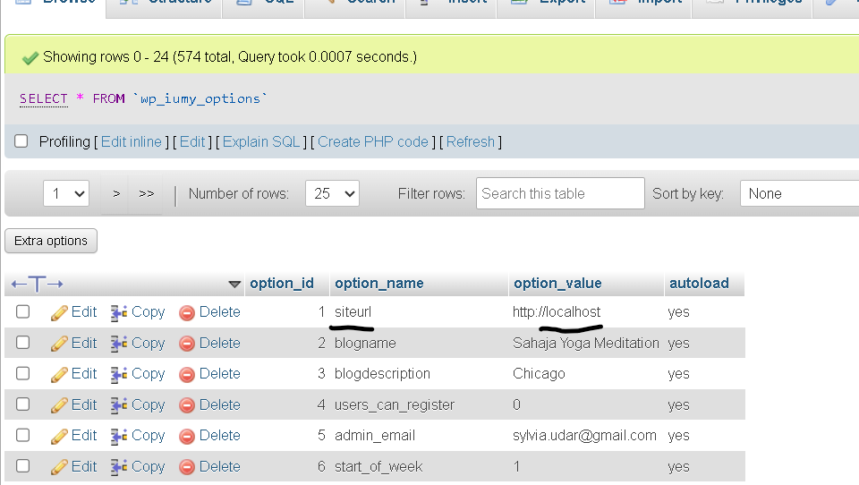
* It still did not work, so we used root user instead of “uw92ksggalt4u”, made changes to WP-Config.php file as per phpMyAdmin “SQL DB”  
    
  A screenshot of a computer

  Description automatically generated  
    
  A screenshot of a computer program

  Description automatically generated
* Then we restarted Apache and SQL Modules, refreshed the browser tab and it was able to browse the designated site:  
    
  A screenshot of a computer

  Description automatically generated

1. Created a GitHub Repo for this project.



