**DeltaX - Backend Assignment**

**(The Project Follows Repository Design Pattern)**

**Step-1  
Database Design**

**Database Name**

->IMDB

**Entities**

->Gender Table

->Actor Table

->Poster Table

->Producer Table

->Movie Table

->ActorMovieMappings Table

**Step-2**

**ER-Diagram**

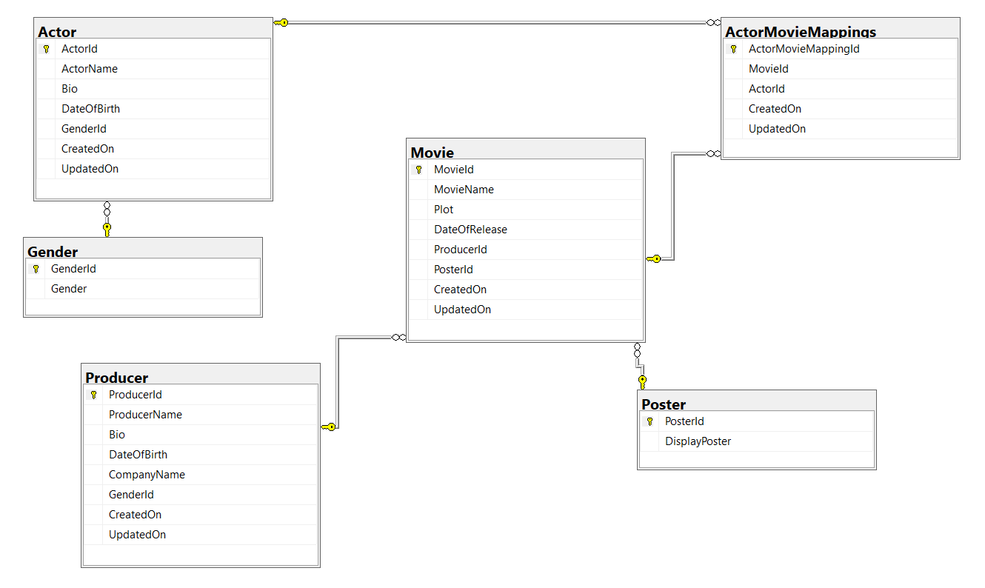

**Step-3**Database Create and Insert Records Query are attached in Database Folder Please run the scripts.

**Step-3**

**Download Following Packages from NuGet-Package Manager**

->Microsoft.EntityFrameworkCore.SqlServer

-> Microsoft.EntityFrameworkCore.Tools

->MicrosoftExtensions.Configuration

->Mapster

->System.Linq

->**Then Run the following command in PackageManagerConsole to have the Models created following th DB-FirstApproach.**

**Please Update the Server Name accordingly,**Scaffold-DbContext "Server=(Server-Name);Database=IMDB;Persist Security Info=False;MultipleActiveResultSets=True;Encrypt=False;TrustServerCertificate=False;Trusted_Connection=True;Connection Timeout=30;" Microsoft.EntityFrameworkCore.SqlServer

**Step-4  
Api-Calls and Screenshots  
  
1) Add Actor Api Call**

**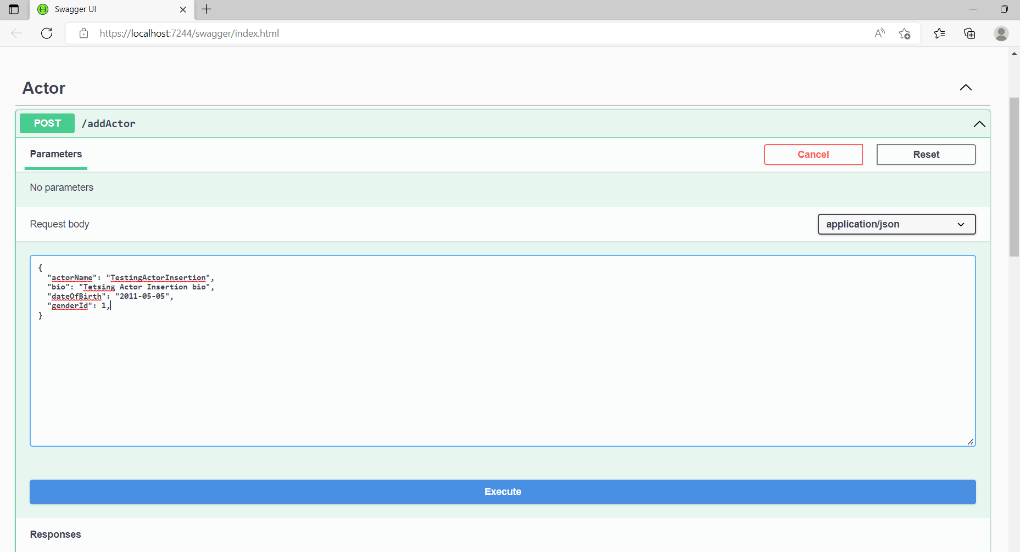  
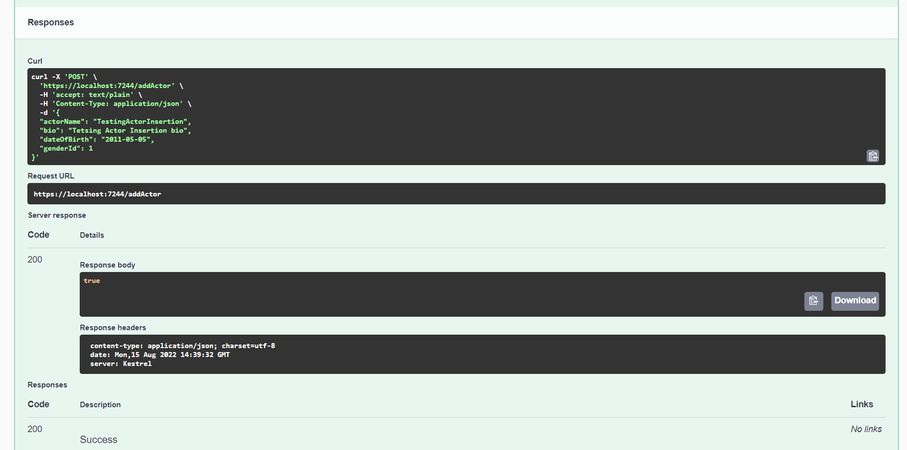  
  
  
  
  
2) Add Movie Api Call  
  
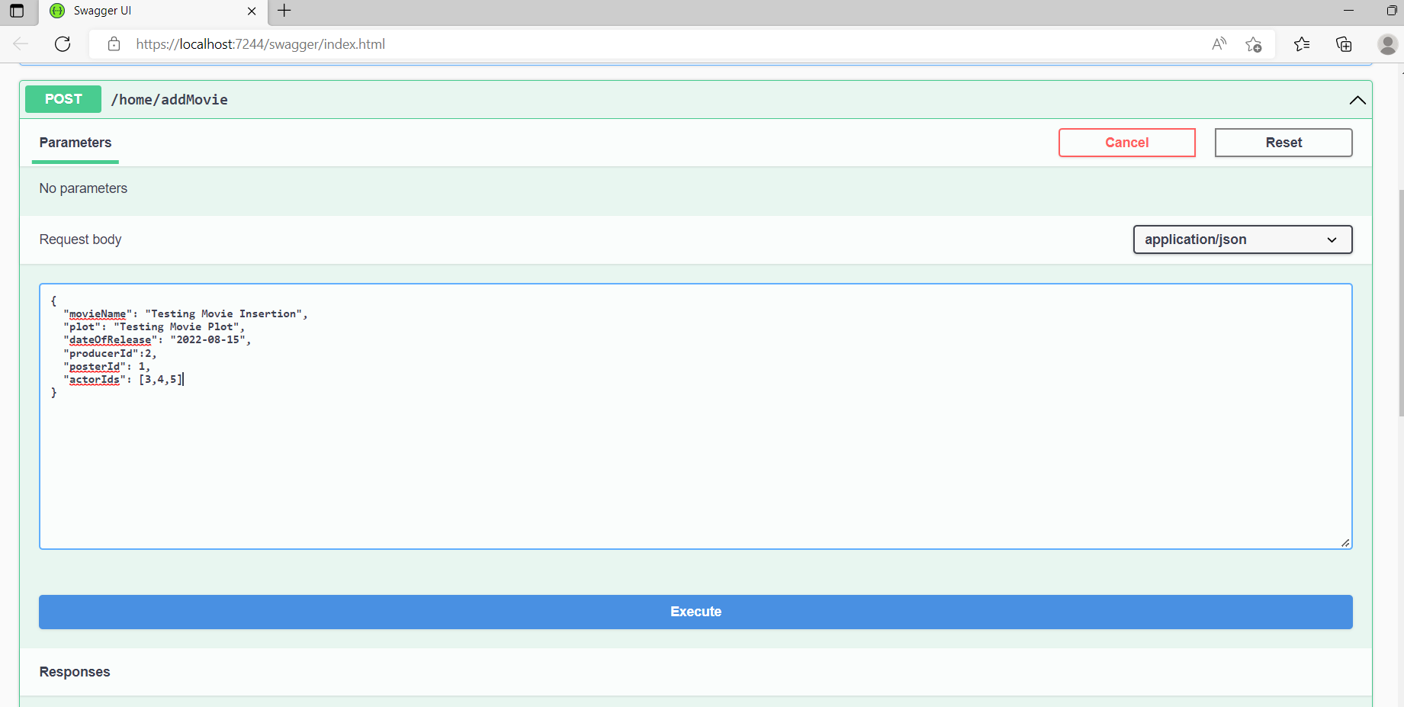  
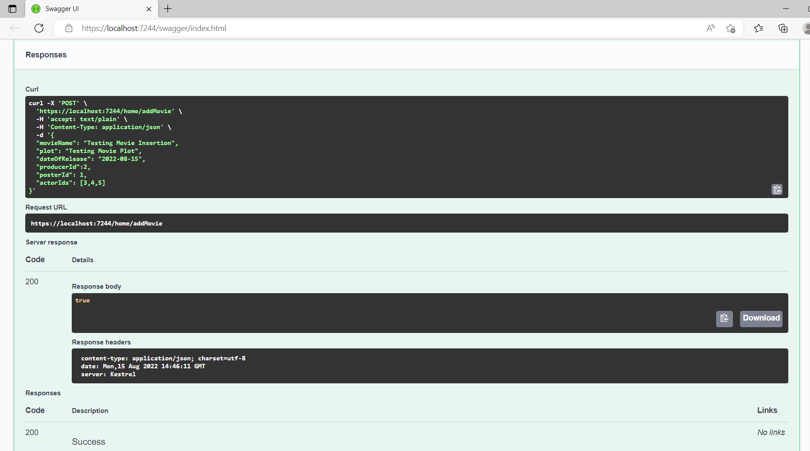  
  
  
3) Update Movie Api Call**

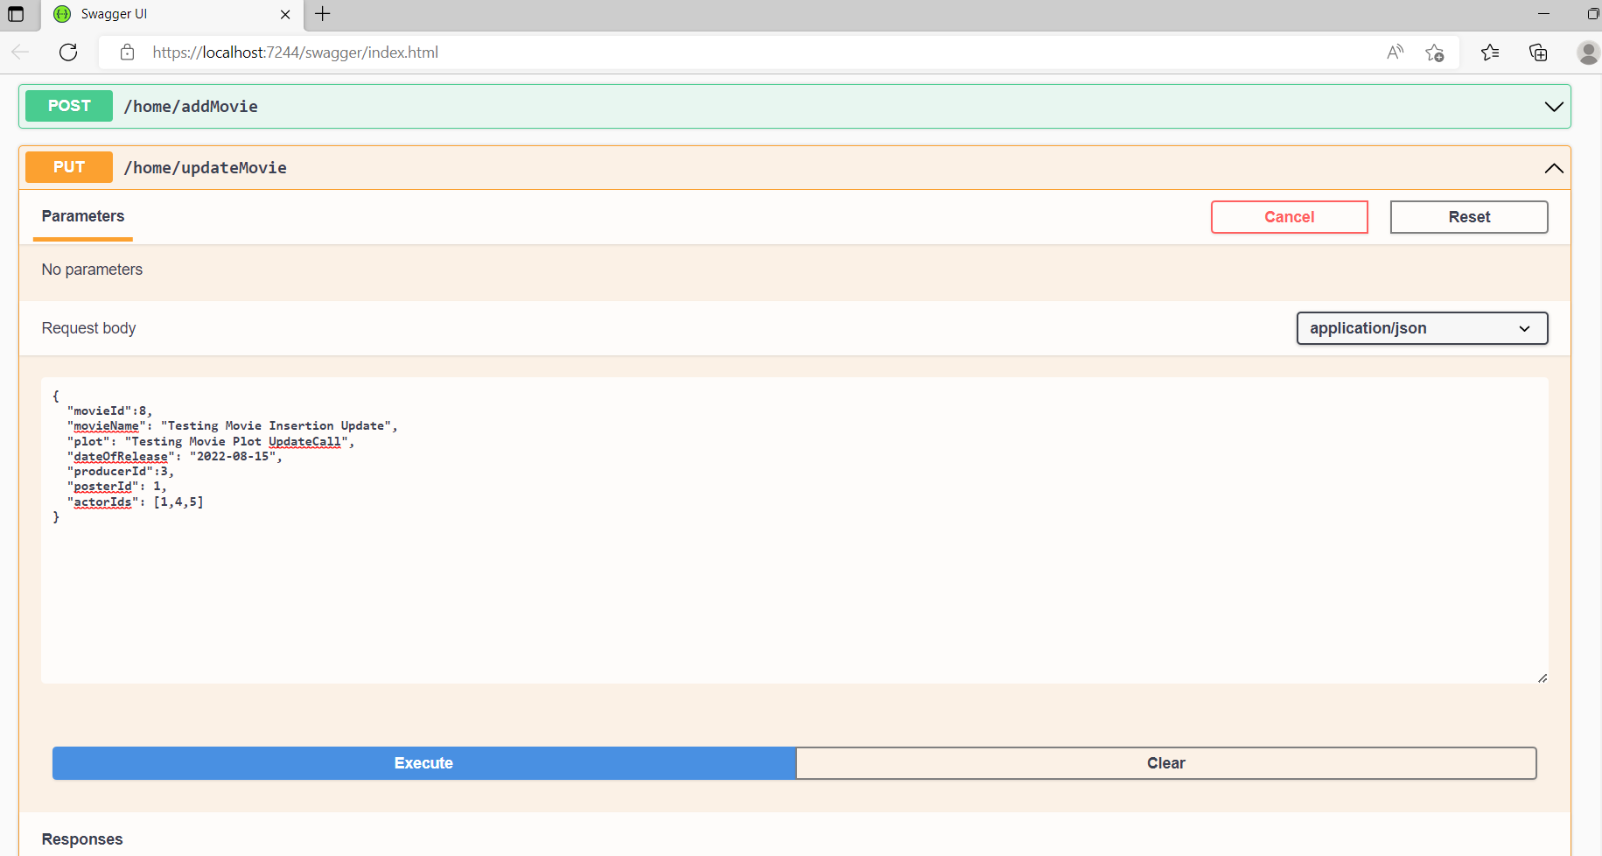  
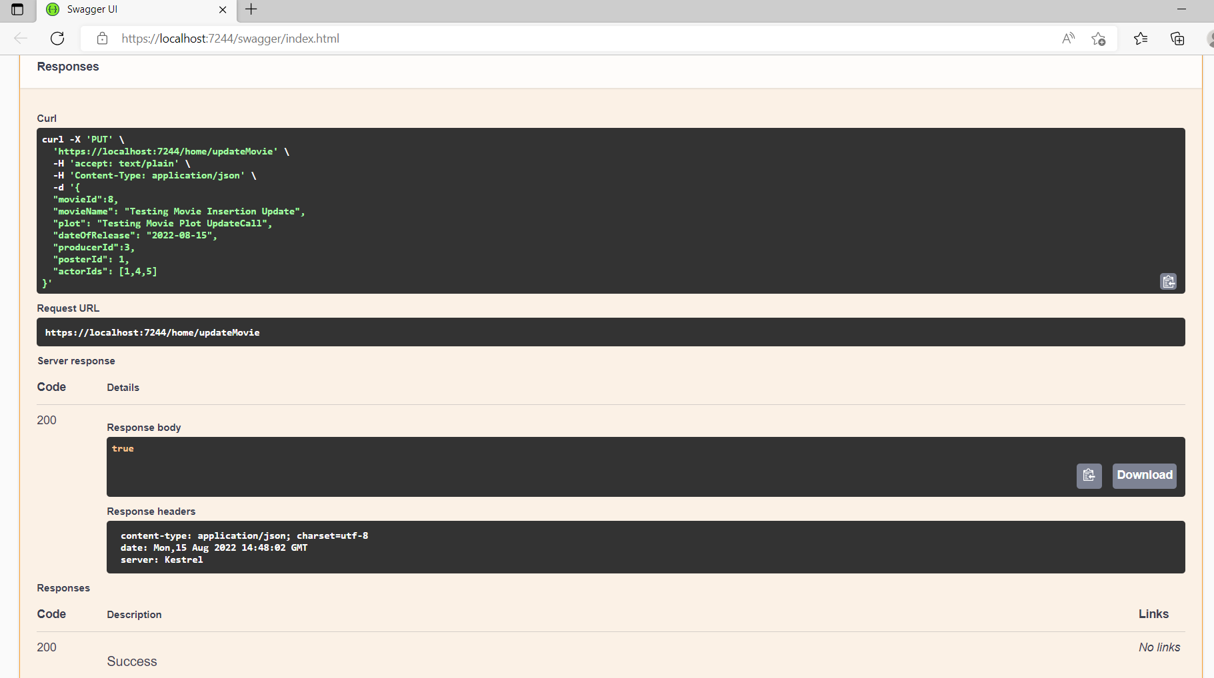  
  
**4) Add Producer Api Call**  
  
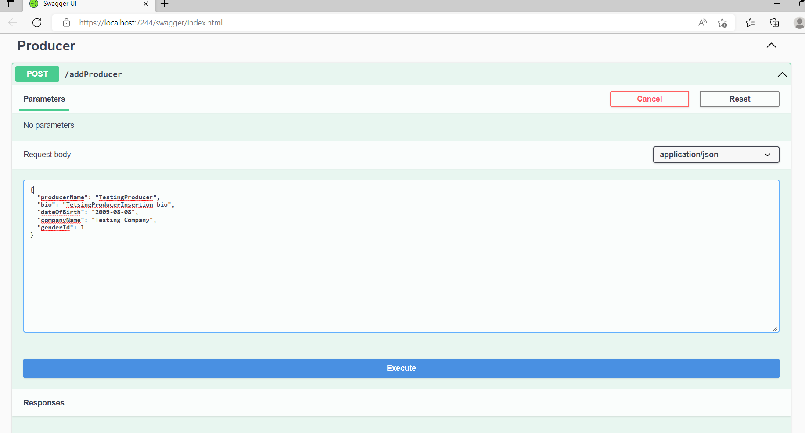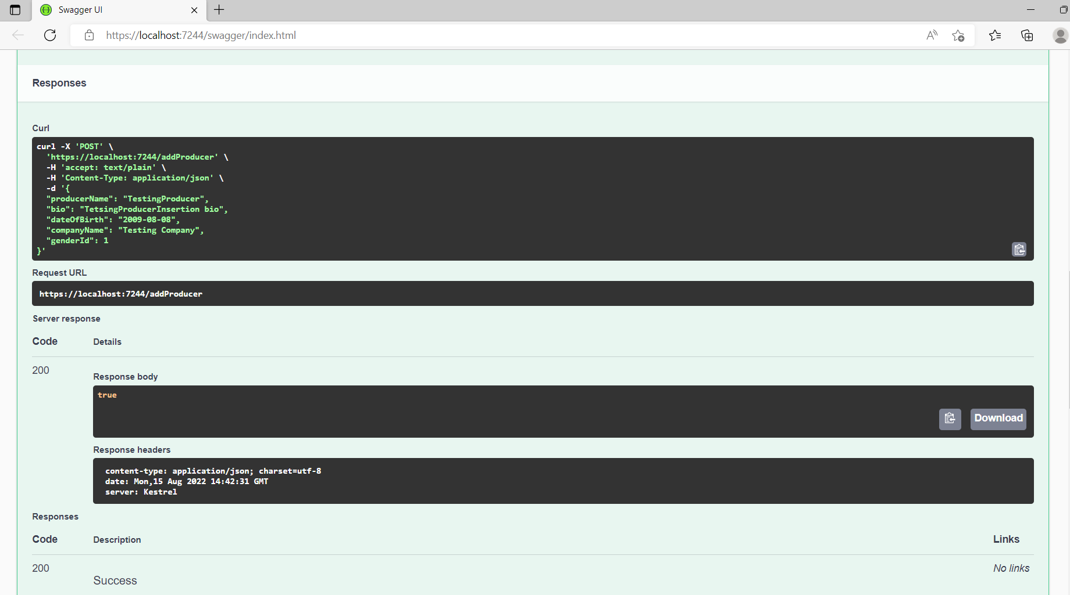

**5) Movie Home Page  
  
