### **WASTE MANAGEMENT SYSTEM**

#### **A PROJECT REPORT**

##### ***Submitted by***

**ABHISHT PRATAP SINGH (2115000041)**

**RAMESHWAR SINGH (2115000827)**

**YUGUL PRATAP SINGH (2115001177*)***

***SAKSHI SINGH (2115000898)***

***in partial fulfillment for the award of the degree of***

#### ***BACHELOR OF ENGINEERING***

**IN**

##### Computer Engineering and Application

**GLA University, Mathura**

DECEMBER 2023

#### **BONAFIDE CERTIFICATE**

This is to certify that this project report of **WASTE MANAGEMENT SYSTEM** is the combined Bonafide work of “ABHISHT PRATAP SINGH, RAMESHWAR SINGH, YUGUL PRATAP SINGH AND SAKSHI SINGH **”** who carried out the project work under my supervision.

|  |  |
| --- | --- |
|  |  |
| **SIGNATURE OF HOD**    **DR. ROHIT AGARWAL**    **HEAD OF THE DEPARTMENT**  Department of CEA | **SIGNATURE SUPERVISOR**    **Er. Sanjay Madaan**  **SUPERVISOR**  **ASSISTANT PROFESSOR**  Department of CEA |

Submitted for the project viva-voce examination held on

**INTERNAL EXAMINER EXTERNAL EXAMINER**

**ABSTRACT**

The “Waste Management System” mini project aims to develop a comprehensive solution for managing waste in urban areas. The system is designed to streamline the process of waste collection, segregation, transportation, processing, and disposal. It leverages technology to monitor and control waste management operations, ensuring efficiency and sustainability.

The project focuses on three key areas:

1. **Waste Collection**: The system uses smart bins equipped with sensors to monitor waste levels in real-time. This information is relayed to a central server, which schedules pick-ups based on the fill-level of the bins, optimizing collection routes and reducing operational costs.
2. **Waste Segregation and Processing**: The waste collected is segregated into different categories (organic, recyclable, non-recyclable) using automated sorting mechanisms. Organic waste is processed into compost, while recyclable materials are sent to recycling facilities. Non-recyclable waste is treated and disposed of in an environmentally friendly manner.
3. **Monitoring and Control**: The system includes a user-friendly dashboard that provides real-time updates on waste levels, collection schedules, and processing status. It also includes features for reporting issues and providing feedback, ensuring continuous improvement of the system.

The “Waste Management System” project is a step towards creating cleaner, healthier cities by effectively managing waste and promoting recycling and sustainability. It demonstrates how technology can be leveraged to solve real-world problems and contribute to environmental conservation.

#### 

**ACKNOWLEDGEMENT**

I take this occasion to thank God, almighty for blessing us with his grace and taking our endeavour to a successful culmination. I extend my sincere and heartfelt thanks to our esteemed guide, Er. Sanjay Madaan Sir, for providing me with the right guidance and advice at the crucial junctures and for showing me the right way.

I would like to thank the other faculty members also, at this occasion. Last but not the least, I would like to thank my friends and family for the support and encouragement they have given me during the course of our work.

#### **TABLE OF CONTENTS**

1. Introduction
   1. Identification of client and need
   2. Problem Identification
   3. Task Identification
   4. Timeline
   5. Organization of the report
2. Literature Survey

2.1 Timeline of the reported problem

2.2 Proposed solutions

2.3 Bibliometric analysis

2.4 Review Summary

2.5 Problem Definition

2.6 Goals / Objective

3. Design Flow

3.1 Evaluation & Selection of Specifications/Features

3.2 Design flow

3.3 Design Solution

3.4 Implementation plan/methodology

4. Results and Validation

4.1 Implementation of Solution

5. Conclusion

6. Future Work

#### 

#### **INTRODUCTION**

#### **1.1 Client Identification/Need Identification/Identification of relevant**

Contemporary society is grappling with a myriad of waste-related challenges, ranging from the sheer volume of waste generated to the environmental impact of improper disposal. The rise of smart cities and the integration of technology in various facets of life present an opportune moment to address these issues. This project seeks to align with the global movement towards sustainable practices, incorporating innovative solutions to tackle waste management in an increasingly digital world.

**1.2 Identification of Problem**

The existing waste management systems often suffer from inefficiencies, leading to environmental degradation and health hazards. Inefficient waste collection, lack of real-time monitoring, and inadequate public participation are among the key issues faced. This project aims to identify and rectify these problems through the implementation of an Online Waste Management System, fostering a more organized, responsive, and environmentally conscious approach**.**

**1.3 Identification of Tasks**

The primary tasks include the development of a user-friendly platform for waste management, integrating features such as real-time monitoring, waste categorization, and data analytics. Additionally, user engagement strategies will be employed to encourage active participation from the community. The system will be designed to facilitate seamless communication between stakeholders, including waste management authorities, service providers, and the general public**.**

**1.4 Timeline**

The project timeline has been carefully structured to ensure efficient development and implementation. In the First week we structured the things which we will learn during this project. In Second week we studied about Front End i.e HTML and CSS .In Third week we studied about back end i.e PHP . In fourth week we worked in this project

**1.5. Organization of the Report**

This report will be organized into comprehensive sections, beginning with an introduction and followed by a literature review, methodology, system design, implementation details, testing procedures, and concluding with recommendations for future enhancements. Each section will delve into specific aspects of the project, providing a holistic view of the Online Waste Management System and its potential impact on waste management practices.

As we embark on this journey, the Online Waste Management System project promises not only to address current challenges but also to pave the way for a more sustainable and technologically advanced approach to waste management.

**2. LITERATURE REVIEW/BACKGROUND STUDY**

##### **2.1. Timeline of the reported problem**

The story of our Online Waste Management System project is intricately woven into the evolving narrative of waste management challenges. Over the past decade, urban centers have experienced an unprecedented surge in population, leading to a proportional increase in waste generation. Traditional waste management systems, once deemed sufficient, have struggled to cope with this surge, resulting in inefficiencies, environmental degradation, and compromised public health. As the timeline unfolded, the urgency of addressing these challenges became apparent, necessitating a paradigm shift in waste management strategies.

**2.2 Proposed solutions**

Amid the escalating concerns, the idea of an Online Waste Management System emerged as a beacon of hope. The advent of smart technologies and the growing prevalence of digital solutions inspired our vision for a system that transcends the limitations of traditional waste management. By leveraging the power of connectivity, real-time monitoring, and data analytics, we sought to revolutionize how waste is managed, providing a comprehensive and sustainable solution to the contemporary problems plaguing our communities.

**2.3. Bibliometric analysis**

The journey toward our proposed solution was guided by an extensive bibliometric analysis, delving into the existing literature on waste management, smart city technologies, and digital solutions. This analysis not only informed our approach but also highlighted gaps in current research that our project endeavors to fill. The synthesis of knowledge from diverse sources served as the bedrock upon which the Online Waste Management System project stands.

**2.4. Review Summary**

A critical review of existing waste management systems underscored the need for a more integrated and technologically advanced solution. Common pitfalls, such as lack of real-time monitoring, inadequate community engagement, and the absence of data-driven decision-making, were identified. The review became a compass, guiding our project toward addressing these shortcomings and building a system that not only addresses current issues but also anticipates and adapts to future challenges.

##### **2.5. Problem Definition**

The heart of the matter lies in the inefficient and outdated waste management systems that fail to keep pace with the demands of modern urban living. The problem is not just about waste disposal but also encompasses the broader issues of environmental sustainability, public health, and community participation. Our project sets out to define and rectify these problems, providing a holistic solution that aligns with the dynamic nature of contemporary waste management challenges.

##### **2.6. Goals/Objectives**

The overarching goal of our Online Waste Management System project is to create a dynamic and responsive platform that transforms the landscape of waste management. Objectives include the development of a user-friendly interface, integration of real-time monitoring capabilities, fostering community engagement through innovative features, and providing actionable insights through data analytics. The project envisions not just a solution but a catalyst for positive change in how communities approach and manage their waste.

As we embark on this expedition, the Online Waste Management System project emerges not just as a response to a problem but as a testament to our commitment to crafting a sustainable and technologically advanced future for waste management. Through this report, we aim to share our journey, insights, and the potential impact of our solution on reshaping the narrative of waste management in the digital age.

**3**. **DESIGN FLOW/PROCESS**

**3.1** **Evaluation & Selection of Specifications/Features**

Conduct a comprehensive analysis of existing waste management systems and technologies. Identify key specifications and features based on user needs, technological feasibility, and sustainability goals.

**3.2. Design Flow**

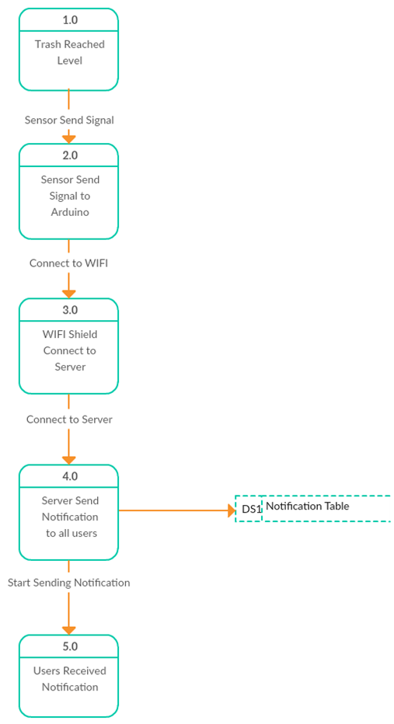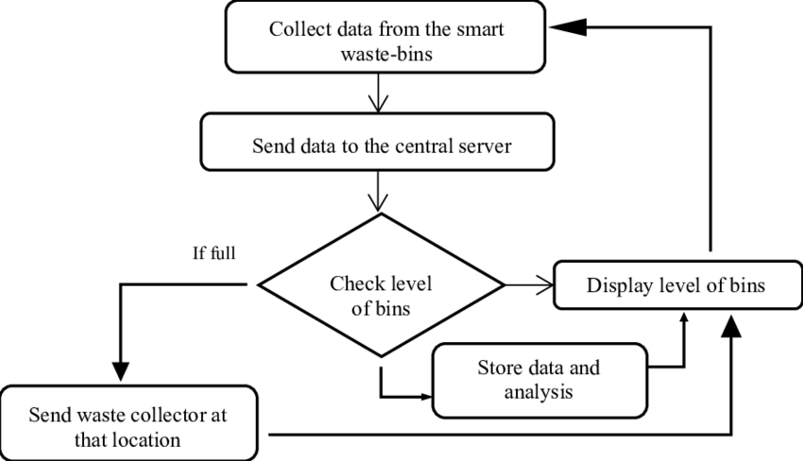.

##### 

##### **3.3. Design selection**

From the above designs we chose the second design as it is a modern way of doing the things and was more easy to design and work on practically.

##### **3.4.** **Implementation plan/methodology**

* User Interface:

Represents how users interact with the system through web browsers or mobile applications.

* Frontend Application:

Comprises HTML, CSS, JavaScript, and frontend frameworks.

Renders the user interface and manages user interactions.

* Web Server:

Handles HTTP requests and responses.

Serves static files and forwards dynamic requests to the application server.

* Application Server:

Contains business logic and processes user requests.

Coordinates with the database for data retrieval and updates.

* Database Management:

Stores and manages data related to users, complaints, waste management, etc.

* External Services:

Integrates with external services like Maps API for location services, notification services, etc.

**4 . RESULTS ANALYSIS AND VALIDATION**

##### **4.1.** Implementation of solution

##### 1. Head Section

##### • Meta tags for character set and viewport settings.

##### • Title of the web page.

##### • Favicon and Apple Touch Icon links.

##### • Google Fonts and vendor CSS files for styling.

##### 2. Body Section:

##### • Header with navigation links.

##### • Hero section with a call to action and a background image.

##### • Main content sections such as clients, about us, why us, skills, call to action, and FAQs.

##### • Footer with contact information, useful links, services, and social media links.

##### 3. JavaScript and External Libraries:

##### • AOS (Animate On Scroll) library for scroll animations.

##### • Bootstrap and Bootstrap icons for styling.

#### • Lightbox (glight box) for displaying images.

#### • Swiper library for sliders.

#### 4. Dynamic Content:

#### • The page includes dynamic content such as the waste management guidelines, implementation problems, and FAQ sections.

#### 5. Responsiveness:

#### • The page is designed to be responsive, ensuring a good user experience on various devices CONCLUSION AND FUTURE WORK

##### **5.1. Conclusion**

In conclusion, the presented HTML code represents a website for a Waste Management System (WMS). The website is well-structured with various sections catering to different aspects of waste management and related information. Key features include an informative homepage with a call to action, sections detailing the purpose and functionalities of the Waste Management System, an insightful exploration of the challenges in medical waste management, and a FAQ section addressing common queries about waste management practices.

The design is visually appealing, employing a clean and modern aesthetic. Navigation is made easy with a well-implemented menu structure, allowing users to seamlessly explore different sections of the website. The use of icons and images enhances the overall user experience and helps communicate information more effectively.

Moreover, the website incorporates responsive design elements, ensuring compatibility with various devices. It utilizes external libraries and frameworks such as Bootstrap, AOS, and Swiper, showcasing a commitment to industry best practices for web development.

The report on waste management challenges in medical facilities provides a valuable addition to the website, shedding light on the importance of proper waste disposal in healthcare settings. The FAQ section addresses common concerns and guides users on waste management practices at home and in the community.

In terms of functionality, the website includes features such as complaint submission, complaint preview for administrators, and a call to action for users to contact the municipality. The inclusion of social media links strengthens community engagement and awareness.

Overall, the HTML code for this Waste Management System website not only fulfills its functional objectives but also demonstrates a commitment to user experience and community education on effective waste management practices. It serves as a commendable platform for promoting environmental responsibility and sustainable waste management.

##### **5.2. Future work**

1. User Feedback and Analytics:

• Implement a feedback system for users to provide suggestions or report issues.

• Integrate analytics to track user interactions and gather insights into how users engage with the platform.

2. Mobile App Development:

• Consider developing a mobile application to make it more accessible for users on smartphones.

• Ensure that the app is available on both Android and iOS platforms.

3. Real-time Updates:

• Implement real-time updates for users to track the progress of their complaints or reports.

• Use push notifications to alert users about the status of their submitted issues.

4. Community Engagement:

• Create forums or discussion boards to engage the community in discussions related to waste management.

• Encourage users to share tips and ideas for better waste management practices.

5. Enhanced Reporting:

• Improve the reporting system with multimedia support, allowing users to attach images or videos to their complaints.

• Implement a map-based interface for users to pinpoint the exact location of an issue.

6. Integration with Social Media:

• Enable users to share their activities or contributions to waste management on social media platforms.

• Integrate social media APIs for easy sharing and promotion.

7. Education and Awareness:

• Develop a section or feature dedicated to waste management education.

• Include articles, videos, or infographics to educate users on the importance of waste management.

8. Gamification:

• Add gamification elements to encourage users to participate actively.

• Reward users with badges, points, or recognition for their contributions to waste management.

9. Partnerships:

• Collaborate with local businesses, NGOs, or government bodies to strengthen the waste management ecosystem.

• Explore partnerships for waste collection, recycling, or awareness campaigns.

10. Accessibility and Inclusivity:

• Ensure the platform is accessible to people with disabilities.

• Provide multilingual support to cater to a broader audience.

11. Security and Privacy:

• Regularly update and audit the security measures to protect user data.

• Clearly communicate the privacy policy to users and ensure compliance with data protection regulations.

12. Scalability:

• Design the system to handle a growing user base and an increasing volume of data.

• Consider serverless or cloud-based solutions for scalability.