ICC Cost Analysis Report: Corrected Sections
How to use this document. Each part below replaces the part of the same name in your Word report. The sections were rewritten because the original script predicted the wrong variable (V.1, project locality, instead of Y) and compared the result with a tolerance in the wrong units. Every number below comes from the corrected ICC-cost-analysis.R in the repository (seed 2, 247 training rows and 121 test rows after removing the blank row). Sections 1 (Introduction) and the figures/text for the histogram, boxplots, scatter and bar plots in §3 are unchanged unless listed here.

Corrections to 2. Data Understanding
Replace the statements in the left column with the text on the right. The units come from Data Descriptions.xlsx: V.2 and V.3 are in m², V.4 is in units of 10,000,000 IRR, V.5, V.6, V.8 and Y are in units of 10,000 IRR, and V.7 is in months.
Where | Replace | With
Data Structure | The data object is a data frame containing 369 rows and 9 variables. | The data frame has 369 rows and 9 variables. Row 369 is completely empty, so there are 368 usable projects.
Data Types | V.1 to V.7 and Y are integers. V.2, V.3, V.4, V.6, and V.8 seem to be numeric. | V.1, V.5, V.7, V.8 and Y are integers. V.2, V.3, V.4 and V.6 are numeric with decimals. V.1 is a category (a zip-code coded as 1 to 20), not a quantity.
Key Points | …workforce (V.7), and potentially costs (V.5). The target variable (Y) could be project completion time, budget, or some other outcome. | V.2 and V.3 are areas in m², V.4 to V.6 and V.8 are cost figures, and V.7 is the duration of construction in months. The target Y is the actual construction cost (the output), as defined in the data description.
V-4 to V-6 | V-4 has a wide range from 3.7 to 7,208.2 Iranian Rials. | V-4 is measured in units of 10,000,000 IRR and ranges from 3.7 to 7,208.2 units (about 37 million to 72 billion IRR). V-5 and V-6 are in units of 10,000 IRR.
V-8 | Prices per square meter range from 40 to 5,700 Iranian Rials, with a mean of approximately 1,081.88 Iranian Rials. | Prices per square meter range from 40 to 5,700 units of 10,000 IRR (400,000 to 57 million IRR per m²), with a mean of 1,081.88 units (about 10.8 million IRR per m²).
Y | Actual construction costs range from 20 to 900,000 Iranian Rials, with an average cost of approximately 228,790 Iranian Rials. | Actual construction costs range from 20 to 900 units of 10,000 IRR (200,000 to 9,000,000 IRR), with a mean of 228.79 units (about 2,287,900 IRR) and a median of 190 units (1,900,000 IRR).
Mean values | V-4: 302.21 Iranian Rials, V-5: 161.58 Iranian Rials, V-6: 552.82 Iranian Rials, Y: 228.79 Iranian Rials | Quote the unit: V-4 302.21 (units of 10,000,000 IRR), V-5 161.58, V-6 552.82 and Y 228.79 (units of 10,000 IRR), V-8 1,081.88 (units of 10,000 IRR per m²).

Replacement for the Correlation Analysis bullets
The correlation matrix (cor of V.1 to V.8 and Y, after removing the blank row) shows the following.
- Strong relationship with the target: V.5 (r = 0.973) and V.8 (r = 0.800) are very strongly related to the actual cost Y. This makes sense: V.5 is the preliminary estimated cost per unit and V.8 is the price per unit area, both set at the start of the project.
- Moderate relationship: V.4, the total preliminary estimated cost, has r = 0.580 with Y.
- Weak relationships (below 0.4): V.6 (0.298), V.2 floor area (0.200), V.7 duration (0.184) and V.3 lot area (0.136). Duration of construction (V.7) has weak correlations with most variables, so the duration, which ranges from 5 to 48 months, does not strongly drive cost on its own.
- Project locality (V.1): the correlation of −0.291 with Y should be treated with caution. V.1 is a zip-code category stored as a number, so its size has no meaning and a Pearson correlation is not a valid summary for it.
Potential multicollinearity. Three pairs of predictors have a correlation above 0.7: floor area V.2 with lot area V.3 (0.950), V.5 with V.8 (0.814), and V.2 with V.4 (0.718). These variables carry overlapping information, which makes individual coefficients unstable in ordinary regression. This is the reason ridge and lasso regression were chosen for the modelling.

Other corrections
- Figure 3 (histogram of V.2): the tallest bar is the first one, so most projects have a floor area below 2,000 m² (median 1,195 m²), not between 2,000 and 4,000. The units are m², not ft². The outlier near 15,670 m² is correct.
- Summary of Y: all costs in the original text should be quoted in units of 10,000 IRR, as shown in the table above.

3. Data Preparation (replace the outlier part and add the points below)

Data issues identified and how each was handled
Issue found | What was done | Why
One completely blank row (row 369), found with colSums(is.na(data)). | The row falls in the test set and is removed with na.omit(test) before the matrices are built. | It holds no information. Left in, it would give NA values in the predictions and metrics.
V.1 (project locality) is a category stored as a number. | V.1 is not used as a numeric predictor. | Its numeric size is meaningless. With 20 levels and only 368 rows, adding it as dummy variables would also add 19 sparse columns.
Predictors are on very different scales (V.2 in m², V.8 in 10,000 IRR). | The predictors are standardised with the training-set mean and standard deviation. | Ridge and lasso penalise all coefficients equally, which only works fairly if the predictors have the same scale.
Outliers in V.2 and V.4 (right-skewed variables). | Identified with the boxplot rule and the IQR rule, but kept in the training data. | See the decision below.

Outlier Removal (replacement text)
- The boxplot rule (boxplot.stats) flags 24 outliers in V.2 (floor areas from 4,040 to 15,670 m²) and 30 outliers in V.4 (values from 804 to 7,208.2 units of 10,000,000 IRR). In the original text the V.4 range was given as 720.8 to 2,668, which is incorrect.
- The IQR rule was applied to the training set only. The original code compared every column with the quartile limits of all the columns, which produced the 18 warnings mentioned in the earlier version. The corrected code compares each column with its own limits, produces no warnings, and flags 46 of the 247 training rows.
Decision. The flagged projects are genuine large projects, not data errors: the largest buildings simply have the largest costs. The company needs to estimate those projects too, and the test set contains them, so removing them from the training data would make the model less able to cost large projects. The outlier-free data (cleaned_data) is therefore used for exploration only. The models are trained on the full training set, and the test set is left untouched.

4. Modelling

Creating Predictor Matrix and Response Vector
- The data were partitioned once, with set.seed(2): 67% for training and cross-validation (247 rows) and the rest for the final test (122 rows, 121 after the blank row is removed). The test set was not used for any model choice.
- Response: y_train and y_test hold Y, the actual construction cost (not the first column, which is V.1).
- Predictors: x_train and x_test hold V.2, V.3, V.4, V.5, V.6, V.7 and V.8. Y is not a predictor, and V.1 is excluded as explained in section 3.

Excluding Variable V.3
A second predictor matrix without V.3 (lot area) was created by column name (x_train_excl_V3 and x_test_excl_V3). V.3 is highly correlated with V.2 (r = 0.95), so this tests whether it adds anything. The View function confirms that the intended column was removed.

Standardizing Predictor Variables
The training predictors are standardised with scale() so that each has mean 0 and standard deviation 1. The test predictors are then standardised with the training mean and standard deviation (the scaled:center and scaled:scale attributes of the training matrix). Standardising the test set with its own mean and standard deviation would use test-set information and shift its values, which is data leakage.

5. Building Training Model

Models Created
- Model 1 (ridge_model): ridge regression, alpha = 0, all seven predictors. standardize = FALSE because the data are already standardised.
- Model 2 (lasso_model): lasso regression, alpha = 1, all seven predictors. The lasso can set coefficients exactly to zero.
- Model 3 (ridge_model_excl_V3): ridge regression without V.3.
- Model 4 (ridge_model_lambda_min): ridge regression refitted at the single lambda.min found by cross-validation (cv_ridge_model_lambda_min).
- Model 5 (lasso_model_lambda.min): lasso regression refitted at the single lambda.min found by cross-validation (cv_lasso_model_lambda_min).
glmnet() fits a whole path of 100 lambda values and does not itself have a lambda.min. lambda.min is an output of cv.glmnet(), so Models 4 and 5 are fitted after the cross-validation step.

Examining Model Output
- dim(coef(ridge_model)) is 8 x 100: 8 rows (seven predictors plus the intercept) and 100 columns (one for each lambda value).
- As lambda increases, all coefficients shrink towards zero (Figure 13). The fully standardised ridge fit at lambda.min gives V.5 by far the largest coefficient (117.6), followed by V.8 (22.6), V.7 (18.2) and V.4 (18.1), while V.3 (−1.0) and V.6 (1.0) stay close to zero and V.2 is slightly negative (−8.6). V.5, the preliminary estimated cost per unit, is therefore the dominant variable, which agrees with its correlation of 0.973 with Y.
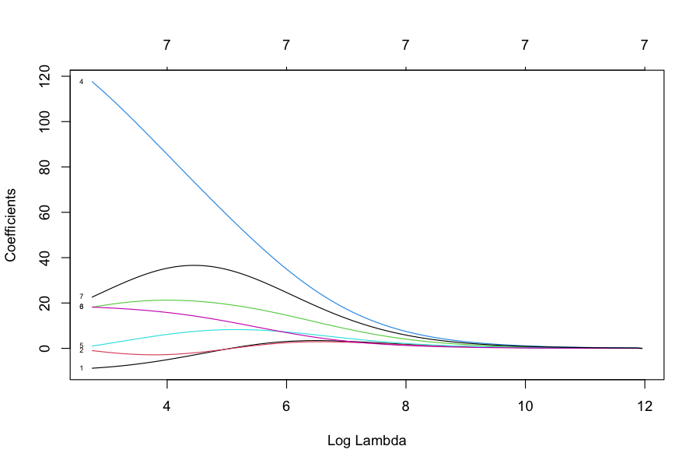
Figure 13. Coefficient change as a function of lambda (ridge, Model 1)

6. K-Fold Cross-Validation

Model Fitting with Cross-Validation
Five models were fitted with cv.glmnet using 5 folds on the training set only, with the seed fixed (set.seed(2)) so that the folds are reproducible:
- cv_ridge_model: ridge regression, alpha = 0 (Model 1).
- cv_lasso_model: lasso regression, alpha = 1 (Model 2).
- cv_ridge_model_excl_V3: ridge regression without V.3, alpha = 0 (Model 3).
- cv_ridge_model_lambda_min: ridge regression, alpha = 0, used at lambda.min (Model 4).
- cv_lasso_model_lambda_min: lasso regression, alpha = 1, used at lambda.min (Model 5).
Models 1 to 3 are scored at lambda.1se (the default choice of cv.glmnet: the largest lambda whose error is within one standard error of the minimum, giving a simpler model) and Models 4 and 5 at lambda.min (the lambda with the lowest cross-validated error). In the earlier version Model 1 and Model 3 used alpha = 1 and Model 2 and Model 5 used alpha = 0, so the ridge and lasso labels were reversed.
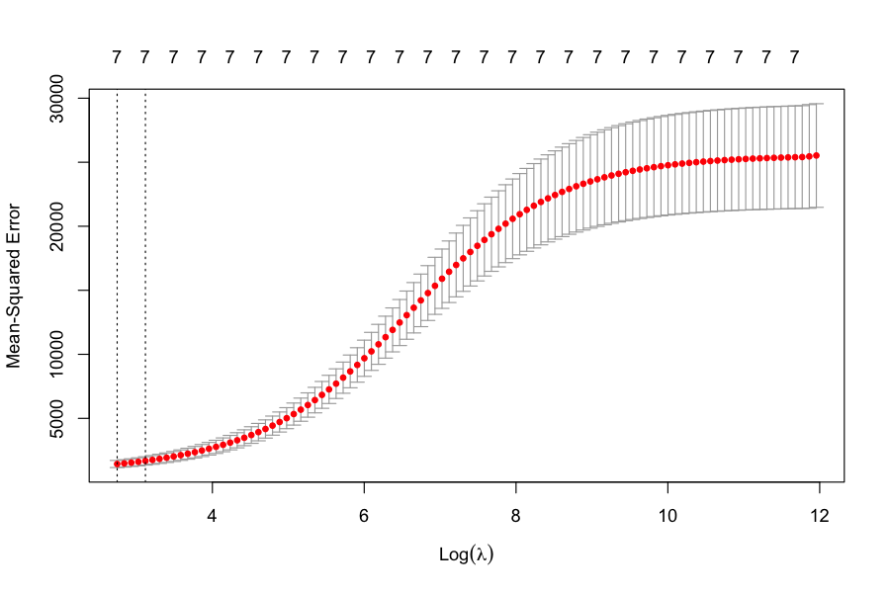
Figure 14. Model 1 ridge regression: cross-validated error against lambda
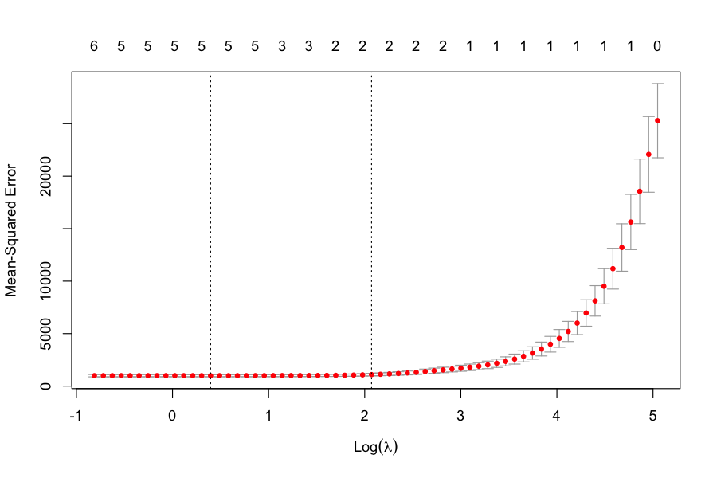
Figure 15. Model 2 lasso regression
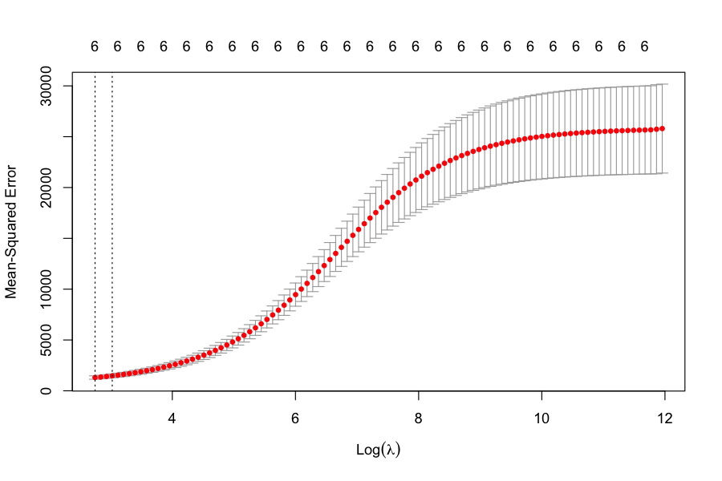
Figure 16. Model 3 ridge regression without V.3
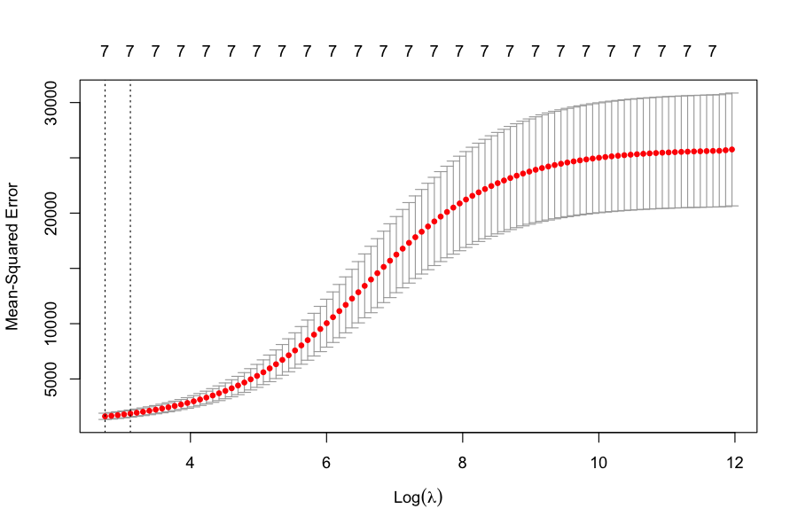
Figure 17. Model 4 ridge regression at lambda.min
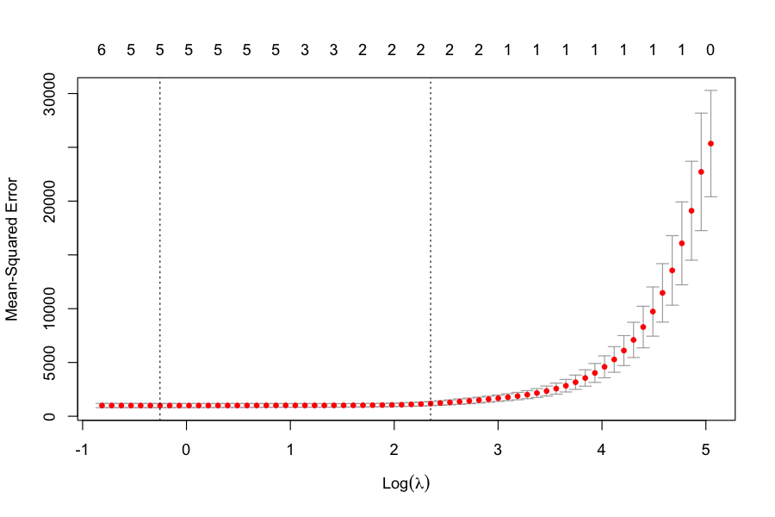
Figure 18. Model 5 lasso regression at lambda.min
Each plot has the usual shape: the error is highest on the left, where a large lambda shrinks the coefficients too much, and then flattens out as lambda gets smaller. The two dotted vertical lines mark lambda.min and lambda.1se.

Cross-validation results (training data)
Model | Lambda used | CV MSE | CV RMSE
1 Ridge | lambda.1se (22.59) | 1677.8 | 40.96
2 Lasso | lambda.1se (7.93) | 1092.7 | 33.06
3 Ridge excl. V.3 | lambda.1se (20.59) | 1470.7 | 38.35
4 Ridge, lambda min | lambda.min (15.57) | 1620.1 | 40.25
5 Lasso, lambda min | lambda.min (0.775) | 995.3 | 31.55

Observations.
- Lasso Lambda Min (Model 5) has the lowest cross-validated MSE (995.3, RMSE 31.55), so it was selected as the final model. Lasso at lambda.1se (RMSE 33.06) is close behind; the difference between these two is within the fold-to-fold variation of cross-validation, and both are clearly better than every ridge model (RMSE 38.4 to 41.0).
- Ridge models perform worse because ridge keeps all seven predictors and only shrinks them, while the lasso can drop the ones that add little once V.5 is known. Removing V.3 from the ridge model (Model 3) improves its error a little (38.35 against 40.96), which fits the high correlation between V.2 and V.3.
- Selected model coefficients (standardised predictors, Y in units of 10,000 IRR): intercept 232.04, V.5 = 153.70, V.7 = 17.89, V.6 = −4.32, V.4 = 2.73, V.8 = 0.73, with V.2 and V.3 set exactly to zero by the lasso. V.2 and V.3 are strongly correlated with each other (0.95) and only weakly related to Y (0.20 and 0.14), so they add nothing once V.5 is in the model.
- All of these errors are from the training data, so they are estimates of how well the models should do. The test set was not used to choose between models or lambda values.

7. Evaluation
Replace the previous Table 1 and the test results. The previous test MSE of 34.63 (RMSE 5.88) and the statement that 100% of predictions fall within the tolerance should be removed: the earlier model was predicting V.1 (project locality), and the predictions were constant (the vertical column in the old Figure 19), so those results did not describe construction cost at all.
Method | Performance | Notes
Ridge | CV RMSE: 40.96 | Cross-validated error at lambda.1se, training data
Lasso | CV RMSE: 33.06 | Cross-validated error at lambda.1se, training data
Ridge (Excl. V.3) | CV RMSE: 38.35 | Variable V.3 excluded, lambda.1se
Ridge (Lambda Min) | CV RMSE: 40.25 | Optimal lambda chosen by cross-validation
Lasso (Lambda Min) | CV RMSE: 31.55 | Optimal lambda chosen by cross-validation. Selected model
Lasso (Lambda Min), test set | RMSE: 31.27; MAE: 22.20; R²: 0.956 | 121 unseen projects, used once
Baseline: predict the training mean | RMSE: 149.2 | 121 test projects, for comparison
Table 1: Model Evaluation Results (Y in units of 10,000 IRR)

Test set performance
Measure | In units of Y (10,000 IRR) | In IRR
MSE | 977.83 | not applicable
RMSE | 31.27 | about 312,700 IRR
MAE (typical error) | 22.20 | about 222,000 IRR
R-squared | 0.956 | 95.6% of the variation in cost is explained
Predictions within +/- 500,000 IRR (+/- 50) | 109 of 121 (90.1%) | 95% interval 83.5% to 94.2%
Largest single error | 100.7 | about 1,007,000 IRR

The target of +/- 500,000 IRR equals +/- 50 in the units of Y, because Y is recorded in units of 10,000 IRR. The earlier check compared the error with 500,000 directly, so it was always satisfied. A model that simply predicted the training mean would give an RMSE of 149.2 and keep only 15.7% of predictions within the tolerance, so the lasso model is a large improvement.
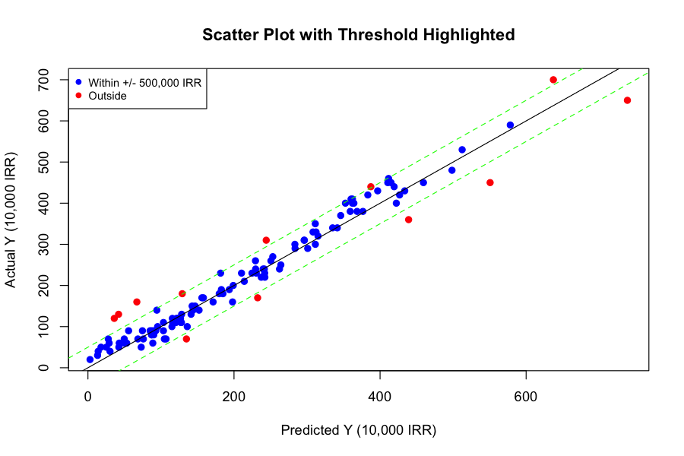
Figure 19a. Test set: predicted against actual cost, with the +/- 500,000 IRR band
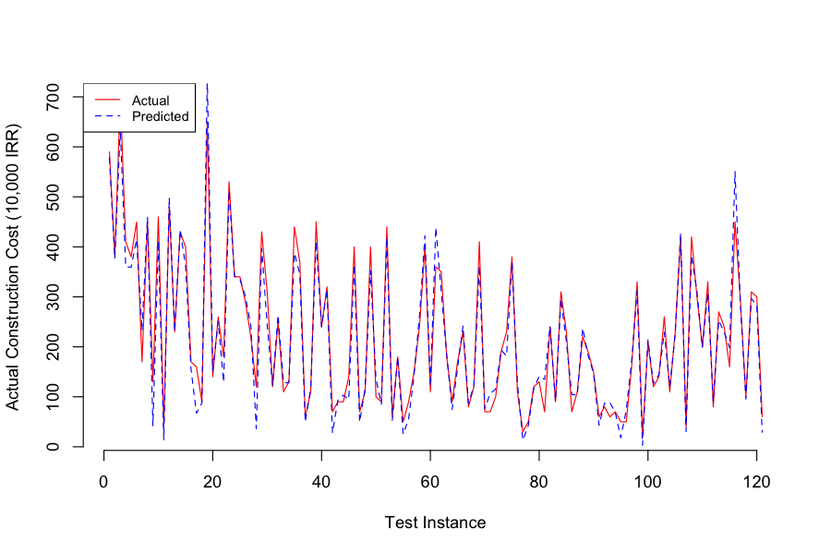
Figure 19b. Test set: actual and predicted cost for each test project
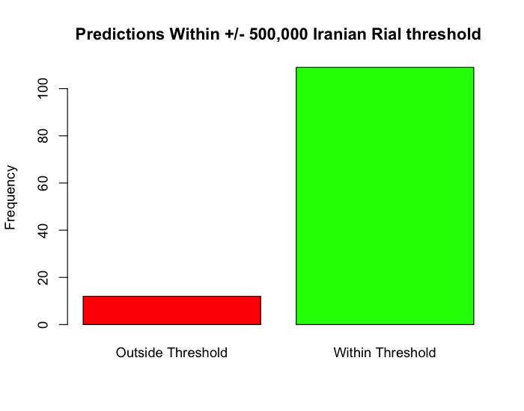
Figure 20. Predictions within and outside the +/- 500,000 IRR threshold

Final evaluation of model usefulness
- Where it works: about 9 in 10 estimates are within the +/- 500,000 IRR the company asked for, and the typical error (MAE) is about 222,000 IRR. For projects with an actual cost of 300 units (3 million IRR) or less, 92.9% of estimates are within tolerance (85 projects).
- Where it falls short: 12 of the 121 test projects (9.9%) are outside the tolerance, and the miss rate is higher for the larger projects: 16.7% of projects above 300 units are outside the tolerance (6 of 36), against 7.1% for projects up to 300 units (6 of 85).
- Conclusion: the model is useful as an early cost-estimating tool and clearly better than a simple average, but it does not yet meet the requirement for every project. It should be used with a warning that estimates for the largest projects can be off by more than 500,000 IRR (the largest error was about 1 million IRR).
- Limits of the result: the test set has 121 projects, and the 95% interval for the success rate is wide (83.5% to 94.2%). Also, the data come from one company and one split. More large projects, or a model on the log of the cost, would be the next steps to improve the larger estimates.
- Real-world factors: changes in material costs or labour rates after the preliminary estimate (V.5) was made are not in the data and would affect accuracy.

Appendix: Code (replace Appendix A with the following)
This is the full corrected ICC-cost-analysis.R.
# Libraries
library(glmnet) # This library contains the functions for training regularised linear regression models.
library(DescTools) # Descriptive statistics library.
library(ggplot2)

data <- read.csv("data.csv")

set.seed(2) # Setting random seed for random sample reproducibility

# Gathering training indices: 67% for training/cross-val, the rest for test.
train_indices <- sample(1:nrow(data), nrow(data) * 0.67, replace = FALSE)

# Now we'll partition the data as per the test design/plan.
train <- data[train_indices,]
test <- data[-train_indices,]

################## Data Understanding Code #####################
Str(data) # Display the structure of the data
View(data)
summary(data) # Summary statistics of the data
dim(data) # Dimensions of the data (rows and columns)
nrow(data) # Number of rows in the data
ncol(data) # Number of columns in the data

## DescTools::
# We've used Desc() to gather descriptive statistics and visualisations of data before.
Desc(data)

# Calculate the mean for each variable
mean_values <- sapply(data, mean, na.rm = TRUE)
print(mean_values)

# Calculate the median for each variable
median_values <- sapply(data, median, na.rm = TRUE)
print(median_values)

# Function to calculate mode
calculate_mode <- function(x) {
ux <- unique(x)
ux[which.max(tabulate(match(x, ux)))]
}

# Calculate the mode for each variable
mode_values <- sapply(data, calculate_mode)
print(mode_values)

# Calculate the range for each variable
range_values <- sapply(data, function(x) max(x, na.rm = TRUE) - min(x, na.rm = TRUE))
print(range_values)

# Calculate the variance for each variable
variance_values <- sapply(data, var, na.rm = TRUE)
print(variance_values)

# Calculate the standard deviation for each variable
std_dev_values <- sapply(data, sd, na.rm = TRUE)
print(std_dev_values)

# Count missing values for each variable
missing_values <- colSums(is.na(data))
print(missing_values)

# Identify rows with missing values
rows_with_missing <- which(rowSums(is.na(data)) > 0)
print(rows_with_missing)

# View the row with missing values
print(data[369, ])

# Remove the row with missing values
data <- data[-369, ]

### Correlation###
# Exploring associations using Pearson's correlation statistic
# is important if we might wish to explore the data using
# linear regression. cor(data) below facilitates calculations
# of correlation matrices based on input matrices or data
# frames.
train.corr <- cor(train)
print(train.corr)

ggcorrplot::ggcorrplot(train.corr) # Correlation heat map

# Faceted scatter plots of Total Floor Area (V.2) and Preliminary Estimated Construction Cost (V.4) by Project Locality (V.1)
ggplot(data, aes(x = V.2, y = V.4)) +
geom_point() +
facet_wrap(~V.1) +
labs(title = "Scatter Plots of V.2 vs V.4 by Project Locality", x = "Total Floor Area (m^2)", y = "Preliminary Estimated Construction Cost (IRR)")

# Correlation matrix
correlation_matrix <- cor(data[, c("V.1","V.2", "V.3", "V.4", "V.5", "V.6", "V.7", "V.8", "Y")], use = "complete.obs")
print(correlation_matrix)

# Identify potential multicollinearity (absolute correlation > 0.7)
col_to_check <- which(abs(correlation_matrix) > 0.7 & correlation_matrix != 1, arr.ind = TRUE)
if (any(col_to_check)) {
print(paste0("High correlation detected between: ", rownames(correlation_matrix)[col_to_check[, 1]], " and ",
rownames(correlation_matrix)[col_to_check[, 2]]))
# Further investigation needed to decide if variable removal or other techniques are necessary
} else {
print("No high correlations (> 0.7) detected among relevant variables.")
}

#################### Data Preparation Code ######################

library(tidyverse) # Streamlined data manipulation, visualization and analysis
library(caret) # Building, training, evaluating and tuning models

head(train, 4)
tail(train, 4)
class(train) # show the data type
str(train) # Checking the structure/format of the data.
summary(train)

train <- mutate_at(train, vars(V.1, V.5, V.7, V.8, Y), as.numeric) # convert total to numeric variable
str(train) # let`s check the data structure again

is.na(train) # classic way to check NA`s
sum(is.na(train)) # counting NA`s
apply(is.na(train),2, which) # which indexes of NA`s (df only)
which(complete.cases(train)) # identify observed complete values

train <- na.omit(train)

clean.vector <- na.omit(list(train)) # clean/remove a vector NA`s
clean.df <- na.omit(train) # clean/remove a dataframe NA`s
apply(is.na(clean.df),2, which) # make sure if there are missing values

any(is.na(clean.vector))

any(is.na(clean.df))

train %>% pull() %>% head() # extract column values of `state` as a vector
print(train)

#Histogram of a numerical variable
hist(train$V.2,
main = "Histogram of V.2 (Total Floor Area)",
xlab = "Total Floor Area (m^2)", ylab = "Frequency",
col = "skyblue", border = "black")
abline(v = mean(train$V.2),
col = "red",
lwd = 2) # Add a vertical line for the mean
legend("topright",
legend = paste("Mean:",
round(mean(train$V.2), 2)),
col = "red",
lwd = 2) # Add a legend for the mean

#Boxplot of a numerical variable to identify outliers
boxplot(train$V.4, train$V.2,
main = "Boxplot of Preliminary Estimated Construction Cost (IRR)",
xlab = "Variable V.4",
ylab = "Construction Cost (IRR)",
col = "skyblue", # Customize colors
border = "black",
notch = TRUE, # Add a notch
pch = 19, # Adjust outlier symbol
horizontal = FALSE, # Horizontal orientation
grid = TRUE # Add grid lines
)
boxplot(train$V.2,
main = "Boxplot of Preliminary Estimated Construction Cost (IRR)",
xlab = "Variable V.4",
ylab = "Construction Cost (IRR)",
col = "skyblue", # Customize colors
border = "black",
notch = TRUE, # Add a notch
pch = 19, # Adjust outlier symbol
horizontal = FALSE, # Horizontal orientation
grid = TRUE # Add grid lines
)
# scatter plot
plot(train$V.2, train$V.4,
main = "Scatter Plot: Total Floor Area vs Preliminary Estimated Construction Cost",
xlab = "Total Floor Area (m^2)",
ylab = "Preliminary Estimated Construction Cost (IRR)",
col = "blue",
pch = 19)

#bar plot
barplot(table(train$V.1),
main = "Bar Plot of Project Locality",
xlab = "Project Locality",
ylab = "Frequency",
col = "skyblue")

# Time series plot of Actual Construction Costs (Y) over time (V.7)
plot(train$V.7, train$Y,
type = "l",
main = "Line Plot: Duration of Construction vs Actual Construction Costs",
xlab = "Duration of Construction (Months)",
ylab = "Actual Construction Costs (IRR)",
col = "red")

# heatmap
heatmap(cor(train[, c("V.1","V.2", "V.3", "V.4", "V.5", "V.6", "V.7", "V.8", "Y")]),
main = "Correlation Heatmap",
xlab = "Variables",
ylab = "Variables")

# Example density plot
plot(density(train$V.8),
main = "Density Plot of Price per Unit Area",
xlab = "Price per Unit Area (IRR)",
col = "blue")

pairs(train[, c("V.2", "V.3", "V.4", "V.5", "V.6", "V.7", "V.8", "Y")])

heatmap(cor(train[, c("V.2", "V.3", "V.4", "Y")]),
main = "Correlation Heatmap (Subset of Variables)",
xlab = "Variables",
ylab = "Variables")

#### Handling of the outliers########
#by examining each variable by boxplot, I have found outliers in 2 variables i.e. V.2 and V.4

# Boxplot before removing outliers
par(mfrow=c(1, 2))
boxplot(data$V.2, main="Boxplot of V.2 (Before)")
boxplot(data$V.4, main="Boxplot of V.4 (Before)")

# Identify outliers for V.2 and V.4 variables
outliers_V2 <- boxplot.stats(data$V.2)$out
outliers_V4 <- boxplot.stats(data$V.4)$out

# Remove outliers from the dataset
cleaned_data <- data[!(data$V.2 %in% outliers_V2 | data$V.4 %in% outliers_V4), ]

# Boxplot after removing outliers
par(mfrow=c(1, 2))
boxplot(cleaned_data$V.2, main="Boxplot of V.2 (After)")
boxplot(cleaned_data$V.4, main="Boxplot of V.4 (After)")

# Summary of removed outliers
cat("Outliers removed from V.2:", outliers_V2, "\n")
cat("Outliers removed from V.4:", outliers_V4, "\n")

# Remove rows with NA values
cleaned_data <- na.omit(cleaned_data)

# Summary of cleaned dataset
cat("Summary of cleaned dataset:\n")
summary(cleaned_data)

### IQR Method - to identify & handle outliers ###

# The IQR is used to identify and deal with outliers. It is a measure of
# the spread of the data values. It is a reliable measure of
# dispersion because it is not affected by extreme values of outliers.
#
# In the IQR method a range is defined by using first and third quartile and a
# multiplier which is usually set as 1.5. All the values below the lower
# limit and above the upper limit are considered as outliers.

# Calculate IQR for each variable
Q1 <- apply(train, 2, quantile, probs = 0.25)
Q3 <- apply(train, 2, quantile, probs = 0.75)
IQR <- Q3 - Q1

# Each column is compared with its OWN limits (Q1, Q3 and IQR hold one value per column)
outliers <- sapply(names(train), function(v) train[[v]] < (Q1[v] - 1.5 * IQR[v]) | train[[v]] > (Q3[v] + 1.5 * IQR[v]))

cleaned_data <- train
cleaned_data[outliers] <- NA
cleaned_data <- na.omit(cleaned_data)

summary(cleaned_data)

# cleaned_data is for exploration only. The outliers are genuine large projects, not
# data errors, so the models below are trained on the full training set (train).

################## Modelling Code ###################

# Create Predictor matrix & Response vector for both train & test set
# The response is Y (actual construction cost). Y is not a predictor, and V.1
# (project locality, a zip-code category) is not used as a numeric predictor.
predictors <- c("V.2", "V.3", "V.4", "V.5", "V.6", "V.7", "V.8")

test <- na.omit(test) # the blank row is in the test set, remove it before building the matrices

x_train <- as.matrix(train[ , predictors]) # predictor matrix for the training set.
y_train <- train$Y # response vector for the training set.

x_test <- as.matrix(test[ , predictors]) # predictor matrix for the test set.
y_test <- test$Y # response vector for the test set.

# Excluding variables V.1 and V.3 from the model and adding predictor matrix
# in the training & test set

x_train_excl_V3 <- as.matrix(x_train[ , colnames(x_train) != "V.3"])
View(x_train_excl_V3) # checking the correct variable has been removed
x_test_excl_V3 <- x_test[ , colnames(x_test) != "V.3"]
View(x_test_excl_V3) # checking the correct variable has been removed

# a matrix is a two-dimensionsal collection of elements of the same data type
# (numeric, character, or logical) arranged into a fixed number of rows and columns.

## Standardizing the predictor variables ##

# Standardizing the predictor variables to have mean
# zero and unit variance. This is important for ridge regression
# because it ensures that the penalty term is applied equally to
# all the coefficients. Using scale function to do this.

x_train <- scale(x_train) # standardize the training predictors
# standardize the test predictors with the TRAINING mean and sd, so no test set information is used
x_test <- scale(x_test, center = attr(x_train, "scaled:center"), scale = attr(x_train, "scaled:scale"))

x_train_excl_V3 <- scale(x_train_excl_V3)
x_test_excl_V3 <- scale(x_test_excl_V3, center = attr(x_train_excl_V3, "scaled:center"), scale = attr(x_train_excl_V3, "scaled:scale"))

##### Build Training Model - Cross Validation using Ridge Regression ####

# To perform ridge regression, I’ll use functions from the glmnet package.

# I’ll use the glmnet() function to fit the ridge regression model
# and specify alpha=0 to select Ridge Regression

# Setting alpha equal to 1 is equivalent to using Lasso Regression and
# setting alpha to some value between 0 and 1 is equivalent to using an elastic net.

# I’ll use the default values of alpha and lambda and
# let the function choose the optimal values for us.

# Alpha = 0 corresponds to ridge regression,
# Alpha = 1 corresponds to lasso regression and
# 0 < alpha < 1 corresponds to elastic net regression,
# a combination of ridge and lasso.

# Ideally, producing multiple models and based on the lowest mean squared
# error and decide on the final model for implementation.

## Fitting the ridge regression model ##

# Model 1 for ridge regression
ridge_model <- glmnet(x_train, y_train, alpha = 0, standardize = FALSE)

# Model 2 for Lasso regression
lasso_model <- glmnet(x_train, y_train, alpha = 1, standardize = FALSE)

# Model 3 removing variable 3
ridge_model_excl_V3 <- glmnet(x_train_excl_V3, y_train, alpha = 0, standardize = FALSE)

# (The predictor value/ input features will need to be amended to exclude V3 in this example)

# Models 4 and 5 (ridge / lasso at lambda_min) are fitted after the cross-validation below,
# because lambda.min is an output of cv.glmnet(), glmnet() itself does not have one.

# Note that by default, the glmnet() function standardizes the
# variables so that they are on the same scale. To turn off this default setting,
# use the argument standardize=FALSE.

# View summary model which will show the length, class, mode, and dimensions of the elements.
summary(ridge_model)

# The corresponding values of lambda, beta, df, dev. ratio, and a0.
# The beta element is a sparse matrix, which means that it only stores
# the non-zero values of the coefficients.
# The df element is the degrees of freedom, the number of non-zero coefficients.
# The dev.ratio element is the fraction of deviance the model explains.
# The a0 element is the intercept term.

# Associated with each value of λ is a vector of ridge regression coefficients,
# stored in a matrix that can be accessed by coef()
# coef(model)

# To check the coefficients using the dim()
dim(coef(ridge_model))

ridge_model

# Associated with each value of λ is a vector of ridge regression coefficients,
# stored in a matrix that can be accessed by coef(). In this case, it is a
# 5X100 matrix, with 5 rows (one for each predictor, plus an intercept) and
# 100 columns (one for each value of lambda).

ridge_model$lambda[20]

coef(ridge_model) [ , 20]

# Plotting the model object using plot function, shows coef change as a func of lambda

plot(ridge_model, xvar = "lambda", label = TRUE)# plot the coefficients vs lambda

# The x-axis is on a log scale (Log Lambda), so the smaller lambda
# values are on the right, and the larger values are on the left.

# The y-axis shows the values of the coefficients, and each line
# corresponds to a different predictor variable.

# In this example, when lambda log is 8, the coefficients are essentially zero.
# When we relax lambda the coefficients grow away from zero in a smooth way.
# The sum of squares of the coefficients are getting bigger and bigger until
# we reach a point where Lambda is effectively zero & the coefficients
# are regularized & so these would be the coefficients that you get from an
# ordinary least squares fit of these variables.

### Perform k-fold cross-validation to find optimal lambda value ###

# Next, we’ll identify the lambda value that produces the
# lowest test mean squared error (MSE) by using k-fold
# cross-validation a technique that splits the data into
# several subsets and uses some for training and some for testing.

# glmnet has the function cv.glmnet() that automatically
# performs k-fold cross validation. A fold is a subset of the
# data used for testing, while the rest is used for training.
# The default value is 10, meaning the data is split into 10 subsets,
# and each subset is used as a test set once.

set.seed(2) # the folds are random, so fix the seed to make the cross-validation results reproducible

# Model 1 - Ridge Regression cross validation
cv_ridge_model <- cv.glmnet(x_train, y_train, alpha = 0, nfolds = 5)
# Performs 5 fold cross validation on ridge model (alpha = 0)

# Model 2 - Lasso Regression cross validation
cv_lasso_model <- cv.glmnet(x_train, y_train, alpha = 1, nfolds = 5)
# Performs 5 fold cross validation on lasso model (alpha = 1)

# Model 3 - Ridge Regression with variable 3 excluded
cv_ridge_model_excl_V3 <- cv.glmnet(x_train_excl_V3, y_train, alpha = 0, nfolds = 5)

# Model 4 - Ridge Regression with lambda.min
cv_ridge_model_lambda_min <- cv.glmnet(x_train, y_train, alpha = 0, nfolds = 5)
ridge_model_lambda_min <- glmnet(x_train, y_train, alpha = 0, lambda = cv_ridge_model_lambda_min$lambda.min, standardize = FALSE)

# Model 5 - Lasso Regression with lambda.min
cv_lasso_model_lambda_min <- cv.glmnet(x_train, y_train, alpha = 1, nfolds = 5)
lasso_model_lambda.min <- glmnet(x_train, y_train, alpha = 1, lambda = cv_lasso_model_lambda_min$lambda.min, standardize = FALSE)

summary(cv_ridge_model)
summary(ridge_model_lambda_min)

# The cvm element is the mean cross-validated error for each value of lambda.

# The cvsd element is the standard deviation of the cross-validated error for
# each lambda value.

# The cvup and cvlo elements are the upper and lower confidence bounds
# for the cross-validated error for each lambda value.

# The nzero element is the number of non-zero coefficients for each value of lambda.

# The lambda.min element is the value of lambda that gives the minimum
# cross-validated error.

# The lambda.1se element is the largest value of lambda, giving a
# cross-validated error within one standard error of the minimum.

## plotting the cv_model object using the plot function ##

# Shows the cross-validated error changes as a function of lambda.

# The x-axis is on a log scale, so the smaller lambda values are on
# the right, and the larger values are on the left.

# The y-axis shows the values of the cross-validated error, and the
# error bars show the confidence bounds.

# The vertical dotted lines indicate the values of lambda that give
# the minimum cross-validated error and the largest error within
# one standard error of the minimum.

plot(cv_ridge_model) # plot the cross-validated error vs lambda

# This is a plot of the cross validated MSE and from the right hand side
# it dips downs. In the beginning the MSE is very high and the coefficients
# are restricted to be too small and then it starts to level off.
# This indicates that the full model is doing a good job.

# There are two vertical lines:
# The first one indicates the min. MSE.
# The second indicates the one standard error of the min. MSE.
# This is a more restricted model that can do as well as the min. MSE and
# we can decide to use this value instead of the min. MSE.

plot(cv_lasso_model) # Model 2 Lasso Regression
plot(cv_ridge_model_excl_V3) # Model 3 Ridge Regression with V3 removed
plot(cv_ridge_model_lambda_min) # Model 4 Ridge regression with lambda min.
plot(cv_lasso_model_lambda_min) # Model 5 Lasso regression with lambda min.

### This will show the results of the best results from each model. ###

cv_ridge_model
cv_lasso_model
cv_ridge_model_excl_V3
cv_ridge_model_lambda_min
cv_lasso_model_lambda_min

# This will pick the coefficient corresponding to the best model.
coef(cv_ridge_model)
coef(cv_lasso_model_lambda_min)
coef(ridge_model_lambda_min)

#### Let's store the validation results! They will be useful to compare against the test set results.
# Models 1-3 use the default choice of lambda of cv.glmnet (lambda.1se),
# Models 4 and 5 use lambda.min, so each row is a different model/lambda combination.
cv_mse_1se <- function(cv) cv$cvm[cv$lambda == cv$lambda.1se]

# Model 1 Ridge model MSE & RMSE
cross_validation_ridge_MSE <- cv_mse_1se(cv_ridge_model)
cross_validation_ridge_RMSE <- sqrt(cross_validation_ridge_MSE)

# Model 2 Lasso model MSE & RMSE
cross_validation_lasso_MSE <- cv_mse_1se(cv_lasso_model)
cross_validation_lasso_RMSE <- sqrt(cross_validation_lasso_MSE)

# Model 3 Ridge model excluding Var. 3 MSE & RMSE
cross_validation_ridge_excl_V3_MSE <- cv_mse_1se(cv_ridge_model_excl_V3)
cross_validation_ridge_excl_V3_RMSE <- sqrt(cross_validation_ridge_excl_V3_MSE)

# Model 4 Ridge model with lambda min. MSE & RMSE
cross_validation_ridge_lambda_min <- min(cv_ridge_model_lambda_min$cvm)
cross_validation_ridge_lambda_min_RMSE <- sqrt(cross_validation_ridge_lambda_min) # The square root of the MSE of the ridge regression model excl V3

# Model 5 Lasso model with lambda min.
cross_validation_lasso_lambda_min <- min(cv_lasso_model_lambda_min$cvm)
cross_validation_lasso_lambda_min_RMSE <- sqrt(cross_validation_lasso_lambda_min) # The square root of the MSE of the ridge regression model excl V3

# Create a data frame to store the MSE and RMSE values
model_comparison <- data.frame(
Model = c("Ridge", "Lasso", "Ridge Excl. V3", "Ridge Lambda Min", "Lasso Lambda Min"),
MSE = c(cross_validation_ridge_MSE, cross_validation_lasso_MSE, cross_validation_ridge_excl_V3_MSE, cross_validation_ridge_lambda_min, cross_validation_lasso_lambda_min),
RMSE = c(cross_validation_ridge_RMSE, cross_validation_lasso_RMSE, cross_validation_ridge_excl_V3_RMSE, cross_validation_ridge_lambda_min_RMSE, cross_validation_lasso_lambda_min_RMSE)
)

# Print the data frame
print(model_comparison)

# min() can be used to get the smallest MSE from the evaluated lambda values.
# The square root of the MSE of the ridge regression model

### Find optimal lambda value that minimizes test MSE ###

# From the above results we can see the Lasso Lamda Min has produced the lowest MSE.
# (Lasso is clearly better than ridge, the Lasso and Lasso Lambda Min rows differ by
# less than the fold-to-fold noise of cross-validation.)
# Model MSE RMSE
# 1 Ridge 1677.7765 40.96067
# 2 Lasso 1092.7348 33.05654
# 3 Ridge Excl. V3 1470.7228 38.35000
# 4 Ridge Lambda Min 1620.1191 40.25070
# 5 Lasso Lambda Min 995.2982 31.54835

# I've selected the optimal value of lambda, it's time for me
# to assess the performance of the lasso regression model on the test set.

# I'll utilize the predict function to generate predictions of the response variable f
# or the test set, employing the lasso regression model with the chosen lambda value.

# Next, I'll compare these predicted values with the actual values and compute
# various metrics to gauge the accuracy of the predictions,
# including Mean Squared Error (MSE),
# Root Mean Squared Error (RMSE), and the
# coefficient of determination (R-squared).
# Using the predict function,

# I'll generate the predicted values for the test set using prediction func;

### To determine the optimal lambda value that minimizes cross-validated error, element.
# Lower values of lambda indicate stronger regularization,
# while higher values indicate weaker regularization
cv_lasso_model_lambda_min$lambda.min

#################### Final Evaluation ####################

test <- na.omit(test) # Remove NA value from test set
anyNA(test) # If there are any missing values in the test set they will need to be handled.

# The test set predictor matrix has already been created, and scaled with the
# training mean and sd, earlier.

is.infinite(x_test)
is.infinite(y_test)

head(x_test)
head(y_test)

# Check if the test set is scaled similarly to the training set
summary(x_test)

# Make test set predictions.
predictions <- predict(lasso_model_lambda.min, s = lasso_model_lambda.min$lambda, newx = x_test)

summary(predictions) # Verify the prediction process

# Finally, let's evaluate how well (or poorly) we have done on the test set.

test_MSE <- MSE(predictions, y_test)
test_RMSE <- RMSE(predictions, y_test)

test_MSE
test_RMSE

# The model holds a single lambda, the one chosen by cross-validation on the training
# set (lambda.min). It is not chosen using the test set.

lam.best <- min(lasso_model_lambda.min$lambda)
lam.best

coef(lasso_model_lambda.min, s = lam.best)

############## Plot of test set predictions vs actual values ######################

# Check that the lengths are the same (stop if not, rather than padding with zeros)
length(predictions)
length(y_test)
stopifnot(length(predictions) == length(y_test))

# Ensuring both vectors have the same length
min_length <- min(length(predictions), length(y_test))
predictions <- predictions[1:min_length]
y_test <- y_test[1:min_length]

# Now plot the data
plot(x = predictions, y = y_test, frame = FALSE, pch = 19,
col = "red", xlab = "Predicted Values", ylab = "Actual Values")

######Dual line chart for predicted vs. actual values########
test_instances <- seq_along(y_test)

plot(x = test_instances, y = y_test, frame = FALSE, pch = 19, type = "l",
col = "red", xlab = "Test Instance", ylab = "Actual Construction Cost (10,000 IRR)")

lines(x = test_instances, y = predictions, pch = 18, col = "blue", type = "l", lty = 2)

# Adding legend
legend("topleft", legend=c("Actual", "Predicted"), col=c("red", "blue"), lty = 1:2, cex=0.8)

###### verify if the model predictions fall within +/- 500,000 Iranian Rial##############

# Calculate the absolute difference between predictions and actual values
abs_diff <- abs(predictions - y_test)

# Check if the absolute difference is within the specified threshold
# Y is recorded in units of 10,000 IRR (see the Data Descriptions), so
# +/- 500,000 IRR is +/- 50 in the units of Y.
tolerance <- 500000 / 10000
within_threshold <- abs_diff <= tolerance

# Count the number of predictions within the threshold
num_within_threshold <- sum(within_threshold)

# Calculate the percentage of predictions within the threshold
percentage_within_threshold <- (num_within_threshold / length(y_test)) * 100

print(percentage_within_threshold)

# Print the results
cat("Number of predictions within +/- 500,000 Iranian Rial threshold:", num_within_threshold, "\n")
cat("Percentage of predictions within +/- 500,000 Iranian Rial threshold:", percentage_within_threshold, "%\n")

#####ploting the visual for it
# Convert the logical vector to a factor with labels "Within Threshold" and "Outside Threshold"
within_threshold_factor <- factor(within_threshold, levels = c(FALSE, TRUE), labels = c("Outside Threshold", "Within Threshold"))

# Create a bar plot to visualize the proportion of predictions within the threshold
bar_colors <- c("red", "green")
bar_names <- c("Outside Threshold", "Within Threshold")
barplot(table(within_threshold_factor), col = bar_colors, main = "Predictions Within +/- 500,000 Iranian Rial threshold", ylab = "Frequency")

# Add a legend to the plot
legend("topleft", legend = bar_names, fill = bar_colors, cex = 0.8)

#########Plotting another scatter plot####################

# Create a vector to indicate whether each prediction is within the threshold of its
# actual value (+/- 50 in the units of Y, i.e. +/- 500,000 IRR)
within_threshold <- abs(predictions - y_test) <= tolerance

# Define colors for points based on whether they are within the threshold
point_colors <- ifelse(within_threshold, "blue", "red")

# Create the scatter plot
plot(predictions, y_test, col = point_colors, pch = 19,
xlab = "Predicted Values", ylab = "Actual Values",
main = "Scatter Plot with Threshold Highlighted")

# Add the perfect-fit line and the threshold band around it
abline(a = 0, b = 1, col = "black")
abline(a = tolerance, b = 1, col = "green", lty = 2)
abline(a = -tolerance, b = 1, col = "green", lty = 2)

# Add legend
legend("topright", legend = c("Within Threshold", "Outside Threshold"),
col = c("blue", "red"), lwd = 3, cex = 0.5, text.width = 0.9)

