**TASK 1- SMART BILLING USING IOT**

Proposed Concept:

To developments IoT shifts the game every day. Sales and promotions are part of the process, like never, combining technologies.

IoT is a difficult thing to describe. It serves as a network which connects all tech stuff over the Internet. The data could then be transmitted and retrieved by the devices concerned.

This knowledge sharing could become a major part of the industry, which implies infinite possibilities for incorporation into daily goods.

Aim:

I will be making the smart sales environment in the shopping marts which will provide the customer to purchase goods and get their transaction done by themselves. Used SQL to save data from which is getting generating by the smart sales devices.

**TASK 2 – ER DIAGRAM**

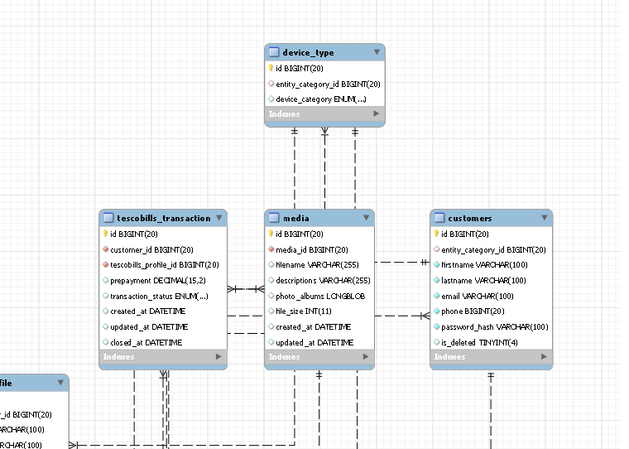

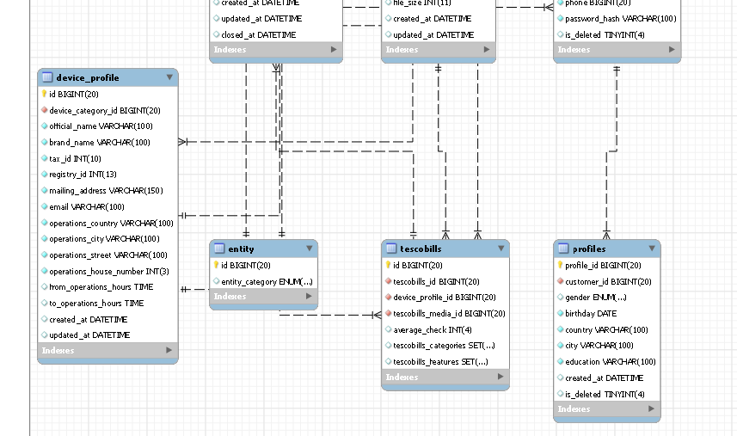

**SQL SCRIPT- TASK 3**

drop database if exists SmartTesco;

create database SmartTesco;

use SmartTesco;

drop table if exists entity;

create table entity (

id SERIAL primary key,

entity_category enum('customers', 'devices')

);

drop table if exists customers;

create table customers (

id SERIAL primary key,

entity_category_id bigint unsigned default 1,

firstname varchar(100) not null,

lastname varchar(100) not null,

email varchar(100) not null,

phone bigint unsigned not null unique,

password_hash varchar(100) not null,

is_deleted tinyint default 0,

foreign key(entity_category_id) references entity(id)

);

drop table if exists profiles;

create table profiles (

profile_id SERIAL primary key,

customer_id bigint unsigned not null,

gender enum ('male', 'female'),

birthday date not null,

country varchar(100) not null,

city varchar(100) not null,

education varchar(100) not null,

created_at datetime default now(),

is_deleted tinyint default 0,

foreign key(customer_id) references customers(id)

);

-- mostly working on tescoBilling device

drop table if exists device_type;

create table device_type (

id SERIAL primary key,

entity_category_id bigint unsigned default 2,

device_category enum('tescoBillingdevice', 'tescoAssistantdevice'),

index(device_category),

foreign key(entity_category_id) references entity(id)

);

drop table if exists device_profile;

create table device_profile (

id SERIAL primary key,

device_category_id bigint unsigned not null,

official_name varchar(100) not null,

brand_name varchar(100) not null,

tax_id int(10) not null unique,

registry_id int(13) not null unique,

mailing_address varchar(150) not null,

email varchar(100) not null,

operations_country varchar(100) not null,

operations_city varchar(100) not null,

operations_street varchar(100) not null,

operations_house_number int(3) not null,

from_operations_hours time,

to_operations_hours time,

created_at datetime default now(),

updated_at datetime on update now(),

index(brand_name,operations_country, operations_city, operations_street),

foreign key (device_category_id) references device_type(id)

);

drop table if exists media;

create table media (

id SERIAL primary key,

media_id bigint unsigned not null,

filename varchar(255),

descriptions varchar(255),

photo_albums longblob,

file_size int,

created_at datetime default now(),

updated_at datetime on update now(),

foreign key (media_id) references device_profile(id)

);

drop table if exists tescobills;

create table tescobills (

id SERIAL primary key,

tescobills_id bigint unsigned not null,

device_profile_id bigint unsigned not null,

tescobills_media_id bigint unsigned not null,

average_check int(4) unsigned,

tescobills_categories set('machine 1', 'machine 2', 'machine 3', 'machine 4', 'machine 5',

'machine 6'),

tescobills_features set('paybydebitcard', 'paybycreditcard', 'paybycash',

'paybygiftcard'),

foreign key(tescobills_id) references device_type(id),

foreign key(tescobills_media_id) references media(id),

foreign key(device_profile_id) references device_profile(id)

);

drop table if exists tescobills_transaction;

create table tescobills_transaction (

id SERIAL primary key,

customer_id bigint unsigned not null,

tescobills_profile_id bigint unsigned not null,

prepayment decimal (15, 2) unsigned,

transaction_status enum('confirmed', 'in processing', 'regected', 'prepayment received', 'on position', 'closed'),

created_at datetime default now(),

updated_at datetime on update now(),

closed_at datetime default now(),

foreign key(customer_id) references customers(id),

foreign key(tescobills_profile_id) references tescobills(id)

);

**DATA DUMPS**

use SmartTesco;

-- Batch insert queries samples

insert into entity values

('1', 'customers'),

('2', 'devices');

insert into customers (id, entity_category_id, firstname, lastname, email, phone, password_hash, is_deleted) values

('21', '1', 'penelope', 'kreiger', 'dean.gerhold@gmail.org', '4', '9836504a445a7f5d246a2985ad8c800996bbc84a', 0),

('22', '1', 'curt', 'weber', 'eliane.rempel@gmail.com', '445', '3f21a4a461cebb2881e276cb4d3e29cb76edd3d0', 0),

('23', '1', 'amiya', 'hintz', 'po\'conner@gmail.org', '1', 'c1efe7a20807099773cfa64fb87e1bf007218369', 0),

('24', '1', 'daniella', 'kuhlman', 'clifford.o\'conner@gmail.com', '3302324395', 'e274b3a22cd79ea06ed5f86f5fa9fc675e853818', 0),

('25', '1', 'ettie', 'crooks', 'kaelyn.lehner@gmail.net', '799', '1db02b5475ec0a59300081ea0ace2a28ed65bb93', 0),

('26', '1', 'meagan', 'krajcik', 'jeremy04@gmail.org', '0', 'f5ccf49a212cabfa8c2db82448827ed4ac6a0835', 0),

('27', '1', 'tyreek', 'bailey', 'wschinner@gmail.org', '569534', '949a79796f91510a115aebd0408ace13f47244bc', 0),

('28', '1', 'mariela', 'mcdermott', 'tate63@gmail.net', '95', 'fc6e2cc0a7fed59998fc0e5bc1f1ef4bcf6fd7b0', 0),

('29', '1', 'kelley', 'conroy', 'barbara.bergstrom@gmail.org', '887841', '789aa85f6580c0e733b8640168c9912b7c4ec84a', 0),

('32', '1', 'jack', 'jakubowski', 'mborer@gmail.com', '123079', '59d9580dbd40dde9e0fcc49aef288dd79ec13455', 0),

('34', '1', 'marilou', 'monahan', 'rollin27@gmail.net', '302702', 'df1fce5ae8a18d7aa0899622dd74f88dd64acb52', 0),

('37', '1', 'nathan', 'weissnat', 'mortiz@gmail.net', '9970511710', '2b6275eb6e989d59a5ca8358023aa0c4117311e4', 0),

('38', '1', 'shawna', 'sauer', 'gladyce.heller@gmail.net', '6279042570', 'ffc2f702dc3ecde7f5a422145f18307c36978da1', 0),

('39', '1', 'maybelle', 'bruen', 'halvorson.mafalda@gmail.com', '48', '1c40d82768a83c26f973da9ea9f1b6d68df6468b', 0),

('40', '1', 'myah', 'o\'kon', 'johathan.schultz@gmail.org', '641', '1153d74a4f649c34a612da36bde7e440b7c6e251', 0);

insert into profiles (profile_id, customer_id, gender, birthday, country, city, education, created_at, is_deleted) values

('1', '21', 'female', '1996-04-26', 'ireland', 'mulingar', '', '2020-04-30 17:18:44', 0),

('2', '22', 'female', '1998-04-16', 'ireland', 'wexford', '', '2020-09-22 21:30:26', 0),

('3', '23', 'female', '1956-05-09', 'ireland', 'athlone', '', '2020-05-05 15:50:22', 0),

('4', '24', 'male', '1989-01-12', 'ireland', 'galway', '', '2020-10-19 02:42:16', 0),

('5', '25', 'male', '1999-09-23', 'ireland', 'tullamore', '', '2020-12-16 23:39:00', 0),

('6', '26', 'male', '1985-01-07', 'ireland', 'dublin', '', '2020-01-08 03:59:36', 0),

('7', '27', 'female', '1996-08-10', 'ireland', 'galway', '', '2020-06-18 13:18:54', 0),

('8', '28', 'female', '1995-10-07', 'ireland', 'tullamore', '', '2020-04-13 20:11:52', 0),

('9', '29', 'female', '1991-03-28', 'ireland', 'athlone', '', '2020-02-14 22:27:53', 0),

('10', '32', 'male', '1996-02-06', 'ireland', 'tullamore', '', '2020-03-20 08:31:46', 0),

('11', '34', 'female', '1992-04-12', 'ireland', 'dublin', '', '2020-02-09 04:18:29', 0),

('12', '37', 'female', '1993-10-04', 'ireland', 'athlone', '', '2020-10-19 15:42:54', 0),

('13', '38', 'female', '1994-08-27', 'ireland', 'galway', '', '2020-09-09 14:14:23', 0),

('14', '39', 'female', '1987-01-22', 'ireland', 'dublin', '', '2020-01-03 02:29:56', 0),

('15', '40', 'female', '1988-05-21', 'ireland', 'galway', '', '2020-05-15 15:54:56', 0);

insert into device_type (id, entity_category_id, device_category) values

('1', '2', 'tescoAssistantdevice'),

('2', '2', 'tescoBillingdevice'),

('3', '2', 'tescoAssistantdevice'),

('4', '2', 'tescoAssistantdevice'),

('5', '2', 'tescoBillingdevice'),

('6', '2', 'tescoBillingdevice');

insert into device_profile (id, device_category_id, official_name, brand_name, tax_id, registry_id, mailing_address, email, operations_country, operations_city, operations_street, operations_house_number, from_operations_hours, to_operations_hours, created_at, updated_at) values

('1', '3', 'sales', 'iotBilling', 1, 9186389, '', 'cremin.luigi@gmail.org', 'ireland', 'galway', '', 3, '08:50:00', '21:50:00', '2020-12-24 15:29:43', '2020-12-07 23:54:34'),

('2', '4', 'assistance', 'iotBilling', 881010, 29, '', 'lysanne.gorczany@gmail.com', 'ireland', 'dublin', '', 84, '06:00:00', '23:50:00', '2020-09-12 04:07:12', '2020-06-13 05:44:23'),

('3', '3', 'assistance', 'iotHelp', 0, 6042885, '', 'kamron.gleason@gmail.org', 'ireland', 'athlone', '', 42, '10:00:00', '23:00:00', '2020-04-30 01:24:35', '2020-03-30 06:28:21'),

('4', '4', 'assistance', 'iotHelp', 969486563, 379613972, '', 'esperanza.lowe@gmail.org', 'ireland', 'wexford', '', 61, '05:00:00', '23:50:00', '2020-08-07 14:44:06', '2020-10-01 20:46:08'),

('5', '4', 'sales', 'iotBilling', 594933, 2833429, '', 'josiah59@gmail.net', 'ireland', 'mulingar', '', 0, '04:50:00', '23:50:00', '2020-01-24 11:00:01', '2020-10-13 03:06:35'),

('6', '3', 'assistance', 'iotHelp', 90298348, 689, '', 'bret.jacobi@gmail.net', 'ireland', 'athlone', '', 0, '10:45:00', '23:50:00', '2020-05-18 02:20:20', '2020-12-23 22:26:17'),

('7', '3', 'sales', 'iotBilling', 951222399, 565, '', 'winfield.o\'conner@gmail.org', 'ireland', 'tullamore', '', 91, '06:30:00', '22:50:00', '2020-09-16 01:37:51', '2020-03-16 05:38:18'),

('8', '3', 'sales', 'iotBilling', 913, 325, '', 'marshall26@gmail.net', 'ireland', 'galway', '', 76, '10:00:00', '22:00:00', '2020-03-07 17:26:31', '2020-11-14 14:49:35'),

('9', '3', 'assistance', 'iotHelp', 51866, 2, '', 'olarson@gmail.net', 'ireland', 'athlone', '', 36, '08:20:00', '21:50:00', '2020-08-12 06:50:36', '2020-12-29 02:49:59'),

('10', '4', 'assistance', 'iotHelp', 771, 35, '', 'tyrese.bednar@gmail.org', 'ireland', 'dublin', '', 7, '02:00:00', '22:50:00', '2020-09-17 16:48:54', '2020-08-11 00:44:15');

insert into media (id, media_id, filename, description, photo_albums, file_size, created_at, updated_at) values

('1', '3', 'file1', 'generated successfully', '', 0, '2020-04-15 22:12:50', '2020-04-06 02:56:27'),

('2', '4', 'file2', 'generated successfully', '', 0, '2020-06-01 22:36:12', '2020-03-13 07:05:38'),

('4', '4', 'file4', 'generated successfully', '', 0, '2020-10-25 08:07:08', '2020-08-04 07:57:52'),

('5', '4', 'file5', 'generated successfully', '', 0, '2020-12-10 03:17:29', '2020-02-21 15:34:30'),

('6', '3', 'file6', 'generated successfully', '', 0, '2020-08-13 04:31:55', '2020-03-26 18:14:20'),

('7', '3', 'file7', 'generated successfully', '', 0, '2020-11-19 10:01:03', '2020-04-15 04:54:20'),

('8', '3', 'file8', 'generated successfully', '', 0, '2020-09-07 11:13:08', '2020-11-09 04:37:06'),

('9', '3', 'file9', 'generated successfully', '', 0, '2020-12-04 16:41:22', '2020-10-07 11:28:25'),

('10', '4', 'file10', 'generated successfully', '', 0, '2020-01-21 23:42:40', '2020-05-28 23:50:12');

insert into tescobills (id, tescobills_id, device_profile_id, tescobills_media_id, average_check, tescobills_categories, tescobills_features) values

('29', '3', '1', '1', 1500, ('machine 1'), ('paybycreditcard')),

('30', '3', '3', '3', 2020, ('machine 4'), ('paybydebitcard')),

('31', '3', '6', '6', 700, ('machine 3'), ('paybygiftcard')),

('32', '3', '7', '7', 900, ('machine 4'), ('paybycash')),

('33', '3', '8', '8', 1700, ('machine 2'), ('paybycash')),

('34', '3', '9', '9', 3000, ('machine 5'), ('paybycash'));

insert into tescobills_transaction (id, customer_id, tescobills_profile_id, prepayment, transaction_status, created_at, updated_at, closed_at) values

('1', '21', '29', null, 'in processing', '2020-05-25 21:30:39', '2020-01-16 05:33:34', '2020-04-08 12:20:29'),

('2', '22', '30', null, 'prepayment received', '2020-01-25 16:40:13', '2020-04-11 02:47:57', '2020-03-18 19:20:19'),

('3', '23', '31', null, 'regected', '2020-08-25 19:07:43', '2020-07-14 19:58:02', '2020-04-12 06:32:43'),

('4', '24', '32', null, 'on position', '2020-11-19 03:59:29', '2020-09-02 09:07:55', '2020-04-01 18:14:03'),

('5', '25', '33', null, 'prepayment received', '2020-01-13 05:06:46', '2020-07-26 18:44:19', '2020-01-18 06:41:40'),

('6', '26', '34', null, 'regected', '2020-06-19 12:39:25', '2020-04-30 18:41:04', '2020-06-25 02:43:11'),

('7', '27', '33', null, 'in processing', '2020-08-21 08:00:50', '2020-09-06 14:12:29', '2020-06-07 20:10:25'),

('8', '28', '30', null, 'confirmed', '2020-08-08 07:16:50', '2020-08-04 09:59:50', '2020-07-12 12:52:09'),

('9', '29', '29', null, 'prepayment received', '2020-07-04 14:41:38', '2020-04-01 12:10:00', '2020-04-16 19:20:31'),

('10', '32', '29', null, 'on position', '2020-04-19 02:25:22', '2020-01-13 12:05:53', '2020-12-17 23:51:48'),

('11', '34', '33', null, 'prepayment received', '2020-11-11 20:04:43', '2020-08-16 11:13:59', '2020-06-29 19:20:57'),

('12', '37', '31', null, 'on position', '2020-03-03 22:48:51', '2020-08-31 08:40:00', '2020-05-13 02:13:35'),

('13', '38', '31', null, 'prepayment received', '2020-07-04 17:06:13', '2020-08-09 14:16:28', '2020-11-09 21:14:35'),

('14', '39', '32', null, 'prepayment received', '2020-02-07 05:03:21', '2020-01-05 18:19:02', '2020-04-27 03:47:43');

**10 QUERIES- TASK 4**

use smarttesco;

-- 1Find the quantity of male customers

select

count(profile_id) as total_male

from profiles

where gender = 'male';

-- 2 customer wants to view brand name

select brand_name from device_profile

where device_category_id = '3'

and operations_city = 'athlone';

-- 3 Sort in ascend order devices by the quantity of operation hours

select

brand_name,

official_name,

timediff(to_operations_hours, from_operations_hours) as total_operations_hours

from device_profile

order by total_operations_hours;

-- 4 Find the average age of male and female customer

select

gender,

avg(timestampdiff(year, birthday, now())) as average_age

from profiles

group by gender;

-- 5 Sort in ascend order the age of minors after the age of adults

select

timestampdiff(year, birthday, now()) as age

from profiles

order by

if(age >= 18,1,0)desc, age asc;

-- 6 Find the total assistance device

select

device_category,

count(*) as total

from device_profile

join device_type on device_category_id = device_type.id

group by device_category;

-- 7 Find the number of customer older than average

select

count(age) as total_older

from

(select

timestampdiff(year, birthday, now()) as age

from profiles

having age > (select

avg(timestampdiff(year, birthday, now()))

from profiles)

order by age) as age;

-- 8 Find the number of customer birthday where firstname starts with 'm'.

select

concat(monthname(profiles.birthday), ' ', day(profiles.birthday)) as Birhday,

concat (customers.firstname, ' ', customers.lastname) as Name

from profiles

join customers on id = customers.id

where firstname like 'm%';

-- 9 Customer wants to know details about the transaction

select

brand_name,

operations_country,

operations_city,

operations_street,

descriptions,

photo_albums,

min(average_check)

from device_profile

join tescobills on device_profile_id = device_profile.id

join media on tescobills_media_id = media.id

where tescobills_features = 'paybycash';

-- 10 Find who used tescoBillingdevice to pay and compare the transaction

select

count(*) as total_customers_transactions,

transaction_status

from customers

join tescobills_transaction

on customers.id = tescobills_transaction .customer_id

where transaction_status = 'confirmed'

or transaction_status = 'on position'

group by transaction_status

order by total_customers_transactions desc;

DF

**STORE PROCEDURE- TASK 5**

use SmartTesco;

drop procedure if exists offers;

-- to check device category and brand name of it.

delimiter $$

$$

create procedure offers()

begin

select

device_category,

brand_name,

photo_albums

from device_type

join device_profile on device_category_id = device_type.id

join media on media_id = device_profile.id

order by rand()

limit 6;

end$$

delimiter ;

call offers();