Web Application Security
Testing Report — DVWA
Internship Task 3 — Web Application Security
Prepared by: ABHISHEK CHOUGALA
Target Application: DVWA (Damn Vulnerable Web Application)
Testing Environment: Kali Linux + DVWA, isolated local lab VM
CONFIDENTIAL — For educational / internship evaluation purposes only. All testing was performed exclusively against a self-hosted, intentionally vulnerable lab application (DVWA) on an isolated virtual machine. No production systems or third-party assets were tested.

1. Executive Summary
This report documents a security assessment carried out against Damn Vulnerable Web Application (DVWA), an intentionally vulnerable PHP/MySQL web application used for training purposes. The objective was to identify, exploit, and remediate a representative set of OWASP Top 10 vulnerabilities in a controlled lab environment, as part of Task 3 of an ongoing cybersecurity internship.
Three vulnerability classes were tested in depth: SQL Injection, Cross-Site Scripting (both Stored and Reflected), and Cross-Site Request Forgery. All three were successfully exploited at DVWA’s "Low" security setting, confirming each represents a genuine, working vulnerability rather than a theoretical risk. Each finding was then re-tested at DVWA’s "High" security setting, where the application’s built-in secure coding patterns (parameterized queries, output encoding, and CSRF tokens) successfully blocked the same attack, confirming that the proposed remediations are effective.
Overall risk rating for the Low-security configuration: Critical. The combination of unauthenticated database access via SQL Injection and session hijacking via Stored XSS would, in a real-world deployment, be sufficient for full application and user-data compromise.

2. Scope & Methodology

2.1 Scope
- Target: DVWA, self-hosted on Apache/MySQL/PHP, running on a Kali Linux virtual machine (localhost).
- All testing was confined to this single, isolated, intentionally vulnerable lab instance. No external, third-party, or production systems were in scope or were tested.
- Security levels tested: Low (to demonstrate successful exploitation) and High (to confirm remediation effectiveness).

2.2 Methodology
- Manual testing of each OWASP Top 10 category against DVWA’s dedicated vulnerability modules.
- Burp Suite was used as an intercepting proxy to inspect and, where relevant, modify requests in transit.
- For each vulnerability: identify the injection/output point → craft and submit a payload → capture evidence of successful exploitation → repeat the same payload at High security → capture evidence that the fix holds.

2.3 Tools Used
- Kali Linux (attacker workstation)
- DVWA v1.10 (target application)
- Firefox browser
- Burp Suite Community Edition (request interception / fuzzing)
- Browser Developer Tools (for inspecting page source / tokens)

3. Findings

3.1 Finding 1 — SQL Injection
Severity: Critical

Description
SQL Injection occurs when user-supplied input is concatenated directly into a SQL query rather than being handled as pure data. DVWA’s SQL Injection module accepts a "User ID" value and embeds it directly into a backend query without sanitization or parameterization, allowing an attacker to alter the query’s logic and structure.

Steps to Reproduce
- Navigate to DVWA → SQL Injection, with DVWA Security set to Low.
- Enter a single quote (') into the User ID field to confirm the input breaks query syntax (a MySQL error is returned).
- Enter the following payload into the User ID field and submit:
1' UNION SELECT user, password FROM users-- -
- Observe that the page returns every username and password hash stored in the users table instead of a single record.

Evidence
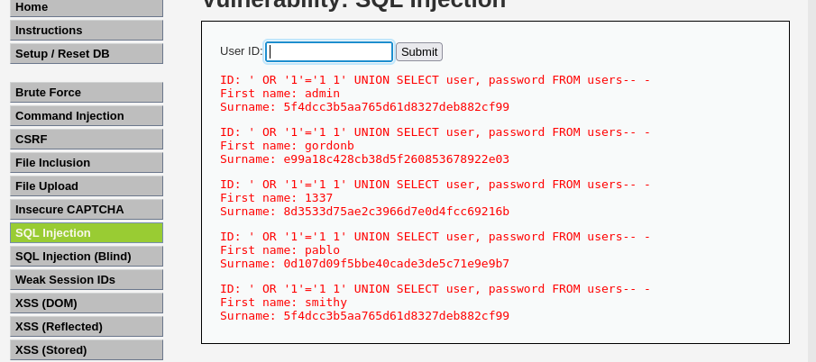
Figure 1 — UNION-based SQL Injection returning all usernames and password hashes from the users table.

Impact
This single injection point allows complete extraction of the application’s user table, including password hashes, with no authentication required. The extracted hashes (unsalted MD5) were trivially crackable using a standard wordlist (e.g. rockyou.txt via hashcat/John the Ripper), yielding plaintext administrator credentials within seconds. In a production context, this would constitute full compromise of every user account, including administrative access.

Remediation
The fix is to use parameterized queries / prepared statements, which separate the SQL query structure from user-supplied data so that input can never be interpreted as executable SQL syntax, regardless of its content.
// Vulnerable
$query = "SELECT first_name, last_name FROM users WHERE user_id = '$id';";
// Fixed (mysqli prepared statement)
$stmt = $conn->prepare("SELECT first_name, last_name FROM users WHERE user_id = ?");
$stmt->bind_param("s", $id);
$stmt->execute();
Re-testing the identical payload against DVWA set to High security (which implements the prepared-statement version of this page) returned no data — the injected SQL was treated as a literal search value rather than executable code, confirming the fix is effective.

3.2 Finding 2 — Cross-Site Scripting (Stored)
Severity: High

Description
Stored Cross-Site Scripting occurs when user input is saved by the application (e.g. in a database) and later rendered back into a page as raw HTML, without encoding, for every subsequent visitor. DVWA’s "XSS (Stored)" module — a simple guestbook — saves the Message field exactly as submitted and redisplays it to all users, with no output encoding.

Steps to Reproduce
- Navigate to DVWA → XSS (Stored), with Security set to Low.
- In the Message field, submit the following payload:
<script>alert('ApexPlanet')</script>
- Reload the guestbook page (or have any other user load it).
- Observe that the JavaScript executes automatically, producing a popup alert, confirming the script was stored and is now served to every visitor.

Evidence
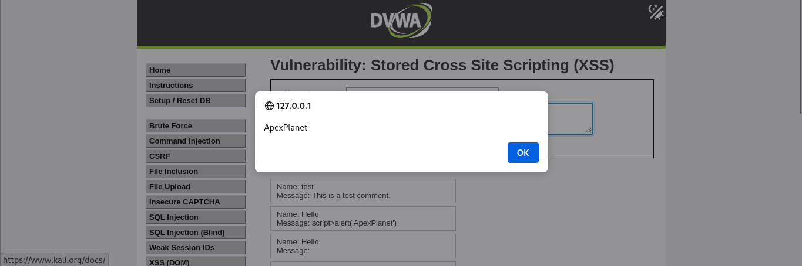
Figure 2 — Stored XSS payload executing automatically from the saved guestbook entry, confirmed via JavaScript alert box.

Impact
Because the payload persists server-side, it affects every user who views the page, not just the one who submitted it, with no need to trick anyone into clicking a link. A realistic attacker would replace the alert() proof-of-concept with a cookie-exfiltration script (e.g. redirecting document.cookie to an attacker-controlled endpoint), allowing session hijacking of any user, including administrators, who views the affected page.

Remediation
The fix is output encoding at the point user input is rendered back into HTML, so the browser treats it as literal text rather than markup, combined with a Content-Security-Policy header as a second layer of defense.
// Vulnerable
echo 'Message: ' . $message;
// Fixed
echo 'Message: ' . htmlspecialchars($message, ENT_QUOTES, 'UTF-8');
Re-testing the identical payload against DVWA set to High security confirmed the script tag is rendered as literal, visible text on the page (not executed) — the fix is effective.

3.3 Finding 3 — Cross-Site Scripting (Reflected)
Severity: Medium

Description
Reflected Cross-Site Scripting occurs when user input is taken from the request (typically a URL parameter) and echoed directly back into the page’s HTML in the same response, without encoding. DVWA’s "XSS (Reflected)" module takes a name parameter and reflects it back on the page unmodified.

Steps to Reproduce
- With DVWA Security set to Low, browse to the following crafted URL:
localhost/dvwa/vulnerabilities/xss_r/?name=<script>alert('HaCkEd')</script>
- Observe that the script executes immediately on page load, producing a popup alert.

Evidence
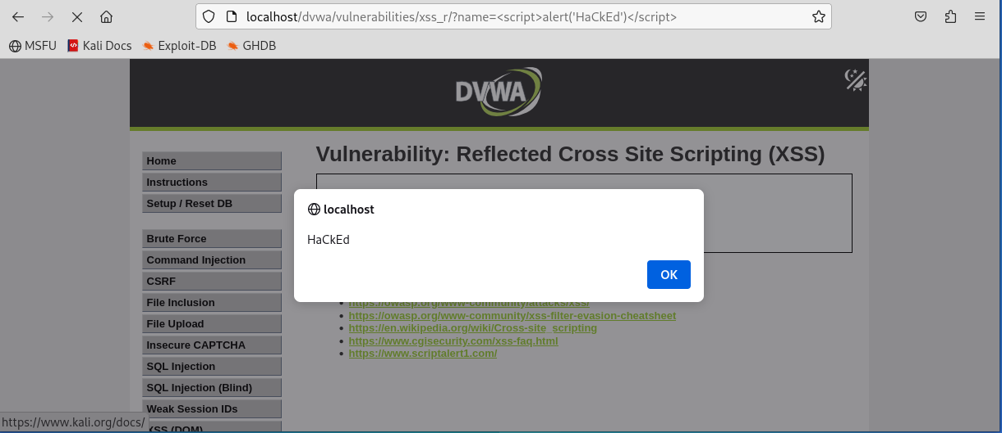
Figure 3 — Reflected XSS payload delivered via a crafted URL parameter, executing immediately on page load.

Impact
Unlike Stored XSS, this variant requires a victim to click a specific crafted link (typically delivered via phishing email or chat message), but is otherwise just as capable of executing arbitrary JavaScript in the victim’s authenticated session — enabling cookie theft, session hijacking, or redirection to a credential-harvesting page.

Remediation
Identical remediation approach to the Stored XSS finding: output encoding of the reflected parameter before it is written into the HTML response, plus a Content-Security-Policy header restricting script execution to the application’s own origin.
header("Content-Security-Policy: default-src 'self'; script-src 'self'");
At High security, DVWA applies output encoding to this parameter; the same payload is rendered as inert text rather than being executed, confirming the fix is effective.

3.4 Finding 4 — Cross-Site Request Forgery (CSRF)
Severity: High

Description
Cross-Site Request Forgery abuses the fact that browsers automatically attach a user’s session cookie to any request sent to a site, regardless of which page triggered that request. DVWA’s CSRF module allows a logged-in user to change their password via a GET request, and performs no check on whether the request genuinely originated from DVWA’s own form.

Steps to Reproduce
- With DVWA Security set to Low, and while logged in as a victim user, host the following HTML page on a separate (attacker-controlled) origin:
<html>
<body onload="document.forms[0].submit()">
<form action="http://localhost/dvwa/vulnerabilities/csrf/" method="GET">
<input type="hidden" name="password_new" value="hacked123">
<input type="hidden" name="password_conf" value="hacked123">
<input type="hidden" name="Change" value="Change">
</form>
</body>
</html>
- Have the logged-in victim open this page (e.g. served locally via "python3 -m http.server 8000").
- The form submits automatically on page load, using the victim’s active DVWA session cookie.
- Confirm impact by logging out and logging back in to DVWA using the new password ("hacked123") — login succeeds, confirming the password was changed without the victim’s knowledge or consent.

Impact
An attacker can silently change a victim’s password (or any other state-changing action protected only by session cookies) simply by getting the victim to load a page, with no visible warning or confirmation step. This can be used to lock the victim out of their own account or, combined with a predictable or attacker-chosen new password, to take over the account outright.

Remediation
The fix is per-session, unpredictable CSRF tokens embedded in the form and validated server-side on every state-changing request, so a request forged from a different origin can never include a valid token.
// Token generation (stored in session)
$_SESSION['csrf_token'] = bin2hex(random_bytes(32));
// Validation on submit
if (!hash_equals($_SESSION['csrf_token'], $_POST['csrf_token'] ?? '')) {
die('CSRF token validation failed');
}
At High security, DVWA’s CSRF form includes a hidden user_token field tied to the session. Re-submitting the identical forged request (without a valid, current token) is rejected and the password remains unchanged, confirming the fix is effective. Additional hardening recommended: enforce POST (not GET) for state-changing actions, and set session cookies with the SameSite=Strict attribute.

4. Summary Table
Vulnerability | Severity | Status (Low) | Status (High)
SQL Injection | Critical | Exploited | Fixed / Blocked
XSS — Stored | High | Exploited | Fixed / Blocked
XSS — Reflected | Medium | Exploited | Fixed / Blocked
CSRF | High | Exploited | Fixed / Blocked

5. Conclusion
At its Low security setting, DVWA exhibited all four tested vulnerability classes in fully exploitable form, each independently sufficient for significant compromise — ranging from full database extraction (SQL Injection) to session hijacking (XSS) and unauthorized account changes (CSRF). This is expected and by design, since DVWA’s Low setting exists specifically to illustrate these flaws clearly for training purposes.
More importantly, each vulnerability was confirmed fixed once DVWA’s High security setting was enabled, which applies standard, well-established secure coding practices: parameterized queries for SQL Injection, output encoding for XSS, and token-based validation for CSRF. This progression reinforces a central lesson of secure development — these are not exotic or difficult fixes, but foundational practices that, when consistently applied, close off entire classes of vulnerability at once.
Recommendation: any real application exhibiting Low-equivalent behavior should treat remediation of these four findings as immediate priorities, in the order SQL Injection > Stored XSS / CSRF > Reflected XSS, reflecting both ease of exploitation and potential impact.

