Beyond Flood Risk: Does Post-Flood Recovery Change Priority Rankings in Kerala?
  - Manuscript concept and preregistration-style research protocol
STATUS (21 October 2026): Protocol plus exploratory agricultural-data pilot completed. 168 official district–crop–year production observations and the published district vulnerability ranking were examined. These are NOT event-attributable recovery measurements, and no multi-domain recovery index or validated predictive model has yet been produced.

Working abstract (prospective; revise after analysis)
Flood susceptibility and social vulnerability maps are widely used to identify areas requiring disaster-risk reduction. Yet a highly flood-prone locality may recover comparatively quickly, whereas another with lower hazard exposure may experience longer disruption to agriculture, livelihoods and services. These distinctions may be missed when prioritisation relies primarily on hazard, exposure and static resilience capacities. This study proposes a recovery-informed ranking framework for Kerala, India, and asks whether direct measurements of post-flood recovery change geographical priorities and improve the identification of prolonged disruption. Multi-temporal Sentinel-1 flood observations will be combined with Landsat/Sentinel-2 seasonal vegetation signals, published crop-area and yield statistics, monthly VIIRS night-time lights where reliable, and official impact information. We will construct sector-specific counterfactual recovery trajectories, quantify cumulative recovery deficits rather than relying only on recovery duration, and compare risk-only and recovery-informed rankings at a common geographic resolution. Weight sensitivity, spatial dependence, event hold-outs and outcome validation will be explicitly tested. The principal contributions will be an auditable measurement protocol and a falsifiable assessment of whether recovery information has value beyond conventional flood-risk indicators. Results remain to be determined.
Keywords: flood recovery; Kerala; resilience; flood-risk ranking; cumulative functional loss; remote sensing; satellite time series; decision validation.

1. Research decision and intended contribution
Primary question: Does the inclusion of empirically observed recovery burden materially alter Kerala flood-priority rankings and improve the ability to identify locations facing prolonged post-flood disruption?
This is NOT a claim that Kerala lacks flood or resilience indices. Kerala already has statewide machine-learning susceptibility studies [1–2] and an urban community-resilience index for Kochi [3]. International work has also incorporated recovery durations in a multi-dimensional flood index [9]. The proposed contribution must therefore come from event-linked recovery measurement, careful comparison with existing rankings, and genuinely independent validation—not from adding a novel name or an arbitrary extra factor.
Decision context: two separate use cases will be reported. (A) Post-event rehabilitation: using data available during an event and its first weeks/months to rank locations for additional restoration attention. (B) Pre-event planning: using only historically available recovery experience to rank locations for subsequent events. Use case B is feasible only if multiple independent, well-observed events are available. The primary pilot will target A; B is a conditional extension.

2. Evidence review: what is already known
Study / source | What exists already | Specific gap for our work
Kerala LightGBM + AHP (2025) [1] | Statewide flood susceptibility; ROC-AUC comparison and expert-weighted indices. | Does not establish observed, multi-domain recovery outcomes as priority targets.
Kerala ML + vulnerability (2026) [2] | Five model comparison; hazard, exposure, sensitivity, adaptive-capacity district scores; temporal flood validation. | No demonstrated out-of-sample ranking validation against measured recovery burden.
CRIF for Kochi (2022) [3] | Seven-dimensional survey/expert-based community resilience index. | Capacity/perception is distinct from repeated measurement of post-event functional restoration.
Kerala floods economic dynamics (2022) [4] | Nighttime lights, wages, expenditure, transactions and credit follow different trajectories after 2018. | Economic proxy alone cannot fully describe multisector local recovery.
Kerala 2018 PDNA [5] | Comprehensive sector loss, damage and recovery-needs assessment. | Planning horizons/needs are not observed time-to-recovery at every local unit.
EO recovery review (2026) [8] | Satellite recovery monitoring and the weaknesses of physical/functional proxies. | Direct validation linking EO indicators to functioning remains important.
Flood resilience index (2026) [9] | Recovery duration combined with hazard, vulnerability and response across five international events. | Need place-level Kerala-specific trajectories, transparent outcome testing and out-of-sample priority evaluation.
Mississippi flood readiness gaps (2026) [10] | Compares investment/readiness priorities to observed flood-loss alignment. | An appropriate decision-validation comparator, not a claim of a wholly new paradigm.

Preliminary evidence-gap statement: In the sources reviewed for this draft, we did not identify a Kerala-wide, independently validated index explicitly benchmarking cumulative recovery burdens against existing flood-priority rankings. This is a scoped observation, not proof that no such paper exists. A reproducible systematic search remains necessary before submission. [1–10]

3. Conceptual definitions and hypotheses
Flood susceptibility: propensity of a location to inundation. Flood risk: potential for adverse consequences arising from flood hazard, exposure and vulnerability. Recovery capacity: resources or characteristics that enable coping and reconstruction. Observed recovery: realised restoration of a defined function after an event. Recovery burden: cumulative magnitude and duration of performance shortfall. Recovery-informed priority: a decision ranking based on available hazard and exposure information plus properly measured or predicted recovery burden.
- H1 — Rank displacement: measured recovery burden will reorder some locations relative to an otherwise matched risk-only ranking. This is necessary but not sufficient for useful improvement.
- H2 — Incremental validity: recovery-informed models will identify higher independently observed subsequent cumulative disruption than risk-only comparators at an identical top-K intervention capacity.
- H3 — Multi-domain divergence: vegetation/cropping and night-time lights will not always return to baseline in the same sequence or at the same rate. Night-time lights cannot stand in for household welfare.
- H4 — Robustness: material rank changes will remain broadly stable across defensible weighting schemes, baseline windows, geographies and missing-data assumptions. If not, the index should not be recommended operationally.

4. Measurement: from post-disaster trajectories to recovery burden
For spatial unit i, event e, sector k and month/season t, estimate a counterfactual normal-function trajectory F^0(i,e,k,t). This must allow seasonal patterns and non-disaster trends, ideally using pre-event histories and a matched, less-affected comparison set. Let F(i,e,k,t) be observed function with missingness and measurement uncertainty recorded. Never treat missing satellite observations as zero or full recovery.
Deficit D(i,e,k,t) = max[0, {F⁰(i,e,k,t) − F(i,e,k,t)} / F⁰(i,e,k,t)] (where a positive denominator is meaningful)
Cumulative recovery burden B(i,e,k;T) = Σ[t=1…T] D(i,e,k,t) × Δt
B represents the area under a deficit curve (e.g. deficit-months); it distinguishes a short deep loss from a prolonged shallow loss. If the counterfactual is near zero (dark nighttime-light pixels, non-cropped parcels) do not apply this ratio: use a suitable standardized difference, minimum-activity gate or mark the domain not applicable. Report absolute as well as relative impacts when differing population/assets make relative deficits misleading. [8,11]
Recovery time is supplementary, not the sole outcome. One prespecified operational threshold might be restoration to ≥90% of estimated normal function for three consecutive valid observations, with a sensitivity analysis at 80/95%. Thresholds must be justified and kept fixed before testing. Sites without observed restoration by the end of follow-up are right-censored, not assigned arbitrary recovery dates.
Where repeated floods strike during follow-up, represent the new shock explicitly and perform a censoring or multi-event sensitivity analysis. A purely “return to 2017 conditions” target is also inappropriate if land use, agriculture or infrastructure was changing before the flood.

5. Candidate recovery domains and what they actually measure
Domain | Operational candidate | External/functional check | Status / critical caveat
Agriculture | Season-matched crop fraction, EVI/NDVI anomaly, re-sowing gaps; block paddy/banana yield/area reports. | Ecostat Kerala block and district crop-area/production series [6]. | Strongest starting domain; crop greenness is not yield.
Economic activity | VIIRS monthly radiance anomalies aggregated to sufficiently large illuminated spatial units. | NIPFP study for aggregate direction; transactions/earnings only if accessible [4]. | Medium; coarse resolution and rural darkness.
Housing | Damaged vs habitable homes; reconstruction completion dates. | KSDMA / RKI administrative records if geocoded and longitudinal. | Access unconfirmed; never infer habitable houses from satellite spectral recovery.
Infrastructure | Road passability, electricity restoration, health/school functionality. | Restoration/closure logs or local authority records. | Low for statewide repeated measurement; retain as exploratory only.
Ecological function | Wetland, riparian vegetation or soil/water persistence relative to local reference. | Field or river-restoration assessments where available. | Greenness does not establish ecological function.

The initial paper should commit to one strongly measured domain plus one corroborative domain, rather than claim a complete socioeconomic/physical/ecological recovery index without data. Agriculture is the recommended primary outcome, night-time lights a secondary proxy. Housing and services enter only after accessible independent records are demonstrated.

6. Study design and leakage-safe comparison
Spatial scale: begin with agricultural blocks where crop reports exist, subject to obtaining stable historical boundaries. Flood exposure can also be computed in 1-km grids, but the same ranking comparison must use identical geographic units. District-only replication of the 2026 published scores is a useful audit/communication exercise, not a sufficiently fine-grained test of local restoration needs. Small wards may be below the meaningful scale of VIIRS.
Candidate events: 2018 is the anchor event. Investigate 2019 and 2021 floods as secondary events if sufficiently complete location/date-specific inundation maps and post-event sector observations exist. This cannot be assumed simply because susceptibility models used these years in validation [2]. Define event-specific pre-, shock- and post-periods before calculating outcomes.
Exposure identification: Sentinel-1 SAR, KSDMA historical hazard rasters and its crowdsourced 2018 depth observations can inform flood-event footprint and severity. The KSDMA page confirms about 13,000 collected points; raw downloadable point coordinates have not yet been verified [7]. The official hazard raster is a hazard baseline, not evidence that a pixel was flooded in a particular event.
Primary descriptive test (post hoc): compare a risk-only order with a recovery-informed order, noting how many units move into/out of the top 5%, 10%, 20%, changes in ranks, and variations by geography and recovery domain. This comparison establishes sensitivity, not superior accuracy.
Primary predictive test (conditional): train/preregister using earlier events or units, use only information available by decision time (e.g. hazard + flood extent + first 90 days’ trajectory), and predict 12/24-month recovery burden in a held-out event/region. On the held-out set, report cumulative observed burden captured in top K, precision for persistent disruption, Spearman/Kendall agreement with the outcome, and bootstrap uncertainty. A stronger claim requires comparing the incremental value over hazard + exposure + socioeconomic capacity + immediate event severity, not only over flood susceptibility.
Do not fit weights, thresholds, event definitions or preprocessing decisions on the same outcomes used for final evaluation. Spatially block train/test splits or use leave-one-catchment-out where feasible; report high uncertainty if the number of independent events is too small for temporal hold-out.

7. Modelling strategy and prespecified baselines
B0: Hazard-only ranking from a documented existing risk/susceptibility surface, aggregated at the chosen unit. B1: Baseline hazard + exposure/sensitivity/adaptive-capacity indicators with consistent directionality. B2: B1 plus early observed recovery indicators (post-event) or prior-event recovery history (pre-event). B3 (optional): a regularised ML model, e.g. gradient-boosted trees, only if performance beyond B1/B2 is validated and credible data volume is available.
For transparent rank-change analysis, standardize comparable components within the training sample and report a predeclared family of weights rather than one weight selected for dramatic reorderings. As a sensitivity test, examine recovery weight λ from 0 to 1 in prespecified increments with other weights re-normalised. Avoid relabelling rank changes as improvements when the ranking contains the same ground-truth recovery variable used as its test target.
Pre-registration quantities: top-K shares; Kendall τ, Spearman ρ; mean absolute rank shift; fraction of previously lower-priority units promoted; held-out top-K cumulative deficit captured; precision–recall for a prespecified “persistent loss” threshold; calibration if probabilities are estimated; spatial block-bootstrap intervals and uncertainty across baseline definitions.

8. Data availability: confirmed sources versus unverified fields
Source | What is verified | Outstanding check
KSDMA historic flood hazard ZIP [7] | Public page directly links historical 10/25/50 and 100/200/500-year raster ZIPs. | Download raster, check CRS, raster values, licensing and time assumptions.
KSDMA 2018 depth crowdsourcing [7] | Official page reports ≈13,000 depth observations. | Whether raw geocoded measurements are accessible rather than map only.
Ecostat agricultural reports [6] | Reports for 2017–18, 2018–19, 2019–20 and 2020–21 are indexed; some include block output. | Harmonise block IDs and definitions, crop-year/season, sample precision.
Sentinel-1 [12] | GEE Sentinel-1 GRD archive covers 2018. | Orbit/polarisation matching, dense vegetation and layover error.
Landsat 8 / Sentinel-2 [13] | Public imagery available before/after 2018; Landsat 8 from 2013. | Monsoon cloud gaps, season matching, valid-observation counts.
VIIRS monthly [14] | Monthly night lights and cloud-free-coverage bands; ≈464 m pixel. | Urban/rural illumination coverage, weather artifacts, annual baseline.
2018 PDNA [5] | Official sector recovery-needs and impact assessment. | Village/block time series—not established by this one-off report.
Rebuild Kerala/housing records | Programme records exist in public reporting. | Machine-readable dates and sub-district geographic identifiers not verified.

Observed agricultural data audit: Kerala district-level rice, banana and plantain production for 2017–18 through 2020–21 has been reconstructed (168 entries). Statewide 2018–19 output relative to 2017–18 rose for rice (+10.9%) and plantain (+0.9%) but declined for banana (−24.2%). This is neither proof nor disproof of local flood damage: counterfactual crop production, flooded agricultural area, cropping choices and seasonal variability are unmeasured. See exploratory results appendix.

9. Feasibility pilot: the first reproducible experiment
- Acquire three to four annual Ecostat crop reports and build a harmonised block-level crop-area/production panel for paddy and one flood-sensitive crop (e.g. banana), preserving changes in reporting practices and uncertainty.
- Obtain KSDMA historical flood raster(s), plus an independent 2018 inundation layer. Establish block-level flooded area, affected cropland area and valid-data coverage.
- Choose a geographically contrasting, sufficiently sampled set of affected blocks (e.g. central Kerala lowlands versus additional eligible districts). Selection must be criterion-driven, not selected by expected result.
- Construct pre-event season-matched Landsat trajectories (preferably ≥3 pre-event years where data permit), and post-event trajectories for 12 and 24 months. Overlay exposure only where flood observations have demonstrable quality.
- Define recovery deficit against comparable less-affected places and pre-event seasonality. Cross-check satellite changes against Ecostat crop production/area without assuming either alone represents household recovery.
- Compare pre-specified risk-only and recovery-inclusive ranks; report top-K turnover and uncertainty. If no independent future recovery endpoints exist, label results DESCRIPTIVE and do not claim predictive validation.

10. Anticipated threats to validity and mitigation
- Outcomes are not interchangeable: satellite greenness, crop production, income, housing and ecological functions have different meanings. Keep them as separate axes until valid joint weighting can be justified.
- Confounding: flood severity, rainfall, land-use change, relief spending and pre-existing disadvantage affect recovery. Match/adjust and describe associations as noncausal absent a credible identification design.
- Seasonality: monsoon cloud coverage and crop calendar alter index values. Use quality flags, same-season comparisons and model valid-pixel counts; never assume a missing scene indicates damage or restoration.
- Ecological fallacy and scale: coarse socioeconomic data cannot support reliable ward-level claims. Aggregate consistently and provide scale sensitivity.
- Composite-index gaming: study must show independent value, not simply that adding a factor changes ranks. Pre-specify alternatives; avoid tuning to rank reversals.
- No guaranteed novelty: existing studies include Kerala resilience indexing [3], recovery-duration flood indices [9], and externally validated readiness ranking [10]. Clearly distinguish the contribution.

11. Planned main-study figures and tables (recovery-model results pending)
Identifier | Planned output | Required evidence
Figure 1 | Conceptual hazard → disruption → sector recovery → priority framework | Protocol only
Figure 2 | Study area, administrative blocks and event flood footprints | Geographic boundary, validated inundation
Figure 3 | Season-corrected recovery trajectories for selected blocks | Observed data with uncertainty intervals
Figure 4 | Existing risk rank vs recovery-adjusted rank and rank mobility | Actual data; sensitivity across weights
Figure 5 | Held-out top-K captured recovery burden versus baselines | Independent held-out event/unit outcomes
Table 1 | Inventory of published Kerala and international recovery indices | Completed targeted review
Table 2 | Recovery indicators, data quality and inclusion rules | Verified data and metadata
Table 3 | Discrimination, top-K utility and rank stability | Executed and repeatable analyses

12. Go / no-go criteria
GO if: (i) 2018 inundation can be mapped with acceptable accuracy; (ii) an adequate block/district agricultural panel can be spatially harmonised; (iii) at least one recovery outcome can be independently checked; and (iv) the comparative index definition and test outcomes can be frozen before evaluation. CONDITIONAL if the multi-domain index has no comparable economic/housing outcome: publish a focused agricultural recovery paper rather than a sweeping resilience score. NO-GO for strong predictive claims if only 2018 post-event observations exist with no independent later event or held-out outcome.

References and data provenance
[1] Kendagannaswamy, M. S., et al. (2025). Multi-criteria decision analysis for regional-scale flood susceptibility mapping in Kerala state, India. Discover Applied Sciences, 7, 598. https://doi.org/10.1007/s42452-025-07182-z
[2] Kendagannaswamy, M. S., et al. (2026). Improving flood susceptibility assessment in Kerala: Integration of advanced machine learning models with socioeconomic vulnerability analysis. Journal of the Indian Society of Remote Sensing, 54, 4385–4403. https://doi.org/10.1007/s12524-026-02440-y
[3] Ali, S., & George, A. (2022). Modelling a community resilience index for urban flood-prone areas of Kerala, India (CRIF). Natural Hazards, 113, 261–286. https://doi.org/10.1007/s11069-022-05299-7
[4] Beyer, R. C. M., Narayanan, A., & Thakur, G. M. (2022). Natural Disasters and Economic Dynamics: Evidence from the Kerala Floods. NIPFP Working Paper 383. https://nipfp.org.in/publication-index-page/working-paper-index-page/natural-disasters-and-economic-dynamics-evidence-from-the-kerala-floods/
[5] Government of Kerala et al. (2018/2019). Kerala Floods and Landslides, August 2018: Post Disaster Needs Assessment. https://sdma.kerala.gov.in/wp-content/uploads/2019/03/PDNA-report-FINAL-FEB-2019_compressed.pdf
[6] Kerala Department of Economics & Statistics. Agricultural Statistics annual reports, 2017–18, 2018–19, 2019–20, 2020–21. https://ecostat.kerala.gov.in/publication-detail/agricultural-statistics-2018-19
[7] Kerala State Disaster Management Authority. Hazard Maps; Crowd Sourcing Flood 2018; State Disaster Management Plan (updated 2026). https://sdma.kerala.gov.in/hazard-maps/
[8] Friedrich, H. K., et al. (2026). Satellite earth observation for recovery from hydrometeorological hazards. Water Security, 28, 100205. https://doi.org/10.1016/j.wasec.2026.100205
[9] Chakraborty, S., Furno, A., & El Faouzi, N. E. (2026). The Flood Resilience Index: Benchmarking Infrastructure Vulnerability and Response Strategies Through Case-Based Analysis. Applied Sciences, 16(10), 4716. https://doi.org/10.3390/app16104716
[10] Bhatta, U., et al. (2026). Targeting flood resilience investments through a readiness gaps index: Evidence from Mississippi. International Journal of Disaster Risk Reduction, 106471. https://doi.org/10.1016/j.ijdrr.2026.106471
[11] Hsu, C. W., et al. (2025). Dissecting resilience curve archetypes and properties. Scientific Reports. https://www.nature.com/articles/s41598-025-95909-8
[12] Google Earth Engine. Sentinel-1 SAR GRD dataset catalogue. https://developers.google.com/earth-engine/datasets/catalog/COPERNICUS_S1_GRD
[13] Google Earth Engine. USGS Landsat 8 Level-2 and Sentinel-2 harmonized datasets. https://developers.google.com/earth-engine/datasets/catalog/LANDSAT_LC08_C02_T1_L2
[14] Google Earth Engine. VIIRS nighttime monthly stray-light-corrected compositing dataset. https://developers.google.com/earth-engine/datasets/catalog/NOAA_VIIRS_DNB_MONTHLY_V1_VCMSLCFG
[15] Zheng, Q., et al. (2025). Nighttime lights reveal substantial spatial heterogeneity and inequality in post-hurricane recovery. Remote Sensing of Environment, 319, 114645. https://doi.org/10.1016/j.rse.2025.114645
[16] Pramanick, N., et al. (2022). SAR based flood risk analysis: A case study Kerala flood 2018. Advances in Space Research, 69(4), 1915–1929. https://www.sciencedirect.com/science/article/pii/S0273117721005433
Literature status: targeted, evidence-oriented search completed to 21 October 2026; not a systematic review. References are starting points to verify and expand, especially local recovery and decision-validation studies. Uploaded papers [1] and [2] were read in detail. Neither this document nor the data audit contains original measured Kerala recovery results.

Appendix A — Exploratory Empirical Pilot (21 October 2026)
Scope: these analyses use actual state agricultural observations and published vulnerability scores to test data feasibility and index sensitivity. They do NOT demonstrate post-flood recovery, attributable disaster losses, causal mechanisms or superiority of any index.

A1. Official district data and observed agricultural trajectories
Agricultural Statistics Reports 2017–18, 2018–19, 2019–20, and 2020–21, Kerala Department of Economics and Statistics, Table 4: 14 districts × three crops (rice, banana and plantain) × four agricultural years (168 reported district-level production values). The 2020–21 rice observations use the wetland series for consistency with the earlier years. Manual transcription and report-page provenance are supplied with the experiment files.
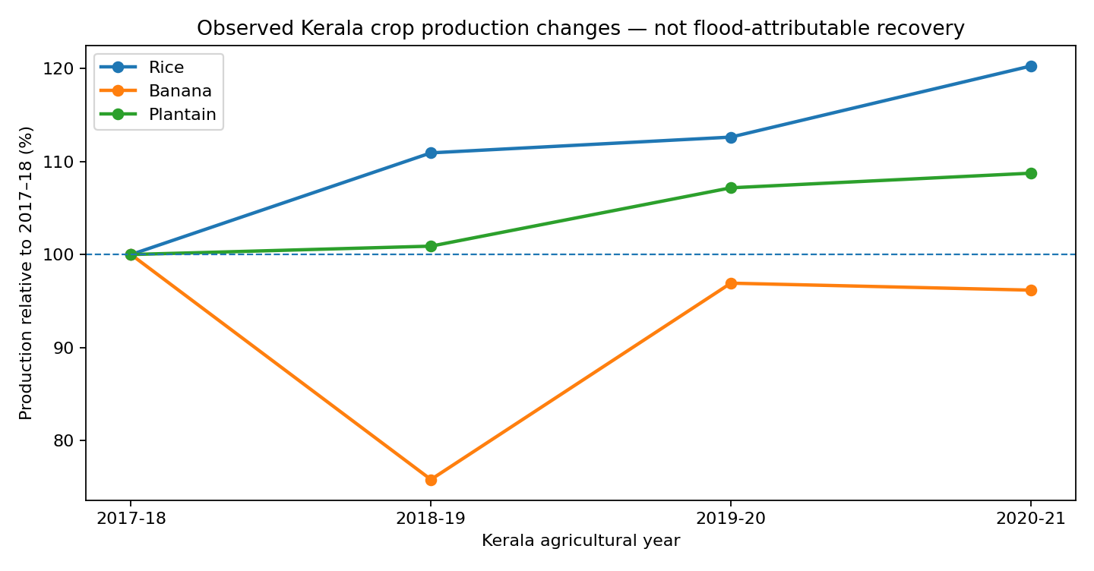
Figure A1. Observed production as a percentage of 2017–18; not flood-attributable losses or a measure of time to functional recovery.

A2. Illustrative ranking stress test
Define annual district-crop production shortfall against 2017–18 as max(0, 1 – reported production / 2017–18 production); average over three crops and three follow-up years. Form a hypothetical composite (1–α) × scaled published district score + α × scaled agricultural shortfall. The 2026 source score postdates the agricultural outcomes, making this purely retrospective.
At α=0.25, 3/5 published top-five districts remained when components were min–max normalized, versus 5/5 under percentile-rank normalization (cutoff ties make exact membership tie-sensitive). The rankings changed across 28 plausible crop sets, time windows and normalizations: 3/5 overlap in four cases, 4/5 in seventeen, and 5/5 in seven. Ranking movement should not be interpreted as index improvement.
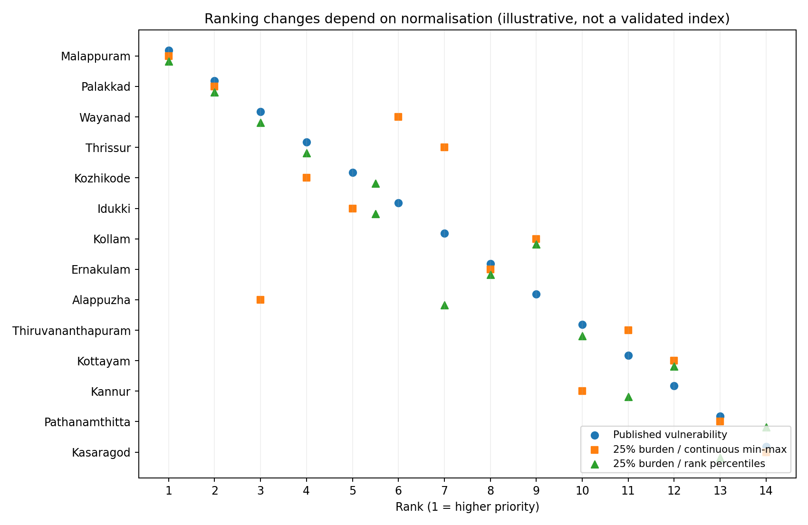
Figure A2. Alternative 25% illustrative composites. No weight has yet been supported by policy outcomes or independent recovery observations.

A3. Diagnostic pseudo-holdout and baseline audit
An illustrative 2020–21 crop-output-shortfall check showed that top-five areas selected by the published risk score captured 36.9% of the 2020–21 crop shortfall proxy, compared with 59.4% using a 25% min–max-normalized blend of earlier crop shortfall and published risk; permutation exceedance fraction 0.077 (10,000 draws). This is NOT a leak-free event-held-out experiment, as the vulnerability score appeared in 2026, contains post-event-derived information and is evaluated against autocorrelated agricultural outcomes. It is not a publication-quality claim of predictive performance.
The published baseline table is arithmetically consistent with 0.30 × hazard + 0.25 × exposure + 0.25 × sensitivity + 0.20 × the variable labelled adaptive capacity (max error 0.0005). Since the text also calls higher adaptive capacity protective, the intended direction should be verified before any rank comparison is reported as an empirical result.

A4. Measurement still required
- Flood footprint/exposure by location (Sentinel-1 and ground-truthed maps); rainfall, soil and crop calendar controls; multiple years of pre-flood production.
- Seasonal agricultural and ecological trajectories at fixed administrative units, with cloud and observation coverage diagnostics; validate remote-sensing proxies against field data.
- At least one independent functional recovery dataset (housing, services, income/expenditure or infrastructure restoration records).
- A decision-time-specific ranking protocol and actual later-event holdout to compare rank stability and capture of cumulative recovery burden.

