Forge Rock Directory Services (FRDS) 6.5 Installation:s

This blog describes how to install Forge Rock Directory Services (FRDS) 6.5 using the manual procedure:

1. Download the installers from following links:

[**https://backstage.forgerock.com/downloads/browse/ds/latest**](https://backstage.forgerock.com/downloads/browse/ds/latest)

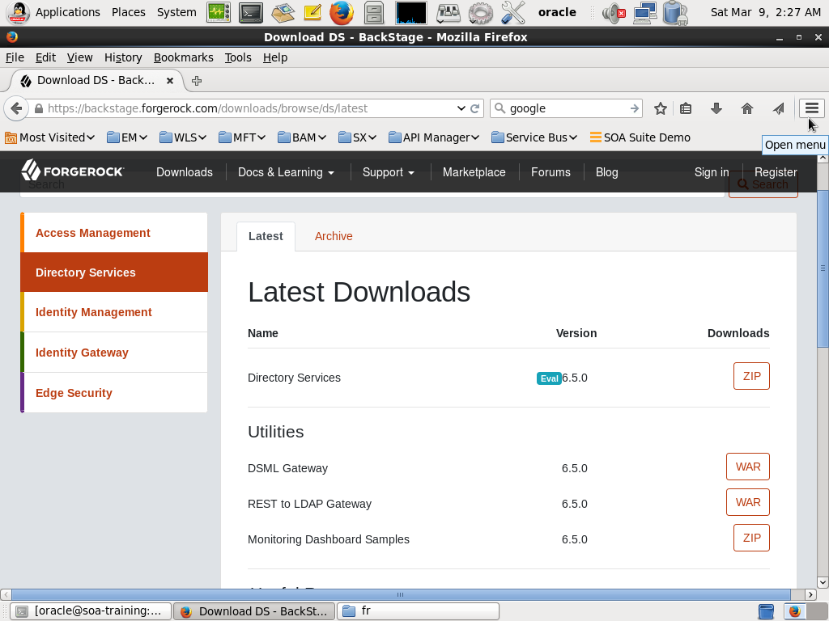

1. Download copy the zip to the directory where you want to install/configure frds:

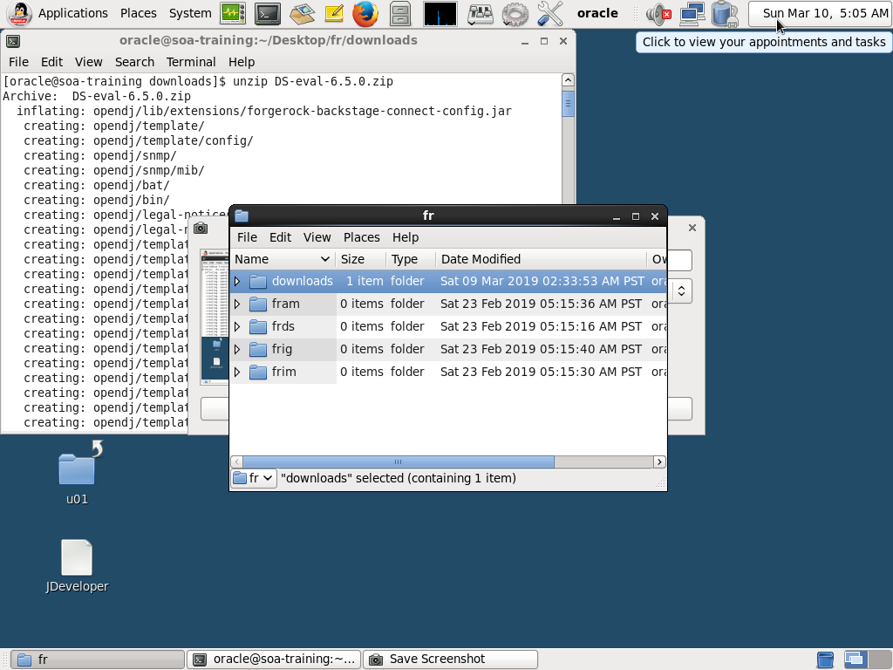

3) Run the setup command to install the FRDS 6.5

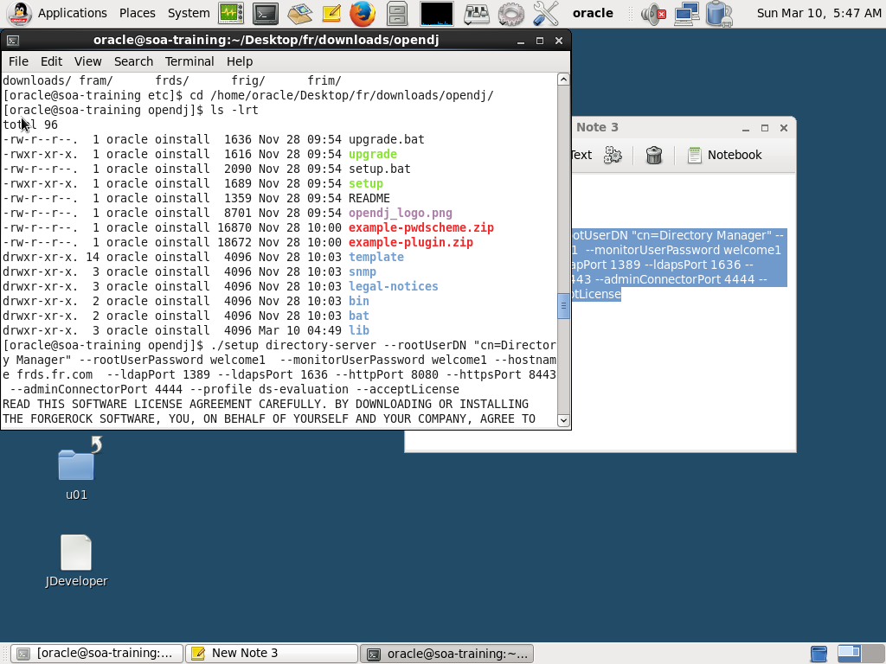

Run the following command to Install FRDS 6.5 Evaluation Version:

|  |
| --- |
| ./setup directory-server --rootUserDN "cn=Directory Manager" --rootUserPassword welcome1 --monitorUserPassword welcome1 --hostname frds.fr.com --ldapPort 1389 --ldapsPort 1636 --httpPort 8080 --httpsPort 8443 --adminConnectorPort 4444 --profile ds-evaluation --acceptLicense |

4) Make sure the output is

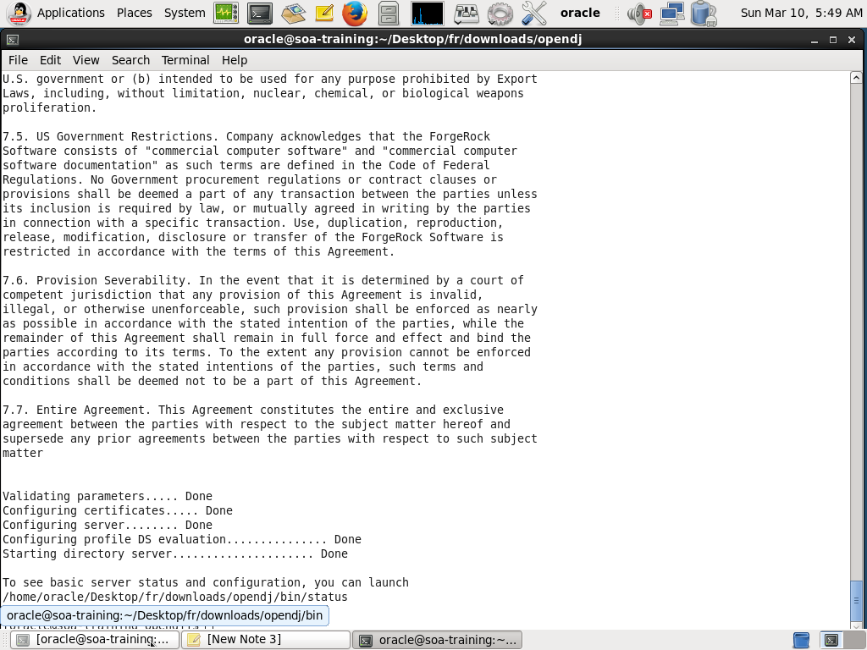

5) check the server status

|  |
| --- |
| /home/oracle/Desktop/fr/downloads/opendj/bin/status --offline |

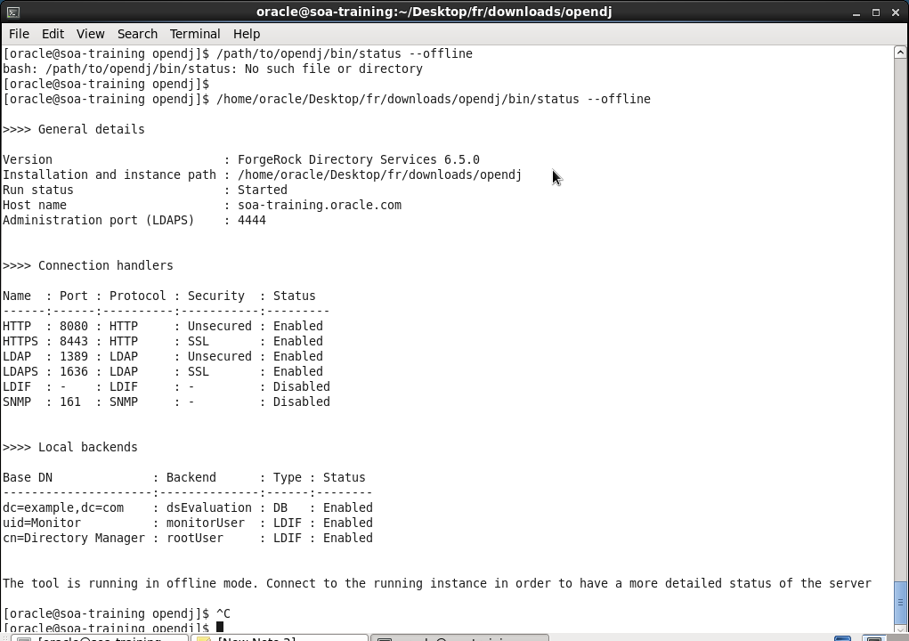

6) Connect to FRDS using Jxplorer:

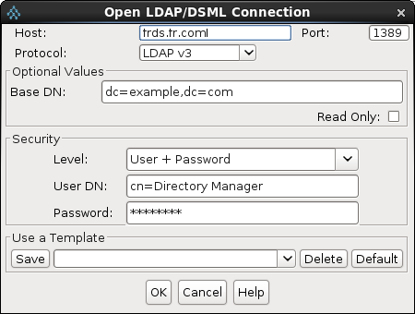

7) Display Users:

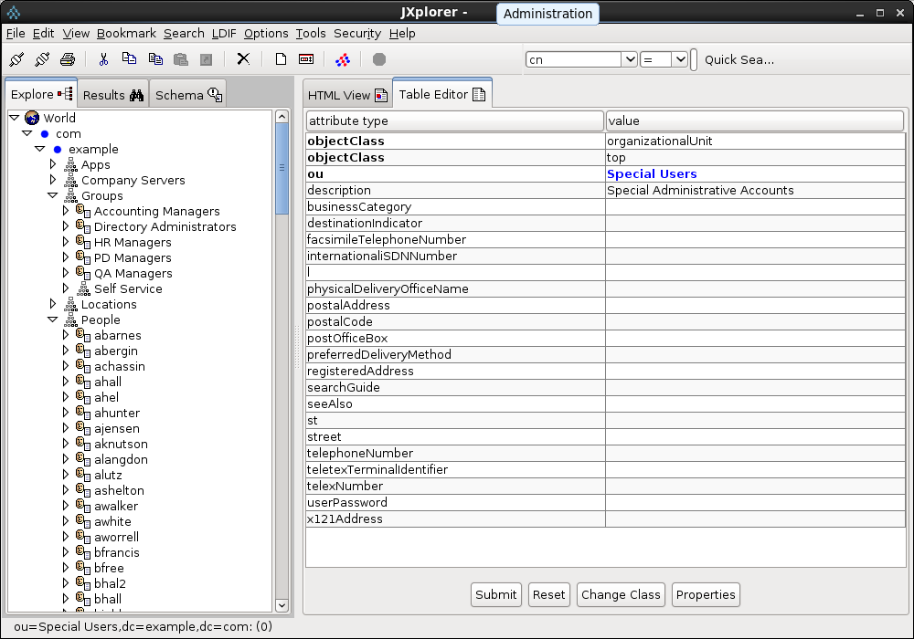

8) Display Users:

|  |
| --- |
| Command to start the server: ./start-ds  Command to stop the server: ./stop-ds |

9) Adding custom attributes and classes:

Make a ldif file

|  |
| --- |
| dn: cn=schema  changetype: modify  add: attributeTypes  attributeTypes: ( temporary-fake-attr-id  NAME 'myCustomAttribute'  EQUALITY caseIgnoreMatch  ORDERING caseIgnoreOrderingMatch  SUBSTR caseIgnoreSubstringsMatch  SYNTAX 1.3.6.1.4.1.1466.115.121.1.15  USAGE userApplications )  -  add: objectClasses  objectClasses: ( temporary-fake-oc-id  NAME 'myCustomObjClass'  SUP top  AUXILIARY  MAY myCustomAttribute ) |

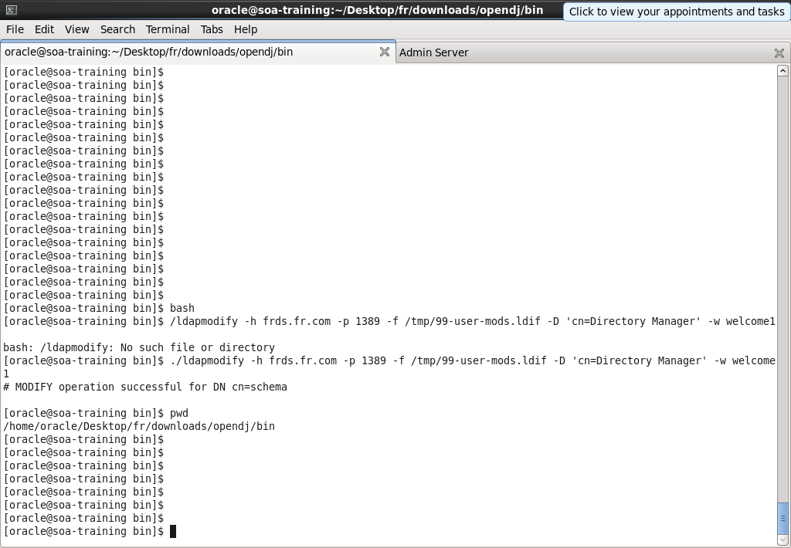

The output generated 99-user.ldif

|  |
| --- |
| [oracle@soa-training schema]$ cat 99-user.ldif  dn: cn=schema  objectclass: top  objectclass: ldapSubentry  objectclass: subschema  cn: schema  attributeTypes: ( temporary-fake-attr-id NAME 'myCustomAttribute' EQUALITY caseIgnoreMatch ORDERING caseIgnoreOrderingMatch SUBSTR caseIgnoreSubstringsMatch SYNTAX 1.3.6.1.4.1.1466.115.121.1.15 USAGE userApplications X-SCHEMA-FILE '99-user.ldif' )  modifiersName: cn=Directory Manager  modifyTimestamp: 20190311132833Z  objectClasses: ( temporary-fake-oc-id NAME 'myCustomObjClass' SUP top AUXILIARY MAY myCustomAttribute X-SCHEMA-FILE '99-user.ldif' )  [oracle@soa-training schema]$ pwd  /home/oracle/Desktop/fr/downloads/opendj/db/schema |

Verify the attribute using Jxplorer:

