**PROJECT REPORT**

**ON**

**Business Continuity Plan**

**for**

**SAP-ERP System at BSL**

*A report submitted in partial fulfilment of the requirement for the award of*

*The degree of*

**BACHELOR OF TECHNOLOGY**

**In**

**COMPUTER SCIENCE AND SYSTEM ENGINEERING**



**Submitted By: -Abhishek Bharti**

**Name of Guide**

Mr. Sudhanshu Shekhar

Manager (C&IT)

SAIL

Department

**CANDIDATES DECLARATION**

I hereby certify that the work, which is being presented in the report/project report, entitled **“Business Continuity Plan for SAP-ERP System at BSL”**, in partial fulfillment of the requirement for the award of the Degree of **Bachelor of Technology** and submitted to the institution is an authentic record of my/our own work carried out during the period *from 27/05/2019 to 20/072019* under the supervision of **Mr. Sudhanshu Shekhar.**

1.

**Date: Signature of the Candidates**

This is to certify that the above statement made by the candidate is correct to the best of my/our knowledge.

**Date: Signature of the Supervisor**

**CERTIFICATE**

This is to certify that the Project entitled **“Business Continuity Plan for SAP-ERP System at BSL”** in partial fulfillment of the requirement for the award of the **Degree B. Tech** in **Computer Science and System Engineering,** submitted to **SAIL, BOKARO STEEL CITY** is an authentic record of bonafide research work carried out by ABHISHEK BHARTI under my supervision and guidance.

**Signature of Guide Signature of HOD**

**Mr. Sudhanshu Shekhar   
Manager (C&IT)**

**SAIL,**

**BOKARO STEEL CITY**

**CERTIFICATE**

This is to certify that Abhishek Bharti from NATIONAL INSTITUTE OF TECHNOLOGY JAMSHEDPUR has undergone project-based training in **Steel Authority of India Limited (SAIL), Bokaro Steel Plant, Bokaro, Jharkhand** for a period of **8 weeks** from 27th May, 2019 to 20th July, 2019 under the guidance of **Mr. Sudhanshu Shekhar, Manager (C&IT), SAIL, Bokaro.**

Her performance was satisfactory so as to fulfill all the requirements for successful completion of the training.

**Signature of Candidate Signature**

**Date: Mr. Rajendra Kumar**

**Assistant Manager**

**HRD, SAIL, Bokaro**

**Date:**

**ACKNOWLEDGEMENT**

The satisfaction that accompanies that the successful completion of any task would be incomplete without the mention of people whose ceaseless cooperation made it possible, whose constant guidance and encouragement crown all efforts with success.

We wish to express my profound gratitude and indebtedness to **Mr. Sudhanshu Shekhar**, Manager (C&IT) BOKARO for introducing the present topic and for their inspiring guidance, constructive criticism and valuable suggestion throughout this project work.

Last but not least, our sincere thanks to all our friends who have patiently extended all sorts of help for accomplishing this undertaking.

**ABSTRACT**

The introduction of an information system such as Enterprise Resource Planning (ERP) in an organization brings with it changes on how users work. An ERP system cuts across the different functional units of an organization and therefore if not properly managed during its implementation may lead to resistance from the users. The different streams of research on ERP systems have mainly been on business continuity, ERP adoption, success measurement, and critical success factors (CSFs). There is a paucity of studies on user participation and the contribution of users towards the successful implementation of ERP systems. This paper reviews the business continuity scope on ERP implementation and dealing with risks to save the organization a significant amount of time and money.

**Key terms:** Enterprise Resource Planning, ERP systems, ERP implementation, user participation, CSFs.

**TABLE OF CONTENT**

**CHAPTERS PAGE**

**1. INTRODUCTION**

1.1 Overview 9

1.2 Motivation 12

1.3 Purpose 13

1.4 Objective 14

**2.OVERALL DESCRIPTION**

2.1 Perspective15

2.2 Functions16

2.3 Technical 17

2.4Business Continuity18

**3. SYSTEM REQUIREMENTS**

3.1External Interface Requirement 22

3.1.1 Hardware & Software interface22

3.2 Functional Requirement24

3.3 Non-functional Requirement 27

**4.MODULES AND DIAGRAMS OF PROJECT**

4.1 DIGRAMS OF MODULES 37

**5.CONCLUSIONANDFUTUREWORK**

4.1 Conclusions 41

4.2 Scope for Future Work 42

**REFERENCES** 43

Chapter 1

**Introduction**

**SAP-ERP System**:

The SAP system is organized into several sets of 'solutions' (essentially, modules) that address the information needs of specific areas of any company's operations. Sitting on top of these already-integrated individual modules is the Cross-Application layer, components of which further ensure that these different solutions 'talk' to each other in a cohesive manner.

An ERP system is a real-time business application that caters to the information needs of an entire enterprise using a single repository of data (a database) and a very sophisticated set of software modules which facilitate decision-making and the actions based on these decisions.

**Why ERP?**

* To survive in the highly competitive business environment
* To achieve Market leadership in Indian & Global market
* To re-engineer business processes
* To adopt best global business practices
* To build state of the art IT infrastructure
* To increase Accuracy & Eliminate Duplicity
* To increase Information Availability and Reduce Inventory & Cycle time

**1.1 OVERVIEW**

INFORMATION TECHNOLOGY

ERP

LEGACY SYSTEMS

There are two types of business application in C&IT: -

1.ENTERPRISE RESOURCE PLANNING(ERP) is the integrated management of core business processes.

2.Legacy system is an older technology running on legacy platforms.

i.e. HP hardware with oracle dB and oracle firms and reports 6i, 10g front end.

SAP ERP is an enterprise management platform that has all the capabilities of supply chain management, product lifecycle management, human capital management, financial management and customer relationship management solutions. It can be deployed as a SaaS service, on-premise or as a hybrid model. What’s good about the solution is that you can customize it the way you want as the vendor has a network of partners that offers customization and integration services.

SAP ERP boasts a customer base of 172,000 businesses worldwide. With the solution, you get to have access to vital applications, analytical tools and data that can greatly help you streamline your processes and help organizations become more competitive. Aside from these, you also get to enjoy full web-enabled support from the vendor. The software can help you in managing your whole organization making tasks such as product planning and general ledger reporting far easier. This one-size-fits-all platform can cater to any business type and size and is so scalable that you will never have to look for another solution again.

SAP ERP has a myriad of benefits that can help your business grow, regardless of what you sell or the services you provide. The following are but some of them:

**Procure to Pay**

When properly managed, procurement can drive your sales and make your business more competitive. SAP ERP can help you manage such process by being able to identify the lowest-cost supplier while ensuring that your business complies with all regulations. It covers all procurement processes, which include requisition, invoicing, and payments. It likewise coordinates inventory levels among different storage locations and is able to consolidate your shipping needs. The solution also allows you to establish strong relationships with the best providers around.

**Core Finance**

As SAP ERP doubles as a financial management tool, it has all the accounting features that you’ll ever need. It consolidates all your business’ financial information into a general ledger. Using the software, you can be assured of accurate and timely financial reporting. Data collected by the platform are readily accessible for use in reporting and analytics. They can be viewed in real time through the product’s dashboards. You can likewise compare costs against revenue using this functionality.

**Plan to Product**

If you are a manufacturer, you can directly link production schedules to the procurement and ordering process. With this feature, you are always aware of what you need for your production process and how much are needed, doing away with the risk of overstocking or understocking. Such applies to any business size, be it a local shop or a multinational company.

This functionality provides you with access to tools that can help you better understand your manufacturing process and come up with ways to boost efficiencies, cut production time and create quality assurance programs. You can identify problematic areas on the factory floor and formulate ways by which to improve them.

**Core Human Resources**

As an HR management solution, SAP ERP helps you manage that which is the most vital of your resources–your workers. It helps in managing business growth while keeping staff engagement and satisfaction at a maximum through centralized HR management and flexible payroll capabilities. You can likewise coordinate HR functions, providing managers with web-enabled access to the solution.

SAP ERP can also manage employee time and attendance, which both staff and managers can access through the Web. This feature can greatly benefit workers, giving them ample time to manage extremely important life events. Requests can be approved through the HR portal provided, leading to improved worker satisfaction. You also get support for recruiting, onboarding, administration, professional development, and promotion.

**Technical Capabilities**

SAP ERP has a number of technical features that can greatly benefit your organization. Its applications are some of the best of their kind as they are built around the solutions integrations. You are likewise able to take advantage of add-on cloud modules that can integrate with the software, such are easily installed and can be accessed from virtually anywhere. Aside from these, the platform’s real time analytics can be accessed at any given time and are known to provide only reliable ERP data. Meanwhile, the products database and technology provide you with the necessary tools, standards and flexibility that make ERP management a less tedious task.

**Business continuity**

Business continuity is the planning and preparation of a company to make sure it overcomes serious incidents or disasters and resumes its normal business operations within a reasonably short period. Despite the perceived benefits of an accelerated implementation, overlooking business continuity planning can increase business risk and project cost in the long run. In an era of increasingly interconnected business processes, knowing the potential implementation risks and planning for and mitigating those risks will save organizations significant time and money.

In a typical ERP system, multiple ERP modules interface with one another so if one module shuts down or experiences a delay, other modules are affected. The more modules that are interconnected, the more an organization suffers when part of the ERP system fails. With so serious a threat, no organization can afford to skip business continuity planning which is necessary to minimize any unscheduled downtime.

* 1. **MOTIVATION**

Customer wanted to deploy an application that suits his/her requirements by replacing the existing software due to the following reasons: -

* The existing Hardware is old, and the response time is high.
* The software is out of maintenance with no updates, or with no company.

(Company Bankrupt/ Merger etc.)

* The customer could not be competitive in the market due to the legacy methods deployed.

B1 - C++, No ABAP, BASIS, NW

* The existing software is not capable to communicate with other systems.
* The software is not user friendly to take the user inputs.
* It cannot communicate with print, fax, SMS and paging devices.
* Too many legacy systems, too little integration, manual inputs and monitoring are the various issues with the current software.

**1.3 PURPOSE**

* Allows easier global integration (barriers of currency exchange rates, languages, and cultures can be bridged automatically)
* Updates only need to be done once to be implemented company-wide
* Provides real-time information, reducing the possibility of redundancy errors
* May create a more efficient work environment for employees
* Vendors have past knowledge and expertise on how to best build and implement asystem
* User Interface is completely customizable allowing end users to dictate the operational structure of the product

**1.4OBJECTIVES**

The objective of the ERP Business Transformation Strategy is to modernize and integrate business processes and systems. This “leapfrog” into the future will empower staff and students to access information and provide services through an intuitive and integrated interface, and ultimately aims to:

* Improve Service Experience
* Enhance Competitiveness
* Modernize Business Processes and Systems
* Automate Business Solutions
* Increase Operating Efficiency
* Provide Access to Standardized College Data

**Chapter-2**

**Overall description**

* 1. **Project Perspective**

Manufacturing ERP systems solve a number of challenges and provide invaluable benefits to manufacturers seeking to reduce costs, manage growth, streamline processes and gain a competitive advantage.[ERP software](https://www.workwisellc.com/erp-software/) integrates all areas of business (materials and inventory, production, operations and sales, accounting and finance, etc.) so that every business function relies on a single database. This “information hub” delivers accurate, real-time information crucial to the manufacturing industry.

Here are the top reasons to upgrade to a modern manufacturing ERP system:

* **Streamline Processes: -** As manufacturers grow, their operations become more and more complex. ERP manufacturing software automates all business operations, providing accurate, real-time information. ERP increases efficiency and productivity by helping users navigate complex processes, preventing data re-entry, and improving functions such as production, order completion and delivery.
* **Cost Reductions: -** With one source of accurate, real-time information, ERP software reduces administrative and operations costs. It allows manufacturers to proactively manage operations, prevents disruptions and delays, breaks up information logjams and helps users make decisions more quickly.
* **Flexibility: -** Modern ERP software systems are robust, flexible and configurable. They are not a one-size-fits-all proposition, but can be tailored around the unique needs of a business. ERP systems also have the ability to adapt with the ever-changing needs of a growing business.
* **Competition: -** ERP systems may require an investment, but there’s also a cost to do nothing. Manufacturers cannot afford to put off an ERP implementation while their competition invests in ERP and starts reaping the benefits.

Benefits:

* Reliable Information
* Total Transparency
* Simplified Transactions
* Optimum Inventory Management
* System Based Planning
* Breakdown Analysis
* Faster Financial Analysis
* Better Audit Control

Features provided by SAP-ERP are:

* Suitable for any government as well as private organization
* Streamlines your processes
* Saves time and money
* Making the organization efficient.

**2.2FUNCTIONS**

* Finance & Controlling (FICO)
* Materials Management & Supplier Relationship Management (MM & SRM)
* Logistics

Advance Planner and Optimizer (APO)

Sales and Distribution (SD)

Production Planning (PP)

Quality Management (QM)

* Plant Maintenance (PM)
* Process Interface (PI)
* Business Information Warehouse (BIW)
  1. **TECHNICAL**
* BASIS Administration
  + System Administration
  + Server Administration
  + SAP HP UX Administration
* Data Centre Management System (BMS)
* Network Administration

Customer (CMO)

Suppliers / Contractors

**ERP: Integrated Platform**

**OVERVIEW OF BUSINESS PROCESSES**

**BSL Outstation Offices**

**FIG:2.1**

**2.4 Business continuity**

Business continuity is the planning and preparation of a company to make sure it overcomes serious incidents or disasters and resumes its normal operations within a reasonably short period

management of business continuity falls largely within the sphere of quality management and risk management, with some cross-over into related fields such as governance, information security and compliance.

Following are five tips for developing an effective business continuity plan:

* **Educate executives about the risks.** If you expect executives to allocate the necessary money and resources for risk mitigation, they need to be educated about the importance of continuity planning.
* **Understand that continuity planning is a business issue; not a technology issue.** ERP systems can be fairly easy to fix after a shutdown but playing catch up with delayed orders and a disrupted supply chain is much more agonizing.
* **Start developing a continuity plan at the beginning of an ERP implementation.** The sooner your organization starts planning, the better. During system integration, your organization should validate its continuity plan to ensure that it addresses all interdependencies within the system as well as between the system and the rest of the IT infrastructure.
* **Assign business continuity experts to the development of the plan.**This skillset is fairly rare within organizations but it is a skillset that can easily be developed if an employee has a working knowledge of [business process management](https://www.panorama-consulting.com/services/business-process-reengineering/) and performance optimization.
* **Test your continuity plan.** Your organization should validate that the plan actually will work and the project team knows what to expect in terms of their role in system recovery.

**Disaster recovery (DR)**

Disaster recovery (DR) involves a set of policies, tools and procedures to enable the recovery or continuation of vital technology infrastructure and systems following a natural or human-induced disaster. Disaster recovery focuses on the IT or technology systems supporting critical business functions, as opposed to business continuity, which involves keeping all essential aspects of a business functioning despite significant disruptive events. Disaster recovery is therefore a subset of business continuity

**Importance of disaster recovery planning**

Recent research supports the idea that implementing a more holistic pre-disaster planning approach is more cost-effective in the long run. Every $1 spent on hazard mitigation (such as a disaster recovery plan) saves society $4 in response and recovery costs.

**Control measures**

Control measures are steps or mechanisms that can reduce or eliminate various threats for organizations. Different types of measures can be included in disaster recovery plan (DRP).

**Quorum Server**

A quorum is the minimum number of votes that a distributed transaction has to obtain in order to be allowed to perform an operation in a distributed system.In a distributed database system, a transaction could be executing its operations at multiple sites. Since atomicity requires every distributed transaction to be atomic, the transaction must have the same fate (commit or abort) at every site. Replication in computing involves sharing information so as to ensure consistency between redundant resources, such as software or hardware components, to improve reliability, fault-tolerance, or accessibility.

Quorum servers ensure the integrity of virtual machines against multiple network failure scenarios, including split brain, and provide for unattended start-up of virtual machines after specific failures. Quorum server communication occurs via the management network.

If only two sites are available and if one server goes down and the surviving server is unable to communicate with the quorum server (for example, because it is on the same site as the down server), the virtual machines at the surviving site are automatically shut down to avoid a potential split-brain scenario.

**HP Service Guard**

* HP Service guard, formerly known as MC/Service Guard, is high-availability cluster software produced by HP that runs on HP-UX and Linux. Service guard has existed since 1990, which HP claims to have been the first high availability solution for UNIX
* Its’ a high availability and disaster recovery clustering solution, that increases uptime for your critical applications by protecting from a multitude of infrastructure and application faults across physical or virtual environments over any distance.
* It reduces impact of unplanned downtime with no compromise on data integrity and performance. Furthermore, it helps achieve near zero planned downtime for maintenance.

**Data centre (DC)**

Data centre is a facility used to house computer systems and associated components, such as telecommunications and storage systems

**Requirements for modern data centres**

* IT operations are a crucial aspect of most organizational operations around the world. One of the main concerns is business continuity; companies rely on their information systems to run their operations. If a system becomes unavailable, company operations may be impaired or stopped completely
* Operate and manage a carrier's telecommunication network
* Provide data centre-based applications directly to the carrier's customers
* Provide hosted applications for a third party to provide services to their customers
* Provide a combination of these and similar data centre applications

**Disk storage replication**

Active storage replication is usually implemented by distributing updates of a block device to several physical hard disks. This way, any file system supported by the operating system can be replicated without modification, as the file system code works on a level above the block device driver layer. It is implemented either in hardware or in software.

**Metro Cluster**

Metro Cluster’s free functionality for FAS and AFF systems for metro high availability with synchronous replication between two sites, this configuration requires additional equipment. Metro Cluster uses Sync Mirror and plex technique where on one site number of disks form one or more RAID groups aggregated in a plex, while on the second site have same number of disks with same type and RAID configuration. One plex synchronously replicates to another in compound with non-volatile memory. Two plexes form an aggregate where data stored and in case of disaster on one site second site provide read-write access to data. Metro Cluster Support Flex Array technology. Metro Cluster configurations are possible only with mid-range and high-end models which provide ability to install additional network cards required to MC to function.

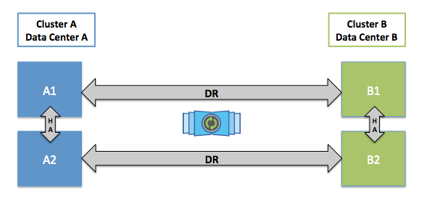

Fig2.4 : Metro Cluster local and DR pare memory replication

**CHAPTER-3**

**SYSTEM REQUIREMENTS**

**3.1EXTERNAL INTERFACES**

**3.1.1 HARDWARE INTERFACE**

* Data Centre – 1 & 2
* Extensive OPTICAL FIBRE CABLE Network
* Large PC User Base

**HARDWARE RESOURCES AT DC1**

* Superdome Server for production systems
* RX8640 Servers for DEV and QAS systems
* Rx6600 - Backup server
* RX2660 - Production Apps servers
* SAN Storage XP24000
* HP MDS 9509 Director SAN Switch
* ESL 322e E-Series Tape Library

**HARDWARE RESOURCES AT DC2**

* Superdome Server for production systems
* Rx6600 - Backup server
* RX2660 - Production Apps servers
* SAN Storage XP24000
* HP MDS 9509 Director SAN Switch
* HP EML 103e Tape Library

|  |  |
| --- | --- |
| **System Requirements** | **Description** |
| Databases | MAXDB 64-BIT, ORACLE 64-BIT, |
| Operating Systems | HP-UX ON IA64, WINDOWS FOR X86_64 |
| Web Browsers | 1  apache |
| Java Platform, Standard Edition | SAP JVM 6.1 |

**3.2FUNCTIONAL REQUIREMENTS**

The functional requirements part discusses the functional behavior that should be possessed by the system. Each requirement maps to a high level function (fi) that transforms the given set of input data (ii) into output data. Different functional requirements possessed by the system are:-

* **ORACLE DATABASE ADMINISTRATION**

->TABLE SPACE MANAGEMENT

->BACKUP (ONLINE,OFFLINE FILE SYSTEM)

->ORACLE PERFORMANCE TUNING

* **SAP ADMINISTRATION**

->SAP CHANGE AND TRANSPORT MANAGEMENT SYSTEM

->ROLES AND AUTHORIZATION

->NEW USER ID CREATION

->PATCH MANAGEMENT

->MAJOR RELEASE UPGRADE

* **COORDINATION WITH HP HARDWARE TEAM FOR OS AND MAINTAINANCE OF HARDWARE**
* **SAP SECURITY MANAGEMENT**

-> R3 PASSWORD POLICY

->New ID Creation Process

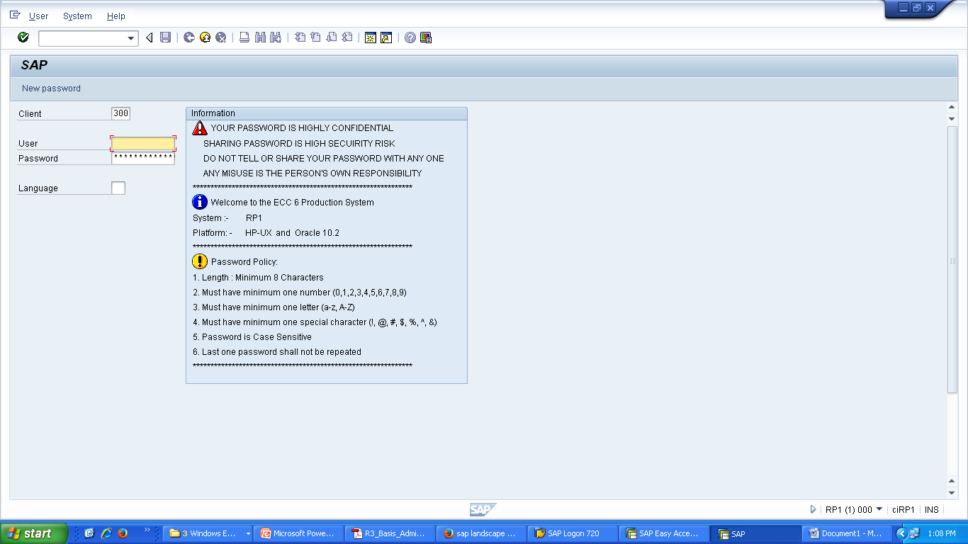

**FIG 3.2 - LOGIN UI**

* **BUSINESS CONTINUITY PLAN**
  + PRD Servers – High Availability Mode
  + Active Primary/Active Secondary DR Site
  + PRD Servers – Metro Cluster
  + Storage Based Clustering
  + Service Guard – Quorum Server
  + Automatic failover from DC1 to DC2
  + Manual failback
* **BACKUP POLICY**
  + Fully Automated Robotic Controlled Tape Library at DC1and DC2
  + ESL 322e E-Series Tape Library
  + HP EML 103e Tape Library
  + Business Copy
  + Daily Online and Archive Backup for all Systems
  + Weekly SMB Offline Backup
  + Quarterly File System Backup

**3.3NON-FUNCTIONAL REQUIREMENTS**

**SAP NetWeaver -Introduction**

SAP NetWeaver (SAP NW) describes all the software and services used for 'Business Enablement'. The SAP Business suite, such as ERP Central Component (ECC) or Supplier Relationship Management (SRM), contains the software components for that specific business solution.

Following are the key points about SAP NetWeaver platform: •

* It is an open technology platform that offers a comprehensive set of technologies for running mission-critical business applications and integrating people, processes, and information. •
* It is a web-based, open integration, application platform that serves as the foundation for Enterprise Service-Oriented Architecture (Enterprise SOA) and allows the integration and alignment of people, information, and business processes across business and technology boundaries. •
* It utilizes open standards to enable integration with information and applications from almost any source or technology. •
* It is the foundation of SAP Business Suite and SAP Business by Design. It also powers partner solutions and custom-built applications.

**SAP NW Development**

SAP NetWeaver was first introduced by Top Tier Software, an Israeli company, in 1997. SAP has acquired this company in the early 2000’s. The first version of SAP NetWeaver was released in 2004 with version NW7.0.

**Note:** The latest available version is SAP NetWeaver 7.5 released in Q4 2015. SAP has tied up with various hardware vendors to provide different application components to enhance the capabilities of the NetWeaver platform. SAP Business Warehouse (BW) Accelerator is one of the examples that was developed to improve data load and query performance in SAP BW.

Various application development has been introduced by SAP based on the NetWeaver platform like ABAP Workbench, Web Dynpro, Visual Composer, SAP Solution Manager and NetWeaver Developer Studio (NWDS) based on JAVA stack.

In the following image, you can see key enablement based on SAP NW Platform: • **Highly Configurable Business Applications** − This includes SAP ECC suite, SAP CRM software suite for Customer Relationship Management, Supply Chain Management and other key modules that are part of SAP Enterprise Resource Planning (ERP) solution.

**Business Enablement Applications −** This contains business enablement applications like SAP Process Integration (PI), Enterprise Portal, and Business Intelligence software suite. •

**Common Development and Technology Platform −** This contains web development and application development technologies like ABAP Workbench, SAP Web Dynpro, Visual Composer, etc

## SAP Net Weaver is one of central component of entire SAP software stack and provides a platform for the other components, as well as JAVA and ABAP applications. SAP Application server consists of multiple application server instances and also database servers. With the use of dialog instance, it also contains a message server and an enqueue server. A dialog instance executed by the user has the following components:

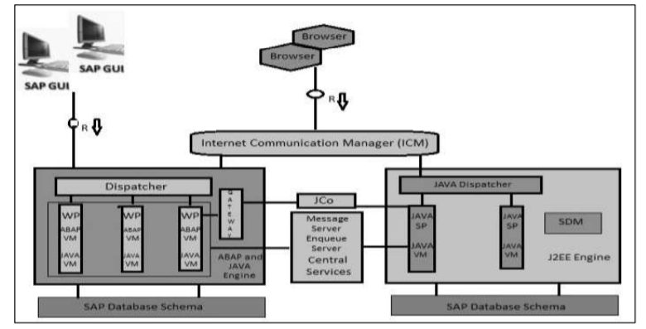

**FIG 3.3.1-DIFFERENT MODULE**

## Internal Communication Manager − It is used to process both the client and the server web requests. It supports protocol – HTTP, HTTPS, SMTP. •

## Dispatcher − Dispatcher is used to distribute the user request to different work processes. If all the work processes are busy, requests are stored in the Dispatcher queue.

## Work Processes − These are used to execute Java or ABAP programs. •

## SAP Gateway − This provides RFC interface between SAP instances. •

## Message Server − This is used for message communication and also balances the load in SAP system.

**HP Superdome Server**

The **HP Superdome** is a high-end server computer developed and produced by [Hewlett Packard Enterprise](https://en.wikipedia.org/wiki/Hewlett_Packard_Enterprise) (formerly [Hewlett-Packard](https://en.wikipedia.org/wiki/Hewlett-Packard)). The latest version of product, "Superdome 2" was introduced in 2010. Superdome 2 scales from 2 to 32 [sockets](https://en.wikipedia.org/wiki/Processor_socket) (up to 128 [cores](https://en.wikipedia.org/wiki/Processor_core)) and 4 TB of memory. When introduced in 2000, the Superdome used [PA-RISC](https://en.wikipedia.org/wiki/PA-RISC) processors. Since 2002,there has been another version of the machine based on [Itanium 2](https://en.wikipedia.org/wiki/Itanium_2) processors, marketed in parallel as the **HP Integrity Superdome**. The classic PA-RISC Superdome was subsequently rebranded to **HP 9000 Superdome**. The predecessor to the Superdome was the HP V-Class (which was based on a design acquired from [Convex](https://en.wikipedia.org/wiki/Convex_Computer)).

The **HP Integrity Superdome 2** utilizes the Intel Itanium 93xx-series microprocessor, otherwise known as "[Tukwila](https://en.wikipedia.org/wiki/Tukwila_(processor))" and is totally redesigned with parts from the [HP Blade System C7000](https://en.wikipedia.org/wiki/BladeSystem) enclosure. Since 2012 Intel Itanium 95xx microprocessor Poulson are available too. In 2017, Intel announced that their most recent Itanium chip (code-named Kittson) would be their last Itanium update.

In 2016, [Hewlett Packard Enterprise](https://en.wikipedia.org/wiki/Hewlett_Packard_Enterprise) released the Superdome X, which is based on [Intel](https://en.wikipedia.org/wiki/Intel) [Xeon](https://en.wikipedia.org/wiki/Xeon) processors.

Superdome usually runs the [HP-UX](https://en.wikipedia.org/wiki/HP-UX) operating system, although the Itanium 2 version is also compatible with many other systems, for example with [Microsoft Windows Server 2008 R2](https://en.wikipedia.org/wiki/Microsoft_Windows_Server_2008_R2),[[3]](https://en.wikipedia.org/wiki/HP_Superdome#cite_note-2008r2requirements-3) [SUSE Linux Enterprise Server](https://en.wikipedia.org/wiki/SUSE_Linux_Enterprise), [Red Hat Enterprise Linux](https://en.wikipedia.org/wiki/Red_Hat_Enterprise_Linux),[[4]](https://en.wikipedia.org/wiki/HP_Superdome#cite_note-4) [Debian Squeeze](https://en.wikipedia.org/wiki/Debian_Squeeze) (while Long Term Support for it has ended), and [OpenVMS](https://en.wikipedia.org/wiki/OpenVMS) V8.2-1

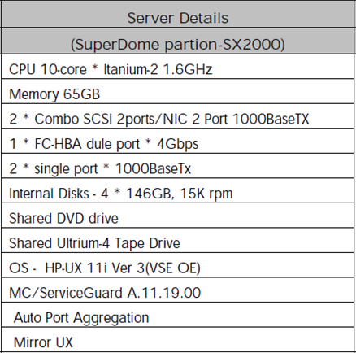

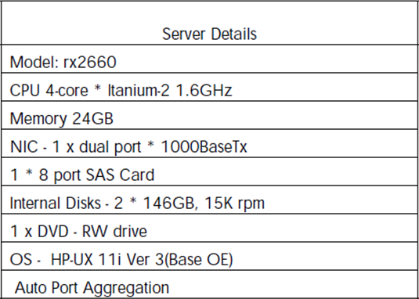

**Application Server Details**

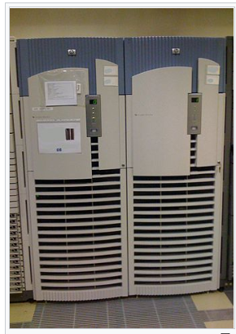

**Figure 3.3.2 Superdome Server**

**HPE 3 PAR storage**

3PAR was founded in mid-1998 or 1999, originally called 3PARdata.The founders included Jeffrey Price and Ashok Singhal, the P and A in the company's name. The R stands for a third partner, Robert Rogers, who left the company in 2001. David Scott became president and CEO in January 2001.

3PAR first shipped the InServ storage server in September 2002. 3PAR's primary competitors in the enterprise storage market are [Dell EMC](https://en.wikipedia.org/wiki/Dell_EMC), [Pure Storage](https://en.wikipedia.org/wiki/Pure_Storage), [NetApp](https://en.wikipedia.org/wiki/NetApp), [Hitachi Data Systems](https://en.wikipedia.org/wiki/Hitachi_Data_Systems) and [IBM](https://en.wikipedia.org/wiki/IBM). 3PAR called itself a pioneer of [thin provisioning](https://en.wikipedia.org/wiki/Thin_provisioning), a mechanism to improve the utilization efficiency of storage capacity deployment.3PAR first announced this capability in June 2002 and shipped it to customers in 2003.

An investment round of almost $33 million was disclosed in February 2004. Investors included [Mayfield Fund](https://en.wikipedia.org/wiki/Mayfield_Fund), [Menlo Ventures](https://en.wikipedia.org/wiki/Menlo_Ventures) and Worldview Technology Partners. In September 2007, 3PAR opened a second research and development office in [Belfast](https://en.wikipedia.org/wiki/Belfast), Northern Ireland. The company completed an [initial public offering](https://en.wikipedia.org/wiki/Initial_public_offering) in November 2007 and was initially listed on the [NYSE Arca](https://en.wikipedia.org/wiki/NYSE_Arca) exchange under the symbol PAR.In the same month, 3PAR introduced Virtual Domains, which allow for secure application data isolation on a consolidated multi-tenant storage platform. In December 2008, 3PAR moved to the NYSE Big Board. One year later, 3PAR opened an Indian subsidiary in Bangalore focused on providing logistical and administrative support for its Global Services and Support operations. In March 2010, the company introduced 3PAR Adaptive Optimization, the industry's first implementation of [autonomic](https://en.wikipedia.org/wiki/Autonomic_Computing) storage tiering for cost optimization in high-end storage systems, targeted at enterprises and service providers. In April 2010, the company was recognized by *Forbes* magazine as the fourth fastest growing technology company in its Tech25 list

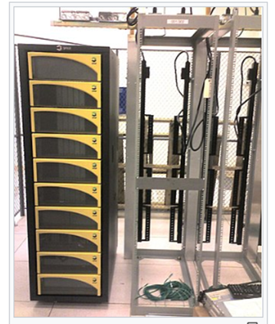

**FIG 3.3.3-HPE 3 PAR STORAGE**

**HPE XP**

The **HP Storage works XP** (XP = extended Platform) is a [computer data storage](https://en.wikipedia.org/wiki/Computer_data_storage) [disk array](https://en.wikipedia.org/wiki/Disk_array) sold by [Hewlett Packard Enterprise](https://en.wikipedia.org/wiki/Hewlett_Packard_Enterprise) using [Hitachi Data Systems](https://en.wikipedia.org/wiki/Hitachi_Data_Systems) hardware and adding their own software to it.[[1]](https://en.wikipedia.org/wiki/HPE_XP#cite_note-1) It's based on the Hitachi [Virtual Storage Platform](https://en.wikipedia.org/wiki/Virtual_Storage_Platform) and targeted towards enabling large scale consolidation, large database, Oracle, SAP, Exchange, and online transaction processing (OLTP) environments.

[**The XP Disk Array family**](https://en.wikipedia.org/wiki/HPE_XP#The_XP_Disk_Array_family)

* [1.1XP 48](https://en.wikipedia.org/wiki/HPE_XP#XP_48)
* [1.2XP 128](https://en.wikipedia.org/wiki/HPE_XP#XP_128)
* [1.3XP 256](https://en.wikipedia.org/wiki/HPE_XP#XP_256)
* [1.4XP 512](https://en.wikipedia.org/wiki/HPE_XP#XP_512)
* [1.5XP 1024](https://en.wikipedia.org/wiki/HPE_XP#XP_1024)
* [1.6XP 10000](https://en.wikipedia.org/wiki/HPE_XP#XP_10000)
* [1.7XP 12000](https://en.wikipedia.org/wiki/HPE_XP#XP_12000)
* [1.8XP 20000](https://en.wikipedia.org/wiki/HPE_XP#XP_20000)
* [1.9XP 24000](https://en.wikipedia.org/wiki/HPE_XP#XP_24000)
* [1.10P9500](https://en.wikipedia.org/wiki/HPE_XP#P9500)
* [1.11XP7](https://en.wikipedia.org/wiki/HPE_XP#XP7)

### XP 24000

A mixture of disk drives configured as RAID 1 (2D+2D and 4D+4D), RAID 5 (3D+1P, 7D+1P, 14D+2P and 28D+4P) and RAID 6 (6D+2P) from 9 to 1152 disk drives for 2.26PB Raw space. (Used at Cloud at Cost)

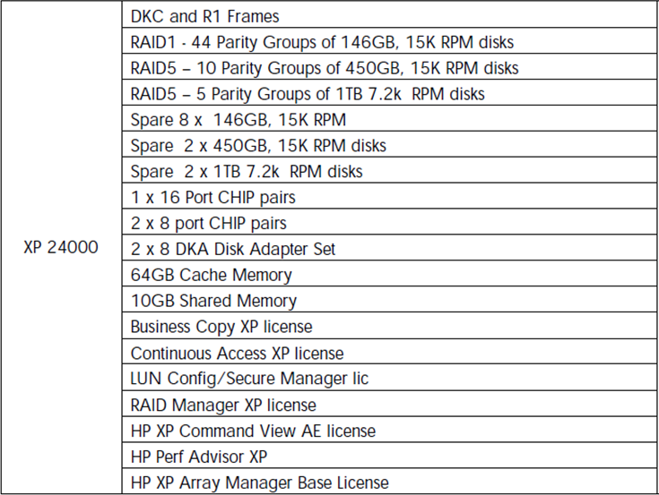

**DC1Storage**

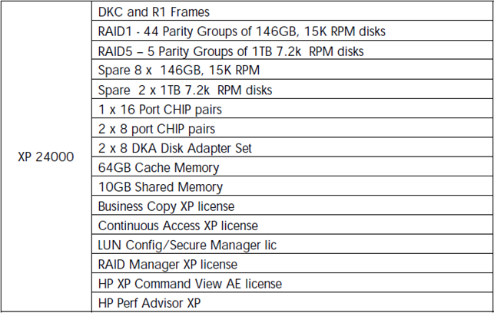

**DC2 Storage**

**Cisco MDSSAN switches**

Cisco MDS 9000 multilayer SAN switches can help lower the total cost of ownership (TCO) of storage environments. They combine a robust, flexible hardware architecture with multiple layers of network and storage-management intelligence. With them, you can build highly available, scalable storage networks with advanced security and unified management.

### Flexibility

MDS 9000 products are adaptable, ready to accommodate future physical, virtual, and cloud environments. They have fully redundant components and fault-tolerant design.

### Superior performance

MDS 9000 products provide for state-of-the-art multiprotocol and multiservice convergence. In addition, you can take advantage of a high-performance SAN extension.

**HPESL Tape library**

HPE Store Ever ESL G3 Tape Libraries deliver enormous scalability to keep pace with unpredictable data growth. Incorporating between 1 and 192 tape drives, end-user can consolidate and store up to 180PB (Compressed 2.5:1) of enterprise data. HPE ESL G3 also delivers high availability through redundant power supplies, dual-robotics capability, while host path connectivity failover provides optimal library performance.

**Product Features**

| **Feature** | **Description** |
| --- | --- |
| Scalability | * Capacity on demand from 100 to 12,006 tape cartridges and 1 to 192 tape drives * Scale from a choice of base configurations in increments of 100 slots * Bulk import/export station for faster cartridge load and unload * Library frames/expansion modules are in a standard 19-inch rack form factor |
| High availability | * Dual-robotics for continuous access to data * Redundant power supplies * Protect against connectivity failover with high availability control path and data path failover * 3 million MSBF |
| Manageability | * Manage multiple libraries from a single pane of glass using Command View Tape Library (CVTL) * Intuitive web GUI * Receive predictive and proactive status and alerts from Tape Assure * Monitor drives, library and media health for dependable data storage * Leading library management tools for monitoring, configuration, upgrading, and troubleshooting * Automated media pool delivers flexible partitioning to meet data growth requirements without reconfiguring software applications |
| Security | Hardware based data encryption through HPE's Enterprise Secure Key Manager (ESKM), or by license to SafeNet's KMIP 1.2 compliant encryption key manager |
| Longevity | * Ideal for archiving cold or active data with a media shelf-life of up to 30 years * Lowest cost per Gb for longer term storage, no on-going power or energy requirement * Portable, high density storage, small footprint with up to 6.35TB of compressed data on a single LTO-6 data cartridge * StoreOpen/LTFS for ease of use and assured interchange |

**HP 1.6TB LTO-4 Ultrium RW Data Cartridge**

The green, 1.6TB **LTO-4 Ultrium RW Data Cartridge** from **HP** is a re-writable tape offering high storage density, ease of management and scalable storage and backup performance. It features read speeds up to 240 MB/s. The LTO Ultrium cartridge memory chip delivers faster access time and enhanced media monitoring. Secure AES 256-bit encryption prevents unauthorized data access.

The 'smart grabber' mechanism and mechanical interlock prevent the leader pin from being pulled inside the tape housing. Sensors detect proper connection and prevent leader loss that would ruin the tape. Additionally, a simplified tape path reduces wear and tear and buildup of debris. HP's own stringent qualification test procedures for load/unload, drop testing, environmental stress testing and more ensure maximum reliability in data restoration. The cartridge is designed to retain its archival quality for up to 30 years.

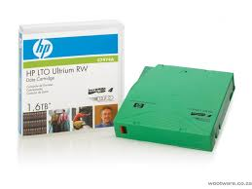

**Chapter-4**

**Modules and diagrams of project**

* The second tier will sanitize the input and attempt to process a response without communicating with the third tier. The second tier can trivially scale to any number of servers without issue. With the popularity of scale-out No-SQL databases, the second tier can also store data. But in general, it is more efficient to cache responses to the third tier.
* The third tier often runs a relational database which is less scalable and more expensive than the webservice running on the second tier. To this end, the third tier should be using as few software licenses as possible and run on more expensive hardware with more memory and faster internal networking.

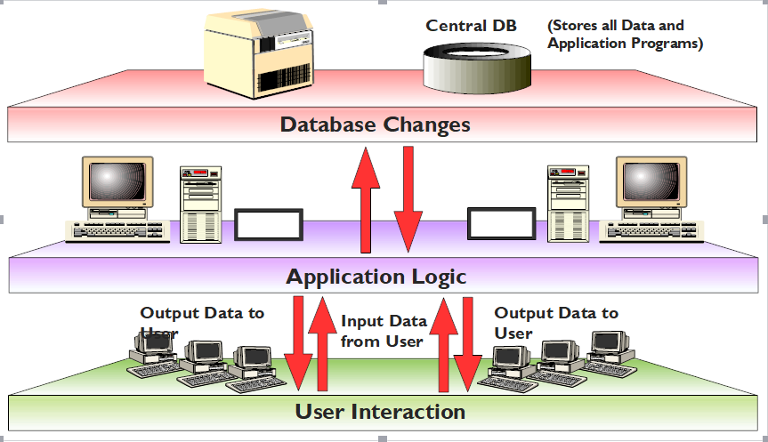

Fig 4.1: sap r/3: 3 tier architecture

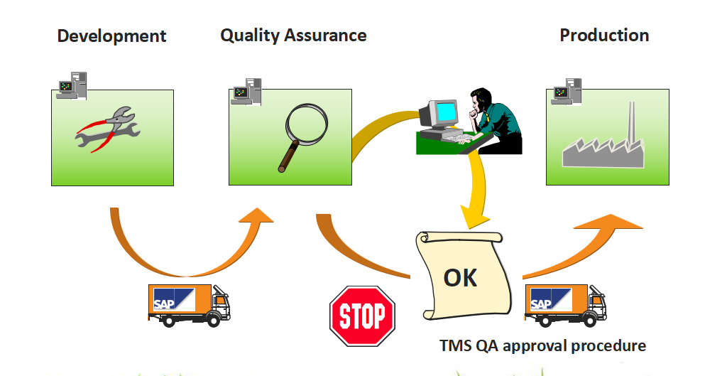

FIG 4.2: CTS-Quality Assurance

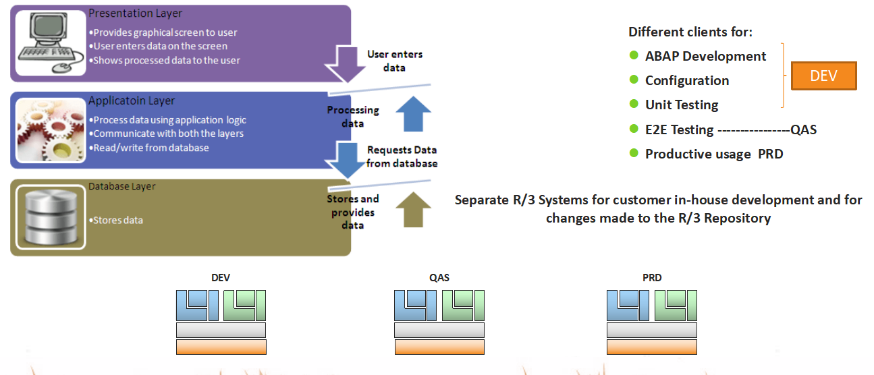

Fig 4.3: SAP 3 system landscape

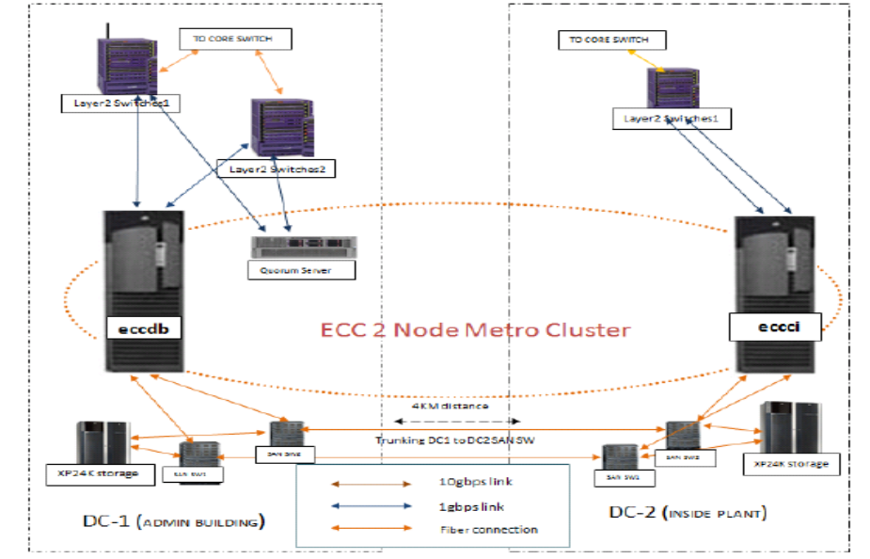

FIG 4.4: ECC - Cluster

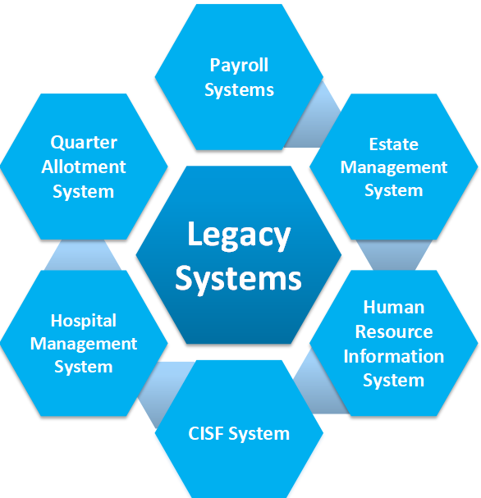

FIG4.5: IT Key Functional Areas: Legacy Systems

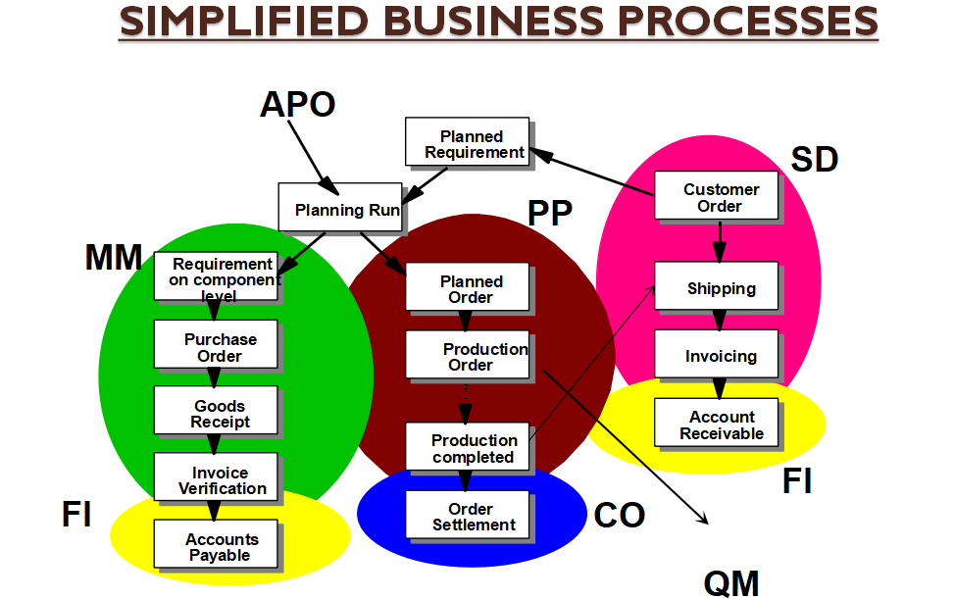

Fig4.6: Business module dependency

**Chapter-5**

**Conclusion and scope for future**

**5.1CONCLUSION**

The introduction of a new information system such as an ERP system will definitely change the way people work. The platform is new, new and different interfaces, data entry is changed and report formats are different. Users often find these changes unnecessary and therefore refuse to accept them. One of the ways to address and reduce the impact of these changes is to encourage user participation in the implementation of ERP systems. In this paper, we have reviewed past ERP research with an aim of building an agenda for user participation in ERP system implementation. As stated earlier, the past research has focused on ERP adoption, success measurement, success factors among other technical aspects of ERP implementation. An information system, including an ERP system, is user-interfaced and designed to provide information processing capability to support the strategy, operations, management analysis, and decision-making functions in an organization. The user is at the centre of an information system. ERP implementations are expensive and complex undertakings, but once they are successfully implemented, significant improvements can be achieved such as easier access to reliable information, elimination of redundant data and operations, reduction of cycle times, increased efficiency hence reducing costs .The implementation of an ERP system differs from that of any traditional information system due to its integrated nature which causes dramatic changes on work flow, organizational structure and on the way people do their jobs; Most ERP systems are not built but adopted and thus they involve a mix of business process reengineering (BPR) and package customization; and ERP implementation is not just a technical exercise but it is a socio-technical challenge as it poses new set of management procedures. In that sense, it has become clear that ERP implementation differs from traditional systems development where the key focus has shifted from a heavy emphasis on technical analysis and programming towards business process design and human elements. Unlike most home-growth legacy systems that were designed to fit individual working convention, ERP systems provide best practices, in other words generic processes and functions at their outset.

**5.2SCOPE FOR THE FUTURE DEVELOPMENT**

There are many people in the SAP world who started working in this area many years ago. Five, ten, even twenty or thirty years of experience are not that uncommon. For them, as for myself, SAP is mostly an [ERP system](http://www.sapexpert.co.uk/tag/erp) written on [ABAP](http://www.sapexpert.co.uk/tag/abap) programming language.

But if you are new to this world, your view on SAP may be very different. In my opinion, the change started when SAP (as a company) started to implement non-ABAP tools into the ERP system. I mean [Java stack](https://help.sap.com/saphelp_nwpi71/helpdata/en/48/03b72c49f04aa5e10000000a421937/content.htm).

The addition of a Java layer was meant to help developers. And I hope it did.  
In the meantime, SAP (as a company) started to move into the adjacent areas and also went shopping.

SAP Portal, SAP HANA and some others are SAP developments that are aimed at the non-ERP segment of business applications. At the same time, Siebel, Fiori and others represent acquisitions that are ERP satellites.

Many of these new products have nothing to do with ABAP. Some of them have nothing to do with ERP either. But SAP still had a point in developing or acquiring them: they want to deliver a complex solution from a single vendor for the end customer.

Sometimes the integration of the complex solution goes well. Sometimes, especially on early and ramp-up phases, not so smoothly. Unfortunately, it is quite often that the customer pays for the additional development for the integration and loses money due to a lack of experience on the part of the implementation team.

What does that mean for us as consultants? It means you can now spread your knowledge to a wider range of systems and technologies, if you wish. It also means that ABAP knowledge may be unnecessary even for an experienced SAP consultant, if (s)he works in a non-ABAP environment.

**Project Member:**

**Guide Name and Signature:**

Mr. SUDHANSHU SHEKHAR

Manager (C&IT)

SAIL, BOKARO STEEL CITY

Signature: ______________