**ASSIGNMENT-2**

**Lexical Analyzer**

**Q1. Given an input sentence, write a Lex Program to count the number of words whose length is greater than 2.**

**Q2. Given a paragraph in English, write a lex program which count the number of words, number of special characters, number of lines, spaces and tabs in the paragraph.**

**Q3. Write a Lex program to check weather given number is odd or even and if it is odd also check whether it is prime or not.**

**Q4. Given an input sentence, write a Lex Program to find the maximum number of characters present in the longest word.**

**Program 1**

%{

#include <stdio.h>

int len=0, counter=0;

%}

%%

[a-zA-Z]+ { len=strlen(yytext);

if(len>2)

{counter++;} }

%%

int main()

{

printf("Enter the string:\n");

yylex();

printf("Number of words having length more than 2=%d\n", counter);

return 0;

}

**Output**

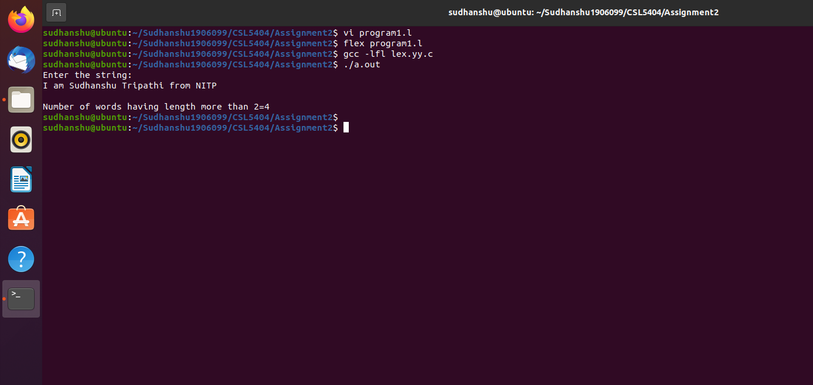

**Program 2**

/*lex code to count the number of lines,

tabs and spaces used in the input*/

%{

#include<stdio.h>

int spl=0,digitc=0,smallc=0,bigc=0,lc=0, sc=0, tc=0; /*Global variables*/

%}

/*Rule Section*/

%%

\n lc++; //line counter

([ ])+ sc++; //space counter

\t tc++; //tab counter

[a-z] smallc++;//digits and letters count

[A-Z] bigc++;//digits and letters count

[0-9] digitc++;//digits and letters count

. spl++;

%%

int main()

{

// The function that starts the analysi

printf("Enter the input.\n");

yylex();

printf("\nNo. of words=%d", sc+1);

printf("\nNo. of special characters=%d", spl);

printf("\nNo. of lines=%d", lc);

printf("\nNo. of spaces=%d", sc);

printf("\nNo. of tabs=%d\n", tc);

}

**Output**

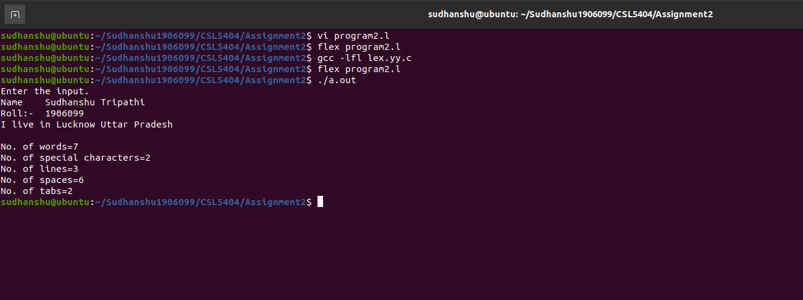

**Program 3**

/* Lex Program to check whether a number is Prime or Not */

%{

/* Definition section */

#include<stdio.h>

#include<stdlib.h>

int flag,c,j;

%}

/* Rule Section */

%%

[0-9]+ {c=atoi(yytext);

if(c==2)

{

printf("Prime number\n");

}

else if(c==0 || c==1)

{

printf("Not a Prime number\n");

}

else

{

for(j=2;j<c;j++)

{

if(c%j==0)

flag=1;

}

if(flag==1)

printf("Not a prime number\n");

else if(flag==0)

printf("Prime number\n");

}

c=atoi(yytext);

if(c%2==0)

{

printf("Even number\n");

}

else

{

printf("Odd number\n");

}

}

%%

// driver code

int main()

{

printf("Enter a number.\n");

yylex();

return 0;

 }

**Output**

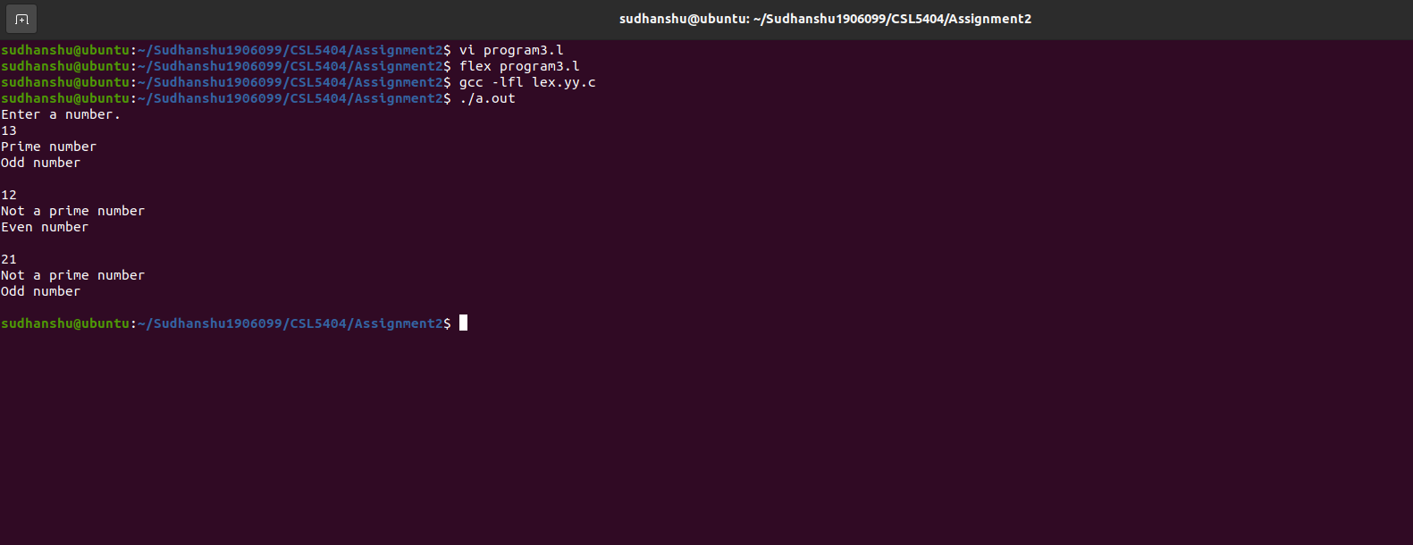

**Program 4**

%{

#include <stdio.h>

int len=0, ans=0;

%}

%%

[a-zA-Z]+ { len=strlen(yytext);

if(len>ans)

{ans=len;} }

%%

int main()

{

printf("Enter the string:\n");

yylex();

printf("Length of the longest word=%d\n",ans);

return 0;

 }

**Output**

