**NAME – ABHIRAJ YOGESH SRIVASTAVA**

**ROLL NO. – 1906137**

**SUBJECT NAME – ARTIFICIAL INTELLIGENCE LAB**

**SUBJECT CODE – CSL5402**

**DATE – 11TH AUGUST, 2021**

**BRANCH – CSE 2**

**ASSIGNMENT-1**

**Q1. WAP to implement a simple calculator.**

**Source Code in Python:**

print("My Calculator!!!")

print ("Select operation")

print ("1.Add")

print ("2.Subtract")

print ("3.Multiply")

print ("4.Divide")

c=int(input("Enter choice(1/2/3/4): "))

arr=['+','-','*','/']

a=int(input("Enter first number: "))

b=int(input("Enter second number: "))

print(a,arr[c-1],b,'= ',end='')

if c==1:

print(a+b)

elif c==2:

print(a-b)

elif c==3:

print((a*b))

else:

print(a/b)

**Output Screenshot:**

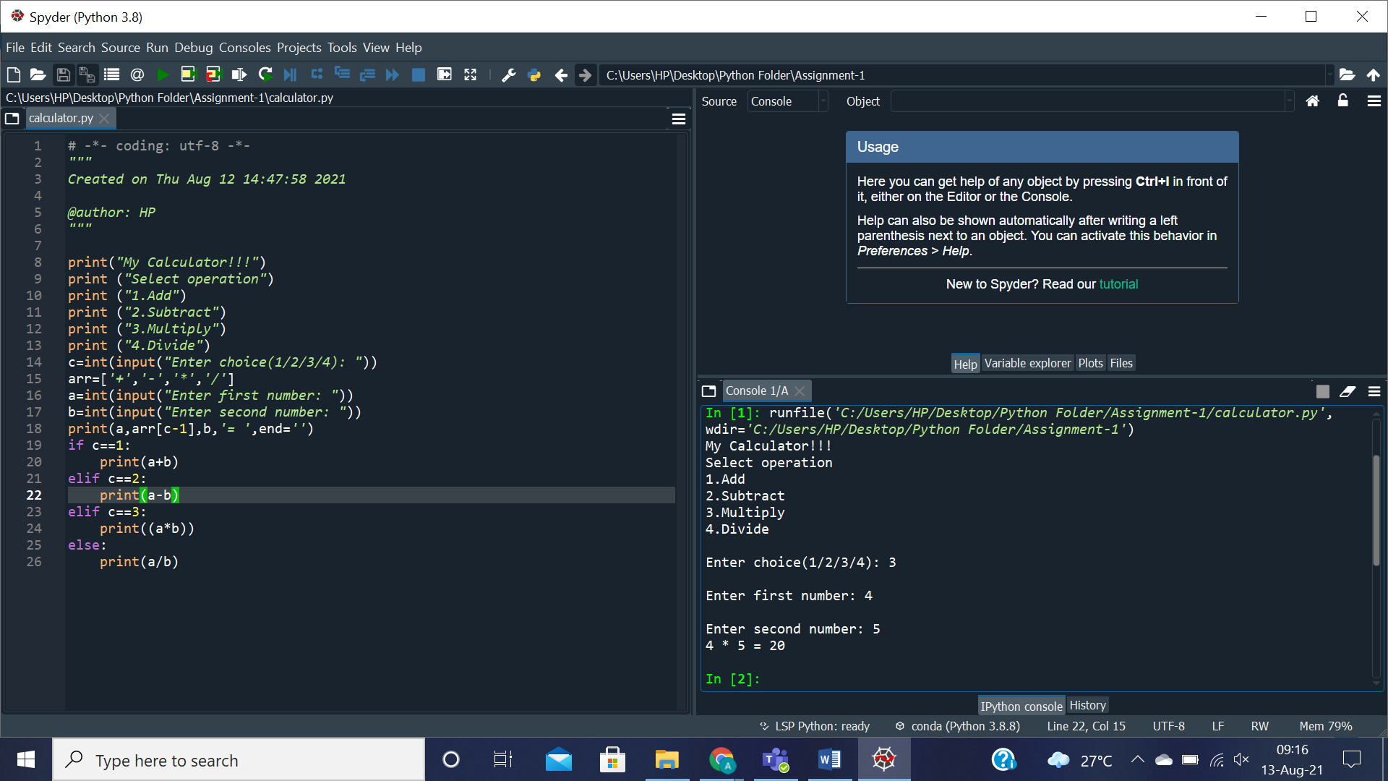

**Q2. WAP to check if its a leap year or not.**

**Source Code in Python:**

print("Leap Year Finder!!!")

y=int(input("Enter the year: "))

if y%100==0:

if y%400==0:

print(y," is a leap year!!")

else:

print(y," is not a leap year!!")

else:

if y%4==0:

print(y," is a leap year!!")

else:

print(y," is not a leap year!!")

**Output Screenshot:**

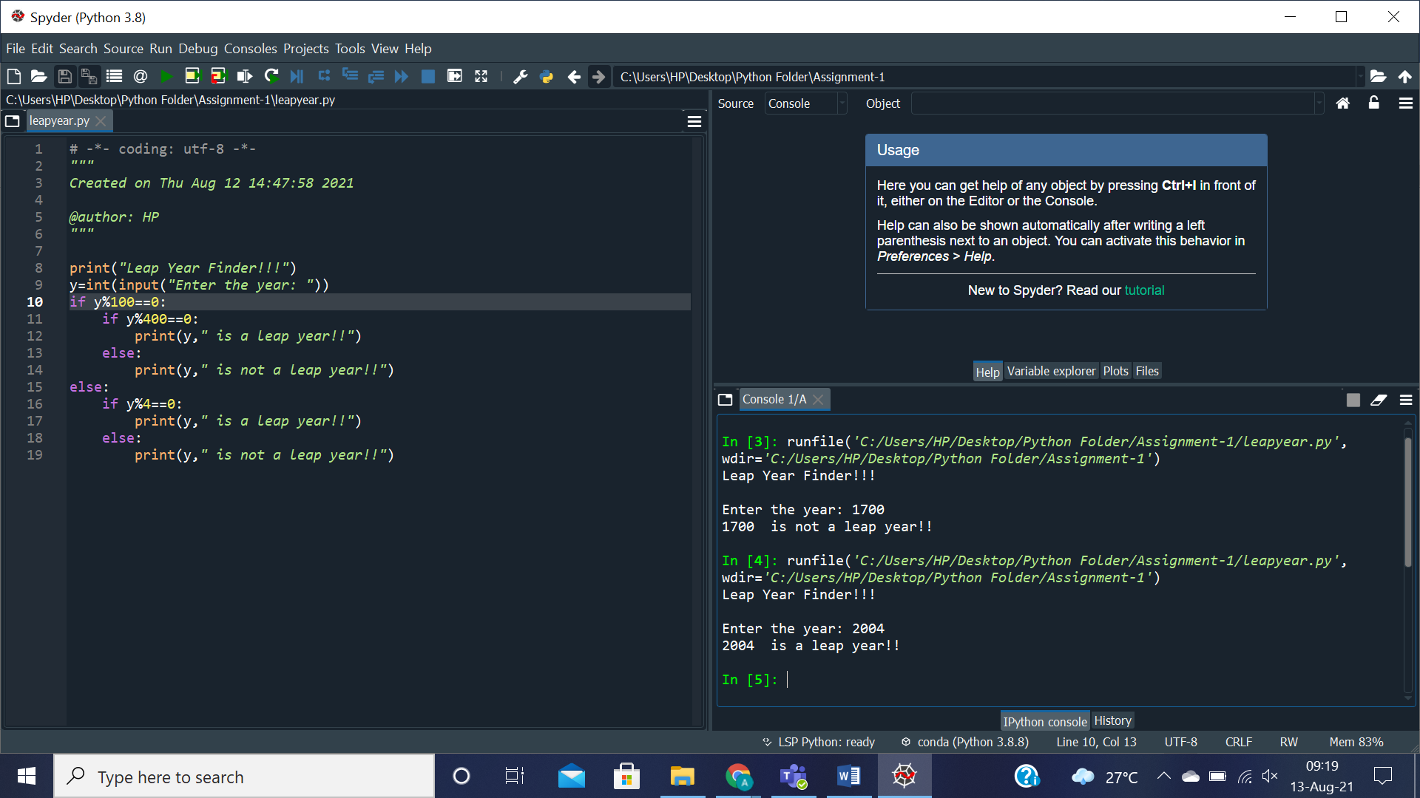

**Q3. WAP to find factorial of a number. Use range() function.**

**Source Code in Python:**

print("Factorial Calculator!!!")

n=int(input("Enter the number: "))

p=1

for i in range(2,n+1):

p*=i

print("Factorial of",n,"=",p)

**Output Screenshot:**

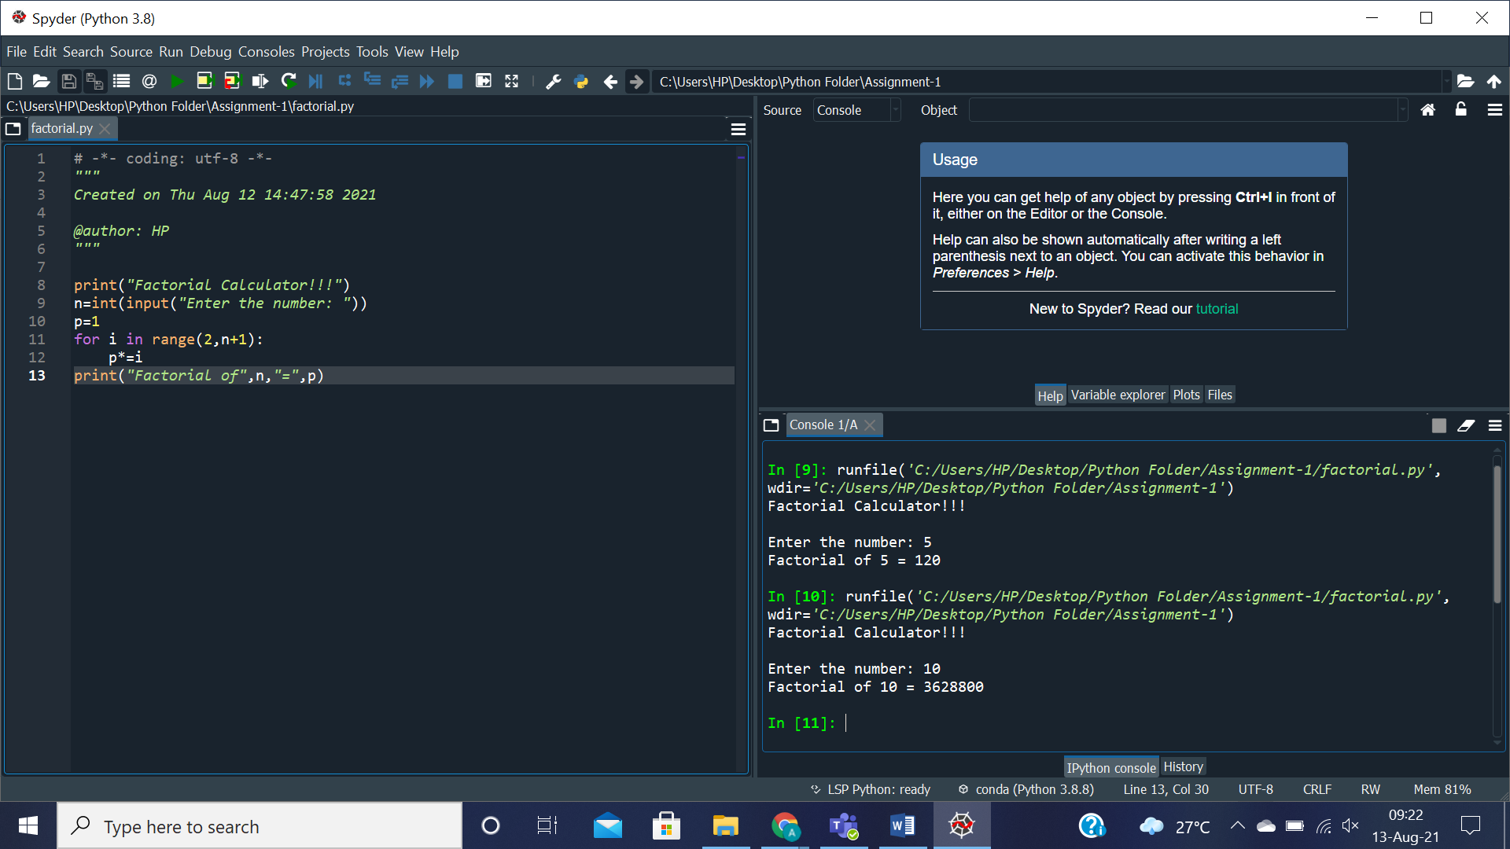

**Q4. WAP to shuffle a deck of cards.**

**Source Code in Python:**

import random

print("Card Shuffler!!!")

print("You got:")

deck=[0]

for i in range (2,53):

deck.insert(i-1,i-1)

random.shuffle(deck)

shape=['Spade','Heart','Club','Diamond']

for i in range(5):

currshape=int(deck[i]/13)

val=(deck[i]%13)+1

currcard=''

if(val>=2 and val<=10):

currcard=str(val)

else:

if(val==1):

currcard='Ace'

elif(val==11):

currcard='Jack'

elif(val==12):

currcard='Queen'

elif(val==13):

currcard='King'

print(currcard,'of',shape[currshape])

**Output Screenshot:**

