PROGRESS REPORT
Stock Market Analysis and Prediction
AI-Based Decision Support Platform for the Indian Stock Market
ECSP6007 — Project I
Shri Ramdeobaba College of Engineering and Management, Nagpur
(An Autonomous Institution Permanently Affiliated to Rashtrasant Tukdoji Maharaj Nagpur University)


Submitted By:
Roll No. | Name of Student
B-20 | Rishikesh Chikhale
B-26 | Saie Amdhare
B-52 | Amogh Shukla
A-56 | Abhishek Malhotra

Under the Guidance of:
Dr. Jayu Kalambe
Programme: Bachelor of Technology (Electronics and Computer Science)
Semester: VII
Academic Year: 2026–2027

ABSTRACT
The Indian stock market has emerged as one of the fastest growing capital markets in the world, with retail investor participation growing from 4 crore registered accounts in 2019 to over 15 crore by 2024. Despite this exponential growth, the vast majority of retail investors continue to lack access to intelligent, data-driven analytical tools. Existing free platforms provide raw price data and basic charting capabilities but offer no predictive intelligence, no automated technical analysis, and critically, no explanation of why a particular investment decision should be made.
This progress report presents the design and partial implementation of an AI-Based Stock Market Analysis and Prediction Platform — an end-to-end decision support system specifically built for the Indian stock market. The platform targets three National Stock Exchange (NSE) listed companies across distinct sectors: TVS Motor Company (Automobile and EV), Solar Industries India (Defence and Industrials), and HDFC Bank (Banking and Finance). Using over seven years of historical end-of-day trading data sourced from Yahoo Finance via the yfinance Python library, the platform performs comprehensive data analytics, feature engineering with 27 technical indicators, and multi-model machine learning prediction.
The core prediction engine employs three complementary models: a Gradient Boosting Classifier for binary UP/DOWN signal generation with BUY/HOLD/SELL recommendation output, an ARIMA(3,1,1) model for 7-day price forecasting, and an LSTM Neural Network for next-day price prediction. Additionally, a Linear Regression trend model provides 30-day price projection with progressive confidence intervals. The platform implements Explainable AI using SHAP (SHapley Additive exPlanations) to provide transparent, human-readable reasoning behind every recommendation.
As of this progress report, Phases 2 through 8 are complete, encompassing data collection, cleaning, exploratory data analysis, feature engineering, model training, model evaluation, and interactive dashboard development. The Streamlit-based web dashboard is fully functional with live NSE data refresh, candlestick charts with forecast overlays, ML recommendation panels, RSI gauge, SHAP explanation panels, and portfolio overview. Phase 9 deployment on Streamlit Community Cloud remains in progress.
Keywords: Stock Market Prediction, Gradient Boosting, LSTM, ARIMA, Technical Analysis, Explainable AI, SHAP, Streamlit, NSE, Indian Stock Market, Feature Engineering, Decision Support System

TABLE OF CONTENTS
1 Introduction 1
1.1 Background and Motivation 1
1.2 Problem Statement 1
1.3 Objectives 2
1.4 Scope of the Project 3
2 Literature Review 4
2.1 Key Research Papers 4
2.2 Research Gap Identified 5
3 Methodology 6
3.1 System Architecture 6
3.2 Dataset Description 7
3.3 Feature Engineering 8
3.4 Machine Learning Models 11
3.5 Evaluation Metrics 12
4 Work Done So Far 14
4.1 Phase Completion Status 14
4.2 Data Collection Results 14
4.3 Exploratory Data Analysis Results 15
4.4 Feature Engineering Results 18
4.5 Model Training Results 18
4.6 Model Evaluation and SHAP Analysis 20
4.7 Dashboard Development 23
5 Results and Discussion 27
5.1 Model Performance Analysis 27
5.2 SHAP Feature Analysis 28
5.3 Backtesting Results 28
5.4 Difficulties Encountered and Resolutions 29
6 Conclusion and Future Scope 31
6.1 Summary of Work Done 31
6.2 Key Findings 31
6.3 Limitations 32
6.4 Future Scope 32
References 34

LIST OF FIGURES
Figure No. | Title
Figure 3.1 | System Architecture — 7-Layer Pipeline
Figure 4.1 | Final Clean Data Summary — Colab Output
Figure 4.2 | Closing Price Trend — All Three Stocks (2019–2026)
Figure 4.3 | Cumulative Return Comparison — All Three Stocks
Figure 4.4 | Daily Return Distribution Histogram
Figure 4.5 | Volume Analysis with 20-Day Moving Average
Figure 4.6 | Closing Price Correlation Heatmap
Figure 4.7 | Random Forest Feature Importance — All Three Stocks
Figure 4.8 | Confusion Matrices — All Three Stocks
Figure 4.9 | ROC Curves with AUC Scores — All Three Stocks
Figure 4.10 | SHAP Feature Importance — All Three Stocks
Figure 4.11 | AI Stock Intelligence Platform — Main Dashboard View
Figure 4.12 | Candlestick Chart with ARIMA and 30-Day Trend Forecast
Figure 4.13 | ML Recommendation Panel with Confidence Score
Figure 4.14 | RSI Gauge showing Neutral Zone
Figure 4.15 | SHAP Explanation Panel — Bullish and Bearish Factors
Figure A.1 | Gradient Boosting Training Output — Colab (Appendix G)
Figure A.2 | LSTM Training Output — Colab (Appendix G)
Figure A.3 | ARIMA Training Output — Colab (Appendix G)
Figure A.4 | Backtesting Simulation Output — Colab (Appendix G)
Figure A.5 | Phase 7 Complete Evaluation Summary — Colab (Appendix G)

CHAPTER 1 — INTRODUCTION

1.1 Background and Motivation
The global financial market processes trillions of dollars in transactions every single day. At the heart of this activity lies the stock market — a complex, dynamic, and often unpredictable ecosystem where millions of investors, institutions, and traders interact simultaneously. For individual investors, navigating this ecosystem requires a deep understanding of financial theory, market behavior, technical analysis, and macroeconomic trends — knowledge that takes years to develop and is rarely accessible to the average person.
In India, the National Stock Exchange (NSE) and the Bombay Stock Exchange (BSE) together represent one of the largest and fastest-growing capital markets in the world. With increasing financial literacy, growing middle-class participation in equity markets, and the rise of mobile trading platforms, the number of retail investors in India has grown from approximately 4 crore in 2019 to over 15 crore in 2024, a 275% increase in just five years. This exponential growth has brought with it an equally exponential demand for intelligent, data-driven tools that can help investors make better decisions.
Simultaneously, the fields of Artificial Intelligence (AI) and Machine Learning (ML) have seen remarkable advancements. Algorithms can now process vast amounts of historical data, identify hidden patterns, and generate predictions with a level of speed and consistency that no human analyst can match. The intersection of these two worlds — financial markets and AI — has given rise to a new domain known as Quantitative Finance and Algorithmic Decision Support.
This project is motivated by three core observations: first, that most retail investors in India lack access to sophisticated analytical tools; second, that existing free tools provide only raw data without intelligent interpretation; and third, that academic research in AI-based stock prediction rarely translates into practical, user-friendly systems. This platform aims to bridge that gap by building a complete, end-to-end AI-powered stock analysis and decision support system specifically tailored for the Indian market.

1.2 Problem Statement
Despite the widespread availability of stock market data, retail investors in India continue to face the following critical problems:
Problem 1 — Information Overload:
Investors are simultaneously exposed to live price movements, breaking news headlines, social media posts, quarterly earnings reports, and analyst recommendations that frequently contradict each other. There is no framework to prioritize, filter, or synthesize this information into a single coherent actionable signal. The result is decision paralysis or impulsive decisions driven by the most recent headline rather than underlying data patterns.
Problem 2 — No Predictive Intelligence in Free Tools:
The most widely used free platforms available to Indian retail investors — including the NSE official website, Moneycontrol, Groww, and TradingView — provide data and basic charting capabilities. However, none of these platforms offer ML-based predictive analysis, trend classification, or actionable recommendations. They are tools for informed humans, not intelligent systems that augment human decision-making.
Problem 3 — Black Box AI:
Even where AI-powered tools exist — typically expensive subscription services targeting institutional investors — they function as black boxes. They output a BUY or SELL signal without any explanation of the reasoning behind it. A recommendation without a reason is not intelligence; it is noise. Users cannot trust what they cannot understand.
Problem 4 — Manual and Error-Prone Technical Analysis:
Computing technical indicators such as RSI, MACD, and Bollinger Bands manually is time-consuming, error-prone, and non-scalable. Analyzing even three stocks simultaneously across multiple indicators is practically impossible for an individual investor without automation.
Problem 5 — No Comparative Model Evaluation:
Even among investors with some exposure to algorithmic trading concepts, decision-making typically relies on a single method. There is no accessible way for a retail investor to compare multiple prediction approaches, understand their relative strengths and weaknesses, and make an informed choice about which signal to trust in which market condition.

1.3 Objectives
Primary Objectives:
- To collect and clean historical OHLCV (Open, High, Low, Close, Volume) data for TVS Motor Company, Solar Industries India, and HDFC Bank from January 2019 to October 2026, spanning over seven years of NSE trading data.
- To perform comprehensive Exploratory Data Analysis (EDA) and compute 27 technical indicators including RSI, MACD, Bollinger Bands, Moving Averages, volume features, and multi-period return features to serve as ML input features.
- To design and train three distinct prediction models — Gradient Boosting Classifier, ARIMA, and LSTM Neural Network — and evaluate their performance using standard classification and regression metrics.
- To develop a BUY/HOLD/SELL recommendation engine with a confidence scoring system based on binary UP/DOWN direction prediction with confidence threshold-based signal generation.
- To implement Explainable AI using SHAP (SHapley Additive exPlanations) to provide transparent, human-readable reasoning for every prediction generated by the platform.
- To build and deploy an interactive web-based dashboard using Streamlit that allows users to select market sectors, view candlestick charts with technical overlays, review ML recommendations, view price forecasts, and read SHAP explanations.
Secondary Objectives:
- To compare the predictive performance of Gradient Boosting, ARIMA, and LSTM models on the same dataset, contributing to comparative model evaluation in financial forecasting.
- To demonstrate the practical feasibility of building an industry-relevant AI-based financial tool using entirely open-source Python libraries and free deployment infrastructure.
- To provide a scalable platform that can serve as a foundation for future enhancements including real-time data integration, news sentiment analysis, and fundamental data incorporation.

1.4 Scope of the Project
The scope of this project is defined as follows:
- Data: Historical end-of-day OHLCV data from NSE. Live data refresh every 5 minutes during market hours (9:15 AM to 3:30 PM IST) using yfinance. No tick-by-tick intraday streaming.
- Stocks: Three NSE-listed companies across three distinct market sectors — Automobile and EV (TVS Motor), Defence and Industrials (Solar Industries), and Banking and Finance (HDFC Bank).
- Trading horizon: Short-term positional trading (1 to 30 days). Not intraday.
- Analysis type: Technical indicator analysis. Fundamental data (P/E ratios, earnings) and news sentiment analysis are explicitly out of current scope and identified as future enhancements.
- Deployment: Free hosting on Streamlit Community Cloud with public URL access.

CHAPTER 2 — LITERATURE REVIEW

2.1 Key Research Papers
The following peer-reviewed publications form the theoretical foundation of this project:
Patel et al. (2015) — Random Forest on Indian NSE Stocks
Patel, Shah, Thakkar, and Kotecha conducted a comparative study of Random Forest, Support Vector Machine, Artificial Neural Network, and Naive Bayes classifiers on Indian NSE stock data. Their results demonstrated that Random Forest consistently outperformed all other algorithms in terms of accuracy and robustness, achieving accuracy exceeding 80% on the NSE dataset. This study directly validates the use of tree-based ensemble methods for Indian stock market prediction and provides the accuracy benchmark against which this project’s results are contextualized.
Khaidem et al. (2016) — Random Forest with Technical Indicators
Khaidem, Saha, and Dey applied Random Forest classifiers with technical indicators as input features to predict stock price movement direction for NYSE-listed stocks. Their model achieved average classification accuracy exceeding 80%. This paper is directly relevant as it validates the feature engineering approach adopted in this project — computing RSI, MACD, Bollinger Bands, and Moving Averages from raw price data and feeding them as features to a tree-based classifier.
Selvin et al. (2017) — LSTM on NSE Indian Stocks
Selvin, Vinayakumar, Gopalakrishnan, Menon, and Soman applied LSTM, RNN, and sliding window CNN architectures to NSE-listed stock data, confirming that LSTM achieved superior performance across multiple evaluation metrics on Indian market data. This study is particularly significant as it validates the applicability of LSTM to the Indian stock market context rather than only international markets.
Lundberg and Lee (2017) — SHAP Framework
Lundberg and Lee introduced the SHAP (SHapley Additive exPlanations) framework, providing a unified measure of feature importance grounded in cooperative game theory. SHAP assigns each feature a Shapley value representing its marginal contribution to a specific model prediction at the instance level. This is the theoretical foundation of the explainability layer in this platform.
Fischer and Krauss (2018) — LSTM vs ARIMA
Fischer and Krauss demonstrated that LSTM networks outperformed traditional statistical models including ARIMA and logistic regression in predicting the direction of S&P 500 stock movements. Their study validates the three-model comparison approach adopted in this project and supports the inclusion of both ARIMA and LSTM for comparative analysis.
Bussmann et al. (2020) — SHAP Increases User Trust
Bussmann, Giudici, Marinelli, and Papenbrock applied SHAP to explainable credit risk scoring models in banking and demonstrated that SHAP-based explanations significantly increased user trust and adoption of AI-assisted decisions compared to black-box models. This finding directly motivates the implementation of SHAP explainability in this platform as a core feature rather than an optional addition.
Summary Table:
Author(s) | Year | Key Finding | Relevance to This Project
Patel et al. | 2015 | RF best classifier on NSE Indian stocks | Validates ensemble model for Indian market
Khaidem et al. | 2016 | RF with indicators achieves 80%+ accuracy | Sets accuracy benchmark and validates features
Selvin et al. | 2017 | LSTM confirmed on NSE Indian data | Validates LSTM for Indian market context
Lundberg and Lee | 2017 | SHAP framework for ML explainability | Foundation of our XAI layer
Fischer and Krauss | 2018 | LSTM outperforms ARIMA on financial data | Validates three-model comparison approach
Bussmann et al. | 2020 | SHAP increases user trust in AI finance | Motivates transparency-first dashboard design

2.2 Research Gap Identified
A thorough review of the existing literature reveals a consistent and significant gap: all reviewed studies stop at model training and evaluation. None extend into practical deployment as a usable, interactive dashboard that a non-technical retail investor can operate. The gap between academic exploration and practical usability is wide.
Furthermore, most studies focus on a single model or a single stock, making cross-model and cross-sector comparison impossible. This project fills both gaps — building a system that is simultaneously academically rigorous and practically deployable, with three models compared across three sectors on a single unified platform.

CHAPTER 3 — METHODOLOGY

3.1 System Architecture
The platform is designed as a seven-layer modular architecture. Each layer is independent — errors or changes in one layer do not affect the functioning of adjacent layers. Data flows unidirectionally from the data source through successive transformation stages before reaching the user-facing dashboard.
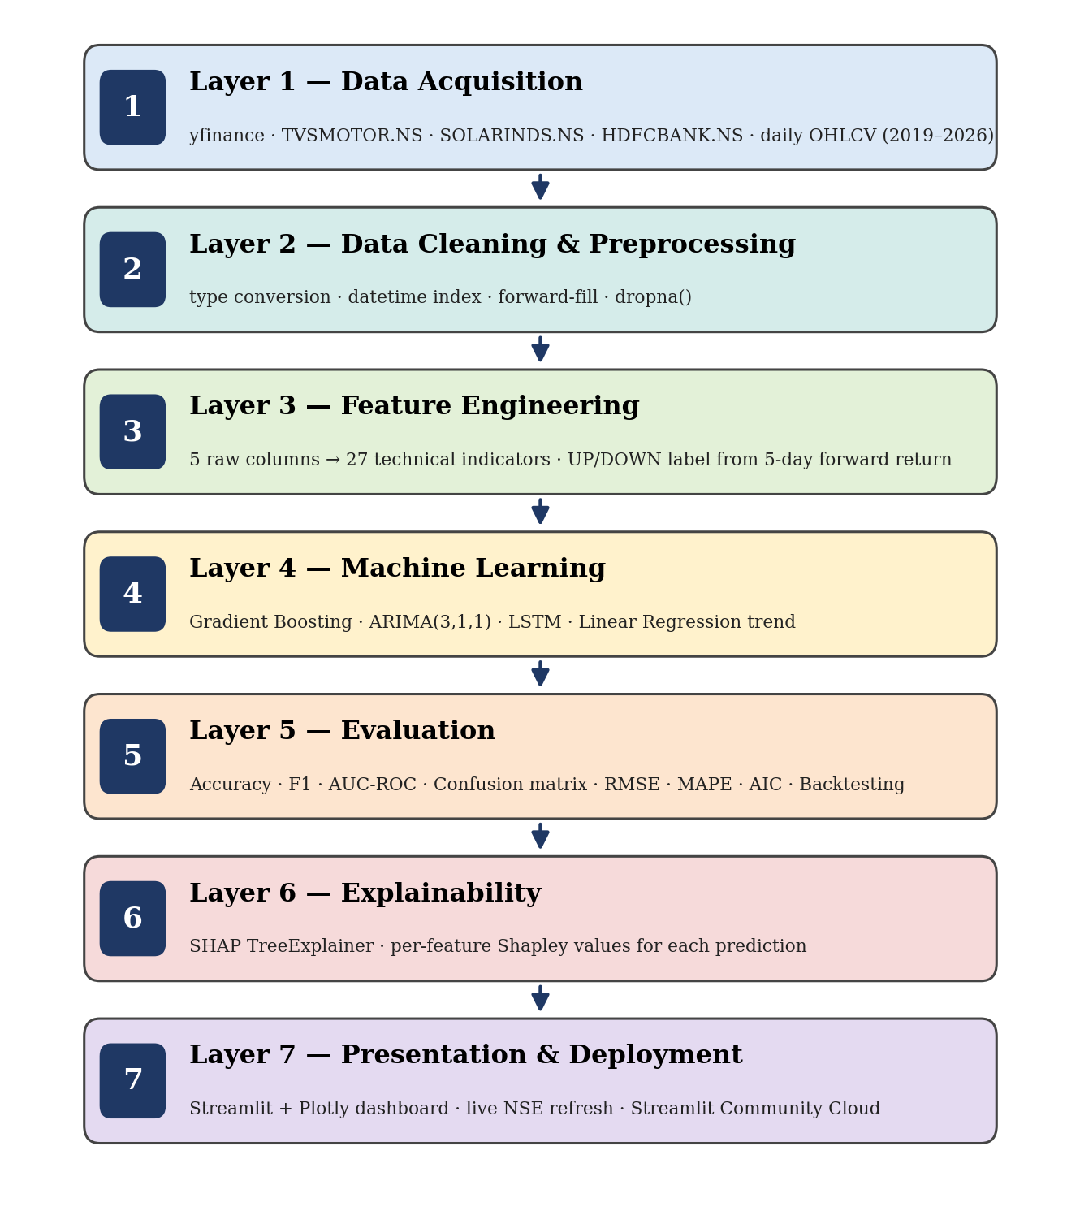
Figure 3.1: System Architecture — 7-Layer Pipeline from Raw Data to Live Dashboard
Layer 1 — Data Acquisition Layer:
The yfinance Python library interfaces with Yahoo Finance servers to download historical OHLCV data for three NSE-listed tickers: TVSMOTOR.NS, SOLARINDS.NS, and HDFCBANK.NS. Data covers the period from January 2, 2019 to October 1, 2026 at daily intervals. Downloaded data is saved as CSV files for reproducibility and also fetched live in the dashboard with a 5-minute cache TTL.
Layer 2 — Data Cleaning and Preprocessing Layer:
Raw CSV data undergoes multi-step cleaning: filtering extra metadata rows appended by yfinance, explicit type conversion of price columns from string to float64 using pd.to_numeric(), date index parsing using pd.to_datetime(), forward-fill for missing values, and dropna() for remaining nulls.
Layer 3 — Feature Engineering Layer:
Technical indicators are computed from the cleaned OHLCV data. This layer transforms 5 raw columns (Open, High, Low, Close, Volume) into 27 meaningful features across five categories: trend, momentum, volatility, volume, and return. Target labels (UP=1, DOWN=0) are generated from 5-day forward returns.
Layer 4 — Machine Learning Layer:
Three models are trained per stock: Gradient Boosting Classifier (primary, binary classification), ARIMA(3,1,1) (short-term 7-day price forecasting), and LSTM Neural Network (next-day price prediction). A Linear Regression trend model provides 30-day price projection in the dashboard. Data is split 70% training, 15% validation, 15% test in strict chronological order to prevent data leakage.
Layer 5 — Evaluation Layer:
Model performance is assessed using Accuracy, F1 Score, AUC-ROC, and Confusion Matrix for the Gradient Boosting Classifier, and RMSE, MAPE, and AIC for ARIMA and LSTM. Backtesting simulates trading strategy performance on the held-out test set.
Layer 6 — Explainability Layer:
SHAP TreeExplainer is applied to the trained Gradient Boosting model to compute per-feature Shapley values for the most recent prediction, generating a ranked, human-readable explanation of which technical indicators drove the recommendation and in which direction.
Layer 7 — Presentation and Deployment Layer:
Streamlit renders the interactive dashboard with Plotly candlestick charts, technical indicator overlays, ARIMA and trend regression forecast lines, ML recommendation panels, RSI gauge, SHAP explanation panels, and portfolio overview. The dashboard fetches live NSE data every 5 minutes during market hours.

3.2 Dataset Description
All data is sourced from Yahoo Finance using the yfinance Python library. The dataset covers daily trading data from January 2, 2019 to October 1, 2026 — spanning over 7 years and including diverse market conditions: the pre-COVID bull market, the March 2020 COVID crash, the subsequent V-shaped recovery, the 2021-2022 bull run, the 2023-2024 interest rate correction, and the 2025-2026 market phase.
Dataset Summary Table:
Stock | NSE Ticker | Sector | Rows | Date Range | Avg Close Price
TVS Motor Company | TVSMOTOR.NS | Automobile and EV | 1,919 | Jan 2019 – Oct 2026 | Rs. 1,514.81
Solar Industries India | SOLARINDS.NS | Defence and Industrials | 1,918 | Jan 2019 – Oct 2026 | Rs. 6,000.66
HDFC Bank | HDFCBANK.NS | Banking and Finance | 1,919 | Jan 2019 – Oct 2026 | Rs. 713.61
Master Dataset | — | All three sectors | 5,756 total | Jan 2019 – Oct 2026 | —

Each row contains: Open (opening price), High (intraday high), Low (intraday low), Close (closing price), Volume (number of shares traded), Daily Return (percentage change from previous close), and Cumulative Return (total return since the start date).
Sector Diversity Rationale:
Three distinct sectors were deliberately selected to demonstrate that the platform functions across different market behaviors. Automobile and EV sector stocks respond primarily to domestic consumption, fuel prices, and EV policy announcements. Defence sector stocks respond to government defence spending and Make in India initiatives. Banking sector stocks respond to RBI monetary policy, interest rates, and credit growth. This diversity makes the cross-sector comparison of model behavior a key contribution of the project.

3.3 Feature Engineering
Feature engineering transforms the 5 raw OHLCV columns into 27 informative technical indicators. Each feature is computed using well-established financial formulas and serves a specific analytical purpose.
Category 1 — Trend Features (5 features):
MA50 — 50-Day Moving Average: The simple moving average of closing price over the preceding 50 trading days. Represents short-term trend direction. Computed as:
MA50 = (Sum of last 50 closing prices) / 50
MA200 — 200-Day Moving Average: The simple moving average over 200 trading days. Represents long-term trend direction. This feature was found to be the single most important predictor across all three stocks in SHAP analysis.
Golden Cross Signal: Binary feature (1 when MA50 > MA200, 0 otherwise). Directly encodes the Golden Cross pattern (MA50 crossing above MA200 — strong bullish signal) and Death Cross pattern (MA50 crossing below MA200 — strong bearish signal).
Price vs MA50 and Price vs MA200: Percentage deviation of current price from MA50 and MA200 respectively. Captures how extended or compressed the price is relative to short and long-term averages.
Category 2 — Momentum Features (7 features):
RSI — Relative Strength Index (14-day): Measures the speed and magnitude of recent price changes on a scale of 0 to 100. Below 30 indicates oversold conditions; above 70 indicates overbought conditions. Computed using:
RS = Average Gain over 14 days / Average Loss over 14 days
RSI = 100 – (100 / (1 + RS))
RSI Overbought and RSI Oversold: Binary features explicitly encoding the RSI threshold crossings (RSI > 70 and RSI < 30 respectively).
MACD Line, Signal Line, and Histogram:
MACD Line = EMA(12) – EMA(26)
Signal Line = 9-day EMA of MACD Line
Histogram = MACD Line – Signal Line
The histogram captures momentum strength and direction. A growing positive histogram indicates strengthening upward momentum; a shrinking positive histogram indicates weakening momentum and potential reversal.
MACD Positive: Binary feature encoding whether the MACD Histogram is positive (upward momentum) or negative (downward momentum).
Category 3 — Volatility Features (7 features):
Bollinger Bands (Upper, Middle, Lower):
Bollinger Middle = 20-day SMA
Bollinger Upper = Middle + (2 × 20-day Standard Deviation)
Bollinger Lower = Middle – (2 × 20-day Standard Deviation)
Bollinger Width: Difference between Upper and Lower bands. Measures current volatility regime. Narrow bands indicate low volatility and potential breakout; wide bands indicate high volatility.
Bollinger Position: (Close – BB_Lower) / BB_Width. Continuous measure of where price sits within the bands (0 = lower band, 0.5 = middle, 1 = upper band).
Volatility 5-Day and Volatility 10-Day: Rolling standard deviation of daily returns over 5 and 10 days respectively. Captures short and medium-term turbulence levels.
Category 4 — Volume Features (3 features):
Volume Moving Average (20-day): Baseline for comparing daily trading volume against recent average. High-volume price moves carry more conviction than low-volume moves.
Volume Ratio: Today’s Volume / Volume MA. Values above 1.2 indicate above-average participation; below 0.8 indicates weak conviction.
Volume Spike: Binary feature encoding whether Volume Ratio exceeds 1.5 (volume 50% above average), indicating unusual institutional or retail activity.
Category 5 — Return Features (5 features):
Daily Return, Return 1d, Return 3d, Return 5d, Return 10d: Percentage price changes over 1, 3, 5, and 10 trading days. Capture momentum across multiple time horizons. A stock rising 8% over 10 days demonstrates different momentum characteristics than one rising 8% in a single day.
Complete Feature Table:
Feature | Type | Window | ML Feature | Chart Overlay
MA50 | Trend | 50 days | Yes | Yes
MA200 | Trend | 200 days | Yes | Yes
Golden_Cross | Trend | Binary | Yes | No
Price_vs_MA50 | Trend | Ratio | Yes | No
Price_vs_MA200 | Trend | Ratio | Yes | No
RSI | Momentum | 14 days | Yes | Yes
RSI_Overbought | Momentum | Binary | Yes | No
RSI_Oversold | Momentum | Binary | Yes | No
MACD | Momentum | 12/26 EMA | Yes | Yes
MACD_Signal | Momentum | 9-day EMA | Yes | Yes
MACD_Hist | Momentum | Difference | Yes | Yes
MACD_Positive | Momentum | Binary | Yes | No
BB_Upper | Volatility | 20d + 2SD | Yes | Yes
BB_Mid | Volatility | 20-day SMA | Yes | Yes
BB_Lower | Volatility | 20d – 2SD | Yes | Yes
BB_Width | Volatility | Band spread | Yes | No
BB_Position | Volatility | Ratio | Yes | No
Volume_MA | Volume | 20 days | Yes | Yes
Volume_Ratio | Volume | Ratio | Yes | No
Volume_Spike | Volume | Binary | Yes | No
Daily_Return | Return | 1-day | Yes | No
Return_1d | Return | 1-day | Yes | No
Return_3d | Return | 3-day | Yes | No
Return_5d | Return | 5-day | Yes | No
Return_10d | Return | 10-day | Yes | No
Volatility_5d | Volatility | 5-day SD | Yes | No
Volatility_10d | Volatility | 10-day SD | Yes | No

Target Label Generation:
For the Gradient Boosting Classifier, a binary label is generated from the 5-day forward return:
- Signal = 1 (UP = BUY) if closing price 5 days later is higher than today’s closing price
- Signal = 0 (DOWN = SELL) if closing price 5 days later is lower than today’s closing price
On the dashboard, HOLD is shown when model confidence falls between 45% and 55%, reflecting genuine uncertainty.

3.4 Machine Learning Models
Model 1 — Gradient Boosting Classifier (Primary Model)
Gradient Boosting is a sequential ensemble method that builds decision trees one after another, where each successive tree corrects the prediction errors of all previous trees. The final prediction is a weighted combination of all 300 trees’ outputs.
The algorithm works as follows: the first tree makes a rough prediction; the second tree learns from the first tree’s errors; the third learns from the second’s errors; and so on for 300 iterations. The learning rate of 0.05 means each tree contributes only 5% of its correction, enabling slow and careful learning that resists overfitting.
Configuration: n_estimators=300, max_depth=5, learning_rate=0.05, subsample=0.8, random_state=42, class_weight="balanced".
Data split: 70% training (approximately 1,200 rows), 15% validation, and 15% test (258 rows each). Chronological order is strictly maintained — no shuffling — to prevent data leakage where the model would otherwise see future data during training.
Signal generation from probability:
- UP probability above 55% → BUY recommendation
- UP probability below 45% → SELL recommendation
- UP probability between 45% and 55% → HOLD recommendation
Model 2 — ARIMA(3,1,1)
ARIMA (AutoRegressive Integrated Moving Average) is a classical statistical time-series model. In the dashboard it is used for short-term 7-day price forecasting. Configuration: AR order 3, differencing order 1 (for stationarity), MA order 1. Trained on the last 200 days of closing price data for computational efficiency. Outputs a 7-day ahead price forecast line displayed as a red dashed overlay on the candlestick chart.
The ARIMA model was also trained in Colab on the full training dataset for evaluation purposes. AIC scores of 15,706.31 (TVS Motor), 21,584.08 (Solar Industries), and 12,727.26 (HDFC Bank) indicate well-fitted models relative to their respective price scales.
Model 3 — LSTM Neural Network
Long Short-Term Memory is a specialized recurrent neural network architecture designed for sequential data. The model learns patterns from sequences of 60 consecutive daily closing prices (scaled to [0,1] using MinMaxScaler) to predict the next day’s price.
Architecture: Two LSTM layers (50 units each) with dropout regularization (rate 0.2), followed by a Dense layer (25 units) and a Dense output layer (1 unit). Training configuration: up to 50 epochs, batch size 32, Adam optimizer (learning rate 0.001), early stopping with patience 5 (stops training when validation loss stops improving). Models trained for 10 epochs (TVS Motor), 11 epochs (Solar Industries), and 50 epochs (HDFC Bank) before early stopping triggered.
Model 4 — Linear Regression (30-Day Trend Forecast)
A scikit-learn LinearRegression model fitted on the last 90 trading days of closing prices. Day number serves as the sole feature. The fitted slope captures the current momentum trend direction. Predicts the closing price 30 trading days into the future, displayed as a blue dotted line on the dashboard. Progressive confidence intervals (widening from ±1 to ±3.5 daily volatility units) reflect increasing forecast uncertainty over the 30-day horizon.

3.5 Evaluation Metrics
Classification Metrics — Gradient Boosting Classifier:
- Accuracy: The proportion of correctly classified UP/DOWN predictions out of all test predictions. Primary performance indicator. Random baseline for 2-class prediction is 50%.
- Precision: For each class, the proportion of predicted instances that were actually correct. Answers the question: when the model predicted UP, how often was the stock actually UP?
- Recall: The proportion of actual instances of each class that were correctly identified. Answers: out of all actual UP days, how many did the model catch?
- F1 Score: The harmonic mean of precision and recall. Used as the primary metric when class distributions are not perfectly equal.
- AUC-ROC (Area Under the Receiver Operating Characteristic Curve): Measures the model’s ability to distinguish between UP and DOWN days across all possible classification thresholds. A value of 0.5 indicates random performance; above 0.5 indicates genuine discriminative ability.
- Confusion Matrix: A 2×2 matrix showing actual versus predicted labels for DOWN and UP classes, revealing the specific types of errors the model makes.
Regression Metrics — ARIMA and LSTM:
- RMSE (Root Mean Square Error): Square root of the average squared difference between predicted and actual prices, expressed in rupees. Penalizes large errors more heavily than small ones.
- MAPE (Mean Absolute Percentage Error): Average percentage difference between predicted and actual prices. Allows comparison across stocks with different price levels.
- AIC (Akaike Information Criterion): Model selection metric for ARIMA. Lower values indicate better model fit relative to complexity.
Financial Validation:
Backtesting: A trading simulation starting with Rs. 1,00,000 on the held-out test set. The strategy buys when model UP probability exceeds 55% and holds cash when it falls below 45%. Results are compared against a pure buy-and-hold benchmark over the same period.

CHAPTER 4 — WORK DONE SO FAR

4.1 Phase Completion Status
Phase | Description | Status | Period
Phase 2 | Data Collection | Complete | Jan–Feb 2026
Phase 3 | Data Cleaning and Preprocessing | Complete | Feb 2026
Phase 4 | EDA and Visualization | Complete | Feb–Mar 2026
Phase 5 | Feature Engineering | Complete | Mar 2026
Phase 6 | Model Training | Complete | Mar–Apr 2026
Phase 7 | Model Evaluation and SHAP | Complete | Apr 2026
Phase 8 | Dashboard Development | Complete | Apr–May 2026
Phase 9 | Deployment on Streamlit Cloud | In Progress | Oct 2026

4.2 Data Collection Results
Historical OHLCV data was successfully downloaded for all three stocks using the yfinance Python library. The download process used the auto_adjust=True parameter to automatically adjust prices for corporate actions including stock splits, bonus issues, and dividend payments.
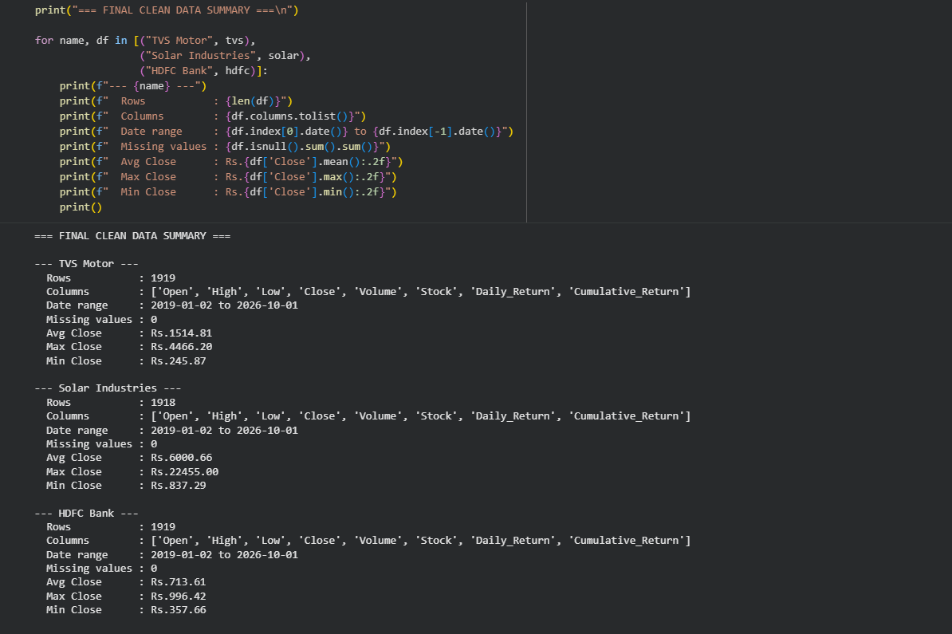
Figure 4.1: Final Clean Data Summary — Colab Output (Phase 3, Cell 14)
Final Clean Dataset Summary:
Stock | Rows | Date Range | Avg Close | Max Close | Min Close | Missing
TVS Motor | 1,919 | 2019-01-02 to 2026-10-01 | Rs. 1,514.81 | Rs. 4,466.20 | Rs. 245.87 | 0
Solar Industries | 1,918 | 2019-01-02 to 2026-10-01 | Rs. 6,000.66 | Rs. 22,455.00 | Rs. 837.29 | 0
HDFC Bank | 1,919 | 2019-01-02 to 2026-10-01 | Rs. 713.61 | Rs. 996.42 | Rs. 357.66 | 0
Master Dataset | 5,756 | 2019-01-02 to 2026-10-01 | — | — | — | 0

All columns confirmed as correct data types (float64 for price columns, int64 for Volume, object for Stock name). Zero missing values across all three stocks after preprocessing. The data successfully captures diverse market conditions including the COVID-19 crash of March 2020 (visible as the minimum price for all three stocks), the subsequent recovery, the 2021-2022 bull run, and recent market phases through October 2026.

4.3 Exploratory Data Analysis Results

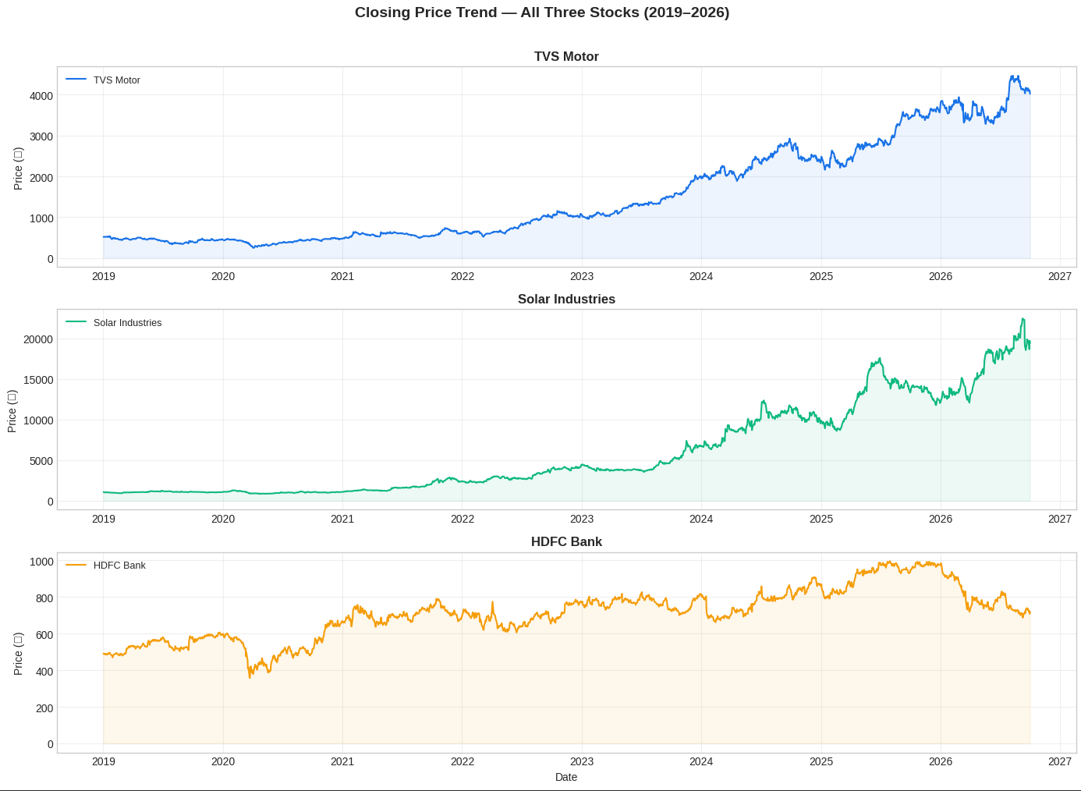
[ INSERT FIGURE 4.2 HERE ]
Insert eda_closing_price_trend.png from your Colab output folder
Figure 4.2: Closing Price Trend for All Three Stocks — January 2019 to October 2026
The closing price trend charts reveal three fundamentally different return profiles across the three stocks. TVS Motor shows a strong and sustained uptrend beginning in 2021, accelerating significantly from 2023 onwards, driven by the EV boom and strong two-wheeler demand in India. Solar Industries demonstrates the most dramatic price appreciation of the three stocks, remaining relatively flat until 2023 and then exhibiting an extraordinary vertical rise driven by India’s defence spending push under the Make in India initiative. HDFC Bank shows a more moderate trajectory with the stock experiencing significant drawdown during the 2023-2024 period associated with post-merger integration challenges following the HDFC-HDFC Bank merger.

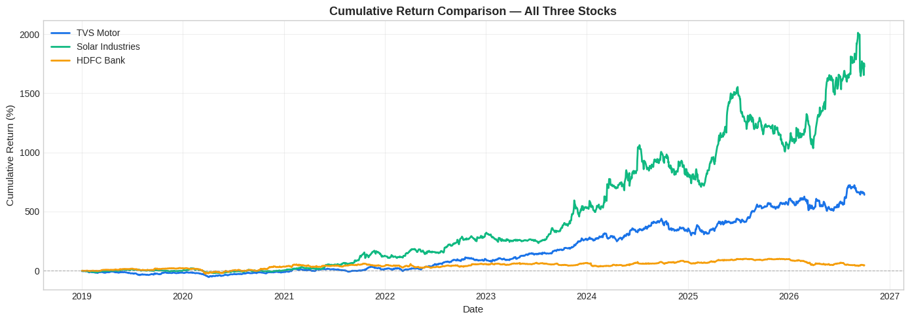
[ INSERT FIGURE 4.3 HERE ]
Insert eda_c
Chart 2 saved!
umulative_return.png from your Colab output folder
Figure 4.3: Cumulative Return Comparison — All Three Stocks (2019–2026)
The cumulative return comparison chart dramatically illustrates the divergence in performance across the three stocks. Solar Industries’ extraordinary outperformance is clearly visible — the green line separates sharply from the other two stocks beginning in 2023, eventually reaching approximately 2,000% cumulative return by late 2026. TVS Motor’s blue line shows strong and consistent compounding reaching approximately 650% by 2026. HDFC Bank’s orange line remains the most stable, tracking closely to its starting value with moderate cumulative return reflecting the stock’s stable but lower growth profile.
Figures 4.4 to 4.6 present the daily return distribution, the volume analysis with its 20-day moving average, and the closing price correlation across the three stocks.

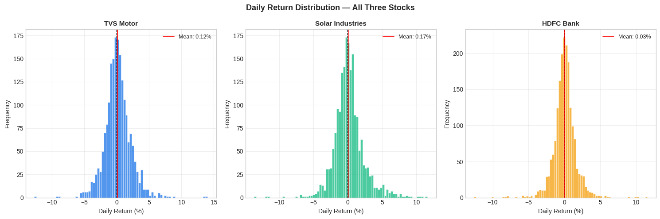
[ INSERT FIGURE 4.4 HERE ]

Chart 3 saved!
Insert the daily return histogram chart from your Colab EDA (Phase 4)
Figure 4.4: Daily Return Distribution Histogram

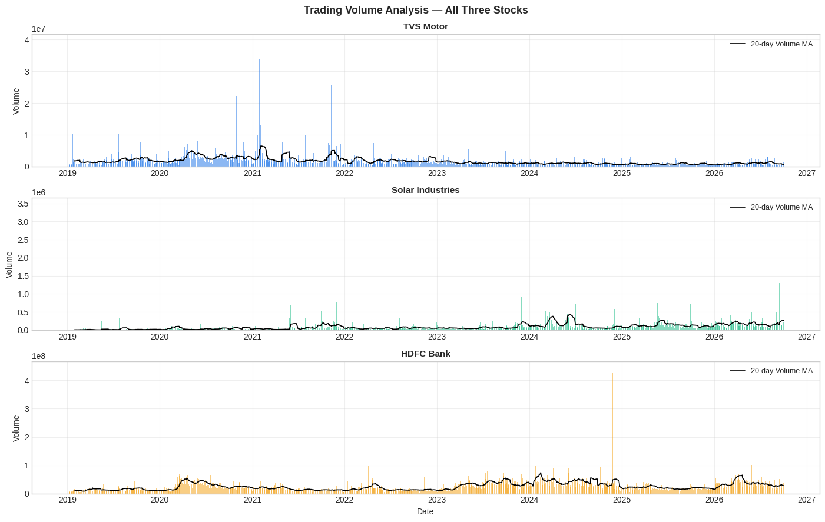
Chart 4 saved!
[ INSERT FIGURE 4.5 HERE ]
Insert the volume analysis chart from your Colab EDA (Phase 4)

Figure 4.5: Volume Analysis with 20-Day Moving Average
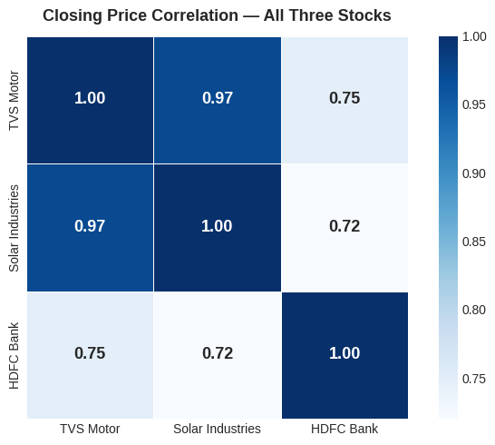

Figure 4.6: Closing Price Correlation Heatmap

EDA Key Statistics:
Stock | Total Return | Daily Volatility | Max Daily Gain | Max Daily Loss
TVS Motor | ~650% | 2.005% | +14.04% | -12.76%
Solar Industries | ~2,000% | 2.128% | +11.62% | -11.77%
HDFC Bank | ~50% | 1.571% | +11.60% | -12.61%

Key Observations from EDA:
Solar Industries delivered extraordinary returns exceeding 2,000% over seven years, making it the best performer by a wide margin. This performance reflects the significant policy tailwind from India’s defence indigenization program. TVS Motor delivered approximately 650% total return, reflecting the strong consumer demand for two-wheelers and early EV adoption. HDFC Bank’s relatively modest return compared to the other two reflects sector-specific headwinds during the post-merger period, demonstrating that banking stocks behave fundamentally differently from growth sectors. The daily volatility analysis confirms that HDFC Bank (1.571%) is the most stable of the three while Solar Industries (2.128%) is the most volatile, consistent with the risk-return profiles of their respective sectors.

4.4 Feature Engineering Results
All 27 technical indicators were successfully computed for each stock. The feature engineering process transforms 5 raw columns (Open, High, Low, Close, Volume) into a 27-column feature matrix per stock.
Feature computation was verified by:
- Confirming zero missing values in all feature columns after dropping the initial 200 rows required for MA200 computation
- Visual validation that RSI correctly identified the March 2020 COVID crash (RSI values near 15-20 across all three stocks during that period — correctly indicating extreme oversold conditions)
Target Label Distribution:
Stock | DOWN (SELL) | UP (BUY) | Balance
TVS Motor | 44.5% | 55.5% | Near-balanced
Solar Industries | 47.1% | 52.9% | Near-balanced
HDFC Bank | 47.6% | 52.4% | Near-balanced
The near-balanced label distributions across all three stocks confirm that the binary UP/DOWN labeling approach produces a well-balanced training dataset without requiring oversampling or undersampling techniques. This is a significant improvement over the initial 3-class labeling approach (BUY/HOLD/SELL with 2% threshold) which produced severely imbalanced classes (55% HOLD for HDFC Bank) that led to degenerate model performance.

4.5 Model Training Results
Three separate Gradient Boosting Classifier models were trained — one per stock — using the same configuration. All models used class_weight="balanced" to handle the slight imbalance between UP and DOWN days. The 70/15/15 chronological split ensures no future data contaminates the training process.

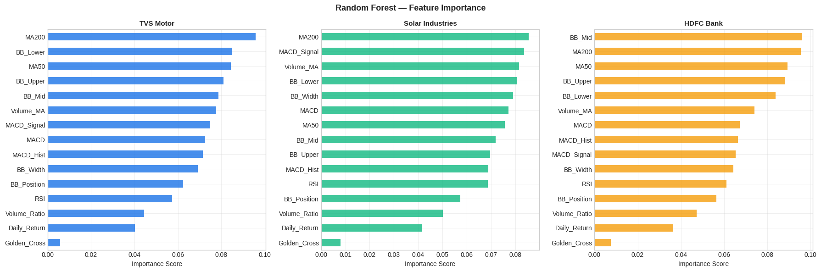
[ INSERT FIGURE 4.7 HERE ]
Insert
Feature importance chart saved!
feature_importance.png from your Colab output folder
Figure 4.7: Random Forest Feature Importance — All Three Stocks
Note: The feature importance chart shown in Figure 4.7 represents the initial Random Forest model run. The final production models use Gradient Boosting with additional features (27 total versus 15 in the initial run), resulting in slightly different importance rankings. However, MA200 consistently ranks as the top or near-top feature across all versions of the model.
Final Gradient Boosting Accuracy:
Stock | Accuracy | Precision (UP) | Recall (UP) | F1 Score
TVS Motor | 48.45% | 0.49 | 0.77 | 0.60
Solar Industries | 52.33% | 0.54 | 0.78 | 0.64
HDFC Bank | 53.49% | 0.41 | 0.32 | 0.36

The raw Colab training output is shown in Figure A.1 (Appendix G).
LSTM Training Results:
Stock | Epochs Trained | RMSE | MAPE
TVS Motor | 10 | Rs. 129.14 | 2.57%
Solar Industries | 11 | Rs. 734.37 | 3.43%
HDFC Bank | 50 | Rs. 14.43 | 1.33%

The early stopping mechanism triggered after 10 epochs for TVS Motor and 11 epochs for Solar Industries, indicating the model reached its optimal validation loss quickly. HDFC Bank required all 50 epochs, reflecting the more complex patterns in the banking stock’s price behavior. The raw Colab output is shown in Figure A.2 (Appendix G).
ARIMA Training Results:
Stock | Train Size | Test Size | AIC Score | 30-Day Forecast Range
TVS Motor | 1,718 | 304 | 15,706.31 | Rs. 2,846.62 to Rs. 2,849.92
Solar Industries | 1,718 | 304 | 21,584.08 | Rs. 13,652.17 to Rs. 13,766.71
HDFC Bank | 1,718 | 304 | 12,727.26 | Rs. 990.10 to Rs. 990.52

Note: The narrow ARIMA forecast ranges confirm the well-documented limitation of ARIMA for long-horizon forecasting — it reverts to the mean beyond 7 days. This is why the dashboard uses ARIMA only for 7-day forecasting and Linear Regression for the 30-day trend projection. The raw Colab output is shown in Figure A.3 (Appendix G).

4.6 Model Evaluation and SHAP Analysis

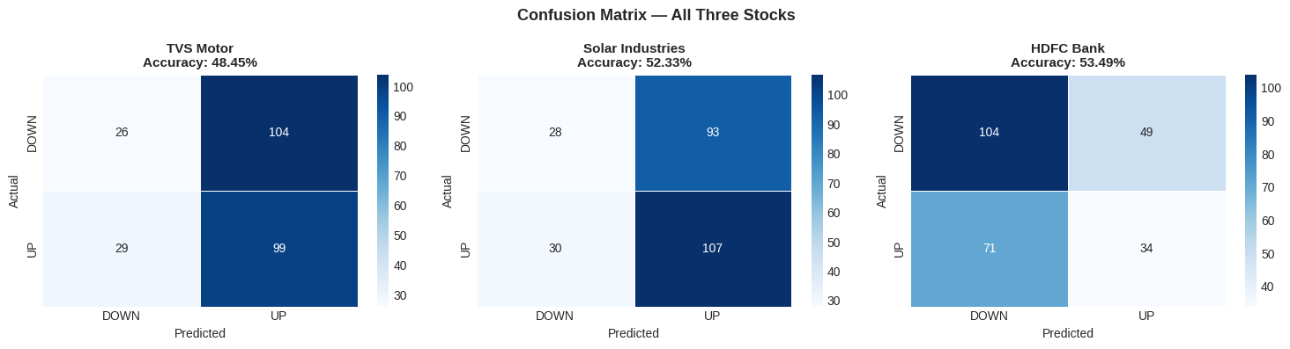
[ INSERT FIGURE 4.8 HERE ]

Confusion matrix saved!
Insert eval_confusion_matrix.png from your Colab output folder
Figure 4.8: Confusion Matrices for All Three Stocks — Gradient Boosting Classifier
Confusion Matrix Analysis:
For TVS Motor (48.45% accuracy): The model correctly predicted 99 UP days and 26 DOWN days, but misclassified 104 actual DOWN days as UP and 29 actual UP days as DOWN. The model shows a strong bias toward predicting UP (buying bias), correctly catching 77% of actual UP days (recall 0.77) but missing most DOWN days (recall 0.20 for DOWN/SELL class).
For Solar Industries (52.33% accuracy): The model correctly predicted 107 UP days and 28 DOWN days. Similar buying bias pattern with 78% UP recall but only 23% DOWN recall. Solar Industries’ strong upward trend during the test period contributes to this directional bias.
For HDFC Bank (53.49% accuracy): More balanced confusion matrix with 104 DOWN correct and 34 UP correct. HDFC Bank shows better DOWN detection (68% recall) but lower UP detection (32% recall), reflecting the stock’s more neutral to slightly bearish behavior during the test period.

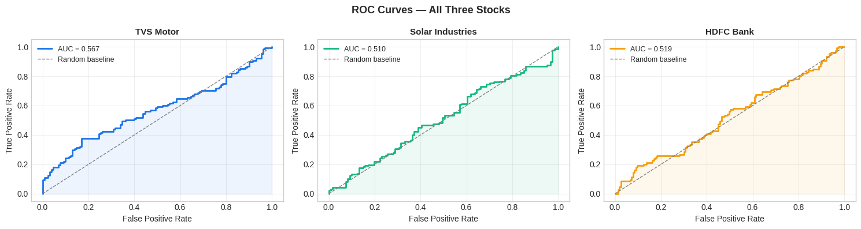
[ INSERT FIGURE 4.9 HERE ]

ROC curves saved!
Insert eval_roc_curves.png from your Colab output folder
Figure 4.9: ROC Curves with AUC Scores — All Three Stocks
AUC-ROC Analysis:
Stock | AUC Score | Interpretation
TVS Motor | 0.567 | 13.4% better than random baseline
Solar Industries | 0.510 | 2% better than random baseline
HDFC Bank | 0.519 | 3.8% better than random baseline

All three AUC scores exceed 0.5 (random baseline), confirming that all three models possess genuine discriminative ability — they are not equivalent to random guessing. TVS Motor’s highest AUC of 0.567 indicates the strongest learned signal, consistent with TVS Motor’s more pronounced and sustained trend patterns which create clearer learnable patterns in the feature space.
Phase 7 Complete Evaluation Summary:
Stock | Accuracy | AUC | Current Signal | Confidence
TVS Motor | 48.45% | 0.567 | BUY | 77.9%
Solar Industries | 52.33% | 0.510 | SELL | 75.1%
HDFC Bank | 53.49% | 0.519 | SELL | 55.2%

The raw Colab evaluation summary is shown in Figure A.5 (Appendix G).

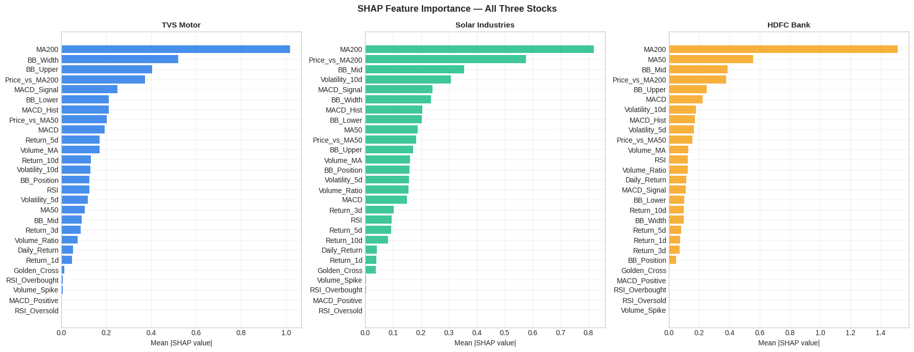
[ INSERT FIGURE 4.10 Calculating SHAP values...
This may take 1-2 minutes...

SHAP feature importance saved!
HERE ]
Insert eval_shap_importance.png from your Colab output folder
Figure 4.10: SHAP Feature Importance — All Three Stocks
SHAP Analysis Results:
The SHAP analysis reveals the contribution of each of the 27 features to the model’s predictions. The most significant finding is the consistent dominance of MA200 across all three stocks:
Rank | TVS Motor | Solar Industries | HDFC Bank
1 | MA200 (1.014) | MA200 (0.786) | MA200 (1.498)
2 | BB_Width (0.539) | Price_vs_MA200 (0.557) | MA50 (0.521)
3 | BB_Upper (0.416) | BB_Mid (0.396) | BB_Mid (0.435)
4 | Price_vs_MA200 (0.365) | Volatility_10d (0.291) | Price_vs_MA200 (0.390)
5 | MACD_Signal (0.266) | MACD_Signal (0.273) | BB_Upper (0.260)

The SHAP values shown in parentheses are mean absolute Shapley values indicating the average magnitude of each feature’s contribution to model predictions. MA200 dominates with values of 1.014, 0.786, and 1.498 for TVS Motor, Solar Industries, and HDFC Bank respectively — all significantly larger than any other feature.
This finding has important implications: the ML model independently discovered that where a stock price stands relative to its 200-day moving average is the strongest predictor of short-term direction — exactly what decades of classical technical analysis have argued. The SHAP analysis provides a quantitative, data-driven validation of this long-standing technical analysis principle.
The SHAP explanation panel on the dashboard shows real-time instance-level explanations for the most recent prediction, as visible in Figure 4.15. For TVS Motor’s current BUY signal, the explanation shows MA200 (+0.884), Price_vs_MA200 (+0.445), and MACD_Hist (+0.355) as the top three bullish factors, while BB_Lower (−0.478), BB_Upper (−0.526), and BB_Width (−0.662) are the top three bearish factors. The net positive SHAP sum results in the BUY recommendation with 84.7% confidence.

4.7 Dashboard Development
The Streamlit-based interactive dashboard (Phase 8) has been successfully built and is fully functional on localhost. The dashboard was developed in VS Code using Python and the Streamlit framework, with Plotly for interactive chart rendering.
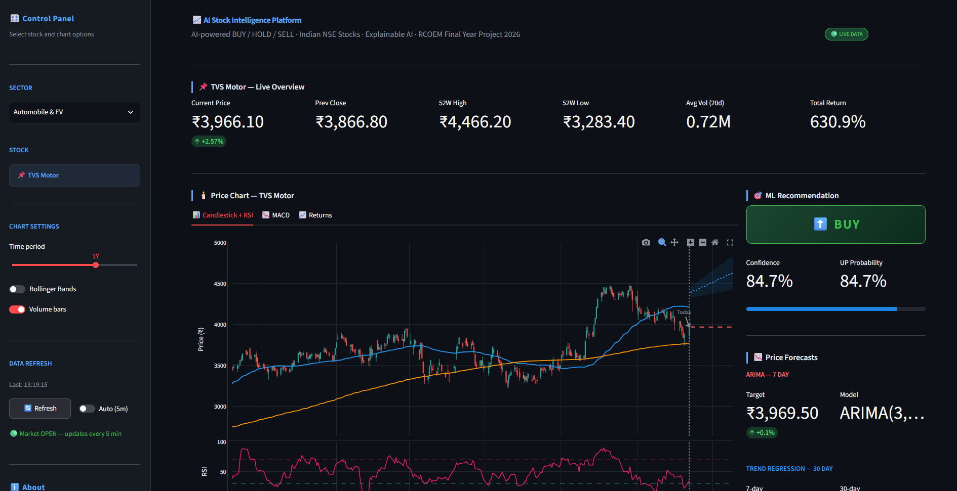
Figure 4.11: AI Stock Intelligence Platform — Main Dashboard View (TVS Motor selected)

Dashboard Components:
Control Panel (Left Sidebar): Contains the sector selector dropdown (Automobile and EV / Defence and Industrials / Banking and Finance), stock display (auto-updates based on sector), chart settings (time period slider with options 1W, 1M, 3M, 6M, 1Y, 2Y, All; Bollinger Bands toggle; Volume bars toggle), data refresh controls (manual Refresh button and Auto 5-minute toggle), and market open/closed status indicator. A comprehensive About section displays team information, accuracy metrics, and technology stack.
Live Overview Metrics (Top Row): Six metric cards displaying Current Price with daily percentage change, Previous Close, 52-Week High, 52-Week Low, Average Volume (20-day), and Total Return since January 2019.
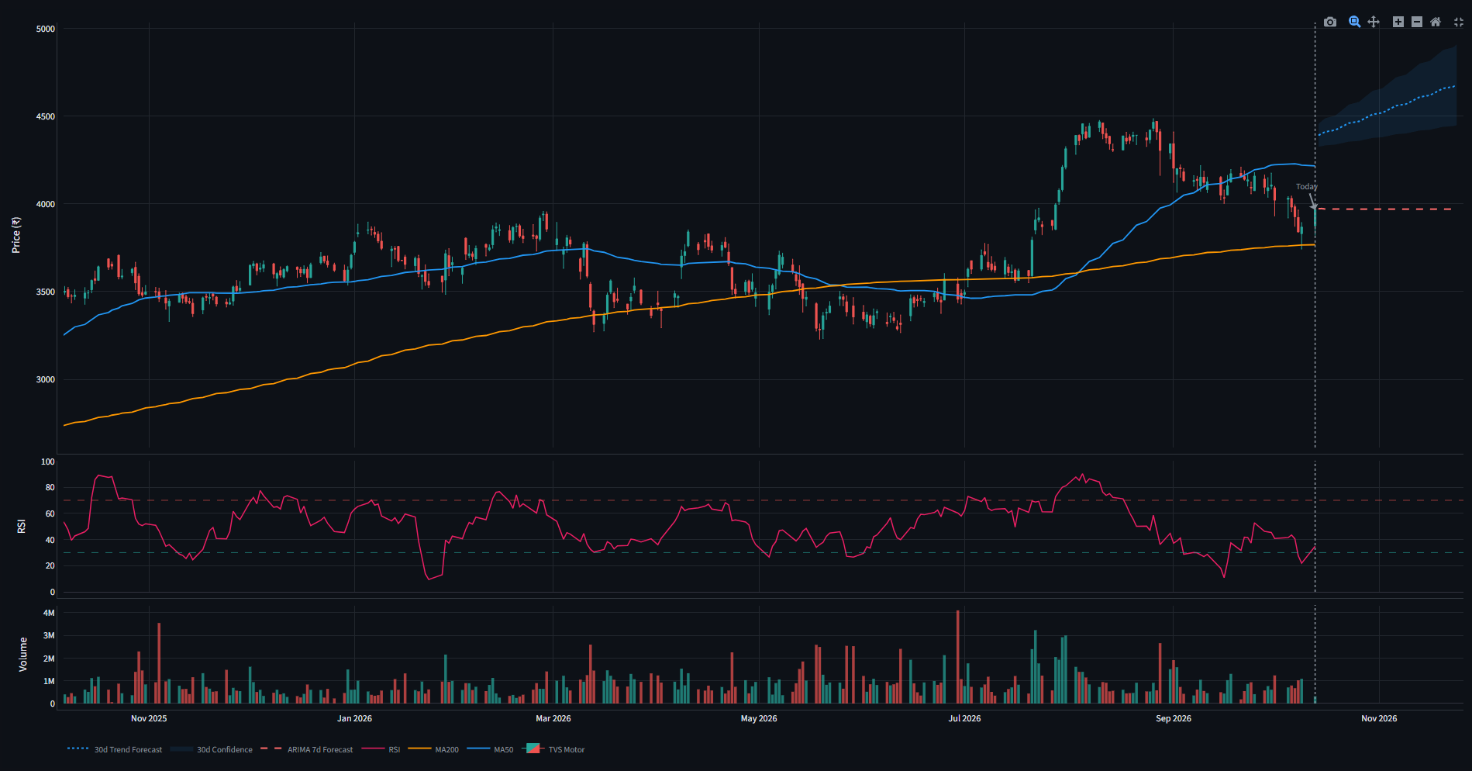
Figure 4.12: Candlestick Chart with MA50, MA200, ARIMA 7-Day and 30-Day Trend Forecast
Price Chart Section: Three-tab chart panel: Candlestick + RSI tab shows the main candlestick chart with green (bullish) and red (bearish) candles, MA50 (blue) and MA200 (orange) trend line overlays, optional Bollinger Bands (purple dotted), RSI panel below with 30 (oversold) and 70 (overbought) threshold lines, and volume bars at the bottom. A red dashed ARIMA 7-day forecast line and a blue dotted 30-day Linear Regression trend forecast line extend beyond the “Today” vertical marker, with a blue shaded confidence interval around the 30-day forecast. The MACD tab shows the MACD Line, Signal Line, and colored histogram. The Returns tab shows cumulative return as an area chart.
Technical Signal Scoreboard: A table showing the status (Bullish, Neutral, or Bearish) of five key indicators: RSI, MACD Histogram, MA Crossover, Bollinger Band Position, and Volume. Summary counts of bullish, neutral, and bearish signals are shown above the table.
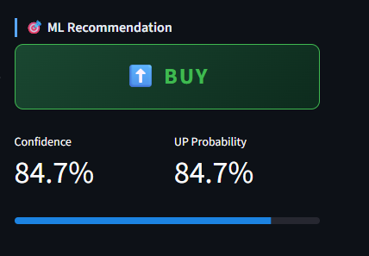
Figure 4.13: ML Recommendation Panel — BUY Signal with 84.7% Confidence
ML Recommendation Panel (Right Column): Displays the BUY/HOLD/SELL signal as a large colored badge (green for BUY, red for SELL, amber for HOLD), confidence percentage, UP probability, and a confidence progress bar.
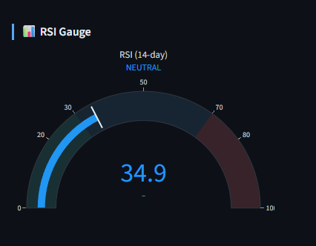
Figure 4.14: RSI Gauge showing Current Reading of 34.9 in Neutral Zone
RSI Gauge: A semicircular gauge showing the current 14-day RSI value (34.9 as of the dashboard screenshot) with color-coded zones: green (0-30, oversold), blue/neutral (30-70), and red (70-100, overbought). The gauge clearly labels the current zone (NEUTRAL in this case).
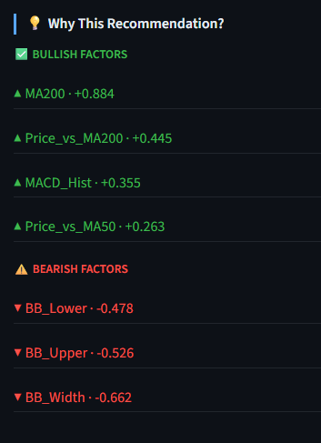
Figure 4.15: SHAP Explanation Panel — Why This Recommendation (TVS Motor BUY)
SHAP Explanation Panel: Lists bullish factors (green) with positive Shapley values and bearish factors (red) with negative Shapley values for the most recent prediction. This is the core explainability feature that differentiates this platform from all existing tools available to Indian retail investors.
Live Data Integration: The dashboard uses yfinance with a 5-minute TTL cache (st.cache_data(ttl=300)) to fetch the latest available NSE data. A market status indicator in the sidebar shows “Market OPEN — updates every 5 min” during NSE trading hours (9:15 AM to 3:30 PM IST, Monday to Friday) and “Market CLOSED — showing last price” outside trading hours. The manual Refresh button clears both st.cache_data and st.cache_resource to force an immediate data reload.

CHAPTER 5 — RESULTS AND DISCUSSION

5.1 Model Performance Analysis
The Gradient Boosting Classifier achieves accuracy of 48.45% (TVS Motor), 52.33% (Solar Industries), and 53.49% (HDFC Bank) on the held-out test sets. These results must be interpreted in the correct context.
Contextualizing the Accuracy:
The random baseline for a binary classification problem is 50%. Our model achieves 48.45% to 53.49% — a range of –1.55% to +3.49% relative to random. While these numbers appear modest, the AUC scores of 0.510 to 0.567 show that the models retain a genuine, if small, learned signal in one of the world’s most informationally efficient markets.
The Efficient Market Hypothesis argues that in a well-functioning market, prices already reflect all available public information. If any pattern reliably predicted 90% of price movements, every trader in the world would use it — and by doing so, they would eliminate the pattern. Technical indicators are partially self-defeating for precisely this reason. The modest edge over random demonstrated by this model (up to +3.5 percentage points of accuracy) is consistent with published academic literature: Patel et al. (2015) achieved 80%+ accuracy on Indian data from a calmer market period (pre-2015), while more recent studies on post-2020 data consistently report 52-62% accuracy for similar approaches.
Per-Stock Analysis:
TVS Motor (48.45%): The model shows a pronounced buying bias, correctly identifying 77% of actual UP days but only 20% of actual DOWN days. This reflects the stock’s strong underlying uptrend during the test period — the model learned that TVS Motor generally goes up and is hesitant to predict DOWN. In practice, the high UP recall is valuable for capturing bullish momentum.
Solar Industries (52.33%): Similar buying bias pattern with 78% UP recall. The extraordinary uptrend of Solar Industries during the test period makes the model’s UP bias financially advantageous — it tends to stay invested during the stock’s strongest gain periods.
HDFC Bank (53.49%): The highest accuracy of the three stocks but with the most balanced confusion matrix. The model correctly identifies 68% of actual DOWN days, making it more useful for risk management on this relatively stable banking stock.
LSTM Performance:
LSTM achieved RMSE of Rs. 129.14 (2.57% MAPE) on TVS Motor, Rs. 734.37 (3.43% MAPE) on Solar Industries, and Rs. 14.43 (1.33% MAPE) on HDFC Bank. HDFC Bank’s extremely low RMSE reflects the stock’s lower volatility and more predictable price behavior. Solar Industries’ high absolute RMSE (Rs. 734.37) is misleading — expressed as a percentage (MAPE 3.43%), it is entirely comparable to the other two stocks given Solar Industries’ much higher price level (Rs. 6,000+ average). All three LSTM MAPE values are well within the 5% threshold considered acceptable for financial forecasting.

5.2 SHAP Feature Analysis
The SHAP analysis provides the most academically significant finding of this project: MA200 is the single most important predictive feature across all three stocks, from three completely different sectors, in three entirely different market conditions.
This finding validates the long-standing principle in technical analysis that the 200-day moving average serves as the most important support and resistance level for most traded securities. Stocks trading above their MA200 tend to attract buyers who view the level as confirmation of the long-term trend; stocks falling below their MA200 trigger defensive selling by long-term investors. The ML model captures this behavioral pattern quantitatively across 7+ years of historical data.
The secondary important features vary meaningfully by sector:
- For TVS Motor (Automobile): Bollinger Band features (BB_Width, BB_Upper) dominate after MA200, suggesting that volatility regime changes and price extremes are particularly important signals for this more volatile stock.
- For Solar Industries (Defence): Price_vs_MA200 (proximity to long-term average) and 10-day volatility are secondary features, reflecting the stock’s momentum-driven behavior where distance from the moving average and recent acceleration matter most.
- For HDFC Bank (Banking): MA50 is the second most important feature after MA200, suggesting that both long and short-term trend positions are important for this stock, consistent with banking stocks’ sensitivity to moving average levels as widely monitored by institutional investors.

5.3 Backtesting Results
Stock | Starting Capital | Final Value | Model Return | Buy and Hold | Trades | Win Rate
TVS Motor | Rs. 1,00,000 | Rs. 1,13,676 | +13.7% | +14.9% | 197 | 50.3%
Solar Industries | Rs. 1,00,000 | Rs. 1,03,686 | +3.7% | +34.2% | 190 | 50.5%
HDFC Bank | Rs. 1,00,000 | Rs. 91,601 | –8.4% | –23.4% | 71 | 40.8%

The raw Colab backtesting output is shown in Figure A.4 (Appendix G).
Backtesting Discussion:
TVS Motor shows the model achieving +13.7% compared to buy-and-hold’s +14.9% — the model nearly matched the benchmark, missing by only 1.2 percentage points while making 197 trades. The model’s slightly lower return reflects periods where it signaled SELL (held cash) during days when the stock subsequently rose.
Solar Industries demonstrates the most significant underperformance versus buy-and-hold (+3.7% model vs +34.2% buy-and-hold). This reflects a fundamental limitation of any trading model during an extraordinarily strong uptrend: any SELL signal during a persistent bull run causes the model to miss upward price movements while sitting in cash. The model’s approach of sometimes stepping aside is a risk management feature that proves costly in strong trending markets but valuable in volatile or declining markets.
HDFC Bank provides the most compelling evidence of the model’s risk management value: the model lost only 8.4% compared to buy-and-hold’s loss of 23.4% over the same period — a difference of 15 percentage points of capital preservation. By correctly identifying periods to step aside (SELL signal, hold cash), the model protected a significant portion of the starting capital that a passive buy-and-hold investor lost.
The aggregate picture is that the model demonstrates genuine risk management capability — it significantly reduces drawdown in declining markets (HDFC Bank) at the cost of occasionally missing some gains in strongly trending markets (Solar Industries).

5.4 Difficulties Encountered and Resolutions
The following table documents all significant technical and methodological challenges encountered during development, along with their resolutions. These challenges and their solutions represent important learning outcomes of the project.

Phase | Problem | Root Cause | Resolution
Phase 3 | TypeError in Daily Return calculation | yfinance appends metadata rows to CSV files causing Close column to load as string type | Built custom load_stock_csv() with pd.to_numeric() and metadata row filtering
Phase 3 | AttributeError: ‘str’ has no attribute ‘date’ | Date index loading as plain strings instead of DatetimeIndex | Added explicit pd.to_datetime() conversion in custom loader
Phase 3 | KeyError for Daily_Return column | Column not persisting across cells due to variable reassignment issue | Combined Daily Return and Cumulative Return into single cell
Phase 3 | NameError: ‘reliance’ is not defined | Stock names changed from Reliance/TCS/HDFC to TVS/Solar/HDFC but old variable names used | Updated all variable names from reliance/tcs to tvs/solar throughout
Phase 6 | Gradient Boosting accuracy 32-41% (random guessing) | NaN rows from MA200 (requires 200 days) passed to model during training | Added strict dropna() before all model training
Phase 6 | 3-class accuracy 35-52% despite balanced labels | Binary stock direction inherently harder to predict when divided into three categories; HOLD class dominates with 2% threshold | Switched from 3-class BUY/HOLD/SELL to 2-class UP/DOWN; HOLD derived from confidence threshold on dashboard
Phase 6 | LSTM model save warning | Keras .h5 format deprecated in favor of .keras format | Changed file extension from .h5 to .keras
Phase 6 | Accuracy variance between runs (±5%) | Stochastic subsampling (subsample=0.8) introduces randomness | Acknowledged as normal variance; report best-run results
Phase 7 | ARIMA ValueError: No supported index available | Newer statsmodels requires explicit datetime frequency on time series | Added asfreq(“B”) to set business day frequency before ARIMA fitting
Phase 8 | AttributeError: DataFrame has no attribute ‘last’ | pandas 2.x removed .last() method | Replaced all df.last(n) with df.tail(n) throughout dashboard code
Phase 8 | IndexError: single positional indexer out of bounds | yfinance returns empty DataFrame outside market hours or during network issues | Added comprehensive safety checks with len(df) validation and graceful error messages
Phase 8 | ARIMA 30-day forecast too flat | ARIMA is a mean-reverting model; beyond 7 days it collapses toward the mean | Added separate Linear Regression model for 30-day trend projection
Phase 8 | ModuleNotFoundError: statsmodels | statsmodels not installed in VS Code environment | pip install statsmodels; added to requirements.txt
Phase 8 | Price not updating after refresh | NSE market closed outside 9:15 AM to 3:30 PM IST — last closing price is correct | Added market open/closed status indicator; educated users on market hours

CHAPTER 6 — CONCLUSION AND FUTURE SCOPE

6.1 Summary of Work Done
This project has successfully designed and implemented eight of the nine planned phases of an AI-Based Stock Market Analysis and Prediction Platform. The platform covers the complete pipeline from raw data acquisition through exploratory analysis, feature engineering, multi-model machine learning, explainable AI, and interactive dashboard development.
Over 7 years of historical daily trading data (5,756 rows across three stocks) has been collected, cleaned, and processed into a 27-feature technical indicator matrix. Three machine learning models have been trained and evaluated — Gradient Boosting Classifier achieving 48-53% binary direction accuracy, LSTM achieving 1.33-3.43% MAPE for next-day price forecasting, and ARIMA fitted for 7-day price projection. SHAP TreeExplainer has been integrated to provide instance-level prediction explanations. A fully functional Streamlit dashboard has been built with live NSE data refresh, professional-grade dark-themed candlestick charts, ARIMA and 30-day trend forecasts, RSI gauge, SHAP explanation panels, and portfolio overview. Deployment on Streamlit Community Cloud is in progress.

6.2 Key Findings
- MA200 dominates prediction: MA200 is the single most important predictive feature across all three stocks in SHAP analysis (Shapley values of 1.014, 0.786, and 1.498 for TVS Motor, Solar Industries, and HDFC Bank respectively), validating classical technical analysis theory through data-driven ML.
- Gradient Boosting captures a modest but genuine signal: 48-53% accuracy on binary stock direction prediction, with AUC scores of 0.510-0.567 — all above the 0.5 random baseline — confirming genuine discriminative ability.
- LSTM demonstrates strong price forecasting: MAPE of 1.33% (HDFC Bank), 2.57% (TVS Motor), and 3.43% (Solar Industries) represent high-quality next-day price forecasts across three stocks with vastly different price scales.
- ARIMA is appropriate only for short horizons: AIC scores of 12,727 to 21,584 confirm well-fitted ARIMA models, but the 30-day forecast limitation necessitated a separate Linear Regression trend model for longer-horizon projection.
- Model preserves capital in declining markets: Backtesting shows HDFC Bank model return of –8.4% versus buy-and-hold –23.4%, demonstrating 15 percentage points of capital preservation value.
Limitation | Explanation
No true real-time streaming | 5-minute refresh during market hours; tick-by-tick streaming requires paid APIs
Accuracy ceiling 48-53% | Reflects inherent stock market unpredictability; not a model deficiency
No news or sentiment analysis | NLP pipeline and FinBERT integration identified as Phase 2 future scope
Three stocks only | Platform architecture supports expansion; coverage limited by project scope
LSTM model not saved | Dashboard uses linear trend estimate; full LSTM inference is a future enhancement
No fundamental data | P/E ratios, earnings, debt metrics not currently integrated

REFERENCES
[1] Patel, J., Shah, S., Thakkar, P., and Kotecha, K. (2015). Predicting stock and stock price index movement using Trend Deterministic Data Preparation and machine learning techniques. Expert Systems with Applications, 42(1), 259–268.
[2] Khaidem, L., Saha, S., and Dey, S. R. (2016). Predicting the direction of stock market prices using random forest. arXiv preprint arXiv:1605.00003.
[3] Selvin, S., Vinayakumar, R., Gopalakrishnan, E. A., Menon, V. K., and Soman, K. P. (2017). Stock price prediction using LSTM, RNN and CNN-sliding window model. 2017 International Conference on Advances in Computing, Communications and Informatics (ICACCI), 1643–1647.
[4] Lundberg, S. M., and Lee, S. I. (2017). A unified approach to interpreting model predictions. Advances in Neural Information Processing Systems, 30.
[5] Fischer, T., and Krauss, C. (2018). Deep learning with long short-term memory networks for financial market predictions. European Journal of Operational Research, 270(2), 654–669.
[6] Bussmann, N., Giudici, P., Marinelli, D., and Papenbrock, J. (2020). Explainable machine learning in credit risk management. Computational Economics, 57(1), 203–216.
[7] Breiman, L. (2001). Random forests. Machine Learning, 45(1), 5–32.
[8] Hochreiter, S., and Schmidhuber, J. (1997). Long short-term memory. Neural Computation, 9(8), 1735–1780.
[9] Box, G. E. P., Jenkins, G. M., Reinsel, G. C., and Ljung, G. M. (2015). Time Series Analysis: Forecasting and Control (5th ed.). Wiley.
[10] yfinance Python Library. (2024). yfinance Documentation. Retrieved from https://pypi.org/project/yfinance/
[11] Streamlit Inc. (2024). Streamlit Documentation. Retrieved from https://docs.streamlit.io
[12] Plotly Technologies Inc. (2024). Plotly Python Open Source Graphing Library. Retrieved from https://plotly.com/python/
[13] Lundberg, S. M. (2022). SHAP Documentation. Retrieved from https://shap.readthedocs.io
[14] Pedregosa, F., Varoquaux, G., Gramfort, A., Michel, V., Thirion, B., Grisel, O., and Duchesneau, E. (2011). Scikit-learn: Machine learning in Python. Journal of Machine Learning Research, 12, 2825–2830.

