Learn the Delays, Then Plan the Gates
A Data-Driven Stochastic Optimisation Model for Robust Airport Gate Assignment
[Member 1] · [Member 2] · [Member 3] · [Member 4] · [Member 5]
[Course code and title] · November 2026
Abstract
Gate plans are fixed the day before operations, but they are carried out against arrival times that shift with weather, traffic and late inbound aircraft. When a delayed aircraft reaches a gate that is still occupied, the plan fails at that gate. This project asks how a delay forecast should be used when a gate plan is built. The study uses synthetic data in which every random element follows a named probability distribution: flights arrive as a Poisson process, ground times are uniform, and delays combine a normal day shock with gamma-distributed flight noise. Arrival delays are learned with gradient boosting from 120 past days. The forecast is then turned into 1,000 joint delay scenarios by resampling the model’s own out-of-sample errors, keeping the part of the error that a whole day shares. A stochastic gate assignment model in the tradition of Şeker and Noyan (2012) is solved with Gurobi. Four plans for a 40-flight thunderstorm day at seven contact gates are scored on 300 unseen outcome days. Planning on the point forecast (predict-then-optimise) did worst, with 3.67 conflicts per day against 0.66 for the timetable-only plan. The plan that used all 1,000 scenarios (estimate-then-optimise) reduced this to 0.12 conflicts per day, 81% fewer than the timetable plan, and left 88% of days free of conflicts. Computational complexity is handled with clique constraints, pair filtering and an exact aggregation of the scenario terms: with 1,000 scenarios the model has 427 variables and 922 constraints instead of 11,291 and 76,970, fits Gurobi’s free licence and solves to optimality in about three seconds on a laptop, against 48 seconds for the scenario-indexed form. Reducing the scenarios with k-means clustering did not beat random selection, because cluster representatives understate the rare bad days that cause conflicts; from 50 scenarios on, both reached the quality of using all 1,000.
Keywords: airport gate assignment; stochastic programming; scenario aggregation; gradient boosting; k-means scenario reduction; prescriptive analytics
Contents
1. Introduction 3
2. Literature Review 4
2.1 The airport gate assignment problem 4
2.2 Gate assignment under uncertain times 4
2.3 Predicting flight delays 5
2.4 From prediction to decision 5
2.5 Scenarios: sampling, reduction and bootstrap 5
2.6 Research gap and the articles used 5
3. Model 6
3.1 Problem setting 6
3.2 Data 7
3.3 Method overview 8
3.4 The stochastic gate assignment model 9
3.5 Four plans from one model 11
3.6 Handling computational complexity 11
3.7 Software 12
4. Results and Discussion 12
4.1 Delay prediction 12
4.2 Performance of the four plans 13
4.3 Answer to RQ1 15
4.4 Model size and solution time 15
4.5 Scenario reduction: k-means, random sampling or all scenarios 16
4.6 Is a larger fixed buffer enough? 17
4.7 Limitations 18
5. Conclusions 18
References 20
Appendix A. Code and Reproducibility 22

1. Introduction
At a busy airport the number of aircraft on the ground at the peak of the day is close to the number of contact gates. Each gate serves one aircraft at a time, so the gate plan decides which aircraft follow each other at the same gate and how much idle time separates them. The plan is drawn up the day before from the timetable. On the day itself, aircraft arrive early or late, and a late arrival stays at the gate longer than planned because it still needs its minimum turnaround. If the next aircraft planned for that gate arrives in the meantime, the two aircraft are in a gate conflict: one of them must wait on the taxiway or be moved to another stand at short notice. Passengers miss connections, ground crews are reshuffled, and the disturbance spreads to later flights.
Airlines and airports now hold large amounts of operational data, and predicting delays with machine learning has become routine. The question this project studies is what to do with such a prediction when the gate plan is built. Three answers are possible. The first ignores the prediction and plans on the timetable, perhaps with a fixed safety buffer between flights. The second, called predict-then-optimise (PTO), replaces the timetable by the forecast arrival times and plans as if they were certain. The third, estimate-then-optimise (ETO), uses the model to estimate the whole distribution of possible delays and plans against a set of scenarios drawn from it. Zhang et al. (2025) compared the last two for gate assignment at a Chinese airport and found ETO to be better. Şeker and Noyan (2012) had earlier written the stochastic model that ETO needs, but with scenarios produced by perturbing the timetable with assumed noise rather than learned from data.
This project joins the two lines in a compact study that can be run and explained in full. It answers three research questions:
- RQ1. On the same flights and the same unseen days, how do a timetable plan, a PTO plan and an ETO plan compare in the number of gate conflicts?
- RQ2. How large does the stochastic model become as the number of scenarios grows, and which modelling choices keep it solvable?
- RQ3. Does reducing the scenarios with an unsupervised method (k-means) help, compared with random sampling or with using all scenarios?
The study makes four contributions.
- Data-driven scenarios with day-level correlation. Delay scenarios are built from the out-of-sample errors of a gradient-boosting model. Each error is split into a shock that the whole day shares and a part that belongs to the flight. In the data used here the shared shock accounts for 54% of the error variance, so scenarios in which flights are delayed independently would understate how often several flights are late together.
- An exact aggregation of the scenario dimension. The conflict cost of a pair of flights depends on the plan only through whether the pair shares a gate. All scenario terms of the pair can therefore be summed into one weight, and the model size no longer grows with the number of scenarios. With 1,000 scenarios the model has 427 variables and 922 constraints, against 11,291 and 76,970 in the scenario-indexed form.
- A fair out-of-sample comparison. Four plans built by one model, together with a family of fixed-buffer plans, are scored on 300 outcome days that no model has seen, with paired bootstrap confidence intervals.
- Evidence on scenario reduction. k-means clustering, the most common way to keep scenario sets small, is compared with random sampling and with no reduction at all. Cluster representatives lose the tails of the delay distribution, which matters for an objective driven by rare conflicts.
Section 2 reviews the literature on the problem, its formulations and the solution methods. Section 3 presents the data, the four steps of the method and the optimisation model. Section 4 reports and discusses the results, and Section 5 concludes.

2. Literature Review

2.1 The airport gate assignment problem
The airport gate assignment problem (AGAP) decides which gate or remote stand serves each flight. The early literature minimised the walking distance of passengers and was solved with integer programming and heuristics (Haghani & Chen, 1998; Bolat, 2001). Because the cost of placing two flights at gates depends on both placements, the AGAP is closely related to the quadratic assignment problem and is NP-hard in general. Much of the research has therefore focused on stronger formulations and on heuristics. Karsu et al. (2021) give exact and heuristic methods, and Karsu and Solyalı (2023) propose a new formulation with a matheuristic. Three surveys summarise the field. Dorndorf et al. (2007) review flight gate scheduling, Bouras et al. (2014) classify models and objectives, and Daş et al. (2020) compare single-objective and multi-objective approaches.

2.2 Gate assignment under uncertain times
A plan that is optimal for the timetable can fail when flights deviate from it. A simple and widely used protection is to keep idle time, or a buffer, between consecutive flights at a gate. Bolat (2000) proposed procedures that spread idle time across gates so that delays are more likely to be absorbed. Yan and Tang (2007) treated stochastic flight delays with a heuristic that includes a planning stage and real-time adjustments, and Dorndorf et al. (2017) studied recovery strategies when arrival and departure times are random. Şeker and Noyan (2012) were the first to write scenario-based stochastic programmes for the AGAP. Their models keep the plan conflict-free for the timetable and minimise the expected number of conflicts over a set of time scenarios, with buffer-time violations as a further criterion. They solved larger cases with tabu search. Later work used robust optimisation with an uncertainty budget that depends on the solution (Xu et al., 2017), chance constraints solved by branch-and-price (Kim et al., 2023) and models of gate blockage (Castaing et al., 2016). In most of these studies the uncertainty is assumed, for example as a perturbation of the timetable, or estimated from unconditional frequencies. It does not depend on the features of the flight and the day.

2.3 Predicting flight delays
Rebollo and Balakrishnan (2014) characterised and predicted air traffic delays with tree-based models, and Wang et al. (2020) predicted estimated arrival times from historical flight data. Delays also travel through the network: Pyrgiotis et al. (2013) modelled how they propagate between airports. Gradient boosting (Friedman, 2001) builds an ensemble of small regression trees in which each tree corrects the errors of the previous ones. It captures interactions, such as storms that matter more in the afternoon, without manual feature engineering, which makes it a common choice for tabular delay data.

2.4 From prediction to decision
A forecast is only an input to a decision, and a better forecast does not always give a better decision. Elmachtoub and Grigas (2022) showed that minimising forecast error is not the same as minimising the cost of the decision that uses the forecast. Bertsimas and Kallus (2020) described how machine learning can estimate the conditional distribution of an uncertain quantity, which can then be used directly by an optimisation model. For gate assignment, Zhang et al. (2025) compared predict-then-optimise with estimate-then-optimise on real data and found that estimate-then-optimise produced more robust plans. They also needed scenario selection and a decomposition method to solve their model in reasonable time.

2.5 Scenarios: sampling, reduction and bootstrap
A stochastic programme with a continuous distribution is usually solved through sample average approximation (SAA), which replaces the distribution by a finite random sample of scenarios (Kleywegt et al., 2002). The sample must be large enough for the solution to be reliable, but every scenario adds variables and constraints. Scenario reduction tries to keep the information of a large sample in a few representative scenarios. Dupačová et al. (2003) did this with probability metrics, and Keutchayan et al. (2023) cluster scenarios according to their effect on the decision. k-means clustering (Lloyd, 1982) is the simplest clustering choice and is widely used for this purpose. Scenarios themselves can be generated by resampling observed errors, which is the idea of the bootstrap (Efron, 1979).

2.6 Research gap and the articles used
Table 1 lists the journal articles that this study builds on and the role each plays in the problem, the formulation or the solution method. The gap addressed here lies between Şeker and Noyan (2012), whose stochastic formulation uses assumed scenarios, and Zhang et al. (2025), who learn scenarios from data but use a different two-stage model and a decomposition algorithm. To our knowledge, the Şeker–Noyan expected-conflict model has not been driven by learned, correlated delay scenarios, its scenario dimension has not been removed by an exact aggregation, and k-means reduction has not been tested against using every scenario in this setting.
Table 1. Journal articles used in this study and their role.
Article | Journal | Role in this study
Şeker & Noyan (2012) | Transportation Research Part E | Problem and formulation: expected conflicts and buffer violations over scenarios, conflict-free nominal plan
Zhang et al. (2025) | Transportation Research Part E | Problem framing: predict-then-optimise against estimate-then-optimise for gate assignment
Dorndorf et al. (2007); Bouras et al. (2014); Daş et al. (2020) | Omega; The Scientific World Journal; Omega | Problem: classes of gate assignment models, objectives and complexity
Bolat (2000); Yan & Tang (2007) | European Journal of Operational Research | Formulation: idle time and buffers as protection against delays (benchmark in Section 4.6)
Xu et al. (2017); Kim et al. (2023) | Transportation Research Part B | Formulation: robust and chance-constrained alternatives
Friedman (2001); Rebollo & Balakrishnan (2014) | Annals of Statistics; Transportation Research Part C | Solution method: gradient boosting for delay prediction
Efron (1979); Kleywegt et al. (2002) | Annals of Statistics; SIAM Journal on Optimization | Solution method: bootstrap scenarios and sample average approximation
Lloyd (1982); Dupačová et al. (2003) | IEEE Transactions on Information Theory; Mathematical Programming | Solution method: k-means and scenario reduction
Bertsimas & Kallus (2020); Elmachtoub & Grigas (2022) | Management Science | Solution method: linking prediction and optimisation

3. Model

3.1 Problem setting
The airport has seven contact gates and a remote apron. On the planning day, 40 flights each arrive, stay on the ground for a scheduled time between 41 and 90 minutes, and depart. Each flight must be placed at one gate or at the apron. The apron has room for all aircraft but is unpopular with passengers and airlines, so each apron placement carries a cost. At the busiest moment of the timetable, seven aircraft are on the ground together, which equals the number of gates. A conflict-free plan therefore exists, but it leaves little room at the peak.
The following assumptions keep the model simple enough to explain while keeping the main difficulty, which is the uncertainty of arrival times.
- Only arrivals are uncertain. An aircraft departs at its scheduled time unless it landed too late to complete the minimum turnaround of $τ=35$ minutes, in which case it departs $τ$ minutes after landing. This rule links departure delays to arrival delays, as in practice.
- Two aircraft at the same gate are in conflict if their actual ground times overlap. Their idle time between them is a buffer violation if it is positive but shorter than $b=15$ minutes.
- The plan must be conflict-free for the times it is built on. Weights of 100 per conflict, 1 per buffer violation and 60 per apron placement express the planner’s priorities.
- Gate size limits, walking distances and towing are ignored. They can be added as extra constraints without changing the method.

3.2 Data
Real gate-level data with weather and delays are not publicly available in a usable form, so the study uses synthetic data from a generator that the models never see (make_data.py). Every random element of the generator follows a named probability distribution, listed in Table 2. A fixed random seed makes the data identical on every run.
Table 2. Probability distributions used by the data generator.
Element | Distribution | Parameters
Arrival times in the timetable | Poisson process | 2.7 flights per hour from 06:00; the time between two arrivals is exponential with a mean of 22.5 minutes
Scheduled ground time | Discrete uniform | 40 to 90 minutes
Airline of a flight | Categorical | AA 50%, BB 30%, CC 20%
Weather of a past day | Categorical | Fine 50%, rain 30%, thunderstorm 20%
Day shock, shared by all flights of a day | Normal | Mean 0, standard deviation 10 minutes
Own delay of each flight | Gamma, shifted | Shape 2, scale 6, minus 12: mean 0, standard deviation 8.5 minutes, skewed to the right
Arrivals follow a Poisson process. This is the usual model when many independent sources each contribute a few events, here many airlines and routes, and it is the standard arrival assumption in queueing models of airports, such as the network model of Pyrgiotis et al. (2013). In a Poisson process the number of arrivals in an hour has a Poisson distribution and the times between arrivals are exponential, so flights come in irregular bunches with quiet spells in between. On the planning day the 40 flights arrive between 06:16 and 19:51. Up to five arrive in one hour, two pairs arrive in the same minute, and the longest gap is 76 minutes (Figure 1). Ground times are uniform, as in the instances of Şeker and Noyan (2012).
The arrival delay of flight $f$ on day $d$ adds the two random parts to a fixed pattern:
$$Δ_{fd}=α_{f}+0.9 \left(h_{f}−6\right)+w_{d}\left(4+\frac{18}{1+e^{−\left(h_{f}−15\right)/1.2}}\right)+5 \left[\text{Friday}\right]+\left(1+0.5 w_{d}\right) \left(u_{d}+v_{fd}\right).$$
Here $h_{f}$ is the hour of arrival, $α_{f}$ the airline effect (+2 minutes for AA, +6 for BB and −2 for CC), $w_{d}$ the weather (0 fine, 1 rain, 2 thunderstorms), $u_{d}$ the normal day shock and $v_{fd}$ the gamma own delay. Delays therefore grow during the day, differ by airline, are higher on Fridays, and thunderstorms raise them most after 15:00, as reported in the delay literature. Bad weather also makes both random parts 1.5 or 2 times wider. Table 3 describes the three files.
Table 3. Data used in the study.
File | Size | Content
history.csv | 4,800 rows (120 days × 40 flights) | Airline, scheduled arrival and departure, hour, day of week, weather (0 fine, 1 rain, 2 thunderstorms) and the observed arrival delay
test_day.csv | 40 rows | The timetable to plan: a Friday with thunderstorms forecast
test_outcomes.csv | 12,000 rows (300 days × 40 flights) | Possible real outcomes of the planning day, used only for scoring
In the history, 52 days had fine weather, 39 rain and 29 thunderstorms. The mean arrival delay was 9.0 minutes on fine days, 17.5 on rainy days and 27.1 on thunderstorm days, with standard deviations of 15.7, 20.1 and 28.3 minutes. On the 300 outcome days of the planning day the mean delay is 33.6 minutes with a standard deviation of 29.8, so delays are large and very uncertain. This is the situation in which a good plan matters most.
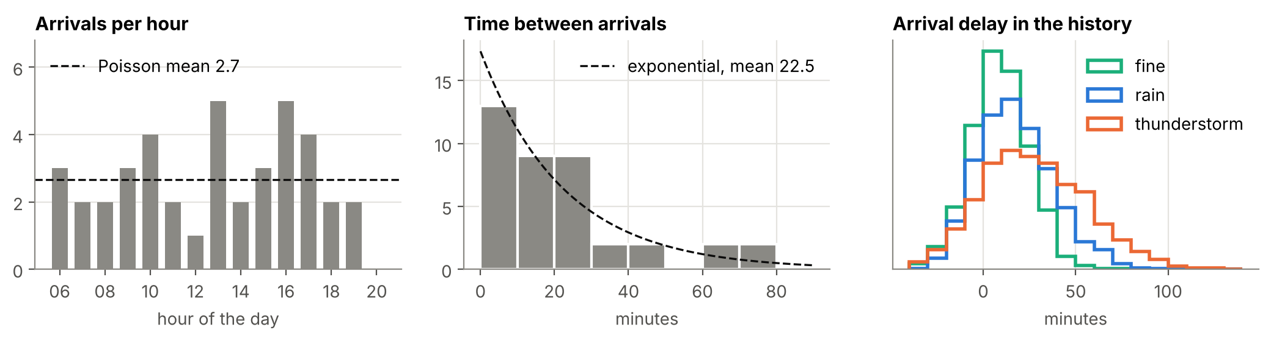
Figure 1. The generated data. Left: arrivals per hour on the planning day, against the Poisson mean of 2.7. Centre: minutes between consecutive arrivals, against the exponential distribution with a mean of 22.5. Right: arrival delays of the 4,800 past flights by weather.

3.3 Method overview
The method has four steps, shown in Figure 2. Each step is one short Python file.
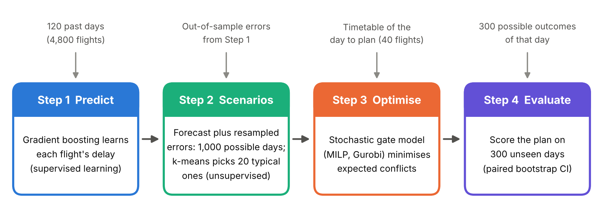
Figure 2. The four steps of the method and the data each step uses.
Step 1: supervised learning of delays. Each flight is described by seven features known the day before: the hour of arrival, the weather forecast, the day of the week, the scheduled ground time and three airline indicators. Three models predict the arrival delay: the average delay for the weather class (a naive benchmark), linear regression and gradient boosting with 300 trees of depth 3 and a learning rate of 0.05 (Friedman, 2001). The models are compared by five-fold cross-validation in which all flights of a day belong to the same fold. A random split would put flights of the same day in both the training and the test part, so the shared day shock would leak into training and the scores would look better than they are. The out-of-fold errors of gradient boosting are kept for Step 2, and the model is refitted on all 120 days to forecast the planning day.
Step 2: scenario generation and reduction. Let $r_{fd}$ be the out-of-fold error for flight $f$ on past day $d$. The errors are standardised by their standard deviation $σ_{w}$ for the weather class $w$ of the day, giving $z_{fd}=r_{fd}/σ_{w\left(d\right)}$. Each standardised error is then split into a day shock and an own error,
ud=140f​zfd, efd=zfd−ud.
A scenario $ω$ for the planning day draws one past day shock and one own error for every flight, both at random with replacement, and adds them to the forecast ${\hat{y}}_{i}$ on the thunderstorm scale $σ_{2}$:
$$Δ_{i}^{ω}={\hat{y}}_{i}+σ_{2}\left(u_{D_{ω}}+e_{E_{iω}}\right).$$
Here $D_{ω}$ is a random past day and $E_{iω}$ a random past flight-day. The scenario arrival time is $a_{i}^{ω}=a_{i}+Δ_{i}^{ω}$, and the departure time follows the turnaround rule, $d_{i}^{ω}=max\{d_{i}, a_{i}^{ω}+τ\}$. This residual bootstrap (Efron, 1979) needs no assumption about the shape of the delay distribution. It keeps the skew of the errors and, through the day shock, the tendency of flights to be late together. Step 2 produces 1,000 such scenarios.
For the unsupervised part, k-means clustering (Lloyd, 1982) groups the 1,000 scenarios, each a vector of 40 delays, into 20 clusters. In each cluster the scenario closest to the centre (the medoid) is kept, with a probability equal to the share of scenarios in the cluster. Keeping a real scenario rather than the cluster average avoids smoothing the delays of a day.
Step 3: stochastic optimisation. The model of Section 3.4 builds a plan for given nominal times and a given set of scenarios. It is solved with Gurobi 13 (Gurobi Optimization, 2025).
Step 4: evaluation. Each plan is scored on the 300 outcome days by counting conflicts, using the actual arrival times and the turnaround rule. Because all plans face the same days, their differences are paired. A 95% confidence interval for the mean difference is obtained from 2,000 bootstrap resamples of the 300 daily differences.

3.4 The stochastic gate assignment model
Table 4 gives the notation. The model follows the expected-conflict model of Şeker and Noyan (2012) but uses the aggregated pair costs introduced below.
Table 4. Notation.
Symbol | Meaning
$F$, $n$ | Flights, $n=40$
$G$ | Contact gates (seven gates); $A$ denotes the apron
$a_{i}$, $d_{i}$ | Nominal arrival and departure times of flight $i$ (the times the plan must respect)
$Ω$, $p_{ω}$ | Scenarios and their probabilities
$a_{i}^{ω}$, $d_{i}^{ω}$ | Arrival and departure times of flight $i$ in scenario $ω$
$δ_{ij}^{ω}$ | Idle time between flights $i$ and $j$ at one gate in scenario $ω$; negative if they overlap
$c_{ij}^{ω}$ | Cost if $i$ and $j$ share a gate in scenario $ω$
$w_{ij}$ | Expected cost if $i$ and $j$ share a gate
$C$ | Maximal sets of flights that are on the ground together at nominal times (cliques)
$P$ | Pairs that do not overlap at nominal times but come within the buffer in some scenario
$x_{ig}$, $x_{iA}$ | 1 if flight $i$ is placed at gate $g$ or at the apron
$y_{ij}$ | 1 if flights $i$ and $j$ share a contact gate
The idle time and the cost of a pair in a scenario are
$$δ_{ij}^{ω}=max\{a_{j}^{ω}−d_{i}^{ω}, a_{i}^{ω}−d_{j}^{ω}\}, c_{ij}^{ω}=100⋅\left[δ_{ij}^{ω}<0\right]+1⋅\left[0≤δ_{ij}^{ω}<b\right],$$
where $\left[⋅\right]$ equals 1 if the condition holds and 0 otherwise. The expected cost of the pair is wij=ω​pωcijω. The model is
min i,j∈P​wij yij+60i∈F​xiA 1
g∈G​xig+xiA=1 ∀i∈F 2
i∈Q​xig≤1 ∀Q∈C, g∈G 3
$$y_{ij}≥x_{ig}+x_{jg}−1 ∀\left(i,j\right)∈P, g∈G \left(4\right)$$
$$x_{ig}, x_{iA}∈\{0,1\}, 0≤y_{ij}≤1. \left(5\right)$$
The objective (1) adds the expected conflict and buffer costs of the pairs that share a gate and the cost of apron placements. Constraint (2) places every flight once. Constraint (3) keeps the plan conflict-free at nominal times: of the flights that are on the ground together, at most one may use each gate. Constraint (4) forces $y_{ij}$ to 1 when both flights use the same gate. The variable $y_{ij}$ does not need to be binary. Its cost $w_{ij}$ is non-negative, so at an optimum it takes the smallest allowed value, which is 0 or 1 for a binary $x$.
The scenario-indexed form. Written in the usual stochastic-programming way, as in Şeker and Noyan (2012), the model has one sharing variable $z_{ij}^{ω}$ for every pair and every scenario in which the pair has a cost, $P_{ω}=\{\left(i,j\right)∈P:c_{ij}^{ω}>0\}$. Objective (1) becomes ω​pωi,j∈Pω​cijωzijω+60i​xiA, and constraint (4) is repeated for every scenario with $z_{ij}^{ω}$ in place of $y_{ij}$.
Proposition 1 (exact aggregation). Both forms have the same optimal plans and the same optimal objective value.
Proof. Fix any plan $x$ that satisfies (2), (3) and (5). In the scenario-indexed form, every $z_{ij}^{ω}$ has a non-negative cost and is bounded below by $max\{0, \max_{g}\left(x_{ig}+x_{jg}−1\right)\}$, which equals 1 if $i$ and $j$ share a gate and 0 otherwise. This bound, call it $s_{ij}\left(x\right)$, does not depend on $ω$, so the best choice is $z_{ij}^{ω}=s_{ij}\left(x\right)$ for all $ω$. The cost of the plan is then i,j​sijxω​pωcijω=i,j​wij sijx, which is the cost of the same plan in the aggregated form with $y_{ij}=s_{ij}\left(x\right)$. Since every plan costs the same in both forms, both have the same optimal plans. $▫$
The proposition holds because whether two flights share a gate is a first-stage decision; only the cost of sharing depends on the scenario. It would not hold for a model with recourse decisions taken after the delays are known, such as reassignments on the day.

3.5 Four plans from one model
All plans in the study are built by the same function. They differ only in the information about delays they receive, as Table 5 shows. This keeps the comparison fair: any difference in performance comes from how the delay information is used, not from a different model.
Table 5. The four plans as inputs to the same model.
Plan | Nominal times (must be conflict-free) | Scenarios | Uses the ML model
Deterministic | Timetable | The timetable only | No
Predict-then-optimise (PTO) | Forecast arrivals, with the turnaround rule | The forecast only | Point forecast
ETO, 20 k-means | Timetable | 20 medoids from k-means, weighted | Distribution
ETO, all 1,000 | Timetable | All 1,000 scenarios, equal weight | Distribution
With a single scenario the model can only see buffer violations at the given times, so the deterministic and PTO plans are the classical buffer-based plans built on the timetable and on the forecast. The two ETO plans keep the published timetable as the nominal plan, which is what a planner would publish, and protect it against the scenarios.

3.6 Handling computational complexity
The AGAP with pairwise costs is NP-hard, and a stochastic version multiplies the pair terms by the number of scenarios. The model above keeps the size small in four ways.
- Clique constraints instead of pair constraints. For interval data, the sets of flights on the ground together can be listed by scanning the arrival times, and the maximal sets are the cliques of an interval graph. On the planning day, 107 pairs of flights overlap at nominal times, but they are covered by only 19 cliques. Constraint (3) therefore needs 133 rows instead of 749 (seven gates each), and the clique rows also give a tighter linear relaxation.
- Pair filtering. A pair enters $P$ only if it does not overlap at nominal times (otherwise constraint (3) already keeps it apart) and it comes within the buffer in at least one scenario. Of the 780 possible pairs, only 22 to 107 remain in the models of this study, depending on the scenario set.
- Exact aggregation. By Proposition 1, the number of sharing variables is $\left|P\right|$ rather than ω​Pω. The model size grows only through the slow growth of $P$, not in proportion to the number of scenarios. Section 4.4 measures this.
- Scenario reduction. k-means reduces the number of scenarios. With aggregation this is no longer needed for size, so Section 4.5 tests whether it still helps the quality of the plan.

3.7 Software
The code is written in Python with NumPy, pandas, scikit-learn (Pedregosa et al., 2011), Matplotlib and gurobipy. It consists of eight files of 20 to 65 lines each, plus one file for the figures. All random numbers are seeded, so every run gives the same data, forecasts and scenarios. When a model has several optimal plans, the computer or the solver version can decide which of them is returned (Section 4.7). The results in Section 4 are from one run on a Windows laptop with Gurobi 13.0.3 and an academic licence. The main study also runs on Gurobi’s free licence, and a run with that licence and the same Gurobi version on another computer gave identical results in Tables 6 and 7. As a second check, the models of Section 4.4 were also solved with the open-source solver HiGHS 1.15. Appendix A lists the files.

4. Results and Discussion

4.1 Delay prediction
Table 6 and Figure 3 report the cross-validated accuracy of the three delay models. Gradient boosting has the lowest error, 14.0 minutes on average against 15.0 for linear regression and 16.2 for the weather benchmark. Its advantage comes from the interaction between weather and time of day: storms raise delays most in the afternoon, which a linear model with separate weather and hour terms cannot represent.
Table 6. Cross-validated accuracy of the delay models (minutes; five folds, grouped by day).
Model | MAE | RMSE
Weather average | 16.17 | 20.88
Linear regression | 14.98 | 19.26
Gradient boosting | 13.97 | 17.93
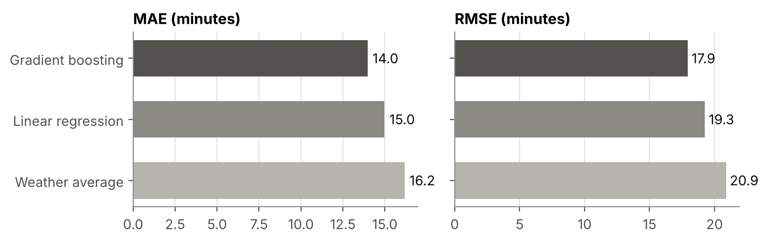
Figure 3. Mean absolute error (MAE) and root mean squared error (RMSE) of the delay models in five-fold cross-validation grouped by day.
Even the best model leaves an error of 17.9 minutes (RMSE), and in thunderstorms the standard deviation of its errors is 23.1 minutes. More than half of the error variance (54%) is the day shock, which no flight-level feature can predict. This is the central reason for the stochastic model: the forecast is useful, but a plan built only on the forecast trusts it far more than it deserves.

4.2 Performance of the four plans
Table 7 and Figure 4 compare the four plans on the 300 outcome days. All plans used contact gates only; none sent a flight to the apron.
Table 7. Out-of-sample performance on 300 unseen days. The last column gives the mean paired difference to the deterministic plan with its 95% bootstrap confidence interval.
Plan | Conflicts per day | Days without conflict | Overlap (min per day) | Difference to deterministic
Deterministic | 0.663 | 53.3% | 7.8 | –
Predict-then-optimise | 3.670 | 5.0% | 46.2 | +3.01 [+2.70, +3.32]
ETO, 20 k-means | 0.233 | 79.0% | 2.4 | −0.43 [−0.52, −0.34]
ETO, all 1,000 | 0.123 | 88.3% | 1.5 | −0.54 [−0.63, −0.45]
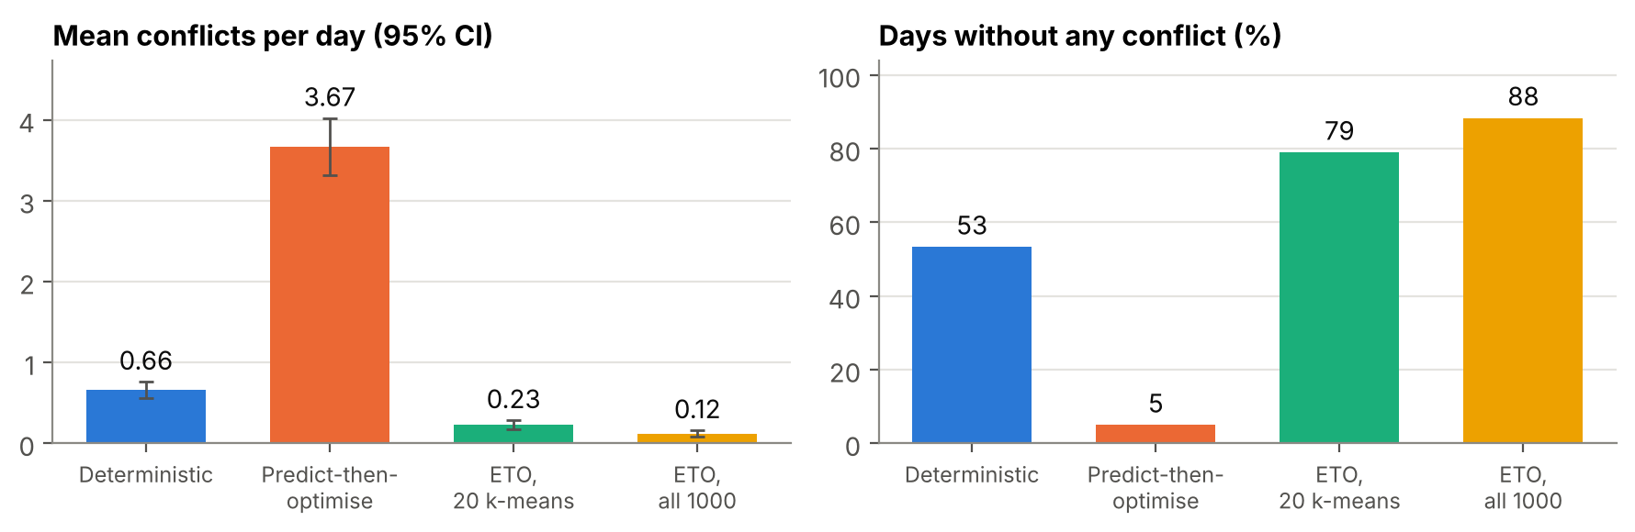
Figure 4. Mean conflicts per day with 95% confidence intervals (left) and share of days without any conflict (right).
Predict-then-optimise is the worst plan by far. It causes 3.7 conflicts per day, five and a half times as many as the timetable plan, and has a conflict-free day only one time in twenty. The reason is visible in its inputs. On a thunderstorm day the forecast arrivals are on average 38 minutes late, but the departures stay fixed unless the turnaround rule pushes them back. The planned ground times therefore shrink from 64.8 minutes in the timetable to 40.1 minutes on average, and 25 of the 40 flights are planned at the minimum turnaround of 35 minutes. The model sees short, well-separated ground times and packs the flights tightly. On the real day, any flight that lands earlier than forecast stays at the gate longer than planned, and with an error of about 20 minutes this happens to half of the flights. This is the effect described by Elmachtoub and Grigas (2022): a forecast that is right on average still leads to a poor decision, because the decision depends on the errors as well.
Estimate-then-optimise is the best plan. Using all 1,000 scenarios, the plan has 0.12 conflicts per day, 37 conflicts in 300 days against 199 for the timetable plan, and the difference to the deterministic plan is clearly significant. Figure 5 shows how this is achieved. Both plans use the same seven gates, but the ETO plan changes who follows whom at each gate. The deterministic plan has ten gaps of less than 30 minutes between consecutive flights at a gate; the ETO plan has five. More important is where the short gaps are. The ETO plan keeps a short gap mainly after an aircraft with a long scheduled ground time, which can absorb a late arrival and still leave on time, and before a flight that is itself likely to be late, which widens the gap on the day. The deterministic plan places short gaps after aircraft such as flight 28, which has only six minutes of slack above the minimum turnaround and a forecast delay of an hour. The deterministic model cannot tell these arrangements apart. In the timetable all of them respect the 15-minute buffer, so its objective value is zero for many different plans and the solver returns one of them arbitrarily.
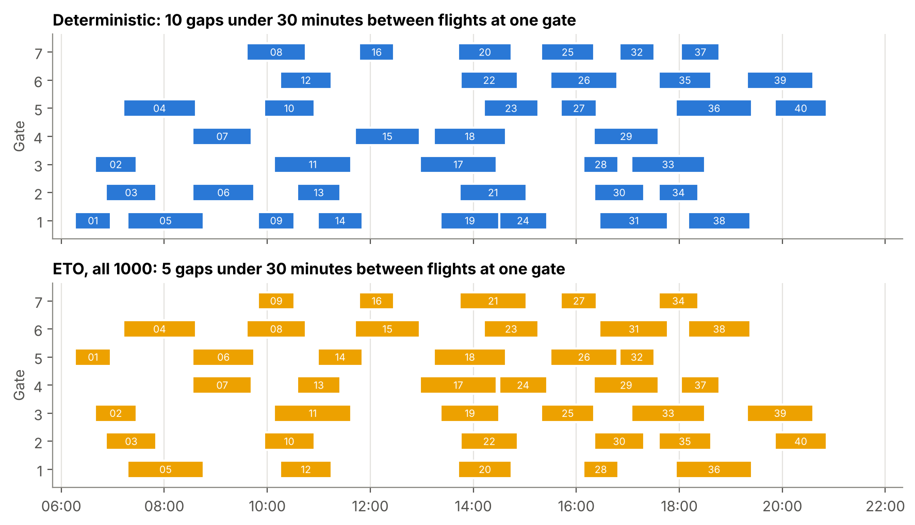
Figure 5. Gate charts of the deterministic plan (top) and the ETO plan with all 1,000 scenarios (bottom). Bars show scheduled ground times; numbers are flight numbers.
The scenario model is well calibrated. For each plan, the conflicts predicted by the 1,000 scenarios can be compared with the conflicts on the 300 outcome days. The scenarios predicted 0.095, 0.215, 0.61 and 2.77 conflicts per day for the ETO plan with all scenarios, the k-means plan, the deterministic plan and the PTO plan. The realised values were 0.123, 0.233, 0.66 and 3.67. Every prediction is slightly low, because the scenario delays (standard deviation 28 minutes) are a little narrower than the true outcomes (30 minutes), but the ranking of the plans is the same. A planner can therefore use the scenarios to judge in advance how risky a candidate plan is.

4.3 Answer to RQ1
On identical flights and identical unseen days, using the full delay distribution (ETO) gave 81% fewer conflicts than planning on the timetable, while using the point forecast (PTO) gave five and a half times more. The way a prediction enters the model matters more than the accuracy of the prediction itself.

4.4 Model size and solution time
Table 8 and Figure 6 show how the two formulations grow with the number of scenarios $K$. The aggregated model grows from 342 to 427 variables and from 327 to 922 constraints as $K$ rises from 5 to 1,000, because only the set of relevant pairs grows. The scenario-indexed model grows almost in proportion to $K$ and reaches 11,291 variables and 76,970 constraints at $K=1,000$. From $K=50$ it exceeds the 2,000-variable and 2,000-constraint limit of Gurobi’s free licence, so with that licence it cannot be solved at all, whereas the aggregated form stays below the limit at every size. With an academic licence Gurobi solved both forms. As a second check, both were also solved with the open-source solver HiGHS (Huangfu & Hall, 2018).
Table 8. Size and solution time in seconds of the two formulations against the number of scenarios $K$ (k-means scenarios for $K≤100$, all scenarios for $K=1,000$). Agg. = aggregated form (this study), S-I = scenario-indexed form. Gurobi with an academic licence on a laptop and a 60-second limit per model; > 60 means stopped at the limit. HiGHS on one thread of another computer with a ten-minute limit; > 600 means not solved within the limit.
$K$ | Agg. variables | Agg. constr. | Agg. Gurobi | Agg. HiGHS | S-I variables | S-I constr. | S-I Gurobi | S-I HiGHS
5 | 342 | 327 | 0.01 | 0.02 | 361 | 460 | < 0.01 | 0.01
10 | 352 | 397 | 0.04 | 0.42 | 417 | 852 | 0.16 | 0.59
20 | 359 | 446 | 0.03 | 0.24 | 491 | 1,370 | 0.10 | 0.63
50 | 376 | 565 | 0.27 | 1.24 | 787 | 3,442 | 0.74 | 3.53
100 | 401 | 740 | 1.95 | 10.42 | 1,334 | 7,271 | > 60 | 32.67
1,000 | 427 | 922 | 3.48 | 5.88 | 11,291 | 76,970 | 47.56 | > 600
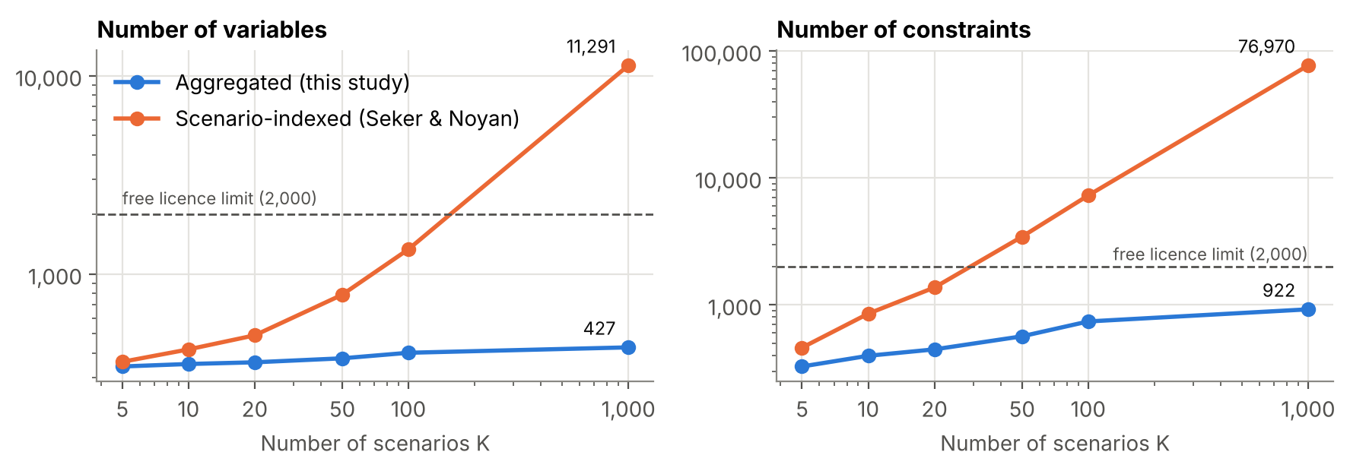
Figure 6. Number of variables (left) and constraints (right) of the two formulations; both axes are logarithmic. The dashed line is the limit of Gurobi’s free licence.
The two forms returned the same objective value in every comparison, as Proposition 1 predicts: in all eleven Gurobi comparisons (k-means and random scenario sets up to $K=100$, and all 1,000 scenarios) and in all five HiGHS comparisons that finished. This includes cases with a non-zero optimum, such as 1.557 with 20 k-means scenarios and 2.720 with 100. Up to 20 scenarios both forms are solved in a fraction of a second. From 50 scenarios on the aggregated form is clearly faster. At $K=100$ Gurobi solved it in 1.9 seconds, whereas it stopped the scenario-indexed form at the 60-second limit with the same plan value of 2.720 but a gap of 0.4% still open. At $K=1,000$ the aggregated form took 3.5 seconds against 47.6 seconds, fourteen times faster. HiGHS shows the same pattern more strongly: 10.4 against 32.7 seconds at $K=100$, and at $K=1,000$ 5.9 seconds for the aggregated form, whereas it did not finish the scenario-indexed form within ten minutes (its best plan cost 9.873 against the optimum of 9.760, and it had not yet found a useful lower bound). The main gains of the aggregation are therefore a model that is 83 times smaller in constraints, fits the free licence, and is solved many times faster.

4.5 Scenario reduction: k-means, random sampling or all scenarios
Since the aggregated model can use all 1,000 scenarios, scenario reduction is no longer needed to make the model solvable. The remaining question is whether a few well-chosen scenarios give a plan as good as many. Figure 7 and Table 9 compare k-means with random selection of the same number of scenarios. Each method was repeated five times with different random seeds.
Table 9. Out-of-sample conflicts per day of the ETO plan by number of scenarios and selection method (mean, with minimum and maximum over five runs).
$K$ | k-means | Random sample
5 | 0.680 (0.680–0.680) | 0.367 (0.220–0.557)
10 | 0.269 (0.217–0.373) | 0.276 (0.150–0.520)
20 | 0.219 (0.180–0.287) | 0.175 (0.123–0.233)
50 | 0.144 (0.130–0.160) | 0.129 (0.120–0.137)
100 | 0.127 (0.113–0.150) | 0.127 (0.110–0.140)
1,000 (all) | 0.123 | 0.123
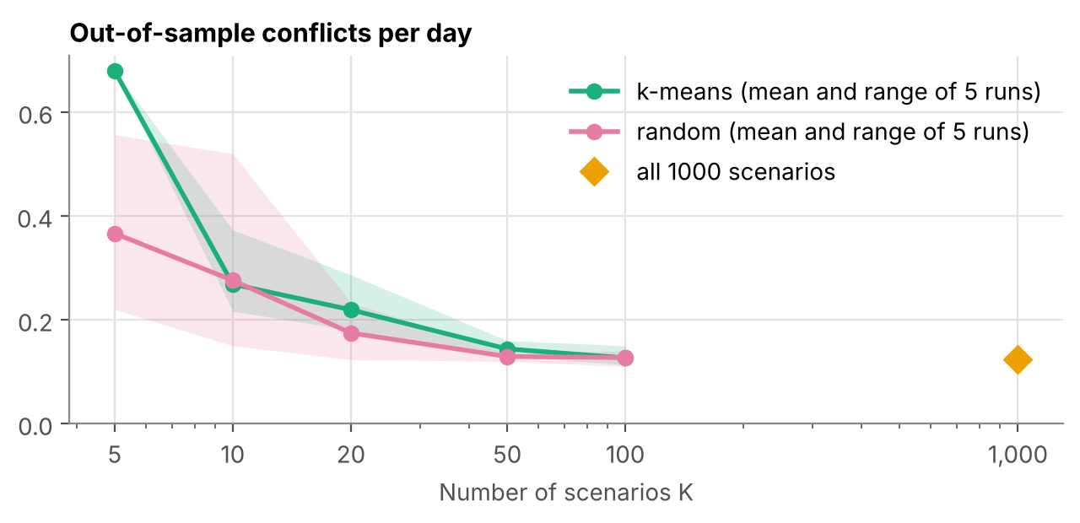
Figure 7. Out-of-sample conflicts per day of the ETO plan against the number of scenarios. Lines show the mean and bands the range of five runs; the diamond is the plan that uses all 1,000 scenarios.
k-means did not help. With five scenarios it was clearly worse than a random sample (0.68 against 0.37 conflicts per day), and from ten scenarios on the two methods were similar. The reason is visible in the objective values. With five k-means scenarios the optimal objective was zero in all five runs, against two of the five random runs. In those runs the model saw no risk at all in its scenarios and could not prefer one plan over another, so all five k-means runs returned the same unprotected plan. A medoid is a typical day of its cluster, and the rare days with a large shock that cause most conflicts are absorbed into clusters of milder days, whereas a random sample sometimes contains such a day. From 50 scenarios on, both methods reached the quality of the plan that uses all 1,000 scenarios (0.13 to 0.14 against 0.123), so on this instance about 50 scenarios are enough. The 20-scenario plan in Table 7 (0.233), which comes from a sixth k-means seed, lies within the range of the five runs here (0.180 to 0.287), which shows how much a reduced scenario set depends on chance. This is a known weakness of distance-based reduction for objectives driven by rare events, and it is one reason why problem-driven clustering has been proposed (Keutchayan et al., 2023). For this model, the exact aggregation is the simpler way to handle many scenarios, because it removes the size problem without discarding any of them.

4.6 Is a larger fixed buffer enough?
A planner could ask whether the same protection can be had more simply, by demanding a larger buffer in the deterministic model. Figure 8 shows the deterministic plan for buffers from 15 to 90 minutes. A 30-minute buffer reduces conflicts from 0.66 to 0.25 per day, close to the 20-scenario k-means plan (0.23). The other buffers are worse and the results jump around: 0.38 at 45 minutes, 1.03 at 60 and 0.63 at 90 minutes. With a long buffer almost every pair violates it, the model can no longer separate risky from harmless pairs, and the plan it returns becomes a matter of chance. A run of the same code on another computer confirmed this: it found the same objective values, but returned other, equally optimal plans, which scored 0.74, 0.43 and 0.94 conflicts per day at these three buffers. The best buffer can only be found by testing plans on outcome days, which is what the stochastic model does internally. Even the best buffer gives twice as many conflicts as the ETO plan with all scenarios (0.25 against 0.12). Uncertainty is not uniform: a fixed buffer protects every flight equally, while the scenarios concentrate protection on the afternoon flights that the storm affects most.
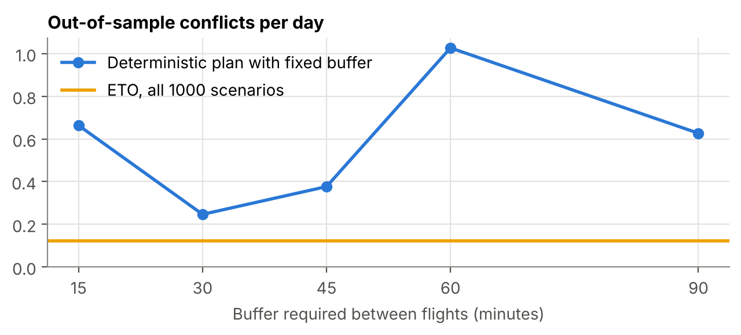
Figure 8. Out-of-sample conflicts per day of the deterministic plan with fixed buffers, compared with the ETO plan that uses all 1,000 scenarios.

4.7 Limitations
The data are synthetic. Their distributions follow common modelling assumptions and patterns reported in the literature, but real arrivals are not exactly a Poisson process, because hub airports schedule flights in banks. The size of the gains also depends on how uncertain the delays are and how full the gates are, so it should be confirmed on real operations data. The instance is small: one day profile with 40 flights and seven gates, chosen so that the main study runs on a free licence and can be explained line by line. At this size the apron was never used, so the trade-off between conflicts and remote stands was not tested. The model ignores gate size limits, passenger walking distance and reassignments on the day. Finally, the models can have several optimal plans, and the solver decides which one it returns. The deterministic model is the extreme case, with an objective of zero for many plans, but ties can also occur in the stochastic model. Another computer or solver version may therefore return a different plan with the same objective value and a different score on the outcome days. This happened in this study: a run on a second computer with the same Gurobi version gave identical results for the four plans of Table 7, but different scores for the fixed buffers (Section 4.6) and for some reduced scenario sets, so single results of this kind should be read with a margin. A secondary objective, for example maximising the smallest gap between flights, would break such ties in a controlled way.

5. Conclusions
This project built a complete prescriptive pipeline for airport gate assignment, from learning delays to scoring plans on unseen days, in about 360 lines of code. Its main findings answer the three research questions.
- RQ1. How a forecast is used matters more than how accurate it is. Planning on the point forecast produced five and a half times more conflicts than ignoring the forecast, because it removed the slack that the timetable provides. Planning against the learned distribution reduced conflicts by 81% relative to the timetable plan, and to half of the best fixed buffer.
- RQ2. In its usual scenario-indexed form the stochastic model grows in proportion to the number of scenarios and exceeds the free Gurobi licence from 50 scenarios on. Clique constraints, pair filtering and the exact aggregation of Proposition 1 keep it at 427 variables and 922 constraints for 1,000 scenarios, solved to optimality in about three seconds, while Gurobi needed 48 seconds for the 83 times larger scenario-indexed form. With the open-source solver HiGHS the difference was larger: 5.9 seconds for the aggregated form, while the scenario-indexed form did not finish within ten minutes.
- RQ3. k-means scenario reduction did not beat random selection. With very few scenarios its medoids hid the rare bad days completely, and from 50 scenarios on a random sample was as good as all 1,000. With aggregation, keeping all scenarios is the simplest safe choice.
For airport planners, the practical message is to treat a delay model as a source of scenarios rather than as a replacement for the timetable, and to check a candidate plan against those scenarios before publishing it. For modellers, the message is that reformulation can make a scenario reduction step unnecessary, which avoids the loss of information that reduction brings.
Several extensions follow naturally. The pipeline should be tested on real delay data, for example from the US Bureau of Transportation Statistics, and on larger days with more gates, where a rolling-horizon decomposition would keep the model fast. The Poisson arrival process could be replaced by one with a time-dependent rate that reproduces the arrival banks of hub airports. Departure delays that do not come from late arrivals, gate size limits and reassignment on the day can be added as further constraints or as a second stage. Finally, problem-driven scenario selection could be compared with the full-sample approach used here.

References
Bertsimas, D., & Kallus, N. (2020). From predictive to prescriptive analytics. Management Science, 66(3), 1025–1044. https://doi.org/10.1287/mnsc.2018.3253
Bolat, A. (2000). Procedures for providing robust gate assignments for arriving aircrafts. European Journal of Operational Research, 120(1), 63–80.
Bolat, A. (2001). Models and a genetic algorithm for static aircraft-gate assignment problem. Journal of the Operational Research Society, 52(10), 1107–1120.
Bouras, A., Ghaleb, M. A., Suryahatmaja, U. S., & Salem, A. M. (2014). The airport gate assignment problem: A survey. The Scientific World Journal, 2014, 923859.
Castaing, J., Mukherjee, I., Cohn, A., Hurwitz, L., Nguyen, A., & Müller, J. J. (2016). Reducing airport gate blockage in passenger aviation: Models and analysis. Computers & Operations Research, 65, 189–199.
Daş, G. S., Gzara, F., & Stützle, T. (2020). A review on airport gate assignment problems: Single versus multi objective approaches. Omega, 92, 102146.
Dorndorf, U., Drexl, A., Nikulin, Y., & Pesch, E. (2007). Flight gate scheduling: State-of-the-art and recent developments. Omega, 35(3), 326–334.
Dorndorf, U., Jaehn, F., & Pesch, E. (2017). Flight gate assignment and recovery strategies with stochastic arrival and departure times. OR Spectrum, 39, 65–93.
Dupačová, J., Gröwe-Kuska, N., & Römisch, W. (2003). Scenario reduction in stochastic programming: An approach using probability metrics. Mathematical Programming, 95(3), 493–511.
Efron, B. (1979). Bootstrap methods: Another look at the jackknife. The Annals of Statistics, 7(1), 1–26. https://doi.org/10.1214/aos/1176344552
Elmachtoub, A. N., & Grigas, P. (2022). Smart “predict, then optimize”. Management Science, 68(1), 9–26. https://doi.org/10.1287/mnsc.2020.3922
Friedman, J. H. (2001). Greedy function approximation: A gradient boosting machine. The Annals of Statistics, 29(5), 1189–1232. https://doi.org/10.1214/aos/1013203451
Gurobi Optimization, LLC. (2025). Gurobi optimizer reference manual (Version 13.0). https://www.gurobi.com/documentation/
Haghani, A., & Chen, M.-C. (1998). Optimizing gate assignments at airport terminals. Transportation Research Part A: Policy and Practice, 32(6), 437–454.
Huangfu, Q., & Hall, J. A. J. (2018). Parallelizing the dual revised simplex method. Mathematical Programming Computation, 10(1), 119–142. https://doi.org/10.1007/s12532-017-0130-5
Karsu, Ö., Azizoğlu, M., & Alanlı, K. (2021). Exact and heuristic solution approaches for the airport gate assignment problem. Omega, 103, 102422.
Karsu, Ö., & Solyalı, O. (2023). A new formulation and an effective matheuristic for the airport gate assignment problem. Computers & Operations Research, 151, 106073.
Keutchayan, J., Ortmann, J., & Rei, W. (2023). Problem-driven scenario clustering in stochastic optimization. Computational Management Science, 20(1), 13.
Kim, J., Goo, B., Roh, Y., Lee, C., & Lee, K. (2023). A branch-and-price approach for airport gate assignment problem with chance constraints. Transportation Research Part B: Methodological, 168, 1–26.
Kleywegt, A. J., Shapiro, A., & Homem-de-Mello, T. (2002). The sample average approximation method for stochastic discrete optimization. SIAM Journal on Optimization, 12(2), 479–502. https://doi.org/10.1137/S1052623499363220
Lloyd, S. (1982). Least squares quantization in PCM. IEEE Transactions on Information Theory, 28(2), 129–137. https://doi.org/10.1109/TIT.1982.1056489
Pedregosa, F., Varoquaux, G., Gramfort, A., Michel, V., Thirion, B., Grisel, O., Blondel, M., Prettenhofer, P., Weiss, R., Dubourg, V., Vanderplas, J., Passos, A., Cournapeau, D., Brucher, M., Perrot, M., & Duchesnay, É. (2011). Scikit-learn: Machine learning in Python. Journal of Machine Learning Research, 12, 2825–2830.
Pyrgiotis, N., Malone, K. M., & Odoni, A. (2013). Modelling delay propagation within an airport network. Transportation Research Part C: Emerging Technologies, 27, 60–75.
Rebollo, J. J., & Balakrishnan, H. (2014). Characterization and prediction of air traffic delays. Transportation Research Part C: Emerging Technologies, 44, 231–241.
Şeker, M., & Noyan, N. (2012). Stochastic optimization models for the airport gate assignment problem. Transportation Research Part E: Logistics and Transportation Review, 48(2), 438–459. https://doi.org/10.1016/j.tre.2011.10.008
Wang, Z., Liang, M., & Delahaye, D. (2020). Automated data-driven prediction on aircraft estimated time of arrival. Journal of Air Transport Management, 88, 101840.
Xu, L., Zhang, C., Xiao, F., & Wang, F. (2017). A robust approach to airport gate assignment with a solution-dependent uncertainty budget. Transportation Research Part B: Methodological, 105, 458–478.
Yan, S., & Tang, C.-H. (2007). A heuristic approach for airport gate assignments for stochastic flight delays. European Journal of Operational Research, 180(2), 547–567.
Zhang, C., Jin, Z., Ng, K. K. H., Tang, T.-Q., Zhang, F., & Liu, W. (2025). Predictive and prescriptive analytics for robust airport gate assignment planning in airside operations under uncertainty. Transportation Research Part E: Logistics and Transportation Review, 195, 103963. https://doi.org/10.1016/j.tre.2025.103963

Appendix A. Code and Reproducibility
The accompanying folder gate_seminar contains the data, the code and a README with set-up steps for Windows and macOS. After installing the packages in requirements.txt, python main.py reproduces Tables 6 and 7 in under half a minute, python experiments.py reproduces the Gurobi columns of Table 8, Table 9 and Figure 8 in a few minutes (the scenario-indexed form from 50 scenarios on needs an academic licence, and tied optima can change some values of Table 9 and Figure 8 on another computer), and python figures.py draws Figure 1 and Figures 3 to 8.
Table A1. Files of the code.
File | Lines | Content
settings.py | 21 | All parameters: gates, buffer, cost weights, scenario numbers
make_data.py | 60 | Synthetic data generator with the distributions of Table 2 (Section 3.2)
step1_predict.py | 36 | Features, three delay models, cross-validation grouped by day
step2_scenarios.py | 31 | Residual bootstrap with day shock; k-means medoids; random selection
step3_optimize.py | 65 | Cliques, pair costs, aggregated and scenario-indexed models in Gurobi
step4_evaluate.py | 23 | Conflicts per day; paired bootstrap confidence interval
main.py | 61 | Steps 1 to 4 for the four plans (Tables 6 and 7)
experiments.py | 64 | Cliques, model size, scenario reduction and buffer studies (Tables 8 and 9)
figures.py | 139 | Figure 1 and Figures 3 to 8

