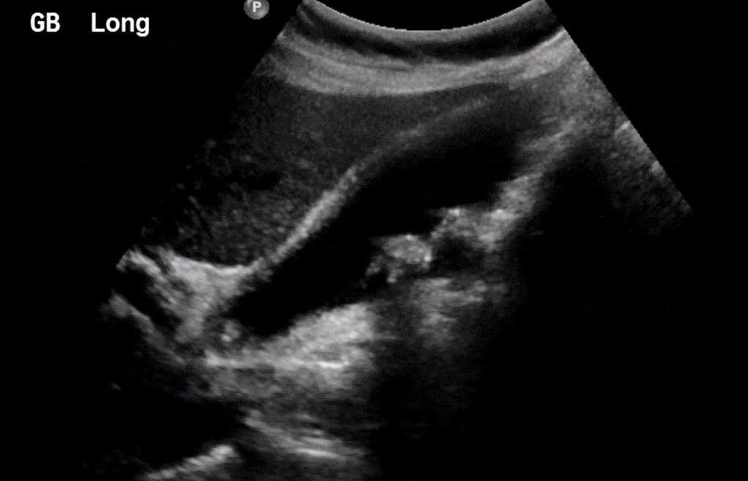

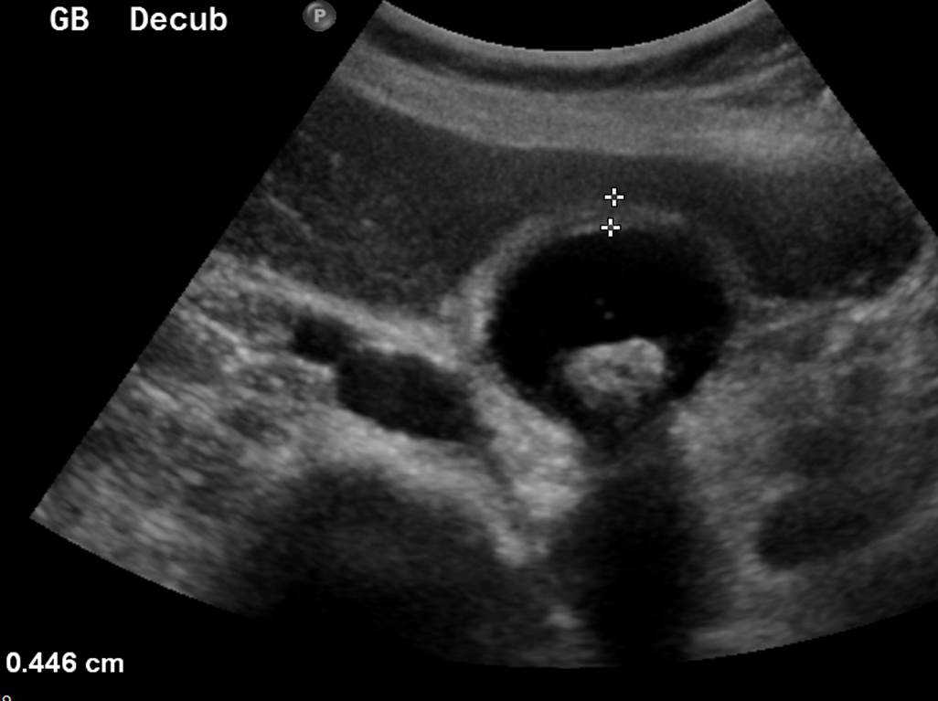

**Figure 1:** Ultrasound images demonstrate distended gallbladder with intraluminal stones and diffuse wall thickening consistent with acute calculous cholecystitis.

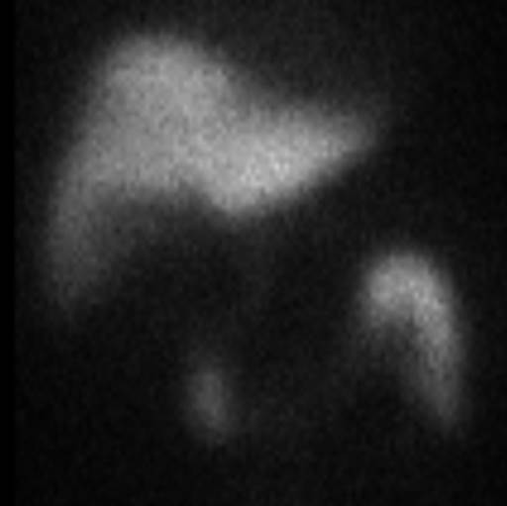

**Figure 2:** A 44-year-old man with acute cholecystitis. Cholescintigraphy image obtained 60 minutes after administration of 99mTc-hepatic iminodiacetic acid (HIDA) shows non-visualization of gallbladder consistent with acute cholecystitis.

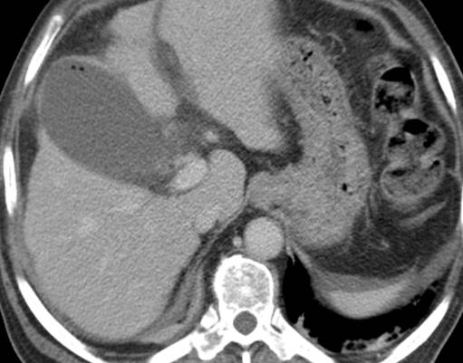

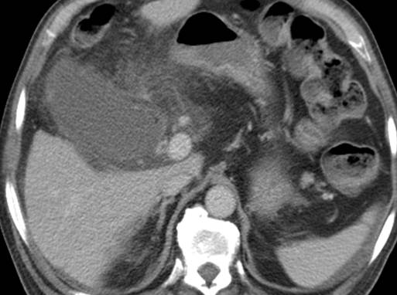

**Figure 3:** Contrast-enhanced axil CT images depict distended gallbladder with pericholecystic fat stranding and few foci of intraluminal air (arrow) consistent with acute emphysematous cholecystitis.

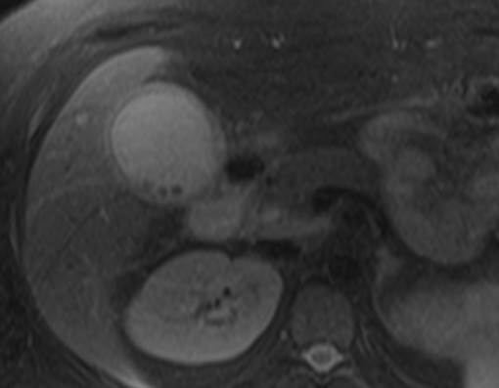

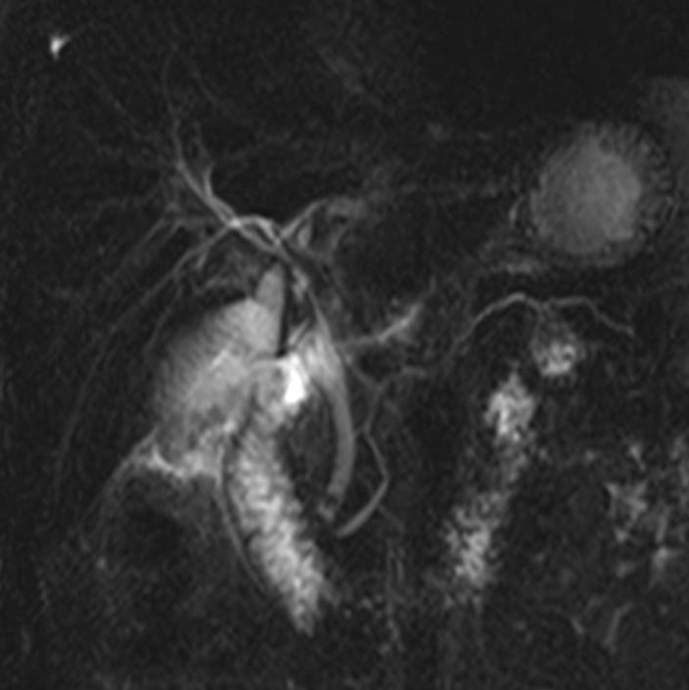

**Figure 4:** Axial T2- weighted MR image and MRCP image demonstrate acute calculous cholecystitis and a stone in the distal common bile duct (arrow).

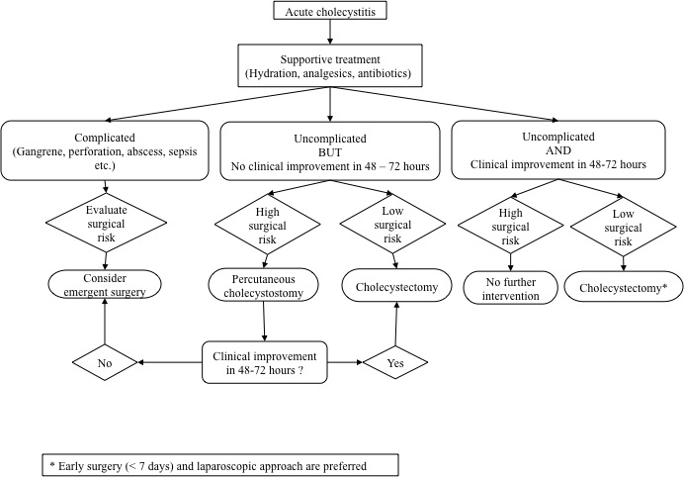

**Figure 5:** Flowchart describing the management of acute cholecystitis, including supportive care, cholecystostomy, and cholecystectomy.

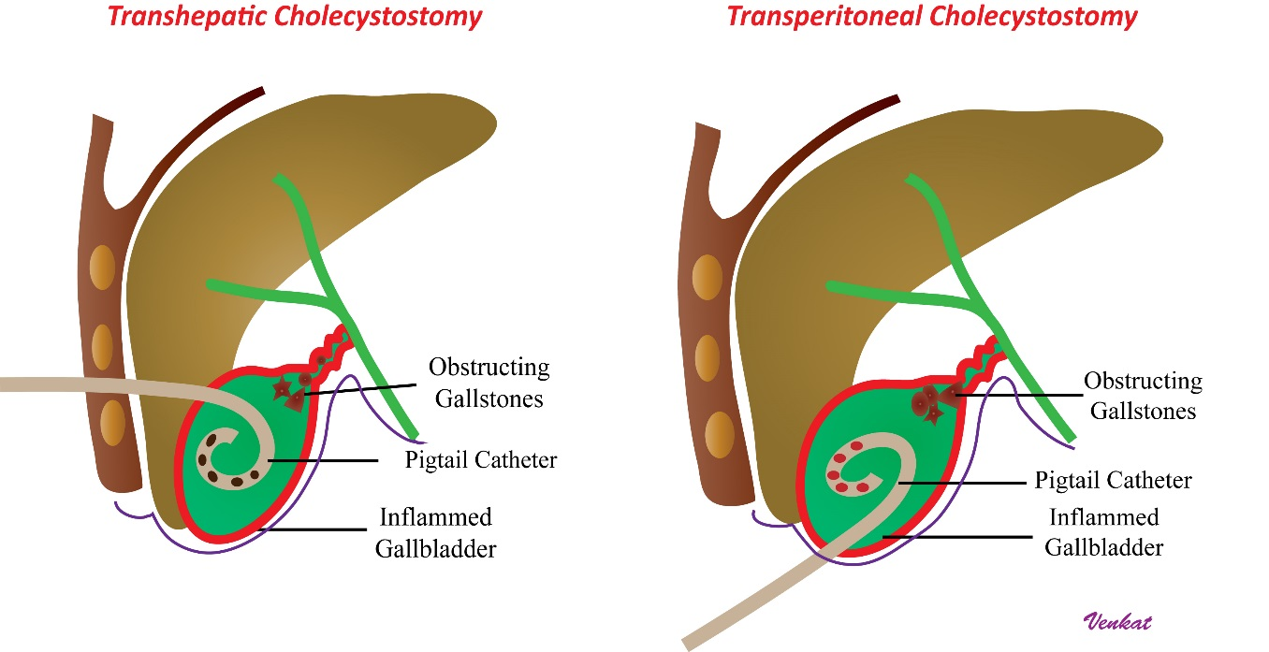

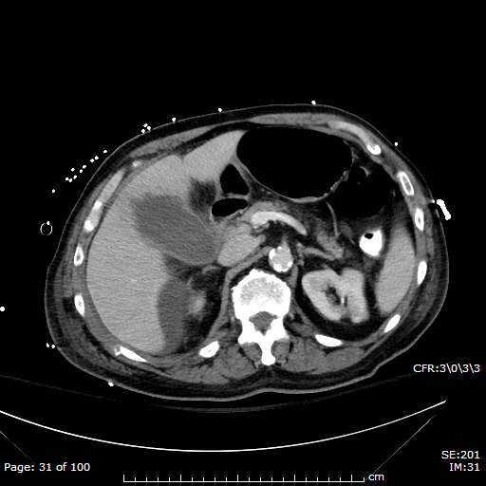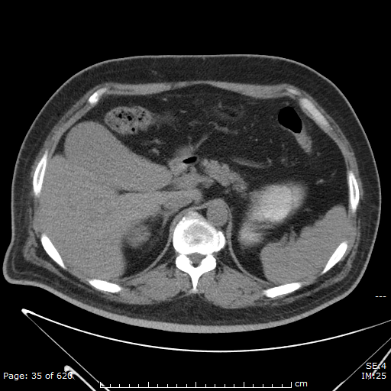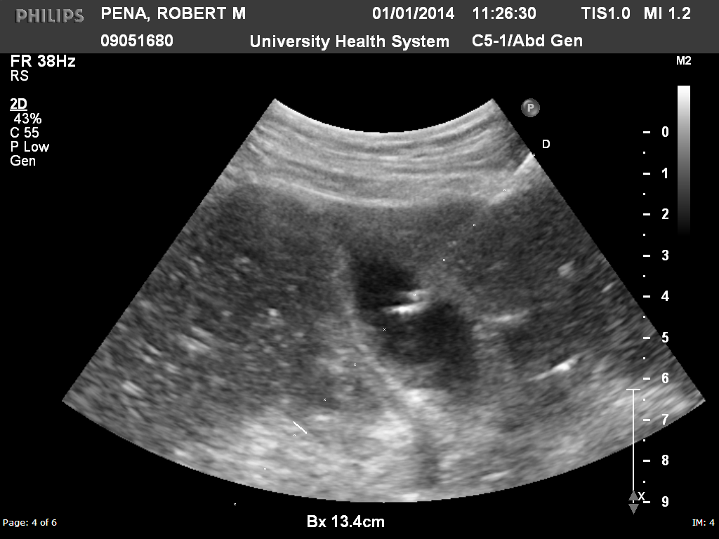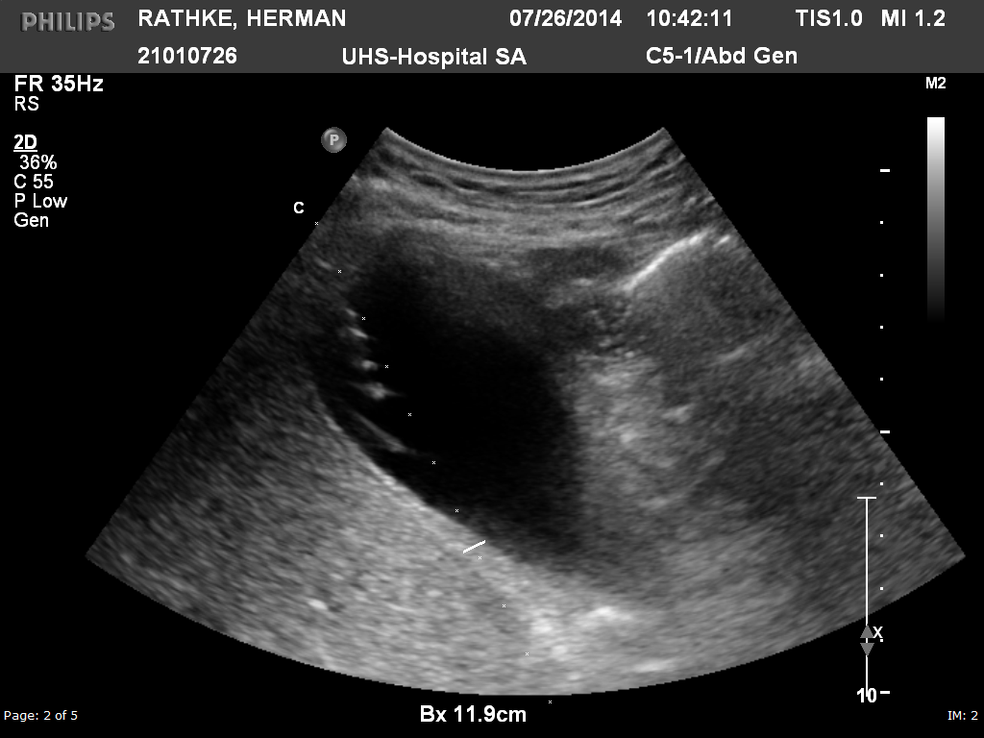

**Figure 6:** Transhepatic and transperitoneal approaches to percutaneous cholecystostomy – schematic diagram, CT imaging helping to plan TH or TP access, and the ultrasound-guided needle access for TH and TP access

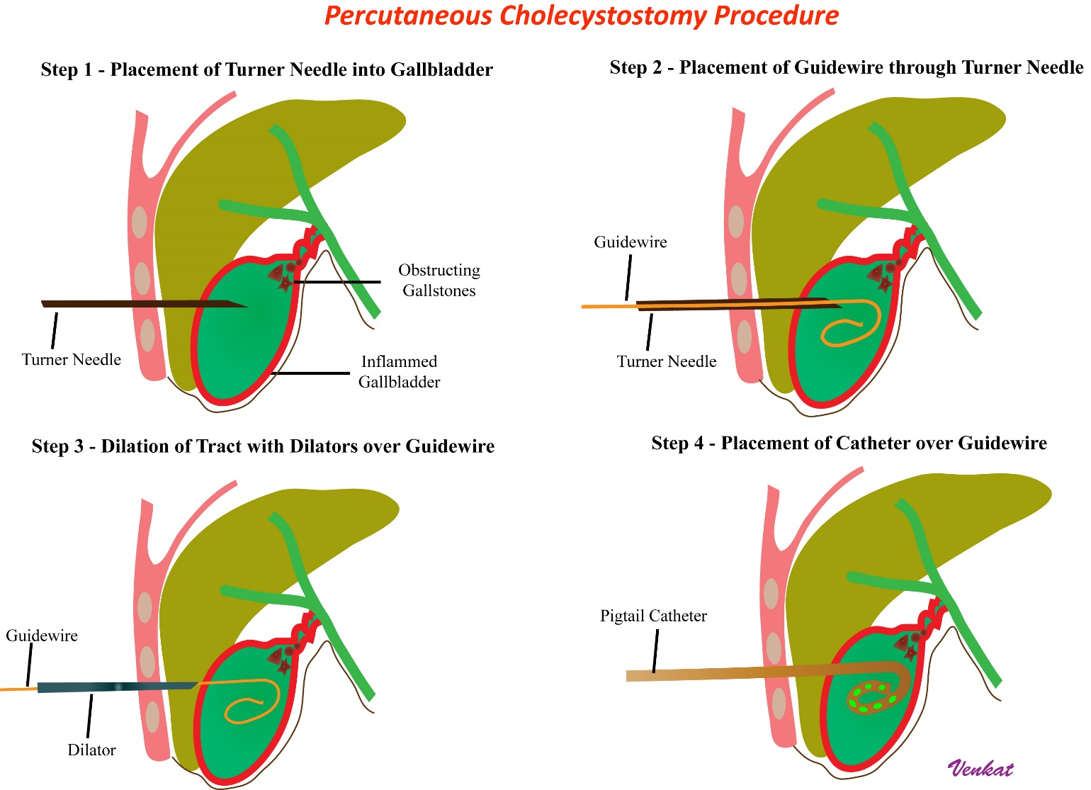

**Figure 7:** Seldinger approach to percutaneous cholecystostomy – schematic diagram delineating transhepatic needle access, guidewire placement, serial dilatation of the tract, and locking pigtal catheter placement.

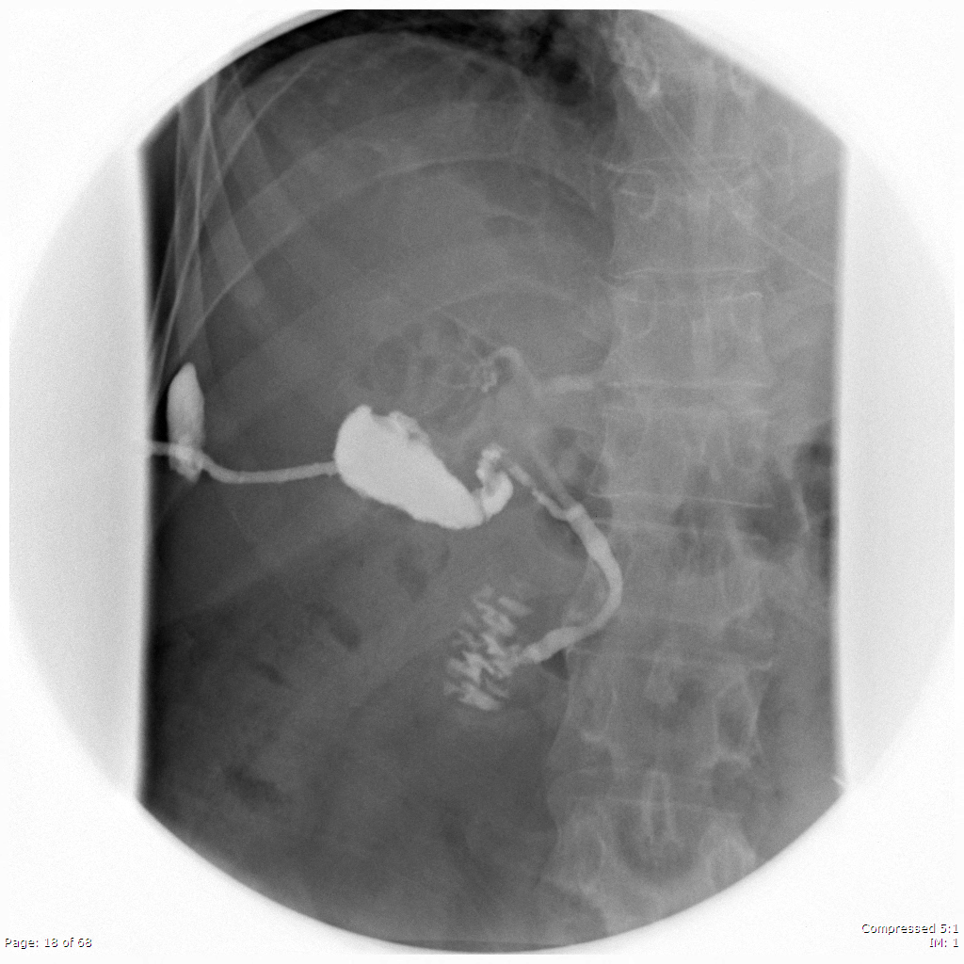

**Figure 8:** Percutaneous cholecytostogram in a 55-year-old man 3 weeks after PC procedure demonstrates patent cystic duct, antegrade flow of contrast into the duodenum, and a mature tract with some contrast leakage to the superficial soft tissues

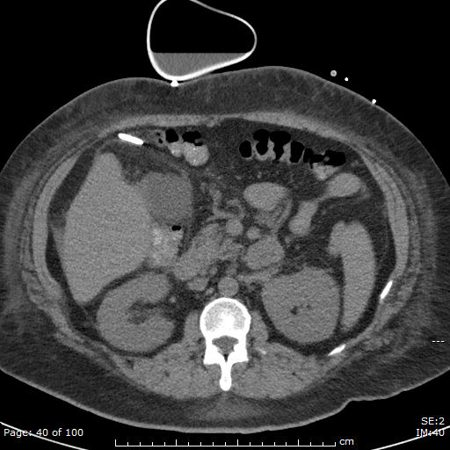 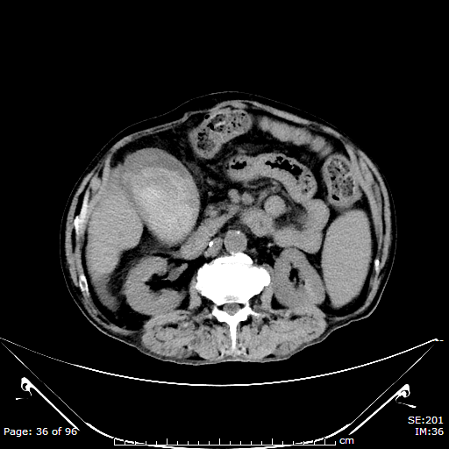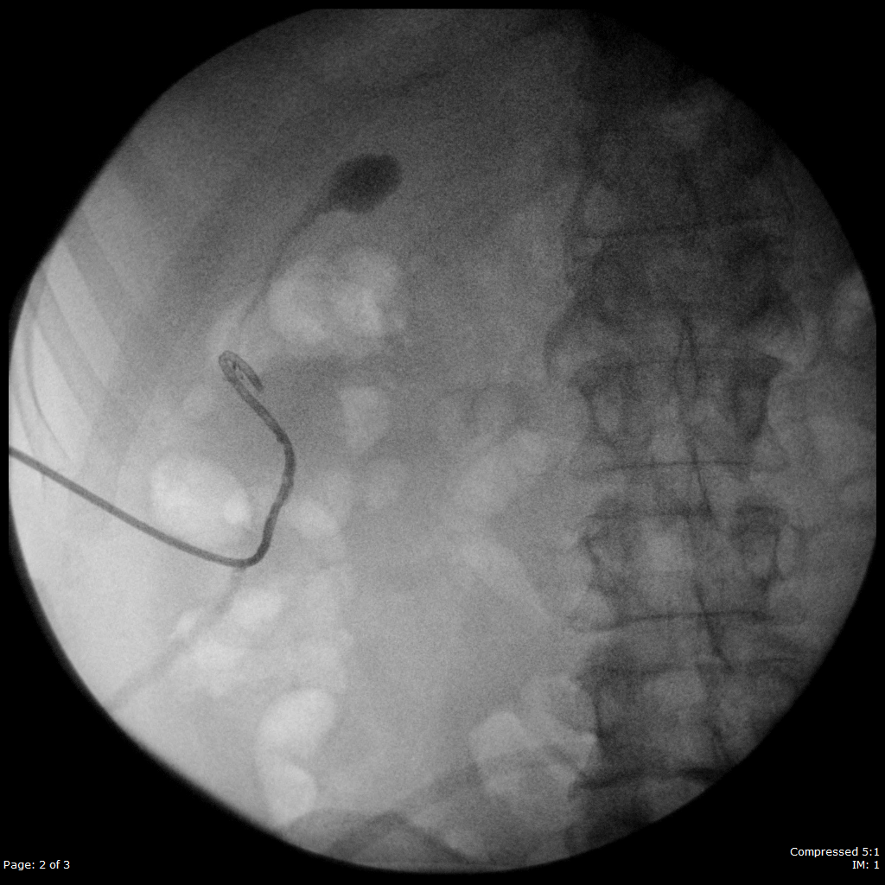 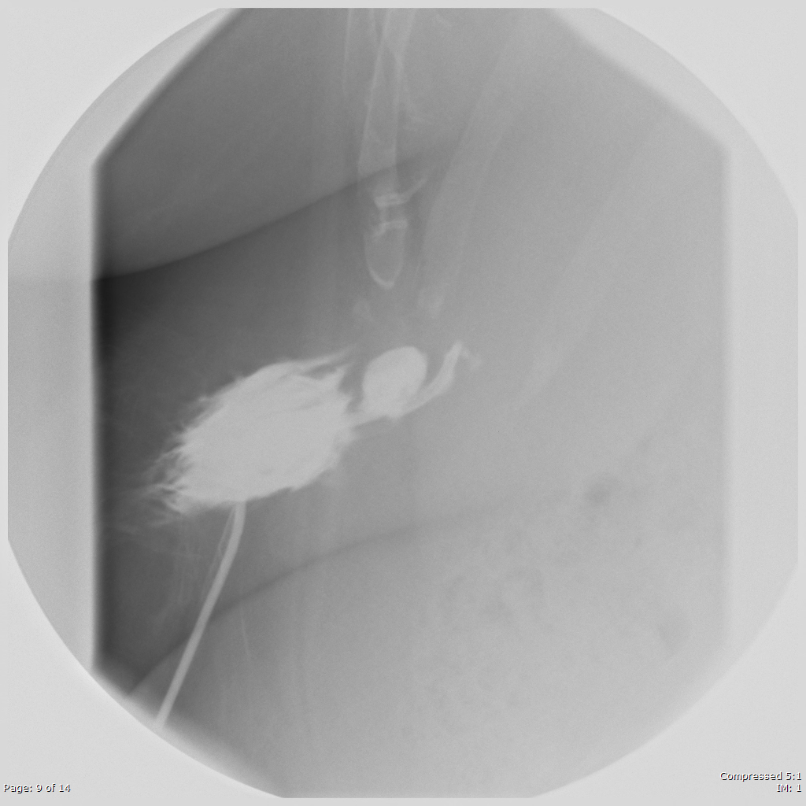

**Figure 9:** CT and percutaneous cholecytostograms revealing complications after PC tube placement in different patients – catheter dislodgement outside the GB, hemorrhage in the gallbladder, intraperitoneal bile leakage, and pericholecystic bile leakage.