Topic- Restaurant Website

* **Why this project?**

We will know that due to increasing technology demand the whole world is become a digital. Due to this, we take benefits of that demand. I think every restaurant have their own website because there is lot of advantages like we can reserve table online for our family dinner due to this there is no need for waiting. Also we can order food online there is no need to go restaurant. And main thing is that the website contains menu book of restaurant this make easy way to go our own favourite food/dish restaurant. There is no need to search the location of restaurant because the website contains address of the respective restaurant.

* **Why this technologies?**

Following are the list of technologies which is used in project:

1.HTML, CSS for website structure and design.

2.Bootstrap4 for responsive design.

3.JQUERY for online reservation of tables.

4.Carousel for trending items.

5.Font awesome cdn for restaurant social accounts link.

6.npm lite-server to sync browser while making changes in code this change is reflecting in our browser without refreshing it.

7.Feedback form for knowing customers opinion about restaurant.

* Some Screenshots of technologies -

**1.Carousel** – It contain slide show of trending item used for easy to navigate items for users. It also contain play/pause button.

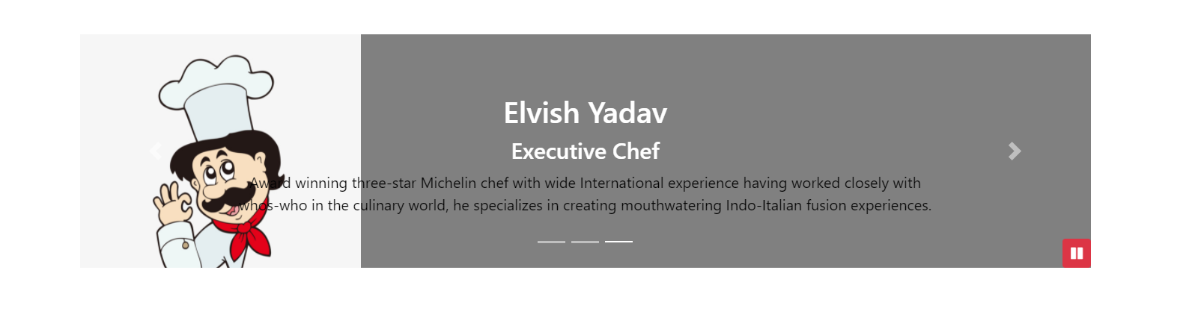

**2.Reservation Table button** – With the help of JQUERY the popup form will appear as seen in following screenshot. It used for reservation.

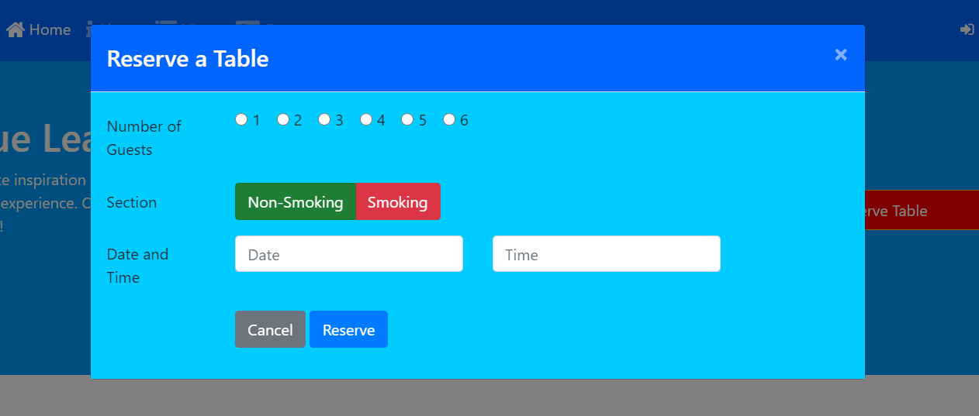

**3. Bootstrap accordion**- This is helpful for showing large amount of data in small space with the help of its collapsible item property.

