**Communication Management Plan Version 1.0**

**Date:** 5/28/2020

**Project Name**: IntelWise

1. **Stakeholder communications requirements:** A project progress report is sent across all the stakeholders via an Email. Chinmayi is responsible for sending this email as per the communications summary listed below.
2. **Communications summary:**

|  |  |  |  |  |
| --- | --- | --- | --- | --- |
| **Stakeholders** | **Communications Name** | **Delivery Method/Format** | **Producer** | **Due/Frequency** |
| Project steering committee | Weekly status report | Hard copy and short meeting | Omkar Abhiteja | Monday,Wednesday 10 AM |
| Sponsor and champion | Monthly status report | Hard copy and short meeting | Omkar Abhiteja | First Tuesday every week at 10 AM |
| Affected employees | Project announcement | Memo, e-mail, intranet site, and announcement at department meetings | Sushmita / Gangadhar | Due 5th June,2020 |
| Project team | Weekly status report | Short meeting | Chinmayi | Thursday 10 AM |

1. **Comments/Guidelines:**

* If meetings occur during a public holiday then the meetings would be held on the next working day.
* If the meetings get cancelled due to any problems, a details report on what items were to be discussed in the meeting needs to be shared with all the stakeholders.
* Any delay in sending reports should be communicated at least 2 hours earlier.
* After every meeting, a report on what was discussed and what was the outcome of the meeting needs to be communicated to all stakeholders.

1. **Escalation procedures for resolving issues:**

To report any development issues in the project, the below escalation matrix is used

Gangadhar 🡪 Omkar Abhiteja 🡪 Chinmayi 🡪 Sushmita

To report any issues related to scope, deadlines, etc. The escalation matrix to be followed is:

Team 🡪 Chinmayi 🡪 Stakeholders

1. **Revision procedures for this document:**

In case there are any changes to this document, the steps mentioned should be followed in order

1. Team makes necessary changes to the document with a new version number
2. Chinmayi reviews the document and sends it to the stakeholders for signoff.
3. After receiving all the signoff’s, they are documented and stored for a future reference.
4. The updated document is published to all the stakeholders over an email communication by Chinmayi.

**Flow Chart for the above procedure is mentioned below:**

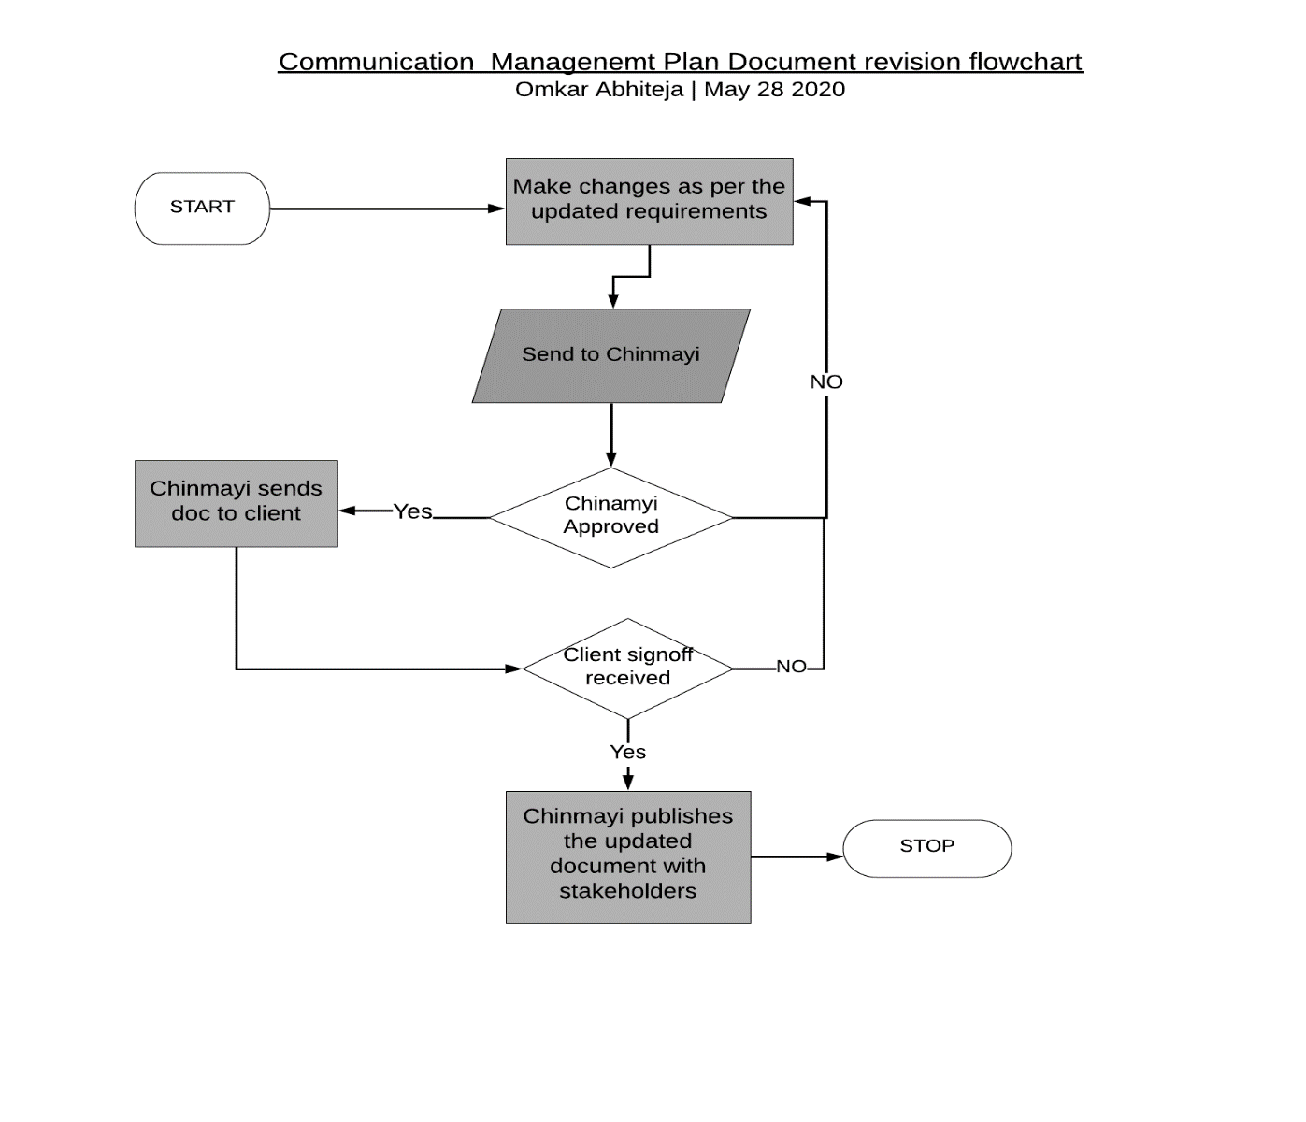

1. **Glossary of common terminology:**

* Champion 🡪 The project champion is the person within an organization implementing a project who takes on the burden of ensuring everyone involved is on board and behind the ultimate success of the project.
* Deadline 🡪 Target date indicating when you want a task to be completed.
* Escalation 🡪 An escalation is the process of calling upon higher levels of project leadership or management to resolve an issue.
* Flow Chart 🡪 A type of diagram that represents a workflow or process.
* Project progress report 🡪 A document that explains in detail how you far you've gone towards the completion of a project.
* Stakeholder 🡪 A stakeholder is a party that has an interest in a company and can either affect or be affected by the business.
* Project Steering committee 🡪 Project steering committees are likely a part of a larger project governance structure that has the duty of managing the team's progress when it comes to meeting project goals and deadlines.
* Scope 🡪 Features and functions of a product, or the scope of work needed to finish a project.
* Sponsor 🡪 The project sponsor is that person or group who owns the project.